**UML AND TESTING TOOLS LAB**

**Home Energy Optimization System**

**BATCH-14**

***A Project report submitted in partial fulfillment***

***of the requirements for the award of the degree of***

**BACHELOR OF TECHNOLOGY**

**IN**

**INFORMATION TECHNOLOGY**

**Submitted By:**

**A21126511006** **B.Ramesh**

**A21126511035** **M.Santosh Bhargav**

**A21126511051**   **P.Goutham Ganesh**

**A21126511054**   **S.Chandrashekar**



**DEPARTMENT OF INFORMATION TECHNOLOGY**

**ANIL NEERUKONDA INSTITUTE OF**

**TECHNOLOGY AND SCIENCES**

**ACKNOWLEDGMENT**

An endeavor over a long period can be successful with the advice and support of many well-wishers. We take this opportunity to express our gratitude and appreciation to all of them.

We owe our tributes to Prof.M.Rekha Sundari, Head of the Department, Information technology, ANITS, for providing us with the required facilities for the implementation of the project work.

We wish to express our sincere thanks and gratitude to lecturer in charge A.Surekha mam, Assistant Professor of Information Technology, ANITS for analyzing problems associated with our project work and for guiding us throughout the project.

We express our warm and sincere thanks for the encouragement, untiring guidance and the confidence she had shown in us. We are immensely indebted for her valuable guidance throughout our project.

We thank all the staff members of IT department for their valuable advices and for providing resources as and when required.

From:

A21126511006 (B.Ramesh)

A21126511035 (M.santosh Bhargav)

A21126511051 (P.Goutham Ganesh)

A21126511054(S.Chandrashekar)

**DEPARTMENT OF INFORMATION TECHNOLOGY**

**ANIL NEERUKONDA INSTITUTE OF TECHNOLOGY AND SCIENCES**

**(UGC AUTONOMOUS)**

**(*Affiliated to AU, Approved by AICTE and Accredited by NBA & NAAC with ‘A’ Grade*)**

**Sangivalasa, bheemili mandal, visakhapatnam dist.(A.P)**

**CERTIFICATE**

This is to certify that the project reported entitled “Home Energy OptimizationSystem” submitted by B.Ramesh , M. Santosh Bhargav, P. Goutham Ganesh, S. Chandrasekhar in partial fulfillment of the requirements for the award of the degree of **Bachelor of Technology in Information Technology** of Anil Neerukonda Institute of technology and sciences, Visakhapatnam is a record of bonafide work carried out under my guidance and supervision.



**Lecturer Incharge**  **Head of the Department**

**A.Surekha**  **Prof.M.Rekha Sundari**

Department of IT Department of IT

ANITS ANITS

**INDEX**

|  |  |  |
| --- | --- | --- |
| **S. NO.** | **TOPIC** | **PAGE NO.** |
| **1.** | **PROBLEM STATEMENT** |  |
| **2.** | **SRS FORMAT** |  |
| **3.** | **UML DIAGRAMS** |  |
| **4.** | **SAMPLE PAGE** |  |
| **5.** | **RESULTS** |  |

**Problem Statement:**

The Home Energy Optimization System (HEOS) seeks to address the complexities of residential energy consumption. It must contend with fluctuating energy usage patterns, integrate renewable sources effectively, and manage costs based on real-time pricing data while considering user preferences and comfort. Data privacy and security are paramount, and the system must be scalable, compatible with existing home technologies, and capable of smart energy source selection. Real-time feedback and visualizations are crucial for user engagement. Furthermore, HEOS must adhere to local regulations and incentives, ultimately aiming to create sustainable, cost-efficient, and user-friendly solutions for homeowners to optimize energy consumption and reduce their environmental impact.

**2.DESCRIPTION:**

A Home Energy Optimization System (HEOS) is a smart technology that optimizes energy use in homes. It monitors and manages energy from various sources, integrates renewables, reduces costs through pricing insights, adapts to user preferences, and ensures data security. HEOS provides real-time feedback and is compatible with existing home systems while complying with regulations, ultimately making homes more efficient and sustainable.

**SOFTWARE REQUIREMENTS SPECIFICATIONS**   **(SRS)**

**1. Introduction**

**1.1 Purpose**

The purpose of this document is to define the requirements for the development of the Optitech. This aims to optimize residential energy consumption, integrate renewable energy sources, and enhance user comfort while ensuring data privacy and security.

**1.2 Scope**

optitech will manage energy usage, analyze consumption  patterns, and make informed decisions to minimize costs and reduce environmental impact. It will be compatible with various home configurations and automation systems.

**2. Project Goals and Objectives**

The project aims to:

* Energy cost management.
* Electricity bill estimation

**3. Scope**

Home energy optimization system includes:

* Less energy consuming devices.
* Desired amount of bill.
* Estimation of watts should be comsumed.

**4. Stakeholders**

* consumers
* optitech development team(Batch-14)

**5. Requirements**

* **Functional Requirements:**
  + customers can buy less energy consuming devices.
  + They can get estimated electricity bill.
* **Non-Functional Requirements:**
  + Response time should be less than 2 seconds.
  + The system should handle 10,000 simultaneous users.

**5.1 User Registration and Authentication**

Users should be able to register with unique usernames and passwords.

Users must verify their email addresses during registration.

Authentication mechanisms should ensure secure access

**5.2 User roles**

Admin:

-manage user accounts and profiles.

-Handle user queries and disputes

-Recommend low power consumption products

User:

- create account

* + **-**bill generation
  + **-**buying products

**5.3 Project Management**

User can login or can create a account and buys products which consume less energy.

The products can be recommended based on customer reviews.

User can also estimate the electricity bill based and previous month consumption and desired electricity bill.

**6. Architecture**

optitech follows a client-server architecture, with a web-based front-end and a backend database.

**7. Design and Implementation**

* Utilizes a microservices design pattern.
* We are implementing services based on Basic HTML,CSS,PHP and JS.

**8. Testing**

* Testing conducted using Agile methodology.
* Unit tests, integration tests, and user acceptance tests performed.

**9. Deployment**

* Deployment on a 000webhost Page.

**10. User Manual**

* How to register an account.
* List of devices.

**11. Maintenance and Support**

* Regular maintenance every month for updates and bug fixes.
* Support available via email and a dedicated helpline.

**12. Risk Management**

* Risks identified: server downtime, security breaches.
* Mitigation strategies outlined.

**13. Project Timeline**

* Project initiation: August 2023
* Development: Oct 2023 - Nov 2023
* Testing: October 2023
* Deployment: Nov 2023
* Maintenance: Ongoing

**14. Conclusion**

This Software Requirements Specification outlines the functional and non-functional requirements for the Home Energy Optimization System (HEOS). It serves as a foundation for system design, development, and testing, with the ultimate goal of providing homeowners with a sustainable, cost-effective, and user-friendly solution for energy consumption optimization and environmental impact reduction.

**USE CASE DIAGRAM:**

File management system involves several types of diagrams to represent different aspects of the system. Here are some of the key UML diagrams you might consider

1. **Use case diagram**

**Aim:** To design and implement HOES using use case diagram.

**Purpose:** In the Unified Modelling Language (UML), a use case diagram can summarize the details of your system's users (also known as actors) and their interactions with the system. To build one, you'll use a set of specialized symbols and connectors. An effective use case diagram can help your team discuss and represent:

* Scenarios in which your system or application interacts with people, organizations, or external systems
* Goals that your system or application helps those entities (known as actors) achieve
* The scope of your system

**Content:** Actors, Use Cases and their relations

**Procedure:**

**Step 1:** First create an actor admin.

**Step 2:** Create another actor user.

**Step 3:** Now, create all required use cases such as login, register, bill generation , etc….

**Step 4**: All use cases are connected to appropriate associated relationships.

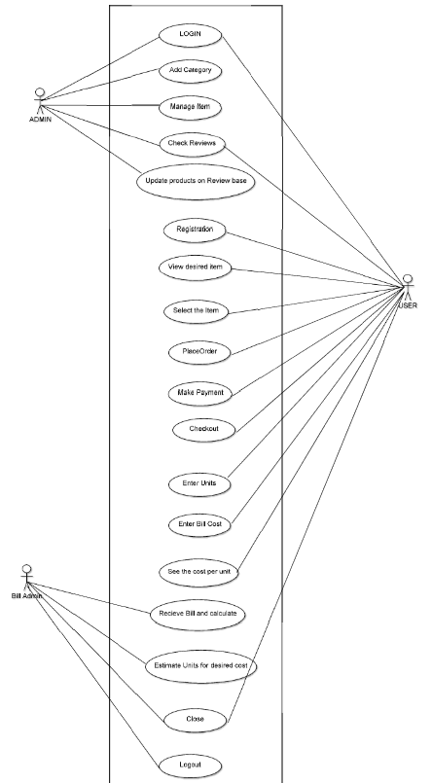

1. **Class diagram:**

**Aim:** To design and implement HOES through class diagram.

**Purpose:** Class diagrams are a type of structure diagram because they describe what must be present in the system being modelled.

* The various components in a class diagram can represent the classes that will actually be programmed, the main objects, or the interactions between classes and objects.
* The class shape itself consists of a rectangle with three rows. The top row contains the name of the class, the middle row contains the attributes of the class, and the bottom section expresses the methods or operations that the class may use

**Contents:** Classes, relationships, collaboration, dependencies, generalization, association relationships.

**Procedure:**

**Step 1:** Initially classes (admin, products , bill admin ,customer ) are created.

**Step 2:** Appropriated relationships between classes are provided.

1. **State Chart diagram**

**Aim:** To design and implement investor’s lancer using state chart diagram.

**Purpose:** State chart diagram describes the flow of control from one state to another state. States are defined as a condition in which an object exists and it changes when some event is triggered. The most important purpose of State chart diagram is to model lifetime of an object from creation to termination.

**Contents:** Initial state, Transition state, Fork, Join, Self transition, composite state, final state.

**Procedure:**

**Step 1:** First it goes to login page after initial state.

**Step 2:** After entering the login details it goes to state authentication.

**Step 3:** After authentication it checks for the offers and traverse to other states and finally reaches the final state.

**4. Sequence diagram**

**Aim:** To design and implement investor’s lancer using sequence diagram.

**Purpose:** A sequence diagram shows the sequence of messages passed between objects. Sequence diagrams can also show the control structures between objects. For example, lifelines in a sequence diagram for a banking scenario can represent a customer, bank teller, or bank manager.

**Contents:** Actors, lifelines, messages, guards

**Procedure**:

Step 1: First an actor and user is created.

Step 2: An object is created for User.

Step 3: Now we create operations for the objects.

Step 4: In sequence diagrams interactions are done through time ordering of message.

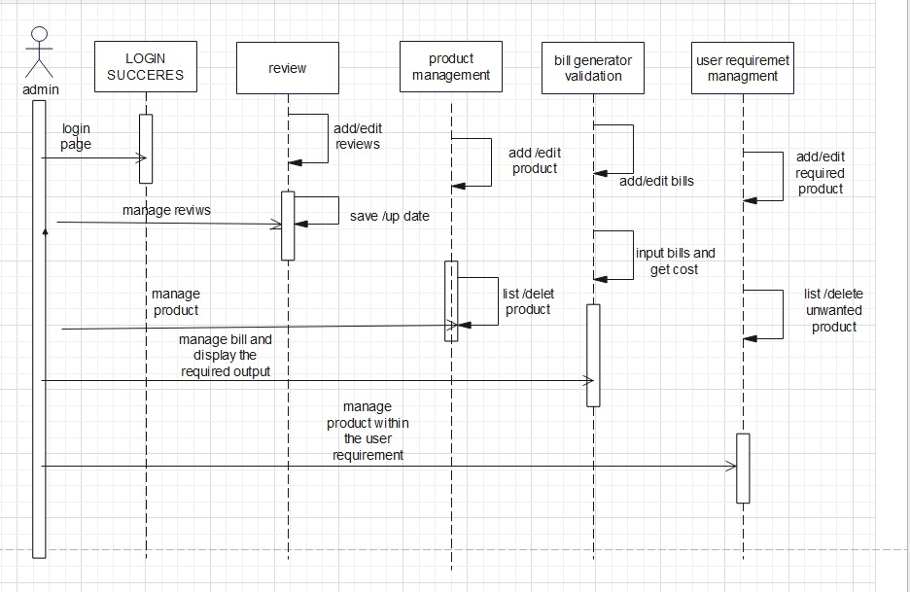

**5 . Deployment diagram**

**Aim:** To design and implement investor’s lancer using deployment diagram

**Purpose:** Deployment diagrams are used to visualize the topology of the physical components of a system, where the software components are deployed. Deployment diagrams are used to describe the static deployment view of a system.

- Envisions the hardware topology of the system.

- Represents the hardware components on which the software components are installed.

- Describes the processing of nodes at the runtime.

**6. Activity diagram**

**Aim:** To design and implement investor’s lancer using activity diagram.

**Purpose**: An activity diagram is a type of Unified Modelling Language (UML) flowchart that shows the flow from one activity to another in a system or process. It's used to describe the different dynamic aspects of a system and is referred to as a 'behaviour diagram' because it describes what should happen in the modelled system.

**Content:** Activities, activity partition, forks, join nodes, pin.

**Procedure**:

Step 1: Initial state is created.

Step 2: Go to Bill Gen page and give the required inputs and also create a estimated bill watts for the required cost

Step 3: Use this activities, activity partition, forks, join nodes, pin whenever needed.

**7 . Collaboration diagram**

**Aim:** to design and implement investor’s lancer using collaboration diagram

**Purpose:** A collaboration diagram, also known as a communication diagram, is an illustration of the relationships and interactions among software objects in the Unified Modeling Language (UML). Developers can use these diagrams to portray the dynamic behaviour of a particular use case and define the role of each object.

**Content:** Objects, actors, links, messages

**Procedure:**

Step 1: First an actor is created and named as freelancer

Step 2: An object is created and the interaction is done through organization

Step 3: Appropriate messages are between freelancer and entrepreneur

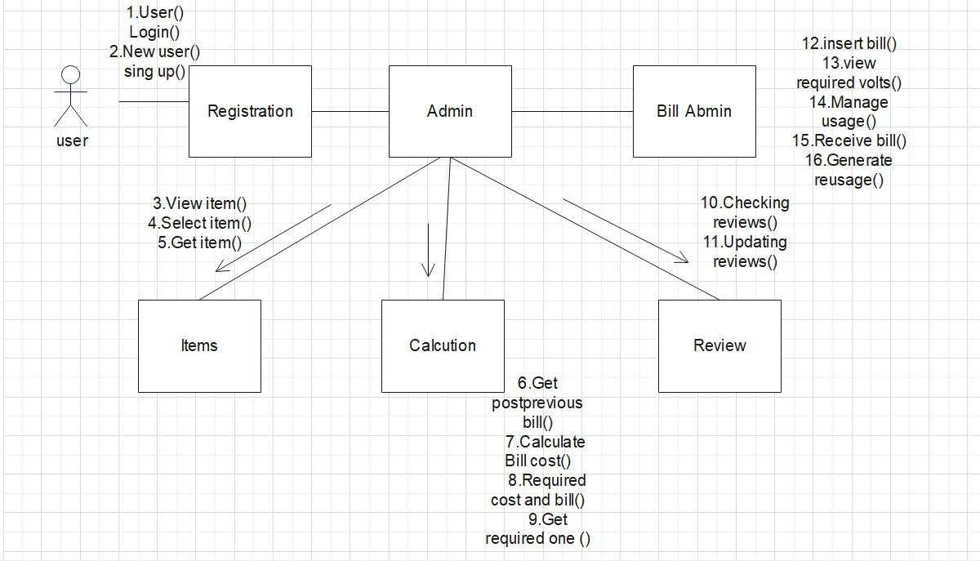

**8. Component Diagram**

**Aim:** To design and implement investor’s lancer using component diagram.

**Purpose:** The purpose of a component diagram is to show the relationship between different components in a system. For the purpose of UML 2.0, the term "component" refers to a module of classes that represent independent systems or subsystems with the ability to interface with the rest of the system.

**Content:** Component, interface, relationships.

**Procedure:**

Step 1: User can be able to get all the items which are recommended for the less power consumption and also they can able to get an estimated watts for the required bill cost.

Step 2: In this way it undergoes to the scheduled process to various states and finally reaches to final state.

Step 3: Use these components, interfaces, relationships whenever needed.

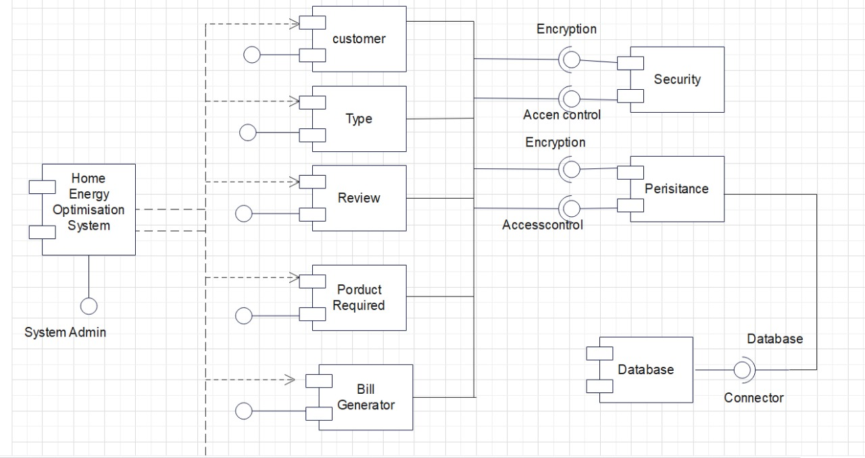

**Sample Page:**

Source: https://bhargav1429.000webhostapp.com/uml/umlpro.html