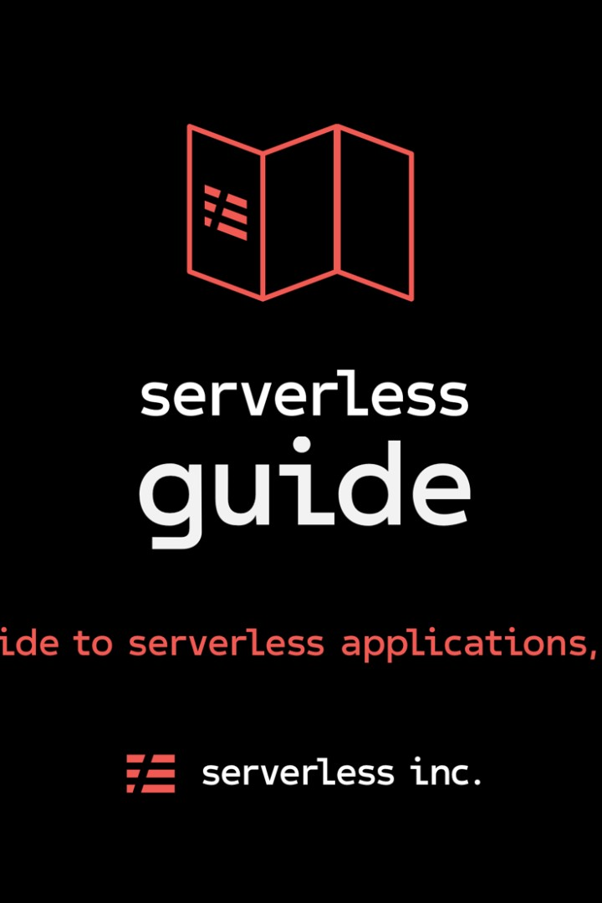

Building a Serverless IoT

Data Processing Solution

Learn how to create a powerful serverless IoT data processing solution using IBM Cloud Functions and device integration. This guide will walk you through the process of integrating smart devices and setting up data collection.

**By:**Santosh T

# Step 1: Device Integration

Start by integrating your smart devices into the system. Connect each device securely and ensure they can communicate with the cloud platform. This will allow for seamless data collection and processing.

## Connect Devices



Integrate your smart devices and ensure secure connections.

## Collect Data

Gather data from each device to be

processed and analyzed.

## Cloud Integration

Integrate your devices with an efficient cloud platform for data storage and processing.

# Step 2: Data Collection

With the devices integrated, it's time to set up data collection. Define the types of data to be collected and establish data gathering protocols. Ensure that the collected data is accurate, reliable, and in the desired format for further processing.

## 1 Define Data Types

Gathering Protocols

Determine the specific types of data to be collected from each device.

2

Establish protocols and methods for

gathering data effectively. 3 Accuracy Validation

Verify the accuracy of the collected data to ensure reliability.

# Step 3: Data Processing

Now that the data is collected, it's time to process it. Use IBM Cloud Functions to create serverless functions that will analyze and transform the collected data. Leverage the power of cloud computing to perform complex calculations and extract valuable insights.

## Data Analysis

Analyze the collected data to identify patterns, trends, and anomalies.

## Data Transformation

Transform the data into a format that is suitable for further analysis.

## Insight Extraction

Extract valuable insights and actionable information from the processed data.

Step 4: Real-time Monitoring

Enable real-time monitoring of the IoT data. Set up alerts and notifications based on predefined rules and thresholds. Ensure that any anomalies or critical events are immediately detected and appropriate actions are taken.

### Alerts and Notifications

Set up alerts and notifications for real-time detection of anomalies.

### Rule-Based Monitoring

Define rules and thresholds to monitor the data in real-time.

### Actionable Response

Take appropriate actions in response to detected anomalies or critical events.

# Step 5: Data Visualization

Visualize the processed data to gain meaningful insights and facilitate decision-making. Use charts, graphs, and dashboards to present the data in a clear and concise manner. Allow users to interact with the visualizations to explore the data further.

## Charts and Graphs

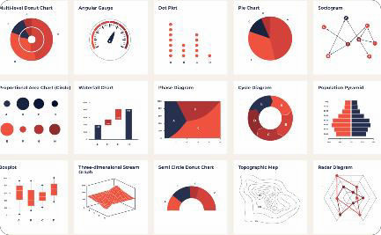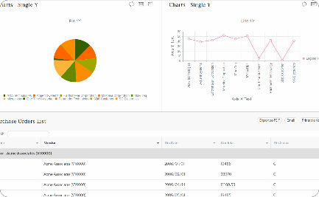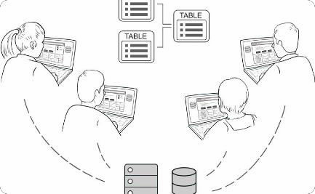

Present the processed data using visually appealing charts and graphs.

## Data Dashboard

Create a user-friendly dashboard to display key metrics and insights.

## Interactive Interface

Enable user interaction with the visualizations to explore data in detail.

# Step 6: Actionable Insights

Once the data is visualized, extract actionable insights from it. Identify trends, make predictions, and optimize processes based on the derived insights. Use the power of data-driven decision-making to drive innovation and improve efficiency.

## Trend Identification

Identify trends and patterns in the data to gain a deep understanding of the system.

## Predictive Analysis

Use predictive models to forecast future outcomes and make informed decisions.



## Process Optimization

Optimize processes based on the insights gained from the data analysis.

# Step 7: Continuous Improvement

Building a serverless IoT data processing solution is an iterative process. Continuously monitor and evaluate the system's performance. Identify areas for improvement and implement necessary changes to enhance efficiency, reliability, and security.

## Performance Monitoring

Regularly monitor the system's performance to identify bottlenecks or areas of improvement.

## System Optimization

Implement changes and optimizations to enhance system efficiency and reliability.

## Security Enhancements

Strengthen the security measures to protect the system from potential threats.

Step 8:DEVICE INTEGRATION AND DATA INTEGRATION

# Example code for data collection from a motion sensor import paho.mqtt.client as mqtt

def on_connect(client, userdata, flags, rc): print("Connected with result code "+str(rc)) client.subscribe("motion_sensor")

def on_message(client, userdata, msg): print("Received message:", msg.payload.decode()) Client = mqtt.Client()

client.on_connect = on_connect client.on_message = on_message client.connect("broker.example.com", 1883, 60) client.loop_forever()

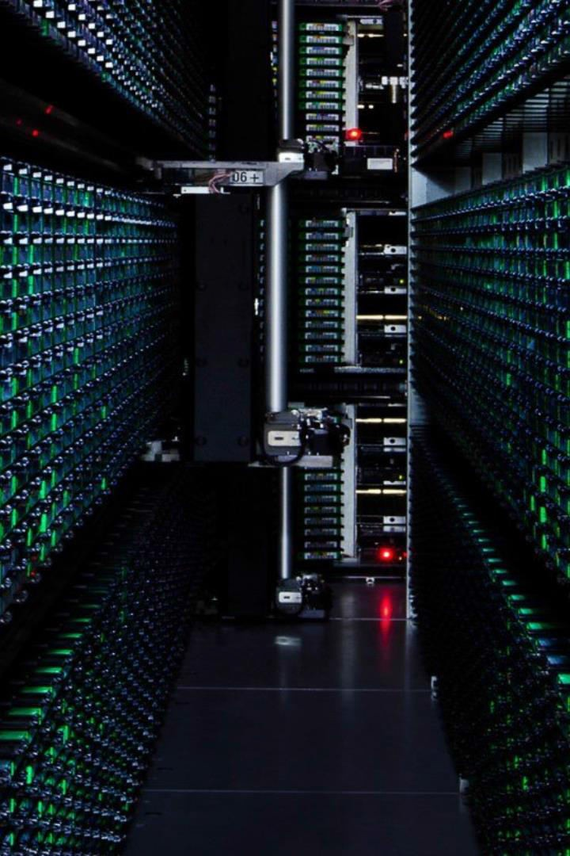

Conclusion

In conclusion, building a serverless IoT data processing solution using IBM Cloud Functions and device integration can empower your organization with valuable insights and enable data-driven decision- making. Follow the outlined steps to create a powerful system that extracts maximum value from the collected IoT data.