**EXCEPTIONS**

Exception is an exceptional event that occurs during execution of program, that disturbs the normal flow of program.

Exception is an abnormal behavior of an application, occurs when the execution time and terminates the flow of execution if not handled. Exceptions may be database connection errors, network connection errors, file not found error, file corrupted error and so many.

1. What is an exception object and throwing an exception?

When an error occurs within the method, the method creates an object and handles it to the run time to handle, the object is called exception object. Which contains information about the exception.

The object is created and handles (delegates) it to the run time system to handle is called throwing an exception.

After the method throws an exception the run time system looks for the caller of the method to handle, those methods are called call stack.

2. How to handle exceptions?

Exceptions handled by try, catch, and finally blocks.

***Try:*** Try block is used to enclose the code that might throw an exception.

***Catch***: The block catches all the exceptions that have occurred in the try block. Each catch block is an exception handler that handles the exceptions. It can contain specific type of exception to handle that occur in the try block or subclasses of the exception type.

***Finally****:* this block always performs irrespective of exception is catching or not.

3. Difference between error and exception?

Errors typically happen when an application is running while the exception is occurred by the application.

|  |  |
| --- | --- |
| ***Exception*** | ***Error*** |
| Belongs to java.lang package | Belongs to java.lang |
| Exceptions are created by application itself. | Errors are occurred when application is running. |
| Compiler will check for checked exceptions whereas it will not care about the un-checked exceptions. | Compiler will not check errors because they are occurring at run-time. |

4. What is the use of exception handling?

If there is no exception handling, then the application execution terminates. To avoid this, exception handling is necessary.

* Avoids the unexpected termination of program.
* Provides flexibility to the programmers to handle exceptions thereby making application more robust and immune to unexpected errors.
* Programmers can understand the reason for the termination of applications.

5. Types of exceptions in java?

There are two types of exception are present checked and un-checked exceptions.

The parent most of the exception is throwable.

Exception

Error

throwable

***1)Checked exceptions:***

Occurs during compilation time, compiler will check whether the exception is handled, if not then throws an error accordingly.

***2)Unchecked exceptions:***

Occurs during application execution time. Compiler will not check whether the exception is handled or not. It is compiled and throws exception at the run time. All the subclasses of java.lang.RuntimeException class and java.lang.Error classes belong to runtime exceptions.

6. Briefly explain the usage of throw and throws keys?

Both throw and throws are the keys of exception handling.

***throw:*** The throw key is used to explicitly throw an exception inside the method or block of code. The exception is handed over to the run time to handle it.

***throws:*** The throws key is used to delegate or declare which exceptions are thrown by the method. Is used with method signature specifies that method may throw an exception.

7. What is the difference between final, finally and finalize keywords?

*FINAL:*

* Final is a keyword used with variables, methods, and classes, when variable is marked as final it is like a constant it cannot modify in future.
* If the method is final, then it cannot be inherited by the subclass means final methods are not overridden.
* If the class is final then it does not allow inheritance, classes cannot inherit the final classes.

*FINALLY:*

* The finally is a keyword used in the exceptions.
* It executes the statements irrespective of exception is handled or not.

*FINALIZE:*

* The finalize method is called by the java garbage collector when the object is no longer needed.

8. What are the kinds to handle exceptions?

There are multiple kinds of catching the exceptions.

* try with catch
* try only
* try with finally
* try, catch, and finally
* try with multiple catch
* try with multi catch
* try with resource

9. How to handle checked exceptions?

Checked exceptions are also called compile time exceptions; compiler will check whether the exception is handled or not. If not handled properly the program will not be compiled. Can be handled by try-catch block or throws clause in the method declaration.

10. Differentiate between checked and unchecked exception?

|  |  |
| --- | --- |
| ***Checked exceptions*** | ***Unchecked exceptions*** |
| They are checked by the compiler. | They are not checked by the compile. |
| Until and unless exception is handling the compilation of the program is not possible. | Compilation may possible but exception may arise during runtime if exception is not handled properly. |
| Checked exceptions are subclasses of Exception class. | They are subclasses of RuntimeException class. |
| Ex: IOExceptions, FileNotFoundException etc.. | Ex: ArithmeticException, NullPointerException etc.. |

11. What is stack trace and how it is related to exception?

Stack trace is information consisting of names of classes and methods that were invoked right from the start of the program execution to the point where an exception occurred. This is helpful to know where the exception occurred and reason for exception.

12. What are the methods of the Exception class?

Exception class several methods below they are:

*getMessage()* :- returns a string that describes the exception.

*printStackTrace()* :- prints stack trace of the exception to the console.

*equals()* :- compares two exceptions for equality.

*toString()* :- returns string representation of the exception.

*clone()* :- creates clone or copy the exception.

*hashCode()* :- returns hash code for the exception.

*getCause()* :- returns cause of the exception if available.

*getStackTrace()* :- returns an array of StackTarceElement objects that represents the stack trace of the exception.

*initCause()* :- initializes the cause of the exception.

13. What is exception chaining?

One exception is thrown due to another exception called exception chaining. This helps developers to identify what situations an exception was thrown that in turn cause another exception.

14. Explain unreachable catch block?

This error is thrown by the compiler when multiple catch blocks and keep parent classes first and subclasses later. The catch block should follow the order, the specific ones (subclasses) are at the top and general ones (parent classes) are at the bottom. If not followed, an unreachable catch block error is thrown during compile time.

15. Explain try with resource block?

The try-with-resource statement is used for resource management, the resource that is opened in the try block will be automatically closed when try block finishes.

In earlier versions resources are usually closed in the finally block.

try (resource initialization) {

}

catch () {

} // finally block in not needed.

The resource that is declared inside the parenthesis of the try block must implement the AutoCloseable interface or Closeable interface.

16. NullPointerException?

* It is a *Runtime Exception* (extends Runtime Exception).
* A special null value can be assigned to an object reference.
* When using the reference of that object throw a ***NullPointerException***.
* These include.
  + Calling the instance method of a null object.
  + Accessing or modifying the field (variable) of the null object.
  + Taking length of null as if it were an array.
  + Accessing or modifying the slots of null as if it were an array.
  + Throwing null as if it were throwable value.

17. How to resolve NullPointerException?

To avoid *NullPointerException*, we must ensure that all *objects are initialized* *properly* before their usage. When declaring a reference variable, we must ensure that object is not null before we access a field or method of the object.

18. Explain *Errors* in java?

Error is an ***illegal operation*** performed by the developer which leads to ***abnormal*** working of program. Errors remains undetected until the program is compiled or executed. Some of the errors will restrict the program getting compiled until they are not removed.

19. What are the types of errors?

There are 3 types of errors are there:

1. *Run-time Errors*
2. *Compile time Error*
3. *Logical Errors*

20. Explain Run-time Errors?

Runtime errors occur during the execution of the program. Sometimes these are discovered when the user enters the invalid data.

21. Explain *CloneNotSupportedException*?

If the object on which clone() method invoke implement the Cloneable interface. If the object does not cloned, then is arises the exception called *CloneNotSupportedException*.

**SERVLETS**

1. What is servlet?

It is a class used to extend capabilities of server that host applications by means of request response programing model. Servlets dynamically extend the functionality of the web server.

2. What is servlet? Explain in brief.

* Servlet is an interface.
* Servlet is a small java program which runs within web server.
* Servlet receives and responds to requests from the clients across http.
* Which comes under javax package.
* There are two ways to implement this servlet one is by implementing Servlet interface with GenericServlet class and another way is by extending GenericServlet to HttpServlet class.
* This Servlet interface defines methods to initialize servlet, to service requests and to remove a servlet from the server.
* These methods are called life cycle methods of servlet.

3. How servlet works?

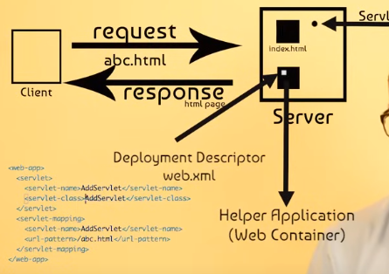

* Initially the request from the client goes to the server.
* The server sends it to the web container (Helper application).
* The web container uses Deployment Descriptor (web.xml) to detect which servlet should call.
* The servlet processes the information and sends the response to the client.
* The response may be in html, jsp or in any forms.

List out the HTTP protocol methods?

1. Get
2. Post
3. Put
4. Options
5. Delete

The get() is used to get information from server to client. The post() is used to send data to the server. The post() will not put data into url (query string).

4. What is cookie?

A cookie is information that is present between multiple client requests. A cookie has a name, a single value and attributes such as comment, path, version number, and maximum age.

5. Differentiate between PrintWriter and ServletOutputStream?

|  |  |
| --- | --- |
| PrintWriter | ServletOutputStream |
| It is a character stream class. | It is byte stream class. |
| Used to write character based information. | Used to write primitive as well as character based information. |

What is servlet mappings?

Servlet mapping is used to map the requests to servlets. Servlet mapping is a process of defining an association between URL pattern and a servlet.

Difference between GenericServlet and HttpServlet?

Both GenericServlet and HttpServlet classes are abstract classes, so we can’t create instance of the classes. The HttpServlet basically extends the GenericServlet and also inherits the properties from the GenericServlet.

|  |  |
| --- | --- |
| GenericServlet | HttpServlet |
| It is protocol independent. | It is a protocol dependent. |
| Supports only the service() method. | Supports doGet(), doPost(), and other methods. |
| Belongs to java.servlet package. | Belongs to java.servlet.http package. |

What is RequestDispatcher?

The RequestDispatcher is an interface it defines object that receives the request from the client and sends or dispatches it to the other resource such as JSP, HTML, or Servlet. It can call any type of resource with the help of

RequestDispatcher dispatcher = Request.getRequestDispatcher(“any.jsp”);

dispatcher.forward(request, response);

The RequestDispatcher has two methods to receive and respond to the request.

1. forward (ServletRequest request, ServletResponse response) { …. }

This method forwards the requests from one client to the another resource. Usually the requests from the client to server are sending using the request object.

1. Include (ServletRequest request, ServletResponse response) { … }

This method includes the content of the resources in the response object.

What is servlet filter?

A Filter is an object that is invoked either at the pre-processing or post-processing of a request.

The Servlet Filter is used for:

* Logging the request parameters to log files.
* Authentication and Authorization of the request for the needed resources.
* Formatting the request body/header before sending it to the servlet.
* Compressing the response data sent to client.
* Change the response by adding some cookie and header information.

What is load-on-startup in servlet?

The load-on-startup element in the web.xml or within the @WebServlet annotation is used to load the servlet at the time of deploying the project or the server to start. This saves time for the response of the first request.

Explain MVC pattern?

The MVC is a design pattern which divides application into three parts namely Model, View, and Controller.

Model: A model deals with behavior of the application, contains database connectivity, business logic. It notifies View and Controller if any changes occur.

View: A view displays information to the user. It takes information from the model using which it generates output.

Controller: A controller takes inputs from the user and sends the commands to model or view. It controls the flow of the application.

What is workflow of Servlet?

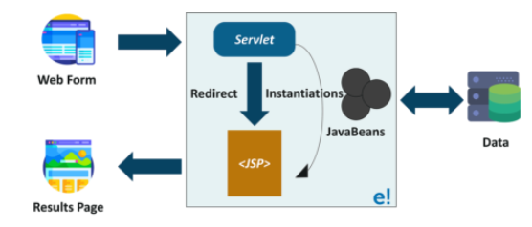

A Servlet is s server side programming language, is used to create java web applications. It is located at the server side and helps to generate dynamic web pages.

It acts as a mediator between incoming HTTP request from the browser and database.

A request is received from a webpage by the servlet. The servlet redirects request to the appropriate JSP pages and JSP page sends response as a result.

3. Life-cycle methods of servlet?

* The servlet is constructed then initialized with *init()* method.
* Any calls from clients to the *service()* method are handled.
* If the servlet is taken out of service, then destroyed with the *destroy()* method and then garbage is collected and finalized.

In addition to life-cycle methods servlet also provides *getServletConfig()* by this servlet can be used to get any startup information, *getServletInfo()* gives the basic information about the servlet itself such version, author.

init(ServletConfig config): this method is used by the container to initialize the servlet. This method is invoked only once in the lifecycle of the servlet.

service(ServletRequest req, ServletResponse resp): this method is called once for every request, a container can’t invoke service method until init() is executed.

Destroy(): the destroy method is called after the service has been completes.

What is deadlock?

A deadlock can occur when multiple threads competing for shared resources, means each thread is waiting for a resource that the another thread holds.

Deadlocks typically arise when multiple threads are accessing shared resources such as database connections, files.

Deadlock situation can be created in servlet by calling doPost() inside the doGet() or doGet() inside the doPost() will create a deadlock situation.

Explain ServletConfig object?

The ServletConfig object is used to pass configuration information to servlet. Every servlet has its own ServletConfig object and servlet container is responsible for instantiating the object.

Difference between ServletConfig and ServletContext?

|  |  |
| --- | --- |
| ServletConfig | ServletContext |
| ServletConfig is a unique object per servlet. | ServletContext is a unique object for a complete application. |
| ServletConfig is used to provide the init parameters to the servlet. | ServletContext is used to provide application level init parameters that all other servlets can use. |
| Attributes in the ServletConfig can’t be set. | We can set attributes in the ServletContext that other servlets can use. |

What is interServlet communication?

interServlet communication is a method to invoke another servlet using RequestDispatcherforward() and include() methods and provide additional attribute in the request for other servlet use.

What is MIME type?

The Context Type response header is called MIME (Multipurpose Internet Mail Extension) type. The Server sends the MIME type to client, to let the client to know the what kind of data server is sending. It helps client to rendering the data for the user. Most commonly used MIME types are text/html, text/xml, and etc.

What is use of HttpServletRequestWrapper and HttpServletResponseWrapper?

Both the classes are used to help developers with a custom implementation of request and response types. Programmers can extend these classes and override only specific methods that they need to implement for customized request and response objects.

Explain session management?

Session management is the process of the maintaining the user sessions in the web applications. Session are used to track user interaction with web applications across the HTTP request. This allows the server to maintain the information about the user.

1) Session creation: when a user accesses a web application for the first time, the servlet container (Apache Tomcat) creates a unique session object for the user. This typically involves generating the session id, which is then sent to client browser.

2) Session tracking: the unique Session ID is typically stored in a cookie on the client side. On subsequent requests, the client sends session ID back to the server for identifying the user session.

3) Session attributes: within each session the session attributes can store, which represents key value pairs representing the data associated the user’s session.

4) Session timeout: sessions have timeout period; after which they expire if there is no activity from the user.

5) Session invalidation: sessions can also be invalidated programmatically by the servlet. This typically occurs when user logs out, or session expiring.

6) Session management: Java Servlet API provides the session management through which session can be create, access, and manage the session.

Explain CGI?

The CGI stands for Common Gate Interface. It consists of a set of code segments at server side using which server interacts with the client.

The main drawbacks of CGI are:

1. If there are multiple incoming requests, then the response generated by the server will be very slow, which results in low efficiency.
2. CGI is platform independent.

Explain web container?

A web container or servlet container is used to interact with servlet, that includes servlet, JSP, XML files inside it. Web container’s responsibility is to manage the life cycle of a servlet.

What is servlet chaining?

The servlet chaining or looping is the process where output of one servlet is given as input to other servlet is called servlet chaining.

Why servlets doesn’t have main()?

Because servlets are executed on web server that why servlets doesn’t have main(). The client requests for servlets to server, then the server sends those requests to the web container where the servlets are deployed.

What is servlet context?

Servlet context is an object that contains information about the application and web container. Using the servlet context, we can LOG EVENTS, get the URL of the specific resource, and store the attribute for the other servlet to use.

The servlet context has following methods:

getInitParameter() : returns the values of parameter.

getInitParameterNames() : returns the names of parametes.

setAttribute() : used to set the values of attribute.

getAttribute() : used to get the values of the attributes.

removeAttribute() : used to remove the attributes.

3. Explain Servlet API?

A Servlet does not have main method instead of that Servlet has methods for purpose of handling requests. It invokes service methods every time Server sends a request to Servlet. To handle requests Servlet must override service method that allow two parameters these are request object and response object. Request object is used to inform the servlet about the request and response object is used to give the response.

4. Define init and destroy methods of servlet?

Servlet Init method is used to initialize the servlet.

After the web container loads and instantiate the Servlet class and before it delivers requests from clients, the web container initializes the servlet. This process allows the servlet to read configuration data, initialize process, and perform any other one-time activities.

When a servlet container determines that servlet should be removed from the service, the container calls the destroy method to destroy the service.

5. What are the methods of Servlet?

6. What is cookie?

**WRAPPER CLASSES**

1. What is wrapper class?

Wrapper classes are classes that allow us to access primitive datatypes as objects.

Ex: Integer is wrapper class it is used to represent primitive int type. We can use wrapper classes to represent primitive types.

Wrapper classes are Byte, Short, Integer, Float, Double, Long, BigInteger, BigDecimal.

2. What are the uses of wrapper classes?

* Wrapper classes allow us to create an object.
* We can add them to collections and pass them as arguments to methods.
* They provide methods to manipulate data and the ability to convert to different types.
* They help to improve performance.
* Ex: when we use autoboxed Integer object, the java compiler can convert the object to primitive int value automatically.
* Because compiler does not have to generate code to convert object to primitive value.

Integer myInt = new Integer(10);

int myInt2 = myInt.intValue(); // Converts the Integer object to a primitive int value

3. How to convert String type to primitive datatype?

It is possible to convert String datatype to primitive types using static *parse()* methods provided by the wrapper classes.

4. What is difference between *parseInt()* and *valueOf()* methods?

The parseInt() is used to convert String datatype to primitive type, whereas valueOf() is used to convert object into a String.

5. Are all wrapper classes immutable?

No, not all wrapper classes are immutable. Only Byte, Boolean, Short, Character are immutable. Integer, Float, Double, Long are mutable.

6. What does the compareTo() method do?

The *compareTo()* method is used to compare two wrapped objects. It returns 0 if two objects are same, positive 1 if the first object is greater than second object and negative -1 if the first object is less than second object.

7. Explain autoboxing?

Autoboxing in java is the automatic conversion of primitive type into their corresponding wrapper classes. With autoboxing the compiler automatically converts primitive types into wrapper classes.

Ex: int a = 10;

Integer b = a; //autoboxing

**COLLECTIONS**

Collection is like a container, an object that groups multiple elements into to a single unit. Collections are used to store, retrieve, manipulate, and communicate aggregate data. They represent data items that form natural group.

Ex: Telephone directory, Mail folder, Poker cards.

Collection hierarchy:

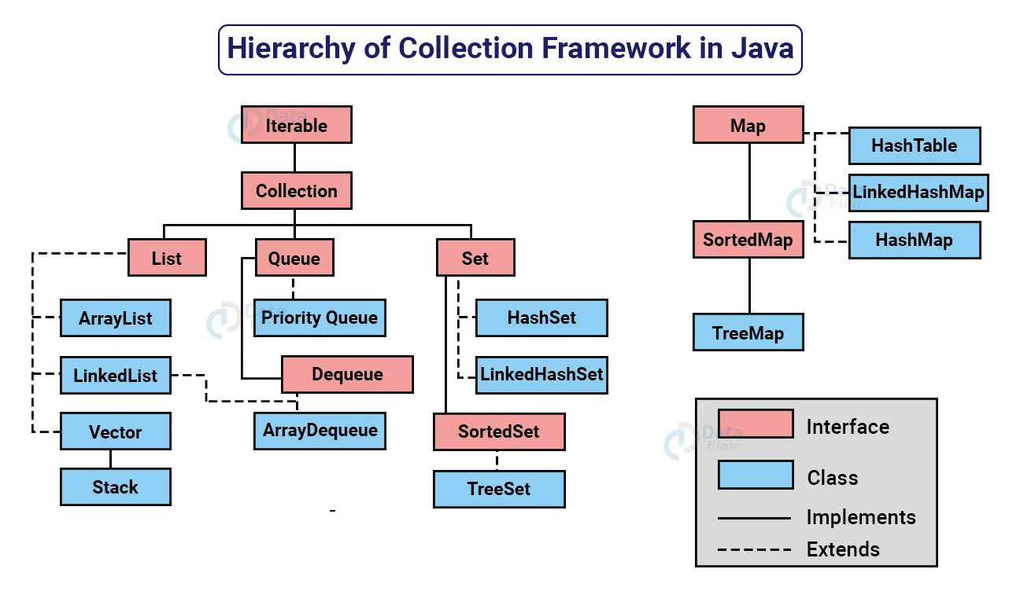

1. What is the collections framework?

Is a unified architecture for representing and manipulating collections. Collection framework contains interfaces, implementations, and algorithms.

* *Interfaces:* Allow collections to be manipulated independently of the details of their representations.
* *Implementation:* These are the concreate implementations of the collection interface, they are reusable data structure.
* *Algorithms:* These are methods to perform operations such sorting and searching.

2. What are the benefits of collections framework?

1. ***Reduces programming efforts:*** provides useful data structures and algorithms to manipulate collections.
2. ***Increases programming speed and quality:*** collections framework provides high-performance, high-quality data structures and algorithms to manipulate.
3. ***Allows interoperability among unrelated API’s:*** collections frameworks provide interoperability among unrelated APIs to perform operations.
4. ***Reduces effort to learn and use new API’s:*** earlier there are lot of APIs are present to work with collections but know by using efficient APIs this problem resolved.
5. ***Reduces effort to design new API’s:*** no need to design new APIs to work with collections instead of using standard collections interfaces.
6. ***Foster software reuse:***

3. Explain Collections class?

*java.util.Collections* is a class consisting of static methods (algorithms) to perform on the collections. This class contains methods for algorithms, like binary sorting, search, shuffling etc.

4. Explain Collection interface?

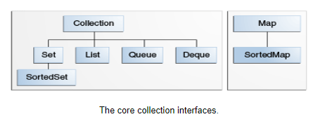

Collection interface is the root hierarchy of the java collection framework. It encapsulates different types of interfaces that are independent of their representation. Collection interface provides methods to perform operations on the collections.

5. Explain Iterator interface?

Iterator is an interface that contains two abstract methods and one non-return (void) method like hasNext(), next() and remove() respectively. This interface allows collections to iterate over the collection. There are three ways to iterate a collection they are Aggregate operation, for each Construct, and iterator.

Iterator provides the iterator method to iterate the collection and provides the remove() method to remove the element that satisfies the condition during iteration.

6. Explain Set interface?

A Set is a collection interface that restricts the duplicate elements stored in the collection. It does not maintain insertion order of the elements. It contains methods that are inherited from the Collection interface and uses those methods to restricts duplicate elements by using hashCode() and equals() methods.

Set interface has three implementations:

* HashSet: It stores elements in hash table, it makes no guarantees concerning order of the iteration.
* TreeSet: It stores elements in red-black tree, orders based on the values of the elements.
* LinkedHashSet: Which is implemented as a hash table with linked list running through it. It stores elements based on the insertion order.

7. What is ArrayList?

ArrayList is a data structure used to elements that have dynamic behavior i.e., it can grow its size by adding elements and can shrink size by removing elements.

8. What are the methods of Collection?

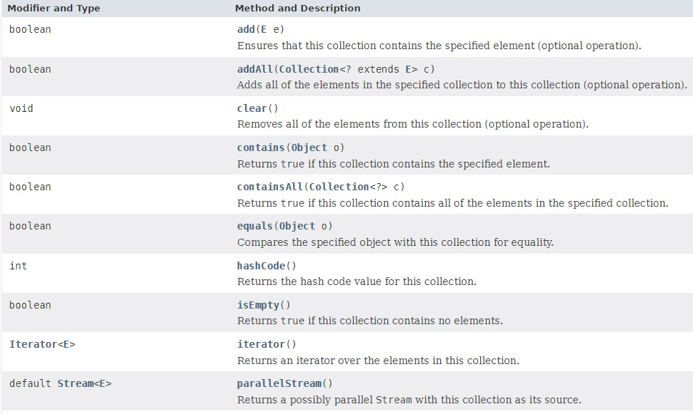

9. Explain List interface?

List is the data structure of the collection framework. List stores multiple items based on insertion order; it extends methods from the collection to operate on the collections. It has two implementations they are ArrayList and LinkedList. It can contain duplicate items also.

10. Explain Queue interface?

Queue is a data structure, besides basic collection operations queue provides additional insertion, removal, and inspection operations. Queue typically, but not necessarily orders elements in FIRST IN FIRST OUT (FIFO) manner.

11. Explain Map?

Map is an object that maps keys to values, it can’t contain duplicate keys, one has map to at most one value. It has methods (put, get, remove, containsKey, containsValue, size, and empty) to perform basic operations on map data, for the bulk operations we use clear, putAll methods, for collection view keyset, entrySet, and values are used.

12. List out differences between ArrayList and LinkedList?

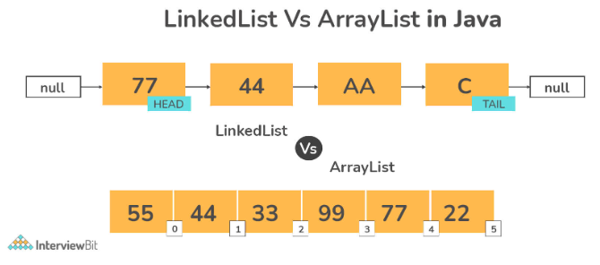

|  |  |
| --- | --- |
| ***ArrayList*** | ***LinkedList*** |
| Elements of this class are stored in a dynamic array. | Elements of this class are stored in a doubly linked list. |
| This class implements List interface. As a result, it can be used as List. | This class implements both List and Deque as a result it can be used as both List and Deque. |
| Because of internal implementations, manipulating ArrayList takes longer time. Internally ArrayList is scanned, and memory are shifted whenever we remove an element. | There is no internal implementations on LinkedList, so it doesn’t take much time to manipulate. The reference link is changed after traversing the list. |
| This class is more useful when the application requires the data storage and access. | This class is more useful when the application requires data manipulation. |

13. Differentiate between ArratList and Vector?

|  |  |
| --- | --- |
| ***ArrayList*** | ***Vector*** |
| Can’t be synchronized | Can be synchronized |
| It is not a legacy class | It is a legacy class |
| Not thread safe | Thread safe |

14. Difference between Iterator and ListIterator?

|  |  |
| --- | --- |
| ***Iterator*** | ***ListIterator*** |
| Used to traverse array items in forward direction only | Used to traverse array items in both directions. |
| Can be used with Queue, List, Set | Used with List |
| Performs only remove operation | Can perform operations like add, remove, set operations while traversing the collection |

15. Difference between List and Set?

|  |  |
| --- | --- |
| ***List*** | ***Set*** |
| List maintains insertion order. | Set doesn’t maintain insertion order. |
| Duplicate elements are allowed in list. | Duplicate elements are not allowed. |
| List is an index based. | Set is not an index based. |
| Elements can accessed by their index. | Set not allow access to their elements from their certain position. |
| It is possible to store null elements several times. | A null value can stored only once. |

16. Differentiate between HashSet and TreeSet?

|  |  |
| --- | --- |
| ***HashSet*** | ***TreeSet*** |
| HashSet doesn’t provide any ordering guarantee. | TreeSet provides ordering or sorting guarantee. |
| HashSet uses equals() method for comparison and avoids duplicates. | TreeSet uses compareTo() method for comparison. |
| HashSet uses HashTable as data structure. | TreeSet uses Red-Black Tree. |
| HashSet allows one null element. | TreeSet doesn’t allow null objects. |
| Implemented using HasMap. | Implemented using TreeMap. |
| HashSet is faster. | TreeSet is slower. |

17. Can we add null element to the TreeSet?

No. We can’t add null element to the TreeSet because it uses compareTo() method for comparing, it throws NullPointerException if it contains null element.

**JAVA DATABASE CONNECTIVITY (JDBC)**

JDBC is a Java API used to make things easy. Which is used to execute common SQL queries and operate on the database.

JDBC API is Java API that can access any kind of tabular data that is stored in relational database. It uses JDBC Drivers to connect with database.

The database is used to store the information in such a way that it can be retrieve from the database whenever needed. It stores data in tables in a row and column manner. The tables are relations; it collects objects of the same type.

**JDBC helps to write Java applications that manages activities:**

1. *To connect to database.*
2. *Send queries and update statements to the database.*
3. *Retrieve and process the data received from the database.*

DriverManager class is used to establish the connection with database using the getConnection() method. It loads JDBC Driver in java application to establish the connection. Connection is an interface.

Connection conn = DriverManager.getConnection();

The connection object is needed to create Statement object. The Statement is an interface.

Statement stm = conn.createStatement();

Statement object is used to create ResultSet object using executeQuery() method.

ResultSet rs = stm.executeQuery();

**Components of JDBC:**

*JDBC API****:*** The JDBC API provides methods and interfaces to access relational data using java programming language. Using API also allowed to execute SQL queries, retrieve data, and process the data.

*JDBC DriverManager****:*** The JDBC DriverManager class defines objects which can connect to JDBC driver. It loads JDBC Driver in java applications for establishing connection with the database.

*JDBC Test Suite:* It is used to test the operations like updating, deleting, inserting etc., being performed by the JDBC Drivers.

*JDBC-ODBC Bridge Drivers:* It will connect database drivers to the database. JDBC-ODBC bridge interprets JDBC method call to the ODBC function call.

***JDBC ARCHITECTURE:***

JDBC API supports both *two tier* and *three tier* processing model for database access.

*1) Two tier Architecture:*

* In Two tier model the java applications directly communicate with data source (database).
* JDBC Drivers helps applications to communicate with the data source.
* A user’s commands are delivered to the data source (database) and results are sent back to the user.

*2) Three tier Architecture:*

* In three tier architecture model the ***middle tier*** exists in between the user and the database.
* The middle tier acts as a service provider which receives the commands from the user and sends those to the database and vice versa.
* Three tier model is more effective than two tier because it has a middle tier.
* Advantage is it maintains control over the data access.

***STEPS TO PROCESS SQL STATEMENT WITH JDBC:***

1. *Establish connection.*
2. *Create a statement.*
3. *Execute the query.*
4. *Process the ResultSet object.*
5. *Close the connection.*

***1. Establishing connection:***

First, need to establish connection with the data source. Data source may be any database, or any other data source which needs to be use or any external file that corresponds to Driver.

* DriverManager: It is an implementation class; it connects an application with the data source (database) which is specified by the database URL.
* Connection is done using method DriverManager.getConnection().

***2. Create statement:***

Statement is an interface that represents SQL statement. Statement will generate ResultSet objects, which is a table of data. To create a Statement object, Connection object is needed using createStatement().

Coonection conn = DriverManager.getConnection(url, username, password);

Statement stm = conn.createStatement();

There are 3 different kinds of statements.

1. ***Statement****:* Statement used to implement simple SQL statements with no parameters.
2. ***PreparedStatement****:* Extends Statement, used for precompiling SQL statements that might contain input parameters.
3. ***CallableStatement****:* Extends PreparedStatement, used to execute stored procedures that may contain both input output parameters.

***3. Execute Queries:***

Queries can be executed by calling execute() method of the Statement interface such as the following

ResultSet rs = stm.execute(query);

* ***execute()*** : Returns true if the first object that the query returns ResultsSet object. This method is useful when query could return one or more ResultSet objects. Return type is Boolean.
* ***executeQuery()*** : Returns one ResultsSet object. Return type is ResultSet.
* ***executeUpdate()*** : Returns an integer representing the number of rows affected by the SQL statement. This method is useful when dealing with INSERT, DELETE OR UPDATE SQL statements. Return type is int.

***4. Processing the ResultSet Object:***

* ResultSet is an interface that provides methods for retrieving and manipulating results of executed query.
* We can access the data in the ResultSet through cursor.
* The cursor is not a database cursor.
* The cursor is a pointer that points to one row of the data in the ResultSet object.
* Initially the cursor is positioned before the first row.
* The next() returns false when cursor is positioned after the last row.
* The next() is used to move forward to the rows.

ResultSet rs = stm.executeQuery(query);

While(rs.next()){

// doSomething

}

***5. Close the Connection:***

After completed using the Connection, Statement, and ResultSet object close the connection by calling the close method. It is necessary to release the data source connection after the usage.

* The resources must be closed regardless of whether the SQLException is handled or not.
* It is important to avoid resource leakage.
* Resource leak is a type of bug that occurs when resource is not properly released. This leads to several problems like system performance, increased memory usage, and security vulnerability.

**QUESTIONS:**

**1.** What is JDBC Driver?

The JDBC Driver is a software component(API) having various classes and interfaces, that enables java application to interact with database. It acts as a mediator in between java application and database.

2. Explain PreparedStatement?

* PreparedStatement is more convenient to send SQL statements to the database.
* When executing the statement many times the PreparedSatement is used to reduce the time for executing the statement.
* The advantage of using PreparedStatement is that in most cases SQL statement is sent to DBMS, where it is compiled.
* The PreparedStatement object contains not just SQL statement, but a SQL statement that has been precompiled.
* This means that when the PreparedStatement is executed, the DBMS can just run the PreparedStatement SQL statement without having to compile it first.
* PreparedStatement is used when we need to give input data to the query at run time and also if we want to execute query many times.

3. Explain Stored Procedures? What are parameter types in stored procedure?

Stored Procedure is a group of SQL statements that form single unit to perform operations, and they are encapsulate a set of operations or queries to execute on a database.

Stored Procedures can be compiled and executed with different parameters and results, and they can have any combination of input, output or both input/output parameters. Stored procedures are call using the CallableStatement.

In stored procedure there are three types of parameters are present.

* IN: It is used for passing the input values to procedure. With the help of setXXX() method.
* OUT: Is used for getting the values form the procedure. With the help of getXXX() method.
* IN/OUT: It is used for passing input values, and obtaining the values from the procedure using the setXXX() and getXXX() methods.

4. What is JDBC Driver?

The JDBC Driver is a software component(API) contains various classes and interfaces to connect with database. To connect to individual database, JDBC requires particular drivers for each specific database.

5. Which datatype is used for storing images and files in database table?

CLOB: is used to store files in the database. It stores the character type of data.

BLOB: is used to store binary type of data. Using this type can store images, videos and audio type of data.

6. What is DatabaseMetaData?

* DatabaseMetaData is an interface that provides methods to obtain information about the database.
* Information like database name, database version, driver name, total number of tables or views, et.

7. List out the differences between JDBC and ODBC?

|  |  |
| --- | --- |
| ***ODBC(OPEN DATABASE CONNECTIVITY)*** | ***JDBC(JAVA DATABASE CONNECTIVITY)*** |
| Used for programing languages like C, C++, Java, etc. | Used only for Java language. |
| ODBC is platform dependent. | JDBC is platform independent. |
| Most of the ODBC drivers are developed in native languages like C, C++ | JDBC drivers are developed using Java language. |
| Not recommended to use ODBC for java application because of low performance. | JDBC is recommended for Java application. |
| ODBC is procedural. | JDBC is object oriented. |

8. What is RowSet?

* RowSet is an object that encapsulates a row set from either JDBC result sets or tabular data source.
* It supports component based development models like JavaBeans with the help of standard set of properties and event notification.
* The advantage of using the RowSet are is easier, flexible, scrollable and updatable by default.

9. What is Serialization and Deserialization?

**Serialization:**

* Serialization is the process of the converting a ResultSet object into a stream of bytes that can be stored in file, database, or transmitted over the network.
* To serialize the ResultSet object using the ObjectOutputStream class.
* By using the method called writeObject() which takes argument and writes it to stream of bytes.

**Deserialization:**

* It is a process of converting a byte stream back into an original object is called deserialization.
* Deserialization is used to retrieve the object that have been stored in the database.
* To desterilize the object using the getObject() method.

Object obj = resultSetObj.getObject(“serializedObject”);

10. Difference between RowSet and ResultSet?

|  |  |
| --- | --- |
| ***ResultSet*** | ***RowSet*** |
| ResultSet can’t be serialized because it handles connection to database. | RowSet is disconnected from the database so is can be serialized. |
| By default ResultSet object is non scrollable and non-updatable. | RowSet is scrollable and updatable. |
| ResultSet object is a JavaBean object. | RowSet object is a JavaBean object. |
| ResultSet is returned by executeQuery()  of the Statement interface. | RowSet extends the ResultSet interface and is returned by calling the RowSetProvider.createFactory()  .createJdbcRowSet() |
| It is difficult to pass ResultSet from one class to another has it has connected to database. | It is easier to pass RowSet from one class to another has it has not connected to database. |

11. Explain the types of ResultSet?

There are three types of ResultSet are there to control the cursor pointing in forward, backward, and in a particular row. If do not declare any type, then TYPE_FORWARD_ONLY will call.

1. *ResultSet.TYPE_FORWARD_ONLY:* Using this the cursor can only move forward from start to end in the ResultSet.
2. *ResultSet.TYPE_SCROLL_INSENSITIVE:* Using this cursor can move both forward and backward direction. Here, the result set is insensitive to the changes done in the database by others, that occurs after the result set was created.
3. *ResultSet.TYPE_SCROLL_SENSITIVE:* Using this cursor can move on both the directions, and result set is sensitive to changes made to the database by others, that occurs after the result set was created.

12. Difference between Statement and PreparedStatement.

|  |  |
| --- | --- |
| ***Statement*** | ***PreparedStatement*** |
| Query is compiled every time we run the program. | Query is compiled only once. |
| It is used when executing query without providing the parameters at runtime. | It is used when query need input parameters. |
| Performance is less. | Performance is more. |
| It is suitable for executing DDL statements such as CREATE, ALTER, DROP and TRUNCATE. | It is suitable for DML statements such as INSERT, UPDATE, and DELETE. |
| It executes static SQL statements. | It executes pre-compiled SQL statements. |