**Creating Developer Org**

Creating a developer org in salesforce.

1. Go to developers.salesforce.com/Signup
2. Click on sign up.
3. On the sign-up form, enter the following details:
   1. First name & Last name
   2. Email
   3. Role: Developer
   4. Company: College Name
   5. County: India
   6. Postal Code: pin code
   7. Username: should be a combination of your name and company

This need not be an actual email id, you can give anything in the format: [username@organization.com](mailto:username@organization.com)

Click on sign up after filling these.

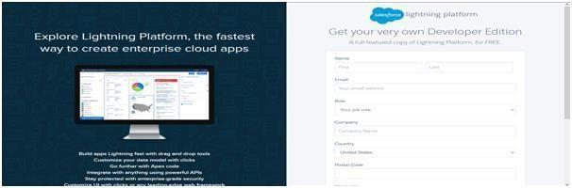

**Account Activation**

Go to the inbox of the email that you used while signing up. Click on the verify account to activate your account. The email may take 5-10mins, as

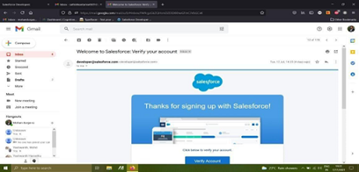

Login to Your Salesforce Account

1. Go to salesforce.com and click on login.

2. Enter the username and password that you just created.

3. After login this is the home page which you will see.

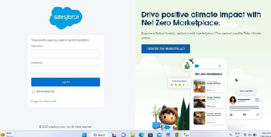

*Salesforce Login*

https://login.salesforce.com

Login to Your Salesforce Account

1. Go to salesforce.com and click on login.

2. Enter the username and password that you just created.

3. After login this is the home page which you will see.

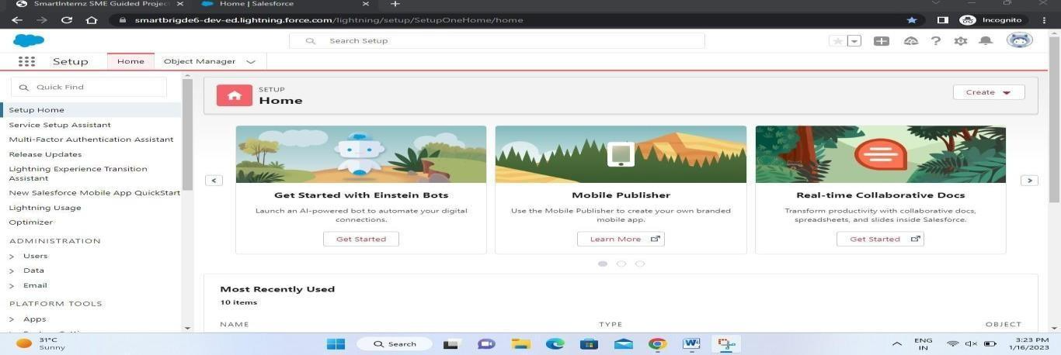

Salesforce Login htttps://login.salesforce.com

**Account Activation**

Go to the inbox of the email that you used while signing up. Click on the verify account to activate your account. The email may take 5-10mins, as



Login to Your Salesforce Account

1. Go to salesforce.com and click on login.

2. Enter the username and password that you just created.

3. After login this is the home page which you will see.



*Salesforce Login*

https://login.salesforce.com

Login to Your Salesforce Account

1. Go to salesforce.com and click on login.

2. Enter the username and password that you just created.

3. After login this is the home page which you will see.



Salesforce Login htttps://login.salesforce.com

**Creation Of Semester Tab For Candidate Internal Result Card**

Now create a custom tab. Click the Home tab.

1. Enter Tabs in Quick Find and select Tabs.

2. Under Custom Object Tabs, click New.

3. For Object, select Semester.

4. For Tab Style, select any icon.

5. Leave all defaults as is. Click Next, Next, and Save

6. In the same way create Tabs for all Custom Objects -Candidate, Course Details, Lecturer Details, Internal results .

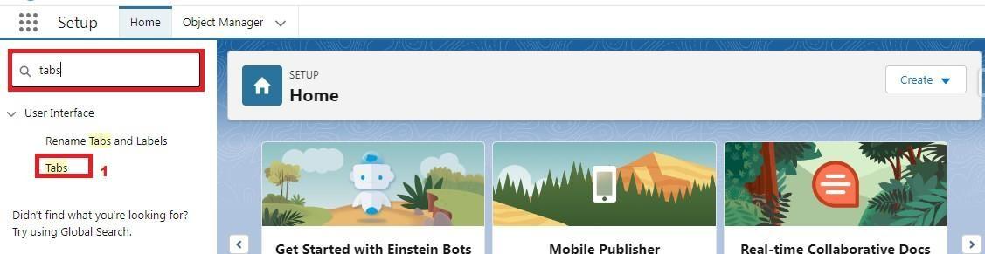

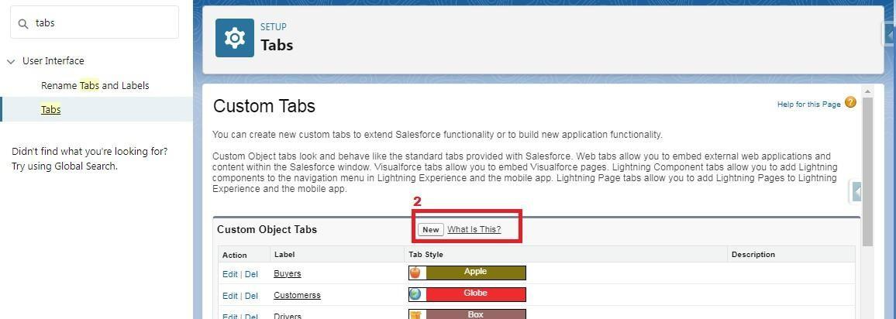

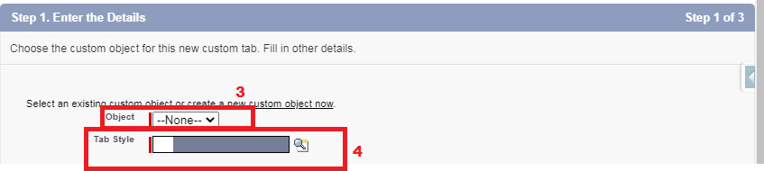

**Creation Of Semester Tab For Candidate Internal Result Card**

Now create a custom tab. Click the Home tab.

1. Enter Tabs in Quick Find and select Tabs.

2. Under Custom Object Tabs, click New.

3. For Object, select Semester.

4. For Tab Style, select any icon.

5. Leave all defaults as is. Click Next, Next, and Save

6. In the same way create Tabs for all Custom Objects -Candidate, Course Details, Lecturer Details, Internal results .







**Creation Of Text Field On "Lecturer Details" & Look Up Field For The “Candidate” Object**

1.Click the gear icon and select Setup. This launches Setup in a new tab.

2. Click the Object Manager tab next to Home.

3. Select Lecturer Details

4. Select Fields & Relationships from the left navigation

5. Click New

6. Select the Text as the Data Type, click next.

7. For Field Label, enter Lecturer Role

8. Enter Length 40

9. Click Next, Next, then Save & New.

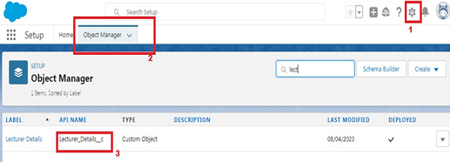  
  
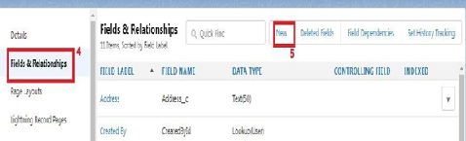

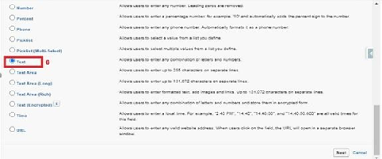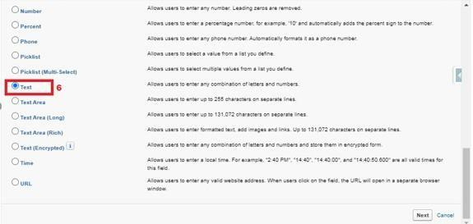

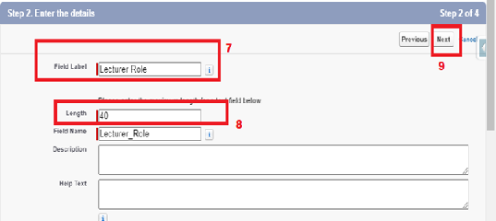

Now Let’s create a Lookup field on candidate object

1. Click the gear icon and select Setup. This launches Setup in a new tab.

2. Click the Object Manager tab next to Home.

3. Select candidate.

4. Select Fields & Relationships from the left navigation

5. Click New

6. Select the lookup as the Data Type, then click Next.

7. In related select Semester

8. For Field Label Semester Name, enter.

9. Click Next, Next, then Save & New.





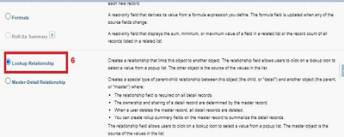

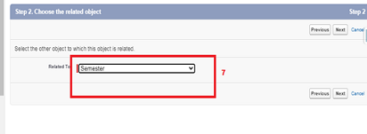

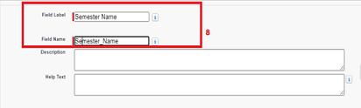

Note- Similarly create all lookup fields on their respective objects.

**Creation Of Auto Number Field On Candidate Object, Number Field On Course Details Object & Formula Field Course Details Object**

Let’s create a Number field on Course Details object

1. Click the gear icon and select Setup. This launches Setup in a new tab.

2. Click the Object Manager tab next to Home.

3. Select Course Detail.

4. Select Fields & Relationships from the left navigation

4. Click New & select number field, click Next

6. For Field Label Duration, enter.

7. Give Help Text- Enter Course duration value in Years

8. Click Next, Next, then Save & New.





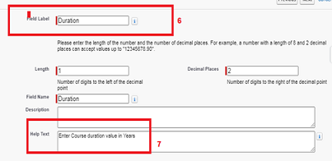

Now Let’s create a Formula field on Internal Results object

1. Click the gear icon and select Setup. This launches Setup in a new tab.

2. Click the Object Manager tab next to Home.

3. Select Internal results.

4. Select Fields & Relationships from the left navigation.

5. Click New

6. Select the Formula as the Data Type, then click Next.

7. Give field label Candidate Roll Number

8. Select formula return type text, Click Next

9. Click Insert Field

10.Create and insert formula Candidate r.Candidate_Roll_Number   c, and then click Insert.

11.Click Next, Next, then Save.





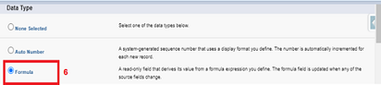

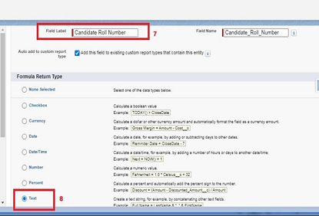

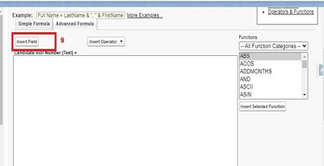

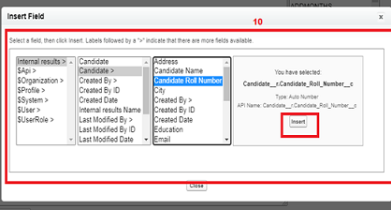

Now Let’s create an auto number field on Candidate object

1. Click the gear icon and select Setup. This launches Setup in a new tab.

2. Click the Object Manager tab next to Home.

3. Select Candidate.

4. Select Fields & Relationships from the left navigation

5. Click New

6. Select the Auto Number as the Data Type, then click Next.

7. For Field Label Candidate enter Roll Number.

8. Give a display format

9. Click Next, Next, then Save & New.





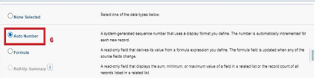

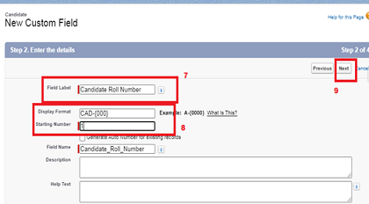

**Creating A User**

1. From Setup, in the Quick Find box, enter Users.

2. Select Users.

3. Click New User.

4. Enter the First Name, Class, Last Name, Teacher and (Your) email address anda unique username in the form of an email address. By default, the username is the same as the email address.

5. Select a User License as salesforce.

NOTE- As Salesforce license can only be used by 2 Users at a time in Dev Org, so If you don’t find salesforce license then deactivate a user who has salesforce license Or change the license type from Salesforce to any other.

6. Select a profile as Standard user.

7. Check Generate new password and notify the user immediately to have the user’s login name and a temporary password emailed to your email.  
  
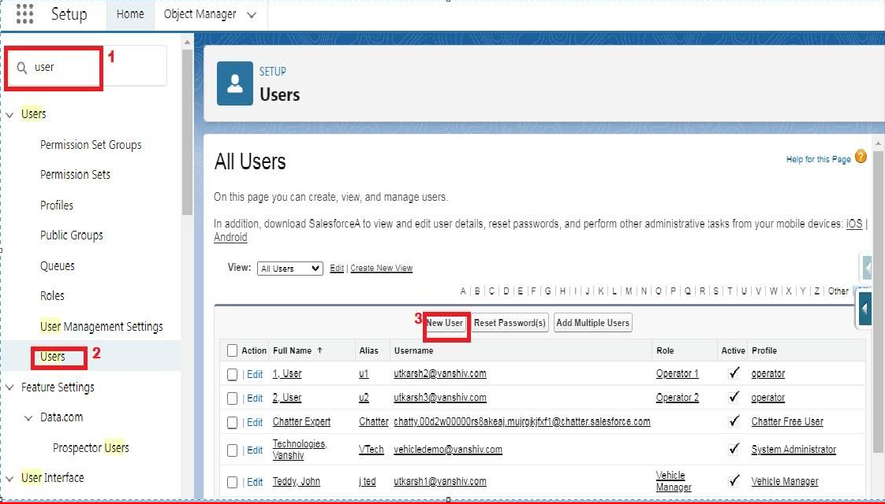

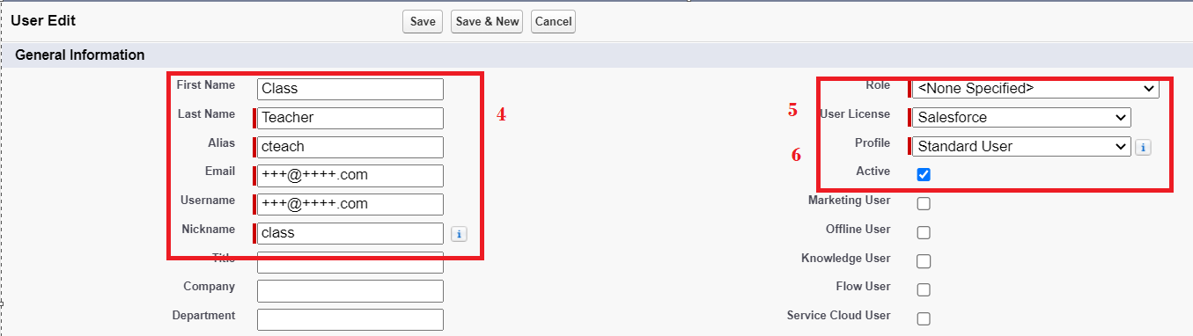

**Creating A User**

1. From Setup, in the Quick Find box, enter Users.

2. Select Users.

3. Click New User.

4. Enter the First Name, Class, Last Name, Teacher and (Your) email address anda unique username in the form of an email address. By default, the username is the same as the email address.

5. Select a User License as salesforce.

NOTE- As Salesforce license can only be used by 2 Users at a time in Dev Org, so If you don’t find salesforce license then deactivate a user who has salesforce license Or change the license type from Salesforce to any other.

6. Select a profile as Standard user.

7. Check Generate new password and notify the user immediately to have the user’s login name and a temporary password emailed to your email.  
  




**View Record (Course Details)**

Viewing the Records of Course Detail Object

1. Click on App Launcher on left side of screen.

2. Search Candidate Internal Result Card & click on it.

3. Click on Course details Tab.

4. Click on any record name. you can see the details of the Driver

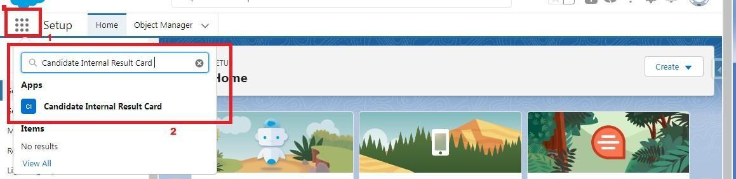

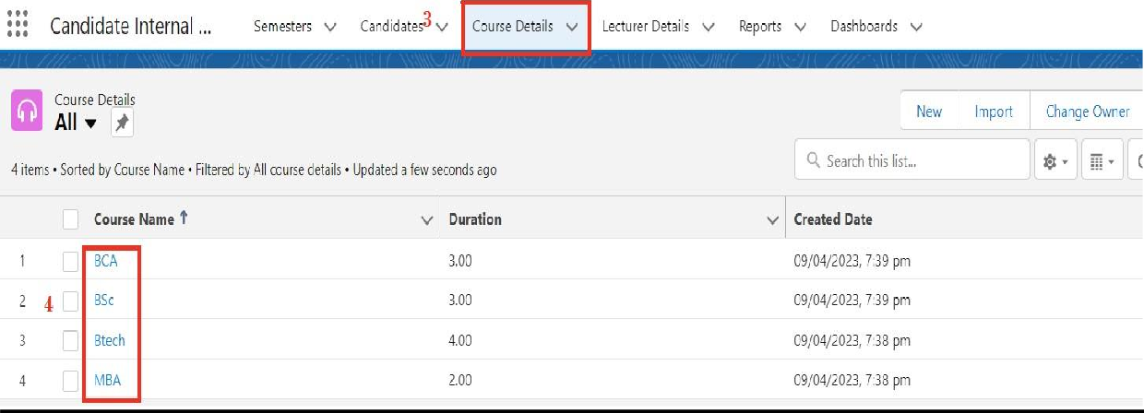

**View Record (Course Details)**

Viewing the Records of Course Detail Object

1. Click on App Launcher on left side of screen.

2. Search Candidate Internal Result Card & click on it.

3. Click on Course details Tab.

4. Click on any record name. you can see the details of the Driver





**Create Report**

1. Click App Launcher

2. Select Candidate Internal Result Card App

3. Click reports tab

4. Click New Report.

5. Click the report type as Semesters with Course Click Start report.

6. Customize your report, in group rows select - Course Name, in group column Select Duration (In this way we are making a Matrix Report).

7. Click refresh

8. Click save and run

9. Give report name – Candidate Internal Result Report

10.Click Save

NOTE: In this report you can see your all record of the object you selected for reporting (What you Selects in “Select a report type option”).



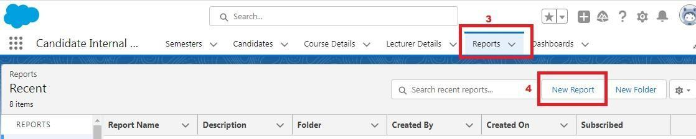

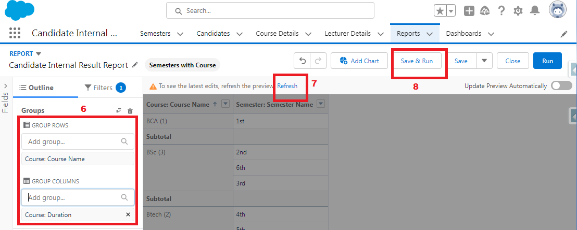  
  
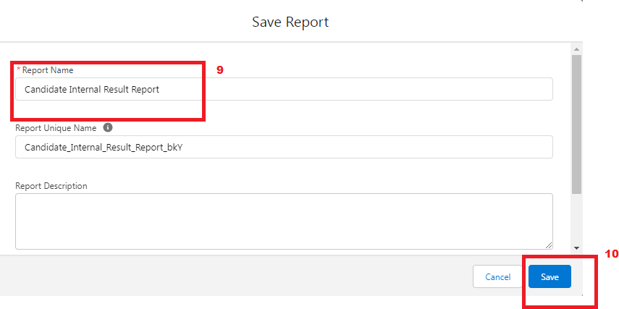

1.    On the report builder page, locate the "Fields" pane on the left-hand side.

2.    Find the field for which you want to create a bucket field and drag it to the report preview section.

3.    Click on the field in the report preview to open the field properties.

4.    In the field properties, locate the "Summarize" option and click the drop-down arrow.

5.    Select "Bucket Field" from the available options.

6.    In the bucket field settings, define the buckets based on your requirements. You can specify the bucket ranges, labels, and groupings.

7.    Click "OK" or "Apply" to save the bucket field settings.

8.    Customize the report layout and add any additional fields or filters as needed.

9.    Once you are satisfied with the report setup, click "Save" to save the report.

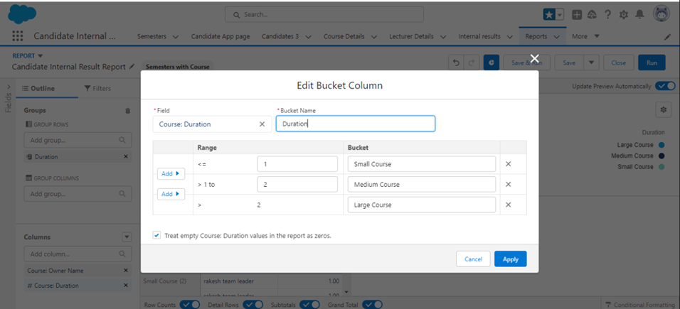

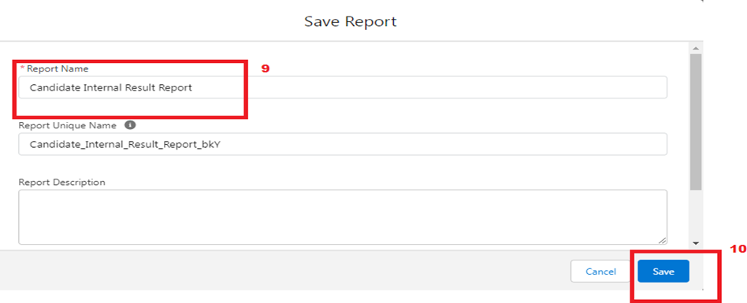

**Create Report**

1. Click App Launcher

2. Select Candidate Internal Result Card App

3. Click reports tab

4. Click New Report.

5. Click the report type as Semesters with Course Click Start report.

6. Customize your report, in group rows select - Course Name, in group column Select Duration (In this way we are making a Matrix Report).

7. Click refresh

8. Click save and run

9. Give report name – Candidate Internal Result Report

10.Click Save

NOTE: In this report you can see your all record of the object you selected for reporting (What you Selects in “Select a report type option”).





  
  


1.    On the report builder page, locate the "Fields" pane on the left-hand side.

2.    Find the field for which you want to create a bucket field and drag it to the report preview section.

3.    Click on the field in the report preview to open the field properties.

4.    In the field properties, locate the "Summarize" option and click the drop-down arrow.

5.    Select "Bucket Field" from the available options.

6.    In the bucket field settings, define the buckets based on your requirements. You can specify the bucket ranges, labels, and groupings.

7.    Click "OK" or "Apply" to save the bucket field settings.

8.    Customize the report layout and add any additional fields or filters as needed.

9.    Once you are satisfied with the report setup, click "Save" to save the report.





### vView Dashboard

1. Click on App Launcher on left side of screen.

2. Search Candidate Internal Result Card & click on it.

3. Click on Dashboard Tab.

4. Click on Candidate Internal Result Card see graph view of records



