Hands-On Data Lab Implementation
Data Engineer Internship, Task 2
Name: Santosh | Notebook: Task2_Data_Lab.ipynb

1. Introduction
The goal of this task was to set up a working data analysis environment and complete practical exercises in data manipulation, visualization and basic analysis. I worked in Google Colab with Python, and used the built-in restaurant tips dataset from Seaborn. Every code block and output in this report comes from my own run of the notebook Task2_Data_Lab.ipynb.

2. Environment Setup
I used Google Colab, which gives a ready Jupyter environment in the browser without any local installation. The steps were:
- Opened Google Colab and created a new notebook named Task2_Data_Lab.
- Imported the required libraries: NumPy, Pandas, Matplotlib and Seaborn (all available in Colab by default).
- Ran a version check to confirm that the environment works.
To set up the same environment on a local computer, the equivalent command is: pip install jupyter numpy pandas matplotlib seaborn, followed by running jupyter notebook.
Code
# check Python and library versions (proves the environment is ready)
import sys
import numpy
import pandas
import matplotlib
import seaborn

print("Python :", sys.version.split()[0])
print("NumPy :", numpy.__version__)
print("Pandas :", pandas.__version__)
print("Matplotlib :", matplotlib.__version__)
print("Seaborn :", seaborn.__version__)
Output
Python : 3.13.18
NumPy : 2.1.3
Pandas : 2.2.3
Matplotlib : 3.10.0
Seaborn : 0.13.2

3. Dataset Overview
The tips dataset has 244 rows and 7 columns. Each row is one restaurant bill. The columns are total_bill, tip, sex, smoker, day, time and size (the party size). There are no missing values, and four columns (sex, smoker, day, time) are stored as categories.
Code
import pandas as pd
import seaborn as sns
import matplotlib.pyplot as plt

# built-in restaurant tips dataset
df = sns.load_dataset("tips")

print(df.head())
print("Shape:", df.shape)
print()
df.info()
print()
print(df.describe())
print()
print("Missing values:")
print(df.isnull().sum())

Output
total_bill tip sex smoker day time size
0 16.99 1.01 Female No Sun Dinner 2
1 10.34 1.66 Male No Sun Dinner 3
2 21.01 3.50 Male No Sun Dinner 3
3 23.68 3.31 Male No Sun Dinner 2
4 24.59 3.61 Female No Sun Dinner 4
Shape: (244, 7)

<class 'pandas.core.frame.DataFrame'>
RangeIndex: 244 entries, 0 to 243
Data columns (total 7 columns):
# Column Non-Null Count Dtype
--- ------ -------------- -----
0 total_bill 244 non-null float64
1 tip 244 non-null float64
2 sex 244 non-null category
3 smoker 244 non-null category
4 day 244 non-null category
5 time 244 non-null category
6 size 244 non-null int64
dtypes: category(4), float64(2), int64(1)
memory usage: 7.4 KB

total_bill tip size
count 244.000000 244.000000 244.000000
mean 19.785943 2.998279 2.569672
std 8.902412 1.383638 0.951100
min 3.070000 1.000000 1.000000
25% 13.347500 2.000000 2.000000
50% 17.795000 2.900000 2.000000
75% 24.127500 3.562500 3.000000
max 50.810000 10.000000 6.000000

Missing values:
total_bill 0
tip 0
sex 0
smoker 0
day 0
time 0
size 0
dtype: int64

From describe(): the average bill is about 19.79 dollars, the average tip is about 3.00 dollars, and the average party size is about 2.6 people.

4. Data Manipulation
I practiced the main pandas operations: filtering rows, sorting, creating new columns and grouping data.
Code
# --- filtering ---
dinner = df[df["time"] == "Dinner"]
print("Dinner rows:", len(dinner))

big_bills = df[df["total_bill"] > 30]
print("Bills above 30:", len(big_bills))

# --- sorting: top 5 biggest bills ---
top5 = df.sort_values("total_bill", ascending=False).head(5)
print(top5)

# --- new columns ---
df["tip_percent"] = (df["tip"] / df["total_bill"] * 100).round(2)
df["bill_per_person"] = (df["total_bill"] / df["size"]).round(2)
print(df[["total_bill", "tip", "tip_percent", "bill_per_person"]].head())

# --- groupby ---
print("\nAverage bill by day:")
print(df.groupby("day", observed=True)["total_bill"].mean().round(2))

print("\nAverage tip % by time:")
print(df.groupby("time", observed=True)["tip_percent"].mean().round(2))

print("\nNumber of orders by day and time:")
print(df.groupby(["day", "time"], observed=True).size())

Output
Dinner rows: 176
Bills above 30: 32
total_bill tip sex smoker day time size
170 50.81 10.00 Male Yes Sat Dinner 3
212 48.33 9.00 Male No Sat Dinner 4
59 48.27 6.73 Male No Sat Dinner 4
156 48.17 5.00 Male No Sun Dinner 6
182 45.35 3.50 Male Yes Sun Dinner 3
total_bill tip tip_percent bill_per_person
0 16.99 1.01 5.94 8.49
1 10.34 1.66 16.05 3.45
2 21.01 3.50 16.66 7.00
3 23.68 3.31 13.98 11.84
4 24.59 3.61 14.68 6.15

Average bill by day:
day
Thur 17.68
Fri 17.15
Sat 20.44
Sun 21.41
Name: total_bill, dtype: float64

Average tip % by time:
time
Lunch 16.41
Dinner 15.95
Name: tip_percent, dtype: float64

Number of orders by day and time:
day time
Thur Lunch 61
Dinner 1
Fri Lunch 7
Dinner 12
Sat Dinner 87
Sun Dinner 76
dtype: int64

What I learned from this step
- Of the 244 orders, 176 were dinner, and only 32 bills were above 30 dollars.
- The five biggest bills were all from Saturday or Sunday dinner, with the largest at 50.81 dollars.
- Two new columns were created: tip_percent (tip divided by bill, times 100) and bill_per_person.
- Sunday (21.41) and Saturday (20.44) have the highest average bills, while Friday (17.15) has the lowest.
- Average tip percent is slightly higher at lunch (16.41) than at dinner (15.95).
- The day and time grouping shows that Saturday and Sunday only have dinner orders, and Thursday is almost all lunch (61 of 62 orders). This matters when comparing lunch and dinner, because time and day are mixed together in this data.

5. Data Visualization
I created five charts with Matplotlib and Seaborn, one for each common chart type: bar chart, histogram, scatter plot, line chart and box plot.
Code
sns.set_style("whitegrid")

# 1. bar chart: average bill by day
df.groupby("day", observed=True)["total_bill"].mean().plot(kind="bar", color="steelblue")
plt.title("Average Bill by Day")
plt.xlabel("Day")
plt.ylabel("Average Bill ($)")
plt.xticks(rotation=0)
plt.show()

# 2. histogram: distribution of bills
plt.hist(df["total_bill"], bins=15, color="orange", edgecolor="black")
plt.title("Distribution of Total Bill")
plt.xlabel("Total Bill ($)")
plt.ylabel("Number of Orders")
plt.show()

# 3. scatter plot: bill vs tip
plt.scatter(df["total_bill"], df["tip"], color="green", alpha=0.6)
plt.title("Total Bill vs Tip")
plt.xlabel("Total Bill ($)")
plt.ylabel("Tip ($)")
plt.show()

# 4. line chart: average tip by party size
df.groupby("size")["tip"].mean().plot(kind="line", marker="o", color="red")
plt.title("Average Tip by Party Size")
plt.xlabel("Party Size")
plt.ylabel("Average Tip ($)")
plt.show()

# 5. box plot: tip percent for lunch vs dinner
sns.boxplot(x="time", y="tip_percent", data=df)
plt.title("Tip Percent: Lunch vs Dinner")
plt.show()

5.1 Bar chart: average bill by day
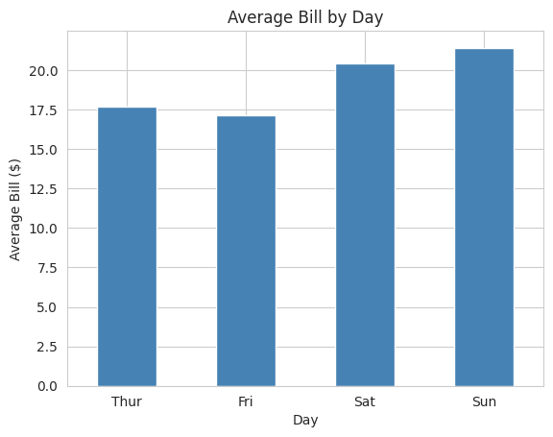
Figure 1: Average bill by day
Weekend bills are higher than weekday bills. Sunday has the highest average, and Friday the lowest.

5.2 Histogram: distribution of total bill
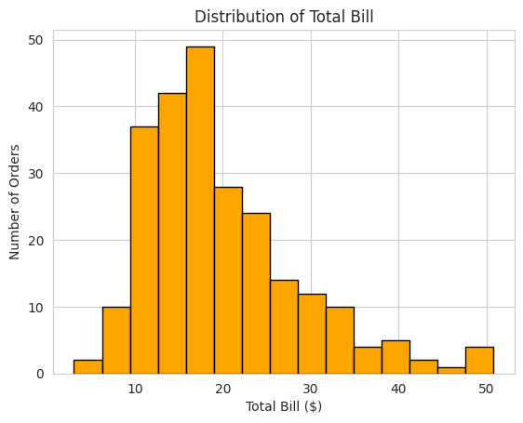
Figure 2: Distribution of total bill
Most bills fall between 10 and 20 dollars, with the peak near 15 to 18 dollars. The distribution is skewed to the right: a small number of large bills (above 40 dollars) stretch the tail.

5.3 Scatter plot: total bill vs tip
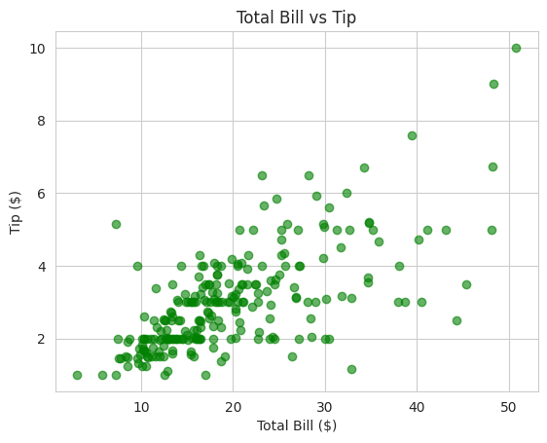
Figure 3: Total bill vs tip
Tips rise as bills rise, so there is a clear positive relationship. The points are more spread out for bigger bills, and a few tips are much higher than the pattern would suggest.

5.4 Line chart: average tip by party size
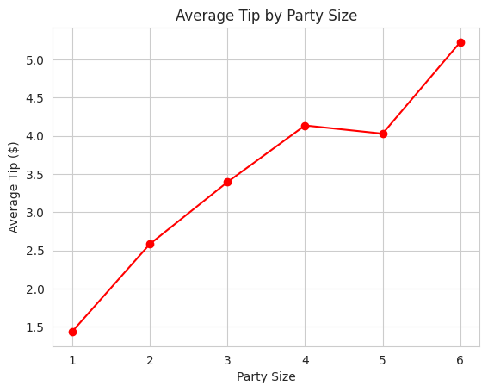
Figure 4: Average tip by party size
The average tip increases as the party gets bigger, from about 1.4 dollars for one person to about 5.2 dollars for six. There is a small dip at party size 5. Large parties are likely rare in the data, so those points may be less reliable.

5.5 Box plot: tip percent, lunch vs dinner
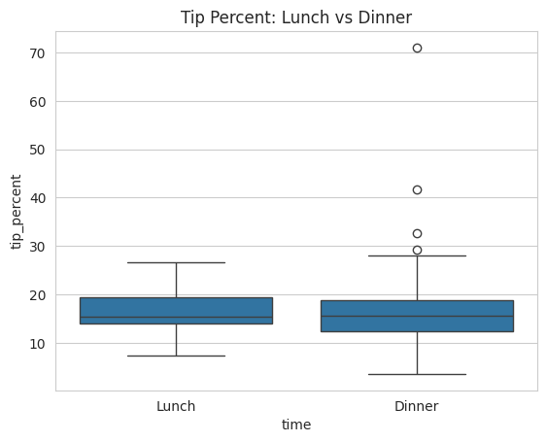
Figure 5: Tip percent, lunch vs dinner
The median tip percent is similar for lunch and dinner, at around 15 to 16 percent. Dinner shows a wider spread and several outliers, including one tip above 70 percent of the bill.

6. Basic Analysis
Code
# correlation between bill and tip
corr = df["total_bill"].corr(df["tip"])
print("Correlation (bill vs tip):", round(corr, 2))

print("Average tip %:", round(df["tip_percent"].mean(), 2))
print("Busiest day:", df["day"].value_counts().idxmax())

print("\nAverage tip % smokers vs non-smokers:")
print(df.groupby("smoker", observed=True)["tip_percent"].mean().round(2))

print("\nAverage bill by party size:")
print(df.groupby("size")["total_bill"].mean().round(2))

print("\nNote: correlation does not mean causation.")
Output
Correlation (bill vs tip): 0.68
Average tip %: 16.08
Busiest day: Sat

Average tip % smokers vs non-smokers:
smoker
Yes 16.32
No 15.93
Name: tip_percent, dtype: float64

Average bill by party size:
size
1 7.24
2 16.45
3 23.28
4 28.61
5 30.07
6 34.83
Name: total_bill, dtype: float64

Key findings
- Correlation between bill and tip is 0.68, a moderately strong positive relationship. Bigger bills tend to get bigger tips.
- The average tip is about 16.08 percent of the bill.
- Saturday is the busiest day by number of orders.
- Smokers (16.32 percent) and non-smokers (15.93 percent) tip almost the same, so the difference is small.
- The average bill grows steadily with party size, from 7.24 dollars for one person to 34.83 dollars for six.
Correlation does not mean causation. The results describe this sample of 244 bills only, and they should not be treated as proof of why customers tip the way they do.

7. Conclusion
In this task I set up a working Python data environment and completed practical exercises on a real dataset: inspecting the data, filtering, sorting, grouping, creating new columns, drawing five types of charts and doing a basic analysis. I also learned to check the data for hidden effects, such as the overlap between day and meal time. These skills will be used in the next tasks for deeper analysis.

8. GitHub Link
https://github.com/Santoshgutte1522/data-engineer-internship.git

