NIFTY 50 Risk Radar
Task 6: Final Data Science Capstone | Data Engineer Internship | Santosh
Risk profiling, high-volatility alerts and portfolio back-testing for 25 NIFTY 50 stocks (January 2016 to October 2026). This report is for education and portfolio purposes and is not investment advice.

1. Executive Summary
Retail investors and small advisory teams often judge a stock only by its past return. The risk that comes with that return, how stocks move together, and when a calm stock is about to become unstable are usually missing. In this capstone I built a small risk system for 25 large Indian stocks using 10 years of daily prices (2,674 trading days), the NIFTY 50 index and the India VIX.
The project has three parts and each one answers a business question:
- Risk profiling: which stocks are risky and which are steady? I calculated return, volatility, Sharpe ratio, maximum drawdown and beta for every stock, and grouped the stocks into 5 risk profiles with KMeans.
- Early warning: can we tell in advance that the next 5 days will be unusually volatile for a stock? I trained Logistic Regression and Random Forest models on 60,375 stock-days and tested them on a later period (2023 to 2026).
- Portfolio construction: can a minimum-variance portfolio reduce risk compared with simply holding the index? I back-tested monthly rebalancing from 2017 to 2026.

Main results
Question | Result
Risk profile | Every stock is more volatile (22.0% to 35.6% a year) than the NIFTY 50 index (16.1%) because the stocks do not move together (average correlation 0.28).
Risk groups | 5 groups. The best return per unit of risk are Group 5 (Bajaj Finance, Tata Steel; Sharpe 0.58) and Group 3 (Reliance, ICICI Bank, Bharti Airtel, L&T, Titan; Sharpe 0.51). Group 2 (TCS, Infosys, ITC, Maruti, Sun Pharma, Wipro) has the weakest (Sharpe 0.11).
Alert model | Weak but real signal. ROC-AUC 0.592 against 0.583 for a simple persistence rule and 0.5 for random. The 10% of days with the highest alert score were high-volatility days 41.1% of the time, against 26.3% overall and 21.4% for the lowest-scored 10%.
Portfolio | Minimum-variance: 15.4% a year with 13.5% volatility and a Sharpe of 0.70, against 10.9%, 16.3% and 0.30 for the index. In the COVID crash it fell 24.7% against 36.5% for the index.

Recommendations in one line each
- Use the 5 risk groups to match stocks to investor risk profiles, with Group 1 as a steady core.
- Treat the alert score as a ranking tool to reduce position size, not as a sell signal, because most alerts (about 59% even in the top decile) are false.
- Watch market-wide signals (VIX and the NIFTY 5-day move) first. They carry more than half of the model's importance.
- Use a capped minimum-variance portfolio to control crash risk, and review it regularly, because it lagged in 2026.
An honest note on the results: the alert model beats the baselines only by a small margin, and the portfolio comparison is flattered by two biases (survivorship and dividends) that are explained in Section 10.

2. Problem Definition

2.1 Business context
Indian retail investing has grown fast, but most beginners still choose stocks by last year's return. A stock that gained 30% a year can also fall 60% from its peak on the way (Bajaj Finance did both in this data). An advisory team needs a clear, data-based way to describe risk, to warn clients when risk is rising, and to build portfolios that survive crashes.

2.2 Stakeholder and objectives
Stakeholder: a small investment advisory team that manages portfolios of large-cap Indian stocks for retail clients.
- Describe the risk and return of each stock in a consistent way, and group similar stocks.
- Build an early-warning model that flags stocks likely to be unusually volatile in the next 5 trading days.
- Test whether a rule-based low-risk portfolio can reduce volatility and crash losses compared with the NIFTY 50 index.

2.3 Success criteria (set before modelling)
Objective | Success criterion
1. Risk profile | All stocks have return, volatility, Sharpe, drawdown and beta, and the groups are interpretable
2. Alert model | Beats the simple persistence rule on ROC-AUC on a later test period, and higher alert scores really mean more high-volatility days
3. Portfolio | Lower volatility and a smaller worst drawdown than the NIFTY 50 index in the back-test

2.4 Scope
25 large NIFTY 50 stocks, daily data, long-only portfolios. Out of scope: intraday data, derivatives, taxes and transaction costs, and predicting the direction of the price. I deliberately do not predict whether a price goes up or down tomorrow, because that is close to a coin flip on daily data, and a model that claims otherwise is usually wrong. Predicting how bumpy the next week will be is a more honest and more useful question.

3. Data Collection and Preparation

3.1 Data
- Source: Yahoo Finance, downloaded in Python with the yfinance library. Prices are adjusted for splits, bonuses and dividends (auto_adjust).
- Stocks (25): Reliance, TCS, HDFC Bank, Infosys, ICICI Bank, Hindustan Unilever, ITC, SBI, Bharti Airtel, Kotak Bank, L&T, Axis Bank, Asian Paints, Maruti, Sun Pharma, Titan, Bajaj Finance, Wipro, NTPC, ONGC, UltraTech Cement, Nestle India, Power Grid, Tata Steel and HCL Tech.
- Market data: the NIFTY 50 index (^NSEI) and the India VIX (^INDIAVIX), which measures the volatility the market expects.
- Period: 4 January 2016 to 30 October 2026. Close price and volume for each day.

3.2 Cleaning
Step | Result
Download | 2,675 days x 27 series (25 stocks, index, VIX); all 27 series returned data
Missing values | VIX had 20 missing days and the index 7 (holidays differ). Gaps of up to 3 days were forward-filled
Incomplete days | 1 day still incomplete and dropped, leaving 2,674 days with 0 missing values
Daily returns | 2,673 days x 25 stocks

3.3 Risk and return measures
- Annual return: compound annual growth rate (CAGR).
- Volatility: standard deviation of daily returns x square root of 252.
- Sharpe ratio: (annual return minus 6% risk-free rate) divided by volatility. The 6% is my assumption, close to Indian government bond yields.
- Maximum drawdown: the worst fall from a previous peak.
- Beta: how much the stock moves for a 1% move in the NIFTY 50 (1.0 = same as the market).

3.4 Features for the alert model
For each stock and day I built 13 features that use only information known on that day:
Group | Features
Stock returns | ret_1d, ret_5d, ret_20d (return over 1, 5 and 20 days)
Stock volatility | vol_5d, vol_20d, vol_60d (standard deviation of daily returns), vol_ratio (5-day / 20-day)
Stock position and activity | from_high_60d (distance from the 60-day high), volume_ratio (today's volume / 20-day average)
Market | vix, vix_chg_5d, nifty_ret_5d, nifty_vol_20d

Target: 1 if the volatility of the next 5 days is above the stock's own 75th percentile of the past 250 days, otherwise 0. This makes the target relative to each stock, so a naturally calm stock and a naturally wild stock can be compared. The result is 60,375 stock-days (13 January 2017 to 23 October 2026), and 25.5% of them are high-volatility days.

4. Exploratory Analysis: Risk and Return
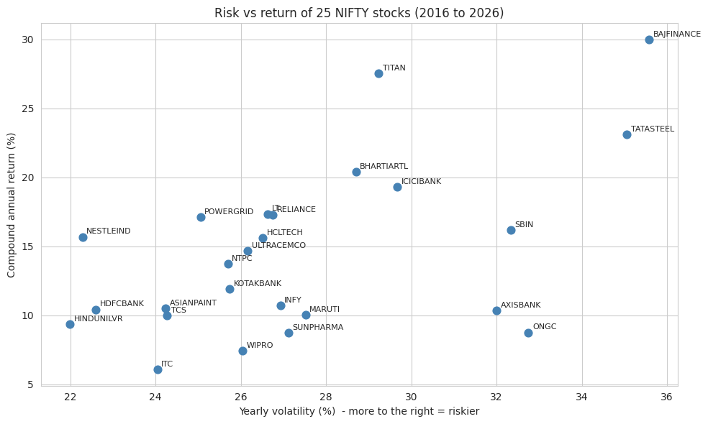
Figure 1: Risk and return of the 25 stocks
From 2016 to 2026 the NIFTY 50 index grew 10.8% a year with 16.1% volatility. The stocks show a wide range:
- Best return: Bajaj Finance (30.0% a year) and Titan (27.5%). Best Sharpe ratio: Titan (0.74), then Bajaj Finance (0.67) and Bharti Airtel (0.50).
- Weakest: ITC (6.1% a year, Sharpe 0.00) and Wipro (7.4%, Sharpe 0.05). ITC earned about the same as the 6% risk-free assumption, for much more risk.
- Riskiest: Bajaj Finance (35.6% volatility, beta 1.39) and Tata Steel (35.1%). Calmest: Hindustan Unilever (22.0%) and HDFC Bank (22.6%). Lowest beta: Nestle India (0.52).
- High return needs high risk only up to a point: Titan and Bajaj Finance earned the most, but ONGC, Axis Bank and SBI took 32% to 33% volatility for only 9% to 16% a year.
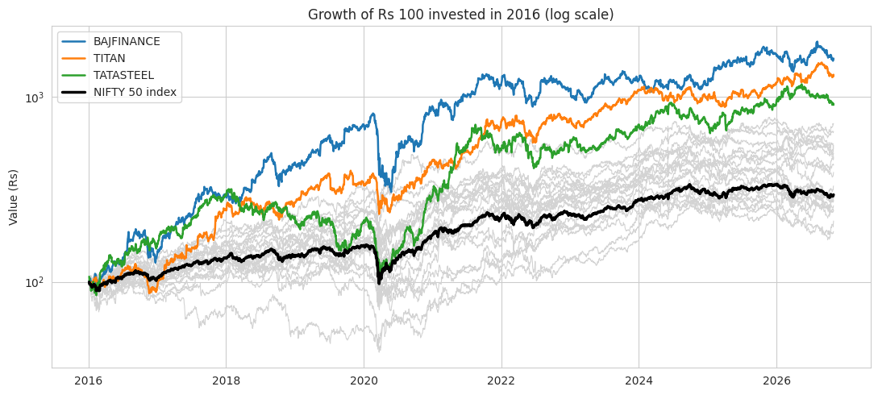
Figure 2: Growth of Rs 100 invested in 2016 (log scale)
Rs 100 became Rs 296 in the index, Rs 1,613 in Bajaj Finance, Rs 1,318 in Titan and Rs 905 in Tata Steel. ITC ended at Rs 187. The index is a price index, so it does not include dividends, which is explained in Section 10. The deep dip in early 2020 is visible in every line.
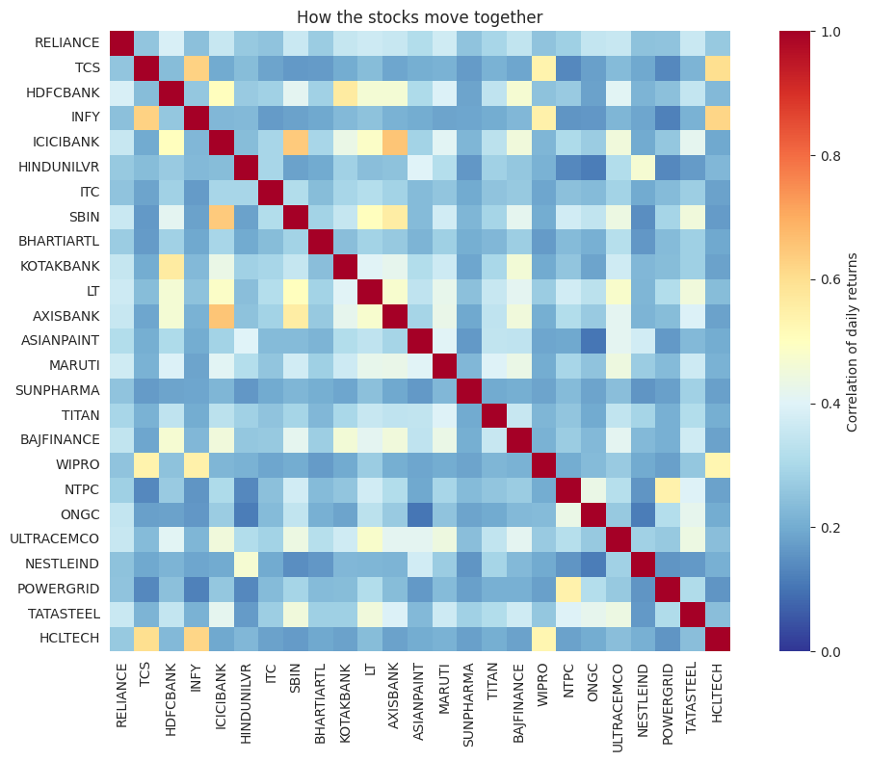
Figure 3: How the stocks move together (correlation of daily returns)
- The average correlation between two stocks is only 0.28. This is why every stock is more volatile (22.0% to 35.6%) than the index (16.1%): the index averages out the stock-specific moves.
- The most similar pairs are the private banks and SBI (ICICI Bank and Axis Bank 0.65, ICICI Bank and SBI 0.64) and the IT stocks (TCS and Infosys 0.63). The heatmap shows the IT stocks (TCS, Infosys, Wipro, HCL Tech) and the banks as visible blocks.
- The least similar pairs are Hindustan Unilever and ONGC (0.12), ONGC and Nestle India (0.12) and Asian Paints and ONGC (0.10), so these combinations diversify the most.
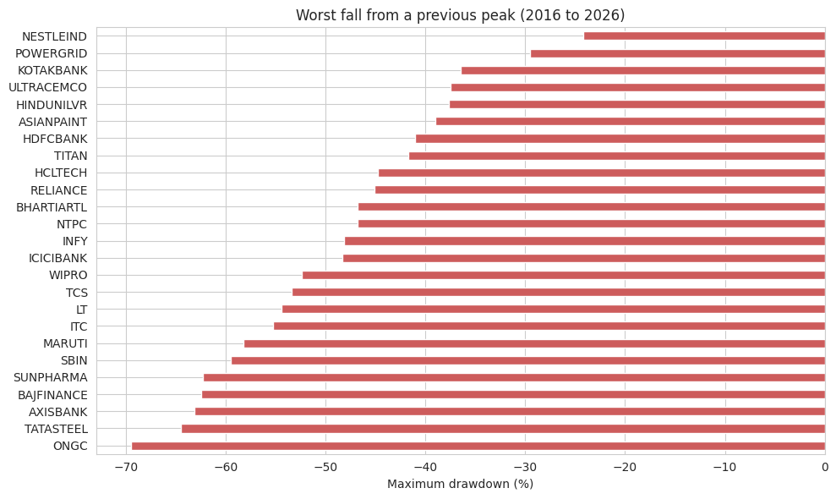
Figure 4: Worst fall from a previous peak
ONGC had the deepest fall (69.5%), and Tata Steel (64.5%), Axis Bank (63.1%) and Bajaj Finance (62.4%) followed. Nestle India (24.2%) and Power Grid (29.6%) were the most resistant. On average, the 25 stocks were 42.8% below their previous peaks at the worst point of the COVID crash, 23 March 2020. This is the benchmark crash for the whole project.

5. Risk Groups (KMeans Clustering)
I clustered the stocks on four standardised measures: annual return, volatility, maximum drawdown and beta. I tried 2 to 6 groups and measured the silhouette score (2: 0.37, 3: 0.27, 4: 0.27, 5: 0.30, 6: 0.27). I chose the best between 3 and 5 groups, which is 5, so the result is detailed enough to be useful. The scores are low, which means the groups overlap and should be read as soft profiles, not hard categories.
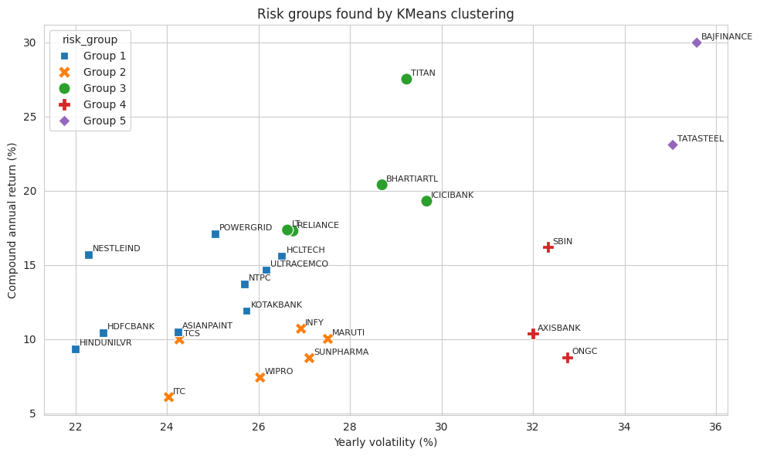
Figure 5: Risk groups found by KMeans
Group | Stocks | Return | Volatility | Max drawdown | Beta | Sharpe
1 (calmest) | 9: HDFC Bank, HUL, Kotak, Asian Paints, NTPC, UltraTech, Nestle, Power Grid, HCL Tech | 13.2% | 24.5% | -37.5% | 0.78 | 0.29
2 | 6: TCS, Infosys, ITC, Maruti, Sun Pharma, Wipro | 8.8% | 26.0% | -55.0% | 0.78 | 0.11
3 | 5: Reliance, ICICI Bank, Bharti Airtel, L&T, Titan | 20.4% | 28.2% | -47.3% | 1.05 | 0.51
4 | 3: SBI, Axis Bank, ONGC | 11.8% | 32.4% | -64.0% | 1.17 | 0.18
5 (riskiest) | 2: Bajaj Finance, Tata Steel | 26.5% | 35.3% | -63.5% | 1.34 | 0.58

How I read the groups (my own labels):
- Group 1, steady core: lower volatility, the smallest drawdown (-37.5%) and beta below 1.
- Group 2, poor reward for the risk: similar volatility to Group 1 but the lowest return and a -55% drawdown.
- Group 3, quality growers: strong return (20.4%) at moderate risk, the best Sharpe among the less extreme groups.
- Group 4, risk without the reward: high volatility, beta above 1.1 and a -64% drawdown, with only 11.8% a year.
- Group 5, high risk and high return: the highest return and the highest risk, with the largest beta (1.34).
The groups are based on 10 years of history, so membership can change. For example, the IT stocks sit in Group 2 because of their weak 2016 to 2026 returns, not because of anything in their business.

6. Volatility Alert Model

6.1 Set-up
- Question: will the next 5 trading days be unusually volatile for this stock (above its own 75th percentile of the past year)?
- Split by time, never randomly: training 13 January 2017 to 20 December 2022 (36,675 stock-days) and testing 2 January 2023 to 23 October 2026 (23,500 stock-days). I left a gap of about 8 trading days between them because each target looks 5 days ahead, so no training row can see into the test period.
- High-volatility days are 25.1% of training and 26.3% of test days, so the classes are imbalanced. I used balanced class weights.
- Models: Logistic Regression (with standardised features) and Random Forest (200 trees, depth 8). Two baselines: always predict calm, and a persistence rule (if volatility is above the threshold today, predict that it stays high).

6.2 Results on the test period
Model | Accuracy | Precision | Recall | F1 | ROC-AUC
Baseline: always calm | 0.737 | 0.000 | 0.000 | 0.000 | 0.500
Baseline: persistence rule | 0.652 | 0.335 | 0.331 | 0.333 | 0.583
Logistic Regression | 0.649 | 0.351 | 0.396 | 0.372 | 0.592
Random Forest | 0.676 | 0.354 | 0.286 | 0.317 | 0.584

- Accuracy is misleading here. "Always calm" has the highest accuracy (0.737) because 74% of days are calm, but it never finds a single high-volatility day (recall 0). That is why I judge the models on ROC-AUC, precision and recall.
- Logistic Regression is the best model (AUC 0.592, F1 0.372), but only slightly better than the persistence rule (0.583) and Random Forest (0.584). The three ROC curves lie very close to each other.
- At the default threshold the Logistic Regression model caught 2,440 of the 6,169 high-volatility days (recall 0.396) with 4,521 false alarms (precision 0.351).
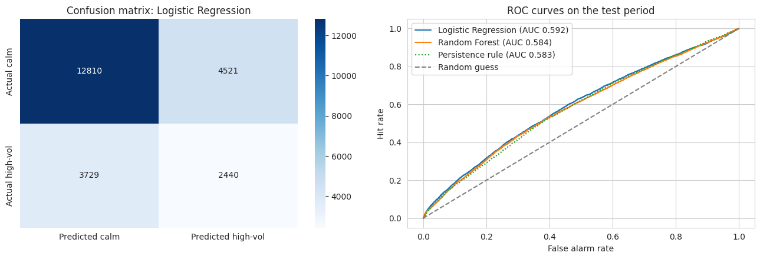
Figure 6: Confusion matrix of the best model (left) and ROC curves (right)

6.3 Does a higher alert score mean more risk?
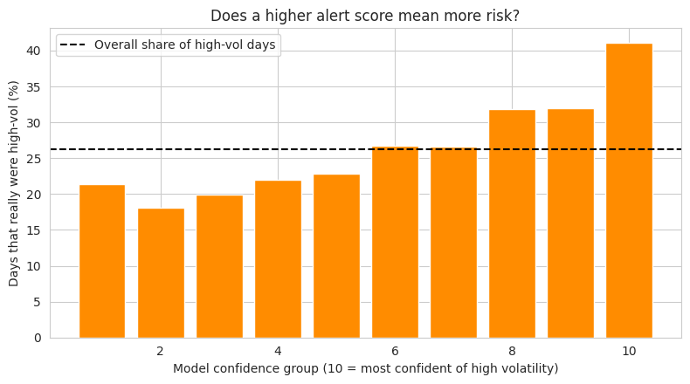
Figure 7: Share of days that were really high-volatility, by alert score group
This is the most useful view for the business. I sorted all test days by the model's score and cut them into 10 equal groups. In the top 10% of scores, 41.1% of the days were high-volatility, which is 1.6 times the overall rate (26.3%). In the lowest 10% it was 21.4%. The rate rises almost steadily from the lowest groups to the highest, so the model works as a ranking tool, but a 41% hit rate also means that most alerts are false.

6.4 What drives the alert?
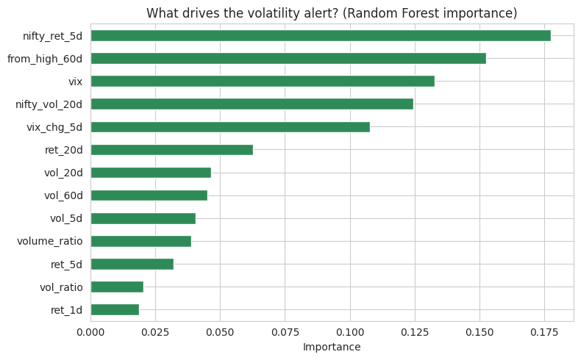
Figure 8: Random Forest feature importance
- The top five features are nifty_ret_5d (0.177), from_high_60d (0.152), vix (0.133), nifty_vol_20d (0.124) and vix_chg_5d (0.108).
- The four market-wide features (nifty_ret_5d, vix, nifty_vol_20d, vix_chg_5d) together hold about 54% of the total importance. A stock's own volatility history (vol_5d, vol_20d, vol_60d) matters much less (about 0.04 to 0.05 each).
- The VIX supports this: its average was 18.5 on days before high-volatility periods and 15.7 before calm periods.
- Importance values from a Random Forest are only a guide, because they can favour features with many different values, and I did not run a permutation test.

7. Portfolio Back-test

7.1 Method
- Three strategies from February 2017 to October 2026: equal weight across the 25 stocks, minimum variance, and the NIFTY 50 index.
- Minimum variance: on the last trading day of every month, I used the past 252 days of returns to find the weights with the lowest portfolio variance, long-only, with a maximum of 15% in any stock (SLSQP optimiser from SciPy). The portfolio is then held for the next month. No future data is used.
- Costs, taxes and slippage are not included.

7.2 Results
 | Return a year | Volatility | Sharpe | Max drawdown
Equal weight | 17.3% | 15.4% | 0.73 | -34.4%
Minimum variance | 15.4% | 13.5% | 0.70 | -26.8%
NIFTY 50 index | 10.9% | 16.3% | 0.30 | -38.4%

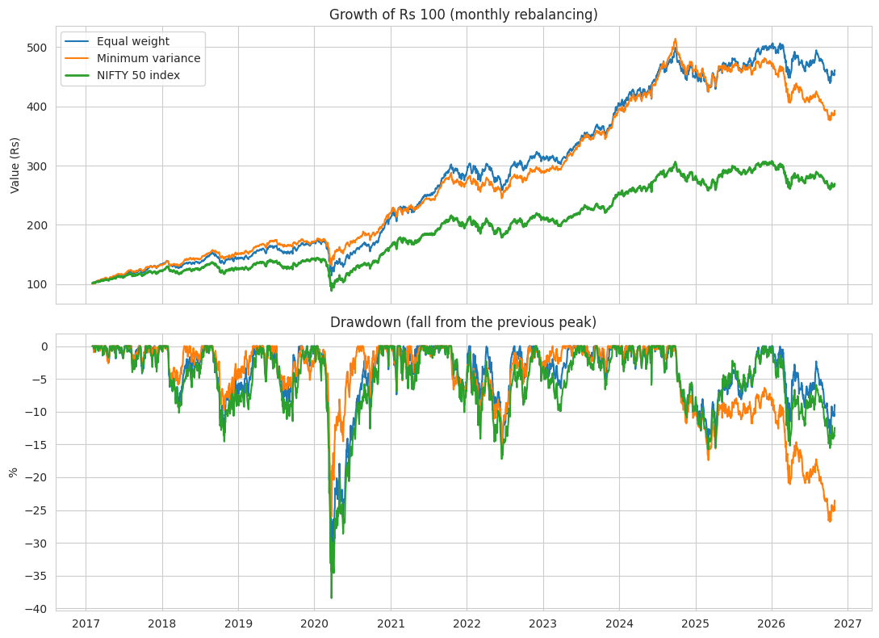
Figure 9: Growth of Rs 100 and drawdowns of the three strategies
- COVID crash (19 February to 23 March 2020): minimum variance fell 24.7%, equal weight 33.1% and the index 36.5%. This is the clearest benefit of the low-risk approach.
- Minimum variance has the lowest volatility (13.5%) and the smallest worst drawdown (-26.8%), but it does not give the highest return.
- The average weights are in defensive stocks: Nestle India 9.2%, Hindustan Unilever 9.0%, Sun Pharma 8.9%, HDFC Bank 8.4%, Power Grid 8.1% and TCS 7.9%.
- A warning from the chart: the minimum-variance worst drawdown (-26.8%) is not from 2020. It is at the end of the data, in late 2026, and at that point it is much deeper than the index drawdown. The defensive stocks it prefers were weak in 2026. I did not investigate the reason, but it shows that low-risk portfolios can lag, and the strategy needs regular review.
- Equal weight beat the index by about 6.4 percentage points a year. This result should not be taken at face value, because of the two biases in Section 10.

8. Results Against the Success Criteria
Criterion | Outcome | Met?
Risk profile with 5 measures and interpretable groups | All 25 stocks measured; 5 groups with clear profiles (silhouette 0.30, so overlapping) | Yes
Alert model beats persistence on ROC-AUC; higher score means more risk | AUC 0.592 vs 0.583; top decile 41.1% vs bottom 21.4% | Yes, but only slightly
Portfolio with lower volatility and smaller worst drawdown than the index | 13.5% vs 16.3% volatility; -26.8% vs -38.4% drawdown | Yes, but see the 2026 warning

9. Business Recommendations
These are for an advisory team and are based only on this dataset. They are not investment advice.
# | Recommendation | Evidence | How to measure
1 | Build client portfolios around Group 1 as a steady core, and add a small satellite from Group 3. Avoid using Group 2 and Group 4 stocks as core holdings. | Group 1: lowest drawdown (-37.5%), beta 0.78. Group 3: Sharpe 0.51. Groups 2 and 4: Sharpe 0.11 and 0.18 with -55% and -64% drawdowns. | Portfolio volatility and drawdown by client risk level, reviewed every quarter
2 | Diversify across unlike stocks, not just across names. Do not treat ICICI Bank, Axis Bank and SBI as three separate bets. | Average correlation 0.28, but 0.64 to 0.65 within the private banks and SBI. Lowest pairs near 0.10 to 0.12 (ONGC with HUL, Nestle, Asian Paints). | Average pairwise correlation inside each portfolio
3 | Use the alert score to reduce position size or tighten reviews, not as a sell signal. Put the top 20% of alerts on a watch list. | Top 10% of scores: 41.1% were high-volatility days vs 26.3% overall. Most alerts are still false. | Hit rate of the watch list; drawdown of reduced positions vs full positions
4 | Monitor the market first: set review triggers on the India VIX and the NIFTY 5-day move. | Market features hold about 54% of model importance; VIX averaged 18.5 before high-volatility periods vs 15.7 before calm ones. | How often the triggers were followed by high volatility
5 | Offer a capped minimum-variance option for cautious clients, rebalanced monthly, with a review of its sector mix each quarter. | Volatility 13.5% vs 16.3%; COVID crash -24.7% vs -36.5%; but a deep drawdown in 2026. | Worst drawdown and volatility against the index, every quarter
6 | Upgrade the data before using this for real money: add delisted stocks, dividends for the index, and trading costs. | Biases in Section 10. | Re-run the back-test and compare with these results

10. Limitations and Ethics
- Survivorship and selection bias. I chose 25 stocks that are in the NIFTY 50 today, which means they are companies that did well enough to stay there. Stocks that fell out of the index, or were delisted, are missing. This likely makes the equal-weight and minimum-variance returns look better than a real investor in 2016 could have achieved.
- Dividends. The stock prices are adjusted for dividends, but the NIFTY 50 (^NSEI) is a price index without dividends. The index is therefore understated compared with the stocks, by roughly the dividend yield (typically around 1% a year, not measured here). The return comparison between the portfolios and the index is not like for like, while the volatility and drawdown comparison is less affected.
- The alert model is weak. An AUC of 0.59 beats the baselines by a small margin. I tested one period only (2023 to 2026) and did not tune the models heavily.
- The 5 risk groups have low silhouette scores (about 0.30), so the groups are overlapping profiles.
- The Sharpe ratio depends on my 6% risk-free assumption. The cluster result and the portfolio depend on 2016 to 2026, a period that includes the COVID crash and a long bull market.
- No transaction costs, taxes, impact or limits on trading. Monthly rebalancing would cost something in real life.
- Past data does not guarantee the future. This report is for learning and for a portfolio, and is not financial advice.

11. Conclusion and Next Steps
The Risk Radar shows that the 25 stocks sit in five clear risk profiles, that diversification gives the index about 40% lower volatility than a typical stock, and that a capped minimum-variance portfolio would have cut the COVID crash loss by about a third compared with the index. The early-warning model gives a modest but real ranking signal, driven mainly by market-wide stress rather than by a stock's own history.
Next steps: include delisted stocks and a total-return index to remove the biases, add sector and fundamental data (such as valuation and earnings changes), try gradient boosting with a walk-forward test, and turn the alert into a small web app that ranks stocks every day.

Project files
- Notebook: Task6_Capstone_NIFTY_Risk_Radar.ipynb (Google Colab, Python: pandas, NumPy, scikit-learn, SciPy, Matplotlib, Seaborn, yfinance)
- Data: nifty_prices_clean.csv (cleaned daily prices of the 25 stocks, the index and the VIX)
- GitHub folder: https://github.com/Santoshgutte1522/data-engineer-internship/tree/main/Task6_Capstone_NIFTY_Risk_Radar
- Appendix A: Risk and Return of Every Stock
Stock | Return | Volatility | Sharpe | Max drawdown | Beta | Group
Titan | 27.5% | 29.2% | 0.74 | -41.7% | 0.93 | 3
Bajaj Finance | 30.0% | 35.6% | 0.67 | -62.4% | 1.39 | 5
Bharti Airtel | 20.4% | 28.7% | 0.50 | -46.8% | 0.82 | 3
Tata Steel | 23.1% | 35.1% | 0.49 | -64.5% | 1.30 | 5
ICICI Bank | 19.3% | 29.7% | 0.45 | -48.3% | 1.29 | 3
Power Grid | 17.1% | 25.1% | 0.44 | -29.6% | 0.64 | 1
L&T | 17.4% | 26.6% | 0.43 | -54.4% | 1.12 | 3
Nestle India | 15.7% | 22.3% | 0.43 | -24.2% | 0.52 | 1
Reliance | 17.3% | 26.8% | 0.42 | -45.1% | 1.08 | 3
HCL Tech | 15.6% | 26.5% | 0.36 | -44.8% | 0.74 | 1
UltraTech Cement | 14.7% | 26.2% | 0.33 | -37.5% | 1.02 | 1
SBI | 16.2% | 32.3% | 0.32 | -59.5% | 1.29 | 4
NTPC | 13.7% | 25.7% | 0.30 | -46.8% | 0.76 | 1
Kotak Bank | 11.9% | 25.7% | 0.23 | -36.5% | 1.00 | 1
HDFC Bank | 10.4% | 22.6% | 0.20 | -41.1% | 1.02 | 1
Asian Paints | 10.5% | 24.2% | 0.19 | -39.0% | 0.74 | 1
Infosys | 10.7% | 26.9% | 0.17 | -48.2% | 0.82 | 2
TCS | 10.0% | 24.3% | 0.16 | -53.4% | 0.70 | 2
Hindustan Unilever | 9.3% | 22.0% | 0.15 | -37.6% | 0.60 | 1
Maruti | 10.0% | 27.5% | 0.15 | -58.3% | 1.04 | 2
Axis Bank | 10.4% | 32.0% | 0.14 | -63.1% | 1.32 | 4
Sun Pharma | 8.7% | 27.1% | 0.10 | -62.3% | 0.64 | 2
ONGC | 8.8% | 32.8% | 0.08 | -69.5% | 0.89 | 4
Wipro | 7.4% | 26.0% | 0.05 | -52.4% | 0.74 | 2
ITC | 6.1% | 24.0% | 0.00 | -55.3% | 0.73 | 2

