Real-World Dataset Analysis Project
Earthquake Activity in India and Nearby Regions, 2000 to 2026
Data Engineer Internship, Task 3
Name: Santosh | Notebook: Task3_Earthquake_Analysis.ipynb

1. Introduction
India sits on one of the most active earthquake zones in the world, because the Indian plate is pushing into Asia. In this task I analysed a real earthquake dataset from the United States Geological Survey (USGS) for India and the surrounding region. I chose this dataset because it is official, recent, completely real (every row is a recorded earthquake), and I downloaded it myself with my own filters, so the file is my own and not a common practice dataset.
The goal of the project is to understand where earthquakes happen, how strong and how deep they are, how activity changes over time, and what this means for earthquake risk in India. The steps follow the task objectives: select a dataset, explore it, clean it, do exploratory data analysis, create visualizations, and present insights. All code is in the notebook Task3_Earthquake_Analysis.ipynb and every number in this report comes from my own run of it.

2. Key Findings
- The dataset has 15,381 real earthquakes of magnitude 4 and above from 2000 to October 2026, a median of 459 per year. Most are light: 88.6% are below magnitude 5.
- India has the most earthquakes (5,073, or 33% of the total). At least 2,180 of them (about 43%) are near Port Blair and Bamboo Flat in the Andaman and Nicobar Islands.
- The big spike in 2004 and 2005 is not a trend. It comes from aftershock sequences: 448 quakes in December 2004, 1,023 in January 2005, and 342 in October 2005 after the magnitude 7.6 Kashmir earthquake.
- About 72.6% of earthquakes are shallow (under 70 km). Depth depends on location: Afghanistan averages 143 km (Hindu Kush), while Nepal averages only 16 km.
- Big earthquakes are rare but not as rare as many people think: 115 quakes of magnitude 6 or more and 15 of magnitude 7 or more in 26.8 years in this region. The b-value is 1.08, so each step up in magnitude is about 12 times rarer.
- Eight of the ten strongest earthquakes are shallow (under 40 km), and the only deep ones are in the Hindu Kush region.
- There is no real seasonal pattern. Monthly counts only look uneven because of the 2004 to 2005 aftershocks.

3. Dataset Selection and Context

3.1 Why this dataset
- It comes from a reliable official source, the USGS Earthquake Catalog.
- It is real measured data, with missing values, inconsistent labels and outliers, so the cleaning step is genuine.
- It has a clear real-world purpose: understanding earthquake risk, which matters for planning, building safety and disaster preparedness.
- I defined the region, period and magnitude filter myself, so the file is unique to this project.

3.2 Dataset summary
Item | Detail
Source | USGS Earthquake Catalog (United States Geological Survey), official public API
What one row is | One earthquake recorded by seismographs
Region | Latitude 6 to 37, longitude 68 to 98 (India, the Himalayas and neighbouring countries)
Period | 1 January 2000 to 27 October 2026 (downloaded on 28 October 2026)
Filter | Magnitude 4.0 and above
Size (raw) | 15,383 rows and 22 columns
Size (clean) | 15,381 rows and 20 columns (21 after adding country_group)

3.3 Main variables
Column | Meaning
time | Date and time of the earthquake (UTC)
latitude, longitude | Location of the epicentre
depth | Depth below the surface in km
mag, magType | Magnitude and the method used to measure it (mb, mww, mwc, ...)
place | Text description, such as '45 km SSW of Saiha, India'
nst, gap, rms, magNst, depthError | Quality measures of the location and magnitude
net, id, status | Network that reported it, unique event id, review status

3.4 Analysis questions
- Where do earthquakes happen, and which countries have the most?
- How strong and how deep are they?
- Has activity changed over time, and are there unusual years?
- Is there a seasonal pattern?
- What does the data say about earthquakes in India specifically?

4. Methodology
- Download the data from the USGS API, one year at a time (the API limits the number of rows per request).
- Explore the structure: shape, data types, missing values, duplicates, categories and basic statistics.
- Clean the data: remove wrong event types, fix data types and labels, drop mostly empty columns and check outliers.
- Create new columns: year, month, country, magnitude class and depth class.
- Do exploratory analysis with Pandas, NumPy and statistics: group summaries, correlation, seasonality, and the magnitude and frequency relationship.
- Create 8 visualizations and interpret them.
- Write insights, recommendations and limitations.
The download code is below. The region is a rectangle that covers India and its neighbours, and the date filter runs year by year from 2000 to 2026.
Code
import pandas as pd

# download earthquakes (magnitude 4 and above) for India and nearby region
# we download one year at a time because the USGS site limits rows per request
all_years = []

for year in range(2000, 2027):
url = (
"https://earthquake.usgs.gov/fdsnws/event/1/query?format=csv"
f"&starttime={year}-01-01&endtime={year}-12-31T23:59:59"
"&minlatitude=6&maxlatitude=37&minlongitude=68&maxlongitude=98"
"&minmagnitude=4&orderby=time-asc"
)
try:
part = pd.read_csv(url)
print(year, "->", len(part), "earthquakes")
all_years.append(part)
except Exception as e:
print(year, "-> no data or error:", e)

df = pd.concat(all_years, ignore_index=True)

# save a raw copy (we will upload this to GitHub too)
df.to_csv("india_earthquakes_raw.csv", index=False)

print("\nShape:", df.shape)
print(df.head())
print()
df.info()

5. Data Exploration
The raw data has 15,383 rows and 22 columns. I checked missing values, duplicates, event types and magnitude types.
Output
Rows, columns: (15383, 22)

Missing values (top):
missing percent
horizontalError 8955 58.2
magError 8436 54.8
dmin 8398 54.6
depthError 5477 35.6
nst 4653 30.2
gap 1239 8.1
magNst 1224 8.0
rms 8 0.1

Duplicate rows: 0
Duplicate event ids: 0

Event types:
earthquake 15381
landslide 2

Magnitude types:
mb 14008
mwc 846
mww 362
mwb 120
mwr 30
ml 7
ms 5
mw 2
ms_vx 2
Mb 1

What I found
- There are no duplicate rows or duplicate event ids.
- 2 of the 15,383 events are landslides, not earthquakes, so they must be removed.
- The magnitude type has an inconsistent label: 'Mb' (1 row) and 'mb' (14,008 rows) are the same type.
- 91% of magnitudes use the mb method. The rest use moment magnitude types (mwc, mww, mwb, mwr, mw) and a few others, so magnitudes are not all measured the same way.
- Three columns are more than 50% empty (horizontalError, magError, dmin).
- All events have status 'reviewed', so they were checked by USGS analysts.
Column | Missing | Percent | Decision
horizontalError | 8,955 | 58.2% | Dropped (over 50% empty)
magError | 8,436 | 54.8% | Dropped (over 50% empty)
dmin | 8,398 | 54.6% | Dropped (over 50% empty)
depthError | 5,477 | 35.6% | Kept (not needed for the analysis)
nst | 4,653 | 30.2% | Kept (not needed for the analysis)
gap | 1,239 | 8.1% | Kept
magNst | 1,224 | 8.0% | Kept
rms | 8 | 0.1% | Kept

The two key numeric columns look reasonable:
Output
depth mag
count 15383.000000 15383.00000
mean 57.851897 4.49077
std 63.797702 0.39884
min 0.000000 4.00000
25% 10.000000 4.20000
50% 30.000000 4.40000
75% 83.950000 4.70000
max 400.570000 7.80000
Negative depths: 0

The average magnitude is 4.49 and the median is 4.4, which is expected because the data starts at magnitude 4. The depth has a mean of 57.9 km but a median of only 30 km, so a smaller number of deep earthquakes pulls the mean up. There are no negative depths.

6. Data Cleaning and Preprocessing
Step | Problem found | Action | Result
Duplicates | Checked rows and event ids | drop_duplicates on id | 0 found
Wrong event type | 2 landslide events in the file | Kept type == earthquake | 2 removed
Data type | time stored as text | pd.to_datetime (UTC) | datetime column
Inconsistent text | magType had 'Mb' and 'mb' | Lowercase and strip spaces | 1 label fixed
Mostly empty columns | 3 columns over 50% missing | Dropped them | 3 columns removed
Unneeded columns | updated, locationSource, magSource | Dropped them | 3 columns removed
Key columns | Checked time, location, depth, mag | Nothing to fix | 0 missing
Outliers | Depth 1,258 and magnitude 402 beyond IQR range | Kept them | Real measurements
Country names | 42 labels, many for the same place | Merged variants, grouped small ones | 10 groups

Code
# 1. remove duplicate events
before = len(df)
df = df.drop_duplicates(subset="id")
print("Duplicates removed:", before - len(df))

# 2. keep only real earthquakes (remove blasts, etc.)
before = len(df)
df = df[df["type"] == "earthquake"]
print("Non-earthquake events removed:", before - len(df))
df = df.drop(columns=["type"])

# 3. fix data types
df["time"] = pd.to_datetime(df["time"], utc=True)

# 4. fix inconsistent text
df["magType"] = df["magType"].str.lower().str.strip()
df["place"] = df["place"].str.strip()
for col in ["magType", "net", "status"]:
df[col] = df[col].astype("category")

# 5. drop columns that are more than 50% empty, and columns we do not need
missing_pct = df.isnull().mean() * 100
drop_cols = missing_pct[missing_pct > 50].index.tolist()
print("Dropping (over 50% missing):", drop_cols)
df = df.drop(columns=drop_cols)
df = df.drop(columns=["updated", "locationSource", "magSource"])

# 6. check the important columns have no gaps
print("\nMissing in key columns:")
print(df[["time", "latitude", "longitude", "depth", "mag"]].isnull().sum())

# 7. outliers using the IQR rule
def check_outliers(series):
q1 = series.quantile(0.25)
q3 = series.quantile(0.75)
iqr = q3 - q1
low = q1 - 1.5 * iqr
high = q3 + 1.5 * iqr
count = ((series < low) | (series > high)).sum()
return count, round(low, 2), round(high, 2)

for col in ["depth", "mag"]:
count, low, high = check_outliers(df[col])
print(col, "-> outliers:", count, "| normal range:", low, "to", high)

print("\nThese outliers are real measurements (very deep or very strong quakes), so we keep them.")
print("Rows left:", len(df))

Output
Duplicates removed: 0
Non-earthquake events removed: 2
Dropping (over 50% missing): ['dmin', 'horizontalError', 'magError']

Missing in key columns:
time 0
latitude 0
longitude 0
depth 0
mag 0
dtype: int64
depth -> outliers: 1258 | normal range: -100.97 to 194.95
mag -> outliers: 402 | normal range: 3.45 to 5.45

These outliers are real measurements (very deep or very strong quakes), so we keep them.
Rows left: 15381

Outliers
Using the IQR rule, 1,258 depths and 402 magnitudes fall outside the normal range. I did not remove them. A very deep or very strong earthquake is a real measurement, and it is exactly the kind of event this analysis is about. Removing them would hide the most important events. The 'normal range' for depth even goes below zero (-100.97 km), which just shows that depth is skewed and the IQR rule is only a guide here.

Country names and new columns
The 'place' column is text, so I took the part after the last comma as the country. This gave 42 different labels, and many of them are the same place written differently: 'India region' is India, 'Burma (Myanmar)' is Myanmar, and 'western Xizang' and 'Southern Tibetan Plateau' are in China. I merged these and grouped countries with fewer than 50 quakes into 'Other'.
Code
# time columns
df["year"] = df["time"].dt.year
df["month"] = df["time"].dt.month

# country = the text after the last comma in "place"
df["country"] = df["place"].str.split(",").str[-1].str.strip()

# magnitude class
df["mag_class"] = pd.cut(
df["mag"],
bins=[3.9, 4.9, 5.9, 6.9, 10],
labels=["Light (4-4.9)", "Moderate (5-5.9)", "Strong (6-6.9)", "Major (7+)"]
)

# depth class
df["depth_class"] = pd.cut(
df["depth"],
bins=[-100, 70, 300, 1000],
labels=["Shallow (<70 km)", "Intermediate (70-300 km)", "Deep (>300 km)"]
)

print("Different 'countries':", df["country"].nunique())
print(df["country"].value_counts().head(15))
print()
print(df["mag_class"].value_counts())
print()
print(df["depth_class"].value_counts())

# save the clean file (we will upload this to GitHub too)
df.to_csv("india_earthquakes_clean.csv", index=False)
print("\nFinal shape:", df.shape)
df.info()

Output
Different 'countries': 42 (before fixing the names)

After fixing and grouping:
India 5073
Afghanistan 3658
China 1754
Indonesia 1551
Myanmar 1247
Pakistan 999
Nepal 773
Other 171
Bangladesh 78
Tajikistan 77

After cleaning, the dataset has 15,381 rows. I saved it as india_earthquakes_clean.csv, and the raw download is saved as india_earthquakes_raw.csv.

7. Exploratory Data Analysis

7.1 Earthquakes over time
Output
Quakes per year (median): 459.0
Latest quake in data: 2026-10-27 18:57:53 UTC

Top 5 years:
2005 2294
2004 871
2008 869
2015 816
2025 694

Skewness -> magnitude: 1.69 | depth: 1.5

The median is 459 earthquakes a year. 2005 is far above everything else, with 2,294. Both magnitude (skewness 1.69) and depth (1.50) are right-skewed: most earthquakes are small and shallow, with a long tail of strong and deep ones.

7.2 Investigating the 2004 and 2005 spike
Instead of just calling these years outliers, I looked at what was inside them.
Output
Year 2004 -> 871 quakes
Top countries: India 468, Afghanistan 114, China 96
Busiest months: Dec 448, Jul 60, Apr 59
Strongest: 2004-12-26, M7.2, 284 km WNW of Sabang, Indonesia

Year 2005 -> 2294 quakes
Top countries: India 863, Indonesia 834, Pakistan 323
Busiest months: Jan 1023, Oct 342, Feb 184
Strongest: 2005-10-08, M7.6, 21 km NNE of Muzaffarabad, Pakistan

- In 2004, 448 of the 871 earthquakes happened in December, and the strongest was a magnitude 7.2 on 26 December 2004 near Sabang, Indonesia. This matches the date of the huge Sumatra-Andaman earthquake. Its main shock is south of my region's boundary (the region starts at latitude 6), so it is not in the data, but its aftershocks are.
- In 2005, 1,023 of the 2,294 earthquakes happened in January. This fits a continuing aftershock sequence, and India (863) and Indonesia (834) are the top two countries that year, which probably points to the Andaman and Sumatra area.
- The second bump in 2005 is October (342 quakes), with Pakistan at 323 for the year. The strongest quake of 2005 was the magnitude 7.6 Kashmir earthquake on 8 October near Muzaffarabad.
So the spike is a cluster of aftershocks from specific major earthquakes, not a general increase in activity. This is important when reading the yearly chart. The years 2015 (816) and 2025 (694) are also above the median, and they contain major earthquakes in Nepal and Myanmar, so they probably include aftershocks too. The year 2008 (869) is also high, and I did not investigate it in this task.

7.3 Summary by country
Country / region | Quakes | Avg magnitude | Max magnitude | Avg depth (km)
India | 5,073 | 4.54 | 7.7 | 32.85
Afghanistan | 3,658 | 4.37 | 7.5 | 143.37
China | 1,754 | 4.51 | 7.8 | 19.46
Indonesia | 1,551 | 4.61 | 7.2 | 32.41
Myanmar | 1,247 | 4.50 | 6.9 | 48.73
Pakistan | 999 | 4.49 | 7.6 | 22.91
Nepal | 773 | 4.47 | 7.8 | 16.15
Other | 171 | 4.50 | 7.7 | 49.54
Bangladesh | 78 | 4.44 | 5.7 | 21.15
Tajikistan | 77 | 4.33 | 6.2 | 106.28

India has the most earthquakes, then Afghanistan. Their depths are very different: Afghanistan averages 143 km because of the deep Hindu Kush earthquakes, while Nepal (16 km), China (19 km) and Pakistan (23 km) are mostly shallow. Indonesia has the highest average magnitude (4.61), but this is a small difference.

7.4 Magnitude and depth classes
Class | Quakes | Share
Light (M4 to 4.9) | 13,631 | 88.6%
Moderate (M5 to 5.9) | 1,634 | 10.6%
Strong (M6 to 6.9) | 101 | 0.7%
Major (M7 and above) | 15 | 0.1%
Shallow (under 70 km) | 11,164 | 72.6%
Intermediate (70 to 300 km) | 4,212 | 27.4%
Deep (over 300 km) | 5 | under 0.1%

7.5 The strongest earthquakes
Date | Mag | Depth (km) | Place
2001-11-14 | 7.8 | 10.0 | Southern Qinghai, China
2015-04-25 | 7.8 | 8.2 | 67 km NNE of Bharatpur, Nepal
2001-01-26 | 7.7 | 16.0 | 17 km NW of Bhachau, India (Gujarat)
2025-03-28 | 7.7 | 10.0 | Mandalay, Myanmar
2005-10-08 | 7.6 | 26.0 | 21 km NNE of Muzaffarabad, Pakistan
2009-08-10 | 7.5 | 24.0 | 266 km N of Bamboo Flat, India
2010-06-12 | 7.5 | 35.0 | Nicobar Islands, India region
2015-10-26 | 7.5 | 231.0 | Hindu Kush region, Afghanistan
2002-03-03 | 7.4 | 225.6 | 51 km SW of Jurm, Afghanistan
2015-05-12 | 7.3 | 15.0 | Nepal

Eight of the ten have a depth under 40 km. The only deep ones are the two Hindu Kush earthquakes at 231 km and 225.6 km. Three of the top ten are in 2015 and one is in 2025, which is recent. Shallow earthquakes of the same magnitude generally shake the surface more strongly, so shallow depth in the strongest events is a risk signal.

7.6 Correlation
 | mag | depth | latitude | longitude
mag | 1.00 | -0.16 | -0.18 | 0.18
depth | -0.16 | 1.00 | 0.43 | -0.53
latitude | -0.18 | 0.43 | 1.00 | -0.76
longitude | 0.18 | -0.53 | -0.76 | 1.00

- Magnitude and depth have a weak negative correlation (-0.16): deeper earthquakes tend to be slightly weaker, but the relationship is weak.
- Latitude and longitude have a strong negative correlation (-0.76). This is not a physical relationship. It reflects the L-shape of the plate boundary in the region: the quakes run along the north and west, then down the east side.
- Depth has a negative correlation with longitude (-0.53) and a positive one with latitude (0.43). The deepest quakes are in the north-west (Hindu Kush).

7.7 Seasonality
Monthly counts over all years are: Jan 2,019, Feb 1,020, Mar 1,397, Apr 1,279, May 1,155, Jun 1,169, Jul 1,298, Aug 1,224, Sep 957, Oct 1,402, Nov 1,131, Dec 1,330. January looks high only because 1,023 of its 2,019 quakes are from January 2005. Without that, January would be about 996, similar to February and September. The remaining months range between roughly 950 and 1,400 with no clear season. This is what we expect, because earthquakes come from plate movement deep underground and do not follow the weather.

7.8 How often do big earthquakes happen?
Seismologists use the Gutenberg-Richter law: as magnitude goes up, the number of earthquakes drops in a straight line on a log scale. I counted the earthquakes at or above each magnitude and fitted a line.
Output
Magnitude vs count (quakes at or above):
4.5 -> 7068
5.0 -> 1750
5.5 -> 402
6.0 -> 115
6.5 -> 38
7.0 -> 15
b-value: 1.08

The b-value of 1.08 is close to 1, which is the typical value for earthquakes worldwide. A b-value of about 1 means that each step of one magnitude unit gives roughly 10 to 12 times fewer earthquakes. It also means that out of every 8 or so earthquakes of magnitude 6 or more, about 1 reaches magnitude 7 (115 versus 15 in this data). Over 26.8 years, that is roughly 4.3 earthquakes of magnitude 6 or more per year and one of magnitude 7 or more every 1.8 years across the whole region, though aftershocks make these counts clustered rather than evenly spread.

8. Data Visualizations
I created eight charts: a line chart, a bar chart, histograms, a map-style scatter plot, a box plot, a scatter plot, a heatmap and a log-scale frequency plot.

8.1 Earthquakes per year (line chart)
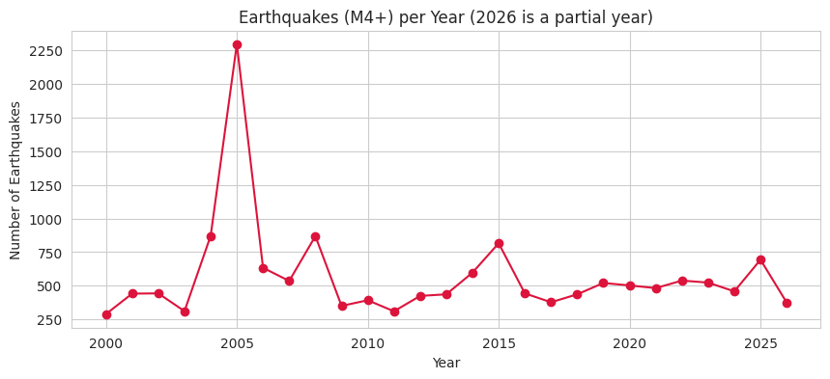
Figure 1: Earthquakes (M4+) per year
Yearly counts stay between about 300 and 900 except for one huge peak in 2005. After 2005 the line returns to a stable level, with smaller rises in 2015 and 2025. There is no sign of a steady increase. The 2026 point is lower because the year is only partly complete (up to 27 October).

8.2 Earthquakes by country (bar chart)
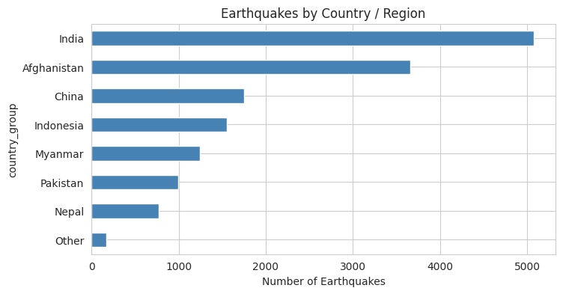
Figure 2: Earthquakes by country or region
India is first with 5,073, followed by Afghanistan with 3,658. The next five (China, Indonesia, Myanmar, Pakistan, Nepal) are between 773 and 1,754. Indonesia appears because my region box includes the northern tip of Sumatra.

8.3 Distribution of magnitude and depth (histograms)
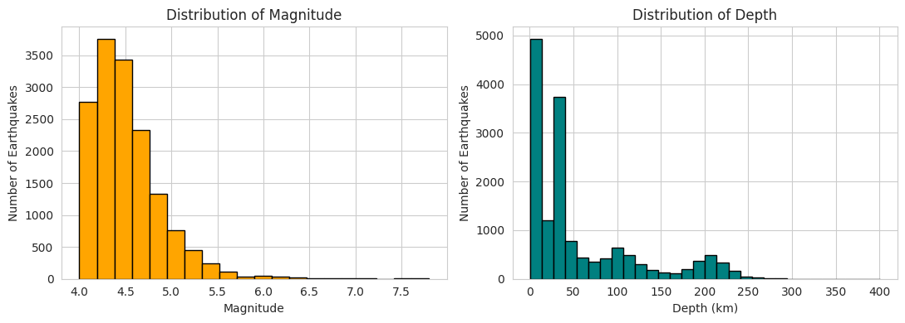
Figure 3: Distribution of magnitude and depth
Magnitude is strongly right-skewed: the number of earthquakes falls quickly as magnitude rises, and there are very few above 6. Depth has two main peaks, one at the shallowest end (0 to about 13 km) and one at about 27 to 40 km, and a smaller bump around 100 to 230 km. The two sharp peaks are probably partly caused by USGS using standard default depths (such as 10 km and about 33 km) when the exact depth cannot be measured well, so they should not be treated as real depth clusters. The smaller bump at greater depths is consistent with the Hindu Kush earthquakes.

8.4 Where do earthquakes happen? (map-style scatter plot)
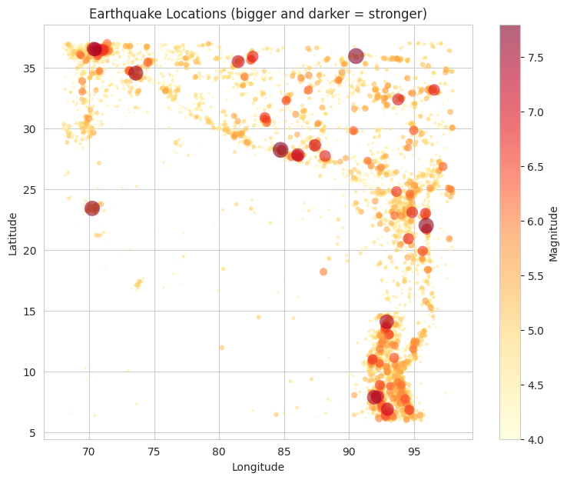
Figure 4: Earthquake locations (bigger and darker means stronger)
This is the most useful chart in the report. The earthquakes follow clear lines, which are the plate boundaries: the Hindu Kush and Pamir area at the top left, the Himalayan arc running east along the north, the Indo-Myanmar ranges on the right side, and the Andaman and Nicobar arc at the bottom right. The interior of peninsular India is almost empty, though a few dots do appear, for example the Gujarat dot of the 2001 Bhuj region and a few small events near 17 N, 73.5 E in Maharashtra. The biggest and darkest points sit on the boundaries.

8.5 Depth by country (box plot)
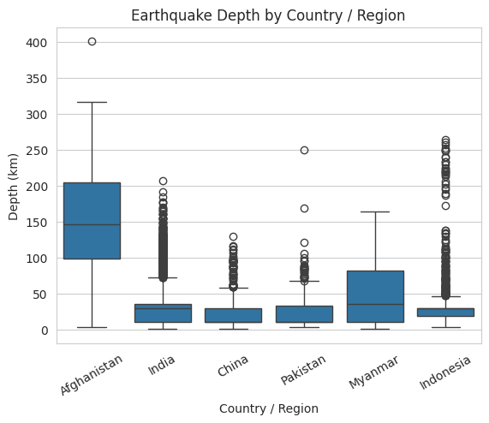
Figure 5: Earthquake depth by country or region
Afghanistan stands apart: its median depth is near 150 km, and its middle half of earthquakes lies between about 100 and 205 km. India, China and Pakistan have low medians and many shallow earthquakes, with the dots above the whiskers showing the occasional deeper ones. Myanmar has a wider spread. China and Pakistan are mostly shallow too (average depths of 19 km and 23 km in the country table).

8.6 Depth versus magnitude (scatter plot)
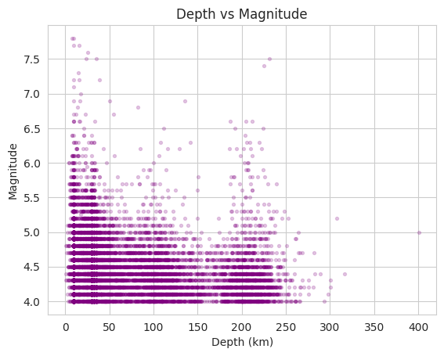
Figure 6: Depth versus magnitude
The horizontal stripes appear because magnitudes are rounded to one decimal place. The strongest earthquakes (above 7) are mostly at low depth, with only two exceptions around 230 km. Most of the dense cloud is below magnitude 5 at all depths. There is no strong link between depth and magnitude.

8.7 Correlation heatmap
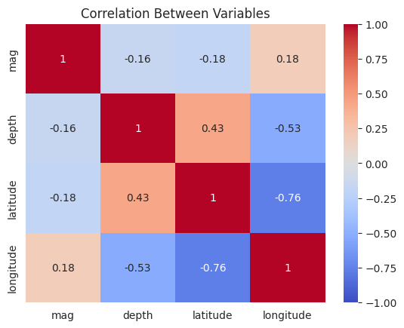
Figure 7: Correlation between variables
This shows the same numbers as the correlation table. The main thing to read from it is the -0.76 between latitude and longitude, which comes from the shape of the plate boundary, not from a cause-and-effect relationship.

8.8 Magnitude versus frequency (log-scale plot)
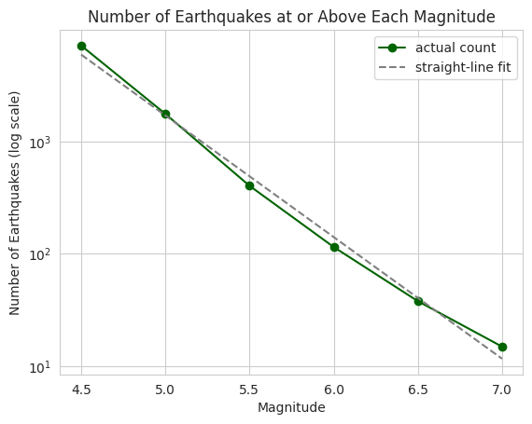
Figure 8: Number of earthquakes at or above each magnitude
On the log scale, the real counts follow the fitted straight line closely. This is the Gutenberg-Richter pattern, and it shows that this catalogue behaves like normal earthquake data. The real counts sit a little above the line at both ends (4.5 and 7.0) and a little below it in the middle (5.5 and 6.0), which is normal for real data, especially at the high end where there are only a few large events.

9. Insights and Interpretation

9.1 Earthquakes in India
Output
India quakes: 5073
India average magnitude: 4.54 | average depth: 32.9
India quakes of magnitude 6+: 39

Nearest towns (India):
Port Blair 1270
Bamboo Flat 910
Shi Yomi 161
Phek 113
Sarupathar 110
Thang 88
Wangjing 88
Bhachau 79

Date | Mag | Depth (km) | Place
2001-01-26 | 7.7 | 16.0 | 17 km NW of Bhachau, India (Gujarat)
2009-08-10 | 7.5 | 24.0 | 266 km N of Bamboo Flat, India
2010-06-12 | 7.5 | 35.0 | Nicobar Islands, India region
2005-07-24 | 7.2 | 16.0 | Nicobar Islands, India region
2011-09-18 | 6.9 | 50.0 | 43 km NW of Mangan, India (Sikkim)

- India accounts for 5,073 earthquakes (33% of the dataset), with an average magnitude of 4.54 and an average depth of 32.9 km. Only 39 (0.8%) are magnitude 6 or more.
- The activity is concentrated in two zones. The first is the Andaman and Nicobar Islands: Port Blair (1,270) and Bamboo Flat (910) alone account for at least 2,180 quakes, about 43% of India's total. The second is northeast India: Shi Yomi in Arunachal Pradesh (161), Phek in Nagaland (113) and Sarupathar in Assam (110).
- The strongest earthquake labelled as India in this dataset is the magnitude 7.7 Bhachau (Gujarat) earthquake of 26 January 2001, at a shallow 16 km. It is a reminder that major events can happen outside the usual Himalayan and island zones.
- The next three strongest are all in the Andaman and Nicobar region (magnitude 7.5 in 2009, 7.5 in 2010 and 7.2 in 2005).
- The Nepal earthquake of 2015 (magnitude 7.8) is not counted as India, but it is close to the border and shows the strength of Himalayan earthquakes.

9.2 What the results mean
- Frequency of risk: the Gutenberg-Richter pattern shows that strong earthquakes are rarer than weak ones, but the rate is not small at the regional level. A magnitude 7 or higher earthquake happens somewhere in this region about every two years on average.
- Shallow depth: 72.6% of earthquakes are shallow, and eight of the ten strongest are shallow, which increases the shaking and the possible damage at the surface.
- Geography matters more than season or year. The map shows that the location along a plate boundary is the main factor, not the time of year.
- Past spikes come from single major earthquakes and their aftershocks, so planners should expect clusters of events after a large one.

10. Recommendations
These are suggestions based on what this data shows. This analysis describes past earthquakes and is not a hazard map or a prediction.
- Give extra attention to preparedness in the Andaman and Nicobar Islands and northeast India, because the data shows the highest number of earthquakes in India there.
- Do not ignore areas outside the main zones. The 2001 Bhachau earthquake was the strongest in India in this data, so building safety rules matter in every seismic zone.
- After any major earthquake, expect an aftershock period of months. Emergency plans should cover this, because 2004 and 2005 show how many aftershocks can follow.
- Prioritise strict building codes and checks in regions with many shallow earthquakes, such as the Himalayan belt and Nepal, China and Pakistan border areas.
- For the next step in analysis: remove aftershocks (declustering), compare with India's National Center for Seismology catalogue, add population or building data, and analyse each Indian state separately.

11. Limitations
- Only earthquakes of magnitude 4 and above are included, so smaller events are missing. How completely the catalogue records a magnitude 4 earthquake can differ between older and newer years and between regions.
- The region is a rectangle, so it contains parts of other countries (Indonesia, China, Afghanistan and others) and does not follow the border of India.
- The country is taken from the text of the 'place' column, which is not always consistent, so some quakes may be assigned imperfectly. Place names also contain a few unreadable characters, for example 'Muzaffar?b?d'.
- Magnitudes use different methods (91% mb), so they are not perfectly comparable.
- Many depths use fixed default values, so depth analysis is approximate.
- Aftershocks make events clustered, so simple yearly or per-year averages can be misleading.
- 2026 is a partial year, and I did not investigate the high count of 2008.
- Correlation does not mean causation, and nothing in this report predicts when or where the next earthquake will happen.

12. Conclusion
I downloaded and analysed 15,381 real earthquakes from the USGS catalogue for India and nearby regions from 2000 to 2026. After cleaning the data (removing two non-earthquake events, fixing labels, dropping three mostly empty columns and merging country names), I explored it with statistics and eight visualizations.
The data shows that earthquakes follow plate boundaries, that most are small and shallow, that the 2004 and 2005 spike was caused by aftershocks of major earthquakes rather than a trend, and that India's activity is concentrated in the Andaman and Nicobar Islands and the northeast. The frequency pattern follows the Gutenberg-Richter law with a b-value of 1.08. This project also showed me why checking what is behind an outlier is better than simply removing it.

13. Tools, Source and GitHub Link
- Tools: Python, Pandas, NumPy, Matplotlib, Seaborn, Google Colab.
- Data source: USGS Earthquake Catalog, https://earthquake.usgs.gov/fdsnws/event/1/ (downloaded on 28 October 2026).
- GitHub folder: https://github.com/Santoshgutte1522/data-engineer-internship/tree/main/Task3_Earthquake_Analysis
- The folder contains the notebook, this report, the raw data file, the cleaned data file and a README.

