Hello thanks for taking the time too look at my proposal for a custom web application using three.js.

<https://www.youtube.com/watch?v=BDshx-qCyJE>

the link provided above starting at the :25 second mark, shows what I want in the web app;

1. Create a license board that allows the user to mouse click a particular license
2. When the license is clicked a popup shows details of that license
3. The user can click on the popup for options; 1. Obtain license 2. Earn License
4. When the user selects Earn License the web app loads another scene where

The visuals are like the sphere grid in final fantasy 10; <https://www.youtube.com/watch?v=BGVtYkF1wKE>

In this scene, the user can click on the first sphere and allows them to do a specific quiz that the sphere entails, each sphere has a lecture and a quiz, if the user passes the quiz the sphere is earned, if all the spheres are earned then the user can obtain the license, theres multiple licenses, and each license has a sphere grid with enough spheres that are unlockable to obtain the license

1. The admin can manipulate and add licenses to the board and amount of spheres in it’s grid, and build and set the contents of the quizzes, here’s an example of a quiz;

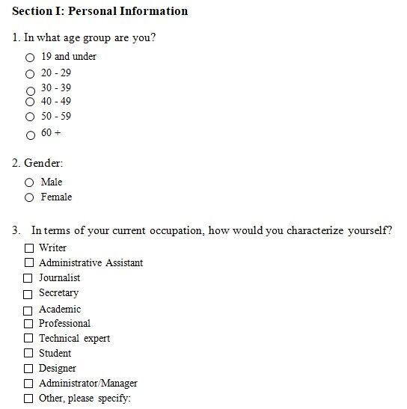

Is this something you can do? Would you recommend someone that can? What price would you charge? How long would this take?