PROFIT ANALYSIS REPORT
Multiple Linear Regression | 50 Startups Dataset
Prepared by: Gopi Santhosh Reddy
Date: June 2026

1. Executive Summary
This report presents a comprehensive analysis of startup profitability using Multiple Linear Regression (MLR) on the 50 Startups dataset. The objective was to model and predict profit based on three key expenditure categories — R&D Spend, Administration, and Marketing Spend — across three US states: California, New York, and Florida.

Key highlights from the analysis:
- The regression model achieves an R² of 0.92 on test data, indicating exceptional predictive accuracy.
- R&D Spend is the strongest positive driver of profit.
- Marketing Spend contributes moderately, while Administration has a marginally negative effect.
- Florida startups lead in average profitability ($119K), followed by New York ($114K) and California ($104K).
- Total marketing expenditure ($10.55M) accounts for the largest share of combined spend
2. Dataset Overview
The 50 Startups dataset contains financial records for 50 companies operating across three US states. Each record includes spending across three categories and the resulting profit.

2.1 KPI Summary

KPI | Value | Description
Total Startups | 50 | Companies in the dataset
Sum of Profit | 5.60M | Total combined profit across all startups
Avg Profit | 112K | Average profit per startup
Total R&D Spend | 3.69M | Total research & development expenditure
Total Ad Spend | 6.07M | Total administration expenditure
Total Marketing Spend | 10.55M | Total marketing expenditure

The dataset represents a diverse range of startup sizes and investment strategies. With an average profit of $112K against a combined spend pool of $20.21M (R&D + Administration + Marketing), there is clear variation in how efficiently different startups convert expenditure into profit

3. Multiple Linear Regression Model

3.1 Model Equation

Profit = 48,091.40 + 0.7856 × R&D Spend − 0.0055 × Administration + 0.0325 × Marketing Spend

3.2 Coefficient Interpretation
- Intercept (48,091.40): The base expected profit when all spending variables are zero.
- R&D Spend (+0.7856): For every $1 increase in R&D Spend, profit increases by approximately $0.79 — the strongest positive predictor.
- Administration (−0.0055): A marginal negative effect; higher admin costs slightly reduce profit, suggesting diminishing returns.
- Marketing Spend (+0.0325): Moderate positive impact; every $1 increase in marketing yields ~$0.033 in additional profit.

3.3 Model Performance Metrics

Metric | Value | Interpretation
R² Score (Test) | 0.92 | Model explains 92% of profit variance on unseen data — excellent fit
R² Score (Train) | 0.95 | 95% variance explained on training data — strong learning
MAE | 6.31K | Average absolute prediction error of ~$6,310 — highly accurate
RMSE | 7.80K | Root mean squared error of ~$7,800 — low error magnitude

The model demonstrates excellent generalization with a minimal gap between train (0.95) and test (0.92) R² scores, indicating no significant overfitting. The MAE of $6.31K and RMSE of $7.80K are low relative to the profit range, confirming high prediction reliability.
4. Scatter Plot Analysis
Three scatter plots on the dashboard (Page 1) visualize the relationship between each independent variable and profit. Trend lines indicate the direction and strength of each relationship.

4.1 R&D Spend vs Profit
- Strong positive linear correlation observed.
- Data points cluster tightly around the trend line, indicating high predictability.
- Startups with R&D Spend above $150K consistently achieve profits exceeding $150K.
- This confirms R&D Spend as the most influential predictor in the regression model.

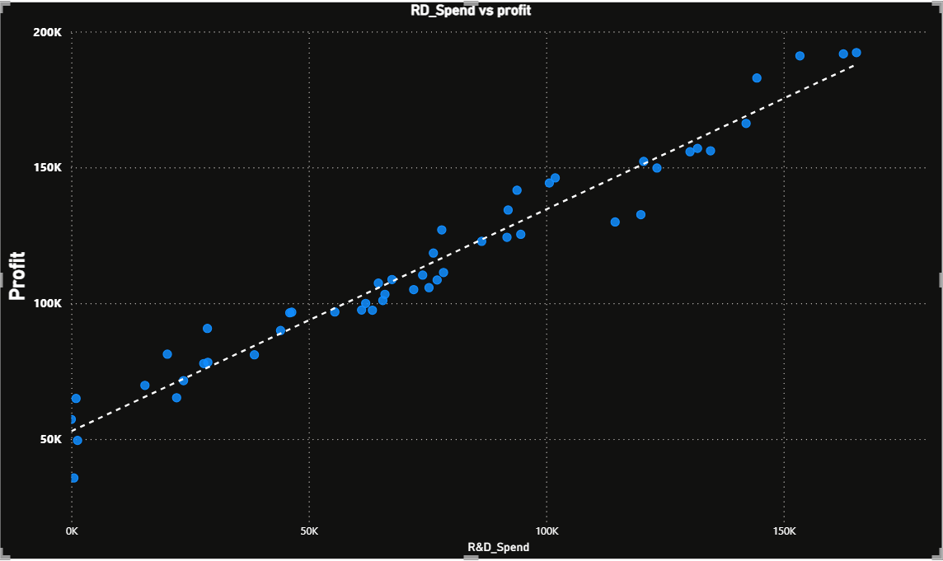

4.2 Administration vs Profit
- Moderate positive trend with considerable scatter, suggesting a weaker and less consistent relationship.
- Some startups with high administration costs (~$200K) still achieve profits around $100K–$160K, implying other factors compensate.
- The negative coefficient in the model reflects this inefficiency — admin spend beyond a threshold does not translate to proportional profit gains.

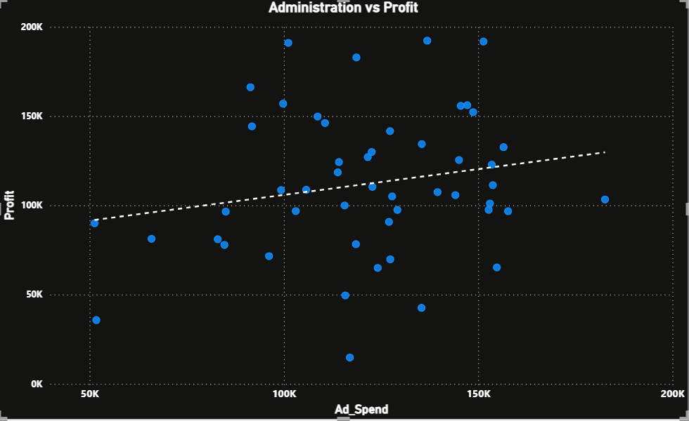

4.3 Marketing Spend vs Profit
- Positive but moderate correlation.
- Data points show more variance compared to the R&D plot, particularly at higher marketing spend levels.
- The relationship is weaker at the lower end of marketing spend, becoming stronger as spend increases beyond $200K.\

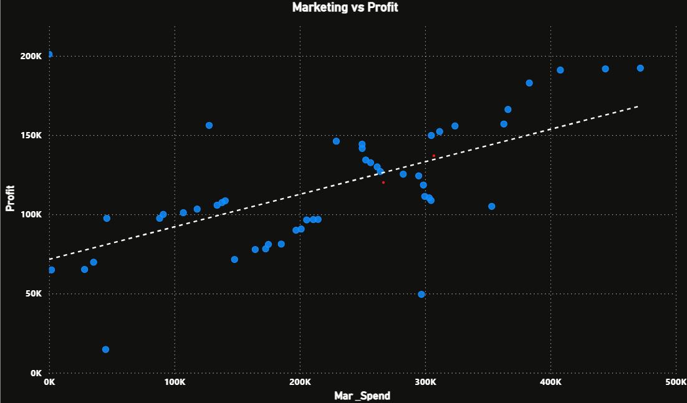

5.1 Startup Distribution by State
The 50 startups are nearly evenly distributed across the three states:

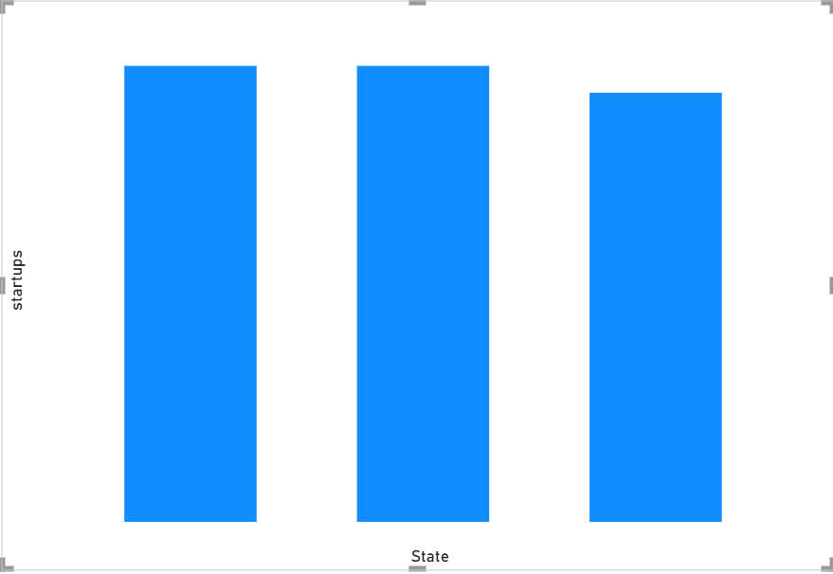5. State-Wise Analysis

State | No. of Startups | Avg Profit | Rank
Florida | 16 | $119K | 1st
New York | 17 | $114K | 2nd
California | 17 | $104K | 3rd

5.2 Average Profit by State
- Florida leads with an average profit of $119K despite having the fewest startups (16), suggesting a higher-quality startup cohort operating environment.
- New York ($114K) ranks second, closely trailing Florida, despite having the most startups (17).
- California ($104K) ranks third — still above the overall average of $112K on a per-startup basis, indicating a healthy but more competitive market.

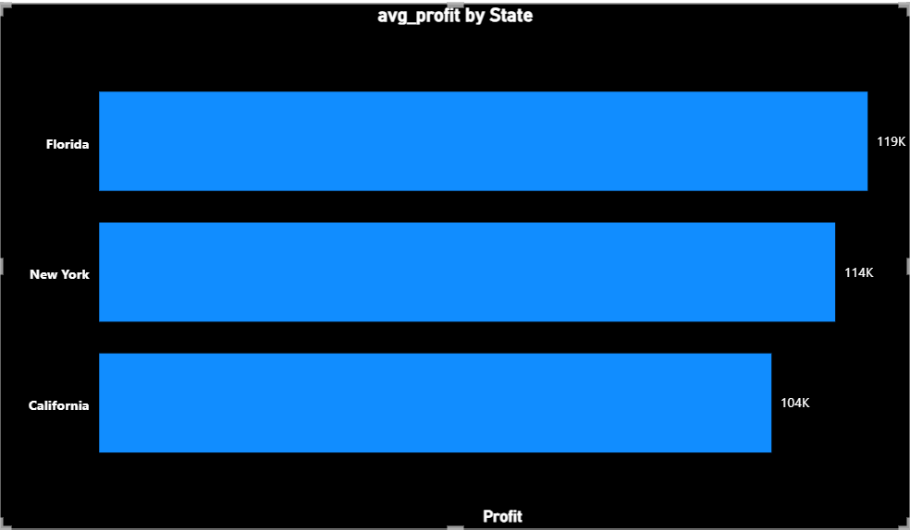

6. Total Spend Composition
The pie chart on Page 2 (Insights) reveals the overall spend distribution across categories:

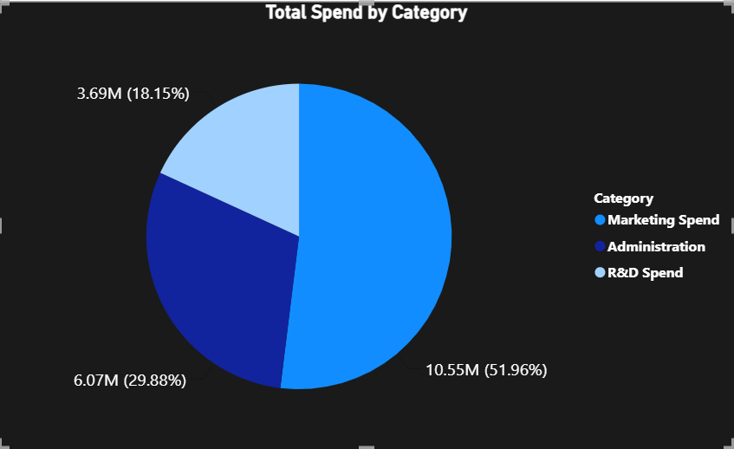

Category | Amount | Share
Marketing Spend | $10.55M | 51.96% — Largest share; dominant investment priority
Administration | $6.07M | 29.88% — Significant operational overhead
R&D Spend | $3.69M | 18.15% — Smallest share, yet highest profit impact per dollar

A key insight from this breakdown is that R&D Spend, despite having the smallest share of total expenditure (18.15%), has the highest coefficient in the regression model (+0.7856). This indicates that R&D is the most capital-efficient investment category — generating nearly $0.79

5.3 R&D, Administration & Marketing Spend by State

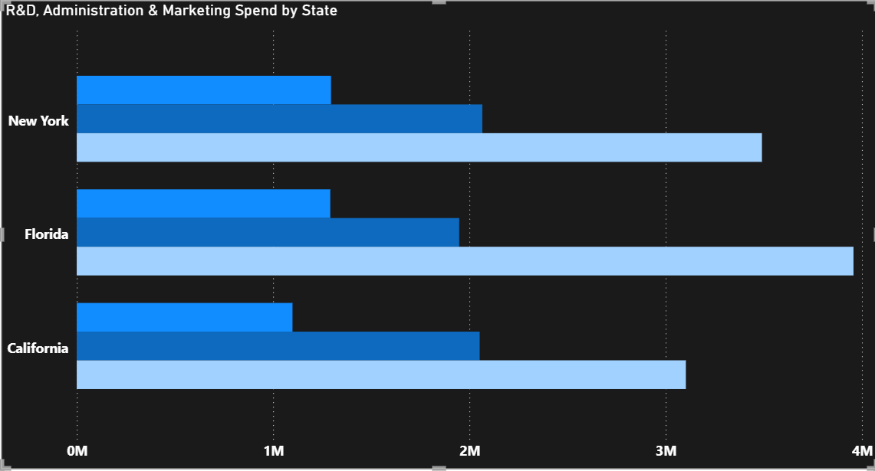

New York leads all three spend categories, reflecting the highest total investment in operations.
- Florida and California show comparable spending patterns, with Florida achieving a better profit-to-spend ratio.
Marketing Spend is consistently the largest expenditure category across all states
in profit for every dollar spent.

7. Sample Profit Predictions
The dashboard (Page 2 Insights) displays model predictions for two input scenarios:

R&D Spend | Administration | Marketing Spend | Predicted Profit
23,940.93 | 96,489.63 | 1,37,001.10 | 70,818.24
21,892.92 | 81,910.77 | 1,64,270.70 | 70,174.34

- Both scenarios yield closely matched predicted profits (~$70K), suggesting the model is sensitive to R&D Spend as a key differentiator.
- The difference in marketing spend ($27,269.60) between the two scenarios yields only a $643.90 difference in predicted profit, confirming marketing's lower per-dollar impact.

8. Key Findings & Insights
- R&D Investment is the highest-return lever: A $1 increase in R&D generates ~$0.79 in profit — nearly 24x more than the same spend on marketing.
- Administration spend shows diminishing returns: Beyond a threshold, increased admin costs marginally reduce profitability.
- Florida startups are the most profitable per capita despite a smaller count, warranting further investigation into state-specific advantages.
- Marketing has the largest spend share (51.96%) but moderate profit impact, suggesting potential reallocation opportunities toward R&D.
- The model generalizes well (R² test = 0.92) and can reliably predict profit for new startup inputs.
- Low MAE ($6.31K) relative to average profit ($112K) means predictions are off by less than 6% on average — commercially viable accuracy.

9. Recommendations
- Increase R&D budget allocation: Given its outsized coefficient, redirecting 10–15% of marketing spend toward R&D could meaningfully improve profitability.
- Audit administration costs: The negative coefficient on administration suggests inefficiencies. An operational review targeting admin cost reduction is advisable.
- Benchmark Florida startups: Investigate what differentiates Florida startups (higher avg profit with lower count) — be it sector mix, operating model, or market conditions.
- Deploy the MLR model for investment screening: With MAE of $6.31K and R² of 0.92, the model is suitable for preliminary profit forecasting in due diligence workflows.

10. Conclusion
The Multiple Linear Regression model built on the 50 Startups dataset successfully identifies R&D Spend as the primary profit driver, achieving an R² of 0.92 on test data. The Power BI dashboard (PRDA-01) effectively communicates these findings through KPI cards, scatter plots, state-wise comparisons, and model predictions. The analysis provides actionable insights for startup investment strategy, operational cost management, and geographic market prioritization.

The model equation:
Profit = 48,091.40 + 0.7856(R&D) − 0.0055(Admin) + 0.0325(Marketing)

...remains a reliable and interpretable tool for profit estimation, with clear business implications for resource allocation and strategic planning.

— End of Report —

