**User Book mini CRUD Application**

**Requirement:**

Write CRUD Controller for two entities using H2 in-memory database, make one of them “User”

Entity and use it for enabling spring-security. The other entity should be “Book” with a field “belongsTo” pointing to the user it belongs to. When a user is creating a book, it should belong to that user only. If the book is being edited, on the user which it belongs to should be able to edit. One user can create another user. Each controller should have Post, Get(2 flavors by id and full list)

**Technologies Used:**

1. **Core Java** - logic is built on using Java
2. **Spring Web -** for building a MVC Architecture CRUD web service
3. **JPA -** for database operations
4. **Spring-Dev-Tools**  - for live re-load server
5. **h2 - database** - for storing the data in database
6. **Spring Boot -** for building REST CRUD API
7. **Post Man -** for making Restful request calls

**Creating UserBook using PostMan**

We are making Rest call using POST with <http://localhost:8080/createUser> which stores the user and book using oneToMany mapping and results the list of users.

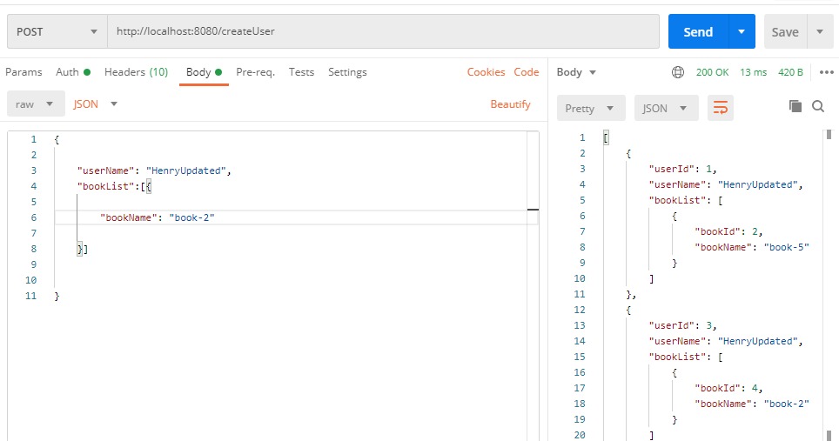

**Getting/Reading userBookList by using Flavor-1 ie using only userid**

We are using GET to fetch the specific user details based on userid localhost:8080/getUserBooks/1.

This request servers with the response of that specific user details

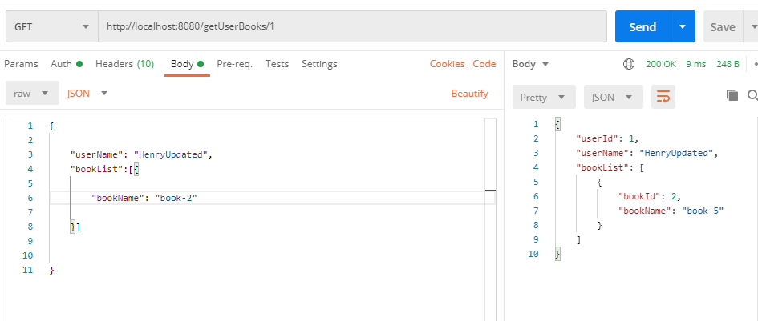

**Getting/Reading userBookList by using Flavor-2 ie using all userBook List**

We are using GET to fetch the all user details based on userid <http://localhost:8080/getAllUserList.>

This request servers with the response of all the stored users with their books

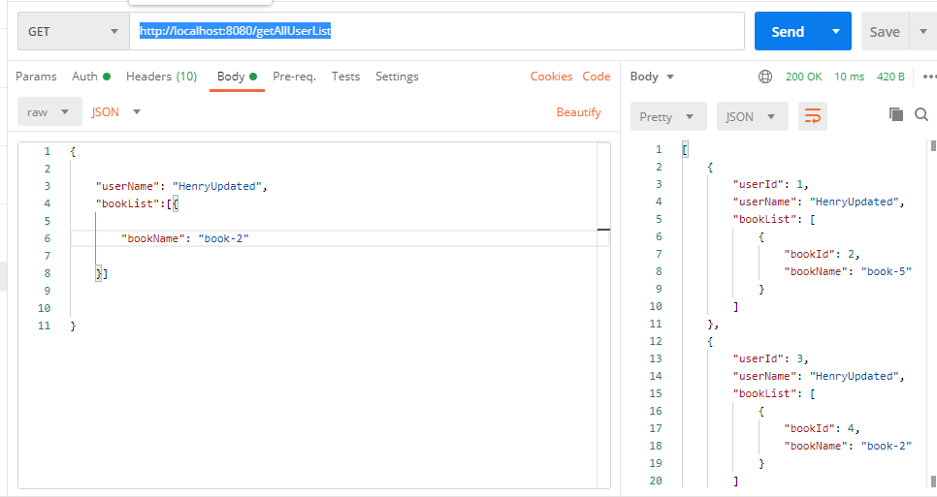

**Updating userBookList**

To update userBookList we are using PUT mapping with <http://localhost:8080/updateUserBooks/1>. This will update the specific details of user which you need to update in Data Store.

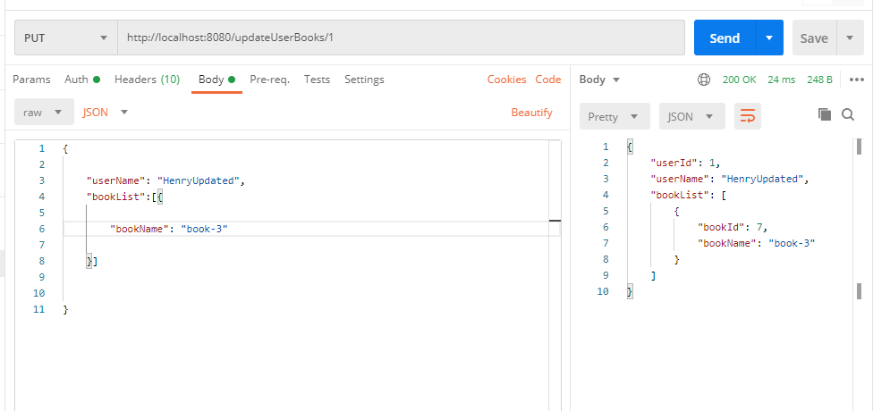

**Deleting the UserBookList**

We are deleting the user details using DELETE mapping with <http://localhost:8080/deleteUserBooks/3>. This call will delete the specific user and return all the currently remaining users.

