# RV COLLEGE OF ENGINEERING®

# BENGALURU – 560059

(Autonomous Institution Affiliated to VTU, Belagavi)

**DEPARTMENT OF INFORMATION SCIENCE AND ENGINEERING**



**“Diabetes Prediction Using Machine Learning”**

**Experiential Learning REPORT**

**Biology for Engineers (18BT42B)**

**IV SEMESTER**

**2021-2022**

**Submitted by**

**SANTOSH VISHWANATHAN (1RV20IS043)**

**Under the Guidance of**

**Prof H.Raju**

**Department of ISE, RVCE,**

**Bengaluru - 560059**

**RV College of Engineering®, BENGALURU - 560059**

***(Autonomous Institution Affiliated to VTU, Belagavi)***

# Department of INFORMATION Science and Engineering



**CERTIFICATE**

Certified that the **Experiential Learning** work titled “A study on Genetic Algorithms” has been carried out by **Santosh Vishwanathan (1RV20IS043),** bonafide student

of RV College of Engineering, Bengaluru, have submitted in partial fulfillment for the

**Assessment of Course: Biology for Engineers (18BT42B) – Experiential Learning**

during the year 2021-2022. It is certified that all corrections/suggestions indicated for the

internal assessment have been incorporated in the report.

**Head of Department**

Department of ISE,

RVCE, Bengaluru–59

**Faculty Incharge**

Department of ISE,

RVCE., Bengaluru –59

**RV College of Engineering®, bENGALURU - 560059**

***(Autonomous Institution Affiliated to VTU)***

ABSTRACT

Numerous people around the world suffer from diabetes. Diabetes affects 422 million people worldwide, and it causes 1.5 million fatalities yearly. Due to a shortage of professionals to provide guidance or patients' negligence in seeking treatment, low- and middle-income countries account for the majority of diabetic patients. However, little do these populations know that these conditions can also result in kidney illness, stroke, eye difficulties, and nerve damage. A comparison of the effectiveness of various machine learning algorithms such as Logistic Regression, Support Vector Machines, Decision Tree and Random Forest algorithms are used to develop a diabetes prediction technique. While determining whether a person has diabetes or not, a variety of parameters are taken into account, including age, BMI, skin thickness, insulin level, etc. A simple user interface with additional capabilities like weight tracking, scheduling hospital visits, and setting up a video conference with the doctor for a phone consultation is built.

Keywords: Diagnosis, Diabetes-Mellitus, Decision Trees, Machine Learning, Support Vector Classifier, Diabetes Predictor

**LITERATURE REVIEW:**

|  |  |
| --- | --- |
| **TITLES & AUTHORS** | **RESULT OUTCOMES** |
| G. Swapna, R. Vinayakumar, and K. P. Soman, “Diabetes detection using deep learning algorithms,” ICT Express, vol. 4, no. 4, pp. 243–246, 2018, doi: 10.1016/j.icte.2018.10.005. | The classification of diabetic and healthy HRV signals using deep learning architectures is presented in this research paper. The paper utilizes convolutional neural networks (CNN), long short-term memory (LSTM), and their combinations to extract intricate temporal dynamic elements from the input HRV data. Support vector machine (SVM) have been utilized to classify using these features. In the research paper, deep learning techniques have been used to analyze HRV data in order to detect diabetes. For CNN 5-LSTM with SVM network, a maximum accuracy value of 95.7% was attained. |
| U. M. Butt, S. Letchmunan, M. Ali, F. H. Hassan, A. Baqir, and H. H. R. Sherazi, “Machine Learning Based Diabetes Classification and Prediction for Healthcare Applications,” J. Healthc. Eng., vol. 2021, 2021, doi: 10.1155/2021/9930985 | In this paper, a machine learning-based method for classifying, identifying, and predicting diabetes in its early stages has been developed. Additionally, it offers a hypothetical IoT-based diabetes monitoring system for a healthy and affected individual to track their blood glucose (BG) level. Three distinct classifiers have been used to classify diabetes, including logistic regression, random forest, and multilayer perceptrons (MLP) (LR). Long short-term memory (LSTM), moving averages (MA), and linear regression have all been used for predictive analysis (LR). A benchmark PIMA Indian Diabetes dataset is utilized for experimental evaluation. |
| Y. Jian, M. Pasquier, A. Sagahyroon, and F. Aloul, “A machine learning approach to predicting diabetes complications,” Healthc., vol. 9, no. 12, 2021, doi: 10.3390/healthcare9121712. | In this study, various supervised classification algorithms youre used to create various models to predict and categorize eight complications of diabetes. Metabolic syndrome, dyslipidemia, neuropathy, nephropathy, diabetic foot, hypertension, obesity, and retinopathy are some of the consequences. For a more precise evaluation of the performance, repeated stratified k-fold cross-validation (with k = 10 and a total of 10 repetitions) was used. The performance of the models was assessed using accuracy and F1-score, which had maximum values of 97.8% and 97.7%, respectively. |
| M. K. Hasan, M. A. Alam, D. Das, E. Hossain, and M. Hasan, “Diabetes prediction using ensembling of different machine learning classifiers,” IEEE Access, vol. 8, pp. 76516–76531, 2020, doi: 10.1109/ACCESS.2020.2989857. | This literature proposes a robust framework for diabetes prediction that makes use of the following features: outlier rejection, data standardization, feature selection, K-fold cross-validation, and various Machine Learning (ML) classifiers, including the Multilayer Perceptron (MLP) and k-nearest Neighbor. Another idea to enhance diabetes prediction is the weighted assembly of several ML models, where the weights are calculated using the matching Area Under ROC Curve (AUC) of the ML model. With sensitivity, specificity, false omission rate, diagnostic odds ratio, and AUC as 0.789, 0.934, 0.092, 66.234, and 0.950, respectively, the paper suggests ensemble classifier as the best performing classifier and it beats the state-of-the-art findings by 2.00% in AUC. |

**INTRODUCTION**

Diabetes is one of the most fast growing diseases among people affecting almost 463 million people worldwide aged from 20-79 years as of 2019 accounting for roughly 9.3% of the global population and is expected to increase even among wengsters posing a major threat to human health.

Diabetes is a chronic disease. Either there is insignificant concentration of insulin in our body or the body is not able to effectively use the insulin produced by the endocrine system which causes drastic increase in the blood sugar [glucose] level. This disease further makes our body vulnerable to serious health complications such as: - coronary failure. visual deficiency/blindness and kidney failure.

Glucose is the simplest form of carbohydrate converted from all sources of carbohydrates in our diet, which can directly be converted to energy and used by all cells of our body. Lack of metabolism of glucose in our body due to insufficient insulin secretion by pancreas or insulin resistance is the main cause of diabetes. This disease should be detected at early stage to prevent fatal consequences in the future.

Diabetes is often termed as ‘silent killer’ which indicates that this disease, if not detected at an early stage will slowly deteriorate our body organs and lead to serious chronic health complications such as Retinopathy, Neuropathy and Nephropathy and may also lead to complications in pregnancy, cardiac arrest, high blood pressure and birth defects.

**OBJECTIVES**

shows how GA is combined with various other methods and technique to

derive optimal solution, increase the computation time of retrieval system the applications of genetic algorithms in various fields.

shows how GA is combined with various other methods and technique to

derive optimal solution, increase the computation time of retrieval system the applications of genetic algorithms in various fields.

shows how GA is combined with various other methods and technique to

derive optimal solution, increase the computation time of retrieval system the applications of genetic algorithms in various fields.

The main objective of this research is to provide an accurate and precise diabetes predictor which can holistically predict diabetes in an individual without having to visit the hospital repeatedly with the test results. Our holistic objective through this research is to provide a portal for diabetic patients to track health progress and provide insightful dashboard of important health parameters which would not only benefit the user but also doctors who need not go through the paper based medical case history of the patient to come up with the conclusive treatment/medicine for the patient.

**METHODOLOGY**

Steps implemented in order to build effective diabetes portal for patients is as follows: -

1. Diabetes dataset is procured from PIMA Indians Diabetes Database.[] This dataset consists of over 2000 data points each including 9 health parameters crucial for the prediction of diabetes namely:-
2. Glucose
3. Insulin
4. BMI
5. Age
6. Pregnancies
7. Blood Pressure
8. Skin Thickness
9. Exploratory Data Analysis

Visualization of all features of the dataset among diabetic patients and inter-relationship between each of the features in graphically represented to provide insights on type of machine learning algorithms to apply.

1. Preprocessing of the Data: -

Preprocessing of the data was done based on the nature of distribution of features across diabetic patients. We replaced the missing/ zero values of parameters with measures of central tendency - Mean for Glucose and Blood Pressure and Median for Insulin and BMI.

After ensuring uniformity of values in the dataset, scaling of the dataset is done using StandardScaler function under Sci-kit python library.

1. SMOTE analysis using Imblearn python library for balancing the dataset to correct the imbalance between diabetic and non- diabetic patients for accurate and unbiased prediction of the ML model.
2. Splitting of Training and Testing Data

Using the train\_test\_split function under Sci-kit learn python library [from Sklearn.model\_selection import train\_test\_split], the dataset is split into Testing Data and Training data. [Test Size = 20% and Training Size = 80%]

We split the training and testing dataset into X\_train, Y\_train and X\_test, Y\_test to split the dependent variable (Y = Outcome) and independent variable (X = Health parameters].

1. Training ML Algorithm

According to the scope of current dataset, Supervised ML Algorithms can be used for accurate prediction of diabetes in the patients.

1. **Random Forest Algorithm**: -

We apply random forest classification with set no. of n-estimators [no. of decision trees to be computed]. We train the RFC Classifier by fitting the training data into the model and finally test the classifier with test data.

Accuracy score is computed for determining the accuracy of the given ML algorithm against test data **[Training Accuracy = 99.85% & Accuracy Score = 98%].**

Since there may be evidence of overfitting, hyper-parameter tuning of the Random Forest Algorithm is done using GridSearchCV python library.

Best estimator of the given ML model is estimated. The best parameters for the given RFC can be obtained by taking a range of values initially for each parameter, then minimizing the range in a manner to increase accuracy score of the tuned model [trial and error method].

After hyper-parameter Tuning: - **Accuracy Score of RFC = 98.5% Training Accuracy =99.904% AUC Score = 99.9357%**

1. **Decision Tree Algorithm**

Single Decision Tree Algorithm is trained and tested with **Validation Accuracy = 97.75%**

1. **Logistic Regression**

Logistic Regression Algorithm using linear\_model under Sci-kit learn library.

**Validation Accuracy of the improved model = 75.88% and Area under ROC-AUC curve = 85.30%**

1. **SVC Classification (Support Vector Classifier)**

Preprocessing of the training data based on IQR score is performed before the SVC classifier is fed with training data. The SVC classifier is trained with different kernels such as RBF, Sigmoid, Linear, Poly etc, out of which the best accuracy obtained by RBF kernel in current scenario.

Hyper-parameter tuning is performed using the GridSearchCV python library with range of parameters for ‘C’ and ‘gamma’ variables.

Obtained **Accuracy Score of tuned model = 99.43% ROC/AUC Score = 98.90% [Best Algorithm for Diabetes Predictor]**

7.  Develop full-fledged web application with the following features:

* User-Login
* Diabetes Predictor: - Real Time Data Logging of Health Parameters for the prediction of diabetes in patients.
* Tele consultation with doctor on virtual meet for checkup at regular intervals (around month etc.)
* Weight tracking facility for the patients
* Dashboard showing graphical interpretation of relationship between various health parameters and their levels of importance for diabetes prediction in patients.

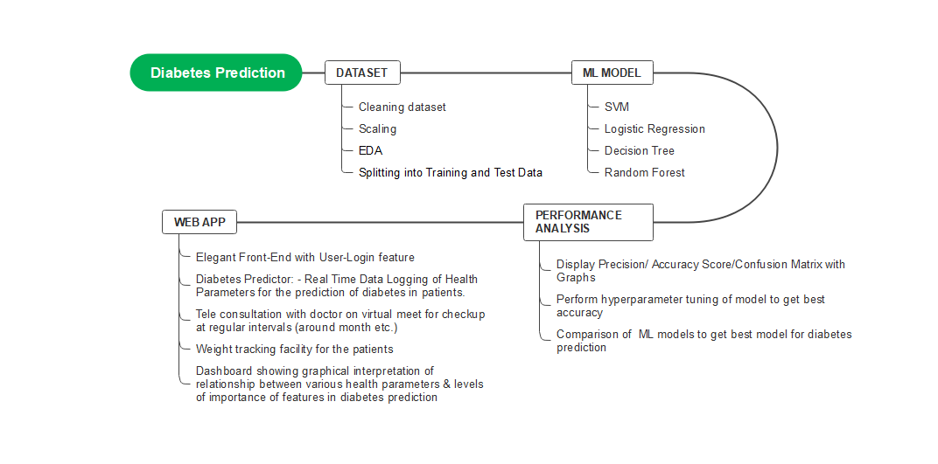

IMPLEMENTATION

4.1. Web Application

A supporting website was designed to provide the functionality for user login and registration, user dashboard, weight tracker, video-consultation and appointment booking with doctor/physician.

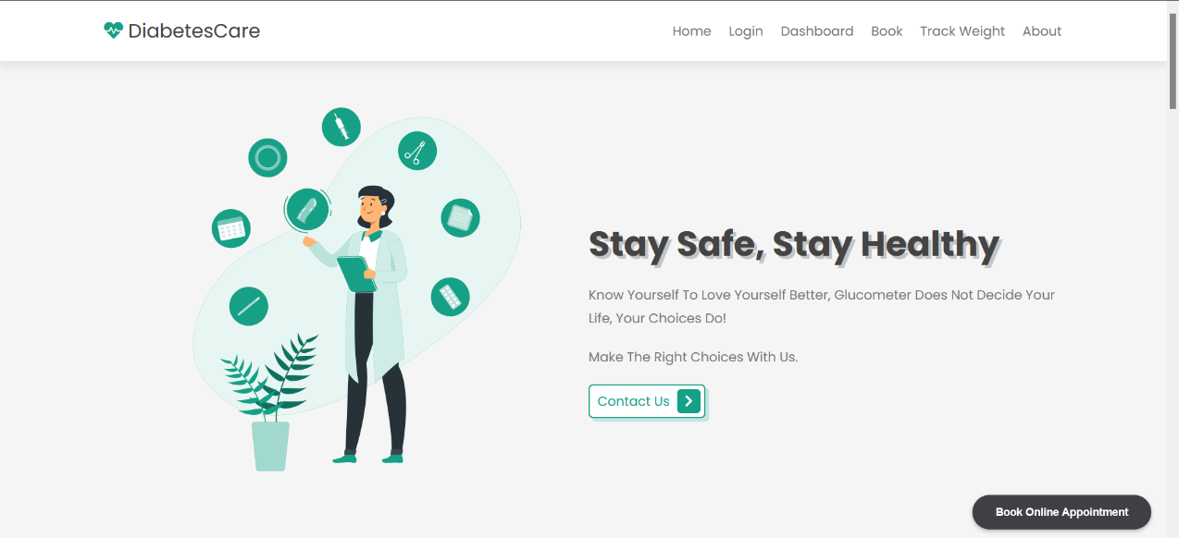

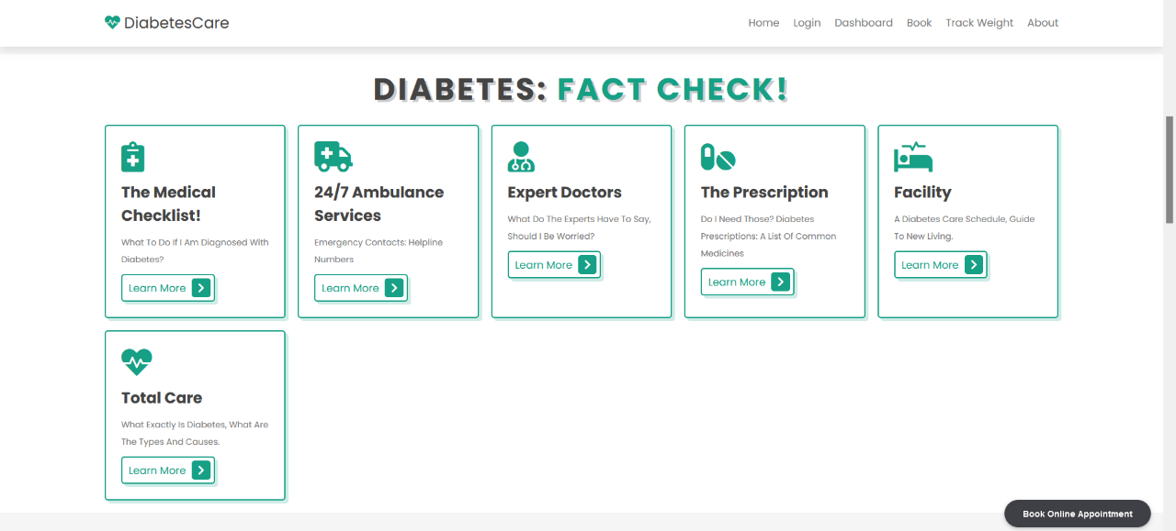

Fig. 2: Landing Page

**Backend:**

* Login and registration functionality was achieved with the help of Google firebase authentication for secure authentication and sign in through email, password, google/Facebook login.
* Appointment booking functionality was achieved using Calendly API which provides the features to retrieve Calendly links, sync scheduled meetings and manage users on the website.
* The weight tracker feature was implemented using Pixela API which is a service that provides GitHub like graph which expresses the degree of various activities on a daily basis with a vivid gradation.
* Email communication is made possible using FormSubmit API which provides the functionality to connect to their email server endpoint and sends message from the correspondent to our email.



Fig 3: Login and contacts Page

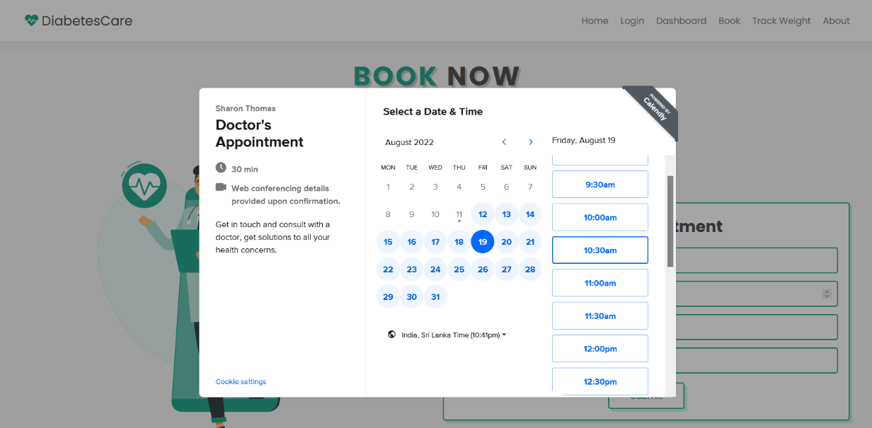

Fig 4: Appointment Booking Feature

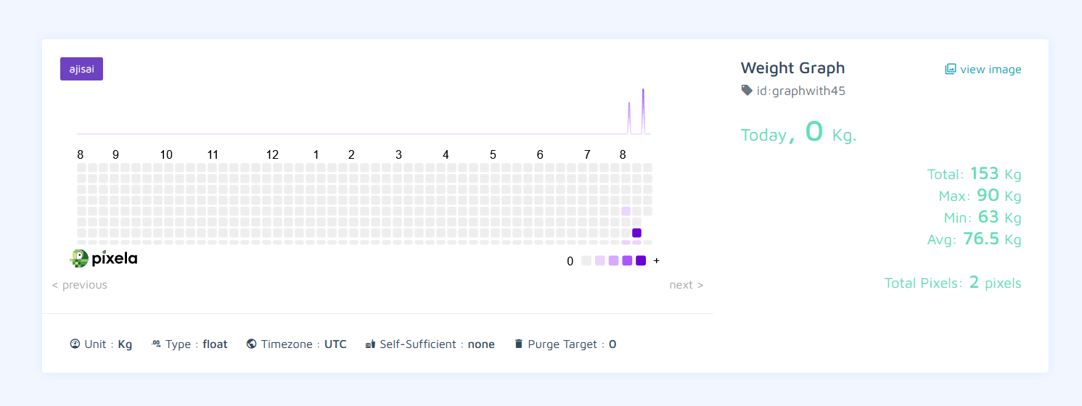

Fig 5: Weight Tracker Board

4.2. Machine Learning Model Development

In this use-case, ML model is designed as classification problem to predict the Outcome (1 - Diabetic and 0- Non-diabetic) from the input from user on their 9 crucial health parameters for diabetes prediction :- Glucose, Insulin, BMI, Age , Pregnancies, Blood Pressure & Skin Thickness.

Exploratory Data Analysis is first performed to analyse variation of the features and inter-relationship between the features that would affect the final prediction (diabetic/non diabetic) which would provide insights into which ML model to apply for this application.

**Exploratory Data Analysis**

**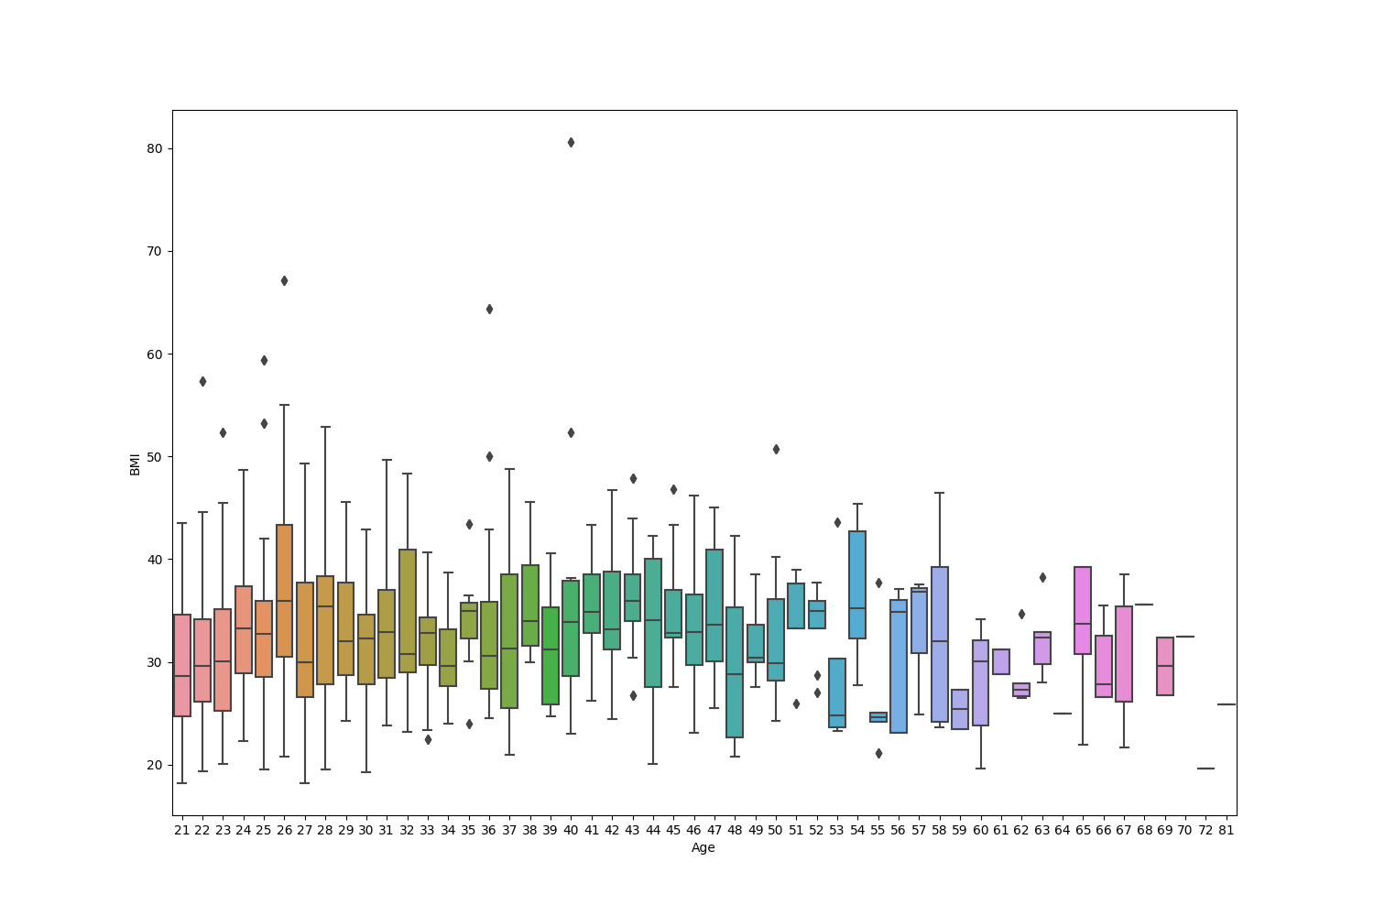**

Fig 6: Age Vs BMI

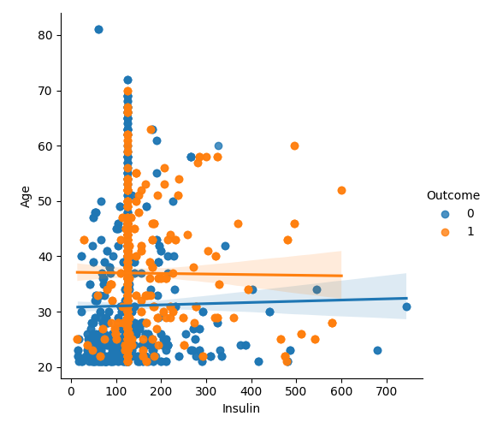

Fig 7: Age Vs Insulin

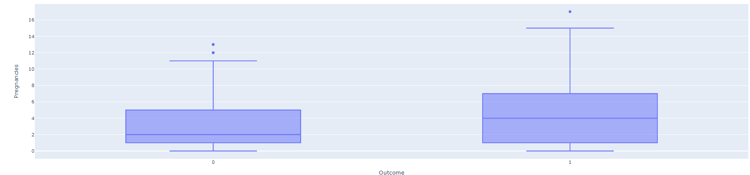

Figure 8: Pregnancies Vs Outcome

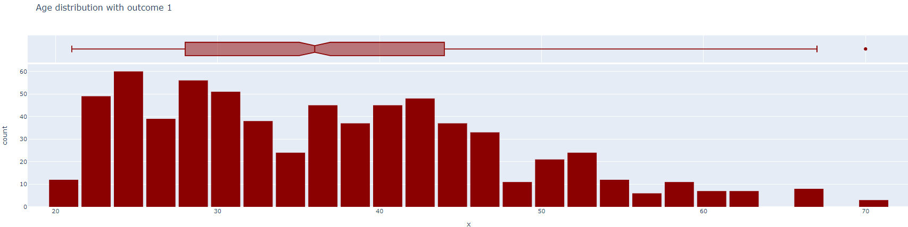

Figure 9: Age Distribution with Outcome – 1

Using Seaborn, Plotly and Matplotlib python library, eye-capturing visualisations on Age Vs BMI, Age distribution with outcome, Insulin Vs Age, Pregnancies Vs Outcome can be plotted to intuitively train ML model based on the data.

Data preprocessing was performed by normalizing the data by filling in null values with mean median or mode, scaling the data and performing SMOTE [Synthetic Minority Oversampling Technique]Analysis on the data in order to balance the majority and minority classes (Diabetic and Non-diabetic respectively) of the dataset to provide the consistent dataset to the ML model to ensure high accuracy.

The preprocessed dataset is split into Dependent and Independent variables and test and train dataset are randomly derived from the dataset using the train\_test\_split function under Sklearn python library. We feed the training data into ML Algorithms - Random Forest Classifier, Decision Tree Classifier, SVC (Support Vector Classification) and Logistic Regression Algorithm.

Among all classifier algorithm, the accuracy of random forest algorithm is very high due to formation of multiple decision trees and running the algorithm to choose the perfect set of parameters to ensure high accuracy of the predicted class/value of the ML algorithm.

**A. Random Forest Classifier**

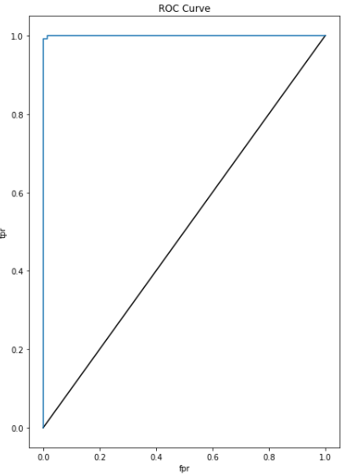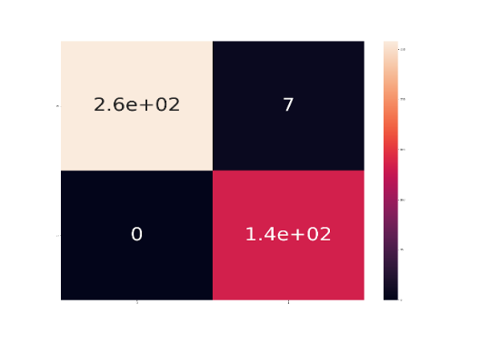

Fig 10: Confusion Matrix and ROC Curve

In Decision Tree classification, each feature in the dataset is continually split based on the value of a feature forming tree-like structure, which can be tuned using hyperparameter estimation to find the best split at each node with the main objective to minimise the loss function. Main

advantage of the Decision Tree classifier is no pre-processing of data required since each decision is made looking at one feature at a time, so their values don’t need to be normalised.

Gini Impurity, Entropy are the main two criterion for loss function in Decision Tree Classifier.

**B. Decision Tree Classifier**

**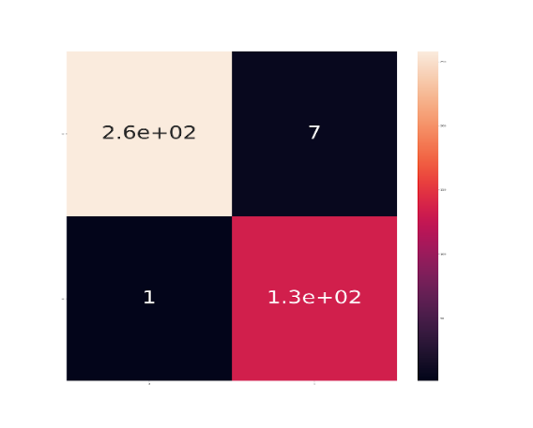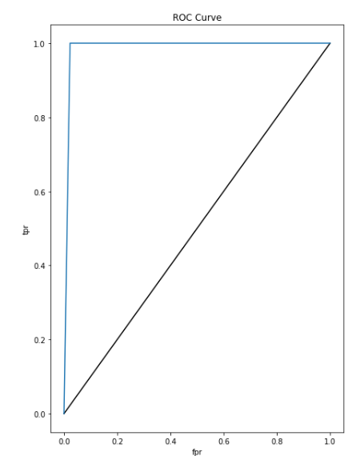**

Fig 11: Confusion Matrix and ROC Curve

Logistic regression is a model that is used to predict categorical outputs i.e. binary values indicating a yes or no. It focuses on giving the category of the output rather than the exact value of prediction. Implementation of logistic regression uses a sigmoid function. The advantage of this model is that it is easy to interpret and poses a less chance of overfitting but the disadvantage is the accuracy that it gives.

**C.  Logistic Regression**

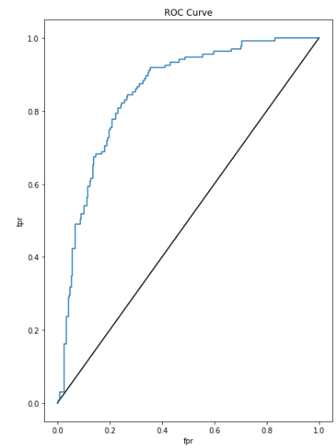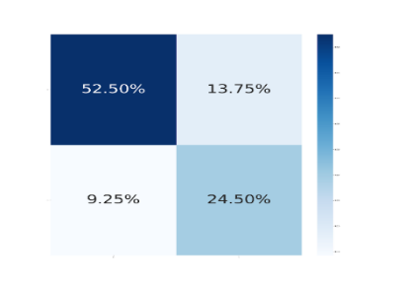

Fig 12: Confusion Matrix and ROC Curve

**SVC Classifier**

Support Vector Machines (SVMs) are a set of supervised learning methods used for classification, regression, and outlier detection. A support vector machine’s advantages lie in it’s ability to handle high dimensional space and is effective in cases where a number of dimensions is greater than the number of samples. Based on the factors mentioned in patients, a vector support machine (SVC) was implemented to predict the diagnosis of diabetes mellitus (DM). There are three types of output variables: those without diabetes, those with a predisposition to diabetes, and those with diabetes. In a data set of Indian patients, an SVC had an accuracy of 99.43%.

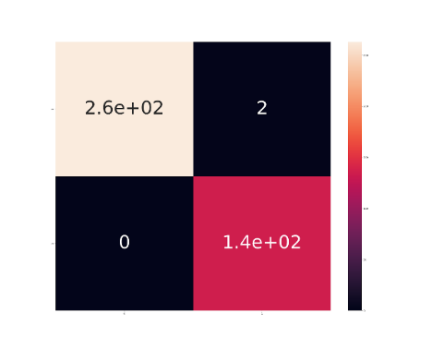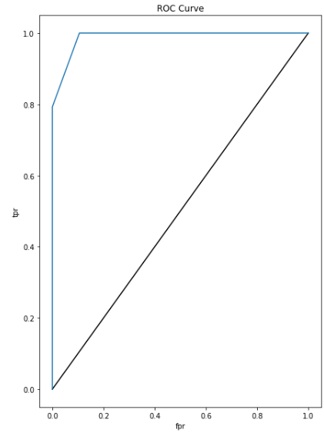

Fig 13: Confusion Matrix and ROC Curve

4.3. Dashboard and Diabetes Predictor Development

**Diabetes Predictor**

The entire ML model is rendered in the website format using Streamlit python library. The website consists of two pages - Diabetes Predictor and Dashboard.

Diabetes Predictor page consists of form- based interface prompting the user to enter values for the health parameters - Glucose, Insulin, BMI, Age, Pregnancies, Blood Pressure and Skin Thickness. Upon submitting inputs to the diabetes predictor, we obtain the output as Diabetic (class – 1) or non-diabetic (class – 0).

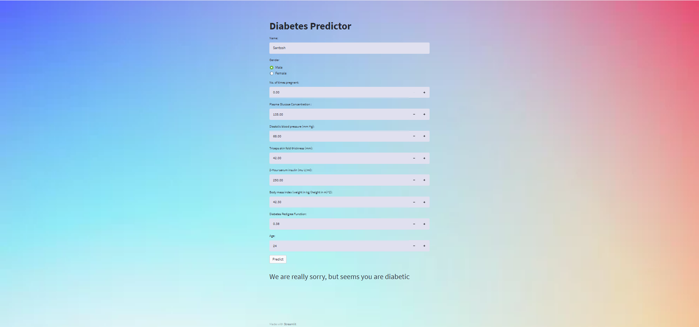

Fig 14: Diabetes predictor with positive result

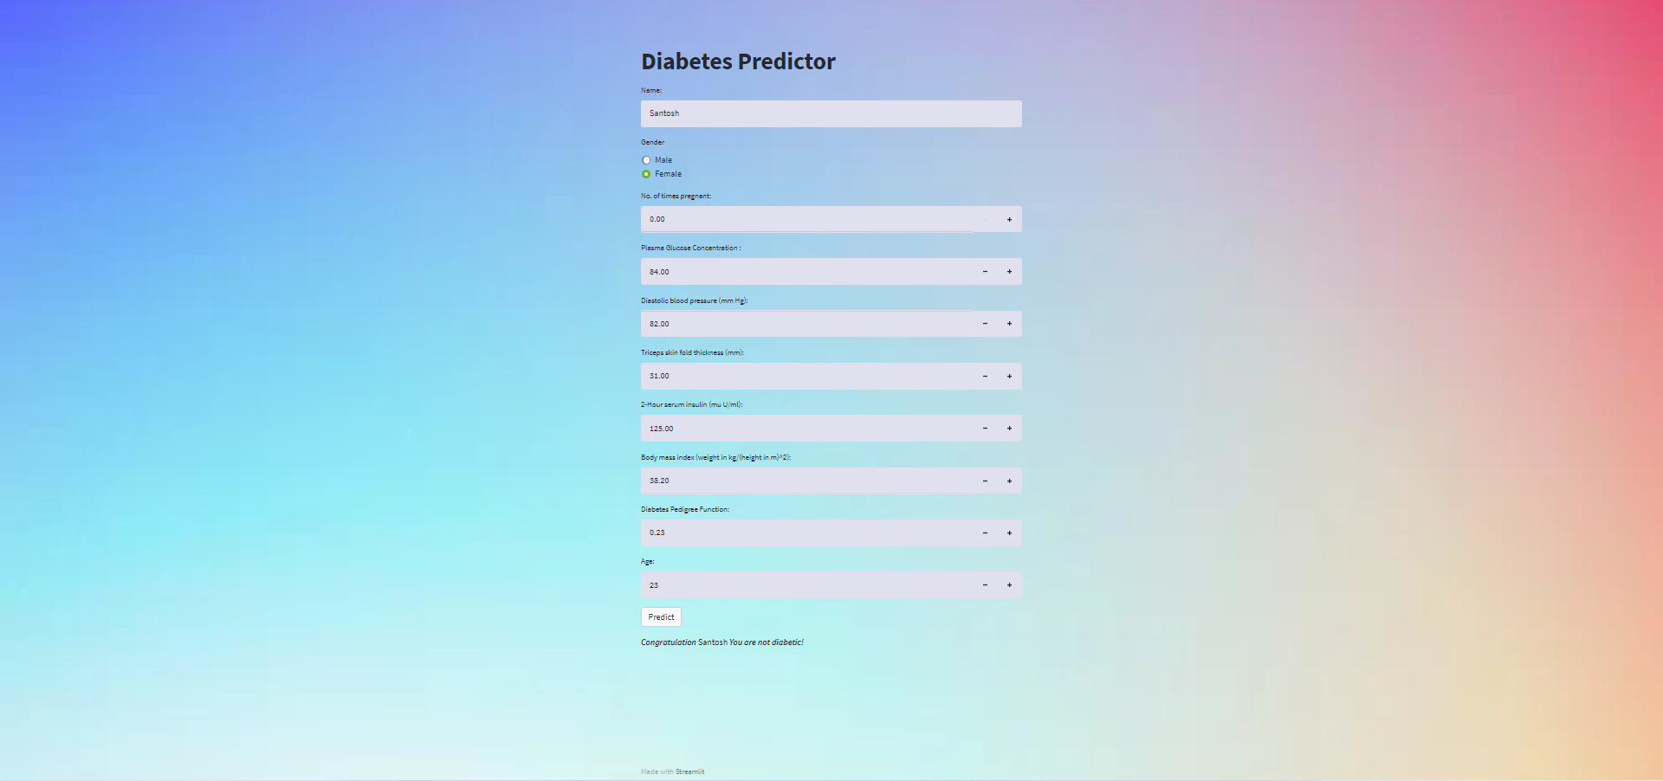

Fig 15: Diabetes Predictor with negative result

**Dashboard**

Dashboard page shows graphical interpretation of results of the ML models applied for accurate diabetic prediction along with elegant visualizations of inter-relationship between each health parameter and levels of importance of each feature in diabetes prediction of the patient. Accuracy of each algorithm in prediction of final outcome also has been visualized in the webpage.

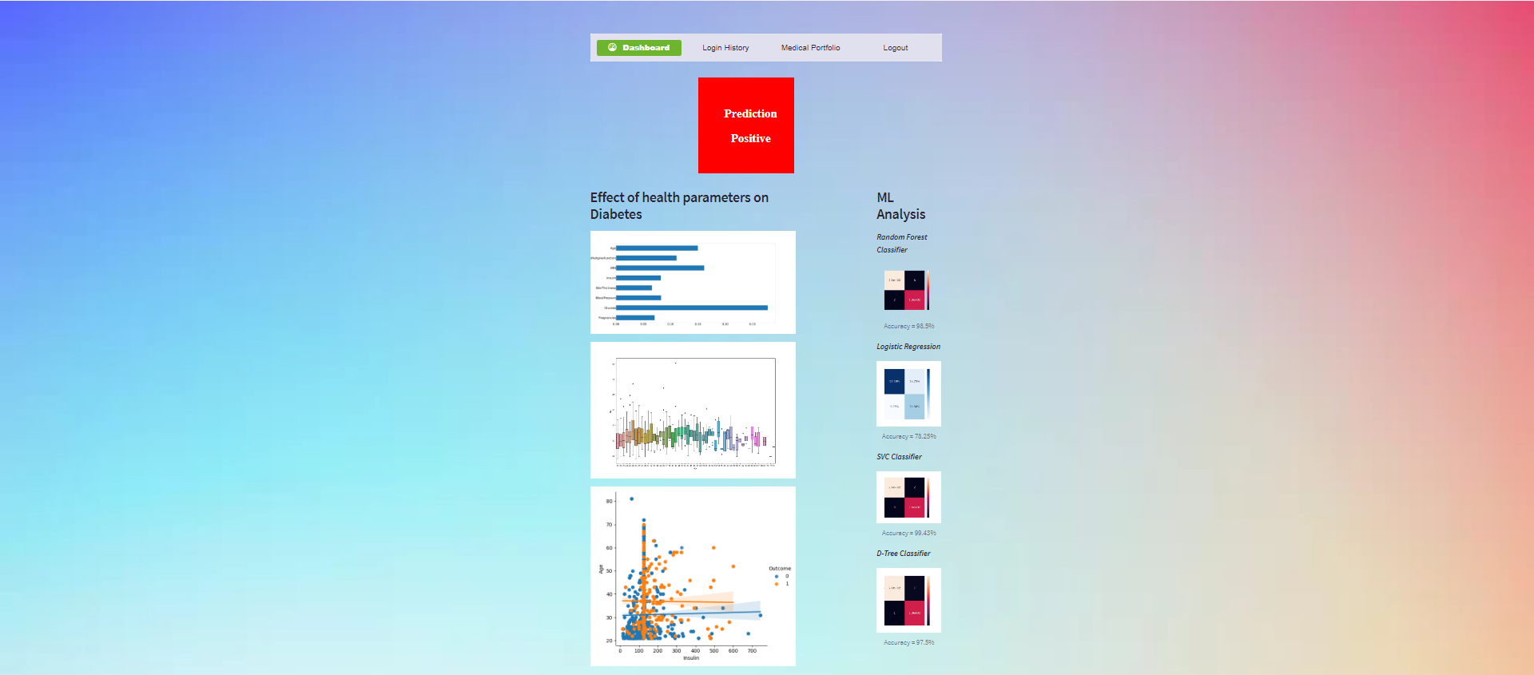

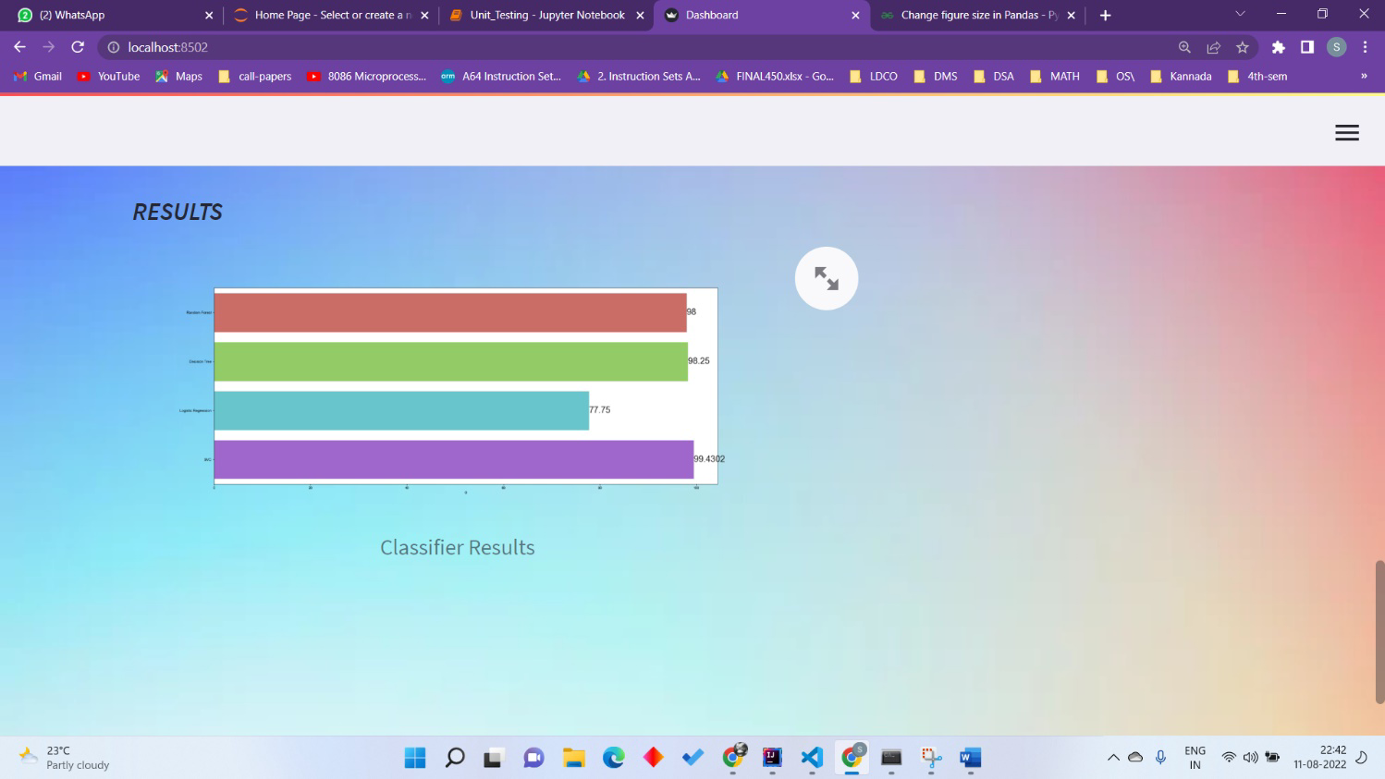

Fig 16: Dashboard for diabetic patient

**RESULTS AND DISCUSSION**

The ROC-AUC score and the accuracy score are the two important metrics to be considered when comparing machine learning algorithms to determine the best-fit for the use-case, i.e. to predict diabetes (positive/negative) in patients.

Table: Accuracy and ROC AUC Comparison for different machine learning models

|  |  |  |
| --- | --- | --- |
| ML Algorithm | Accuracy Score | ROC AUC Score |
| Decision Tree | 97.75% | 98.021% |
| Logistic Regression | 75.88% | 85.30% |
| SVC | 99.43% | 98.90% |
| Random Forest | 98.5% | 99.9357% |

A person's age, body mass index (BMI) and blood glucose concentration are the most important factors for diagnosing diabetes mellitus (DM). The diagnosis of DM by a doctor is complicated because several factors are involved in the disease, and human error can occur during diagnosis. Performing a blood test does not provide enough information to diagnose the disease accurately. We thereby conclude that the support vector classifier model (SVC) experimentally provided the highest efficiency with the accuracy of 99.43% and an area under the ROC Score of 98.90%.

**TYPES AND COMPLICATIONS OF DIABETES**

There are broadly, three main categories of diabetes which are:-

**1. Type – 1 Diabetes**

Type 1 diabetes is believed to be an autoimmune condition. Your [immune system](https://www.niddk.nih.gov/Dictionary/I/immune-system) attacks and destroys the cells in your pancreas that make insulin. Type 1 diabetes is usually diagnosed in children and weng adults, although it can appear at any age. People with type 1 diabetes need to take insulin every day to stay alive.

**Risk factors for Type 1 diabetes include:**

* Having a family history (parent or sibling) of Type 1 diabetes.
* Injury to the pancreas (such as by infection, tumor, surgery or accident).
* Presence of autoantibodies (antibodies that mistakenly attack your own body’s tissues or organs).
* Physical stress (such as surgery or illness).
* Exposure to illnesses caused by viruses.

**2. Type – 2 Diabetes**

Type 2 diabetes starts out as insulin resistance. This means your body cannot use insulin efficiently, which causes your pancreas to produce more insulin until it cannot keep up with demand. Insulin production then decreases, which causes high blood sugar which subsequently causes Type-2 diabetes. This is the most common type of diabetes. Up to 95% of people with diabetes have Type 2. It usually occurs in middle-aged and older people. Other common names for Type 2 include adult-onset diabetes and insulin-resistant diabetes.

**Risk factors for prediabetes and Type 2 diabetes include:**

* Family history (parent or sibling) of prediabetes or Type 2 diabetes.
* Being Black, Hispanic, Native American, Asian-American race or Pacific Islander.
* Having overweight/obesity.
* Having [high blood pressure](https://my.clevelandclinic.org/health/diseases/4314-hypertension-high-blood-pressure).
* Having low HDL [cholesterol](https://my.clevelandclinic.org/health/articles/11920-cholesterol-numbers-what-do-they-mean) (the “good” cholesterol) and high triglyceride level.
* Being physically inactive.
* Being age 45 or older.
* Having gestational diabetes or giving birth to a baby weighing more than 9 pounds.
* Having [polycystic ovary syndrome](https://my.clevelandclinic.org/health/diseases/8316-polycystic-ovary-syndrome-pcos).
* Having a history of heart disease or [stroke](https://my.clevelandclinic.org/health/diseases/5601-stroke-understanding-stroke).
* Being a smoker

**3. Gestational Diabetes**

Gestational diabetes is diabetes that can develop during pregnancy. It affects women who haven't been affected by diabetes before. It means we have [high blood suga](https://www.diabetes.org.uk/diabetes-the-basics/gestational-diabetes/symptoms-and-complications)r and need to take extra care of yourself and your bump. This will include [eating well](https://www.diabetes.org.uk/guide-to-diabetes/enjoy-food/eating-with-diabetes/i-have-gestational-diabetes) and [keeping active](https://www.diabetes.org.uk/diabetes-the-basics/gestational-diabetes/testing-and-treatment#activity).

It usually goes away again after giving birth. It is usually diagnosed from a blood test 24 to 28 weeks into pregnancy.

**Risk factors for gestational diabetes include:**

* Family history (parent or sibling) of prediabetes or Type 2 diabetes.
* Being African-American, Hispanic, Native American or Asian-American.
* Having overweight/obesity before your pregnancy.
* Being over 25 years of age**.**

**DIABETES COMPLICATIONS**

If your blood glucose level remains high over a long period of time, your body’s tissues and organs can be seriously damaged. Some complications can be life-threatening over time.

Complications include:

* Cardiovascular issues including coronary artery disease, chest pain, heart attack, stroke, high blood pressure, high cholesterol, atherosclerosis (narrowing of the arteries).
* Nerve damage (**neuropathy**) that causes numbing and tingling that starts at toes or fingers then spreads.
* Kidney damage (**nephropathy**) that can lead to kidney failure or the need for dialysis or transplant.
* Eye damage (**retinopathy**) that can lead to blindness; cataracts, glaucoma.
* Foot Damage including nerve damage, poor blood flow and poor healing of cuts and sores.
* Skin infections.
* Hearing loss.
* Depression.
* Dementia.
* Dental problems.

Complications of gestational diabetes:

**In the mother Preeclampsia** (high blood pressure, excess protein in urine, leg/feet swelling), risk of gestational diabetes during future pregnancies and risk of diabetes later in life.

**In the newborn:** Higher-than-normal birth weight, low blood sugar (hypoglycemia), higher risk of developing Type 2 diabetes over time and death shortly after birth.

**Neuropathy**

**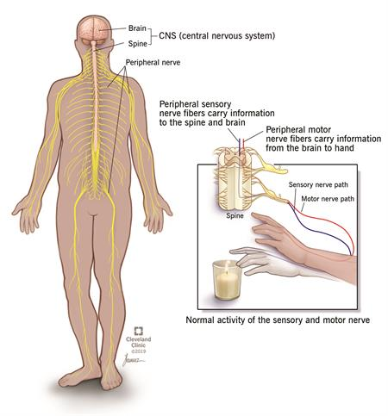**

Neuropathy is damage or dysfunction of one or more nerves that typically results in numbness, tingling, muscle weakness and pain in the affected area. Neuropathies frequently start in your hands and feet, but other parts of your body can be affected too.

Neuropathy, often called peripheral neuropathy, indicates a problem within the peripheral nervous system. Your peripheral nervous system is the network of nerves outside your brain and spinal cord. Your brain and spinal cord make up your central nervous system. Think of the two systems working together this way: Your central nervous system is the central station. It is the control centre, the hub from which all trains come and go. Your peripheral nervous system are the tracks that connect to the central station. The tracks (the network of nerves) allow the trains (information signals) to travel to and from the central station (your brain and spinal cord). Diabetes is the number one cause in the United States. Other common causes include trauma, chemotherapy, alcoholism and autoimmune diseases.

**Common Symptoms of Neuropathy:-**

**Common signs and symptoms of neuropathy include:**

* Tingling (“pins and needles”) or [numbness](https://my.clevelandclinic.org/health/symptoms/21015-numbness), especially in the hands and feet. Sensations can spread to the arms and legs.
* Sharp, burning, throbbing, stabbing or electric-like pain.
* Changes in sensation. Severe pain, especially at night. Inability to feel pain, pressure, temperature or touch. Extreme sensitivity to touch.
* Falling, loss of coordination.
* Not being able to feel things in your feet and hands – feeling like we’re wearing socks or gloves when we’re not.
* Muscle weakness, difficulty walking or moving your arms or legs.
* Muscle twitching, [cramps](https://my.clevelandclinic.org/health/symptoms/21190-muscle-cramps) and/or [spasms](https://my.clevelandclinic.org/health/diseases/15466-muscle-spasms).
* Inability to move a part of the body (paralysis). Loss of muscle control, loss of muscle tone or dropping things out of your hand.
* [Low blood pressure](https://my.clevelandclinic.org/health/diseases/21156-low-blood-pressure-hypotension) or abnormal heart rate, which causes dizziness when standing up, fainting or lightheadedness.
* Sweating too much or not enough in relation to the temperature or degree or exertion.
* Problems with bladder (urination), digestion (including bloating, nausea/vomiting) and bowels (including diarrhea, constipation).
* Sexual function problems.
* Weight loss (unintentional).

**Neuropathy Treatment:-**

Treatment begins by identifying and treating any underlying medical problem, such as diabetes or infections.

Some cases of neuropathy can be easily treated and sometimes cured. Not all neuropathies can be cured, however. In these cases, treatment is aimed at controlling and managing symptoms and preventing further nerve damage. Treatment options include the following:

* **Medicines** can be used to control pain. A number of different medications contain chemicals that help control pain by adjusting pain signaling pathways within the central and peripheral nervous system. These medications include:
  + Antidepressants such as [duloxetine](https://my.clevelandclinic.org/health/drugs/20580-duloxetine-delayed-release-capsules) or [nortripyline](https://my.clevelandclinic.org/health/drugs/20068-nortriptyline-capsules" \t "_blank).
  + Antiseizure medicines such as [gabapentin](https://my.clevelandclinic.org/health/drugs/18169-gabapentin-capsules-or-tablets) (Neurontin®, Gralise®) and [pregabalin](https://my.clevelandclinic.org/health/drugs/19097-pregabalin-capsules" \t "_blank) (Lyrica®).
  + Topical (on the skin) patches and creams containing [lidocaine](https://my.clevelandclinic.org/health/drugs/19854-lidocaine-skin-cream-or-ointment) (Lidoderm®, Xylocaine®) or [capsaicin](https://my.clevelandclinic.org/health/drugs/18080-capsaicin-topical-cream-lotion-solution)(Capsin®, Zostrix®).
  + Narcotic medications are not usually used for neuropathy pain due to limited evidence that they are helpful for this condition.
* **Physical therapy** uses a combination of focused exercise, massage and other treatments to help we increase your strength, balance and range of motion.
* **Occupational therapy** can help we cope with the pain and loss of function, and teach we skills to make up for that loss.
* **Surgery** is available for patients with compression-related neuropathy caused by such things as herniated disc in back or neck, tumors, infections, or nerve entrapment disorders, such as carpal tunnel syndrome.
* **Mechanical aids**, such as braces and specially designed shoes, casts and splints can help reduce pain by providing support or keeping the affected nerves in proper alignment.
* **Proper nutrition** involves eating a healthier diet and making sure to get the right balance of vitamins and other nutrients.
* **Adopting healthy living habits**, including exercising to improve muscle strength, quitting smoking, maintaining a healthy weight, and limiting alcohol intake.
* [**Transcutaneous electrical nerve stimulation (TENS):**](https://my.clevelandclinic.org/health/treatments/15840-transcutaneous-electrical-nerve-stimulation-tens) This treatment involves placing electrodes on the skin at or near the nerves causing your pain. A gentle, low-level electrical current is delivered through the electrodes to your skin. Treatment schedule (how many minutes and how often) is determined by your therapist. The goal of TENS therapy is to disrupt pain signals so they don’t reach the brain
* **Immune suppressing or immune modulating treatments:** Various treatments are used for individuals whose neuropathy is due to an autoimmune disease. These include oral medications, IV infusion treatments, or even procedures like plasmapheresis where antibodies and other immune system cells are removed from your blood and the blood is then returned to your body. The goal of these therapies is to stop the immune system from attacking the nerves.
* **Complementary treatments:** Acupuncture, massage, alpha-lipoic acid, herbal products, meditation/yoga, behavioral therapy and psychotherapy are other methods that could be tried to help relieve neuropathic pain. Ask your doctor if any of these therapies might be helpful for treating the cause of your neuropathy.

**Nephropathy**

Diabetic nephropathy is a type of progressive kidney disease that may occur in people who have diabetes. It affects people with type 1 and type 2 diabetes, and risk increases with the duration of the disease and other risk factors like high blood pressure and a family history of kidney disease. Diabetic Nephropathy mainly occurs in patient due to Hypertension, i.e. High blood pressure.

Nephropathy results in the damage of kidney function. As the kidney disease progresses, physical changes in the kidneys lead to increased blood pressure. Uncontrolled hypertension can make the progress toward stage five diabetic nephropathy occur more rapidly. The high blood sugar associated with diabetes also causes damage to the kidney through many different and complicated pathways. Most of this damage is directed toward the blood vessels that filter the blood to make urine.

**Symptoms of Diabetic Nephropathy**

The early stages of kidney damage often do not cause noticeable symptoms. We may not experience any symptoms until we are in the late stages of chronic kidney disease.

Symptoms of ESRD may include:

* fatigue
* general overall unwell feeling
* loss of appetite
* headache
* itchy and dry skin
* nausea or vomiting
* swelling of your arms and legs

**Diagnosis of Nephropathy**

1. Microalbuminuria urine test

A microalbuminuria urine test checks for albumin in your urine. Normal urine does not contain albumin, so the presence of the protein in your urine is a sign of kidney damage.\

2. BUN blood test

A BUN blood test checks for the presence of urea nitrogen in your blood. Urea nitrogen forms when protein is broken down. Higher than normal levels of urea nitrogen in your blood may be a sign of kidney failure

3. Serum creatinine blood test

A serum creatinine blood test measures creatinine levels in your blood. Your kidneys remove creatinine from your body by sending creatinine to the bladder, where it is released with urine. If your kidneys are damaged, they cannot remove the creatinine properly from your blood.

High creatinine levels in your blood may mean that your kidneys are not functioning correctly. Your doctor will use your creatinine level to estimate your glomerular filtration rate (eGFR), which helps to determine how well your kidneys are working.

4. Kidney biopsy

If your doctor suspects that we have diabetic nephropathy, they may order a kidney biopsy. A kidney biopsy is a surgical procedure in which a small sample of one or both of your kidneys is removed, so it can be viewed under a microscope.

Treatment of Diabetic Nephropathy:

1. Medications

Regularly monitoring your blood sugar levels, using proper dosages of insulin, and taking medications as directed by your doctor can keep your blood sugar levels under control. Your doctor may prescribe ACE inhibitors, angiotensin receptor blockers (ARBs), or other blood pressure medications to keep your blood pressure levels down.

Kerendia (finerenone) is a prescription medicine that can reduce the risk of sustained GFR decline, end-stage kidney disease, cardiovascular death, nonfatal myocardial infarction, and hospitalization for heart failure in adults with CKD associated with type 2 diabetes.

2. Diet and other lifestyle changes

Your doctor or dietitian will help we plan a special diet that is easy on your kidneys. These diets are more restrictive than a standard diet for people with diabetes. Your doctor may recommend:

* limiting protein intake
* consuming healthy fats, but limiting consumption of oils and saturated fatty acids
* reducing sodium intake to 1,500 to 2,000 mg/dL or less
* limiting potassium consumption, which could include reducing or restricting your intake of high potassium foods like bananas, avocados, and spinach
* limiting consumption of foods high in phosphorus, such as yogurt, milk, and processed meat

3. ESRD treatment

If we ESRD, we will likely need dialysis or a kidney transplant, in addition to treatments for earlier stages of kidney disease.

Dialysis is a procedure that helps to filter the waste out of your blood. There are two main types of dialysis: hemodialysis and peritoneal dialysis. Your doctor will help we decide which is best for we.

The other option for treatment is a kidney transplant. For a kidney transplant, a kidney from a donor will be placed into your body. The success of dialysis and kidney transplants differs with each person.

**Retinopathy**

**Retinopathy** is any damage to the retina of the eyes, which may cause vision impairment.Retinopathy often refers to retinal vascular disease, or damage to the retina caused by abnormal blood flow.Age-related macular degeneration is technically included under the umbrella term retinopathy but is often discussed as a separate entity. Retinopathy, or retinal vascular disease, can be broadly categorized into **proliferative** and **non-proliferative** types. Frequently, retinopathy is an ocular manifestation of systemic disease as seen in diabetes or hypertension. Diabetes is the most common cause of retinopathy in the U.S. as of 2008. Diabetic retinopathy is the leading cause of blindness in working-aged people. It accounts for about 5% of blindness worldwide and is designated a priority eye disease by the World Health Organization.

Symptoms of Retinopathy

Many people often do not have symptoms until very late in their disease course. Patients often become symptomatic when there is irreversible damage. Symptoms are usually not painful and can include:

* Vitreous hemorrhage
* Floaters, or small objects that drift through the field of vision
* Decreased visual acuity.
* "Curtain falling" over eyes

**Prevention of Retinopathy**

Retinopathy is often secondary to diseases such as diabetes or hypertension. Controlling blood sugar levels and blood pressure have been shown to help decrease incidence of retinopathy.

Blood sugar control: If someone has diabetes, or is at high risk for diabetes, it is important for them to have their blood sugar levels checked. The gold standard blood sugar test is the A1C test. Many studies have suggested that lowering A1C levels in someone with elevated A1C levels can lower the incidence and progression of retinopathy. Fortunately, blood sugar control can have benefits beyond just the eye. A primary care physician can help with blood sugar control strategies.

Blood pressure control: Controlling blood pressure can also lower the incidence and progression of retinopathy. A primary care physician can help with blood pressure control strategies.

Other: Besides blood sugar and blood pressure control, there are other modifications that can help. Regular exercise may help lower the incidence and progression of retinopathy. If someone has sleep apnea, treatment of sleep apnea may help as well.

**Treatment of Retinopathy**

Treatment is based on the cause of the retinopathy and may include laser therapy to the retina. Laser photocoagulation therapy has been the standard treatment for many types of retinopathy. Evidence shows that laser therapy is generally safe and improves visual symptoms in sickle cell and diabetic retinopathy. In recent years targeting the pathway controlling vessel growth or angiogenesis has been promising. Vascular endothelial growth factor (VEGF) seems to play a vital role in promoting neovascularization. Using anti-VEGF drugs (antibodies to sequester the growth factor), research have shown significant reduction in the extent of vessel outgrowth. Low quality evidence supports the use of anti-VEGF antibodies, such as bevacizumab or pegaptanib which seems to improve outcomes when used in conjunction with laser therapy to treat retinopathy of prematurity, longer term systemic effects are not known however. The evidence is poorer for treatment of diabetic retinopathy. Use of anti-VEGF drugs did not appear to improve outcomes when compared to standard laser therapy for diabetic retinopathy

**CONCLUSION**

Diabetes left untreated, causes several complications that people are not aware of. In order to simplify the procedure of checking for diabetes for a common man, a supervised learning classification system was developed in this study to determine whether or not a person has diabetes. Several ML models such as Random Forest, Decision tree classifier, SVM and Logistic regression in order to accurately predict Diabetes in the patient were built in this project. A tele consultation(video calling facility) option is established. Numerous other fully functional features such as a weight tracker is enabled for the patient to track his weight periodically. Thus, a full-fledged portal for diabetic patients has been created.

Through this research, we’ve also looked upon the different types of diabetes, their complications such as Retinopathy, Neuropathy and Nephropathy in details and ways to provide treatment to patients and mitigate the ill effects of the disease.

**REFERENCES**

[1] G. Swapna, R. Vinayakumar, and K. P. Soman, “Diabetes detection using deep learning algorithms,” ICT Express, vol. 4, no. 4, pp. 243–246, 2018, doi: 10.1016/j.icte.2018.10.005.

[2] U. M. Butt, S. Letchmunan, M. Ali, F. H. Hassan, A. Baqir, and H. H. R. Sherazi, “Machine Learning Based Diabetes Classification and Prediction for Healthcare Applications,” J. Healthc. Eng., vol. 2021, 2021, doi: 10.1155/2021/9930985.

[3] Y. Jian, M. Pasquier, A. Sagahyroon, and F. Aloul, “A machine learning approach to predicting diabetes complications,” Healthc., vol. 9, no. 12, 2021, doi: 10.3390/healthcare9121712.

[4] A. Mujumdar and V. Vaidehi, “Diabetes Prediction using Machine Learning Algorithms,” Procedia Comput. Sci., vol. 165, pp. 292–299, 2019, doi: 10.1016/j.procs.2020.01.047.

[5] M. K. Hasan, M. A. Alam, D. Das, E. Hossain, and M. Hasan, “Diabetes prediction using ensembling of different machine learning classifiers,” IEEE Access, vol. 8, pp. 76516–76531, 2020, doi: 10.1109/ACCESS.2020.2989857.

[6] Q. Zou, K. Qu, Y. Luo, D. Yin, Y. Ju, and H. Tang, “Predicting Diabetes Mellitus With Machine Learning Techniques,” Front. Genet., vol. 9, no. November, pp. 1–10, 2018, doi: 10.3389/fgene.2018.00515.

[7] S. Singh, S. Bait, J. Rathod, and N. Pathak, “Diabetes Prediction Using Random Forest Classifier and Intelligent Dietician,” Int. Res. J. Eng. Technol., pp. 2155–2157, 2020, [Online]. Available: www.irjet.net.

[8] A. K. Jaggi, A. Sharma, N. Sharma, R. Singh, and P. S. Chakraborty, “Diabetes Prediction Using Machine Learning,” Lect. Notes Networks Syst., vol. 185 LNNS, no. 09, pp. 383–392, 2021, doi: 10.1007/978-981-33-6081-5\_34.