Before reading past below instructions:

1. Create an account in Github using your name in this format: lastname_firstname_section
2. Request access to [Lycevm<3Alabang · GitHub](https://github.com/Lycevm-3Alabang)
3. Upload this file ON YOUR GITHUB ACCOUNT with answer under the title / file name : E3_Assessment__[Section]_[LastnameFirstName]  
   example: E3_Assessment__BSCS32E1_AlamoNinoFrancisco

Help: [Get started with GitHub documentation - GitHub Docs](https://docs.github.com/en/get-started)

**Sample Assessment for Introduction to Programming**

This assessment is designed to evaluate your understanding of basic programming concepts in C#, HTML, CSS, and JavaScript.

Instructions: Read each question carefully and provide complete and clear answers. Avoid multiple-choice format responses. Focus on demonstrating your understanding through code, explanations, and discussions.

**Part 1: C# (30 points)**

(10 points) Write a C# program that calculates the area of a triangle given its base and height. Include user input for both values and display the calculated area.

**Answer:**

* **So here Is my code wherein it just a basic code for the finding the area of the triangle by using an arithmetic operators to find the area of it, and by using a console writeline to print out the output and by input of the user.**

**(10 points) Declare an array of 5 integers and fill it with values based on a user-defined formula (e.g., n^2). Then, print the largest element in the array.**

**Answer:**

* **So heres my code wherein it display the largest element in the array Im just using foreach loop to easily comprehend my code.**

**(10 points) Implement a simple for loop that iterates from 1 to 10 and prints each number along with its square root.**

**Answer:**

* **Heres my code displaying the number from 1-10 with its own square root. By using a for loop and incrementing it to display the output of it**

**Part 2: HTML, CSS, and JavaScript (30 points)**

**HTML (10 points):** You are provided with the following incomplete HTML code snippet:

**HTML**

**<!DOCTYPE html>**

**<html>**

**<head>**

**<title>My Website</title>**

**</head>**

**<body>**

**<h1>Welcome to...</h1>**

**<p>This is a paragraph...</p>**

**<ul>**

**<li>Item 1</li>**

**<li>Item 2</li>**

**</ul>**

**</body>**

**</html>**

Complete the code snippet by adding the following elements:

An image within the <body> tag with a relevant src attribute.

An ordered list (<ol>) with three items.

A hyperlink within a <p> tag that points to an external website.

A CSS styling rule using an inline style attribute to change the font color of the <h3> heading.

CSS (10 points): Create a CSS stylesheet that defines the following styles:

Change the background color of the body element to light blue.

Apply a padding of 20px to all headings (h1, h2, h3).

Set the font size of the <p> tag to 14px.

Make the list items (li) have a bullet point style instead of the default numbers.

**Answer:**

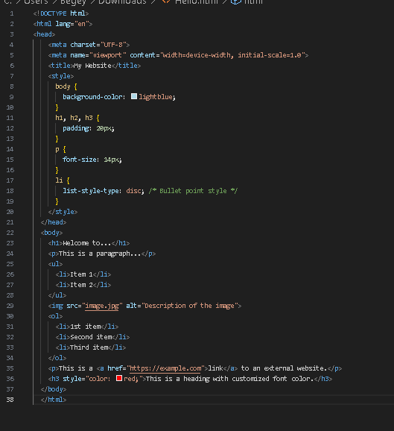

* **Heres my answer providing the instructions or snippets below on the html. By some adding some providing a code snippet it will change the display of this html compare to the unfinished html so by adding some css it will change the color, size and etc of the html for having it’s a design and by following the instructions it will change it into simple website with a design.**

**JavaScript (10 points):** Write a JavaScript function that takes a number as input and returns a string indicating whether the number is even or odd. Then, add a button to your HTML page that, when clicked, calls this function and displays the result (even or odd) in a paragraph element below the button.

**Answer:**

* **The code here it display if the input or enter of a number input could be even or odd. By using the html and a script for the javascript it will get the website that has the functionality to display the correct answer of it.**

**Part 3: Essay Question (40 points)**

Discuss the importance of object-oriented programming (OOP) concepts in software development. Explain the key principles of OOP (encapsulation, inheritance, polymorphism, abstraction) and provide examples of how they can be used to create more efficient, maintainable, and reusable code. Include real-world scenarios or cases where OOP is particularly valuable.

**Answer:**

Object-oriented programming (OOP) is a fundamental approach to software development that emphasizes the organization of code into reusable and modular components called objects. OOP is crucial in modern software development due to its ability to enhance efficiency, maintainability, and reusability of code.

One of the key principles of OOP is encapsulation. **Encapsulation** involves bundling data and methods that operate on that data into a single unit or class. By encapsulating data, OOP hides the internal state of an object and exposes only the necessary functionality through well-defined interfaces. This helps in controlling access to the data, preventing unauthorized modifications, and reducing the complexity of the codebase.

Another important principle of OOP is inheritance. **Inheritance** allows a class to inherit properties and behavior from another class, promoting code reuse and facilitating the creation of hierarchical relationships between classes. By defining common attributes and methods in a superclass and allowing subclasses to extend or override them as needed, inheritance enables the creation of organized and scalable codebases.

**Polymorphism** is another key concept in OOP. Polymorphism allows objects of different classes to be treated as objects of a common superclass through a shared interface. This promotes flexibility and modularity in code design by enabling code to operate on objects without knowing their specific types. Polymorphism is achieved through method overriding and method overloading, enabling developers to write code that works with a variety of object types.

Lastly, abstraction is a crucial aspect of OOP**. Abstraction** involves hiding the complex implementation details and exposing only the essential features of an object or system. By abstracting away implementation details, OOP allows developers to focus on what an object does rather than how it does it. This promotes a high level of understanding, improves code maintainability, and facilitates code reuse.

In real-world scenarios, OOP is particularly valuable in various domains such as graphical user interface development, video game development, and web application development. In these domains, OOP enables developers to create modular, scalable, and maintainable software solutions by organizing code into reusable components, facilitating complex interactions and behaviors, and efficiently modeling data and processes.

Points Distribution:

Each part carries equal weight (30 points).

Code clarity, functionality, and explanations will be considered in grading.

The essay question focuses on understanding and application of OOP concepts.