Social Media Site
A Project Report for Industrial Internship

Submitted by

Sanu Mondal
Aritra Ghosh
Saumadeep Barman
Debarati Mahajan
Srijita Roy

In the partial fulfillment of the award of the degree of

BCA
In the

CS & IT

Of
Narula Institute of Technology



At
Ardent Computech Pvt. Ltd.
Module


(Note: All entries of the preform of approval should be filled up with appropriate and complete information of approval in any respect will be summarily rejected.)
- Name of the Student with Group: 1: Sanu Mondal
2: Aritra Ghosh
3: Saumadeep Barman
4. Debarati Mahajan
5. Srijita Roy

- Title of the Project: Social Media Site
- Name and Address of the Guide: Mr. Subhojit Santra
Sr. Subject Matter Expert &
Technical Head(MERN) Module #132, Ground Floor, SDF Building, GP Block,
Sector V, Bidhannagar, Kolkata, West Bengal, Kolkata - 700091
4. Educational Qualification of the Guide: | Ph.d* | M.Tech | B.Tech*/B.E* | MCA* | M.Sc*

- Working and Teaching experience of the Guide : ………Years

- Software used in the Project: a. Visual Studio Code

1.
2.
3.
4.
5.
Signature of the Student
Date :

For the office use only

Approved |  | Not Approved

Signature of the Guide
Date :
Name: Subhojit Santra
Subject Matter Expert.
Signature, Designation, Stamp of the
Project Proposal Evaluator



CERTIFICATE FROM SUPERVISOR

This is to certify that “Sanu Mondal, Aritra Ghosh, Saumadeep Barman, Debarati Mahajan, Srijita Roy “have successfully completed the project titled "Social Media Site" under my supervision during the period from “05/07/2024” to “05/08/2024” which is in partial fulfilment of requirements for the award of the BCA degree and submitted to the Department of “CS & IT” of “Narula Institute of Technology”.

___________________________
Signature of the Supervisor

Date: dd/mm/yy

Name of the Project Supervisor:

ACKNOWLEDGEMENT

The achievement that is associated with the successful completion of any task would be incomplete without mentioning the names of those people whose endless cooperation made it possible. Their constant guidance and encouragement made all our efforts successful.

We take this opportunity to express our deep gratitude towards our project mentor, Mr. Subhojit Santra for giving such valuable suggestions, guidance and encouragement during the development of this project work.

Last but not the least we are grateful to all the faculty members of Ardent Computech Pvt. Ltd. for their support.

Project Responsibility Form

Serial No | Name of Member | Responsibility
1. | Sanu Mondal | Project Leader, Coding,  Web Page Designing, System Analysis
2. | Aritra Ghosh | Coding, Project  Documentation, PPT Presentation
3. | Saumadeep Barman | Project Documentation,  PPT Presentation, System Analysis
4. | Debarati Mahajan | Coding, Project Documentation
5. | Srijita Roy | Project Documentation,  PPT Presentation,

Self Certificate
This is to certify that the dissertation/project proposal entitled “Social Media Site” done by us, is an authentic work carried out for the partial fulfillment of the requirements for the award of the certificate of Bachelor of Technology under the guidance of Mr. Subhojit Santra. The matter embodied in this project work has not been submitted earlier for the award of any certificate to the best of our knowledge and belief.
Name of the Student
- Sanu Mondal
- Aritra Ghosh
- Saumadeep Barman
- Debarati Mahajan
- Srijita Roy

Signature of the students
a.
b.
c.
d.
e.

Certificate by Guide
This is to certify that this project entitled “Social Media Site” submitted in partial fulfillment of the certificate of Bachelor of Computer Application through Ardent Computech Pvt Ltd, done by the Group Members
- Sanu Mondal
- Aritra Ghosh
- Saumadeep Barman
- Debarati Mahajan
- Srijita Roy
Is an authentic work carried out under my guidance & best of our knowledge and belief.

a.
b.
c.
d.
e.

Signature of the students | Signature of the Guide
Date: | Date:

Certificate of Approval

This is to certify that this proposal of Minor project, entitled “Social Media Site” is a record of bona-fide work, carried out by: 1. Sanu Mondal, 2. Aritra Ghosh,3. Saumadeep Barman, 4. Debarati Mahajan, 5. Srijita Roy under my supervision and guidance through the Ardent Computech Pvt Ltd. In my opinion, the report in its present form partially fulfills all the requirements, as specified by the Narula Institute of Technology as per regulations of the Ardent®. It has attained the standard, necessary for submission. To the best of my knowledge, the results embodied in this report, are original and worthy of incorporation in the present version of the report for Bachelor of Technology.

Guide/Supervisor

Mr. Subhojit Santra
Subject Matter Expert & Technical Head (MERN)
Ardent Computech Pvt Ltd (An ISO 9001:2008 Certified)
Module #132, Ground Floor, SDF Building, GP Block, Sector V, Bidhannagar, Kolkata, West Bengal, Kolkata - 700091

External Examiner(s) Head of the Department
Department of Computer Science

Sonarput , W.B
(Affiliated to MAKAUT , WB)

SL. NO. | NAME OF THE TOPIC | PAGE NO.
1 | Company Profile | 8
2 | Introduction | 9 - 11
2.A. | Objective | 10
2.B. | Scope | 11
3 | System Analysis | 12 - 22
3.A. | Identification of Need | 13
3.B. | Feasibility Study | 14
3.C. | Work Flow | 15
3.D. | Study of the System | 18
3.E. | Input & Output | 19
3.F. | Software Requirements Specification (SRS) | 20
3.G. | Software Engineering Paradigm Applied | 22
4 | System Design | 23 - 32
4.A. | Data Flow Diagram | 24
4.B. | Sequence Diagram | 27
4.C. | Use-Case Diagram | 29
5 | UI snapshot | 33 – 82
6 | Conclusion | 83
7 | Future Scope & Further Enhancements | 84
8 | Bibliography | 85

1. ARDENT COMPUTECH PVT.LTD.
Ardent Computech Private Limited is an ISO 9001-2015 certified Software Development Company in India. It has been operating independently since 2003. It was recently merged with ARDENT TECHNOLOGIES.
Ardent Technologies
ARDENT TECHNOLOGIES is a Company successfully providing its services currently in the UK, USA, Canada and India. The core line of activity at ARDENT TECHNOLOGIES is to develop customized application software covering the entire responsibility of performing the initial system study, design, development, implementation and training. It also deals with consultancy services and Electronic Security systems. Its primary clientele includes educational institutes, entertainment industries, resorts, theme parks, service industry, telecom operators, media and other business houses working in various capacities.
Ardent Collaborations
ARDENT COLLABORATIONS, the Research Training and Development Department of ARDENT COMPUTECH PVT LTD is a professional training Company offering IT enabled services & industrial trainings for B-Tech, MCA, BCA, MSc and MBA fresher’s and experienced developers/programmers in various platforms. Summer Training / Winter Training / Industrial training will be provided for the students of B.TECH, M.TECH, MBA and MCA only. Deserving candidates may be awarded stipends, scholarships and other benefits, depending on their performance and recommendations of the mentors.
Associations
Ardent is an ISO 9001:2015 company.
It is affiliated to National Council of Vocational Training (NCVT), Directorate General of Employment & Training (DGET), Ministry of Labor & Employment, and Government of India.

2. INTRODUCTION

Welcome to Our Social Media platform its dedicated to delivering a seamless and customized connection between people, emphasizing security, ease of use, and an extensive range of features. By using mongodb aggregation, we give personalized suggestions and ensure transparency through customer evaluations and satisfaction. Moreover, our platform offers everyone to expand their reach and connect to people other side of the world.

Social media platforms allow users to have conversations, share information and create web content. There are many forms of social media, including blogs, micro-blogs, wikis, social networking sites, photo-sharing sites, instant messaging, video-sharing sites, podcasts, widgets, virtual worlds, and more.

We invite you to join us on this expedition as we navigate the everchanging landscape, unlocking digital world potential while redefining how people interact with each other in this digital world.

2A.OBJECTIVE

The objective of our social media website project is to create a dynamic and engaging platform that fosters meaningful connections and interactions among users. Our aim is to provide a user-friendly and intuitive interface that encourages active participation and sharing of content, while maintaining a high standard of privacy and security. By integrating innovative features such as real-time messaging, customizable profiles, and community-driven content, we strive to build a vibrant online community where individuals can express themselves freely, discover new interests, and connect with like-minded people from around the world.

Furthermore, our social media platform is designed to support content creators and influencers by offering tools for content monetization, audience engagement, and analytics. We are committed to promoting diverse voices and ensuring that all users have an equal opportunity to reach a wide audience. By continuously updating our features and incorporating user feedback, we aim to stay at the forefront of social media trends and provide a valuable and enjoyable experience for all our members. Ultimately, our goal is to create a positive and inclusive online space that enhances social interaction and enriches the digital lives of our users.

2. B.SCOPE

The scope of our social media website project involves creating a straightforward and user-friendly platform focused on fostering connections and content sharing among users. This includes developing essential features such as user registration, profile management, and a content feed where users can post text updates and photos. We will implement a basic messaging system to enable direct communication between users and a notification system to keep users informed about interactions and updates.

In addition to these core functionalities, the scope covers the integration of essential security measures to protect user data and privacy, such as secure authentication and encryption. We will also incorporate basic content moderation tools to maintain a positive community atmosphere. Our project will include the development of a search feature to help users find friends and content of interest. While the initial launch will focus on a single language, we plan to gradually introduce multi-language support to cater to a broader audience. Regular updates and improvements based on user feedback will be a key part of our approach to ensure the platform remains relevant and enjoyable for all users.

3. B.IDENTIFICATION OF NEED
System analysis is a process of gathering and interpreting facts, diagnosing problems, and the information to recommend improvements to the system. It is a problem-solving activity that requires intensive communication between the system users and system developers. System analysis or study is an important phase of any system development process. The system studies the minutest detail and gets analyzed. The system analysis plays the role of the interrogator and dwells deep into the workings of the present system. The System is viewed as a whole and the input to the system is identified. The outputs from the organization are traced to the various processes. System analysis is concerned with becoming aware of the problem, identifying the relevant and Decisional variables, analyzing and synthesizing the various factors, and determining an optimal or at least a satisfactory solution or program of action.

Various techniques like interviews, questionnaires, etc. must
make a detailed study of the process. The data collected by these sources must be scrutinized to conclude. The conclusion is an understanding of how the system functions. This system is called the existing system. Now the existing system is subjected to close study and problem areas are identified. The designer now functions as a problem solver and tries to sort out the enterprise's difficulties. The solutions are given as proposals. The proposal is then weighed with the existing system analytically and the best one is selected. The proposal is presented to the user for endorsement by the user. The proposal is reviewed on user request and suitable changes are made. This is a loop that ends as soon as the user is satisfied with the proposal.

3. B.FEASIBILITY STUDY
A Feasibility Study is a comprehensive assessment conducted to evaluate the practicality and viability of a proposed project or business endeavor. This study aims to determine whether the project is technically, financially, operationally, and economically feasible. It involves an in-depth analysis of various factors, including market conditions, technical requirements, legal considerations, and financial resources.

During a Feasibility Study, potential risks and challenges
are identified, and potential solutions are explored. The study helps stakeholders make informed decisions by providing insights into the project's potential success or failure. Key components of a Feasibility Study include a market analysis, technical requirements assessment, financial projections, and risk assessment.

Ultimately, a well-conducted Feasibility Study serves as
a crucial foundation for decision-making, guiding stakeholders in deciding whether to proceed with the project or explore alternative options based on a thorough understanding of the associated challenges and opportunities.

3. A.WORKFLOW
This Document plays a vital role in the development life cycle (SDLC) as it describes the complete requirements of the system. It is meant for use by the developers and will be the basic during the testing phase. Any changes made to the requirements in the future will have to go through a formal change approval process.
The Waterfall Model was the first Process Model to be
introduced. It is also referred to as a linear-sequential life cycle model. It is very simple to understand and use. In a waterfall model, each phase must be completed before the next phase can begin and there is no overlapping in the phases.
The waterfall Model illustrates the software development
process in a linear sequential flow; hence it is also referred to as a linear-sequential life cycle model. This means that any phase in the development process begins only if the previous phase is complete. In the waterfall model phases do not overlap.
- Waterfall Model design:
The waterfall approach was the first SDLC Model to be used widely in
Software Engineering to ensure the success of the project. In “The Waterfall” approach, the whole process of software development is divided into separate phases. In the Waterfall model, typically, the Outcome of one phase acts as the input for the next phase sequentially.
- Iterative Waterfall Design:
❑ Definition: The Iterative Waterfall Model is a variation of the traditional Waterfall model, which is a linear and sequential software development methodology. In the Iterative Waterfall Model, the development process is divided into small, manageable cycles, allowing for the revisiting and refinement of phases before progressing to the next stage. It combines the systematic structure of the Waterfall model with the flexibility of iterative development.
The sequential phases in Iterative Waterfall model are:
- Requirement Gathering and analysis: All possible requirements of the system to be developed are captured in this phase and documented in a requirement specification doc.
- System Design: The requirement specifications from first phase are studied in this phase and system design is prepared. System Design helps in specifying hardware and system requirements and also helps in defining overall system architecture.
- Implementation: With inputs from system design, the system is first developed in small programs called units, which are integrated in the next phase. Each unit is developed and tested for its functionality which is referred to as Unit Testing.
- Integration and Testing: All the units developed in the implementation phase are integrated into a system after testing each unit. Post integration the entire system is tested for any faults and failures.
- Deployment of the system: Once the functional and non-functional testing is done, the product is deployed in the customer environment or released into the market.
- Maintenance: Some issues come up in the client environment. To fix those issues patches are released. Also to enhance the product some better versions are released. Maintenance is done to deliver these changes in the customer environment.
All these phases are cascaded to each other in progress and
are seen as flowing steadily downwards (like a waterfall) through the phases. The next phase is started only after the defined set of goals are achieved for the previous phase and it is signed off, so the name “Iterative Waterfall Model”. In this model, phases do not overlap.
❑ Advantages:
- . Flexibility: Iterations permit adjustments based on feedback.
- . Early Delivery: Partial systems can be delivered incrementally.
- . Risk Management: Identifying and addressing issues early in the process.
❑ Disadvantages:
  - Increased Complexity: The iterative nature can make the process more complex.
  - Potential for Scope Creep: Frequent iterations may lead to scope changes.
  - Resource Intensive: Continuous revisiting of phases may demand more resources.

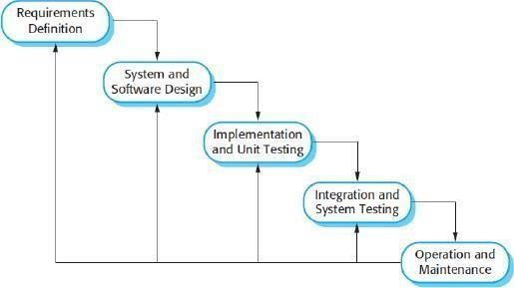
❑ Applications:
The Iterative Waterfall Model is suitable for projects with evolving or unclear requirements. It is commonly used in software development projects where regular feedback and refinement are essential. Additionally, it is applicable in scenarios where partial system delivery is beneficial, allowing stakeholders to assess progress and make adjustments.

3. A.STUDY OF THE SYSTEM
Authentication:
- . User Login: Here user will log in to use the Site.
- . Signup: Here user will register their account in to use the Site.
- . Forget Password: Here The user can reset their password an otp will send to their email address.
Home:
- . Create Post: User can upload a post of their liking it could an image, text or both.
- . Hero: User can see all the post posted by others.
- . Post: User can like, comment or share a post, also the comments can be read by clicking on the post.
Profile:
- Profile Page: Here user can see all the details about someone profile, they can edit their profile or delete any post they had created.
- Post Section: Here, user see all the post created by them and know all details of their post, user can delete their own post.
- Linkers Section: Here, the user sees all the other user linked to you.
Search Page:
- Suggestions: Here, the users get random 5 user to linked with.
- Searching: Here, the user can search other profile using their name or username.
Messaging:
1 Conversations: Here, the user can see all their conversation list with other user.
2 Message: User can-do real-time messaging by clicking on a Conversation.
3 Search: User can search linked users to start a conversation.

3.A. INPUT AND OUTPUT
The main inputs, outputs and the major function the details are:

➢ INPUT:

- . The user can log in by inputting his credentials on the login page. Also register their account by signup page
- . In the search bar, the user can give name or username as input.
- . If the user wants to update his details, the user can provide the changing information in the update form as input.

➢ OUTPUT:

1. User can view the interface i.e., all the posts, user suggestions and conversations.
2. User can like, comment, share posts.
3. User can link to other user and check their profile.
4. User can check their conversation and do real-time messaging.

3. SOFTWARE REQUIREMENT SPECIFICATIONS
Software Requirements Specification provides an overview of the entire project. It is a description of a software system to be developed, laying out functional and non-functional requirements. The software requirements specification document enlists enough necessary requirements that are required for the project development. To derive the requirements, we need to have a clear and thorough understanding of the project to be developed. This is prepared after detailed communication with the project team and the customer.
The developer is responsible for: -
- Developing the system, which meets the SRS and solves all the requirements of the system.
- Demonstrating the system and installing the system at the client’s location after acceptance testing is successful.
- Submitting the required user manual describing the system interfaces to work on it and also the documents of the system.
- Conducting any user training that might be needed for using the system.
- Maintain the system for a period of one year after installation.
Functional Requirements:
- User Registration and Authentication:
  - Users must be able to create an account using an email address and password.
  - Users must be able to log in and log out securely.
  - The system should implement password recovery options.
o Profile Management:
- Users must be able to create and edit their profiles, including adding a profile picture, bio, and personal information.
- Users must be able to set their privacy settings to control who can view their profile and posts.

o Content Creation and Sharing:
  - Users must be able to create and share text posts.
  - Users must be able to upload and share photos.
  - Users must be able to like and comment on posts.
o Feed and Timeline:
  - Users must be able to view a feed of posts from people they follow.
  - The feed should be updated in real-time as new posts are added.
- Messaging:
  - Users must be able to send and receive direct messages from other users.
  - The messaging system should support text messages and photo sharing.
Non-Functional Requirements:
- Performance:
  - Response Time: The system should respond to user actions promptly, with minimal latency.
  - Scalability: The platform must handle increased user loads during peak hours without significant performance degradation.
- Reliability:
  - Availability: The system should be available and accessible to users consistently, minimizing downtime.
  - Fault Tolerance: The system should gracefully handle errors or failures, ensuring uninterrupted service.
o Security:
  - Data Encryption: Ensure secure transmission of sensitive information, such as user details and payment data.
  - Authentication and Authorization: Implement robust mechanisms to authenticate users and authorize access to specific features.
o Usability:
  - Intuitive User Interface: The system should have a user-friendly interface that is easy to navigate.
  - Accessibility: Ensure the platform is accessible to users with disabilities, complying with relevant standards.
❑ Hardware Requirements:
- . Computer has Intel I5 Processor
- . 8 GB RAM
- . DVD-ROM Drive
❑ Software Requirements:
4 . Windows 11 OS
. Visual Studio Code

21

SOFTWARE ENGINEERING PARADIGM APPLIED
Software paradigms refer to the methods and steps, which are taken while designing the software. There are many methods proposed and are in work today, but we need to see where in software engineering these paradigms stand. These can be combined into various categories, though each of them is contained in one another.
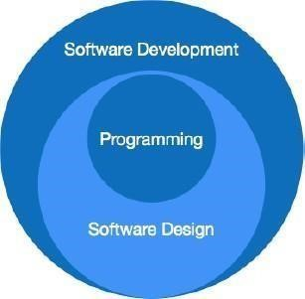
The programming paradigm is a subset of Software design paradigm which is further a subset of the Software development paradigm.
There are two levels of reliability. The first is meeting the right requirements. A careful and thorough systems study is needed to satisfy this aspect of reliability. The second level of systems reliability involves the actual work delivered to the user. At this level, the system’s reliability is interwoven with software engineering and development.
There are three approaches to reliability.
- Error avoidance: Prevents errors from occurring in software.
- Error detection and correction: In this approach, errors are recognized whenever they are encountered, and correcting the error by the effect of the error of the system does not fail.
- Error tolerance: In this approach, errors are recognized whenever they occur, but enables the system to keep running through degraded performance or Applying values that instruct the system to continue process.



4. A.DATA FLOW DIAGRAM
A data flow diagram (DFD) is a graphical representation of the "flow" of data through an information system, modeling its process aspects. A DFD is often used as a preliminary step to create an overview of the system, which can later be elaborated.
DFDs can also be used for the visualization of data processing (structured design).
A DFD shows what kind of information will be input to and output from the system, where the data will come from and go to, and where the data will be stored. It does not show information about the timing of the process or information about whether processes will operate in sequence or in parallel (which is shown on a flowchart).
This context-level DFD is next "exploded", to produce a Level 1
DFD that shows some of the detail of the system being modeled. The
Level 1 DFD shows how the system is divided into sub-systems (processes), each of which deals with one or more of the data flows to or from an external agent, and which together provide all of the functionality of the system as a whole. It also identifies internal data stores that must be present for the system to do its job and shows the flow of data between the various parts of the system.
Data flow diagrams are one of the three essential perspectives of the structured-systems analysis and design method SSADM. The sponsor of a project and the end users will need to be briefed and consulted throughout all stages of a system's evolution. With a data flow diagram, users can visualize how the system will operate, what the system will accomplish, and how the system will be implemented. The old system's dataflow diagrams can be drawn up and compared with the new system’s dataflow diagrams to draw comparisons to implement a more efficient system. Data flow diagrams can be used to provide the end user with a physical idea of where the data they input ultimately affects the structure of the whole system from order to dispatch to report.
How any system is developed can be determined through a data flow diagram model.
In the course of developing a set of leveled data flow diagrams, the analyst/designer is forced to address how the system may be decomposed into component sub-systems and to identify the transaction data in the data model. Data flow diagrams can be used in both the Analysis and Design phase of the SDLC. There are different notations to draw data flow diagrams. Defining different visual representations for processes, data stores, data flow, and external entities.
- DFD Notation :

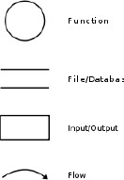

- DFD EXAMPLE :

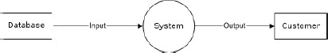
Steps to Construct Data Flow Diagram:-
Four Steps are generally used to construct a DFD.
- Process should be named and referred for easy reference. Each name should be representative of the reference.
- The destination of flow is from top to bottom and from left to right.
- When a process is distributed into lower-level details they are numbered.
- The names of data stores, sources, and destinations are written in capital letters.
Rules for constructing a Data Flow Diagram:-
- Arrows should not cross each other.
- Squares, Circles, and Files must bear a name.
- Decomposed data flow squares and circles can have the same names. ➢ Draw all data flow around the outside of the diagram.
LEVEL 0 DFD OR CONTEXT DIAGRAM:

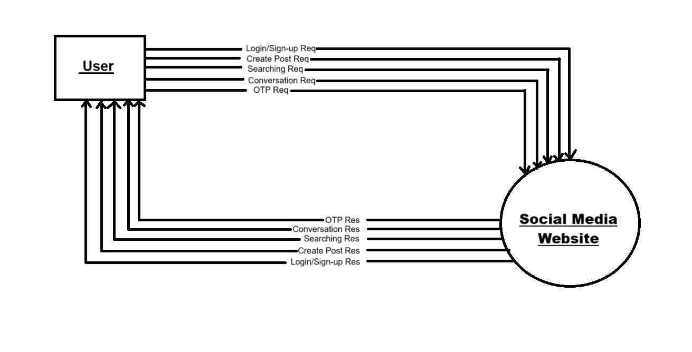
LEVEL 1 DFD:
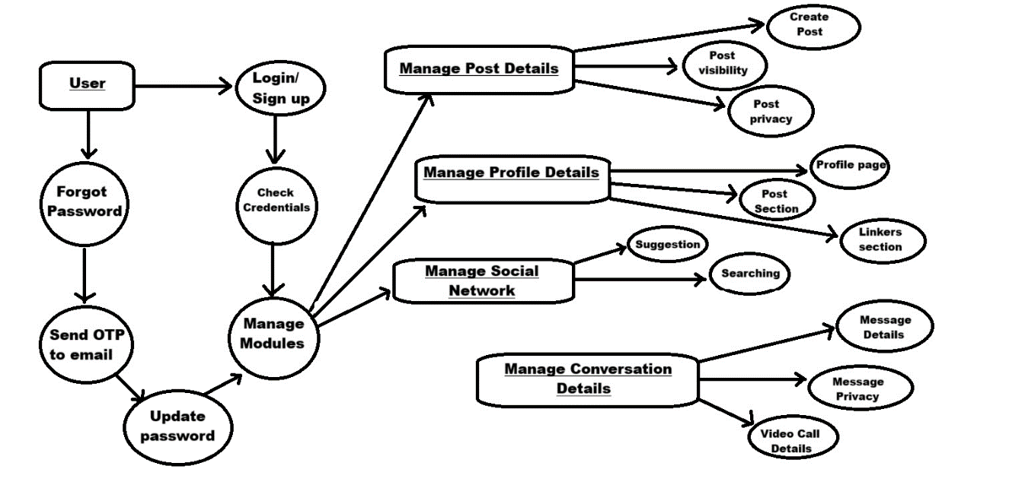

4. A.SEQUENCE DIAGRAM
A Sequence diagram is an interaction diagram that shows how processes operate with one another and what is their order. It is a construct of a Message Sequence Chart. A sequence diagram shows object interactions arranged in a time sequence. It depicts the objects and classes involved in the scenario and the sequence of messages exchanged between the objects needed to carry out the functionality of the scenario. Sequence diagrams are typically associated with use case realizations in the Logical View of the system under development. Sequence diagrams are sometimes called event diagrams or event scenarios.
A sequence diagram shows, as parallel vertical lines (lifelines), different processes or objects that live simultaneously, and, as horizontal arrows, the messages exchanged between them, in the order in which they occur. This allows the specification of simple runtime scenarios in a graphical manner.
A sequence diagram is the most common kind of interaction diagram, which focuses on the message interchange between several lifelines. A sequence diagram describes an interaction by focusing on the sequence of messages that are exchanged, along with their corresponding occurrence specifications on the lifelines.
The following nodes and edges are typically drawn in a UML sequence diagram: lifeline, execution specification, message, fragment, interaction, state invariant, continuation, and destruction occurrence.

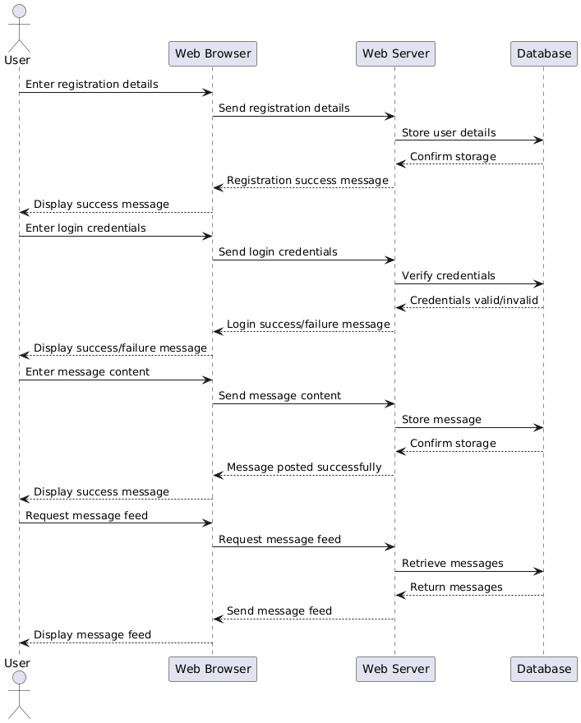

Sequence Diagram of Social Media Website
28

4. A.USE CASE DIAGRAM
A Use case diagram at its simplest is a representation of a user's interaction with the system that shows the relationship between the user and the different use cases in which the user is involved. A use case diagram can identify the different types of users of a system and the different use cases and will often be accompanied by other types of diagrams as well.
So only static behavior is not sufficient to model a system rather dynamic behavior is more important than static behavior. In UML there are five diagrams available to model dynamic nature and a use case diagram is one of them. Now as we have to discuss that the use case diagram is dynamic in nature there should be some internal or external factors for making the interaction.
These internal and external agents are known as actors. So use case diagrams consist of actors, use cases, and their relationships. The diagram is used to model the system/subsystem of an application. A single-use case diagram captures a particular functionality of a system.
So to model the entire system numbers of use case diagrams are used. The purpose of a use case diagram is to capture the dynamic aspect of a system. But this definition is too generic to describe the purpose. Because the other four diagrams (activity, sequence, collaboration, and State chart) are also having the same purpose. So we will look into some specific purpose that will distinguish it from the other four diagrams. Use case diagrams are used to gather the requirements of a system including internal and external influences. These requirements are mostly design requirements. So when a system is analyzed to gather its functionalities use cases are prepared and actors are identified.
Now when the initial task is complete use case diagrams are modelled to present the outside view.
So in brief, the purposes of use case diagrams can be as follows:
- Used to gather requirements of a system.
- Used to get an outside view of a system.
- Identify external and internal factors influencing the system.
- Show the interaction among the requirements actors.
How to draw Use Case Diagram?
Use case diagrams are considered for high level requirement analysis of a system. So when the requirements of a system are analyzed the functionalities are captured in use cases.
So we can say that uses cases are nothing but the system functionalities written in an organized manner. Now the second things which are relevant to the use cases are the actors. Actors can be defined as something that interacts with the system.
The actors can be human user, some internal applications or may be some external applications. So in a brief when we are planning to draw a use case diagram we should have the following items identified.
- Functionalities to be represented as an use case
- Actors
- Relationships among the use cases and actors.
Use case diagrams are drawn to capture the functional requirements of a system. So after identifying the above items we have to follow the following guidelines to draw an efficient use case diagram.
- The name of a use case is very important. So the name should be chosen in such a way so that it can identify the functionalities performed.
- Give a suitable name for actors.
- Show relationships and dependencies clearly in the diagram.
- Do not try to include all types of relationships. Because the main purpose of the diagram is to identify requirements.
- Use note whenever required to clarify some important points.

Use Case Diagram for User

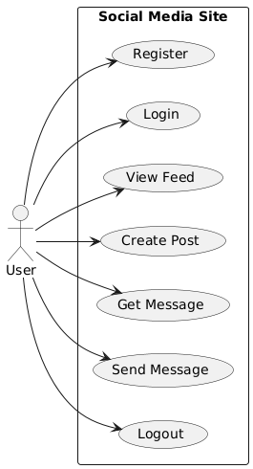

Schema Design
The schema is an abstract structure or outline representing the logical view of the database as a whole. Defining categories of data and relationships between those categories, database schema design makes data much easier to retrieve, consume, manipulate, and interpret.
DB schema design organizes data into separate entities, determines how to create relationships between organized entities, and influences the applications of constraints on data. Designers create database schemas to give other database users, such as programmers and analysts, a logical understanding of data.

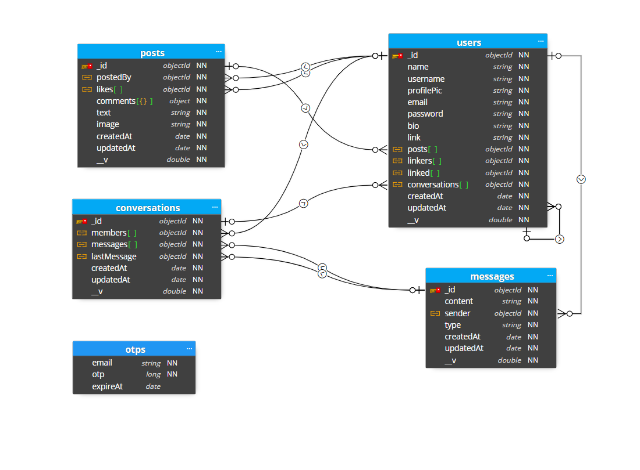

Home Page: -

Dark Theme:

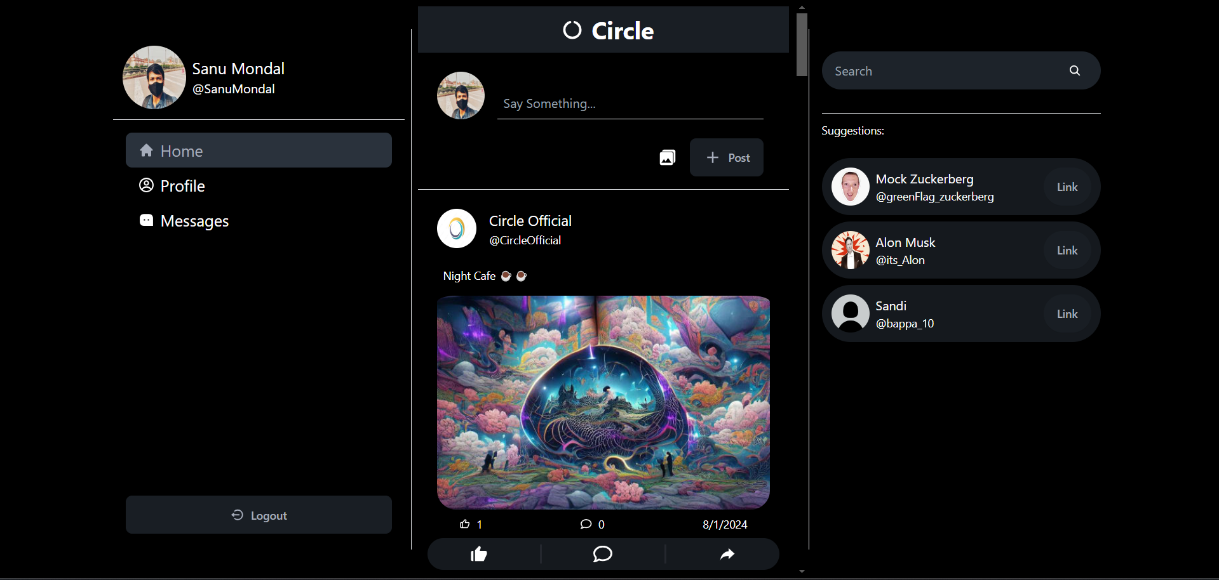

Light Theme:

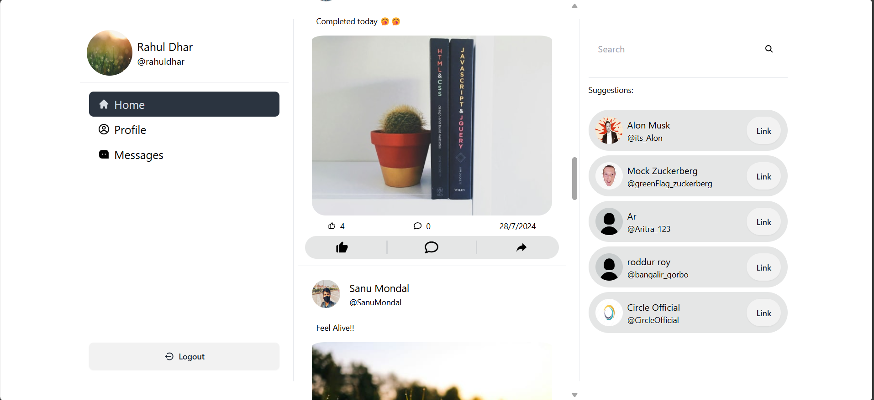
Home.jsx : -
import React from "react";
import { Navigate, Route, Routes } from "react-router-dom";
import Hero from "./Hero";
import MessagePage from "../message/MessagePage";
import Profile from "../profile/Profile";
import Search from "../search/Search";
import NavbarSide from "./NavbarSide";
import SearchPage from "../common/SearchPage";
import PostPage from "../postPage/PostPage";
import VideoPage from "../message/VideoPage";
import{useConversationContext}from"../../Context/ConversationContext";

const Home = () => {
const { videoCall } = useConversationContext();

return (
<>
<NavbarSide />
<Routes>
<Route path="/" element={<Hero />} />
<Route path="/message" element={<MessagePage />} />
<Route path="/profile/:username" element={<Profile />} />
<Route path="/profile" element={<Profile />} />
<Route path="/search/*" element={<Search />} />
<Route path="/post/:id" element={<PostPage />} />
<Route
path="/video/:id"
element={ videoCall ? <VideoPage /> : <Navigate to="/message" />}
/>
</Routes>
<div className="hidden lg:flex h-[90vh] w-1/4 border-l">
<SearchPage />
</div>
</>
);
};

export default Home;
Hero.jsx :-
import React, { useEffect, useState } from 'react'
import Header from "../common/Header";
import Post from "../common/Post";
import CreatePost from "./CreatePost";
import toast from 'react-hot-toast';

const Hero = () => {
const [posts, setPosts] = useState([]);
const [loading, setLoading] = useState(true);
useEffect(() => {
const fetchPosts = async () => {
setLoading(true);
try {
const res = await fetch("/api/post/getposts");
const data = await res.json();
if(data.error){
toast.error(data.error);
setPosts([]);
}else{
setPosts(data);
}
} catch (error) {
console.log({"Hero page": error});
}finally{
setLoading(false);
}
};
fetchPosts();
}, []);
return (
<div className="h-svh lg:w-[500px] md:w-2/3 w-full relative md:p-2 overflow-auto">
<Header />
<CreatePost />
<div className="pb-16">
{
posts?.map((post) => {
return <Post key={post._id} post={post} />;
})
}
</div>

</div>
)
}

export default Hero

<CreatePost />
<div className="pb-16">
{
posts?.map((post) => {
return <Post key={post._id} post={post} />;
})
}
</div>

</div>
)
}

export default Hero

CreatePost.jsx :-
import React, { useState } from "react";
import { IoMdClose } from "react-icons/io";
import { MdAdd } from "react-icons/md";
import AddImage from "../common/AddImage";
import { CreatePostHook } from "../../Hooks/CreatePost.hook";
import { useUserContext } from "../../Context/UserContext";

const CreatePost = () => {
const [image, setImage] = useState(null);
const [preview, setPreview] = useState(null);
const [post, setPost] = useState("");
const { loading, useCreatePost } = CreatePostHook();
const { user } = useUserContext();
const handlePost = (e) => {
e.preventDefault();
const success = useCreatePost(image, post);
if (success) {
setPost("");
setImage(null);
setPreview(null);
}
};
const removeImage = () => {
setImage(null);
setPreview(null);
};
return (
<div>
<div className="border-b pb-4">
<div className="w-full p-6 flex flex-col md:flex-row justify-between gap-2">
<img
src={user.profilePic}
className="w-[60px] h-[60px] rounded-full hidden md:flex"
/>
<div className="flex md:hidden items-center w-72">
<img
src={user.profilePic}
className="w-20 h-20 rounded-full"
/>
<div className="flex flex-col">
<span className="pl-2 text-xl">{user.name}</span>
<span className="pl-2 text-two text-md">@{user.username}</span>
</div>
</div>
<div className="border-b md:w-5/6 p-2 mx-2 flex items-end">
<input
type="text"
placeholder="Say Something..."
className="bg-primary focus:outline-none w-full"
value={post}
onChange={(e) => setPost(e.target.value)}
/>
</div>
</div>
<div className="w-full flex flex-wrap justify-end items-center gap-4 px-8">
{preview && (
<div className="flex flex-col items-end">
<button className="btn btn-ghost rounded-full" onClick={removeImage}>
<IoMdClose />
</button>
<img src={preview} alt="preview" className="w-full rounded-lg" />
</div>
)}
<AddImage setImage={setImage} setPreview={setPreview} />
<button className="btn" onClick={handlePost} disabled={loading}>
{loading ? (
<div className="flex gap-2 items-center">
<div className="loading loading-spinner"></div> Posting
</div>
) : (
<div className="flex gap-2 items-center">
<MdAdd className="text-2xl" /> Post
</div>
)}
</button>
</div>
</div>
</div>
);
};

export default CreatePost;

className="w-[60px] h-[60px] rounded-full hidden md:flex"
/>
<div className="flex md:hidden items-center w-72">
<img
src={user.profilePic}
className="w-20 h-20 rounded-full"
/>
<div className="flex flex-col">
<span className="pl-2 text-xl">{user.name}</span>
<span className="pl-2 text-two text-md">@{user.username}</span>
</div>
</div>
<div className="border-b md:w-5/6 p-2 mx-2 flex items-end">
<input
type="text"
placeholder="Say Something..."
className="bg-primary focus:outline-none w-full"
value={post}
onChange={(e) => setPost(e.target.value)}
/>
</div>
</div>
<div className="w-full flex flex-wrap justify-end items-center gap-4 px-8">
{preview && (
<div className="flex flex-col items-end">
<button className="btn btn-ghost rounded-full" onClick={removeImage}>
<IoMdClose />
</button>
<img src={preview} alt="preview" className="w-full rounded-lg" />
</div>
)}
<AddImage setImage={setImage} setPreview={setPreview} />
<button className="btn" onClick={handlePost} disabled={loading}>
{loading ? (
<div className="flex gap-2 items-center">
<div className="loading loading-spinner"></div> Posting
</div>
) : (
<div className="flex gap-2 items-center">
<MdAdd className="text-2xl" /> Post
</div>
)}
</button>
</div>
</div>
</div>
);
};

export default CreatePost;

<button className="btn" onClick={handlePost} disabled={loading}>
{loading ? (
<div className="flex gap-2 items-center">
<div className="loading loading-spinner"></div> Posting
</div>
) : (
<div className="flex gap-2 items-center">
<MdAdd className="text-2xl" /> Post
</div>
)}
</button>
</div>
</div>
</div>
);
};

export default CreatePost;

Login Page: -

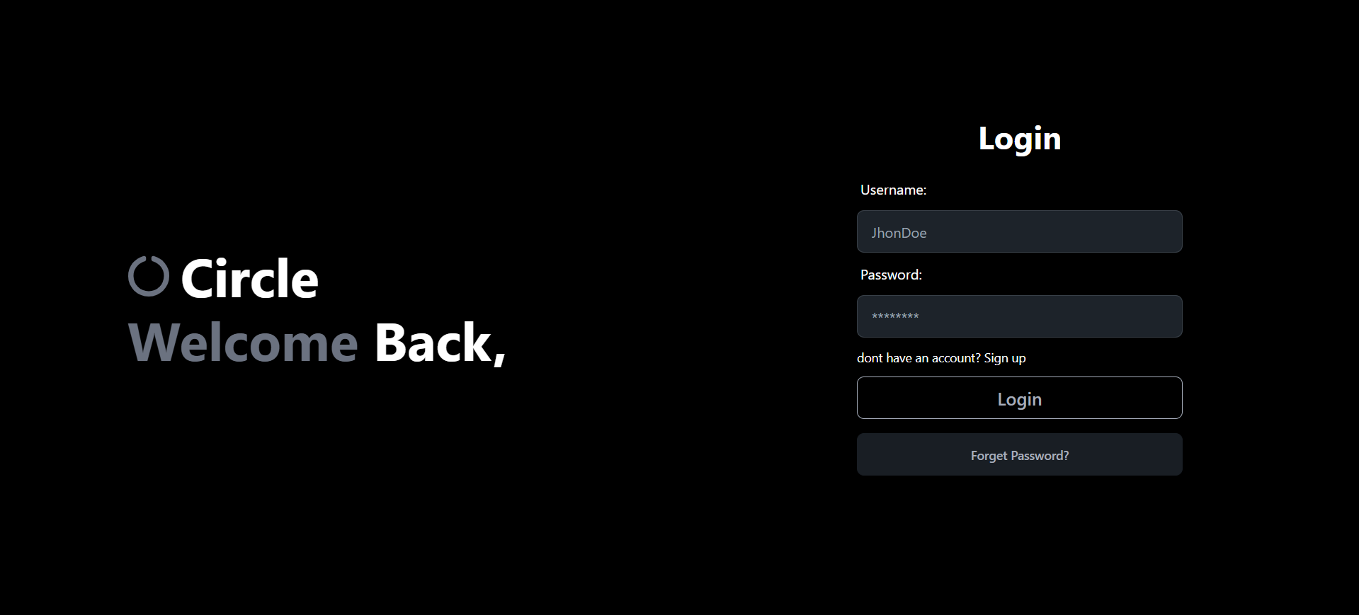

Signup Page: -

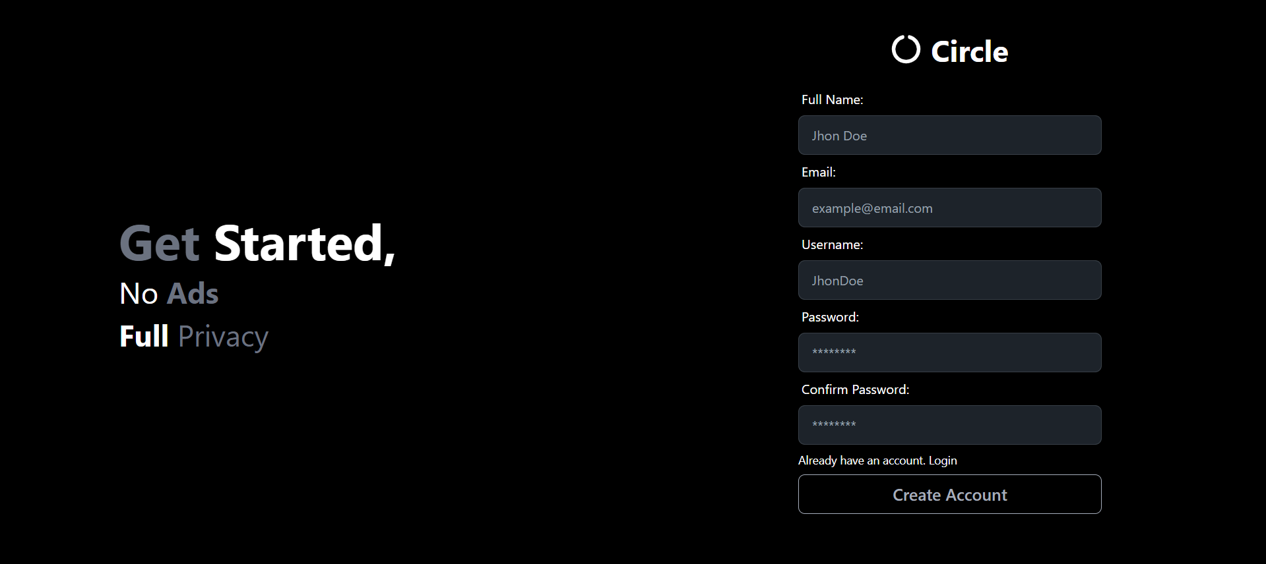

Login.jsx :-
import React, { useState } from "react";
import { FaCircleNotch } from "react-icons/fa";
import { Link } from "react-router-dom";
import { LoginHook } from "../../../Hooks/Login.hook";

const LoginFrom = () => {
const [details, setDetails] = useState({
username: "",
password: "",
});
const{loading, useLogin} = LoginHook();

const handleSubmit = (e) => {
e.preventDefault();
useLogin(details);
}
return (
<div>
<div className="flex flex-col gap-2 justify-center items-center w-full">
<div className="flex md:hidden flex-row gap-3 justify-center items-center text-4xl text-secondary">
<FaCircleNotch className="text-two" />
<h1 className="font-bold "> Circle</h1>
</div>
<div className="md:flex hidden flex-row gap-3 justify-center items-center text-4xl text-secondary">
<h1 className="font-bold "> Log<span className="text-two">in</span></h1>
</div>
<div className="rounded-3xl flex flex-col justify-center items-center md:w-3/4 w-full p-3 gap-4">

<form className="flex flex-col gap-1 w-2/3" onSubmit={handleSubmit}>
<label className="label">Username:</label>
<input
type="text"
placeholder="JhonDoe"
className="input input-bordered w-full"
value={details.username}
onChange={(e) =>setDetails({ ...details, username: e.target.value })}
/>
<label className="label">Password:</label>
<input
type="password"
placeholder="********"
className="input input-bordered w-full"
value={details.password}
onChange={(e) =>setDetails({ ...details, password: e.target.value })}
/>
<Link to="/signup" className="text-two text-xs md:text-sm hover:underline flex gap-1 py-2">
dont have an account? <span className="text-secondary">Sign up</span>
</Link>
<button className="btn btn-outline text-md md:text-xl" type="submit">
{loading? (<span className="loading loading-spinner loading-md"></span>) : "Login"}
</button>
<Link to="/forget-password" className="btn text-xs md:text-sm my-3">
<span>Forget Password?</span>
</Link>
</form>
</div>
</div>
</div>
);
};

export default LoginFrom;

onChange={(e) =>setDetails({ ...details, username: e.target.value })}
/>
<label className="label">Password:</label>
<input
type="password"
placeholder="********"
className="input input-bordered w-full"
value={details.password}
onChange={(e) =>setDetails({ ...details, password: e.target.value })}
/>
<Link to="/signup" className="text-two text-xs md:text-sm hover:underline flex gap-1 py-2">
dont have an account? <span className="text-secondary">Sign up</span>
</Link>
<button className="btn btn-outline text-md md:text-xl" type="submit">
{loading? (<span className="loading loading-spinner loading-md"></span>) : "Login"}
</button>
<Link to="/forget-password" className="btn text-xs md:text-sm my-3">
<span>Forget Password?</span>
</Link>
</form>
</div>
</div>
</div>
);
};

export default LoginFrom;

Signup.jsx :-
import React, { useState } from "react";
import { FaCircleNotch } from "react-icons/fa";
import { Link } from "react-router-dom";
import { SignupHook } from "../../../Hooks/Signup.hook";

const SignupFrom = () => {
const {loading, useSignup} = SignupHook();
const [details, setDetails] = useState({
fullName: "",
email: "",
username: "",
password: "",
confirmPassword: "",
});

const handleSubmit = (e) => {
e.preventDefault();
useSignup(details)
}

return (
<div>
<div className="flex flex-col gap-2 justify-center items-center w-full">
<div className="flex flex-row gap-3 justify-center items-center text-4xl text-secondary">
<FaCircleNotch className="text-two" />
<h1 className="font-bold "> Circle</h1>
</div>
<div className="rounded-3xl flex flex-col justify-center items-center md:w-3/4 w-full p-3 gap-4">
<form className="flex flex-col w-2/3 mb-3">
<label className="label">Full Name:</label>
<input
type="text"
placeholder="Jhon Doe"
className="input input-bordered w-full"
value={details.fullName}
onChange={(e) =>
setDetails({ ...details, fullName: e.target.value })
}
/>
<label className="label">Email:</label>
<input
type="email"
placeholder="example@email.com"
className="input input-bordered w-full"
value={details.email}
onChange={(e) =>
setDetails({ ...details, email: e.target.value })
}
/>
<label className="label">Username:</label>
<input
type="text"
placeholder="JhonDoe"
className="input input-bordered w-full"
value={details.username}
onChange={(e) =>
setDetails({ ...details, username: e.target.value })
}
/>
<label className="label">Password:</label>
<input
type="password"
placeholder="********"
className="input input-bordered w-full"
value={details.password}
onChange={(e) =>
setDetails({ ...details, password: e.target.value })
}
/>
<label className="label">Confirm Password:</label>
<input
type="password"
placeholder="********"
className="input input-bordered w-full"
value={details.confirmPassword}
onChange={(e) =>
setDetails({ ...details, confirmPassword: e.target.value })
}
/>
<Link
to="/login"
className="text-two text-xs md:text-sm hover:underline flex gap-1 py-2"
>
Already have an account.
<span className="text-secondary"> Login</span>
</Link>
<button className="btn btn-outline lg:text-xl" onClick={handleSubmit}>
{loading? (<span className="loading loading-spinner loading-md"></span>) : "Create Account"}
</button>
</form>
</div>
</div>
</div>
);
};

export default SignupFrom;

}
/>
<label className="label">Email:</label>
<input
type="email"
placeholder="example@email.com"
className="input input-bordered w-full"
value={details.email}
onChange={(e) =>
setDetails({ ...details, email: e.target.value })
}
/>
<label className="label">Username:</label>
<input
type="text"
placeholder="JhonDoe"
className="input input-bordered w-full"
value={details.username}
onChange={(e) =>
setDetails({ ...details, username: e.target.value })
}
/>
<label className="label">Password:</label>
<input
type="password"
placeholder="********"
className="input input-bordered w-full"
value={details.password}
onChange={(e) =>
setDetails({ ...details, password: e.target.value })
}
/>
<label className="label">Confirm Password:</label>
<input
type="password"
placeholder="********"
className="input input-bordered w-full"
value={details.confirmPassword}
onChange={(e) =>
setDetails({ ...details, confirmPassword: e.target.value })
}
/>
<Link
to="/login"
className="text-two text-xs md:text-sm hover:underline flex gap-1 py-2"
>
Already have an account.
<span className="text-secondary"> Login</span>
</Link>
<button className="btn btn-outline lg:text-xl" onClick={handleSubmit}>
{loading? (<span className="loading loading-spinner loading-md"></span>) : "Create Account"}
</button>
</form>
</div>
</div>
</div>
);
};

export default SignupFrom;

setDetails({ ...details, confirmPassword: e.target.value })
}
/>
<Link
to="/login"
className="text-two text-xs md:text-sm hover:underline flex gap-1 py-2"
>
Already have an account.
<span className="text-secondary"> Login</span>
</Link>
<button className="btn btn-outline lg:text-xl" onClick={handleSubmit}>
{loading? (<span className="loading loading-spinner loading-md"></span>) : "Create Account"}
</button>
</form>
</div>
</div>
</div>
);
};

export default SignupFrom;

Forget Password: -

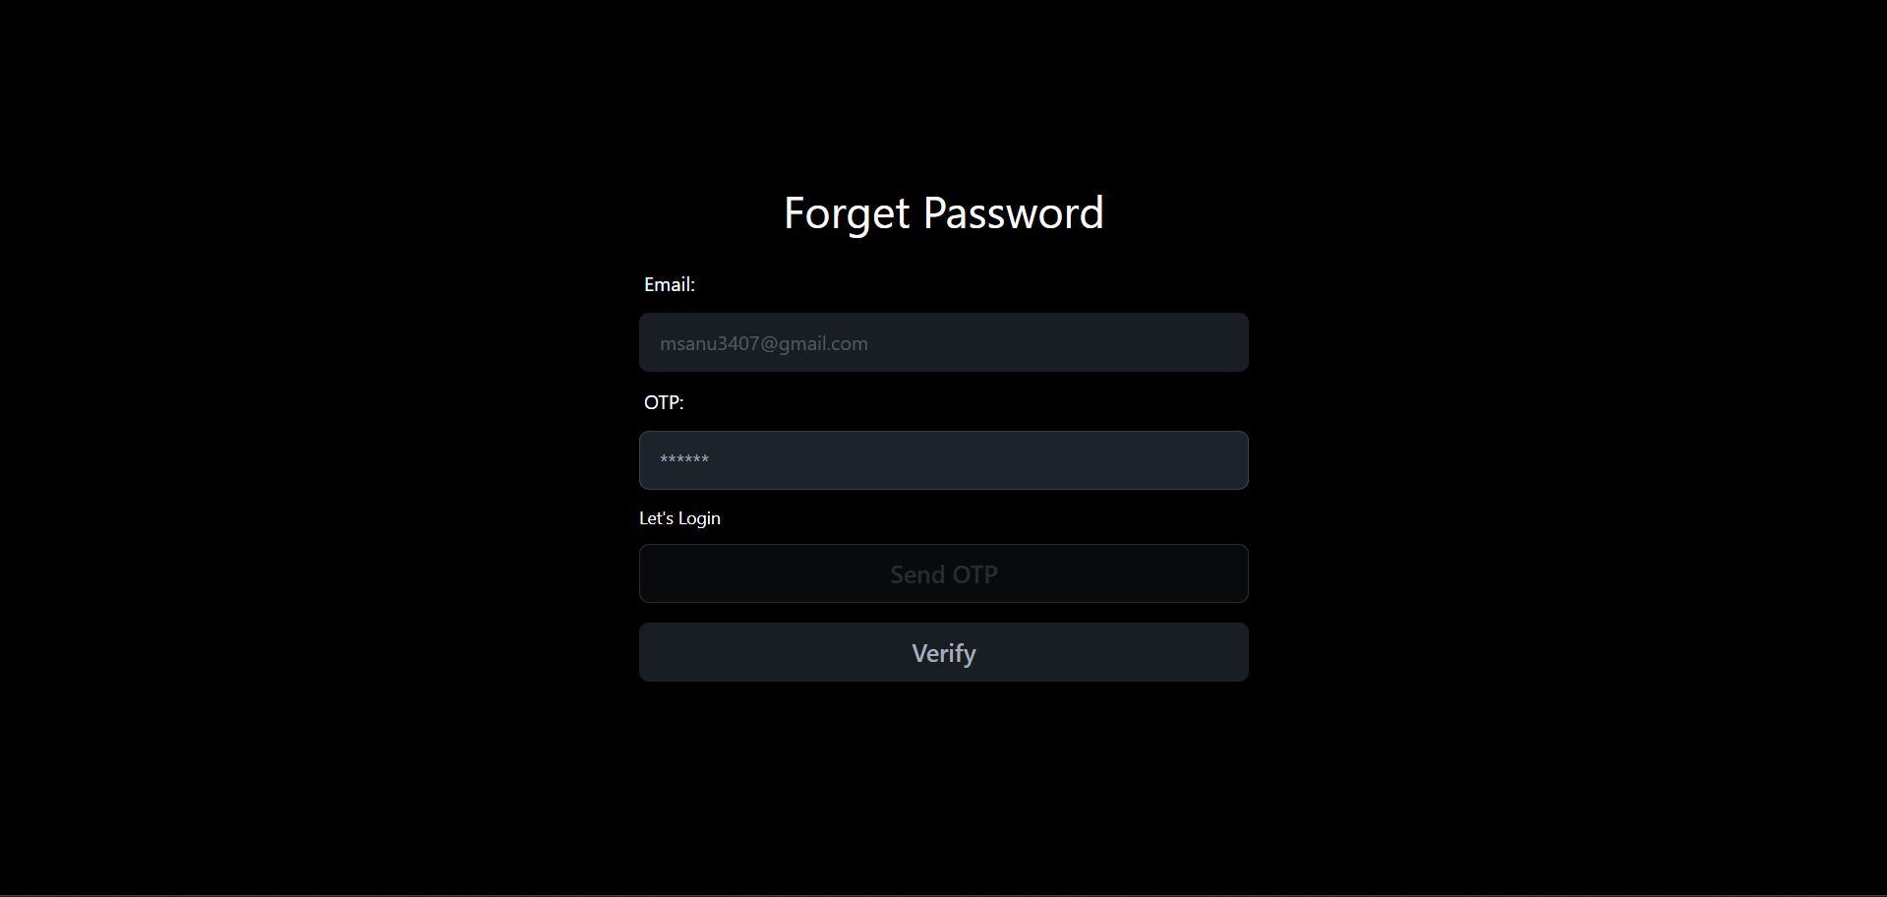

Create Password: -

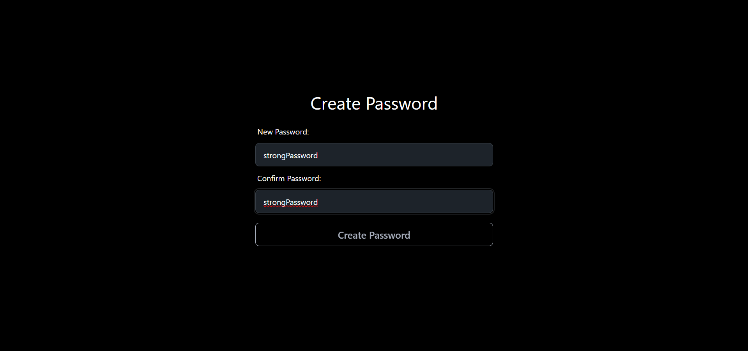

ForgetPassword.jsx :-
import React, { useState } from "react";
import { Link } from "react-router-dom";
import{ForgetPasswordHook}from "../../../Hooks/ForgetPasswordHook";

const ForgetPassword = () => {
const [email, setEmail] = useState("");
const [sent, setSent] = useState(false);
const [otp, setOtp] = useState("");
const { SendOTP, VerifyOtp } = ForgetPasswordHook();

const handleSendOTP = async (e) => {
e.preventDefault();
const success = SendOTP(email);
setSent(success);
};

const handleVerify = async (e) => {
e.preventDefault();
VerifyOtp(email, otp);
}
return (
<div className="w-screen h-screen flex justify-center items-center">
<div className="flex flex-col gap-2 justify-center items-center w-full">
<div className="flex flex-row gap-3 justify-center items-center text-4xl text-secondary">
<h1 className="">
Forget <span className="text-two"> Password</span>
</h1>
</div>
<div className="rounded-3xl flex flex-col justify-center items-center md:w-1/2 w-full p-3 gap-4">

<form className="flex flex-col gap-1 w-2/3">
<label className="label">Email:</label>
<input
type="email"
placeholder="example@email.com"
className="input input-bordered w-full"
value={email}
onChange={(e) => setEmail(e.target.value)}
disabled={sent}
/>
<label className="label">OTP:</label>
<input
type="text"
placeholder="******"
className="input input-bordered w-full"
value={otp}
onChange={(e) => setOtp(e.target.value)}
disabled={!sent}
/>
<Link
to="/login"
className="text-two text-xs md:text-sm hover:underline flex gap-1 py-2"
>
Let's <span className="text-secondary"> Login</span>
</Link>
<button className="btn btn-outline lg:text-xl" disabled={sent} onClick={handleSendOTP}>Send OTP</button>
<button className="btn lg:text-xl my-3" disabled={!sent} onClick={handleVerify}>
Verify
</button>
</form>
</div>
</div>
</div>
);
};

export default ForgetPassword;

/>
<label className="label">OTP:</label>
<input
type="text"
placeholder="******"
className="input input-bordered w-full"
value={otp}
onChange={(e) => setOtp(e.target.value)}
disabled={!sent}
/>
<Link
to="/login"
className="text-two text-xs md:text-sm hover:underline flex gap-1 py-2"
>
Let's <span className="text-secondary"> Login</span>
</Link>
<button className="btn btn-outline lg:text-xl" disabled={sent} onClick={handleSendOTP}>Send OTP</button>
<button className="btn lg:text-xl my-3" disabled={!sent} onClick={handleVerify}>
Verify
</button>
</form>
</div>
</div>
</div>
);
};

export default ForgetPassword;

CreatePassword.jsx :-
import React, { useState } from "react";
import toast from "react-hot-toast";
import { useNavigate } from "react-router-dom";

const CreateNewPassword = () => {
const [details, setDetails] = useState({
password: "",
confirmPassword: "",
});
const navigate = useNavigate();

const handleSubmit = async (e) => {
e.preventDefault();
if (details.password.length < 8) {
return toast.error("Password must be at least 8 characters");
}
if (details.password !== details.confirmPassword) {
return toast.error("Password does not match");
}
const res = await fetch("/api/user/updatepassword", {
method: "POST",
headers: {
"Content-Type": "application/json",
},
body: JSON.stringify({ password: details.password, confirmPassword: details.confirmPassword }),
credentials: "include",
});
const data = await res.json();
if (data.error) {
return toast.error(data.error);
} else {
toast.success("Password updated successfully");
navigate("/");
}
};
return (
<div className="w-screen h-screen flex justify-center items-center">
<div className="flex flex-col gap-2 justify-center items-center md:w-1/2">
<div className="flex flex-row gap-3 justify-center items-center text-4xl text-secondary">
<h1 className="">
<span className="text-two">Create </span>Password
</h1>
</div>
<div className="rounded-3xl flex flex-col justify-center items-center md:w-2/3 w-full p-3 gap-4">

<form className="flex flex-col gap-1 w-full" onSubmit={handleSubmit}>
<label className="label">New Password:</label>
<input
type="text"
placeholder="Password"
className="input input-bordered w-full"
value={details.password}
onChange={(e) =>
setDetails({ ...details, password: e.target.value })
}
/>
<label className="label">Confirm Password:</label>
<input
type="text"
placeholder="Confirm Password"
className="input input-bordered w-full"
value={details.confirmPassword}
onChange={(e) =>
setDetails({ ...details, confirmPassword: e.target.value })
}
/>
<button className="btn btn-outline my-4 lg:text-xl">
Create Password
</button>
</form>
</div>
</div>
</div>
);
};

export default CreateNewPassword;

<div className="flex flex-row gap-3 justify-center items-center text-4xl text-secondary">
<h1 className="">
<span className="text-two">Create </span>Password
</h1>
</div>
<div className="rounded-3xl flex flex-col justify-center items-center md:w-2/3 w-full p-3 gap-4">

<form className="flex flex-col gap-1 w-full" onSubmit={handleSubmit}>
<label className="label">New Password:</label>
<input
type="text"
placeholder="Password"
className="input input-bordered w-full"
value={details.password}
onChange={(e) =>
setDetails({ ...details, password: e.target.value })
}
/>
<label className="label">Confirm Password:</label>
<input
type="text"
placeholder="Confirm Password"
className="input input-bordered w-full"
value={details.confirmPassword}
onChange={(e) =>
setDetails({ ...details, confirmPassword: e.target.value })
}
/>
<button className="btn btn-outline my-4 lg:text-xl">
Create Password
</button>
</form>
</div>
</div>
</div>
);
};

export default CreateNewPassword;

export default CreateNewPassword;

Profile: -

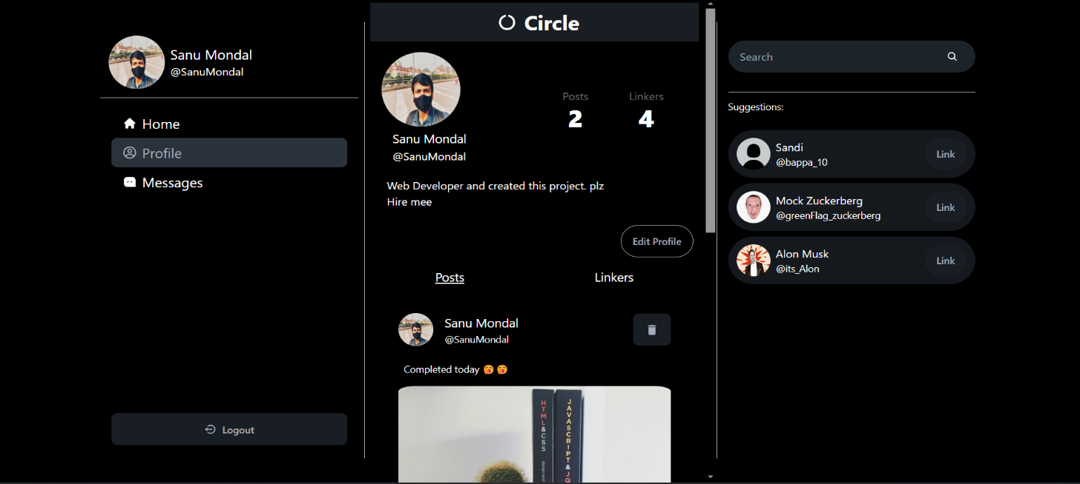

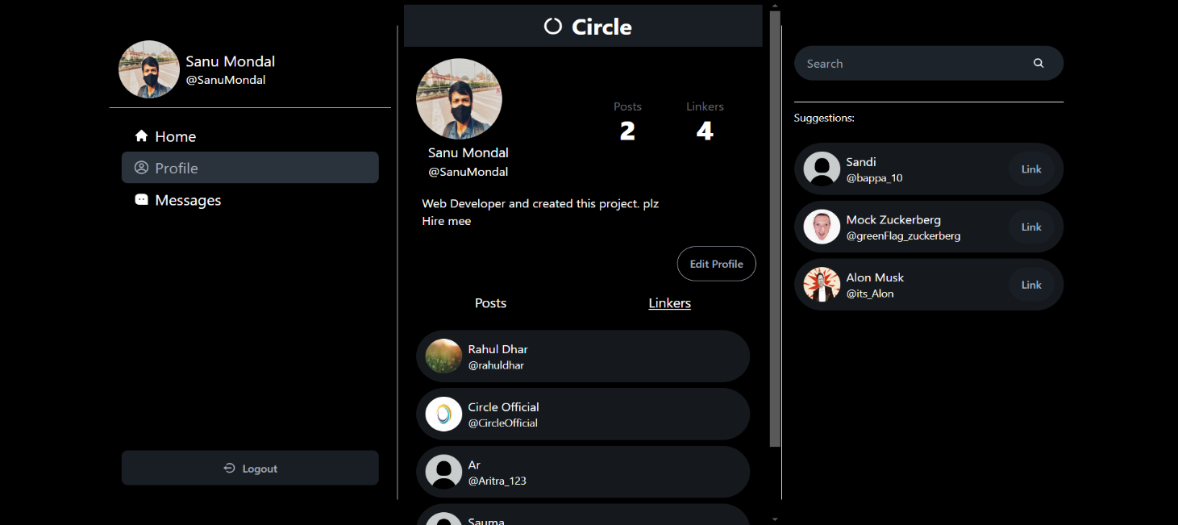

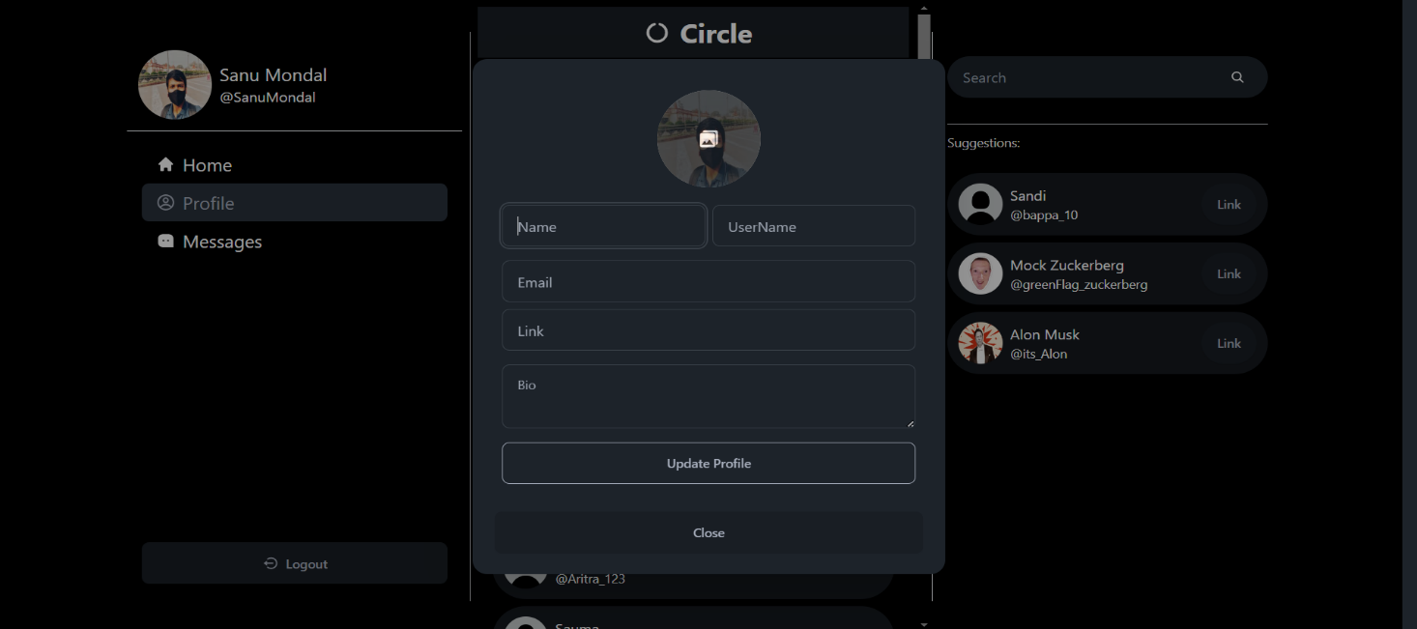

Profile.jsx:-
import React, { useEffect, useState } from "react";
import Header from "../common/Header";
import Post from "../common/Post";
import Account from "../common/Account";
import { useParams } from "react-router-dom";
import { useUserContext } from "../../Context/UserContext";
import { LikeUserHook } from "../../Hooks/LinkUser.hook";
import UpdateProfile from "./UpdateProfile";
import { LogoutHook } from "../../Hooks/Logout.hook";
import { BiLogOutCircle } from "react-icons/bi";

const Profile = () => {
const [postActive, setPostActive] = useState("post");
const { loading, useLogout } = LogoutHook();
const { username } = useParams();
const [profile, setProfile] = useState(null);
const { user } = useUserContext();
const { useLikeUser } = LikeUserHook();
const [isLinked, setIsLinked] = useState(false);

const handleLink = async () => {
await useLikeUser(profile?._id);
setIsLinked(!isLinked);
};

useEffect(() => {
const fetchPoifle = async () => {
try {
if (username) {
const res = await fetch(`/api/user/profile/${username}`, {
credentials: "include",
});
const data = await res.json();
setProfile(data);
setIsLinked(data.linkers.some((linker) => linker._id === user.id));
// console.log(data.linkers, user.id);
} else {
const res = await fetch(`/api/user/profile/${user.username}`, {
credentials: "include",
});
const data = await res.json();
setProfile(data);
}
} catch (err) {
console.log(err);
}
};
fetchPoifle();
// console.log(isLinked);
}, [username, user]);
return (
<div className="h-svh lg:w-[500px] md:w-2/3 w-full relative md:p-2 overflow-auto">
<Header />
{profile && (
<div>
<div className="flex justify-between items-center p-4">
<div className="w-1/2">
<img
src={profile.profilePic}
alt="profile"
className="w-28 h-28 rounded-full"
/>
<div className="px-4 py-1">
<h2 className="text-lg">{profile.name}</h2>
<p className="text-two">@{profile.username}</p>
</div>
</div>
<div className="w-1/2 flex justify-center items-center p-2">
<div className="stat place-items-center w-1/2">
<div className="stat-title">Posts</div>
<div className="stat-value">{profile.posts.length}</div>
</div>
<div className="stat place-items-center w-1/2">
<div className="stat-title">Linkers</div>
<div className="stat-value">{profile.linkers.length}</div>
</div>
</div>
</div>
<div className="px-6 w-5/6">
<p>{profile.bio}</p>
</div>
<div className="px-6 py-2 w-5/6 underline hover:text-blue-600">
<a href={profile.link} target="blank">
{profile.link}
</a>
</div>
<dialog id="my_modal_1" className="modal">
<div className="modal-box">
<UpdateProfile profile={profile} />
<div className="modal-action w-full">
<form method="dialog" className="w-full p-x2">
<button className="btn w-full">Close</button>
</form>
</div>
</div>
</dialog>
<div className="w-full p-2 flex justify-end">
{user.username === profile.username ? (
<div className="flex items-center gap-3">
<button
className="btn btn-secondary rounded-full md:hidden"
onClick={useLogout}
>
{loading ? (
<div className="loading loading-spinner"></div>
) : (
<BiLogOutCircle className="text-lg" />
)}
</button>
<button
className="btn btn-outline rounded-full"
onClick={() => {
document.getElementById("my_modal_1").showModal();
}}
>
Edit Profile
</button>
</div>
) : (
<button
className="btn bg-secondary text-primary hover:text-secondary rounded-full"
onClick={handleLink}
>
{isLinked ? "Linked" : "Link"}
</button>
)}
</div>

<div className="flex w-full justify-around py-2">
<span
className={`text-lg px-6 cursor-pointer hover:underline ${
postActive === "post" && "underline"
}`}
onClick={() => {
setPostActive("post");
}}
>
Posts
</span>
<span
className={`text-lg px-6 cursor-pointer hover:underline ${
postActive === "linkers" && "underline"
}`}
onClick={() => {
setPostActive("linkers");
}}
>
Linkers
</span>
</div>

<div className="pb-12">
{postActive === "post" ? (
<div className="py-2 px-4">
{profile.posts.length === 0 && (
<p className="w-full flex justify-center">No Post Found</p>
)}
{profile.posts.map((post) => (
<Post key={post._id} post={post} />
))}
</div>
) : (
<div className="py-2 px-4">
{profile.linkers.length === 0 && (
<p className="w-full flex justify-center">No Linker Found</p>
)}
{profile.linkers.map((linker) => (
<Account key={linker._id} user={linker} showLink={false} />
))}
</div>
)}
</div>
</div>
)}
</div>
);
};

export default Profile;

credentials: "include",
});
const data = await res.json();
setProfile(data);
}
} catch (err) {
console.log(err);
}
};
fetchPoifle();
// console.log(isLinked);
}, [username, user]);
return (
<div className="h-svh lg:w-[500px] md:w-2/3 w-full relative md:p-2 overflow-auto">
<Header />
{profile && (
<div>
<div className="flex justify-between items-center p-4">
<div className="w-1/2">
<img
src={profile.profilePic}
alt="profile"
className="w-28 h-28 rounded-full"
/>
<div className="px-4 py-1">
<h2 className="text-lg">{profile.name}</h2>
<p className="text-two">@{profile.username}</p>
</div>
</div>
<div className="w-1/2 flex justify-center items-center p-2">
<div className="stat place-items-center w-1/2">
<div className="stat-title">Posts</div>
<div className="stat-value">{profile.posts.length}</div>
</div>
<div className="stat place-items-center w-1/2">
<div className="stat-title">Linkers</div>
<div className="stat-value">{profile.linkers.length}</div>
</div>
</div>
</div>
<div className="px-6 w-5/6">
<p>{profile.bio}</p>
</div>
<div className="px-6 py-2 w-5/6 underline hover:text-blue-600">
<a href={profile.link} target="blank">
{profile.link}
</a>
</div>
<dialog id="my_modal_1" className="modal">
<div className="modal-box">
<UpdateProfile profile={profile} />
<div className="modal-action w-full">
<form method="dialog" className="w-full p-x2">
<button className="btn w-full">Close</button>
</form>
</div>
</div>
</dialog>
<div className="w-full p-2 flex justify-end">
{user.username === profile.username ? (
<div className="flex items-center gap-3">
<button
className="btn btn-secondary rounded-full md:hidden"
onClick={useLogout}
>
{loading ? (
<div className="loading loading-spinner"></div>
) : (
<BiLogOutCircle className="text-lg" />
)}
</button>
<button
className="btn btn-outline rounded-full"
onClick={() => {
document.getElementById("my_modal_1").showModal();
}}
>
Edit Profile
</button>
</div>
) : (
<button
className="btn bg-secondary text-primary hover:text-secondary rounded-full"
onClick={handleLink}
>
{isLinked ? "Linked" : "Link"}
</button>
)}
</div>

<div className="flex w-full justify-around py-2">
<span
className={`text-lg px-6 cursor-pointer hover:underline ${
postActive === "post" && "underline"
}`}
onClick={() => {
setPostActive("post");
}}
>
Posts
</span>
<span
className={`text-lg px-6 cursor-pointer hover:underline ${
postActive === "linkers" && "underline"
}`}
onClick={() => {
setPostActive("linkers");
}}
>
Linkers
</span>
</div>

<div className="pb-12">
{postActive === "post" ? (
<div className="py-2 px-4">
{profile.posts.length === 0 && (
<p className="w-full flex justify-center">No Post Found</p>
)}
{profile.posts.map((post) => (
<Post key={post._id} post={post} />
))}
</div>
) : (
<div className="py-2 px-4">
{profile.linkers.length === 0 && (
<p className="w-full flex justify-center">No Linker Found</p>
)}
{profile.linkers.map((linker) => (
<Account key={linker._id} user={linker} showLink={false} />
))}
</div>
)}
</div>
</div>
)}
</div>
);
};

export default Profile;

<div className="stat-value">{profile.linkers.length}</div>
</div>
</div>
</div>
<div className="px-6 w-5/6">
<p>{profile.bio}</p>
</div>
<div className="px-6 py-2 w-5/6 underline hover:text-blue-600">
<a href={profile.link} target="blank">
{profile.link}
</a>
</div>
<dialog id="my_modal_1" className="modal">
<div className="modal-box">
<UpdateProfile profile={profile} />
<div className="modal-action w-full">
<form method="dialog" className="w-full p-x2">
<button className="btn w-full">Close</button>
</form>
</div>
</div>
</dialog>
<div className="w-full p-2 flex justify-end">
{user.username === profile.username ? (
<div className="flex items-center gap-3">
<button
className="btn btn-secondary rounded-full md:hidden"
onClick={useLogout}
>
{loading ? (
<div className="loading loading-spinner"></div>
) : (
<BiLogOutCircle className="text-lg" />
)}
</button>
<button
className="btn btn-outline rounded-full"
onClick={() => {
document.getElementById("my_modal_1").showModal();
}}
>
Edit Profile
</button>
</div>
) : (
<button
className="btn bg-secondary text-primary hover:text-secondary rounded-full"
onClick={handleLink}
>
{isLinked ? "Linked" : "Link"}
</button>
)}
</div>

<div className="flex w-full justify-around py-2">
<span
className={`text-lg px-6 cursor-pointer hover:underline ${
postActive === "post" && "underline"
}`}
onClick={() => {
setPostActive("post");
}}
>
Posts
</span>
<span
className={`text-lg px-6 cursor-pointer hover:underline ${
postActive === "linkers" && "underline"
}`}
onClick={() => {
setPostActive("linkers");
}}
>
Linkers
</span>
</div>

<div className="pb-12">
{postActive === "post" ? (
<div className="py-2 px-4">
{profile.posts.length === 0 && (
<p className="w-full flex justify-center">No Post Found</p>
)}
{profile.posts.map((post) => (
<Post key={post._id} post={post} />
))}
</div>
) : (
<div className="py-2 px-4">
{profile.linkers.length === 0 && (
<p className="w-full flex justify-center">No Linker Found</p>
)}
{profile.linkers.map((linker) => (
<Account key={linker._id} user={linker} showLink={false} />
))}
</div>
)}
</div>
</div>
)}
</div>
);
};

export default Profile;

<button
className="btn btn-outline rounded-full"
onClick={() => {
document.getElementById("my_modal_1").showModal();
}}
>
Edit Profile
</button>
</div>
) : (
<button
className="btn bg-secondary text-primary hover:text-secondary rounded-full"
onClick={handleLink}
>
{isLinked ? "Linked" : "Link"}
</button>
)}
</div>

<div className="flex w-full justify-around py-2">
<span
className={`text-lg px-6 cursor-pointer hover:underline ${
postActive === "post" && "underline"
}`}
onClick={() => {
setPostActive("post");
}}
>
Posts
</span>
<span
className={`text-lg px-6 cursor-pointer hover:underline ${
postActive === "linkers" && "underline"
}`}
onClick={() => {
setPostActive("linkers");
}}
>
Linkers
</span>
</div>

<div className="pb-12">
{postActive === "post" ? (
<div className="py-2 px-4">
{profile.posts.length === 0 && (
<p className="w-full flex justify-center">No Post Found</p>
)}
{profile.posts.map((post) => (
<Post key={post._id} post={post} />
))}
</div>
) : (
<div className="py-2 px-4">
{profile.linkers.length === 0 && (
<p className="w-full flex justify-center">No Linker Found</p>
)}
{profile.linkers.map((linker) => (
<Account key={linker._id} user={linker} showLink={false} />
))}
</div>
)}
</div>
</div>
)}
</div>
);
};

export default Profile;

onClick={() => {
setPostActive("linkers");
}}
>
Linkers
</span>
</div>

<div className="pb-12">
{postActive === "post" ? (
<div className="py-2 px-4">
{profile.posts.length === 0 && (
<p className="w-full flex justify-center">No Post Found</p>
)}
{profile.posts.map((post) => (
<Post key={post._id} post={post} />
))}
</div>
) : (
<div className="py-2 px-4">
{profile.linkers.length === 0 && (
<p className="w-full flex justify-center">No Linker Found</p>
)}
{profile.linkers.map((linker) => (
<Account key={linker._id} user={linker} showLink={false} />
))}
</div>
)}
</div>
</div>
)}
</div>
);
};
export default Profile;

Updateprofile.jsx:-
import React, { useState } from "react";
import AddImage from "../common/AddImage";
import { UpdateProfileHook } from "../../Hooks/UpdateProfileHook";
import toast from "react-hot-toast";
import { set } from "mongoose";

const UpdateProfile = ({ profile }) => {
const [details, setDetails] = useState({
name: "",
username: "",
email: "",
link: "",
bio: "",
});
const [image, setImage] = useState(null);
const [preview, setPreview] = useState(profile.profilePic || null);
const { loading, updateProfile } = UpdateProfileHook();

const handleUpdate = async () => {
setDetails({ ...details, profilePic: image });
console.log(details);

const user = await updateProfile(details);
if (user) {
toast.success("Profile updated successfully");
}
};

return (
<div className="w-full">
<div className="flex flex-col justify-center items-center gap-2">
<div className="relative w-28 h-28 m-3">
<img src={preview} alt="profile" className="w-28 h-28 rounded-full" />
<div className="absoltue z-30 translate-y-[-100%] rounded-full bg-base-300 opacity-0 hover:opacity-75 w-28 h-28">
<div className="z-50 flex absolute bottom-1/2 right-1/2 translate-x-1/2 translate-y-1/2">
<AddImage setImage={setImage} setPreview={setPreview} />
</div>
</div>
</div>
<div className="flex w-full gap-2 px-2">
<input
type="text"
placeholder="Name"
className="input input-bordered w-full"
value={details.name}
onChange={(e) => setDetails({ ...details, name: e.target.value })}
/>
<input
type="text"
placeholder="UserName"
className="input input-bordered w-full"
value={details.username}
onChange={(e) =>
setDetails({ ...details, username: e.target.value })
}
/>
</div>
<div className="flex flex-col w-full gap-2 p-2">
<input
type="email"
placeholder="Email"
className="input input-bordered"
value={details.email}
onChange={(e) => setDetails({ ...details, email: e.target.value })}
/>
<input
type="text"
placeholder="Link"
className="input input-bordered"
value={details.link}
onChange={(e) => setDetails({ ...details, link: e.target.value })}
/>
</div>
<div className="flex flex-col w-full gap-2 px-2">
<textarea
className="textarea textarea-bordered"
placeholder="Bio"
value={details.bio}
onChange={(e) => setDetails({ ...details, bio: e.target.value })}
></textarea>
</div>
<div className="px-2 w-full py-2">
<button
className="btn btn-outline w-full"
disabled={loading}
onClick={handleUpdate}
>
{loading ? (
<div className="loading loading-spinner"></div>
) : (
"Update Profile"
)}
</button>
</div>
</div>
</div>
);
};

export default UpdateProfile;

y-1/2">
<AddImage setImage={setImage} setPreview={setPreview} />
</div>
</div>
</div>
<div className="flex w-full gap-2 px-2">
<input
type="text"
placeholder="Name"
className="input input-bordered w-full"
value={details.name}
onChange={(e) => setDetails({ ...details, name: e.target.value })}
/>
<input
type="text"
placeholder="UserName"
className="input input-bordered w-full"
value={details.username}
onChange={(e) =>
setDetails({ ...details, username: e.target.value })
}
/>
</div>
<div className="flex flex-col w-full gap-2 p-2">
<input
type="email"
placeholder="Email"
className="input input-bordered"
value={details.email}
onChange={(e) => setDetails({ ...details, email: e.target.value })}
/>
<input
type="text"
placeholder="Link"
className="input input-bordered"
value={details.link}
onChange={(e) => setDetails({ ...details, link: e.target.value })}
/>
</div>
<div className="flex flex-col w-full gap-2 px-2">
<textarea
className="textarea textarea-bordered"
placeholder="Bio"
value={details.bio}
onChange={(e) => setDetails({ ...details, bio: e.target.value })}
></textarea>
</div>
<div className="px-2 w-full py-2">
<button
className="btn btn-outline w-full"
disabled={loading}
onClick={handleUpdate}
>
{loading ? (
<div className="loading loading-spinner"></div>
) : (
"Update Profile"
)}
</button>
</div>
</div>
</div>
);
};

export default UpdateProfile;

/>
</div>
<div className="flex flex-col w-full gap-2 px-2">
<textarea
className="textarea textarea-bordered"
placeholder="Bio"
value={details.bio}
onChange={(e) => setDetails({ ...details, bio: e.target.value })}
></textarea>
</div>
<div className="px-2 w-full py-2">
<button
className="btn btn-outline w-full"
disabled={loading}
onClick={handleUpdate}
>
{loading ? (
<div className="loading loading-spinner"></div>
) : (
"Update Profile"
)}
</button>
</div>
</div>
</div>
);
};

export default UpdateProfile;

Post.jsx:-
import React, { useState } from "react";
import { BiLike } from "react-icons/bi";
import { FaRegComment } from "react-icons/fa6";
import { IoMdShareAlt } from "react-icons/io";
import { useUserContext } from "../../Context/UserContext";
import { LikePostHook } from "../../Hooks/LikePost.hook";
import { BiSolidLike } from "react-icons/bi";
import { CommentPostHook } from "../../Hooks/CommentPost.hook";
import { MdDelete } from "react-icons/md";
import { Link } from "react-router-dom";
import SharePost from "./SharePost";
import DeletePostHook from "../../Hooks/DeletePostHook";
import toast from "react-hot-toast";

const Post = ({ post }) => {
const { user } = useUserContext();
const [liked, setLiked] = useState(post?.likes.includes(user.id) || false);
const { useLikePost } = LikePostHook();
const [text, setText] = useState("");
const [active, setActive] = useState(false);
const { useCommentPost } = CommentPostHook();
const [share, setShare] = useState(false);
const { useDeletepost, loading } = DeletePostHook();

const likePost = async () => {
try {
const p = await useLikePost(post._id);
if (p.error) {
return;
}
post.likes = p.likes;
setLiked(!liked);
} catch (error) {
console.log("Error in likePost", error);
}
};
const commentPost = async (e) => {
try {
e.preventDefault();
const data = await useCommentPost(post._id, text);
post.comments = data.comments;
setText("");
} catch (error) {
console.log("Error in commentPost", error);
}
};
const DeletePost = async () => {
try {
const data = await useDeletepost(post._id);
if (data.error) {
return;
}
if(data.success){
toast.success("Post Will Be Deleted");
}
}catch(error){
console.log("Error in DeletePost", error);
}
};

return (
<div className="border-b last:border-0 pb-3">
<div className="w-full p-6 flex items-center justify-between">
<Link to={`/profile/${post?.postedBy.username}`} className="flex gap-2">

<img
src={post?.postedBy.profilePic}
className="w-[50px] h-[50px] rounded-full"
/>
<div className="flex items-center">
<div className="flex flex-col justify-start">
<span className="pl-2 text-lg">{post?.postedBy.name}</span>
<span className="pl-2 text-two text-sm">
@{post?.postedBy.username}
</span>
</div>
</div>
</Link>

{user.id === post?.postedBy._id && (
<div>
<button className="btn group/delete" onClick={DeletePost}>
{loading && <div className="loading loading-spinner"></div>}
<MdDelete
className="text-xl group-hover/delete:hidden cursor-pointer"

/>
<span className="group-hover/delete:flex hidden transition-all">Delete</span>
</button>
</div>
)}
</div>

<div className="flex flex-col justify-center">
<Link to={`/post/${post?._id}`}>
<div className="w-auto h-auto flex flex-col justify-center items-center px-6">
{post?.text && (
<p className="flex px-2 text-sm w-full">{post?.text}</p>
)}
{post?.image && (
<img
src={post?.image}
className="w-full min-h-20 pt-4 rounded-3xl"
alt="Image not found"
/>
)}
<div className="text-two text-sm w-full px-7 py-2 flex justify-between">
<p className="flex items-center gap-2">
<BiLike /> {post?.likes.length}
</p>
<p className="flex items-center gap-2">
<FaRegComment /> {post?.comments.length}
</p>
<p>{new Date(post?.createdAt).toLocaleDateString()}</p>
</div>
</div>
</Link>
<div className="w-full px-3">
<div className="w-full flex justify-around items-center bg-base-300 text-2xl px-8 py-2 rounded-full cursor-pointer">
<p onClick={likePost}>{liked ? <BiSolidLike /> : <BiLike />}</p>
<div className="divider divider-horizontal"></div>
<FaRegComment
onClick={() => {
setActive(!active);
setShare(false);
}}
/>
<div className="divider divider-horizontal"></div>
<IoMdShareAlt
onClick={() => {
setShare(!share);
setActive(false);
}}
/>
</div>
{active && (
<form className="py-2" onSubmit={commentPost}>
<label className="flex justify-center gap-2">
<div className=" border-b w-full flex items-center">
<input
type="text"
placeholder="Comment"
className="w-full rounded-2xl bg-transparent px-2 focus:outline-none"
value={text}
onChange={(e) => setText(e.target.value)}
/>
</div>
<button type="submit" className="btn btn-outline rounded-full">
Comment
</button>
</label>
</form>
)}
{share && <SharePost post={post} />}
</div>
</div>
</div>
);
};

export default Post;

const commentPost = async (e) => {
try {
e.preventDefault();
const data = await useCommentPost(post._id, text);
post.comments = data.comments;
setText("");
} catch (error) {
console.log("Error in commentPost", error);
}
};
const DeletePost = async () => {
try {
const data = await useDeletepost(post._id);
if (data.error) {
return;
}
if(data.success){
toast.success("Post Will Be Deleted");
}
}catch(error){
console.log("Error in DeletePost", error);
}
};

return (
<div className="border-b last:border-0 pb-3">
<div className="w-full p-6 flex items-center justify-between">
<Link to={`/profile/${post?.postedBy.username}`} className="flex gap-2">

<img
src={post?.postedBy.profilePic}
className="w-[50px] h-[50px] rounded-full"
/>
<div className="flex items-center">
<div className="flex flex-col justify-start">
<span className="pl-2 text-lg">{post?.postedBy.name}</span>
<span className="pl-2 text-two text-sm">
@{post?.postedBy.username}
</span>
</div>
</div>
</Link>

{user.id === post?.postedBy._id && (
<div>
<button className="btn group/delete" onClick={DeletePost}>
{loading && <div className="loading loading-spinner"></div>}
<MdDelete
className="text-xl group-hover/delete:hidden cursor-pointer"

/>
<span className="group-hover/delete:flex hidden transition-all">Delete</span>
</button>
</div>
)}
</div>

<div className="flex flex-col justify-center">
<Link to={`/post/${post?._id}`}>
<div className="w-auto h-auto flex flex-col justify-center items-center px-6">
{post?.text && (
<p className="flex px-2 text-sm w-full">{post?.text}</p>
)}
{post?.image && (
<img
src={post?.image}
className="w-full min-h-20 pt-4 rounded-3xl"
alt="Image not found"
/>
)}
<div className="text-two text-sm w-full px-7 py-2 flex justify-between">
<p className="flex items-center gap-2">
<BiLike /> {post?.likes.length}
</p>
<p className="flex items-center gap-2">
<FaRegComment /> {post?.comments.length}
</p>
<p>{new Date(post?.createdAt).toLocaleDateString()}</p>
</div>
</div>
</Link>
<div className="w-full px-3">
<div className="w-full flex justify-around items-center bg-base-300 text-2xl px-8 py-2 rounded-full cursor-pointer">
<p onClick={likePost}>{liked ? <BiSolidLike /> : <BiLike />}</p>
<div className="divider divider-horizontal"></div>
<FaRegComment
onClick={() => {
setActive(!active);
setShare(false);
}}
/>
<div className="divider divider-horizontal"></div>
<IoMdShareAlt
onClick={() => {
setShare(!share);
setActive(false);
}}
/>
</div>
{active && (
<form className="py-2" onSubmit={commentPost}>
<label className="flex justify-center gap-2">
<div className=" border-b w-full flex items-center">
<input
type="text"
placeholder="Comment"
className="w-full rounded-2xl bg-transparent px-2 focus:outline-none"
value={text}
onChange={(e) => setText(e.target.value)}
/>
</div>
<button type="submit" className="btn btn-outline rounded-full">
Comment
</button>
</label>
</form>
)}
{share && <SharePost post={post} />}
</div>
</div>
</div>
);
};

export default Post;

<span className="pl-2 text-lg">{post?.postedBy.name}</span>
<span className="pl-2 text-two text-sm">
@{post?.postedBy.username}
</span>
</div>
</div>
</Link>

{user.id === post?.postedBy._id && (
<div>
<button className="btn group/delete" onClick={DeletePost}>
{loading && <div className="loading loading-spinner"></div>}
<MdDelete
className="text-xl group-hover/delete:hidden cursor-pointer"

/>
<span className="group-hover/delete:flex hidden transition-all">Delete</span>
</button>
</div>
)}
</div>

<div className="flex flex-col justify-center">
<Link to={`/post/${post?._id}`}>
<div className="w-auto h-auto flex flex-col justify-center items-center px-6">
{post?.text && (
<p className="flex px-2 text-sm w-full">{post?.text}</p>
)}
{post?.image && (
<img
src={post?.image}
className="w-full min-h-20 pt-4 rounded-3xl"
alt="Image not found"
/>
)}
<div className="text-two text-sm w-full px-7 py-2 flex justify-between">
<p className="flex items-center gap-2">
<BiLike /> {post?.likes.length}
</p>
<p className="flex items-center gap-2">
<FaRegComment /> {post?.comments.length}
</p>
<p>{new Date(post?.createdAt).toLocaleDateString()}</p>
</div>
</div>
</Link>
<div className="w-full px-3">
<div className="w-full flex justify-around items-center bg-base-300 text-2xl px-8 py-2 rounded-full cursor-pointer">
<p onClick={likePost}>{liked ? <BiSolidLike /> : <BiLike />}</p>
<div className="divider divider-horizontal"></div>
<FaRegComment
onClick={() => {
setActive(!active);
setShare(false);
}}
/>
<div className="divider divider-horizontal"></div>
<IoMdShareAlt
onClick={() => {
setShare(!share);
setActive(false);
}}
/>
</div>
{active && (
<form className="py-2" onSubmit={commentPost}>
<label className="flex justify-center gap-2">
<div className=" border-b w-full flex items-center">
<input
type="text"
placeholder="Comment"
className="w-full rounded-2xl bg-transparent px-2 focus:outline-none"
value={text}
onChange={(e) => setText(e.target.value)}
/>
</div>
<button type="submit" className="btn btn-outline rounded-full">
Comment
</button>
</label>
</form>
)}
{share && <SharePost post={post} />}
</div>
</div>
</div>
);
};

export default Post;

<p className="flex items-center gap-2">
<BiLike /> {post?.likes.length}
</p>
<p className="flex items-center gap-2">
<FaRegComment /> {post?.comments.length}
</p>
<p>{new Date(post?.createdAt).toLocaleDateString()}</p>
</div>
</div>
</Link>
<div className="w-full px-3">
<div className="w-full flex justify-around items-center bg-base-300 text-2xl px-8 py-2 rounded-full cursor-pointer">
<p onClick={likePost}>{liked ? <BiSolidLike /> : <BiLike />}</p>
<div className="divider divider-horizontal"></div>
<FaRegComment
onClick={() => {
setActive(!active);
setShare(false);
}}
/>
<div className="divider divider-horizontal"></div>
<IoMdShareAlt
onClick={() => {
setShare(!share);
setActive(false);
}}
/>
</div>
{active && (
<form className="py-2" onSubmit={commentPost}>
<label className="flex justify-center gap-2">
<div className=" border-b w-full flex items-center">
<input
type="text"
placeholder="Comment"
className="w-full rounded-2xl bg-transparent px-2 focus:outline-none"
value={text}
onChange={(e) => setText(e.target.value)}
/>
</div>
<button type="submit" className="btn btn-outline rounded-full">
Comment
</button>
</label>
</form>
)}
{share && <SharePost post={post} />}
</div>
</div>
</div>
);
};

export default Post;

placeholder="Comment"
className="w-full rounded-2xl bg-transparent px-2 focus:outline-none"
value={text}
onChange={(e) => setText(e.target.value)}
/>
</div>
<button type="submit" className="btn btn-outline rounded-full">
Comment
</button>
</label>
</form>
)}
{share && <SharePost post={post} />}
</div>
</div>
</div>
);
};

export default Post;

Message: -

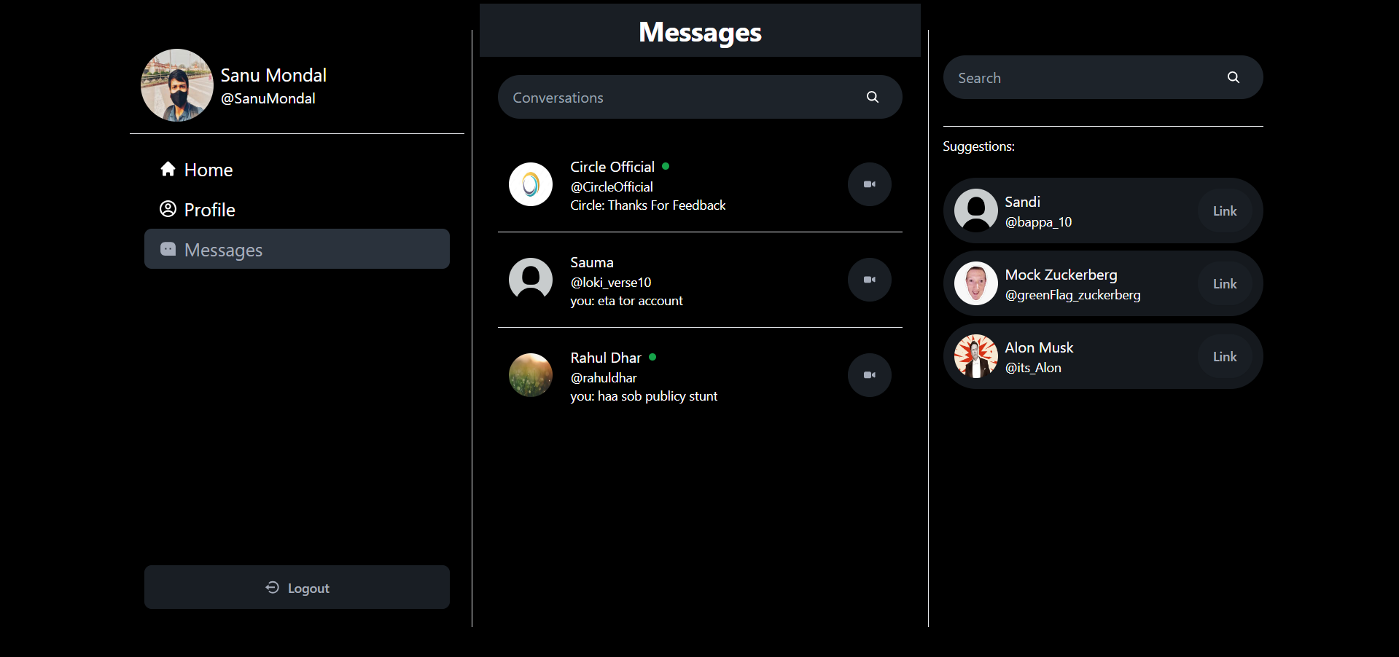

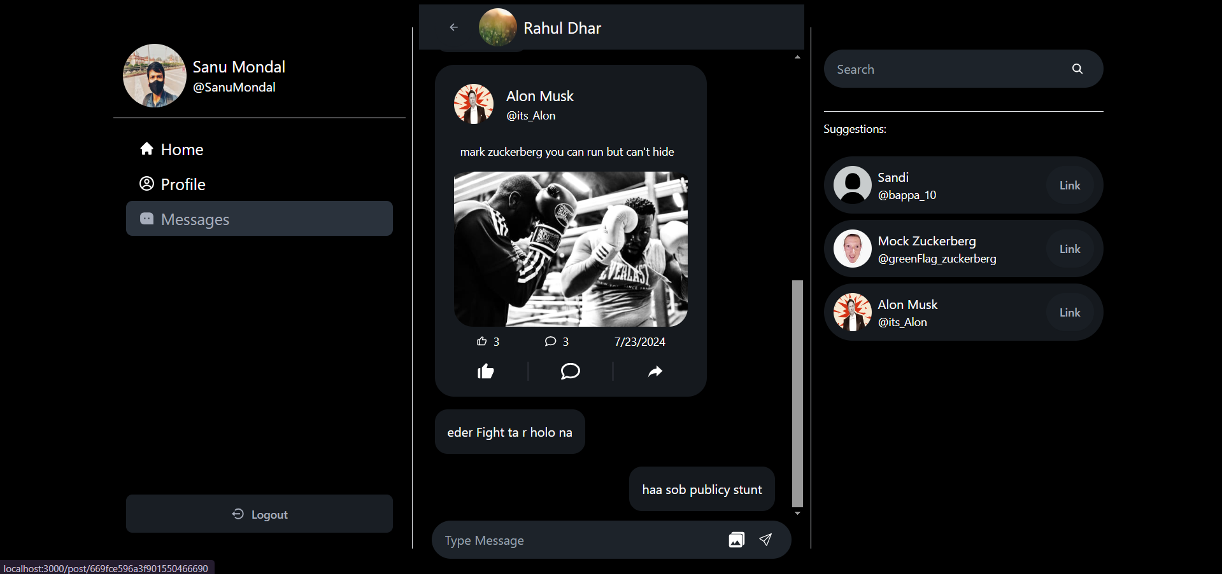

MessagePage.jsx:-
import React, { useEffect } from "react";
import Conversations from "./Conversations";
import Messages from "./Messages";
import { useConversationContext } from "../../Context/ConversationContext";
import { getConversationsHook } from "../../Hooks/GetConversatons.hook";
import VideoPage from "./VideoPage";

const MessagePage = () => {
const { conversation, videoCall } = useConversationContext();
const { useGetConversations } = getConversationsHook();
useEffect(() => {
useGetConversations();
}, [conversation]);
return (
<>
<div className="h-svh lg:w-[500px] md:w-2/3 w-full relative ">
{conversation && !videoCall && (
<div className="h-full md:p-2">
<Messages />
</div>
)}
{!conversation && !videoCall && (
<div className="w-full md:p-2">
<Conversations />
</div>
)}
</div>
</>
);
};

export default MessagePage;

Conversations.jsx:-
import React, { useEffect, useMemo, useState } from "react";
import Conversation from "./Conversation";
import { IoSearch } from "react-icons/io5";
import NewConversation from "./NewConversation";
import { SearchConversationHook } from "../../Hooks/searchConversation.hook";
import { useConversationContext } from "../../Context/ConversationContext";

const Conversations = () => {
const [search, setSearch] = useState("");
const { users, searchConvertationUser } = SearchConversationHook();
const { allConversations } = useConversationContext();

useEffect(() => {
searchConvertationUser(search);
}, [search]);

return (
<div>
<div className="h-[8vh] bg-base-200">
<div className="h-full flex flex-row gap-3 justify-center items-center lg:text-3xl text-2xl text-secondary">
<h1 className="font-bold ">Messages</h1>
</div>
</div>
<div className="w-full px-5 h-[90vh] overflow-auto snap-y">
<div className="py-5">
<label className="input w-full flex items-center justify-end rounded-full">
<input
type="text"
placeholder="Conversations"
className="w-full"
value={search}
onChange={(e) => {
setSearch(e.target.value);
}}
/>
<button className="px-2 rounded-full">
<IoSearch />
</button>
</label>
</div>
{search.length > 0 ? (
<div>
{users.length === 0 && (
<p className="text-center">
You must be Linked with this user to start Conversation
</p>
)}
{users.map((user) => (
<NewConversation key={user._id} user={user} />
))}
</div>
) : (
<div>
{allConversations?.length === 0 && (
<p className="text-center">No Conversations Found</p>
)}
{allConversations &&
allConversations.map((c) => <Conversation key={c._id} c={c} />)}
</div>
)}
</div>
</div>
);
};

export default Conversations;

</button>
</label>
</div>
{search.length > 0 ? (
<div>
{users.length === 0 && (
<p className="text-center">
You must be Linked with this user to start Conversation
</p>
)}
{users.map((user) => (
<NewConversation key={user._id} user={user} />
))}
</div>
) : (
<div>
{allConversations?.length === 0 && (
<p className="text-center">No Conversations Found</p>
)}
{allConversations &&
allConversations.map((c) => <Conversation key={c._id} c={c} />)}
</div>
)}
</div>
</div>
);
};

export default Conversations;

Conversation.jsx:-
import React, { useEffect, useState } from "react";
import { IoIosVideocam } from "react-icons/io";
import { useConversationContext } from "../../Context/ConversationContext";
import { useSocketContext } from "../../Context/SocketContext";
import { VideoCallHook } from "../../Hooks/VideoCallHook";
import { useNavigate } from "react-router-dom";
import { FcVideoCall } from "react-icons/fc";
import { FcEndCall } from "react-icons/fc";
import { set } from "mongoose";

const Conversation = ({ c }) => {
const { setConversation } = useConversationContext();
const { onlineUsers } = useSocketContext();
const { StartCall, EndCall } = VideoCallHook();
const { socket } = useSocketContext();
const [isCalling, setIsCalling] = useState(false);
const navigate = useNavigate();

const handleCall = async () => {
StartCall(c.members[0]);
navigate("/video/"+c.members[0]._id);
};
const handleEndCall = async () => {
EndCall(c.members[0]._id);
setIsCalling(false);
};

const handleClick = () => {
setConversation(c);
};
useEffect(() => {
setConversation(null);
if (socket) {
socket.on("calluser", (callerid) => {
if (c.members[0]._id === callerid) {
setIsCalling(callerid);
}
});
return () => {
socket.off("calluser");
}
}
}, [socket]);
return (
<div className="snap-center border-b last:border-0">
<div className="flex items-center justify-between my-2 p-3">
<div
className="flex gap-3 items-center w-full cursor-pointer"
onClick={handleClick}
>
<img
src={c.members[0].profilePic}
className="w-12 h-12 rounded-full"
/>
<div className="flex flex-col">
<div className="flex items-center gap-2">
<span className="pl-2">{c.members[0].name}</span>
{onlineUsers?.includes(c.members[0]._id) && (
<div className="h-2 w-2 rounded-full bg-green-600"></div>
)}
</div>
<span className="pl-2 text-two text-sm">
@{c.members[0].username}
</span>
<span className="pl-2 overflow-hidden h-5 text-sm">
{c.lastMessage?.sender === c.members[0]._id
? c.members[0].name.split(" ")[0]
: "you"}
: {c.lastMessage?.type === "image" && "Shared a Image"}
{c.lastMessage?.type === "text" && c.lastMessage?.content}
{c.lastMessage?.type === "post" && "Shared a Post"}{" "}
</span>
</div>
</div>
{isCalling ? (
<div className="flex gap-2 justify-center items-center">
<button className="btn rounded-full" onClick={handleCall}>
<FcVideoCall />
</button>
<button className="btn rounded-full" onClick={handleEndCall}>
<FcEndCall />
</button>
</div>
):(
<button className="btn rounded-full" onClick={handleCall}>
<IoIosVideocam />
</button>
)}
</div>
</div>
);
};

export default Conversation;

}
});
return () => {
socket.off("calluser");
}
}
}, [socket]);
return (
<div className="snap-center border-b last:border-0">
<div className="flex items-center justify-between my-2 p-3">
<div
className="flex gap-3 items-center w-full cursor-pointer"
onClick={handleClick}
>
<img
src={c.members[0].profilePic}
className="w-12 h-12 rounded-full"
/>
<div className="flex flex-col">
<div className="flex items-center gap-2">
<span className="pl-2">{c.members[0].name}</span>
{onlineUsers?.includes(c.members[0]._id) && (
<div className="h-2 w-2 rounded-full bg-green-600"></div>
)}
</div>
<span className="pl-2 text-two text-sm">
@{c.members[0].username}
</span>
<span className="pl-2 overflow-hidden h-5 text-sm">
{c.lastMessage?.sender === c.members[0]._id
? c.members[0].name.split(" ")[0]
: "you"}
: {c.lastMessage?.type === "image" && "Shared a Image"}
{c.lastMessage?.type === "text" && c.lastMessage?.content}
{c.lastMessage?.type === "post" && "Shared a Post"}{" "}
</span>
</div>
</div>
{isCalling ? (
<div className="flex gap-2 justify-center items-center">
<button className="btn rounded-full" onClick={handleCall}>
<FcVideoCall />
</button>
<button className="btn rounded-full" onClick={handleEndCall}>
<FcEndCall />
</button>
</div>
):(
<button className="btn rounded-full" onClick={handleCall}>
<IoIosVideocam />
</button>
)}
</div>
</div>
);
};

export default Conversation;

<FcVideoCall />
</button>
<button className="btn rounded-full" onClick={handleEndCall}>
<FcEndCall />
</button>
</div>
):(
<button className="btn rounded-full" onClick={handleCall}>
<IoIosVideocam />
</button>
)}
</div>
</div>
);
};

export default Conversation;

Messages.jsx:-
import React, { useEffect, useState } from "react";
import Message from "./Message";
import { BsSend } from "react-icons/bs";
import { IoArrowBackOutline } from "react-icons/io5";
import { useConversationContext } from "../../Context/ConversationContext";
import { useMessageContext } from "../../Context/MessageContext";
import { sendMessageHook } from "../../Hooks/SendMessage.hook";
import AddImage from "../common/AddImage";
import { IoMdClose } from "react-icons/io";
import toast from "react-hot-toast";
import GetNewMessageHook from "../../Hooks/GetNewMessageHook";

const Messages = () => {
const { conversation, setConversation } = useConversationContext();
const { messages, setMessages } = useMessageContext();
const [input, setInput] = useState("");
const [image, setImage] = useState(null);
const [preview, setPreview] = useState(null);
const { sendMessage, sendImage } = sendMessageHook();
const [loading, setLoading] = useState(false);
const handleSend = async (e) => {
e.preventDefault();
setLoading(true)
try{
if (!input && !image) return toast.error("Message can't be empty");
if (image) {
await sendImage(conversation, image);
}else{
await sendMessage(conversation, input);
}
setInput("");
setImage(null);
setPreview(null);
}catch(error){
toast.error("Error Sending Message")
}finally{
setLoading(false)
}

};

GetNewMessageHook();

useEffect(() => {
const getMessages = async () => {
try {
const res = await fetch(`/api/message/getmessage/${conversation._id}`);
const data = await res.json();
if(data.error){
setMessages([]);
}
setMessages(data);
} catch (error) {
true;
}
};
getMessages();
}, []);
return (
<div className="h-full flex flex-col">
<div className="h-[10vh] bg-base-200">
<div className="h-full flex flex-row gap-3 justify-start px-4 items-center text-secondary">
<div className="flex gap-2 justify-center items-center p-1">
<button
className="btn rounded-full"
onClick={() => {
setConversation(null);
}}
>
<IoArrowBackOutline />
</button>
<img
src={conversation.members[0].profilePic}
className="w-12 h-12 rounded-full"
/>
<h1 className="text-xl h-">{conversation.members[0].name}</h1>
</div>

</div>
</div>
<div className="h-[90vh] flex flex-col justify-end pb-16 md:pb-0">
{messages.length > 0 ? (
<div className="w-full p-3 py-1 overflow-auto">
{messages.map((msg) => (
<Message key={msg._id} msg={msg} chat={conversation.members[0]} />
))}
</div>
) : (
<p className="w-full text-center py-5">
Send Message to Start Conversation
</p>
)}
{preview && (
<div className="flex flex-col items-end m-3 px-4 relative">
<p
className="absolute top-0 right-4 p-4 text-white text-xl"
onClick={() => {
setImage(null)
setPreview(null)
}}
>
<IoMdClose />
</p>
<div className="max-h-[70vh] overflow-auto justify-center w-full">
<img src={preview} alt="preview" className="w-full rounded-lg bg-transparent" />
</div>
</div>
)}
<div className="p-4 pt-0">
<form className="input w-full flex items-center justify-end rounded-full" onSubmit={handleSend}>

<input
type="text"
placeholder="Type Message"
className="w-full"
value={input}
disabled={image}
onChange={(e) => {

setInput(e.target.value);
}}
/>
<div className="flex gap-2">
<AddImage setImage={setImage} setPreview={setPreview} />
<button className="px-2 rounded-full" type="submit" disabled={loading}>
{loading ? (<div className="loading loading-spinner"></div>):<BsSend className="text-secondary" />}
</button>
</div>
</form>
</div>
</div>
</div>
);
};

export default Messages;

Message.jsx:-
import React, { useEffect, useRef, useState } from "react";
import { useUserContext } from "../../Context/UserContext";
import Post from "../common/Post";
import { GetPostHook } from "../../Hooks/GetPost.hook";

const Message = ({ msg }) => {
const { user } = useUserContext();
const [post, setPost] = useState(null);
const {useGetPost} = GetPostHook();
const m = useRef(null)
useEffect(() => {
m.current.scrollIntoView({ behavior: "smooth" });
if(msg.type === "post") {
const fetchPost = async () => {
const p = await useGetPost(msg.content);
if(p.error){
return;
}
setPost(p);
};
fetchPost();
}
}, [msg,m])
return (
<div className={`w-full`}>
<div
className={`w-full flex items-center p-2 justify-${
user.id === msg.sender ? "end" : "start"
}`}
>
<div className="max-w-[80%]" ref={m}>
{msg.type === "image" && (
<img src={msg.content} className="rounded-3xl" />
) }
{msg.type === "text" && (
<div className="bg-base-300 p-4 rounded-2xl flex flex-wrap w-fit">
{msg.content}
</div>
)}
{msg.type === "post" && (
<div className="bg-base-300 rounded-3xl">

{
post === null ? <div className="bg-base-300 p-4 rounded-2xl flex flex-wrap w-fit">Post not Found</div> : <Post post={post} />
}
</div>
)}
</div>
</div>
</div>
);
};

export default Message;

VideoCall.jsx:-
import React, { useEffect, useMemo, useRef, useState } from "react";
import { useConversationContext } from "../../Context/ConversationContext";
import { MdOutlineCallEnd } from "react-icons/md";
import { useSocketContext } from "../../Context/SocketContext";
import { VideoCallHook } from "../../Hooks/VideoCallHook";

const VideoPage = () => {
const { videoCall, setVideoCall } = useConversationContext();
const myVideo = useRef();
const remoteVideo = useRef();
const { peer, peerMap } = useSocketContext();
const {EndCall} = VideoCallHook();
var Call

const handleEndCall = () => {
EndCall();
setVideoCall(null);
};

const getcall = () => {
peer.on("call", function (call) {
console.log("answering call");
navigator.mediaDevices
.getUserMedia({ video: true, audio: true })
.then((stream) => {
call.answer(stream);
myVideo.current.srcObject = stream || null;
call.on("stream", (remoteStream) => {
if (remoteStream) {
remoteVideo.current.srcObject = remoteStream;
}
});
});
});
};

useEffect(() => {

navigator.mediaDevices

.getUserMedia({ video: true, audio: true })
.then((stream) => {
myVideo.current.srcObject = stream || null;
Call = peer.call(peerMap[videoCall], stream);
Call.on("stream", (remoteStream) => {
if (remoteStream) {
remoteVideo.current.srcObject = remoteStream;
}
});
});

getcall();
}, [videoCall]);

window.addEventListener("beforeunload", () => {
Call.close();
handleEndCall();
});

return (
<div className="flex flex-col justify-center items-start h-full p-4 py-6">
<div className="h-[40%] w-full bg-base-300 rounded-t-3xl">
<video
className=" rounded-t-3xl object-cover h-full w-full"
ref={myVideo}
autoPlay
>

</video>
</div>
<div className="h-[40%] w-full bg-base-300">
<video
className="object-cover h-full w-full"
ref={remoteVideo}
autoPlay
>

</video>

</div>
<div className="h-[14%] w-full bg-base-300 flex justify-around items-center rounded-b-3xl">
<button
className="btn btn-error rounded-full text-3xl"
onClick={handleEndCall}
>
<MdOutlineCallEnd />
</button>
</div>
</div>
);
};

export default VideoPage;

Header.jsx:-
import React from "react";
import { FaCircleNotch } from "react-icons/fa";
import { useThemeContext } from "../../Context/ThemeContext";

const Header = () => {
const { theme, setTheme } = useThemeContext();
return (
<div className="w-full">
<div className="h-[8vh] bg-base-200">
<div className="h-full flex flex-row justify-center items-center lg:text-3xl text-2xl text-secondary">
<button
className="btn btn-ghost rounded-full text-2xl p-3"
onClick={() => {
theme === "dark" ? setTheme("light") : setTheme("dark");
}}
>
<FaCircleNotch className="text-two" />
</button>
<h1 className="font-bold "> Circle</h1>
</div>
</div>
</div>
);
};

export default Header;

AddImage.jsx:-
import React, { useRef } from "react";
import { IoMdPhotos } from "react-icons/io";

const AddImage = ({ setImage, setPreview }) => {
const fileInput = useRef(null);
const handleImage = (e) => {
const file = e.target.files[0];
const reader = new FileReader();
reader.onloadend = () => {
setImage(reader.result);
};
reader.readAsDataURL(file);
setImage(reader.result);
setPreview(URL.createObjectURL(file));
};

return (
<div className="flex">

<div>
<input
type="file"
className="hidden"
ref={fileInput}
accept="image/*"
onChange={handleImage}
/>
<IoMdPhotos
className="text-2xl cursor-pointer"
onClick={() => fileInput.current.click()}
/>
</div>
</div>
);
};

export default AddImage;

Real-Time Messaging: -

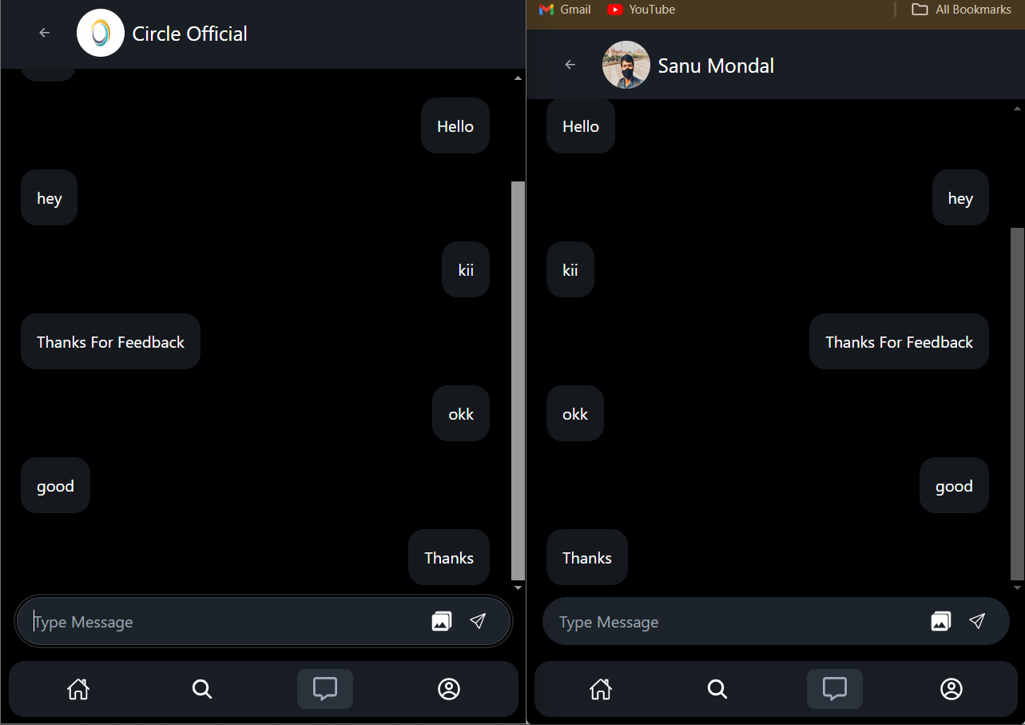

Post: -

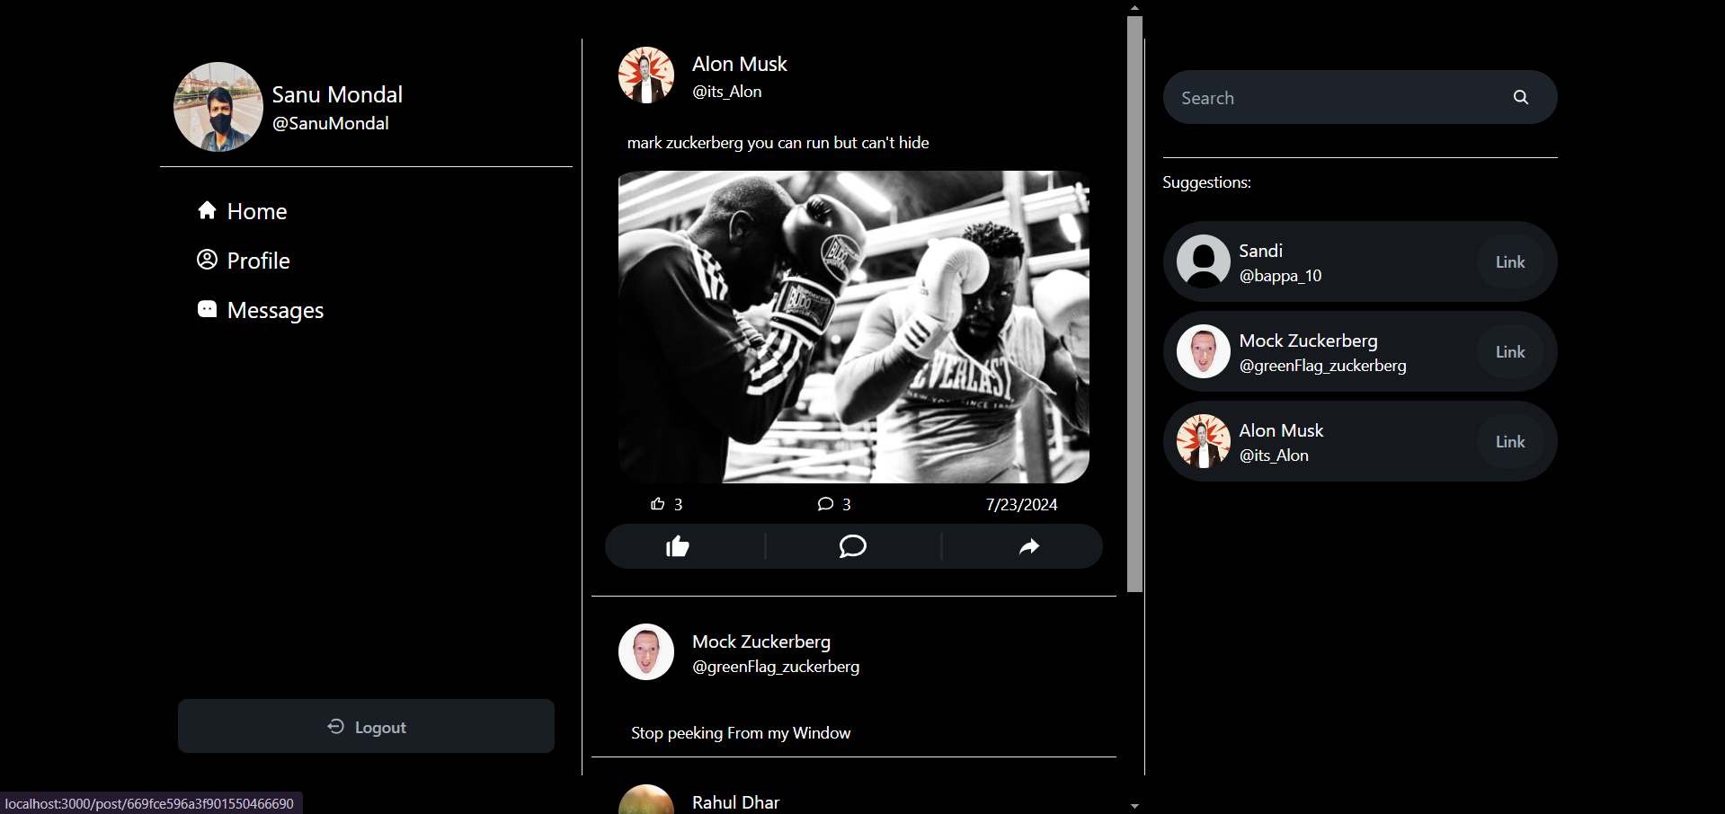

Share - Post: -

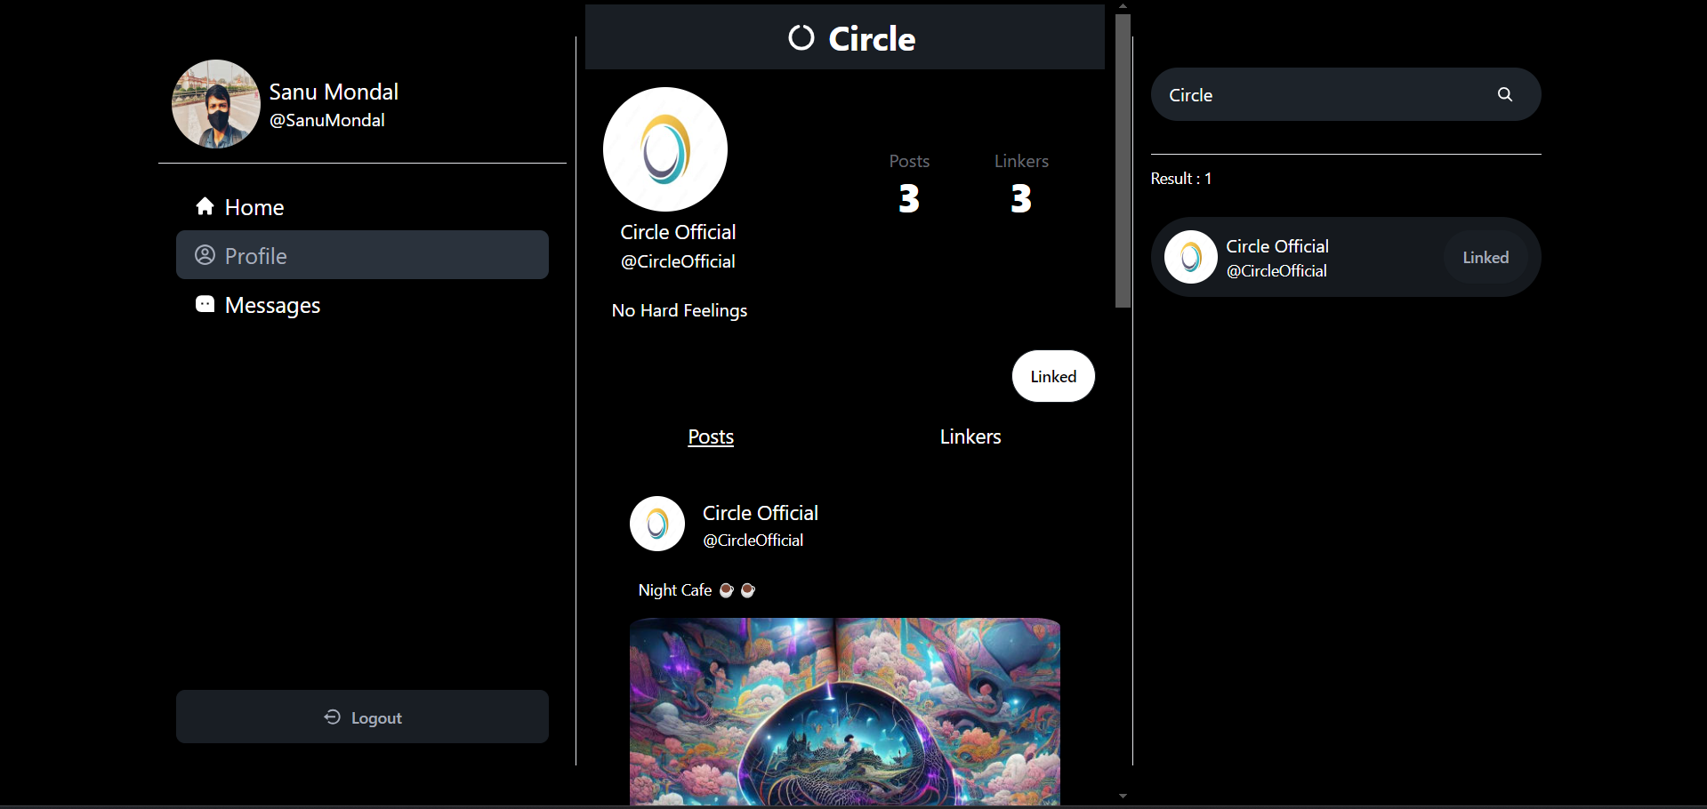

Other Profiles: -


Video Call: -

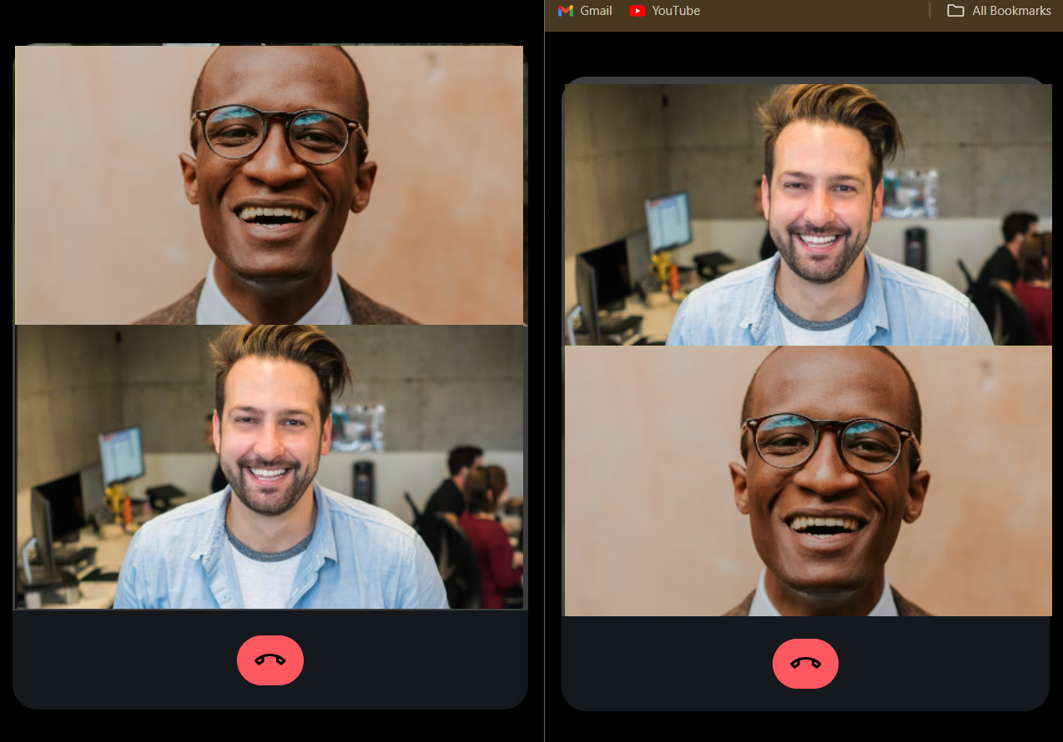

- Data Base

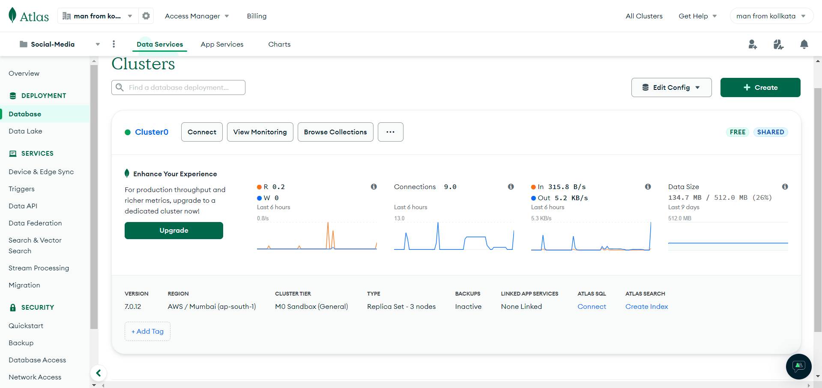

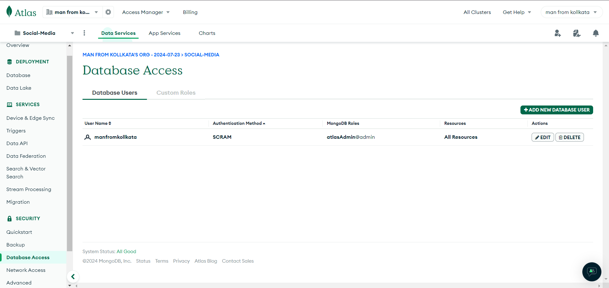

- Collections:

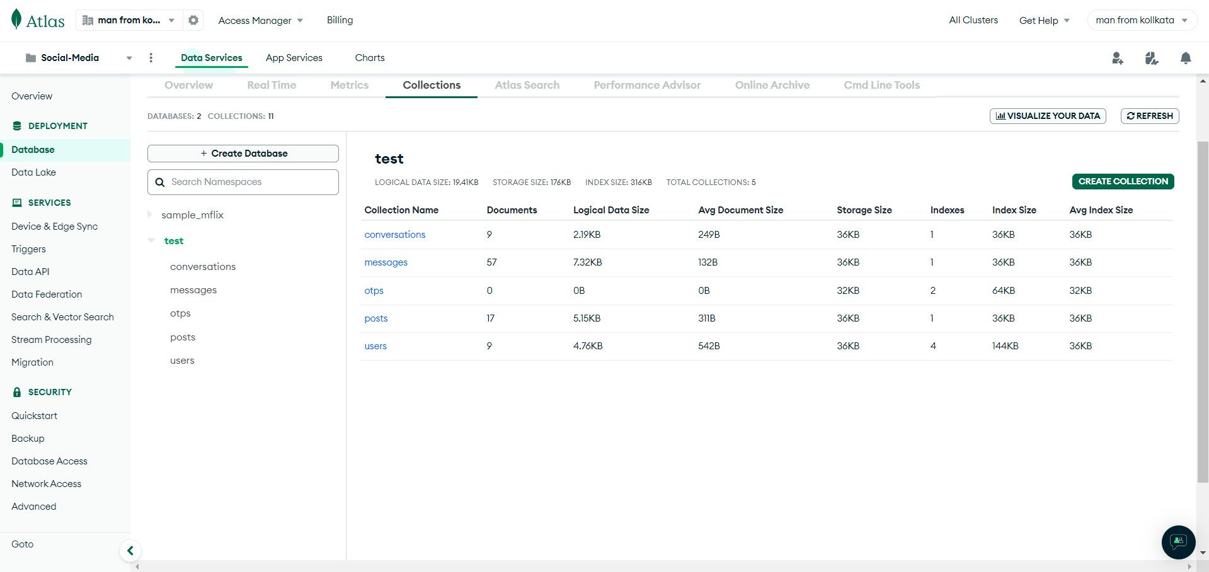

1.User Collection:

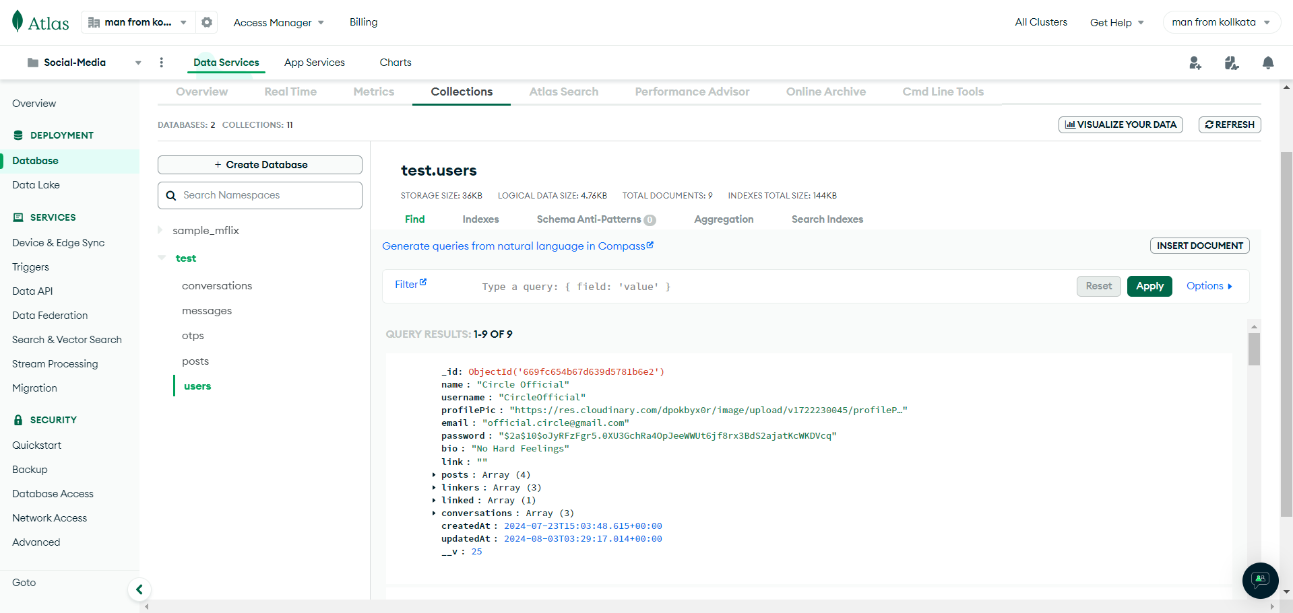

2.Post Collection:

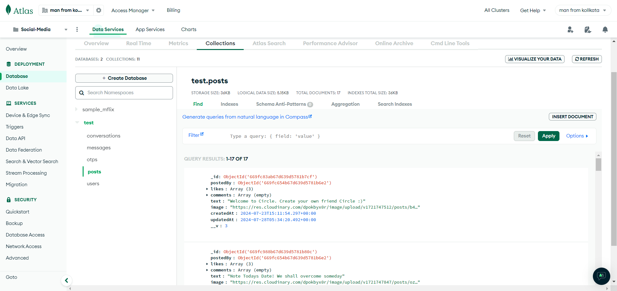

3.Otp Collection:

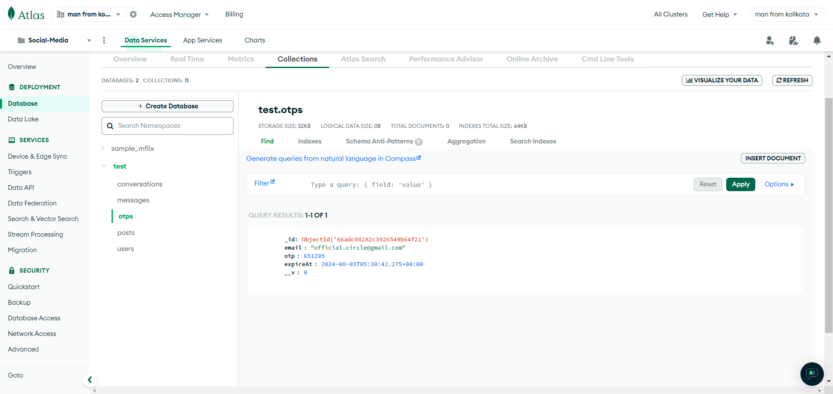

4.Message Collection:

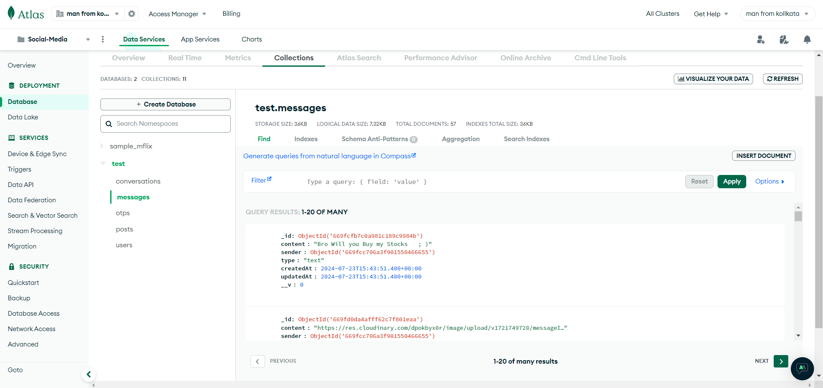

5.Conversation Collection:

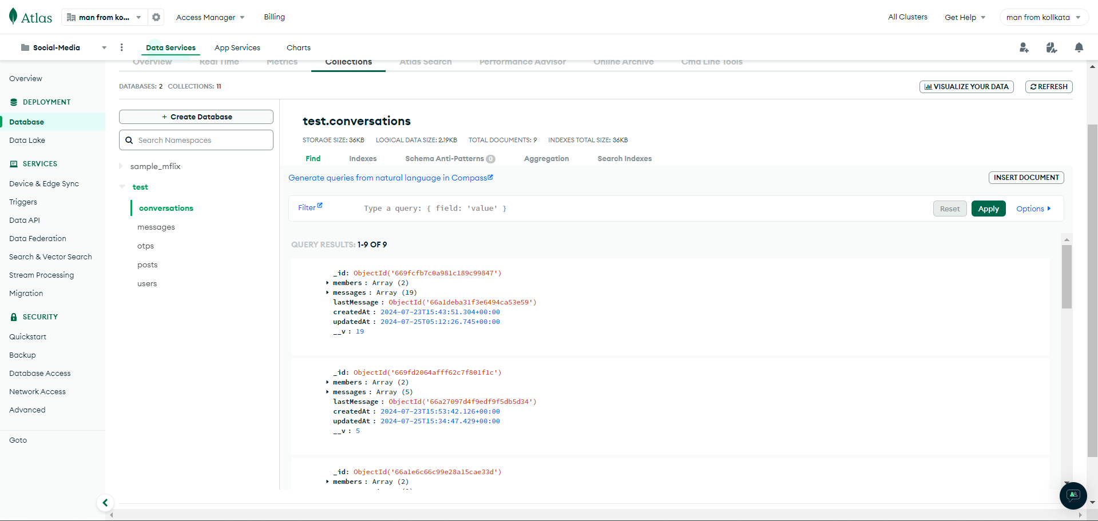

CONCLUSION

In conclusion, the development of our social media website represents a strategic effort to create a simple, yet effective platform for connecting users and fostering meaningful interactions. By focusing on core functionalities such as user registration, profile management, content sharing, messaging, and robust security measures, we aim to provide a seamless and enjoyable user experience.

Throughout this project, our commitment to user feedback and continuous improvement will ensure that the platform evolves to meet the needs and preferences of our community. By prioritizing user privacy, safety, and accessibility, we are confident that our social media website will become a trusted and valued space for users to express themselves, connect with others, and build lasting relationships. This project not only sets the foundation for a successful launch but also paves the way for future enhancements and growth, aligning with our long-term vision of creating a positive and inclusive online environment.

FUTURE SCOPE AND FURTHER ENHANCEMENTS

As we look to the future, there are numerous opportunities to expand and enhance our social media website, ensuring it remains a dynamic and engaging platform for our users. One key area of focus will be the continuous improvement of our user interface and user experience, incorporating user feedback to make the platform more intuitive and enjoyable. We plan to introduce advanced content discovery algorithms to better tailor the user feed and recommendations, enhancing content relevance and user engagement.

Further enhancements will include the integration of additional social features such as groups and communities, where users can join and interact with others who share similar interests. Implementing notifications, event planning and coordination tools will allow users to organize and participate in both virtual and real-life events, fostering deeper connections. We also aim to introduce enhanced security features, including two-factor authentication and improved content moderation tools powered by AI, to ensure a safe and secure environment for all users.

Overall, the future scope of our social media website is vast, with numerous possibilities for growth and innovation. By staying attuned to user needs and industry trends, we will continue to enhance our platform, ensuring it remains a relevant, valuable, and enjoyable space for all our users.

BIBLIOGRAPHY

- www.w3schools.com
- www.youtube.com
- www.pexels.com
- www.codepen.io
- www.google.com
- www.googlefont.com
- www.react.our
- www.codingworld.com

