Overview

This application facilitates and bridge the gap between service providers (vendor-service) and the service receiver (customer-service). The service receivers can hire electricians, yoga trainers and can also avail salon services (both men and women). When a service is requested, the Admin team (admin-service) will be notified first about the request, then they will send a notification to all the expert professionals from the service provider team who are skilled in that particular profession and also are located nearby and once any of the notified experts accept the request, the same will be notified to the customer. There are 5 services in total

vendor-service: provides all the package details and the vendor related information

customer-service: allows customers to avail for specific service(s) and contains other customer related information

admin-service: delegates customer requests to vendor services and vice versa and contains vendor related information.

eureka-naming-server: acts as a service discovery

api-gateway: gateway for all requests.

High Level Design

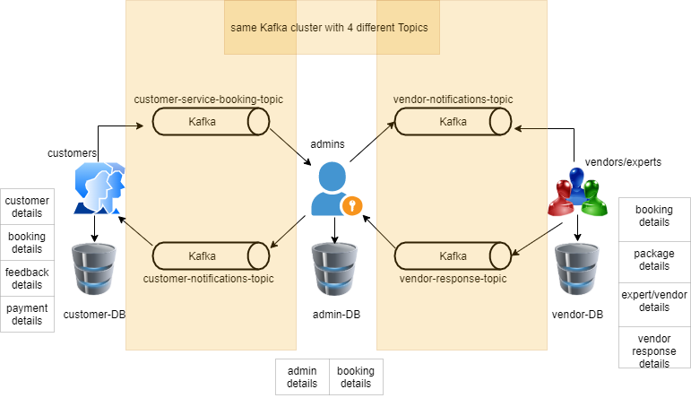

Sequence Diagram

Below image depicts the sequence flow for the service booking details

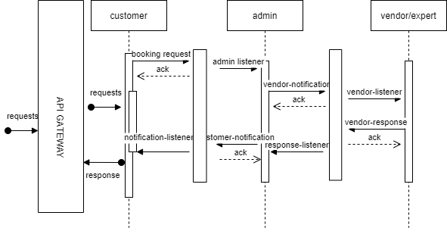

In Details with assumptions

Sample request/response

Tools and Technologies