Filter Rejection Analysis - GNSS / NavIC Active Antenna RF Chains
In-band insertion loss and ripple, near-band and out-of-band rejection of the L1, L2/L5 and NavIC S chains
Rev. A | 2026-10-31 | basis: manufacturer data sheets + circuit simulation

1 Summary
- All filters meet their data-sheet attenuation limits (smallest margin ~3 dB: B8889 cellular bands and the DXP.02.A paths); TA1442A matches its printed VNA markers (46.7 dB at 2390 MHz, 54.0 dB at 2575 MHz).
- Far out of band the chains reject strongly: e.g. LTE B3 uplink 119 dBc after the two B7504 (L1), GSM-900 90 dBc after the two B8889 (L2/L5), 5G n78 90 dBc after the two TA1442A (S). Values beyond ~60-80 dBc are limited by layout leakage in practice.
- Near-band rejection is the weak point of every chain: L1 upper skirt (Iridium 1621 MHz: 20.5 dBc after two filters), L2/L5 lower skirt (DME 1150 MHz: 6.2 dBc), NavIC S (Wi-Fi ch 13 2472 MHz: 1.4 dBc; LTE B41 2506 MHz: 0.0 dBc - inside the filter pass-band).
- Aviation signals are well rejected in the L2/L5 chain: SSR/IFF interrogation 1030 MHz 82 dBc, SSR/ADS-B reply 1090 MHz 85 dBc; the risk is the DME band edge just below L5.
- In band (worst point of each band, G2 excluded): two SAW filters cost B1I 2.2 dB, L1 C/A / E1 / B1C 1.8 dB, G1 2.2 dB, L5 / E5a / B2a 2.0 dB, E5b / B2b 2.2 dB, L2 3.1 dB, G3 1.9 dB, NavIC S SPS 3.1 dB; with the diplexer the L-band filter loss is 5.1-6.7 dB. The LNA ahead of the filters keeps the system noise figure at 0.6-1.2 dB.

2 Chains and filter positions
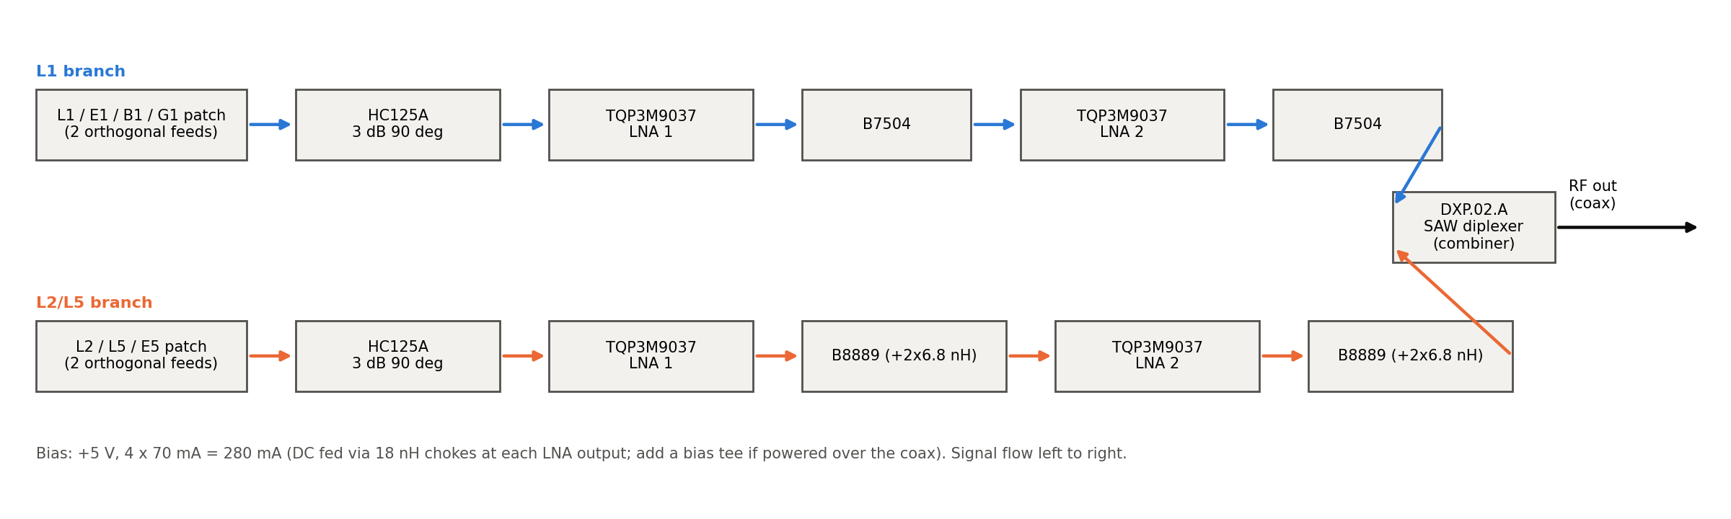
Figure 1 - L-band chains (L1 and L2/L5 combined by the DXP.02.A diplexer).
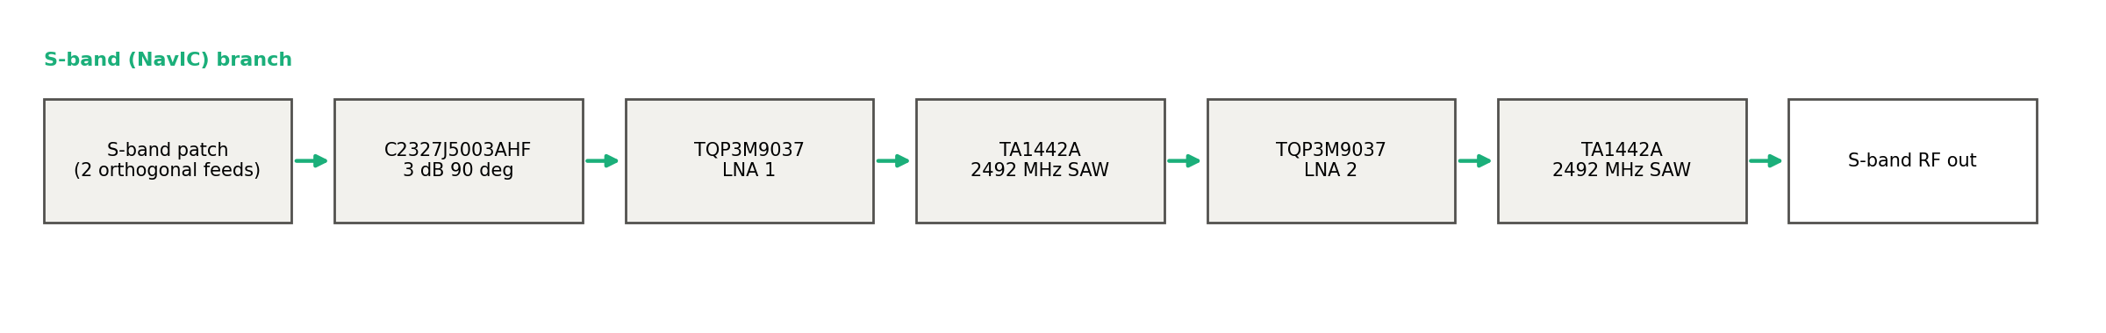
Figure 2 - NavIC S-band chain.
Chain | Filter 1 | Filter 2 | Combiner | Reference (0 dBc)
L1 | B7504 after LNA 1 | B7504 after LNA 2 | DXP.02.A L1 path | 1575.42 MHz
L2/L5 | B8889 (+2 x 6.8 nH) after LNA 1 | B8889 after LNA 2 | DXP.02.A L2/L5 path | 1176.45 MHz
NavIC S | TA1442A after LNA 1 | TA1442A after LNA 2 | - (separate output) | 2492.028 MHz
Table 1 - Filter positions. No filter is in front of LNA 1 in any chain.
Definitions: rejection (dBc) = attenuation at f minus attenuation at the band centre, i.e. how far below the wanted signal an interferer is passed. 'In band' = inside the GNSS signal band (insertion loss, ripple); 'near band' = the filter skirts within ~100 MHz of the band; 'out of band' = everything further away. 'Complete chain' includes the hybrid, the LNAs and their bias networks.
Rejection(f) [dBc] = IL(f) - IL(f_c); two identical filters: Rej_2(f) = 2 x Rej_1(f); chain: Rej = sum of the filter rejections (+ LNA gain slope)

3 In-band performance
Chain | Band | MHz | 1 SAW IL mean dB | 2 SAW IL max dB | 2 SAW ripple dB | +DXP IL max dB | +DXP ripple dB | System gain ripple dB
L1 | B1I | 1559.05-1563.14 | 1.06 | 2.24 | 0.20 | 6.02 | 0.38 | 0.51
L1 | L1 C/A / E1 / B1C | 1574.40-1576.44 | 0.90 | 1.82 | 0.04 | 5.13 | 0.05 | 0.34
L1 | L1 wide (E1/B1C 4.092 MHz) | 1573.37-1577.47 | 0.90 | 1.86 | 0.12 | 5.18 | 0.13 | 0.79
L1 | G1 (FDMA) | 1597.50-1605.90 | 1.04 | 2.23 | 0.23 | 5.79 | 0.29 | 0.11
L2/L5 | L5 / E5a / B2a | 1166.22-1186.68 | 0.92 | 2.00 | 0.44 | 5.33 | 0.71 | 1.14
L2/L5 | E5b / B2b | 1196.91-1217.37 | 0.88 | 2.15 | 0.55 | 5.56 | 0.83 | 0.42
L2/L5 | L2 | 1226.58-1228.62 | 1.48 | 3.12 | 0.29 | 6.69 | 0.32 | 0.41
L2/L5 | G3 (CDMA) | 1197.65-1212.95 | 0.85 | 1.88 | 0.28 | 5.22 | 0.48 | 0.41
L2/L5 | G2 (FDMA) | 1242.94-1251.69 | 5.23 | 17.54 | 10.28 | 21.94 | 10.68 | 10.75
S | NavIC S SPS (2.046 MHz) | 2490.01-2494.05 | 1.50 | 3.07 | 0.14 | - | - | 0.17
S | TA1442A spec band | 2489.50-2494.50 | 1.50 | 3.12 | 0.19 | - | - | 0.22
S | NavIC S RS (16.5 MHz) | 2483.78-2500.28 | 1.53 | 3.40 | 0.50 | - | - | 0.47
Table 2 - In-band insertion loss and ripple of the filter chain, and gain ripple of the complete chain. G2 is outside the B8889 pass-band (large loss and ripple).
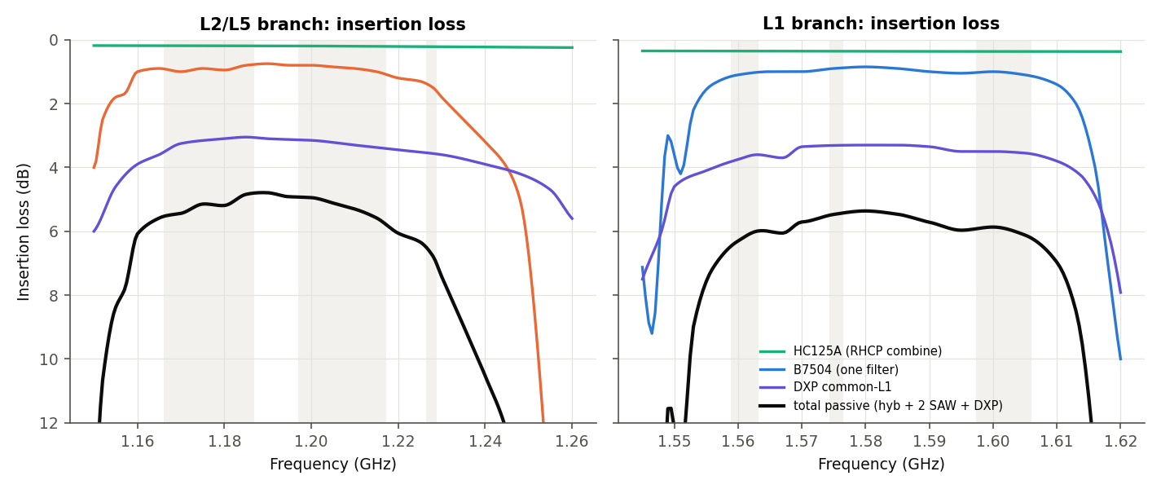
Figure 3 - L-band insertion loss: hybrid, one SAW, DXP path and total passive loss.
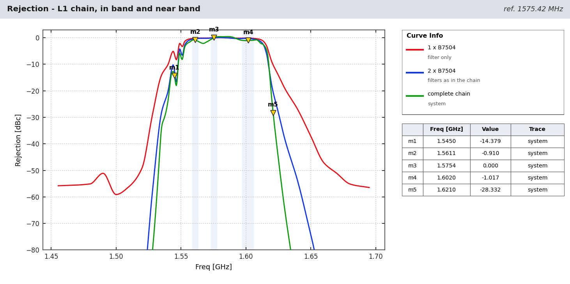
Figure - L1 chain, in band and near band (shaded: signal bands).
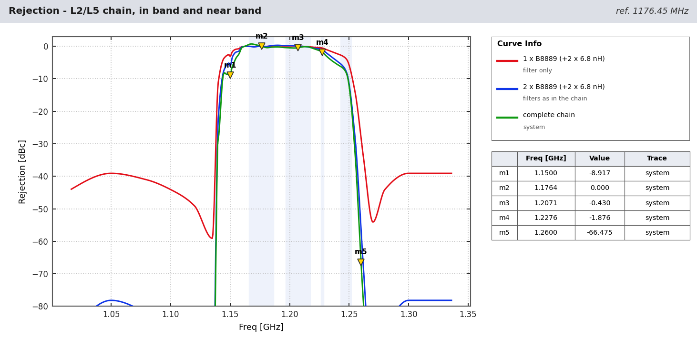
Figure - L2/L5 chain, in band and near band (shaded: signal bands).
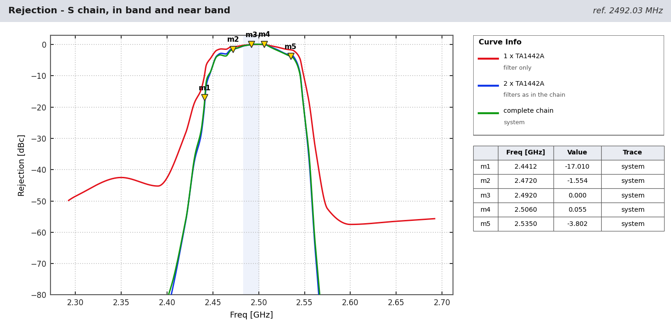
Figure - NavIC S chain, in band and near band (shaded: signal bands).

4 Filter compliance with the data sheets
Filter | Band (MHz) | Spec min att. (dB) | Spec typ (dB) | Model min att. (dB) | Margin (dB)
B7504 | 10-925 | 45 | 58 | 58.0 | 13.0
B7504 | 814-915 | 45 | 58 | 58.3 | 13.3
B7504 | 925-960 | 45 | 60 | 59.4 | 14.4
B7504 | 1427-1463 | 50 | 55 | 56.6 | 6.6
B7504 | 1695-1710 | 50 | 53 | 57.4 | 7.4
B7504 | 1710-1785 | 50 | 53 | 60.0 | 10.0
B7504 | 1850-1980 | 45 | 53 | 54.0 | 9.0
B7504 | 2010-2025 | 45 | 55 | 54.9 | 9.9
B7504 | 2305-2315 | 45 | 52 | 52.0 | 7.0
B7504 | 2401-2483 | 45 | 50 | 49.5 | 4.5
B7504 | 2500-2570 | 45 | 49 | 48.8 | 3.8
B7504 | 4400-4900 | 35 | 41 | 41.0 | 6.0
B7504 | 5150-5850 | 35 | 42 | 42.0 | 7.0
B8889 | 698-748 | 46 | 49 | 49.0 | 3.0
B8889 | 777-798 | 44 | 48 | 47.7 | 3.7
B8889 | 807-915 | 41 | 45 | 45.7 | 4.7
B8889 | 925-960 | 41 | 45 | 45.0 | 4.0
B8889 | 1427-1463 | 30 | 42 | 40.6 | 10.6
B8889 | 1626.5-1660.5 | 20 | 32 | 32.0 | 12.0
B8889 | 1695-1785 | 25 | 40 | 35.9 | 10.9
B8889 | 1850-2025 | 30 | 45 | 43.8 | 13.8
B8889 | 2300-2400 | 36 | 42 | 40.3 | 4.3
B8889 | 2400-2483 | 33 | 39 | 38.2 | 5.2
B8889 | 2500-2690 | 33 | 37 | 36.7 | 3.7
B8889 | 3400-3800 | 29 | 33 | 32.5 | 3.5
B8889 | 5150-5925 | 22 | 26 | 25.1 | 3.1
DXP L1 | 600-1330 | 32 | 38 | 39.0 | 3.7
DXP L1 | 1660-2000 | 27 | 33 | 33.0 | 2.7
DXP L2/L5 | 600-1100 | 17 | 23 | 24.0 | 3.7
DXP L2/L5 | 1320-2000 | 20 | 28 | 29.0 | 5.7
TA1442A | 10-2390 | 33 | 40 | 41.0 | 8.0
TA1442A | 2575-3000 | 43 | 50 | 50.0 | 7.0
Table 3 - Worst-case attenuation of each filter in its specified stop bands (all pass).
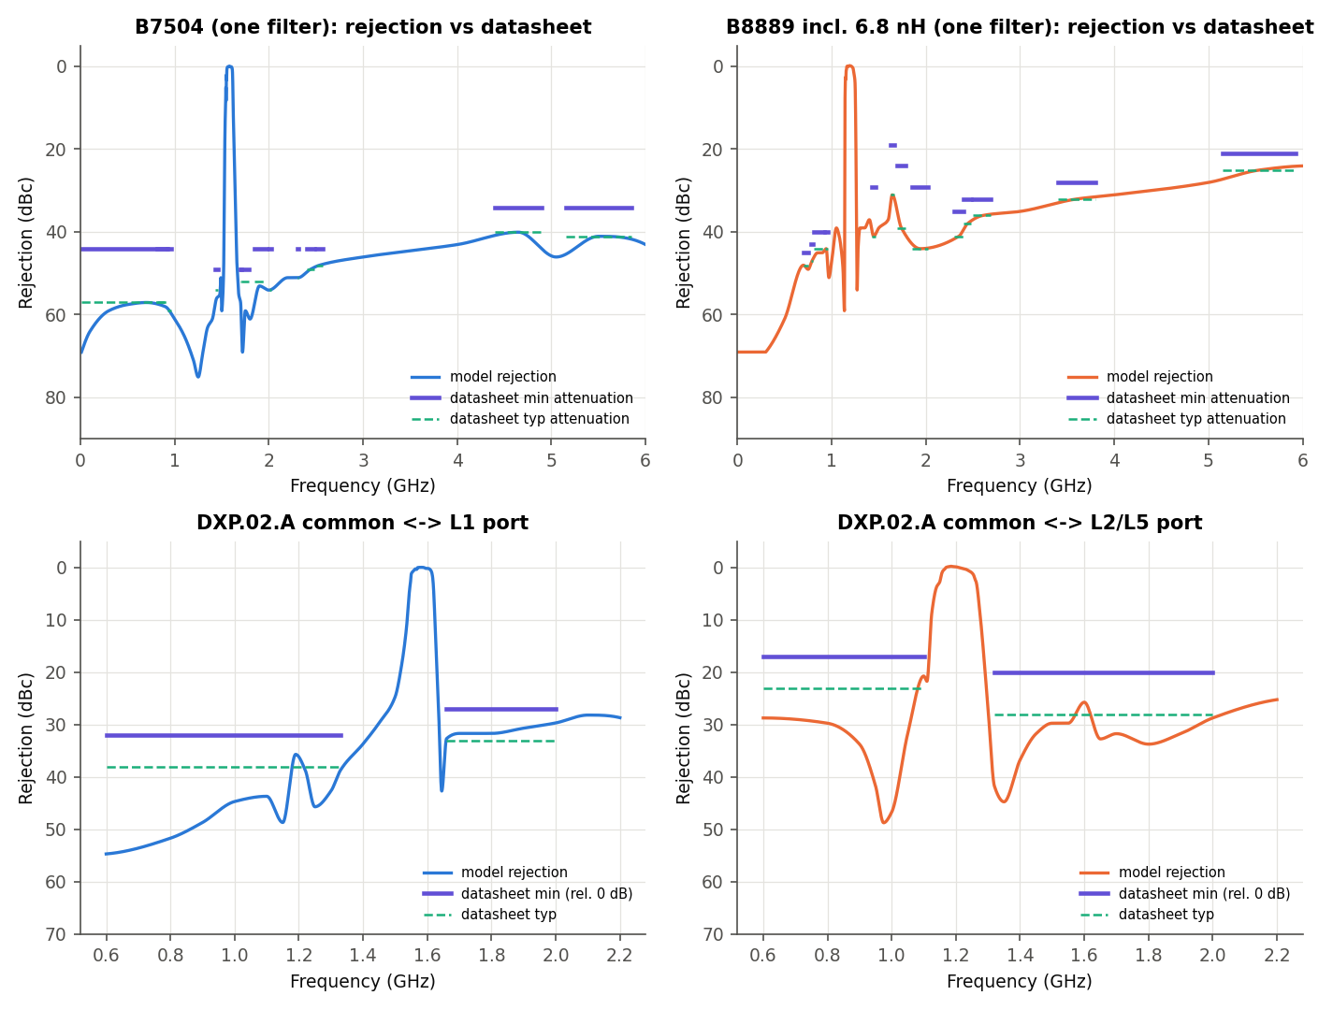
Figure - L-band filters against the data-sheet limits.
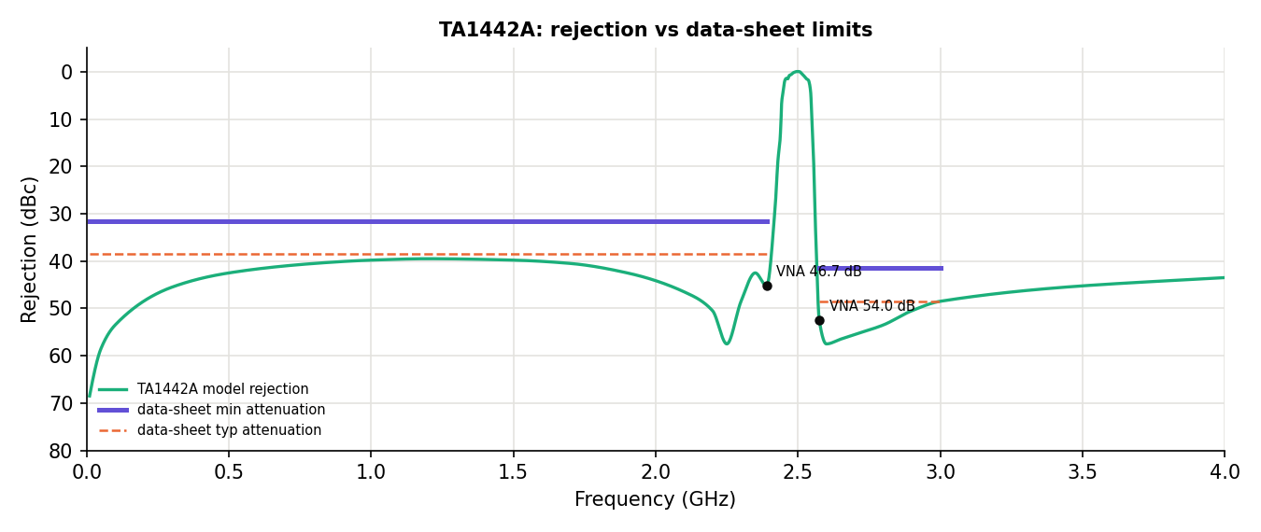
Figure - TA1442A against the data-sheet limits and VNA markers.

5 Near-band and out-of-band rejection of the chains

5.1 L1 chain
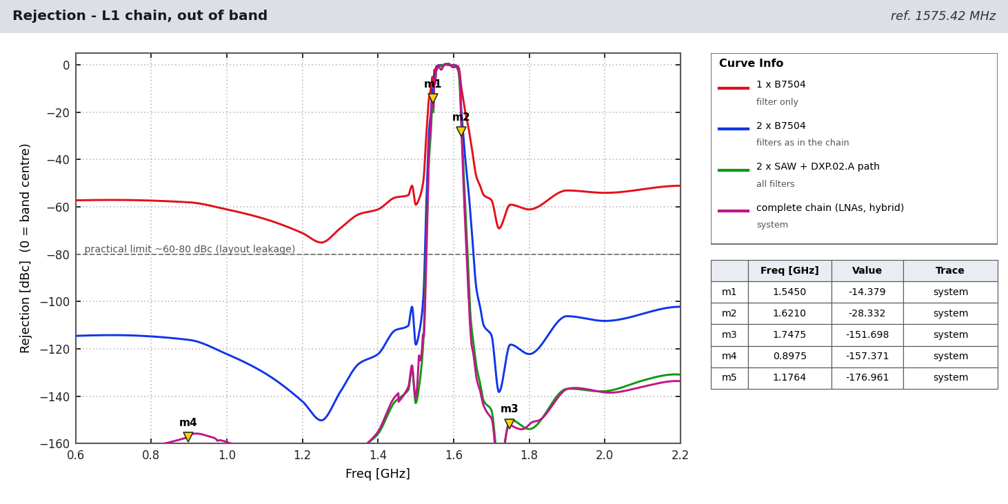
Figure - L1 chain rejection after each filter stage and for the complete chain.
f (MHz) | Service / point | 1 SAW dBc | 2 SAW dBc | 2 SAW + DXP dBc | Complete chain dBc
787 | LTE B13/B14 UL | 57.3 | 114.6 | 166.6 | 161.9
897.5 | GSM-900 / LTE B8 UL | 58.1 | 116.2 | 164.9 | 157.4
1176.45 | L5 (other branch) | 69.5 | 139.0 | 178.2 | 177.0
1227.6 | L2 (other branch) | 73.8 | 147.6 | 188.0 | 192.5
1500 | L-band (LTE B11/B21) | 59.1 | 118.2 | 142.9 | 140.4
1530 | Inmarsat DL | 24.2 | 48.5 | 62.9 | 69.0
1545 | Inmarsat DL | 6.2 | 12.5 | 16.7 | 14.4
1550 | lower skirt | 2.7 | 5.4 | 6.7 | 7.2
1612 | upper skirt | 0.8 | 1.7 | 2.4 | 2.2
1616 | Iridium low | 3.1 | 6.2 | 7.8 | 4.7
1621 | Iridium | 10.3 | 20.5 | 26.4 | 28.3
1626.5 | Iridium / Inmarsat UL | 15.6 | 31.3 | 45.1 | 51.6
1643 | Inmarsat UL | 29.9 | 59.9 | 101.4 | 108.6
1660 | Inmarsat UL top | 47.1 | 94.2 | 126.9 | 131.7
1710 | LTE B3 UL low | 63.5 | 127.1 | 158.8 | 162.0
1747.5 | LTE B3 UL | 59.3 | 118.6 | 150.3 | 151.7
1842.5 | DCS-1800 DL | 58.0 | 116.0 | 147.4 | 147.9
1950 | LTE B1 UL | 53.6 | 107.2 | 137.4 | 137.0
2140 | LTE B1 DL | 51.8 | 103.5 | 131.7 | 134.6
2442 | Wi-Fi 2.4 GHz | 49.1 | 98.2 | - | -
5500 | Wi-Fi 5 GHz | 41.1 | 82.2 | - | -
Table - L1 chain rejection at the main interferer frequencies ('-' = outside the model range).

5.2 L2/L5 chain
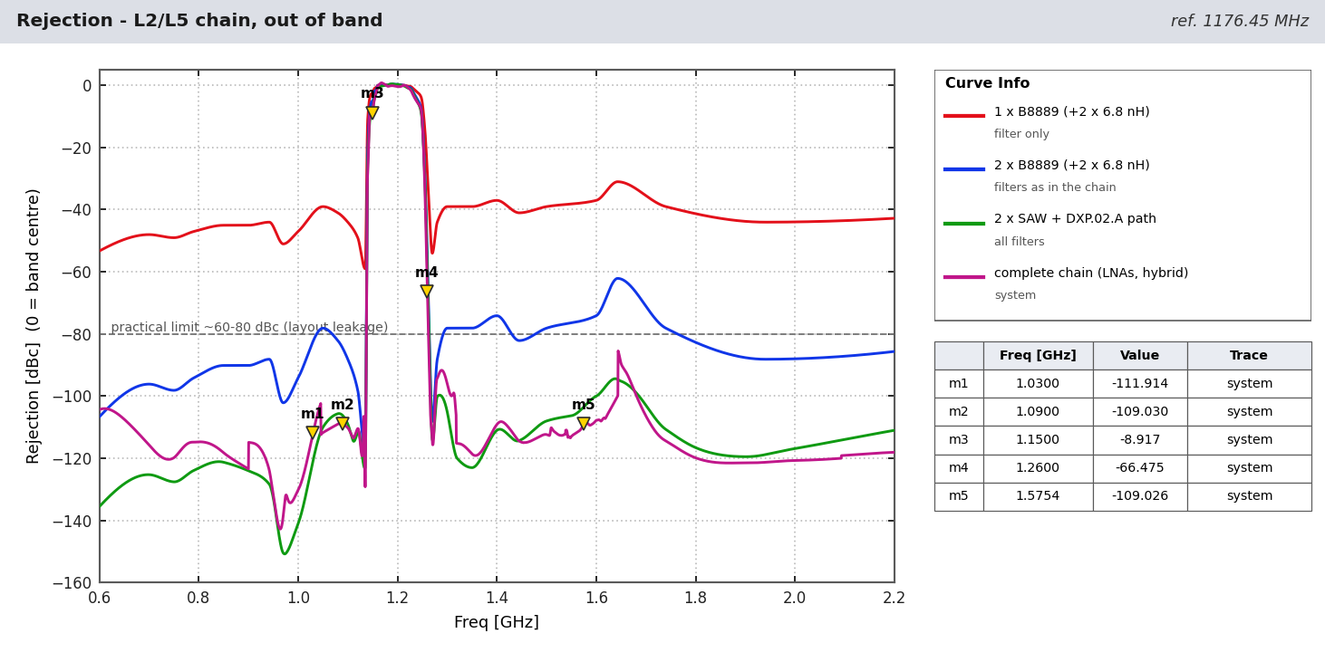
Figure - L2/L5 chain rejection after each filter stage and for the complete chain.
f (MHz) | Service / point | 1 SAW dBc | 2 SAW dBc | 2 SAW + DXP dBc | Complete chain dBc
787 | LTE B13/B14 UL | 47.2 | 94.5 | 124.2 | 114.8
897.5 | GSM-900 / LTE B8 UL | 45.1 | 90.2 | 123.9 | 123.2
960 | DME/TACAN low | 49.0 | 98.1 | 143.2 | 141.4
1030 | SSR / IFF interrogation | 41.2 | 82.4 | 120.8 | 111.9
1090 | SSR / ADS-B reply | 42.4 | 84.7 | 106.3 | 109.0
1150 | DME top | 3.1 | 6.2 | 9.0 | 8.9
1160 | lower skirt | 0.1 | 0.2 | 0.9 | 0.4
1250 | upper skirt | 5.8 | 11.6 | 12.8 | 12.3
1260 | ARNS radar | 28.2 | 56.4 | 58.8 | 66.5
1300 | ARNS radar top | 39.1 | 78.2 | 105.0 | 96.0
1400 | L-band | 37.1 | 74.2 | 111.0 | 109.2
1575.42 | L1 (other branch) | 37.8 | 75.6 | 103.4 | 109.0
1621 | Iridium | 34.0 | 68.0 | 96.5 | 106.4
1710 | LTE B3 UL low | 36.7 | 73.4 | 105.3 | 109.2
1950 | LTE B1 UL | 44.1 | 88.2 | 118.5 | 121.2
2442 | Wi-Fi 2.4 GHz | 38.1 | 76.1 | - | -
5500 | Wi-Fi 5 GHz | 25.2 | 50.5 | - | -
Table - L2/L5 chain rejection at the main interferer frequencies ('-' = outside the model range).

5.3 S chain
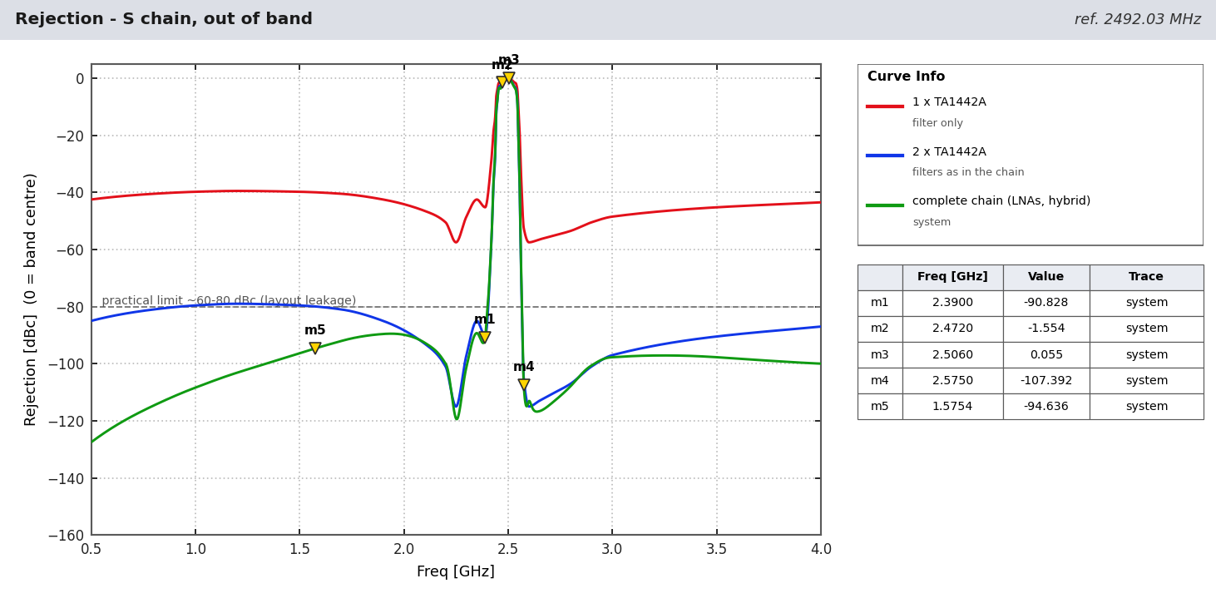
Figure - S chain rejection after each filter stage and for the complete chain.
f (MHz) | Service / point | 1 SAW dBc | 2 SAW dBc | Complete chain dBc
1575.42 | GNSS L1 | 40.0 | 80.0 | 94.6
2110 | LTE B1 DL | 46.8 | 93.6 | 93.1
2350 | LTE B40 | 42.5 | 85.0 | 89.3
2390 | TA1442A spec point | 45.2 | 90.5 | 90.8
2412 | Wi-Fi ch 1 | 34.7 | 69.3 | 68.2
2441 | Bluetooth / ISM | 9.5 | 19.0 | 17.8
2450 | microwave oven | 3.2 | 6.5 | 6.6
2472 | Wi-Fi ch 13 | 0.7 | 1.4 | 1.6
2483.5 | ISM top / Globalstar | 0.2 | 0.4 | 0.4
2500 | Globalstar top | -0.0 | -0.1 | -0.1
2506 | LTE B41 / n41 | -0.0 | -0.0 | -0.1
2535 | LTE B7 UL | 1.7 | 3.4 | 3.8
2570 | LTE B7 UL top | 47.6 | 95.2 | 92.3
2575 | TA1442A spec point | 52.5 | 105.0 | 107.4
2593 | LTE B41 mid | 57.1 | 114.2 | 114.5
2655 | LTE B7 DL | 56.4 | 112.8 | 116.5
3500 | 5G n78 | 45.2 | 90.5 | 97.7
Table - S chain rejection at the main interferer frequencies ('-' = outside the model range).

5.4 Cross-band rejection between the L-band branches
At the combined output the L1 branch rejects L5 by 178 dBc and L2 by 188 dBc (filters + DXP); the L2/L5 branch rejects L1 by 103 dBc. Each branch therefore adds no noise or signal in the other band (noise contribution < 0.01 dB).
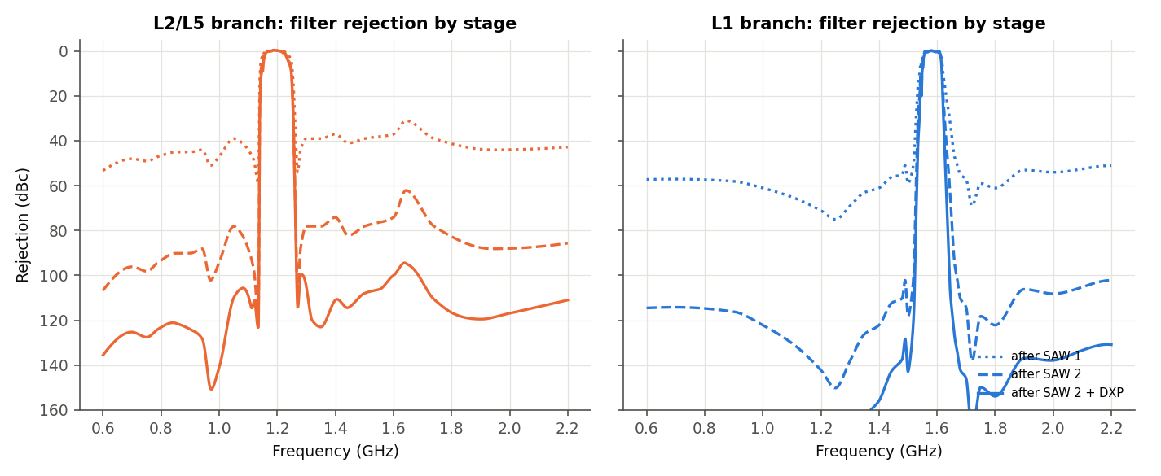
Figure - L-band cumulative filter rejection by stage.

6 Interference consequences
Rejection numbers become power levels in the LNAs. With -10 dBm uplink carriers at the antenna and no filter in front of LNA 1 (planning values):
Chain | Interferer | MHz | At antenna dBm | LNA 2 out dBm | Note
L1 | Iridium | 1621 | -20 | 12.0 | near-band, ~11 dB per B7504
L2/L5 | DME / TACAN | 1150 | -30 | 13.3 | above B8889 +5 dBm rating
L1 | LTE B3 UL | 1747.5 | -10 | -28.0 | well rejected
S | Wi-Fi ch 13 | 2472 | -10 | 25.8 | LNA 2 compressed, TA1442A rating exceeded
S | LTE B41 | 2506 | -10 | 26.3 | LNA 2 compressed
S | LTE B7 UL | 2535 | -10 | 24.5 | LNA 2 compressed
S | 5G n78 | 3500 | -20 | -35.8 | well rejected
Table - Effect of the near-band rejection (LNA OP1dB ~+20 dBm; B8889 rated +5 dBm, TA1442A +10 dBm input).

7 Recommendations
- NavIC S: add a narrow (<= 20 MHz) pre-filter in front of LNA 1 with > 30 dB at 2472 and 2506 MHz (ceramic / cavity), or a narrower SAW as filter 1; the TA1442A 3 dB bandwidth (~62 MHz) is too wide for co-located Wi-Fi and LTE B41/B7.
- L2/L5: add > 30 dB rejection at 960-1150 MHz (DME) ahead of LNA 1, e.g. a pre-LNA SAW or ceramic L5 filter.
- L1: a pre-filter with a steeper upper skirt for Iridium (1616-1626.5 MHz), e.g. RF360 B39162B2611P810 (pre-LNA).
- Expect ~0.5-1.0 dB higher NF with a pre-filter; recheck the budget.
- Layout: keep input and output of each filter separated (ground vias, shielding); otherwise the 100+ dBc model values will not be reached (practical ~60-80 dBc).
- Replace the estimated SAW/diplexer models by the manufacturers' measured S-parameter files to confirm the skirt values used here.

8 Basis and limitations
- Filter models are built from the data-sheet curves (magnitude digitized, table values and VNA markers used exactly); phase is a minimum-phase estimate. In-band accuracy ~+/-0.3 dB, stop band ~+/-2 dB.
- Room temperature (25 C) typical data; SAW temperature drift (e.g. TA1442A -36 ppm/C, ~-0.09 MHz/C at 2.49 GHz) shifts the skirts by a few MHz over temperature and is not included.
- Small-signal analysis: compression and intermodulation are estimated from the LNA data-sheet P1dB/IP3.
- Antenna treated as an ideal RHCP source: the patch's own out-of-band roll-off adds rejection in practice.
- Data: Qualcomm RF360 B7504 / B8889, Taoglas DXP.02.A / HC125A, Tai-Saw TA1442A, TTM C2327J5003AHF, Qorvo TQP3M9037 data sheets. Tables: Extracted_Data/rejection_doc_keyfreq.csv and rejection_doc_inband.csv.

