GNSS L1 + L2/L5 Active Antenna Front End
RF circuit models, Touchstone files, ANSYS Circuit automation and simulation report
RFMW-ANT project 16 | 2026-10-31 | VDD +5 V | data: 8 supplied datasheets

1 Executive summary
This report models a dual-branch GNSS active-antenna front end built only from the eight documents supplied (Qorvo TQP3M9037, Taoglas HC125A and DXP.02.A, Qualcomm RF360 B7504 and B8889, the RF360 GNSS SAW product brief, the RF360 automotive SAW selection table and RF360 application note #18). The topology was confirmed by the user: two patch feeds per band are combined in an HC125A hybrid, followed by LNA - SAW - LNA - SAW, and the two bands are combined in the DXP.02.A SAW diplexer onto one RF output. All four LNAs run at +5 V / 70 mA.
Band | f (MHz) | Gain (dB) | Ripple (dB) | NF (dB) | In VSWR | Out VSWR | GD (ns) | GD ripple (ns)
L1/E1/B1C | 1575.42 | 38.60 | 0.34 | 0.74 | 2.29 | 1.47 | 38.0 | 0.1
B1I | 1561.10 | 37.69 | 0.51 | 0.74 | 1.49 | 1.35 | 44.4 | 6.2
G1 | 1602.00 | 37.56 | 0.14 | 0.73 | 2.07 | 1.26 | 41.8 | 9.7
L5/E5a/B2a | 1176.45 | 41.99 | 1.14 | 0.59 | 1.63 | 1.42 | 27.3 | 14.9
E5b/B2b | 1207.14 | 41.55 | 0.42 | 0.60 | 2.75 | 2.17 | 24.2 | 5.2
L2 | 1227.60 | 40.14 | 0.41 | 0.62 | 1.96 | 1.58 | 32.0 | 0.8
G2 | 1248.00 | 33.40 | 12.37 | 0.67 | 1.52 | 1.36 | 80.1 | 33.1
Table 1 - Simulated system performance at the band centres (virtual RHCP input to RF output, 50 ohm, 25 C). Ripple and group-delay ripple over the signal bandwidth. Group delay is an estimate (min-phase SAW models).
Key findings:
- Noise figure 0.74 dB at L1 and 0.59 dB at L5, set almost entirely by the hybrid loss (0.36 / 0.19 dB) plus LNA 1. The second LNA, both SAWs and the 3.1-3.6 dB diplexer loss add < 0.02 dB.
- Gain 38.6 dB (L1) and 42.0 dB (L5) - higher than most GNSS receivers want (typ. 15-30 dB at the receiver input after the cable). See recommendations.
- All blocks and both branches are unconditionally stable: LNA K >= 1.014, mu >= 1.057 over 0.05-5 GHz; branch mu >= 1.035.
- Input match at the RHCP port is only VSWR 2.29 at L1 and 2.75 at E5b: the LNA S11 (-10 dB) reflects through the hybrid back to the antenna.
- GLONASS G2 (1246-1256 MHz) is not usable: the B8889 pass-band ends at ~1245 MHz (gain ripple 12.4 dB across G2).
- Interference: an aviation DME/TACAN pulse of -30 dBm at 1150 MHz is attenuated only ~4 dB by each B8889 and reaches +13.3 dBm at LNA 2 output - above the B8889 input rating (+5 dBm) and only 8.3 dB below LNA 2 P1dB; Iridium (1621 MHz, -20 dBm) reaches +12.0 dBm in the L1 branch. There is no filter in front of LNA 1, so cellular uplinks at -10 dBm leave only ~7-10 dB back-off at LNA 1.
- Three independent circuit solvers agree: scikit-rf (reference), heavi and circuitRF differ by < 0.01 dB in band. The ANSYS AEDT run is described in section 10.
Data quality: only the LNA S-parameters and noise parameters, the HC125A typical table and the datasheet spec tables are measured/extracted values. The SAW and diplexer Touchstone files are ESTIMATES built from digitized curves with a minimum-phase reconstruction; they reproduce every datasheet insertion-loss and attenuation table entry (section 11) but are not measured data. Replace them with vendor .s2p/.s3p files when available.

2 System architecture and connection diagram
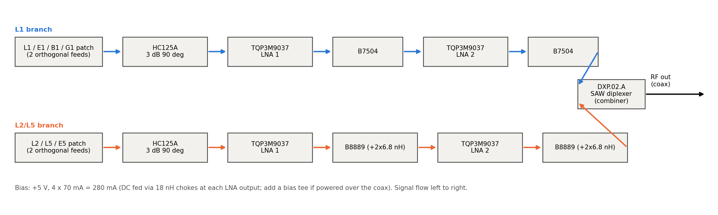
Figure 1 - Connection diagram (user-confirmed topology).
Signal path per branch: two orthogonal patch feeds -> HC125A 3 dB quadrature hybrid (pins 3/4 in, pin 1 out, pin 2 terminated in 50 ohm) -> TQP3M9037 LNA 1 -> SAW -> TQP3M9037 LNA 2 -> SAW -> DXP.02.A port (L1: pin 7, L2/L5: pin 5). The DXP.02.A is used in reverse as a combiner (reciprocal SAW device) and drives the common RF output (pin 2).
Ref | Part | Manufacturer | Function | Qty | Data used
U1-U4 | TQP3M9037 | Qorvo | LNA 0.7-6 GHz, NF 0.4 dB, 20 dB | 4 | S-param + noise tables (5 V)
HY1, HY2 | HC125A | Taoglas | 3 dB 90 deg hybrid 1150-1630 MHz | 2 | Typical table p.6
F1, F2 | B7504 (B39162B7504L210) | Qualcomm RF360 | SAW L1/B1/G1 1559-1606 MHz | 2 | Spec table + digitized plots
F3, F4 | B8889 (B39122B8889P810) | Qualcomm RF360 | SAW L5/E5/B2/L2 1166-1229 MHz (+2x6.8 nH) | 2 | Spec table + digitized plots
DX1 | DXP.02.A | Taoglas | SAW diplexer L1 / L2+L5 | 1 | Spec table + digitized plots
- | SAW product brief, SDST, AN #18 | Qualcomm RF360 | Alternatives / matching method | - | Reference only
Table 2 - Component summary.

3 Extracted datasheet parameters
All extracted numbers are in Scripts/ds_data.py (single source) and exported to Extracted_Data/ as 43 CSV tables plus Extracted_Parameters.xlsx (one sheet per table, with an INDEX sheet naming source page and kind: TABLE = typed from a datasheet table, DIGITIZED = read off a plot, [ASSUMED] = estimate).
Parameter | Value | Source
TQP3M9037 gain / NF / OP1dB / OIP3 @1.95 GHz, 5 V | 20.0 dB / 0.40 dB / +20 dBm / +35 dBm | Qorvo p.2
TQP3M9037 IDD / VDD range / abs. max RF in | 70 mA / 3.0-5.25 V / +22 dBm | Qorvo p.2
TQP3M9037 eval @1.7 GHz (5 V) | 21.4 dB, NF 0.36 dB, OP1dB 20.7, OIP3 34.9 dBm | Qorvo p.6
TQP3M9037 noise parameters | 1.5-2.7 GHz: NFmin 0.29-0.51 dB, |Gopt| 0.02-0.16, Rn 0.04-0.08 ohm | Qorvo p.3
HC125A IL / isolation / VSWR / balance | <= 0.3 dB / >= 22 dB / 1.2 / +/-0.35 dB, 90 deg | Taoglas p.5
HC125A typical @1582 MHz | C -3.25, T -3.27 dB, iso 28.6 dB, phase 92.97 deg | Taoglas p.6
B7504 IL typ/max | 1.1/2.0 (B1), 0.9/1.4 (L1), 1.2/2.0 (G1) dB | RF360 p.7
B7504 min attenuation | 45-60 dB cellular, 35-42 dB at 4.4-5.85 GHz | RF360 p.7
B7504 max input power | +23 dBm @915 (GSM 1:8), +15 dBm CW @1463/1710 MHz | RF360 p.8
B8889 IL typ/max | 0.9/1.5 (L5), 1.0/1.3 (B2b), 1.4/2.6 (L2) dB | RF360 p.7
B8889 matching / max input | 6.8 nH shunt both ports / +5 dBm CW in-band | RF360 p.6, p.8
DXP.02.A IL | 3.8 typ / 4.6 max (L1), 4.2 / 5.2 (L2/L5) dB | Taoglas p.4
DXP.02.A isolation / input power | >= 22 dB (typ 31-35) / 10 dBm | Taoglas p.4
Table 3 - Main extracted parameters (full tables in Extracted_Data/).

4 Design assumptions
Every value not printed in a datasheet. The same list is in Extracted_Data/assumptions_log.md and in the XLSX.
ID | Item | Assumption | Basis / how to close
A1 | Topology | Two branches (patch -> HC125A -> LNA -> SAW -> LNA -> SAW) combined by the DXP.02.A, as confirmed by the user 2026-10-31. Single chain is not possible: B7504 (L1) and B8889 (L2/L5) have disjoint pass-bands. | User decision
A2 | Antenna | Each patch is an ideal dual-feed RHCP source: lossless 90 deg splitter, 50 ohm feeds (PatchCP_ideal_RHCP_feed.s4p). LHCP port terminated at T0 (290 K) for noise. | Replace with measured/HFSS patch S-parameters
A3 | LNA noise below 1.5 GHz | Noise table starts at 1.5 GHz. NFmin 0.38-0.40 dB, Gopt = 0.15/14.1 deg, Rn = 0.08 ohm used at 0.6-1.2 GHz (bounded by the 50-ohm eval NF of 0.40 dB at 0.9 GHz and 0.36 dB at 1.7 GHz). | Ask Qorvo for low-band noise parameters
A4 | LNA bias | VDD = +5 V, 70 mA (user choice); S-parameters at device leads; eval-board bias network (100 pF DC blocks, 18 nH choke, 100 pF + 1 uF bypass). | Datasheet p.2, p.5
A5 | Parasitics | 100 pF 0402: ESL 0.25 nH, ESR 0.15 ohm; 18 nH 0603: Q = 40 at 1.4 GHz, 0.12 pF self-capacitance (SRF ~3.4 GHz); bypass ESL 0.4 nH. | Replace with vendor S-parameter models of the chosen parts
A6 | LNA interpolation | 200 MHz table interpolated with a cubic spline on dB magnitude and unwrapped phase. Linear interpolation changes in-band gain by up to 1.4 dB (heavi test) -> a real model uncertainty. | Download the Qorvo fine-step .s2p
A7 | LNA large-signal | OIP3/OP1dB at L-band interpolated from eval-board values at 0.9 and 1.7 GHz (34.4-34.9 dBm, 22-20.7 dBm). | Datasheet p.6
A8 | HC125A phase | Datasheet gives magnitudes and the coupled-vs-through phase difference (91.9-93.0 deg) only. Absolute through phase = -90 deg x f/1390 MHz; reflection and isolation phase offsets chosen to keep the 4-port passive (165 / 270 deg). | Measured .s4p from Taoglas
A9 | HC125A port mapping | 'Transmission' column = pin1->pin4 (direct, angle theta), 'Coupling' column = pin1->pin3 (theta-90), from the pin table p.7. Feeds on pins 3/4, LNA on pin 1, pin 2 terminated in 50 ohm. | Confirm with Taoglas
A10 | HC125A passivity | The 92 deg phase difference with 0.15-0.29 dB loss is slightly non-passive with arbitrary reflection phases; after the phase choice the matrix is scaled by <= 0.11 dB at the worst frequency. | -
A11 | HC125A out of band | Values held at the 1150/1630 MHz edge outside 1150-1630 MHz. Out-of-band rejection therefore comes from the SAWs/DXP only (conservative). | -
A12 | SAW phase | No measured phase in the datasheets. S21 phase = minimum-phase (Hilbert / real-cepstrum) reconstruction of the digitized magnitude; S11/S22 phase = S21 phase + 90 deg (lossless symmetric reciprocal condition). Group delay is therefore an estimate; ripple agrees with the brief (B7504 GD ripple 4 ns typ). | Use RF360 measured .s2p (available on rffe.qualcomm.com)
A13 | SAW reflection out of band | |S11| = 0.95 sqrt(1-|S21|^2) outside the plotted VSWR range (reflective SAW stop-band), blended over 4 MHz. | -
A14 | B8889 matching | The B8889 model includes the required 6.8 nH shunt inductors (datasheet curves are measured with them). | Datasheet p.6
A15 | DXP model | Digitized curves include the Taoglas eval-board matching (L2 4.3 nH, C1 1.5 pF, L1 4.7 nH, L3 3.3 nH, C2 1 pF). Reflection phase = dominant transmission phase + 90 deg. | Measured .s3p from Taoglas
A16 | Digitizing accuracy | Pass-band plots +/-0.3 dB, wide-band attenuation plots +/-2 dB, VSWR +/-0.1. | -
A17 | PCB | Interconnects ideal (zero length). 50 ohm lines on the real board add ~0.02-0.05 dB/cm loss and phase. | Add MSL models once the layout exists
A18 | Interferer levels | Interferer powers at the antenna feed (-10 dBm cellular UL, -20 dBm Iridium/Inmarsat UL, -30 dBm DME) are example values for a co-located handset/terminal. | Set from the product's EMC environment
A19 | Signal levels | Minimum received power (0 dBic antenna): GPS L1 C/A -128.5 dBm, L5 -127.9 dBm, L2C -130 dBm, GLONASS G1 -131 dBm (signal ICDs). | -
A21 | S-band topology | S-band patch (ideal dual feed) -> C2327J5003AHF -> TQP3M9037 -> TA1442A -> TQP3M9037 -> TA1442A -> separate S-band output (no diplexer). Antenna only mentioned, modelled as ideal RHCP source. | User request 2026-10-31
A22 | S-band LNA match | Qorvo 2300-2600 MHz reference design (2.7 nH shunt, 2.4 pF series, 5.6 nH choke); inductor Q 30-50 @2.5 GHz, ESL/ESR [ASSUMED]. | Datasheet p.10
A23 | C2327J5003AHF model | Magnitudes from excess IL, amplitude balance, isolation and input return loss (same RL assumed at all ports); coupled phase = direct + 90 deg - phase balance; reflection/isolation phases chosen for passivity over 2-3 GHz -> excess IL 0.43 dB vs 0.3 typ / 0.4 max (conservative). | Measured .s4p from TTM
A24 | TA1442A model | Digitized VNA plots p.3-4 with the printed marker values used exactly; S11 = S22 shape (markers differ by < 0.01); min-phase phase. | Measured .s2p from Tai-Saw
A25 | NavIC S signal | 2492.028 MHz, SPS BW 2.046 MHz, RS BW 16.5 MHz, minimum received power -132.3 dBm (0 dBic) used as reference values. | Verify against the IRNSS SPS ICD
A20 | Temperature | All data at 25 C typical. No temperature, part-to-part or aging spread is modelled. | -
Table 4 - Assumptions log.

5 Models and equations

5.1 Component models
- TQP3M9037: datasheet S-parameter table (0.05-5 GHz, device leads) -> TQP3M9037_5V.s2p with the measured noise block; the circuit adds the eval-board bias network (Figure 3).
- HC125A: 4-port from the typical table (magnitudes, coupled-through phase difference) -> HC125A.s4p.
- B7504 / B8889: |S21| digitized from Fig. 4 and anchored to the attenuation table, |S11|/|S22| from VSWR Fig. 5/6, phase by minimum-phase reconstruction -> B7504.s2p, B8889_matched.s2p (the B8889 file includes the 6.8 nH inductors).
- DXP.02.A: 3-port from the digitized p.6-8 curves (eval matching included) -> DXP02A.s3p.
- Patch antenna: ideal dual-feed RHCP source -> PatchCP_ideal_RHCP_feed.s4p (placeholder for the real patch).
- Equivalent circuits: LNA stage = series C(ESL, ESR) - 2-port table - shunt [L(Q) || Cpar] + bypass C(ESL) - series C; SAW static model = capacitive (DC block function, AN #18 Fig. 9).

5.2 Equations
VSWR = (1 + |G|) / (1 - |G|), RL = -20 log10|G|, |G| = (VSWR - 1)/(VSWR + 1)
Min-phase: ln H(w) = ln|H(w)| + j arg H(w), arg H = -Hilbert{ln|H|} (real-cepstrum folding)
SAW reflection phase: arg S11 = arg S22 = arg S21 + 90 deg (S11 S21* + S21 S22* = 0, lossless symmetric 2-port)
Transducer gain G_T = |S21|^2 (50 ohm source and load); group delay tau = -d(arg S21)/d(omega)
RHCP excitation of the hybrid: a3 = 1/sqrt2, a4 = -j/sqrt2 -> b1 = (S13 - j S14)/sqrt2
Rollett K = (1 - |S11|^2 - |S22|^2 + |D|^2) / (2|S12 S21|), D = S11 S22 - S12 S21
Edwards-Sinsky mu = (1 - |S11|^2) / (|S22 - D S11*| + |S12 S21|) (mu > 1: unconditionally stable)
Passive noise (Twiss): C_Y = 2kT0 Re{Y}; C_A = T C_Y T^H, T = [[0, B], [1, D]]
Active noise: C_A = 2kT0 [[Rn, (Fmin-1)/2 - Rn Yopt*], [(Fmin-1)/2 - Rn Yopt, Rn |Yopt|^2]]
Cascade: C_A = C_A1 + A1 C_A2 A1^H; F = 1 + z^H C_A z / (2kT0 Re Zs), z = [1, Zs*]^T
Friis: F = F1 + (F2 - 1)/G1 + ...; 1/IIP3 = sum (G_before,i / IIP3_i) (linear units)
Noise floor N = kT0 B F G = -174 dBm/Hz + 10 log10 B + NF + G; output noise of both branches adds in the DXP: F_L1,sys = (F1 G1 + F2 G2)/G1

6 Schematics
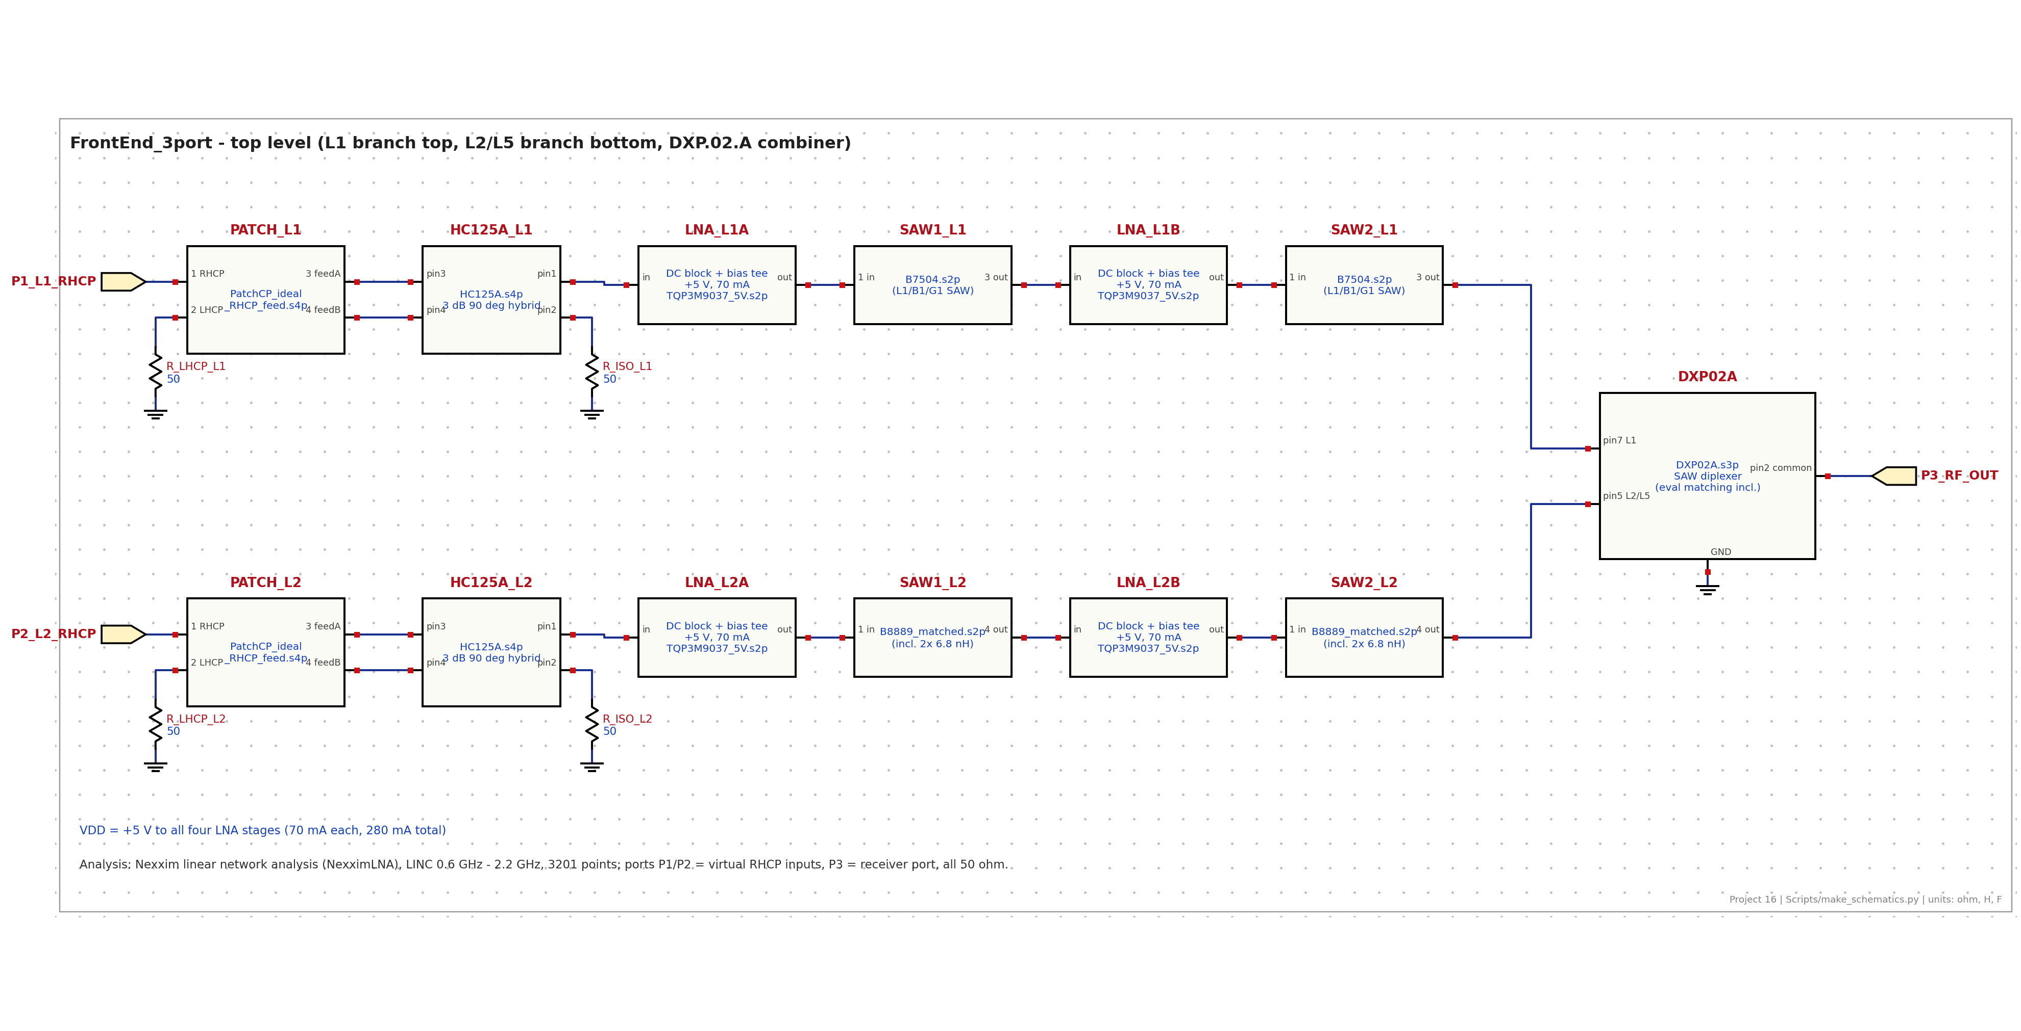
Figure 2 - Top-level schematic, design FrontEnd_3port (as built by Scripts/aedt_circuit.py).
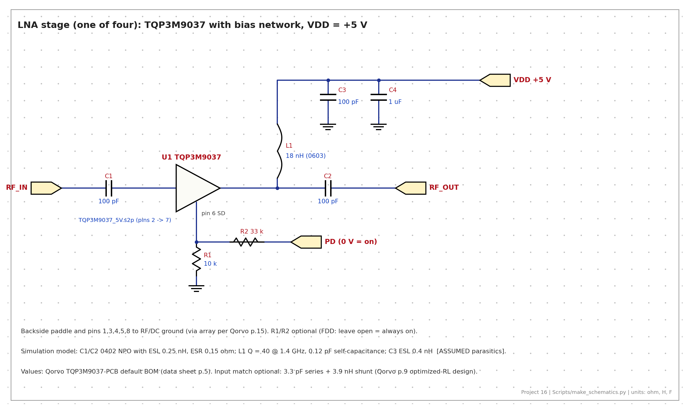
Figure 3 - LNA stage with bias network (one of four).
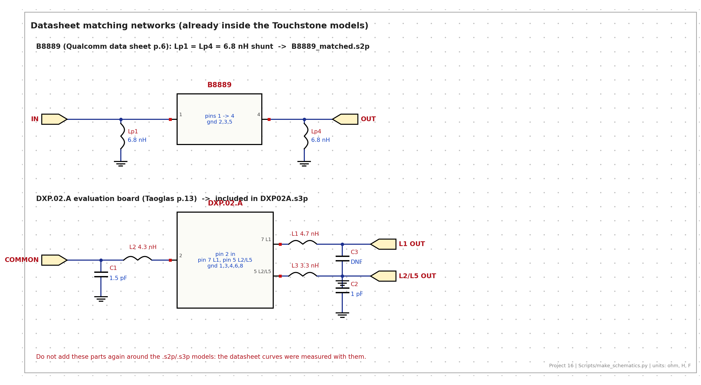
Figure 4 - Datasheet matching networks contained in the SAW and diplexer models.

7 S-parameter results
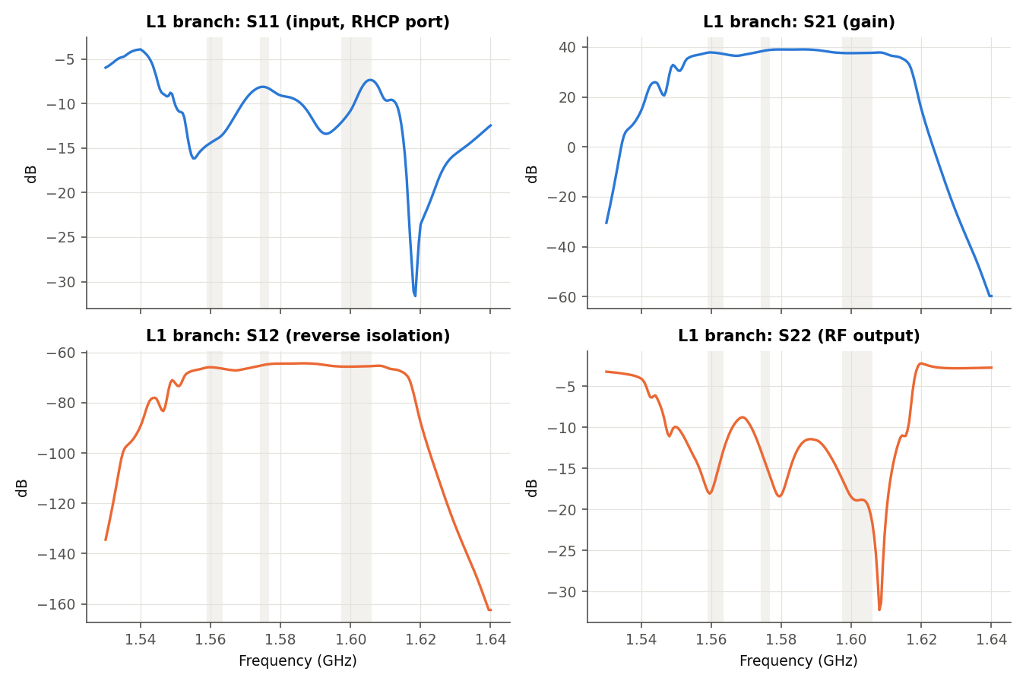
Figure 5 - L1 branch S11 / S21 / S12 / S22 (shaded: B1I, L1/E1, G1).
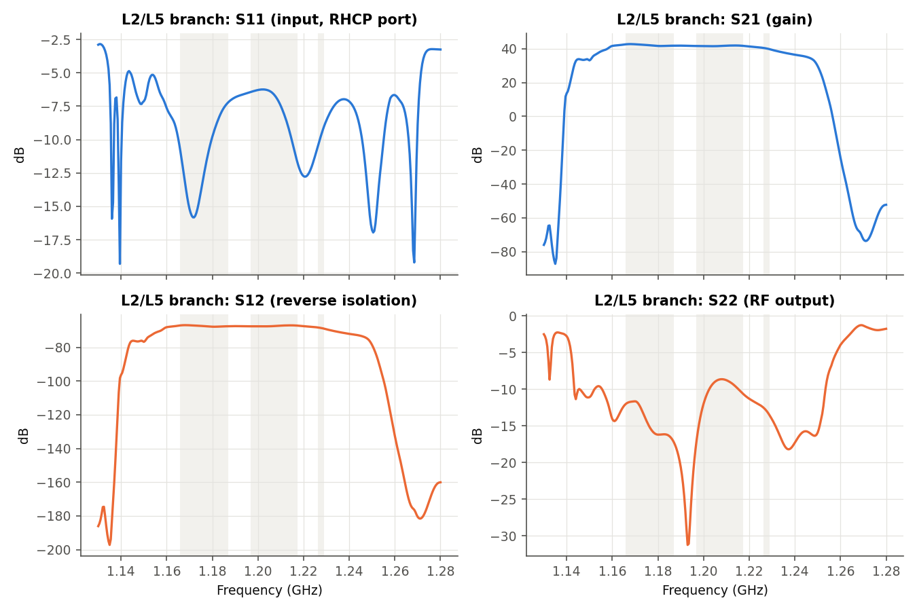
Figure 6 - L2/L5 branch S11 / S21 / S12 / S22 (shaded: L5/E5a, E5b, L2).
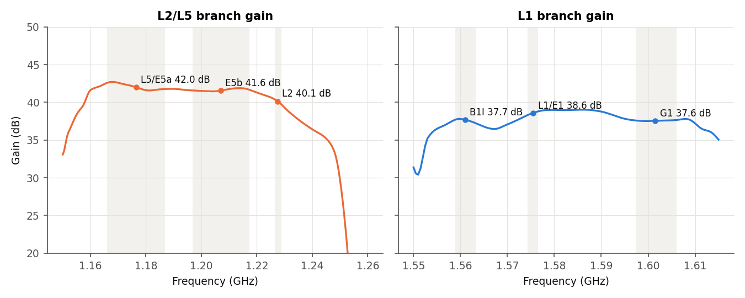
Figure 7 - In-band gain of both branches.
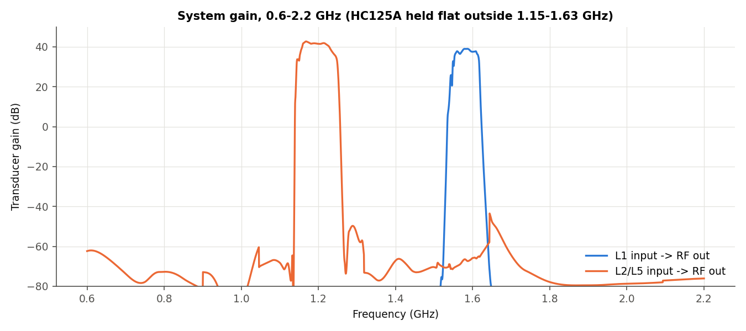
Figure 8 - Wide-band transfer 0.6-2.2 GHz.
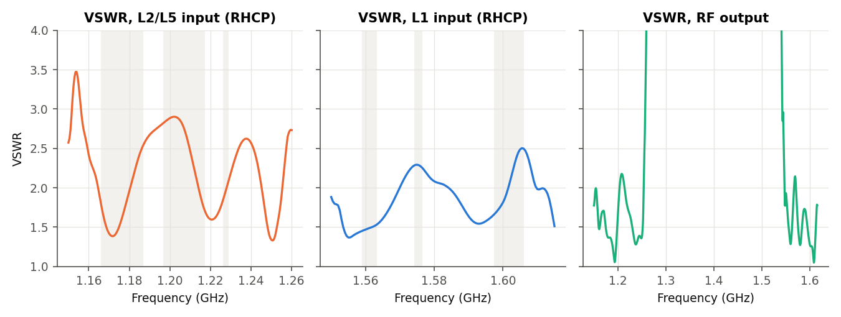
Figure 9 - VSWR at the RHCP inputs and the RF output.
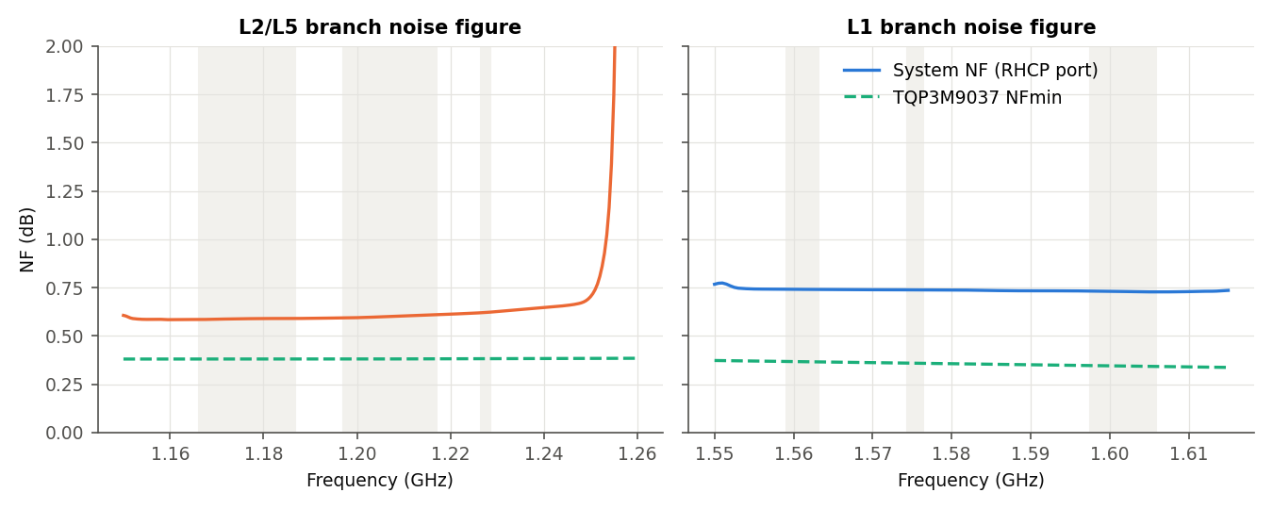
Figure 10 - System noise figure (both branches' output noise included) and LNA NFmin.
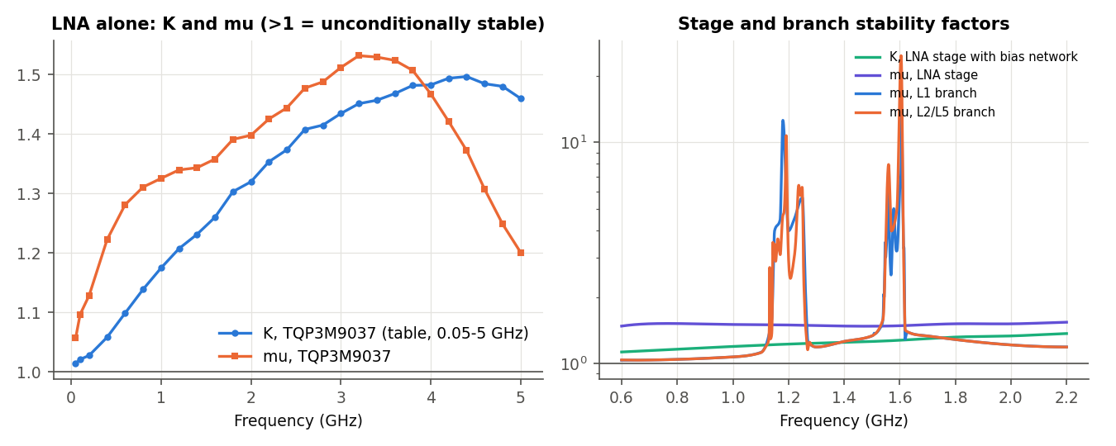
Figure 11 - Stability: K and mu. LNA alone: K_min = 1.014 at 0.05 GHz, mu_min = 1.057, |D|max = 0.71; LNA stage with bias: K_min = 1.13, mu_min = 1.48.
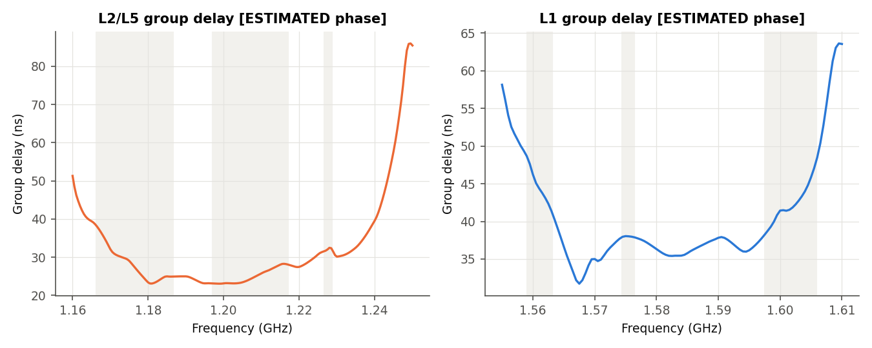
Figure 12 - Group delay (estimated: SAW/DXP phase is minimum-phase).
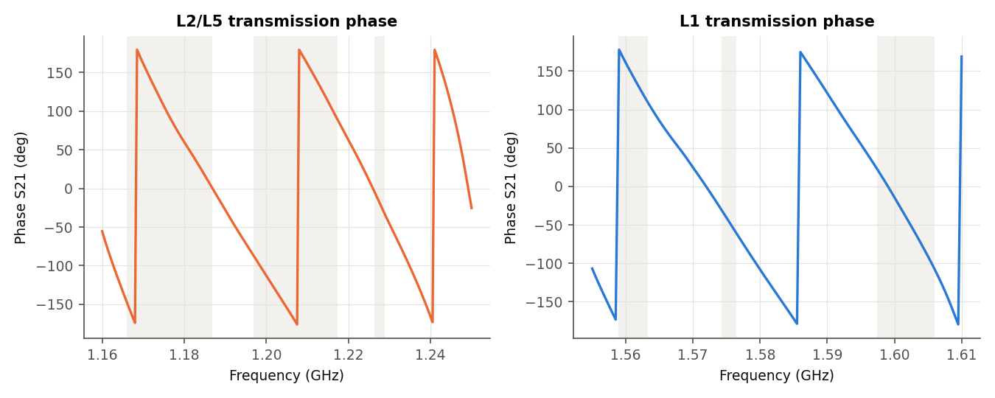
Figure 13 - Transmission phase.
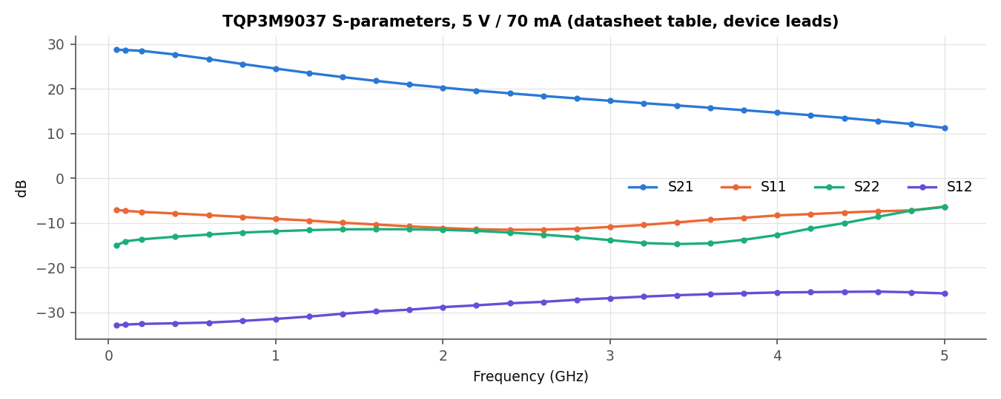
Figure 14 - TQP3M9037 datasheet S-parameters (5 V, 70 mA).
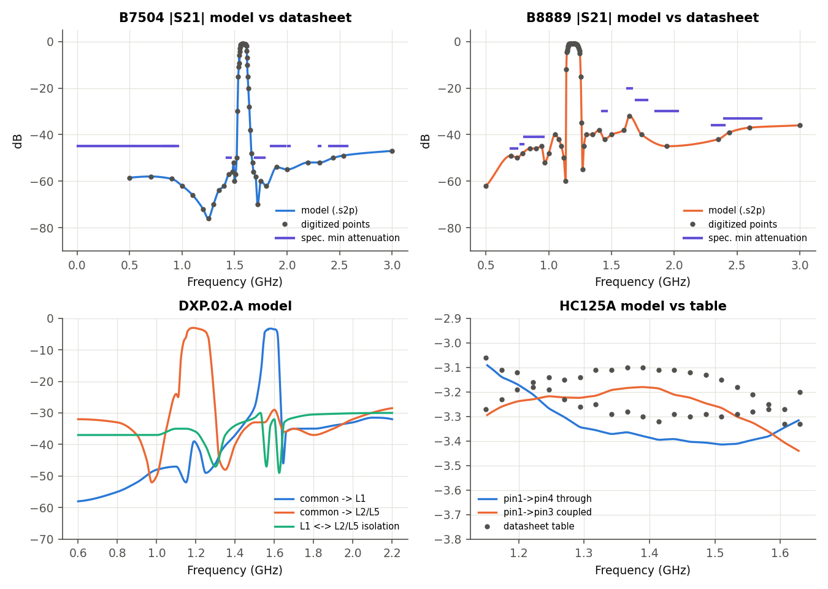
Figure 15 - Component models against the datasheet data.

7A Rejection, insertion loss and other RF parameters
Rejection is quoted in dBc: how far below the band-centre gain a frequency is passed (rejection = G(fc) - G(f)). Filter rejection is shown per component against the datasheet minimum-attenuation table, and for the complete chain. Model rejection beyond ~60-80 dBc is not achievable on a real board: radiation and ground currents leak around the filters, so treat deeper values as 'limited by layout'.
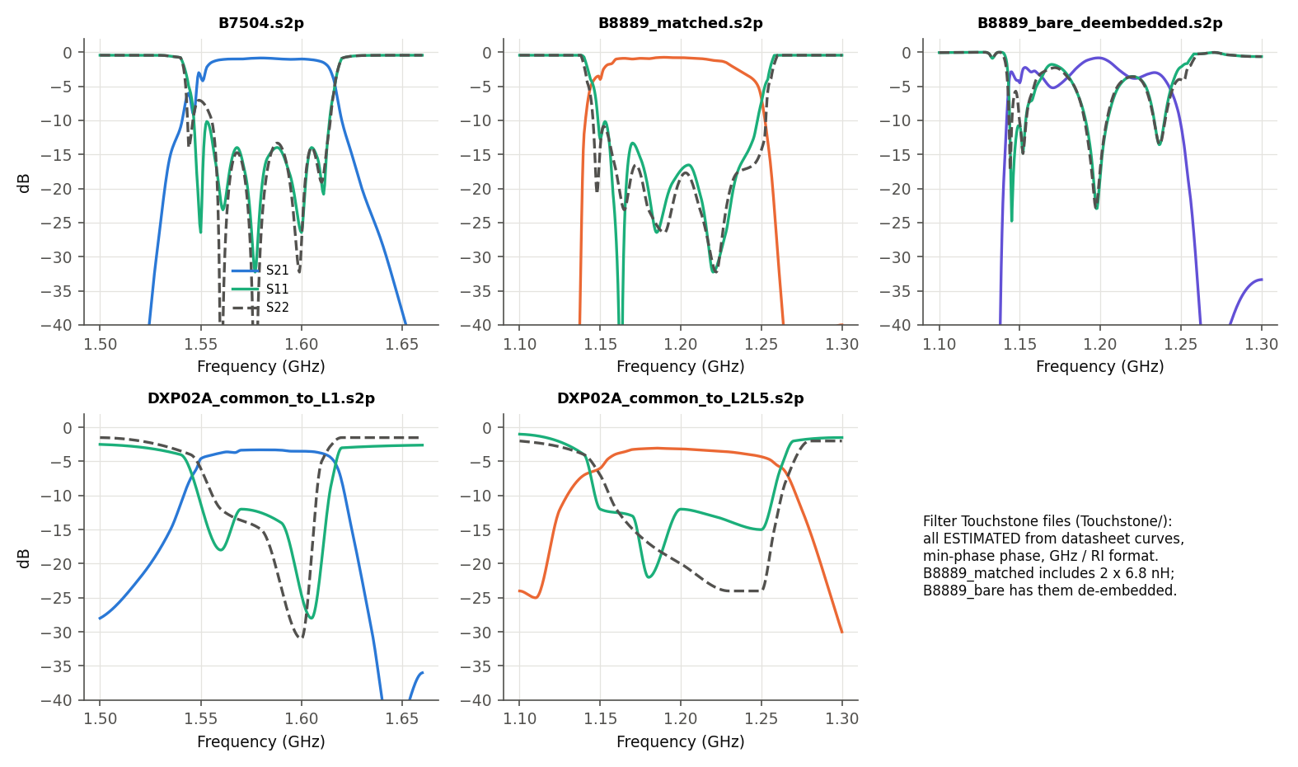
Figure 15-0 - The filter Touchstone files (pass-band view).
File | Points | Range (MHz) | Passive | Use
B7504.s2p | 11981 | 10-6000 | yes | L1 SAW, no matching needed (50 ohm)
B8889_matched.s2p | 11981 | 10-6000 | yes | L2/L5 SAW with its 2 x 6.8 nH (use as one block)
B8889_bare_deembedded.s2p | 11401 | 300-6000 | yes | L2/L5 SAW chip only - add your own matching
DXP02A_common_to_L1.s2p | 3201 | 600-2200 | yes | diplexer L1 path, L2/L5 port in 50 ohm
DXP02A_common_to_L2L5.s2p | 3201 | 600-2200 | yes | diplexer L2/L5 path, L1 port in 50 ohm
DXP02A.s3p | 3201 | 600-2200 | yes | full 3-port diplexer
Table 7A-0 - Filter S-parameter files (all ESTIMATED from datasheet curves).
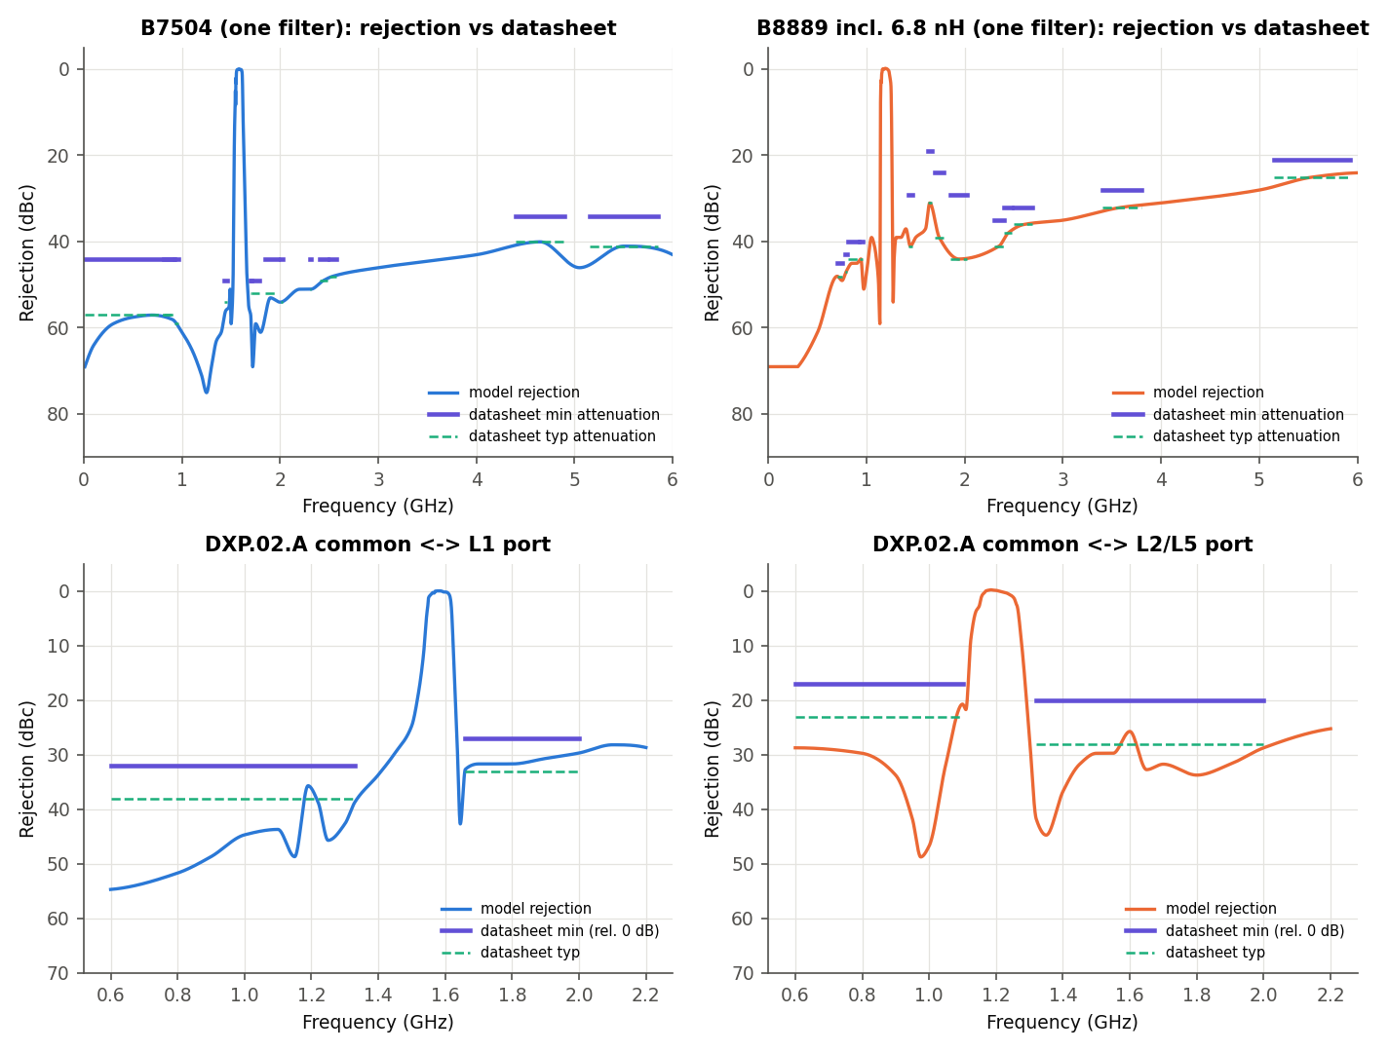
Figure 15A - Rejection of each filter (one device) against the datasheet limits: B7504, B8889 (with its 6.8 nH matching), DXP.02.A common-L1 and common-L2/L5 paths.
Filter | Band (MHz) | Spec min att. (dB) | Spec typ (dB) | Model min att. (dB) | Margin to spec (dB)
B7504 | 10-925 | 45 | 58 | 58.0 | 13.0
B7504 | 814-915 | 45 | 58 | 58.3 | 13.3
B7504 | 925-960 | 45 | 60 | 59.4 | 14.4
B7504 | 1427-1463 | 50 | 55 | 56.6 | 6.6
B7504 | 1695-1710 | 50 | 53 | 57.4 | 7.4
B7504 | 1710-1785 | 50 | 53 | 60.0 | 10.0
B7504 | 1850-1980 | 45 | 53 | 54.0 | 9.0
B7504 | 2010-2025 | 45 | 55 | 54.9 | 9.9
B7504 | 2305-2315 | 45 | 52 | 52.0 | 7.0
B7504 | 2401-2483 | 45 | 50 | 49.5 | 4.5
B7504 | 2500-2570 | 45 | 49 | 48.8 | 3.8
B7504 | 4400-4900 | 35 | 41 | 41.0 | 6.0
B7504 | 5150-5850 | 35 | 42 | 42.0 | 7.0
B8889 | 698-748 | 46 | 49 | 49.0 | 3.0
B8889 | 777-798 | 44 | 48 | 47.7 | 3.7
B8889 | 807-915 | 41 | 45 | 45.7 | 4.7
B8889 | 925-960 | 41 | 45 | 45.0 | 4.0
B8889 | 1427-1463 | 30 | 42 | 40.6 | 10.6
B8889 | 1626.5-1660.5 | 20 | 32 | 32.0 | 12.0
B8889 | 1695-1785 | 25 | 40 | 35.9 | 10.9
B8889 | 1850-2025 | 30 | 45 | 43.8 | 13.8
B8889 | 2300-2400 | 36 | 42 | 40.3 | 4.3
B8889 | 2400-2483 | 33 | 39 | 38.2 | 5.2
B8889 | 2500-2690 | 33 | 37 | 36.7 | 3.7
B8889 | 3400-3800 | 29 | 33 | 32.5 | 3.5
B8889 | 5150-5925 | 22 | 26 | 25.1 | 3.1
DXP L1 | 600-1330 | 32 | 38 | 39.0 | 3.7
DXP L1 | 1660-2000 | 27 | 33 | 33.0 | 2.7
DXP L2/L5 | 600-1100 | 17 | 23 | 24.0 | 3.7
DXP L2/L5 | 1320-2000 | 20 | 28 | 29.0 | 5.7
Table 7A-1 - Filter rejection vs the datasheet attenuation specification (worst point in each band). All bands pass; smallest margins ~3 dB (B8889 cellular bands, DXP).
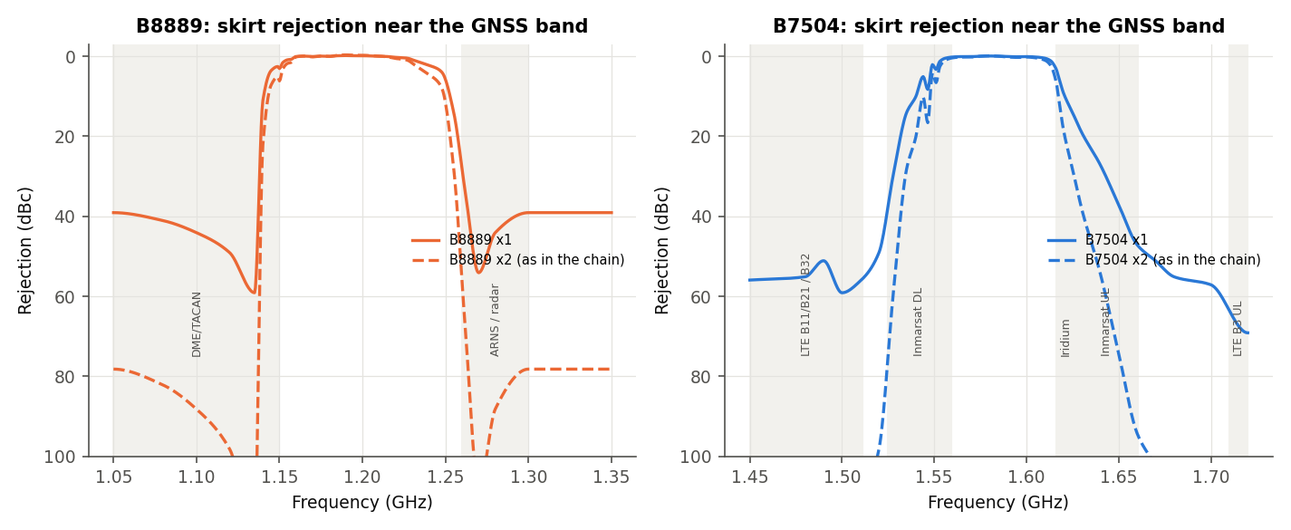
Figure 15B - Skirt rejection next to the GNSS bands, one filter and the two filters in series as used in each branch. The weak points are the B8889 lower skirt (DME, < 4 dB at 1150 MHz per filter) and the B7504 upper skirt (Iridium, ~5-11 dB per filter).
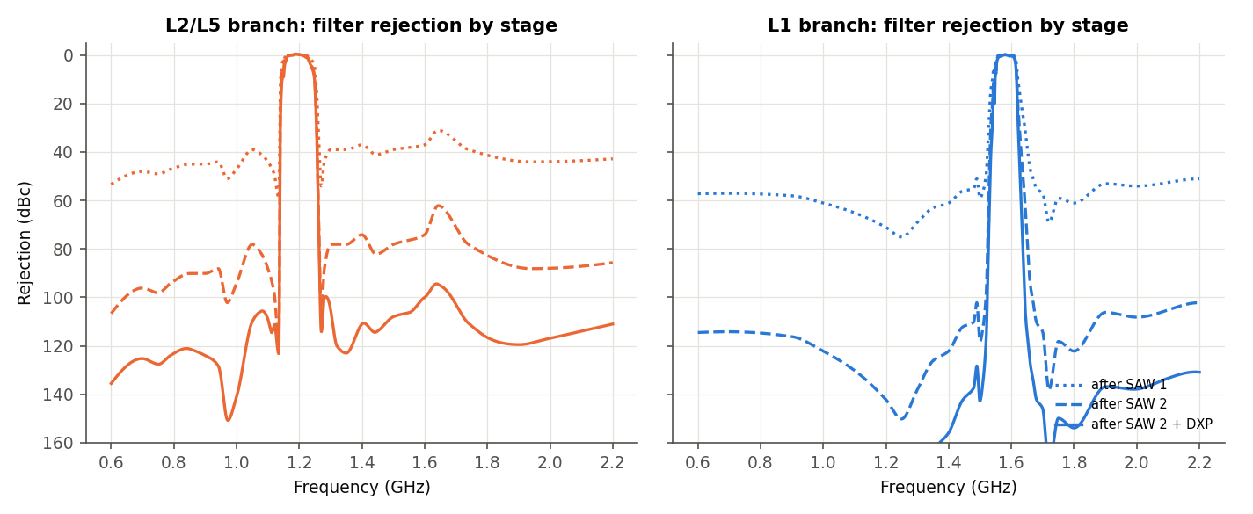
Figure 15C - Cumulative filter rejection: after SAW 1, after SAW 2, after SAW 2 + DXP.
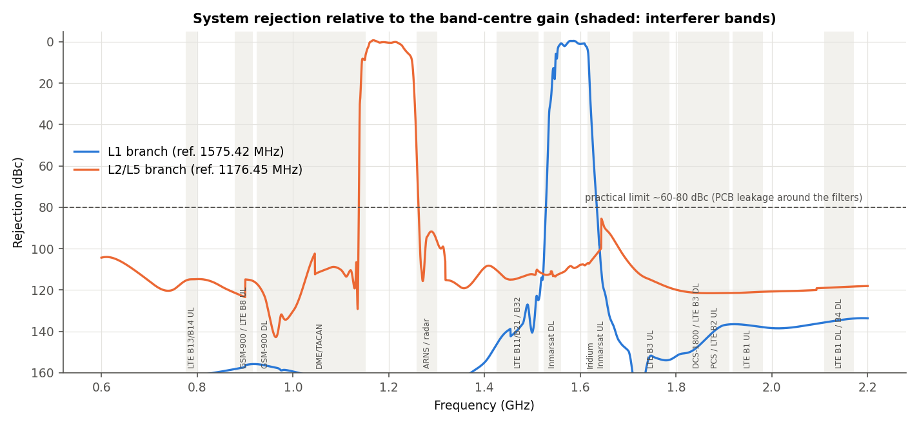
Figure 15D - Rejection of the complete system (LNAs included) with the interferer bands.
Interferer band | MHz | L1 branch min (dBc) | L1 mean (dBc) | L2/L5 branch min (dBc) | L2/L5 mean (dBc)
LTE B13/B14 UL | 777-798 | 161.5 | 161.9 | 114.8 | 114.9
GSM-900 / LTE B8 UL | 880-915 | 155.8 | 157.0 | 114.9 | 119.4
GSM-900 DL | 925-960 | 155.9 | 156.5 | 117.1 | 126.6
DME/TACAN (below L5) | 960-1150 | 157.3 | 163.2 | 8.2 | 111.6
ARNS / radar | 1260-1300 | 168.7 | 185.2 | 66.5 | 96.4
LTE B11/B21 / B32 (L-band) | 1427-1511 | 122.8 | 137.5 | 110.2 | 113.4
Inmarsat DL | 1525-1559 | 0.9 | 29.6 | 110.9 | 112.5
Iridium | 1616-1626.5 | 4.7 | 28.4 | 104.8 | 106.3
Inmarsat UL | 1626.5-1660.5 | 51.6 | 101.9 | 85.5 | 96.2
LTE B3 UL | 1710-1785 | 151.7 | 159.4 | 109.2 | 114.9
DCS-1800 / LTE B3 DL | 1805-1880 | 139.8 | 147.0 | 120.2 | 121.2
PCS / LTE B2 UL | 1850-1910 | 136.7 | 140.4 | 121.5 | 121.5
LTE B1 UL | 1920-1980 | 136.5 | 137.1 | 120.9 | 121.2
LTE B1 DL / B4 DL | 2110-2170 | 133.8 | 134.7 | 118.3 | 118.6
Table 7A-2 - System rejection in the interferer bands (min = worst point in the band). Values above ~80 dBc are model values; expect layout-limited results in practice. Inmarsat DL (1525-1559 MHz) touches the L1 pass-band edge, hence the low minimum.
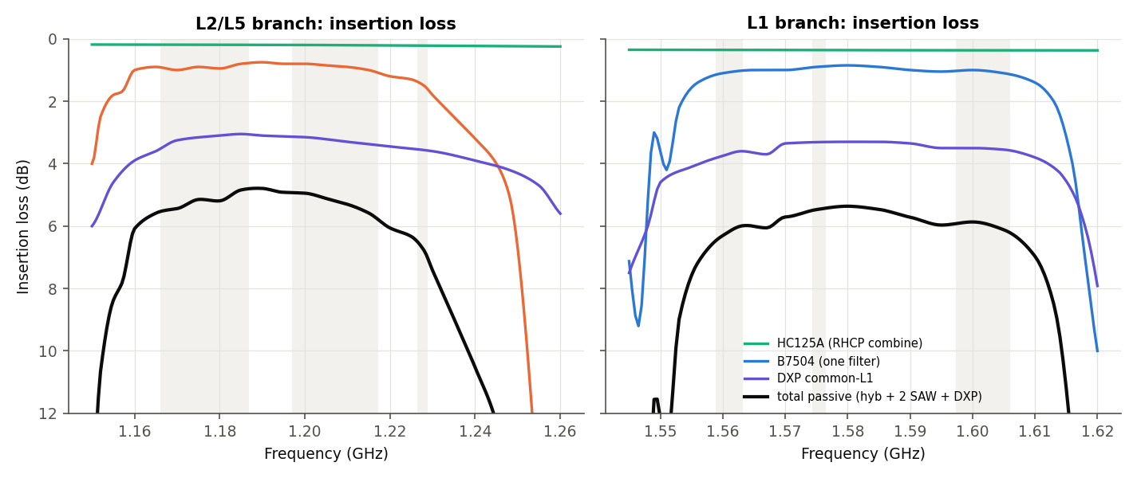
Figure 15E - Insertion loss of each passive part and of the passive chain per branch.
Band | f (MHz) | Hybrid (dB) | SAW, one (dB) | SAW max in BW (dB) | DXP (dB) | Total passive (dB) | Total max in BW (dB)
L1/E1/B1C | 1575.42 | 0.36 | 0.89 | 0.91 | 3.31 | 5.46 | 5.49
B1I | 1561.10 | 0.35 | 1.07 | 1.12 | 3.69 | 6.18 | 6.37
G1 | 1602.00 | 0.37 | 1.02 | 1.13 | 3.51 | 5.92 | 6.21
L5/E5a/B2a | 1176.45 | 0.19 | 0.91 | 1.00 | 3.14 | 5.15 | 5.52
E5b/B2b | 1207.14 | 0.20 | 0.87 | 1.08 | 3.25 | 5.19 | 5.77
L2 | 1227.60 | 0.22 | 1.45 | 1.56 | 3.56 | 6.68 | 6.91
G2 | 1248.00 | 0.24 | 5.00 | 9.56 | 4.20 | 14.44 | 23.81
Table 7A-3 - Insertion loss (total passive = hybrid + 2 SAW + DXP; the LNAs make up for it).
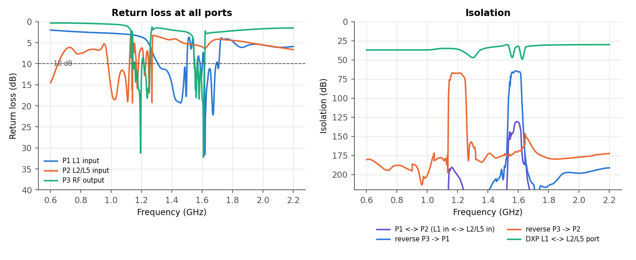
Figure 15F - Return loss at all ports (10 dB line) and isolation: between the two antenna inputs, reverse isolation output-to-input, and the DXP port-to-port isolation.
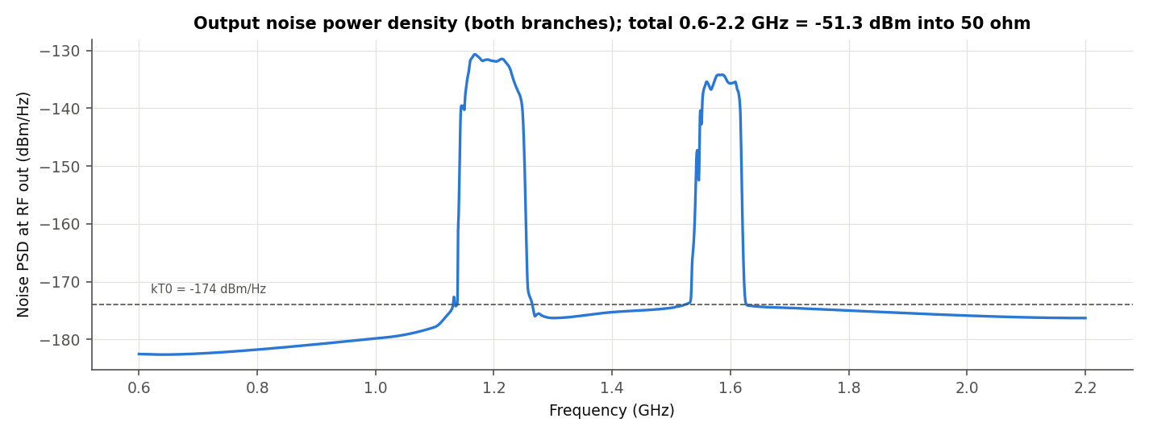
Figure 15G - Output noise density delivered to the receiver. Total noise power 0.6-2.2 GHz = -51.3 dBm (the receiver front end must handle it without compressing).
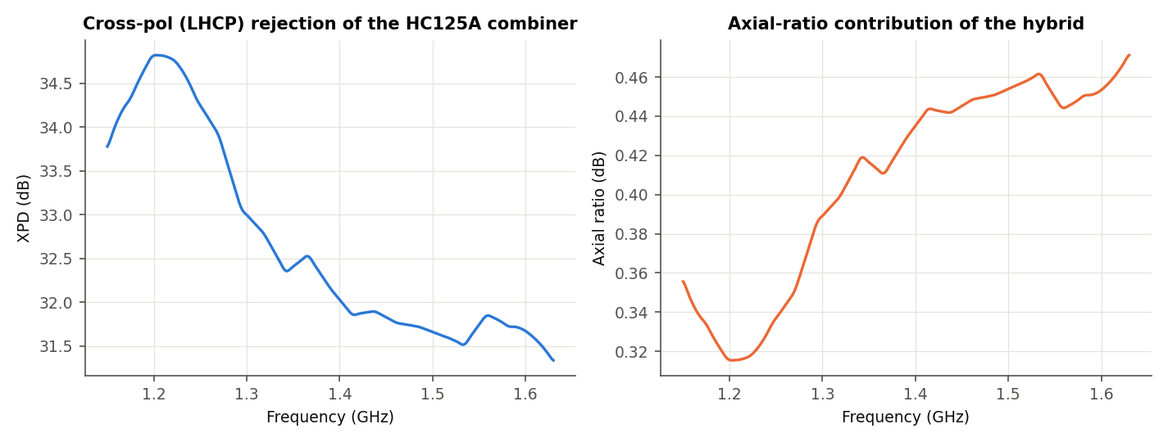
Figure 15H - Cross-polar (LHCP) rejection and axial-ratio contribution caused by the HC125A amplitude/phase imbalance (ideal patch assumed; the real antenna axial ratio adds to this).
Band | Gain | NF | Te (K) | RL in | RL out | Mismatch loss in | Rev. iso | XPD | AR (dB) | GD (ns) | IIP3 / OIP3 (dBm) | IP1dB in / OP1dB out (dBm) | SFDR (dB) | C/N0 (dB-Hz)
L1/E1/B1C | 38.6 | 0.74 | 54 | 8.1 | 14.4 | 0.72 | 65 | 31.8 | 0.45 | 38.0 | -7.9 / 30.7 | -20.8 / 16.8 | 68.2 | 44.8
B1I | 37.7 | 0.74 | 54 | 14.2 | 16.6 | 0.17 | 66 | 31.8 | 0.44 | 44.4 | - | - | - | -
G1 | 37.6 | 0.73 | 53 | 9.2 | 18.9 | 0.56 | 66 | 31.7 | 0.45 | 41.8 | - | - | - | -
L5/E5a/B2a | 42.0 | 0.59 | 42 | 12.5 | 15.2 | 0.25 | 67 | 34.4 | 0.33 | 27.3 | -11.6 / 30.4 | -23.6 / 17.4 | 59.2 | 45.5
E5b/B2b | 41.6 | 0.60 | 43 | 6.6 | 8.7 | 1.07 | 67 | 34.8 | 0.32 | 24.2 | - | - | - | -
L2 | 40.1 | 0.62 | 45 | 9.8 | 12.9 | 0.48 | 68 | 34.7 | 0.32 | 32.0 | -10.5 / 29.6 | -22.7 / 16.5 | 66.5 | 43.4
G2 | 33.4 | 0.67 | 48 | 13.7 | 16.3 | 0.19 | 75 | 34.3 | 0.34 | 80.1 | - | - | - | -
Table 7A-4 - RF parameter summary per GNSS band (dB unless stated). SFDR in the signal bandwidth (2.046 MHz L1/L2, 20.46 MHz L5); C/N0 for the minimum signal with the antenna at 290 K.
Inter-frequency group delay: L1 - L5 = 10.7 ns through the front end (estimated, min-phase SAW models). Dual-frequency receivers calibrate this as an inter-frequency bias; it must be stable over temperature, which SAW filters are not perfectly (not modelled).
Band | Gain typ (dB) | Gain min (dB) | Gain max (dB) | NF typ (dB) | NF max (dB)
L1 | 37.9 | 33.2 | 41.8 | 0.77 | 0.97
L5 | 41.0 | 35.7 | 45.3 | 0.60 | 0.97
L2 | 39.6 | 33.1 | 44.0 | 0.63 | 0.98
Table 7A-5 - Worst case from the datasheet limits (Friis, 50 ohm): LNA gain typ +/-1.5 dB and NF max 0.65 dB, SAW and DXP IL max, hybrid IL max 0.3 dB. The receiver must accept the full gain range.

8 Cascade analysis and power budget
Stage values at band centre in 50 ohm (passives: NF = loss at T0). Signal = minimum received power for a 0 dBic antenna. Noise = kT0 B F G in the signal bandwidth; 'C/N' is the ratio in that bandwidth (negative for GNSS - the signal is recovered by despreading; C/N0 = C/N + 10 log10 B).
Stage | G (dB) | NF (dB) | Cum G | Cum NF | Cum IIP3 (dBm) | Cum IP1dB (dBm) | Signal (dBm) | Noise (dBm) | C/N (dB)
HC125A (RHCP combine) | -0.36 | 0.36 | -0.36 | 0.36 | - | - | -128.9 | -110.9 | -18.0
LNA1 TQP3M9037 + bias | 21.95 | 0.37 | 21.59 | 0.73 | 13.2 | 0.3 | -106.9 | -88.5 | -18.4
B7504 #1 | -0.89 | 0.89 | 20.70 | 0.74 | 13.2 | 0.3 | -107.8 | -89.4 | -18.4
LNA2 TQP3M9037 + bias | 21.95 | 0.37 | 42.65 | 0.74 | -7.9 | -20.8 | -85.8 | -67.5 | -18.4
B7504 #2 | -0.89 | 0.89 | 41.76 | 0.74 | -7.9 | -20.8 | -86.7 | -68.4 | -18.4
DXP.02.A (combiner) | -3.31 | 3.31 | 38.45 | 0.74 | -7.9 | -20.8 | -90.0 | -71.7 | -18.4
Cascade - L1 C/A (1575.42 MHz, 2.046 MHz).
Stage | G (dB) | NF (dB) | Cum G | Cum NF | Cum IIP3 (dBm) | Cum IP1dB (dBm) | Signal (dBm) | Noise (dBm) | C/N (dB)
HC125A (RHCP combine) | -0.19 | 0.19 | -0.19 | 0.19 | - | - | -128.1 | -100.9 | -27.2
LNA1 TQP3M9037 + bias | 23.61 | 0.39 | 23.41 | 0.58 | 11.2 | -0.9 | -104.5 | -76.9 | -27.6
B8889 #1 | -0.91 | 0.91 | 22.50 | 0.59 | 11.2 | -0.9 | -105.4 | -77.8 | -27.6
LNA2 TQP3M9037 + bias | 23.61 | 0.39 | 46.11 | 0.59 | -11.6 | -23.6 | -81.8 | -54.2 | -27.6
B8889 #2 | -0.91 | 0.91 | 45.20 | 0.59 | -11.6 | -23.6 | -82.7 | -55.1 | -27.6
DXP.02.A (combiner) | -3.14 | 3.14 | 42.06 | 0.59 | -11.6 | -23.6 | -85.8 | -58.2 | -27.6
Cascade - L5 (1176.45 MHz, 20.46 MHz).
Stage | G (dB) | NF (dB) | Cum G | Cum NF | Cum IIP3 (dBm) | Cum IP1dB (dBm) | Signal (dBm) | Noise (dBm) | C/N (dB)
HC125A (RHCP combine) | -0.22 | 0.22 | -0.22 | 0.22 | - | - | -130.2 | -110.9 | -19.4
LNA1 TQP3M9037 + bias | 23.39 | 0.40 | 23.17 | 0.61 | 11.4 | -0.7 | -106.8 | -87.1 | -19.7
B8889 #1 | -1.45 | 1.45 | 21.71 | 0.62 | 11.4 | -0.7 | -108.3 | -88.5 | -19.8
LNA2 TQP3M9037 + bias | 23.39 | 0.40 | 45.10 | 0.62 | -10.5 | -22.7 | -84.9 | -65.1 | -19.8
B8889 #2 | -1.45 | 1.45 | 43.65 | 0.62 | -10.5 | -22.7 | -86.4 | -66.6 | -19.8
DXP.02.A (combiner) | -3.56 | 3.56 | 40.09 | 0.62 | -10.5 | -22.7 | -89.9 | -70.2 | -19.8
Cascade - L2C (1227.60 MHz, 2.046 MHz).
L1 C/A: C/N0 at the RF output = 44.7 dB-Hz for the minimum signal (sky noise at 290 K assumed; with a real sky temperature of ~100 K the front-end NF matters more and C/N0 rises by ~2-3 dB). The Friis cascade (50 ohm stages) and the full noise-correlation simulation agree within 0.02 dB.
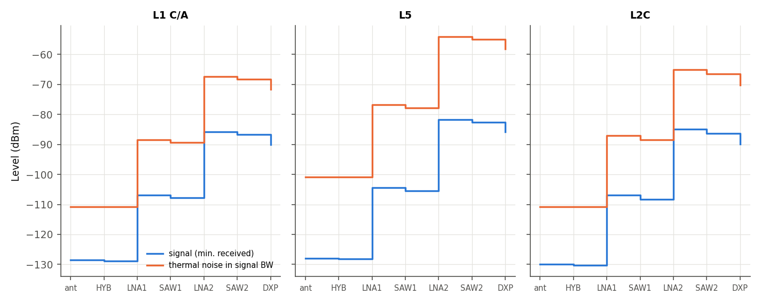
Figure 16 - Level diagram: minimum signal and thermal noise through the chain.
Power consumption: 4 x 70 mA x 5 V = 1.40 W (VDD 4.2 V typ allowed: 4 x ~60 mA). DC is fed through the 18 nH chokes; if the antenna is powered over the coax, add a bias tee at the RF output (the DXP and SAWs block DC; the SAWs are rated 5 V DC max).

9 Interference and linearity
Out-of-band signals at the antenna feed (levels assumed for a co-located terminal, A18) propagated through each branch with the small-signal gains. 'Back-off' = LNA OP1dB minus the interferer level at that LNA output.
Interferer | f (MHz) | P ant (dBm) | Branch | LNA1 out | SAW1 out | LNA2 out | RF out | Back-off LNA1 | Back-off LNA2
LTE B13/B14 UL | 787.0 | -10 | L1 | 15.0 | -43.2 | -18.0 | -131.5 | 7.0 | 40.0
LTE B13/B14 UL | 787.0 | -10 | L2/L5 | 15.0 | -33.1 | -7.9 | -88.9 | 7.0 | 29.9
GSM-900 / LTE B8 UL | 897.5 | -10 | L1 | 14.6 | -44.4 | -19.6 | -130.7 | 7.4 | 41.6
GSM-900 / LTE B8 UL | 897.5 | -10 | L2/L5 | 14.6 | -31.4 | -6.6 | -89.5 | 7.4 | 28.6
DME/TACAN (aviation) | 1150.0 | -30 | L1 | -6.5 | -75.2 | -51.5 | -172.2 | 28.1 | 73.1
DME/TACAN (aviation) | 1150.0 | -30 | L2/L5 | -6.5 | -10.5 | 13.3 | 3.3 | 28.1 | 8.3
ARNS radar | 1260.0 | -40 | L1 | -17.0 | -92.6 | -69.3 | -193.7 | 38.4 | 90.7
ARNS radar | 1260.0 | -40 | L2/L5 | -17.0 | -46.1 | -22.8 | -57.5 | 38.4 | 44.3
Inmarsat L-band DL | 1545.0 | -80 | L1 | -58.3 | -65.4 | -43.3 | -58.0 | 79.2 | 64.3
Inmarsat L-band DL | 1545.0 | -80 | L2/L5 | -58.3 | -97.5 | -75.4 | -147.6 | 79.2 | 96.4
Iridium | 1621.0 | -20 | L1 | 1.4 | -9.7 | 12.0 | -8.3 | 19.4 | 8.8
Iridium | 1621.0 | -20 | L2/L5 | 1.4 | -33.5 | -11.7 | -78.3 | 19.4 | 32.5
Inmarsat UL | 1643.0 | -20 | L1 | 1.3 | -29.5 | -7.8 | -83.5 | 19.5 | 28.6
Inmarsat UL | 1643.0 | -20 | L2/L5 | 1.3 | -30.7 | -9.0 | -76.6 | 19.5 | 29.8
LTE B3 UL | 1747.5 | -10 | L1 | 10.9 | -49.3 | -28.0 | -123.2 | 9.7 | 48.6
LTE B3 UL | 1747.5 | -10 | L2/L5 | 10.9 | -29.4 | -8.1 | -84.3 | 9.7 | 28.7
DCS-1800 DL | 1842.5 | -30 | L1 | -9.4 | -68.3 | -47.4 | -141.0 | 29.7 | 67.7
DCS-1800 DL | 1842.5 | -30 | L2/L5 | -9.4 | -53.0 | -32.1 | -112.2 | 29.7 | 52.4
LTE B1 UL | 1950.0 | -10 | L1 | 10.2 | -44.3 | -23.8 | -111.8 | 9.8 | 43.8
LTE B1 UL | 1950.0 | -10 | L2/L5 | 10.2 | -34.8 | -14.3 | -92.7 | 9.8 | 34.3
Table - Interferer levels in dBm at each node.
- DME/TACAN 960-1215 MHz (pulsed, aviation): the B8889 lower skirt gives only ~4 dB at 1150 MHz, so LNA 2 output reaches +13.3 dBm and the RF output +3.3 dBm for -30 dBm at the antenna. This exceeds the B8889 +5 dBm input rating at SAW 2 and can block the receiver. Critical for aviation/automotive near airports.
- Iridium 1616-1626.5 MHz: B7504 attenuation at 1621 MHz ~11 dB per filter; LNA 2 output +12.0 dBm for -20 dBm at the antenna.
- Cellular uplinks (-10 dBm): LNA 1 sees the full level (no pre-filter); back-off 7-10 dB from OP1dB, ~13 dB below the +22 dBm absolute-maximum input. After SAW 1 the levels drop by 40-60 dB.
- In-band: cascaded input P1dB -21 to -24 dBm and IIP3 -8 to -12 dBm, limited by LNA 2 (the GNSS signal itself is ~100 dB below this).

10 Simulation tool cross-checks
Solver | How | Max |dS| in band vs reference | Script
scikit-rf 1.x (reference) | Network cascade + Circuit, noise-correlation matrices | - | Scripts/simulate.py
heavi 0.7.9 (nodal Y solver) | Same circuit from the Touchstone files, own R/L/C | 0.0037 dB | Scripts/crosscheck_heavi.py
circuitRF 1.6.1 (CLI sparam) | Netlist circuitRF/gnss_frontend.cnl, SnP blocks | 0.0007 dB | Scripts/build_circuitrf.py
Table - Solver agreement on S31, S32, S11, S22, S33 inside 1164-1230 and 1559-1606 MHz.
ANSYS AEDT: the PyAEDT script builds, solves and saves the project. In this session AEDT 2026 R1 is installed but the headless gRPC session could not be started from the automation shell (see the error log, appendix A); run 'python Scripts/aedt_circuit.py' on the workstation (add --gui to watch it). The script exports ANSYS_Project/AEDT_System_3port.s3p, which Scripts/build_all.py then compares with the reference.
Sensitivity found during the cross-check: interpolating the 200 MHz-step LNA table linearly instead of with a cubic spline changes in-band gain by up to 1.4 dB. The LNA table resolution is therefore a model uncertainty of the order of +/-0.7 dB in gain (assumption A6).

11 Model validation against the datasheets
Item | Datasheet typ | Datasheet max | Model
B7504 IL 1559.1-1563.1 MHz | 1.10 | 2.00 | 1.06
B7504 IL 1574.4-1576.4 MHz | 0.90 | 1.40 | 0.90
B7504 IL 1597.5-1605.9 MHz | 1.20 | 2.00 | 1.04
B8889 IL 1166.22-1186.68 MHz | 0.90 | 1.50 | 0.92
B8889 IL 1205.09-1209.19 MHz | 1.00 | 1.30 | 0.87
B8889 IL 1226.58-1228.62 MHz | 1.40 | 2.60 | 1.48
B7504 att 10-925 MHz (min 45) | 58.00 | - | 58.00
B7504 att 814-915 MHz (min 45) | 58.00 | - | 58.34
B7504 att 925-960 MHz (min 45) | 60.00 | - | 59.44
B7504 att 1427-1463 MHz (min 50) | 55.00 | - | 56.58
B7504 att 1695-1710 MHz (min 50) | 53.00 | - | 57.37
B7504 att 1710-1785 MHz (min 50) | 53.00 | - | 60.00
B7504 att 1850-1980 MHz (min 45) | 53.00 | - | 54.00
B7504 att 2010-2025 MHz (min 45) | 55.00 | - | 54.87
B7504 att 2305-2315 MHz (min 45) | 52.00 | - | 51.99
B7504 att 2401-2483 MHz (min 45) | 50.00 | - | 49.48
B7504 att 2500-2570 MHz (min 45) | 49.00 | - | 48.77
B7504 att 4400-4900 MHz (min 35) | 41.00 | - | 41.00
B7504 att 5150-5850 MHz (min 35) | 42.00 | - | 42.00
B8889 att 698-748 MHz (min 46) | 49.00 | - | 49.00
B8889 att 777-798 MHz (min 44) | 48.00 | - | 47.66
B8889 att 807-915 MHz (min 41) | 45.00 | - | 45.71
B8889 att 925-960 MHz (min 41) | 45.00 | - | 45.00
B8889 att 1427-1463 MHz (min 30) | 42.00 | - | 40.59
B8889 att 1626.5-1660.5 MHz (min 20) | 32.00 | - | 32.00
B8889 att 1695-1785 MHz (min 25) | 40.00 | - | 35.90
B8889 att 1850-2025 MHz (min 30) | 45.00 | - | 43.78
B8889 att 2300-2400 MHz (min 36) | 42.00 | - | 40.35
B8889 att 2400-2483 MHz (min 33) | 39.00 | - | 38.25
B8889 att 2500-2690 MHz (min 33) | 37.00 | - | 36.67
B8889 att 3400-3800 MHz (min 29) | 33.00 | - | 32.47
B8889 att 5150-5925 MHz (min 22) | 26.00 | - | 25.07
B7504 group-delay ripple 1597.5-1605.9 MHz [ns] | 4.00 | 15.00 | 3.52
DXP IL band 1 @1582.19 MHz | 3.80 | 4.60 | 3.30
DXP IL band 2 @1206.92 MHz | 4.20 | 5.20 | 3.25
TQP3M9037 gain @2.0 GHz (table) vs spec @1.95 | 20.00 | 21.50 | 20.28
Table - Model vs datasheet (insertion loss: mean over the band; attenuation: worst case in the band).
Every B7504/B8889 attenuation value meets the datasheet minimum and is within ~4 dB of the typical value. The DXP model gives 3.3 dB at the band centres (the measured plots) against 3.8/4.2 dB typical in the table - the table values appear to be band-edge figures (inconsistency I17).

12 Bill of materials
Qty | Ref | Part / value | Package | Manufacturer / note
2 | ANT1, ANT2 | Dual-feed patch, L1 and L2/L5 (or stacked patch) | - | Not supplied - e.g. Taoglas GPDF series
2 | HY1, HY2 | HC125A 3 dB hybrid | 6.35 x 5.08 x 1.5 mm | Taoglas
2 | R1, R2 | 50 ohm (49.9 ohm 1 %) hybrid isolated-port load | 0402 | thin film, RF rated
4 | U1-U4 | TQP3M9037 | DFN 2 x 2 mm, 8 pin | Qorvo
8 | C1/C2 per LNA | 100 pF NPO/C0G 50 V (DC block) | 0402 | Murata GJM/GRM series
4 | C3 | 100 pF NPO (VDD bypass) | 0402 | -
4 | C4 | 1.0 uF X5R 10 V (VDD bypass) | 0402 | -
4 | L1 | 18 nH ceramic, 5 % (RF choke) | 0603 | e.g. Coilcraft 0603CS / Murata LQW18
8 (opt.) | R1/R2 per LNA | 10 k / 33 k shutdown divider | 0402 | only if PD control is used
2 | F1, F2 | B7504 SAW (B39162B7504L210) | 0.9 x 0.7 mm | Qualcomm RF360
2 | F3, F4 | B8889 SAW (B39122B8889P810) | 1.1 x 0.9 mm | Qualcomm RF360
4 | Lp1/Lp4 | 6.8 nH wire-wound, high Q (B8889 matching) | 0402 | e.g. Murata LQW15AN6N8
1 | DX1 | DXP.02.A SAW diplexer | 5 x 5 x 1.7 mm | Taoglas
1 | L2 | 4.3 nH (DXP common) | 0402 | TDK (eval board)
1 | C1 | 1.5 pF (DXP common) | 0402 | Murata (eval board)
1 | L1 | 4.7 nH (DXP L1 port) | 0402 | TDK (eval board)
1 | L3 | 3.3 nH (DXP L2/L5 port) | 0402 | TDK (eval board)
1 | C2 | 1 pF (DXP L2/L5 port) | 0402 | Murata (eval board)
1 | J1 | RF output connector (SMA/U.FL/MMCX) | - | per enclosure
Table - Bill of materials (eval-board reference values).

13 Datasheet inconsistencies and missing parameters
ID | Where | Finding
I1 | B7504 vs product brief | Datasheet p.7 lists 'Group delay typ 4.0 / max 15 ns' (GLONASS band); the product brief lists the same numbers as 'group delay ripple'. The model gives ~13 ns absolute delay and ~4-10 ns ripple, so the datasheet label should read 'ripple'.
I2 | DXP.02.A front page | Lists 'L2 1227.625 MHz'; GPS L2 is 1227.60 MHz.
I3 | DXP.02.A isolation row | 'Isolation (1574.22~1576.62 dB)' - unit should be MHz.
I4 | DXP.02.A pass-band claim | Text p.11: L2 pin covers '1164-1300 MHz'. Measured plot p.8: insertion loss >6 dB above ~1263 MHz, so GLONASS G2 upper half, B3 (1268.5) and E6 (1278.75) are not usable.
I5 | DXP.02.A return loss | Table p.4 band-2 RL typ -8 dB (max -6) vs. the plot p.6 showing 12-24 dB in the L2/L5 band; the plot is used.
I6 | DXP.02.A pin naming | Pin 5 is called 'GPS L2 Output' in the pin table but 'GPS L2/L5 OUT' on the symbol.
I7 | DXP.02.A RL sign | Return loss given as negative numbers with 'Max -6.0' - ambiguous min/max sense.
I8 | HC125A phase balance | Spec says 'Phase balance 90 degrees' with no tolerance; the typical table shows 91.9-93.0 deg (up to 3 deg off), which costs ~0.01 dB of axial-ratio/combining loss.
I9 | HC125A pin table vs table columns | Typical table uses 'Coupling/Transmission' and S11..S44 without stating which pins; the pin table uses 'Pin 1..4'. Mapping assumed (A9).
I10 | TQP3M9037 noise table | NFmin 0.40 dB at 1.5 GHz but 0.29 dB at 1.7 GHz (non-monotonic); Gopt angle jumps 85.8 -> 42.1 -> 157.4 deg between 2.4/2.5/2.6 GHz with |Gopt| ~0.02-0.08 (measurement scatter).
I11 | TQP3M9037 switching speed | Table p.2 note: switching speed with C1 = 10 pF; eval board default C1 = 100 pF (switching table p.5 shows both).
I12 | TQP3M9037 stability | 'Unconditionally stable' claim holds (K >= 1.01, mu >= 1.06 from the table) but the margin is only ~1 % at 50 MHz.
I13 | B8889 spec typo | Data sheet p.7 'Insertion attenuation' first row has no unit; 'linsertion loss' typo on B7504 p.7.
I14 | B8889 vs brief | Brief gives B8889 pass-band 1166-1228 MHz (62 MHz); the datasheet spec bands end at 1228.62 MHz. GLONASS G2 (1246-1256) is outside the B8889 pass-band (>4 dB at 1245 MHz) although the HC125A table and the DXP claim to cover it.
I15 | SDST vs. parts used | The automotive SAW selection table (Feb 2020) does not list B7504 or B8889; equivalent automotive parts are e.g. B39162B2611P810 (L1, 0.9 dB, pre-LNA) and B39122B2620P810 (E5b/L2).
I17 | DXP.02.A insertion loss | Table p.4: IL typ 3.8 dB (L1) / 4.2 dB (L2/L5); the measured plots p.7-8 show 3.3 dB / 3.1-3.2 dB at the band centres and reach 3.8 / 4.2 dB only at the band edges. The model follows the plots.
I18 | TA1442A bandwidth | Cover page 'BW = 5 MHz' is the specified band 2489.5-2494.5 MHz; the measured 3 dB bandwidth is ~62 MHz (about 2453-2537 MHz) and the filter passes Wi-Fi channel 13 and LTE B41/B7 almost unattenuated.
I19 | TA1442A VSWR | Spec VSWR typ 1.2 vs VNA markers 1.04-1.12 in the spec band (sample better than typ).
I20 | C2327J5003AHF note | Spec table footnote: 'values are for the case with shunt capacitor across differential lines' - not explained for a 4-port hybrid; no value given.
I21 | C2327J5003AHF phase balance | Spec typ 4 deg / max 8 deg vs plot ~2.5-3.2 deg over 2.4-2.6 GHz; broadband plot shows >= 20 deg above 4.4 GHz (part not usable there).
I22 | Two datasheet ages | TA1442A approval sheet is from 2011 (rev. 1): check the part is still in production before design-in.
I16 | AN #18 scope | AN #18 covers 315/434/868 MHz RKE receivers (TDA520x, ATA572x). Only its matching method applies here; its component values do not.
Table - Inconsistencies.
Part | Missing parameter | Treatment
TQP3M9037 | Noise parameters below 1.5 GHz (L2/L5 band) | Estimated (A3)
TQP3M9037 | S-parameters at 3.3 V (only 4 typical points) | Not needed (5 V chosen)
TQP3M9037 | Fine-step S-parameters (table step 200 MHz) | Interpolated (A6)
TQP3M9037 | P1dB / OIP3 at 1.18-1.6 GHz | Interpolated (A7)
HC125A | Absolute S-parameter phase, reflection phase, data outside 1150-1630 MHz | Assumed (A8, A11)
B7504 | Phase / group delay outside the GLONASS band, in-band power rating at 1559-1606 MHz, IIP3 | Min-phase estimate; not rated
B8889 | Group delay, phase, IIP3 | Min-phase estimate
DXP.02.A | Phase, group delay, out-of-band data above 2.2 GHz, power-handling per port | Min-phase estimate; held flat
All | Temperature drift of the SAW centre frequency (typ. -30...-40 ppm/K for SAW) | Not modelled
TA1442A | Phase / group delay, power handling per frequency, IIP3 | Min-phase estimate; 10 dBm max input only
C2327J5003AHF | Reflection at ports other than the input, absolute phase | Assumed (A23)
All | Package/PCB parasitics for the layout | Not modelled (A17)
Table - Missing parameters.

14 Limitations
- SAW and diplexer Touchstone files are estimates from digitized plots: magnitude accuracy +/-0.3 dB in band and +/-2 dB in the stop band; phase and group delay are minimum-phase estimates (real SAW delay can be larger).
- HC125A phase is assumed; only magnitudes and the coupled/through phase difference are datasheet values. The HC125A is held flat outside 1150-1630 MHz.
- The antenna is an ideal RHCP source; patch impedance, feed coupling, axial ratio and pattern are not modelled.
- LNA data are 25 C typical at 5 V with 200 MHz steps; no temperature, supply, part-to-part or aging spread.
- No PCB interconnect, via, ground or coupling effects; no layout-induced feedback around the 40 dB of gain.
- Noise below 1.5 GHz and large-signal values at L-band are interpolated/estimated.
- Interference analysis is small-signal (no compression, no intermodulation products, no pulsed DME statistics).
- AN #18 is an RKE (315/434/868 MHz) application note; its method is used, its component values are not.

15 Recommendations
- Add a pre-LNA filter or at least a DME/L-band notch: the L2/L5 branch needs > 30 dB at 960-1150 MHz; e.g. move one B8889 in front of LNA 1 (costs ~0.9 dB NF) or use a ceramic/cavity L5 pre-filter. For L1, a pre-filter with steeper upper skirt (Iridium) such as B39162B2611P810 (0.9 dB, pre-LNA) from the SDST.
- Reduce gain to what the receiver needs (typ. 25-30 dB at the connector): drop to one LNA per branch, or keep two and run LNA 2 at 3.3 V (-1.5 dB gain, -4 dBm OP1dB, 44 mA) or add a pad - this also eases the SAW 2 power rating.
- Improve the RHCP-port match: use the Qorvo optimized-return-loss input network (3.3 pF series + 3.9 nH shunt, p.9) or a two-step AN #18 style match; the hybrid then also sees a better load, improving combining/axial ratio.
- Choose the second B8889 position or replace B8889 by B2642/B2632 if GLONASS G2 is required (B8889 stops at ~1245 MHz).
- Get measured data: RF360 provides measured .s2p for B7504/B8889; Taoglas for HC125A (.s4p) and DXP.02.A (.s3p); Qorvo for the TQP3M9037 fine-step .s2p and low-band noise parameters. Drop them into Touchstone/ and rerun Scripts/build_all.py - every result regenerates.
- Layout: keep 40 dB of gain stable - separate input and output grounds of each LNA with via fences, keep the SAWs between the LNAs, follow the Qorvo via pattern (p.15) and HC125A footprint (p.11-13).
- Next simulation step: import the real patch S-parameters (HFSS) in place of PatchCP_ideal, and add MSL models for the interconnects in AEDT Circuit.

16 Deliverables
Folder | Content
Touchstone/ | TQP3M9037_5V.s2p (extracted, with noise), TQP3M9037_stage_5V_with_bias.s2p, HC125A.s4p, B7504.s2p, B8889_matched.s2p, DXP02A.s3p, PatchCP_ideal_RHCP_feed.s4p (estimated); SIM_*.s2p/.s3p (simulated results)
Scripts/ | ds_data.py, models.py, simulate.py, build_extracted.py, make_schematics.py, aedt_circuit.py (PyAEDT), build_circuitrf.py, crosscheck_heavi.py, make_report.py, build_all.py
ANSYS_Project/ | GNSS_L1_L2L5_FrontEnd.aedt (when AEDT runs), AEDT_System_3port.s3p, aedt_run.log
circuitRF/ | gnss_frontend.cnl netlist and its circuitRF S-parameter result
Report/ | this report (PDF and DOCX), error_log.md
Images/ | schematics (PNG + SVG), connection diagram, all result plots
Extracted_Data/ | 36 CSV tables, Extracted_Parameters.xlsx, assumptions_log.md, results_*.csv, cross-check JSON
Table - Deliverables.

Appendix A - Error log
# | Step | Error | Resolution / status
E1 | Topology | Chain as first written (HC125A - LNA - filter - LNA - filter - DXP) cannot pass both bands: B7504 (L1) and B8889 (L2/L5) have disjoint pass-bands | Asked the user; two-branch topology with the DXP as combiner confirmed
E2 | Tool install | `pip install ansys-aedt-core` not found on the package index | Installed `pyaedt` 1.9.0 (provides `ansys.aedt.core`)
E3 | Tool install | `uvx` install of the PyAEDT MCP server from GitHub blocked by the permission classifier | Not installed; user asked to run it themselves if wanted
E4 | Tool install | heavi 0.7.9 fails to import on Python 3.12 (`mutable default UnassignedType` dataclass error) and downgraded the global numpy | heavi moved to the repo `.venv`; one-line local fix (`__hash__ = object.__hash__` in `heavi/node.py`); global numpy restored to 2.5.4
E5 | Tool install | circuitRF portable zip: `unzip` warns about backslash paths | Extracted with PowerShell `Expand-Archive`; MCP server registered locally (`claude mcp add circuitrf`)
E6 | HC125A model | Table magnitudes with arbitrary reflection/isolation phases gave a non-passive 4-port (largest singular value 1.05) | Phases chosen to minimise the largest singular value (1.013); residual scaling <= 0.11 dB (assumption A10)
E7 | circuitRF | `Token overflow: got 17 tokens, expected 9 for 2-port` when reading MHz / DB Touchstone files | All Touchstone files rewritten as GHz / RI; circuitRF then reads them
E8 | heavi cross-check | First comparison differed by up to 1.4 dB | Cause: linear vs cubic interpolation of the 200 MHz LNA table and missing parasitics. With identical models the difference is < 0.01 dB; the interpolation sensitivity is reported as model uncertainty (A6)
E9 | ANSYS AEDT | PyAEDT 1.9 + AEDT 2026 R1: `Failed to start new AEDT gRPC session` (transport mode WNUA) from both Bash and PowerShell; `ansysedt -grpcsrv` process starts but does not open the port within 10 min | Not solved in this session. Run `python Scripts/aedt_circuit.py --gui` on the workstation (an interactive AEDT can answer licence/first-run prompts), or `--version 2024.1` for the 2024 R1 install. Two idle `ansysedt.exe` processes from these attempts (PIDs 9720, 10988) could not be closed from the session (permission denied) - close them in Task Manager
Table - Errors met while building this project and how they were resolved.

