Multi-band GNSS / NavIC Active Antenna - RF Front End
Technical note: architecture, simulated RF performance, interference risk and actions (L1, L2/L5, NavIC S)
Doc. No.: ________ | Rev.: Draft A | Date: 2026-10-31
Field | Entry
Document | Technical note - RF front end of the multi-band active antenna
Document No. / Rev. | ________ / Draft A
Prepared / Checked / Approved | ________ / ________ / ________
Classification | BEL internal. Technical details for internal circulation only.
Basis | Manufacturer data sheets of the selected parts (listed in section 9); circuit simulation. No hardware measurement yet.
Document control.

1 Scope
This note gives the RF design data of the active antenna front end: the antenna element is only mentioned (dual-feed RHCP patch per band, modelled as an ideal source); everything behind the feeds - hybrid combiners, LNAs, SAW filters and the band combiner - is modelled from the manufacturer data and simulated. Three bands: GNSS L1 (B1I/L1/E1/G1) and L2/L5 (L5/E5a/E5b/L2) on one combined output, and NavIC S-band (2492.028 MHz) on a separate output. All LNAs at +5 V.

2 Architecture
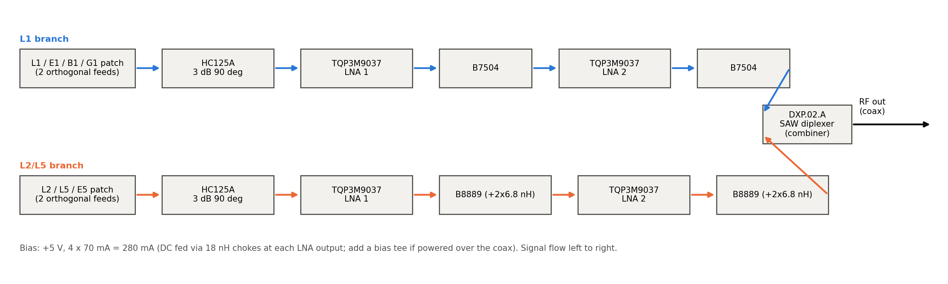
Figure 1 - L-band chain (two branches combined in the DXP.02.A).
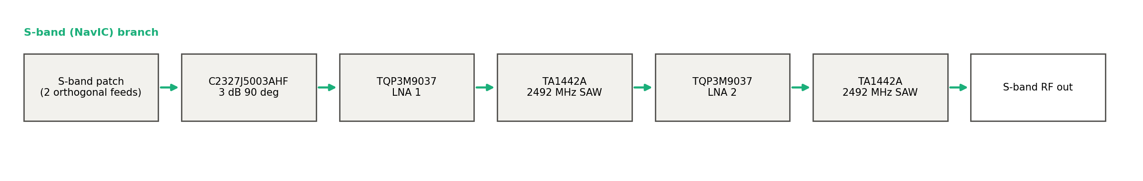
Figure 2 - NavIC S-band chain (separate output).
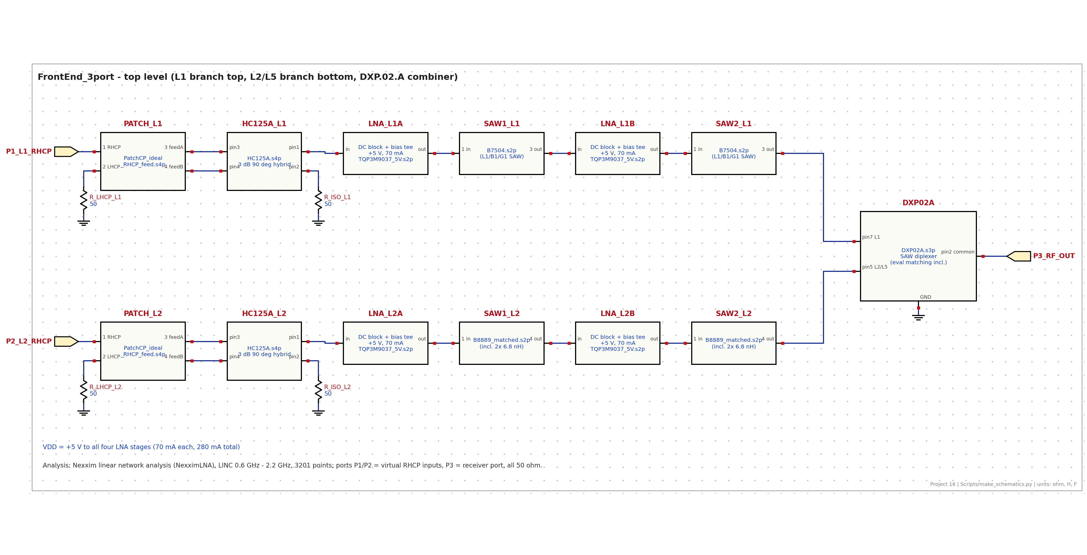
Figure 3 - Simulation schematic, L-band (design FrontEnd_3port).
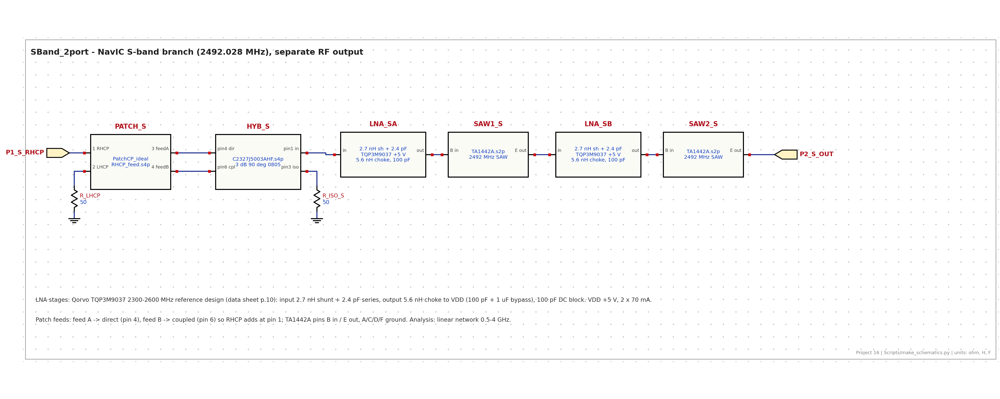
Figure 4 - Simulation schematic, S-band (design SBand_2port).
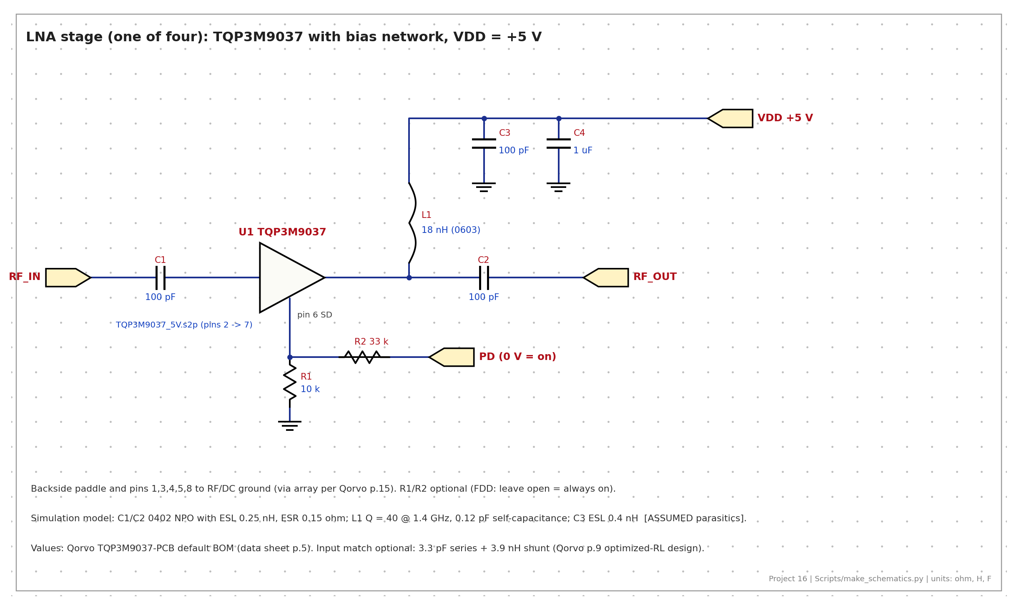
Figure 5 - L-band LNA stage with bias network (S-band stage: Qorvo 2.3-2.6 GHz reference design, 2.7 nH shunt + 2.4 pF series input match, 5.6 nH choke).

3 Performance summary
Band / MHz | Gain dB | NF dB | VSWR in | VSWR out | Ripple dB | GD ns | IIP3 dBm | OP1dB dBm | C/N0 dB-Hz
L1/E1/B1C 1575.42 | 38.6 | 0.74 | 2.29 | 1.47 | 0.34 | 38.0 | -7.9 | 16.8 | 44.8
B1I 1561.10 | 37.7 | 0.74 | 1.49 | 1.35 | 0.51 | 44.4 | - | - | -
G1 1602.00 | 37.6 | 0.73 | 2.07 | 1.26 | 0.14 | 41.8 | - | - | -
L5/E5a 1176.45 | 42.0 | 0.59 | 1.63 | 1.42 | 1.14 | 27.3 | -11.6 | 17.4 | 45.5
E5b/B2b 1207.14 | 41.6 | 0.60 | 2.75 | 2.17 | 0.42 | 24.2 | - | - | -
L2 1227.60 | 40.1 | 0.62 | 1.96 | 1.58 | 0.41 | 32.0 | -10.5 | 16.5 | 43.4
NavIC S 2492.028 | 35.0 | 1.17 | 1.24 | 1.15 | 0.08 | 19.9 | -1.4 | 18.1 | 40.5
Table 1 - Simulated performance, 25 C typical, 50 ohm, from the antenna feed (RHCP) to the RF output. Ripple over the signal bandwidth; C/N0 for the minimum specified signal with the antenna at 290 K.
Item | L-band | S-band
Stability | unconditional; branch mu >= 1.035 | unconditional; mu >= 1.053, stage mu >= 1.12
Reverse isolation | 65 dB (L1), 67 dB (L5) | 58 dB
Cross-pol (LHCP) rejection of hybrid | 31.8 dB (L1), 34.4 dB (L5) | 32.3 dB
Axial-ratio contribution of hybrid | 0.45 dB (L1), 0.33 dB (L5) | 0.42 dB
Output noise power (whole band) | -51.3 dBm | -59.7 dBm
3 dB bandwidth | L1 ~1553-1613 MHz, L2/L5 ~1156-1243 MHz | ~62 MHz (TA1442A is wide)
Inter-band group delay | L1 - L5 = 10.7 ns (estimate) | -
Worst-case gain range (data-sheet limits) | 33-45 dB, NF <= 0.98 dB | -
Supply | 4 x TQP3M9037, 70 mA each at 5 V | 2 x TQP3M9037, 70 mA each at 5 V
Total DC | 6 LNAs: 420 mA at +5 V = 2.1 W
Table 2 - Other parameters.

4 L-band results (simulator plots)
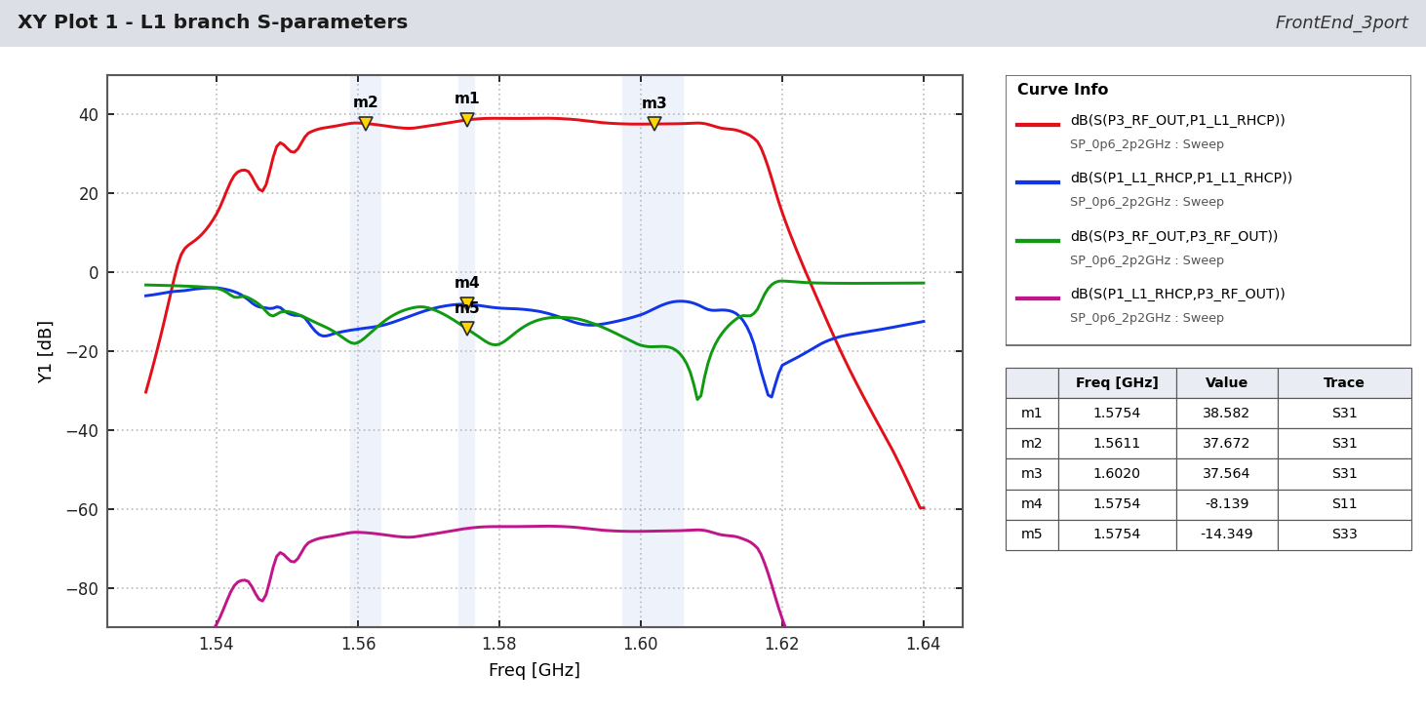
Figure - L1 branch: S31 (gain), S11, S33, S13.
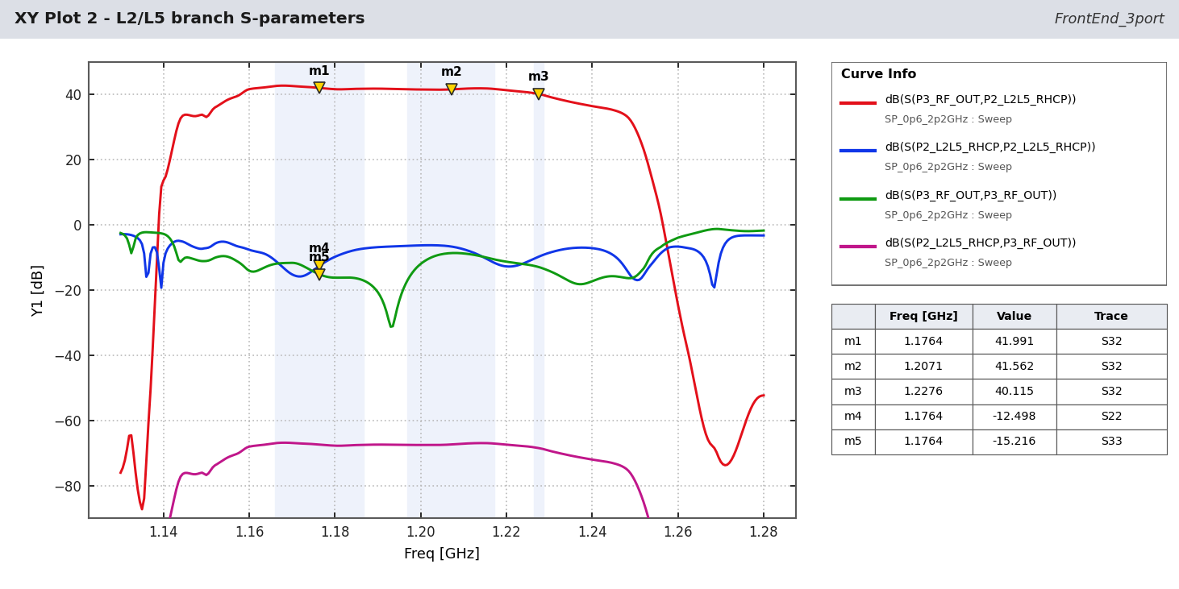
Figure - L2/L5 branch: S32, S22, S33, S23.
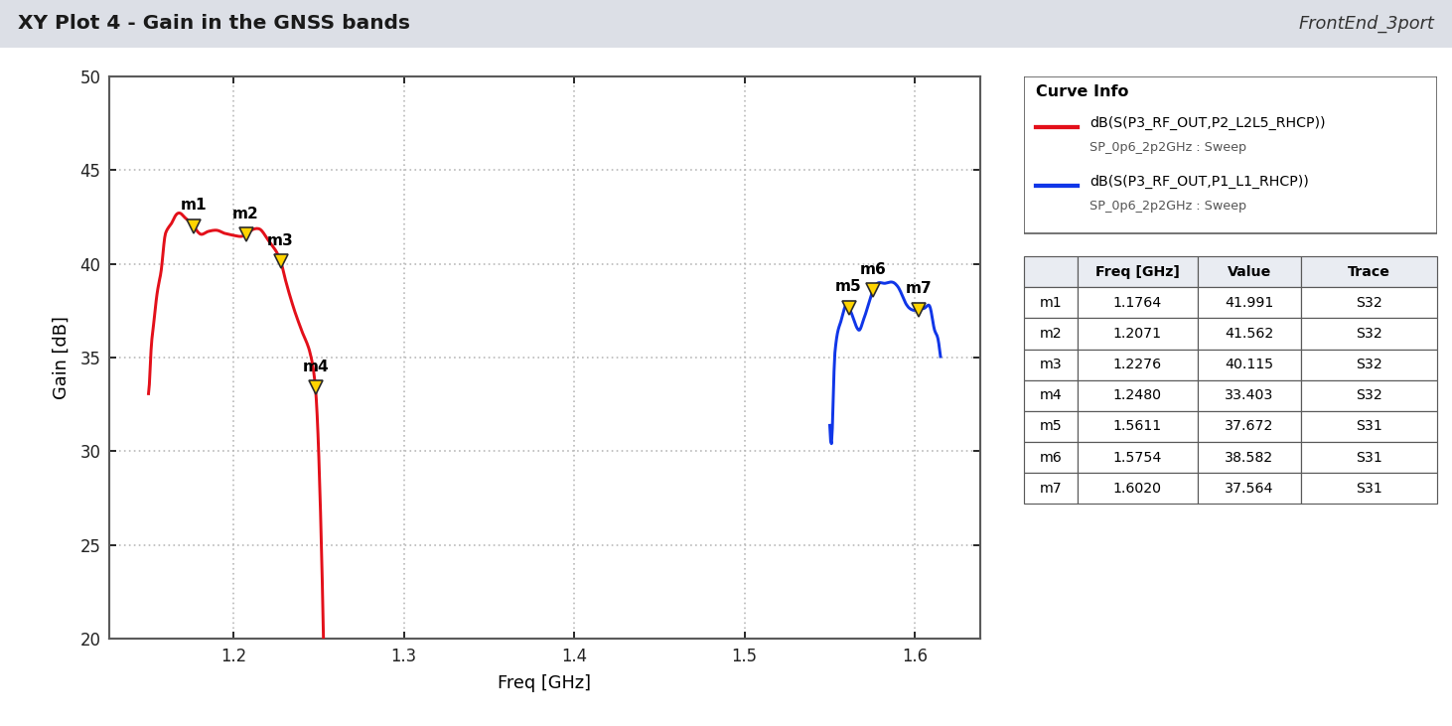
Figure - Gain in the GNSS bands with markers at the signal centres.
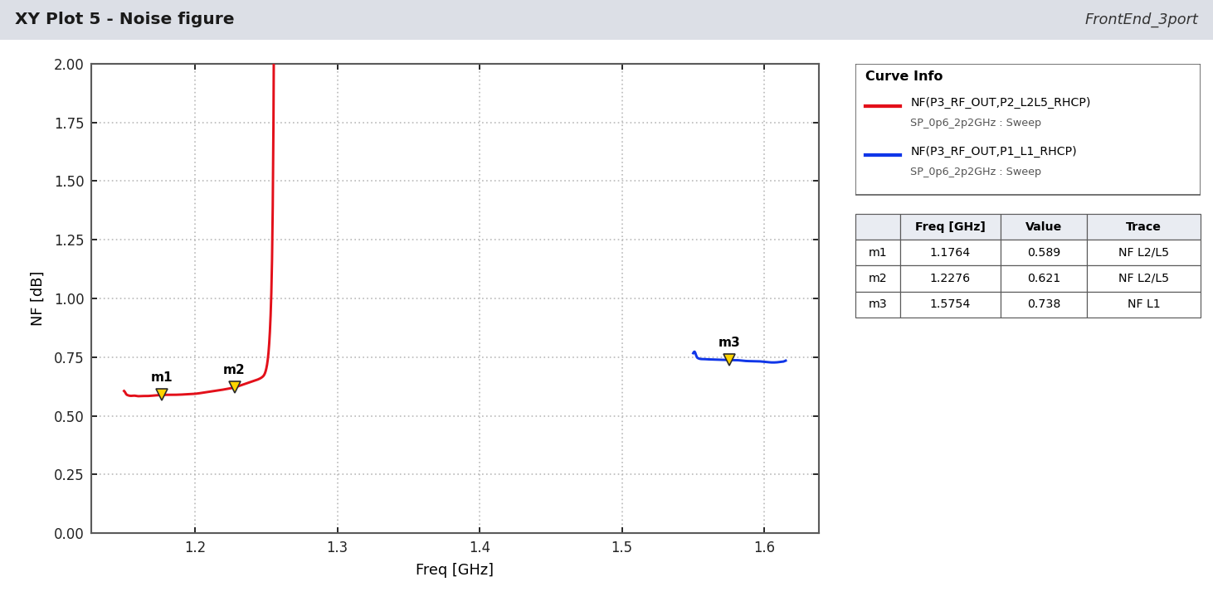
Figure - Noise figure.
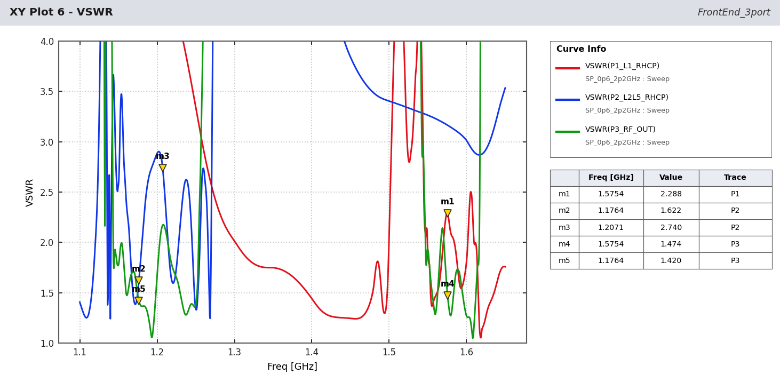
Figure - VSWR at the three ports.
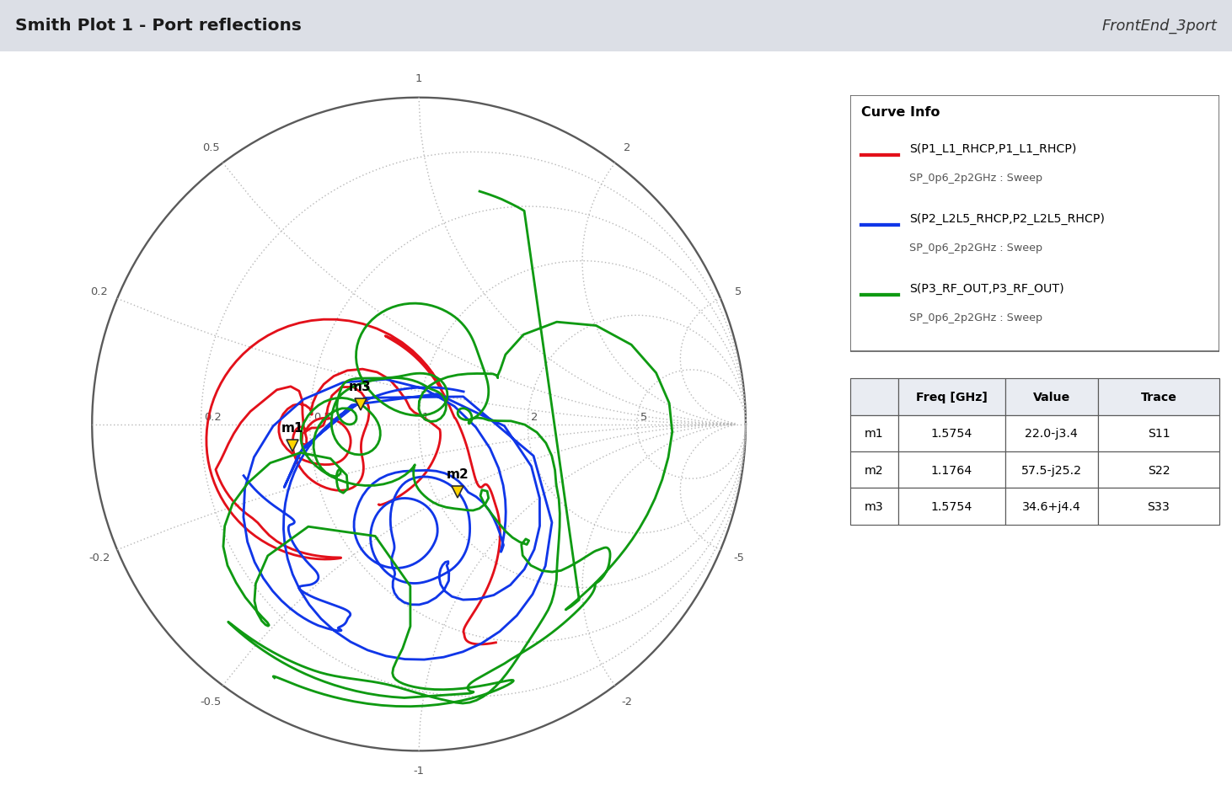
Figure - Port reflections on the Smith chart.
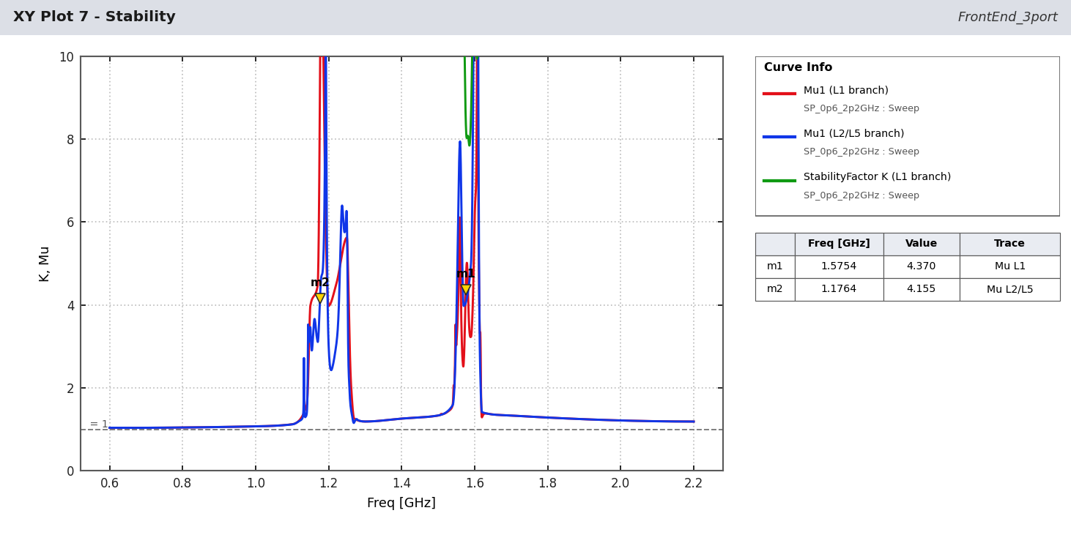
Figure - Stability factors K and mu.
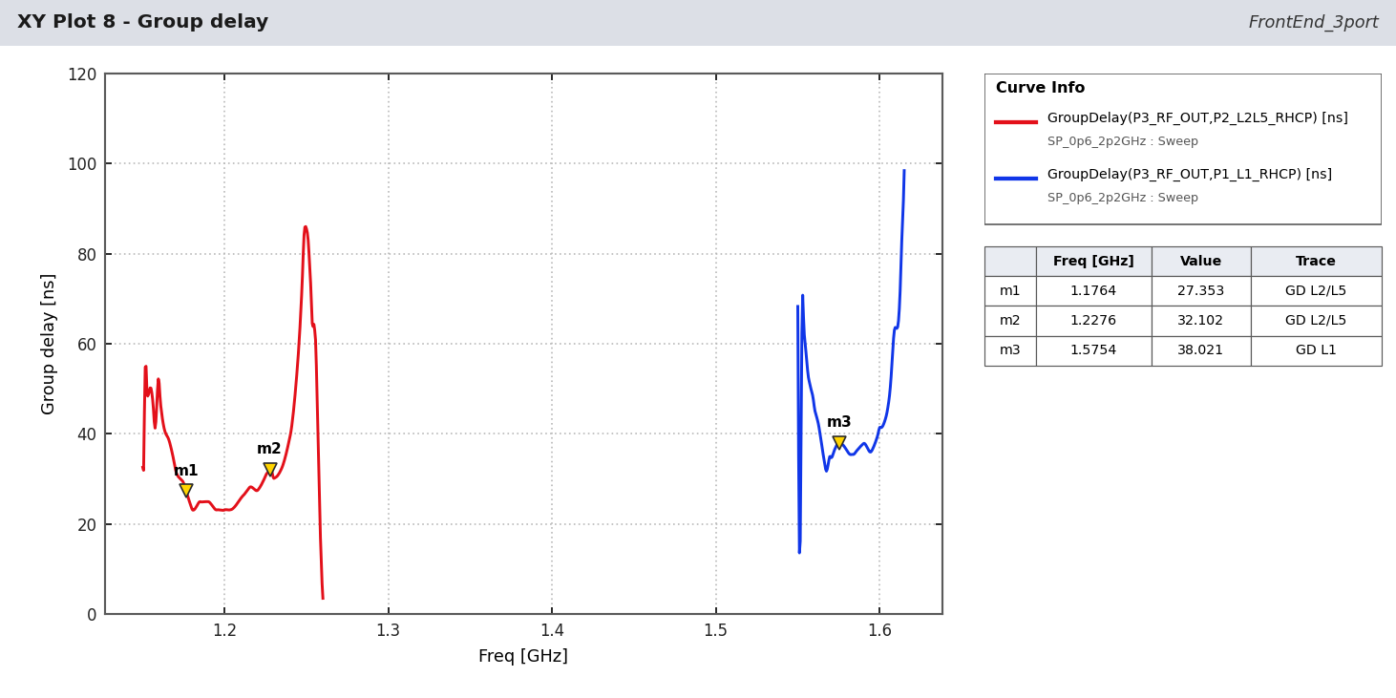
Figure - Group delay (estimated phase of SAW/diplexer models).
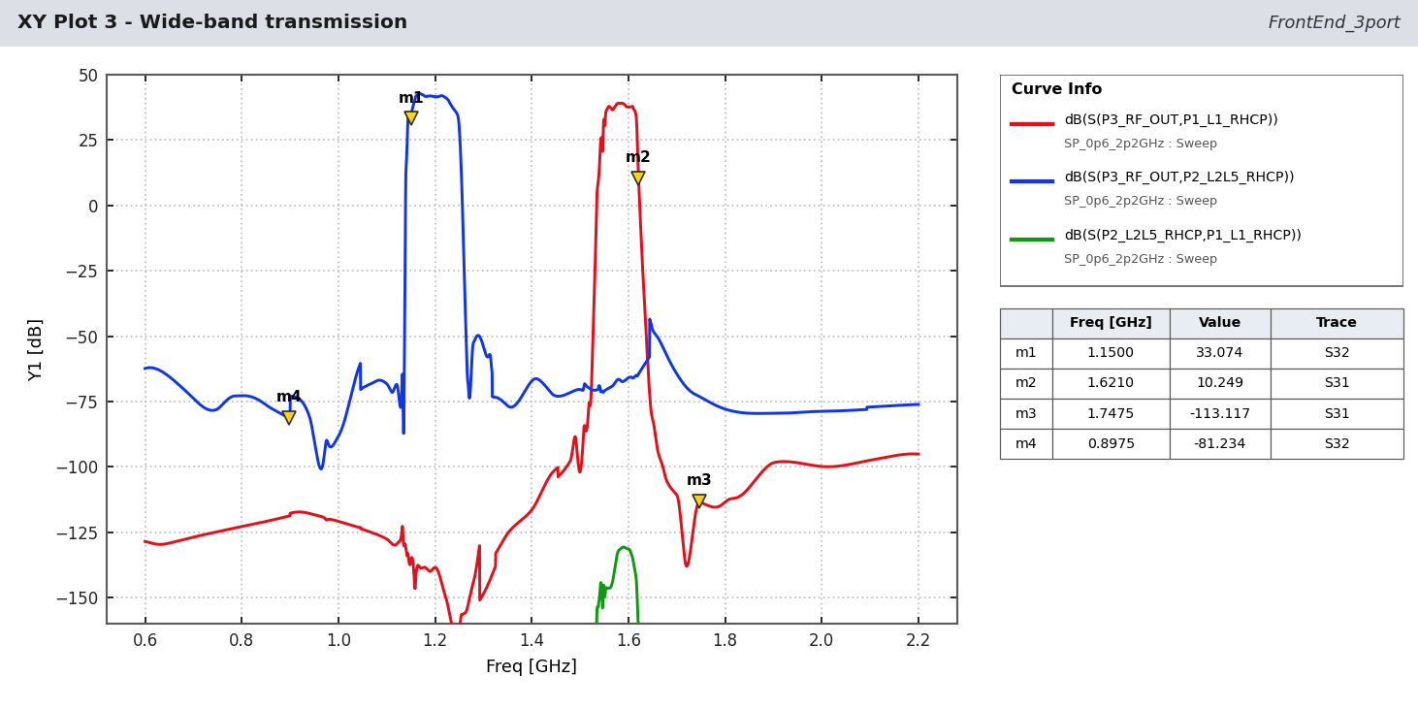
Figure - Wide-band transmission 0.6-2.2 GHz.
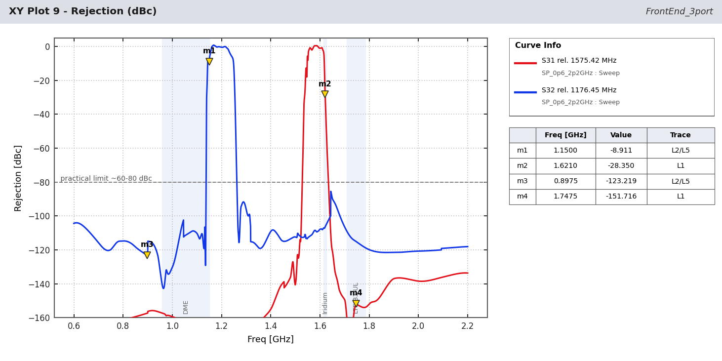
Figure - Rejection in dBc relative to the band-centre gain.

5 NavIC S-band results (simulator plots)
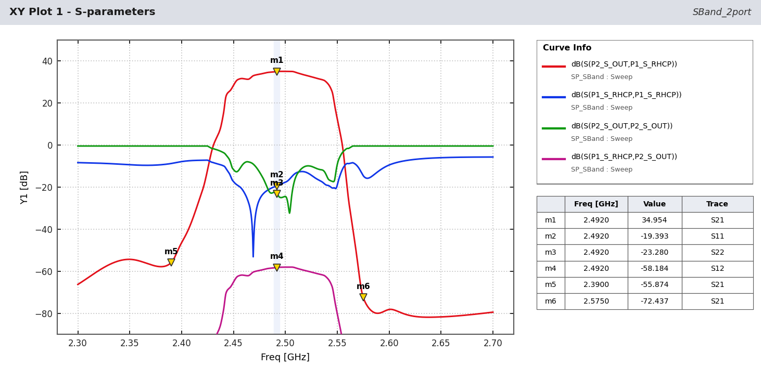
Figure - S-band branch: S21, S11, S22, S12 with markers at 2492.028 MHz and at the TA1442A specification points 2390 / 2575 MHz.
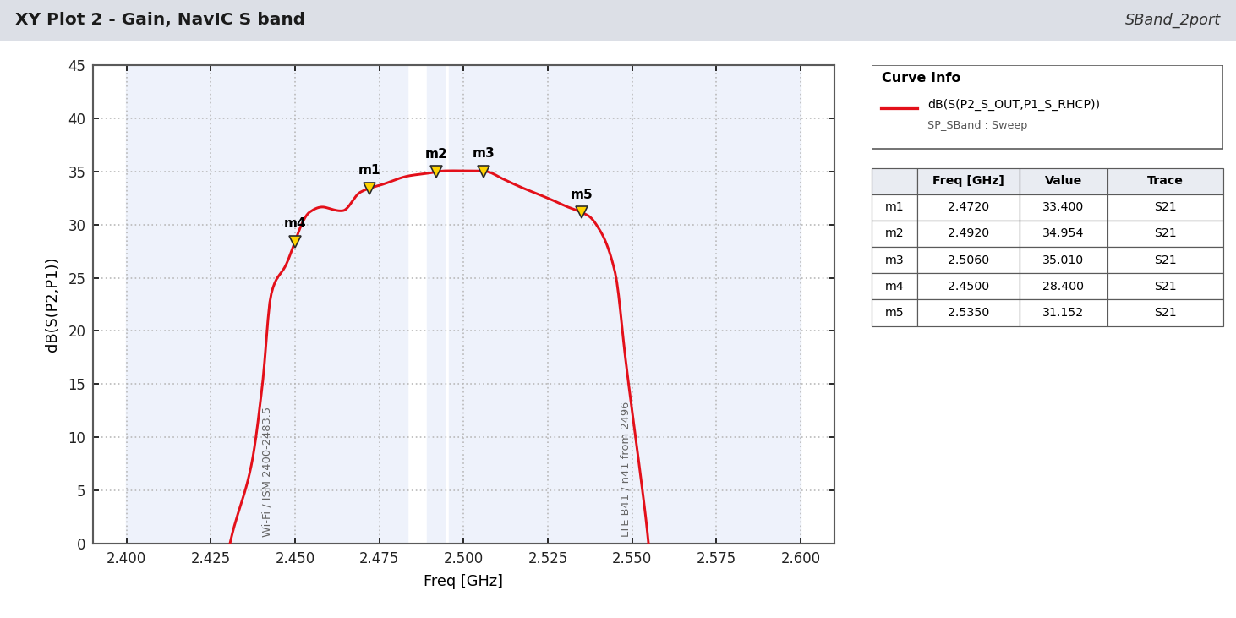
Figure - In-band gain; markers on Wi-Fi channel 13 (2472 MHz), NavIC centre and LTE B41 (2506 MHz).
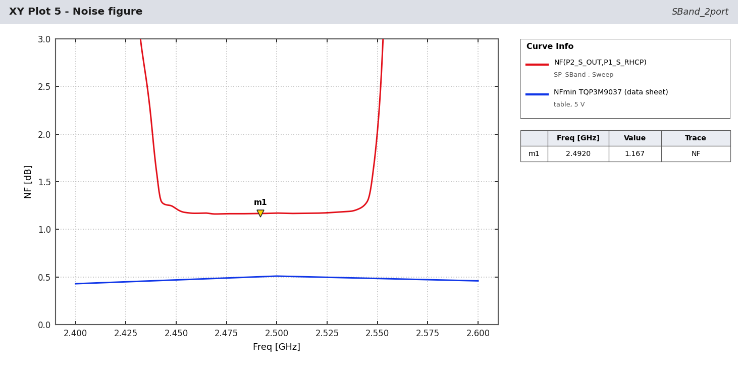
Figure - Noise figure and LNA NFmin.
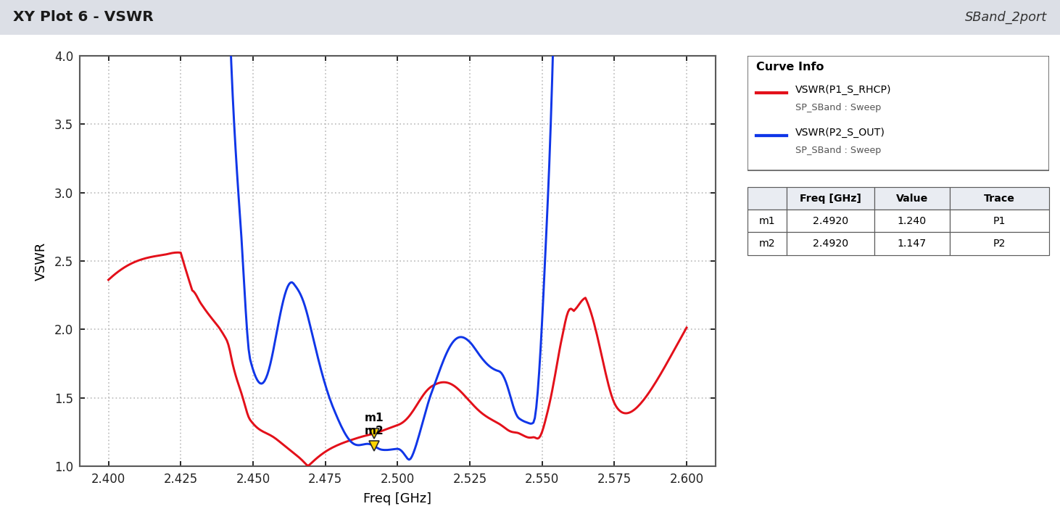
Figure - VSWR.
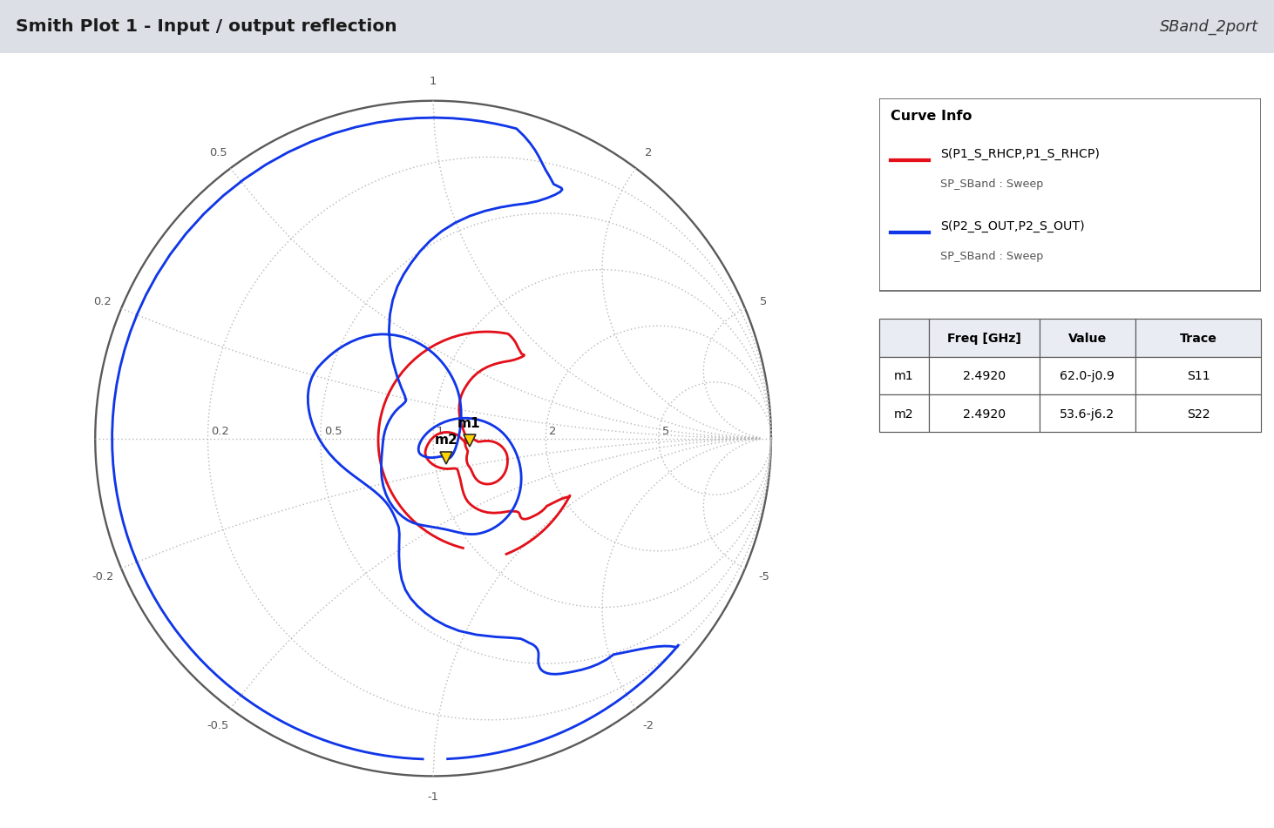
Figure - Input / output reflection.
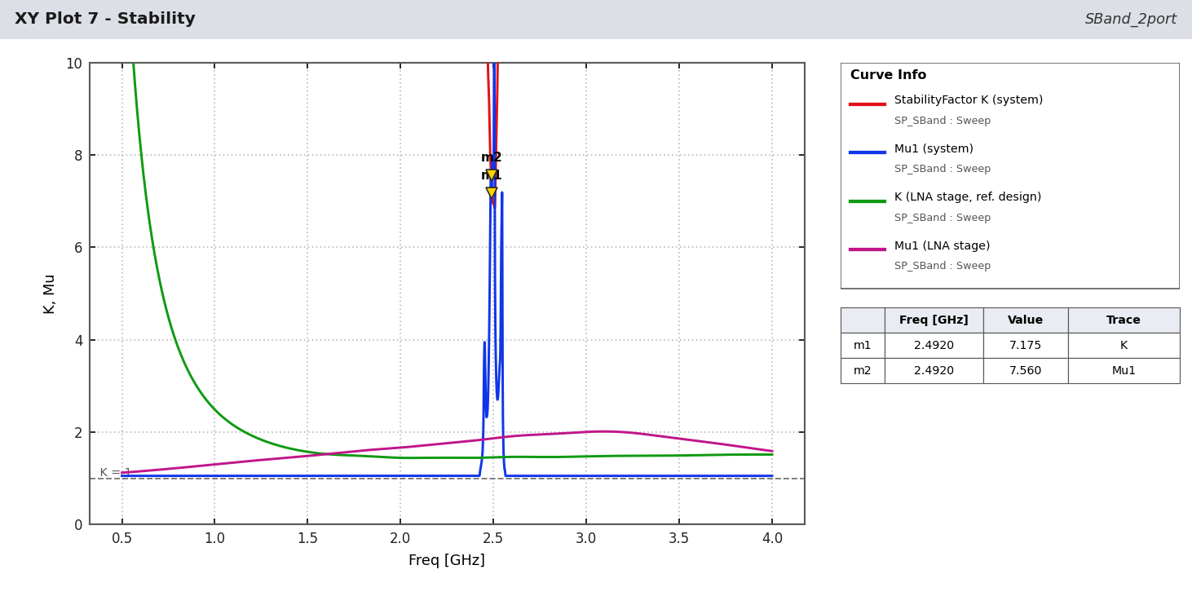
Figure - Stability.
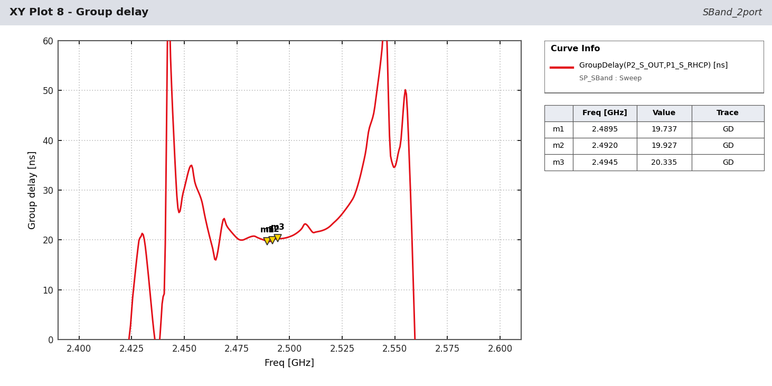
Figure - Group delay (estimated).
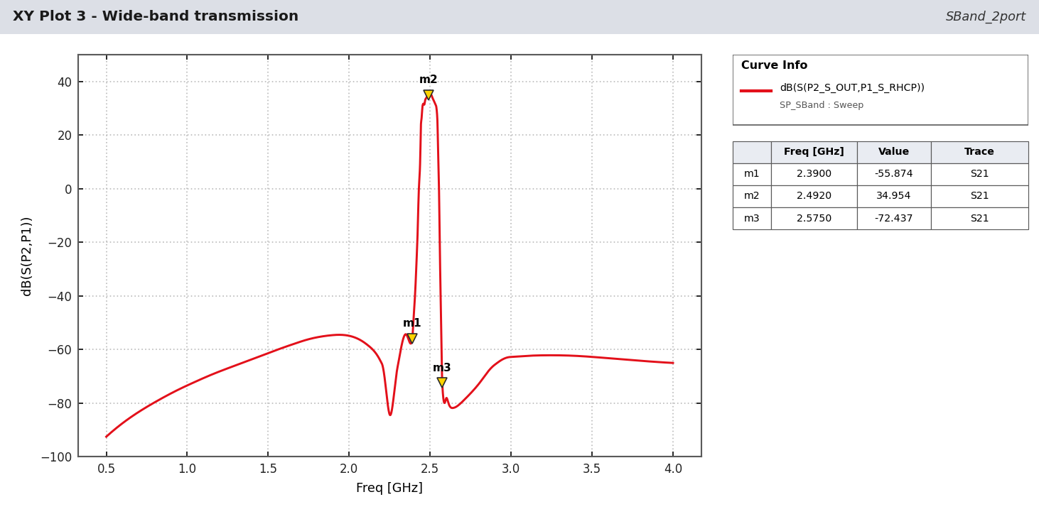
Figure - Wide-band transmission 0.5-4 GHz.
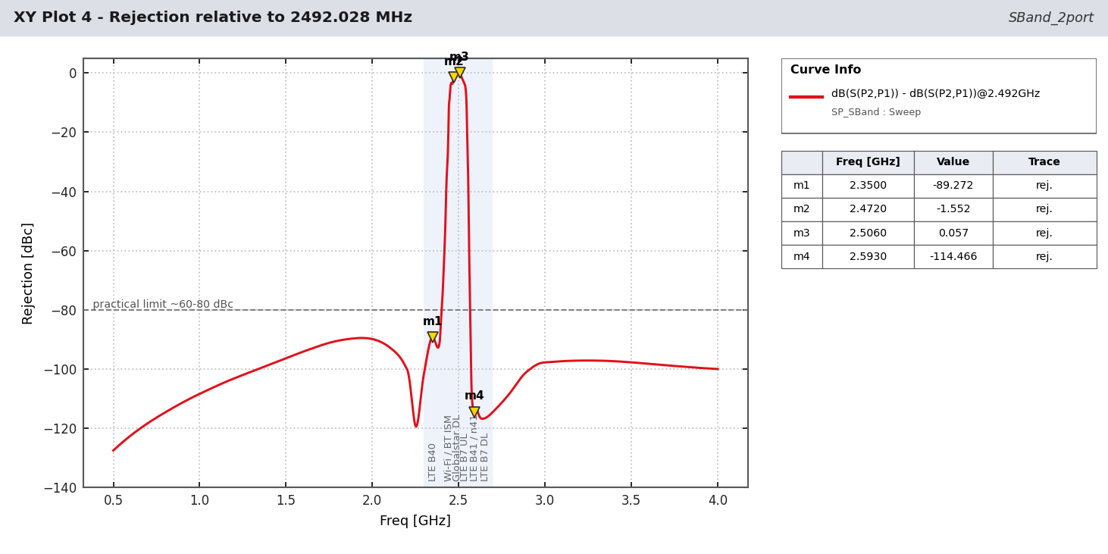
Figure - Rejection relative to 2492.028 MHz.
Stage | G dB | NF dB | Cum G | Cum NF | Cum IIP3 dBm | Cum IP1dB dBm | Signal dBm | Noise dBm
C2327J5003AHF (RHCP combine) | -0.43 | 0.43 | -0.43 | 0.43 | - | - | -132.7 | -110.9
LNA1 TQP3M9037 (ref. design) | 19.17 | 0.73 | 18.73 | 1.16 | 16.3 | 1.9 | -113.6 | -91.0
TA1442A #1 | -1.50 | 1.50 | 17.23 | 1.18 | 16.3 | 1.9 | -115.1 | -92.5
LNA2 TQP3M9037 (ref. design) | 19.17 | 0.73 | 36.40 | 1.19 | -1.4 | -15.9 | -95.9 | -73.3
TA1442A #2 | -1.50 | 1.50 | 34.90 | 1.19 | -1.4 | -15.9 | -97.4 | -74.8
Table 3 - S-band cascade at 2492.028 MHz (signal = -132.3 dBm reference minimum, noise in 2.046 MHz).

6 Cascade budgets, L-band
Stage | G dB | NF dB | Cum G | Cum NF | Cum IIP3 dBm | Cum IP1dB dBm | Signal dBm | Noise dBm
HC125A (RHCP combine) | -0.36 | 0.36 | -0.36 | 0.36 | - | - | -128.9 | -110.9
LNA1 TQP3M9037 + bias | 21.95 | 0.37 | 21.59 | 0.73 | 13.2 | 0.3 | -106.9 | -88.5
B7504 #1 | -0.89 | 0.89 | 20.70 | 0.74 | 13.2 | 0.3 | -107.8 | -89.4
LNA2 TQP3M9037 + bias | 21.95 | 0.37 | 42.65 | 0.74 | -7.9 | -20.8 | -85.8 | -67.5
B7504 #2 | -0.89 | 0.89 | 41.76 | 0.74 | -7.9 | -20.8 | -86.7 | -68.4
DXP.02.A (combiner) | -3.31 | 3.31 | 38.45 | 0.74 | -7.9 | -20.8 | -90.0 | -71.7
Cascade - L1 C/A (1575.42 MHz, 2.046 MHz).
Stage | G dB | NF dB | Cum G | Cum NF | Cum IIP3 dBm | Cum IP1dB dBm | Signal dBm | Noise dBm
HC125A (RHCP combine) | -0.19 | 0.19 | -0.19 | 0.19 | - | - | -128.1 | -100.9
LNA1 TQP3M9037 + bias | 23.61 | 0.39 | 23.41 | 0.58 | 11.2 | -0.9 | -104.5 | -76.9
B8889 #1 | -0.91 | 0.91 | 22.50 | 0.59 | 11.2 | -0.9 | -105.4 | -77.8
LNA2 TQP3M9037 + bias | 23.61 | 0.39 | 46.11 | 0.59 | -11.6 | -23.6 | -81.8 | -54.2
B8889 #2 | -0.91 | 0.91 | 45.20 | 0.59 | -11.6 | -23.6 | -82.7 | -55.1
DXP.02.A (combiner) | -3.14 | 3.14 | 42.06 | 0.59 | -11.6 | -23.6 | -85.8 | -58.2
Cascade - L5 (1176.45 MHz, 20.46 MHz).
Stage | G dB | NF dB | Cum G | Cum NF | Cum IIP3 dBm | Cum IP1dB dBm | Signal dBm | Noise dBm
HC125A (RHCP combine) | -0.22 | 0.22 | -0.22 | 0.22 | - | - | -130.2 | -110.9
LNA1 TQP3M9037 + bias | 23.39 | 0.40 | 23.17 | 0.61 | 11.4 | -0.7 | -106.8 | -87.1
B8889 #1 | -1.45 | 1.45 | 21.71 | 0.62 | 11.4 | -0.7 | -108.3 | -88.5
LNA2 TQP3M9037 + bias | 23.39 | 0.40 | 45.10 | 0.62 | -10.5 | -22.7 | -84.9 | -65.1
B8889 #2 | -1.45 | 1.45 | 43.65 | 0.62 | -10.5 | -22.7 | -86.4 | -66.6
DXP.02.A (combiner) | -3.56 | 3.56 | 40.09 | 0.62 | -10.5 | -22.7 | -89.9 | -70.2
Cascade - L2C (1227.60 MHz, 2.046 MHz).

7 Interference and filtering
Interferer levels at the antenna feed are planning values for a co-located terminal (cellular / Wi-Fi uplink -10 dBm). 'Back-off' is LNA OP1dB minus the level at that LNA output; negative = LNA in compression. The TA1442A is rated +10 dBm input, the B8889 +5 dBm.
Interferer | MHz | P ant | LNA1 out | SAW1 out | LNA2 out | RF out | Back-off LNA2 | SAW2 margin
LTE B40 (2300-2400) | 2350.0 | -10 | 9.1 | -34.9 | -15.5 | -59.5 | 35.1 | 25.5
Wi-Fi ch 1 | 2412.0 | -10 | 8.9 | -27.2 | -7.9 | -44.0 | 27.5 | 17.9
Bluetooth / ISM | 2441.0 | -20 | -1.1 | -12.1 | 7.2 | -3.8 | 12.4 | 2.8
Microwave oven | 2450.0 | -30 | -11.2 | -15.9 | 3.4 | -1.4 | 16.2 | 6.6
Wi-Fi ch 13 | 2472.0 | -10 | 8.8 | 6.6 | 25.8 | 23.6 | -6.2 | -15.8
Globalstar DL (sat.) | 2490.0 | -120 | -101.3 | -102.8 | -83.6 | -85.2 | 103.2 | 93.6
LTE B41 / n41 low | 2506.0 | -10 | 8.7 | 7.2 | 26.3 | 24.8 | -6.7 | -16.3
LTE B7 UL | 2535.0 | -10 | 8.6 | 5.4 | 24.5 | 21.3 | -4.9 | -14.5
LTE B41 / n41 mid | 2593.0 | -10 | 8.4 | -50.1 | -31.3 | -89.8 | 50.9 | 41.3
LTE B7 DL | 2655.0 | -30 | -11.8 | -69.7 | -50.9 | -108.8 | 70.6 | 60.9
GNSS L1 (other band) | 1575.4 | -125 | -107.5 | -149.0 | -131.1 | -172.6 | 150.7 | 141.1
5G n78 | 3500.0 | -20 | -5.0 | -51.7 | -35.8 | -82.6 | 55.4 | 45.8
Table 4 - S-band branch, interferer levels in dBm at each node.
Interferer | MHz | Branch | P ant | LNA1 out | LNA2 out | RF out | Back-off LNA1 | Back-off LNA2
LTE B13/B14 UL | 787.0 | L2/L5 | -10 | 15.0 | -7.9 | -88.9 | 7.0 | 29.9
GSM-900 / LTE B8 UL | 897.5 | L2/L5 | -10 | 14.6 | -6.6 | -89.5 | 7.4 | 28.6
DME/TACAN (aviation) | 1150.0 | L2/L5 | -30 | -6.5 | 13.3 | 3.3 | 28.1 | 8.3
ARNS radar | 1260.0 | L2/L5 | -40 | -17.0 | -22.8 | -57.5 | 38.4 | 44.3
Inmarsat L-band DL | 1545.0 | L1 | -80 | -58.3 | -43.3 | -58.0 | 79.2 | 64.3
Iridium | 1621.0 | L1 | -20 | 1.4 | 12.0 | -8.3 | 19.4 | 8.8
Iridium | 1621.0 | L2/L5 | -20 | 1.4 | -11.7 | -78.3 | 19.4 | 32.5
Inmarsat UL | 1643.0 | L1 | -20 | 1.3 | -7.8 | -83.5 | 19.5 | 28.6
Inmarsat UL | 1643.0 | L2/L5 | -20 | 1.3 | -9.0 | -76.6 | 19.5 | 29.8
LTE B3 UL | 1747.5 | L2/L5 | -10 | 10.9 | -8.1 | -84.3 | 9.7 | 28.7
LTE B1 UL | 1950.0 | L2/L5 | -10 | 10.2 | -14.3 | -92.7 | 9.8 | 34.3
Table 5 - L-band branches, cases that reach the output or load LNA 2.
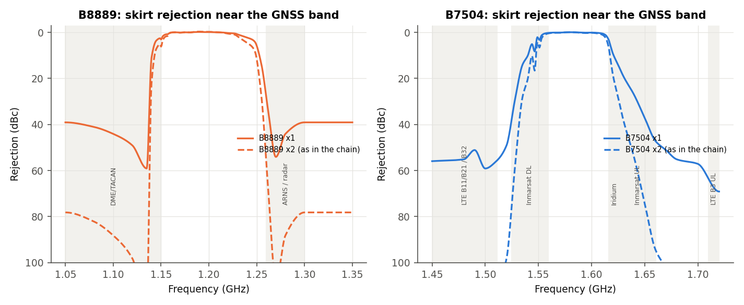
Figure - L-band SAW skirts next to the GNSS bands (one and two filters).
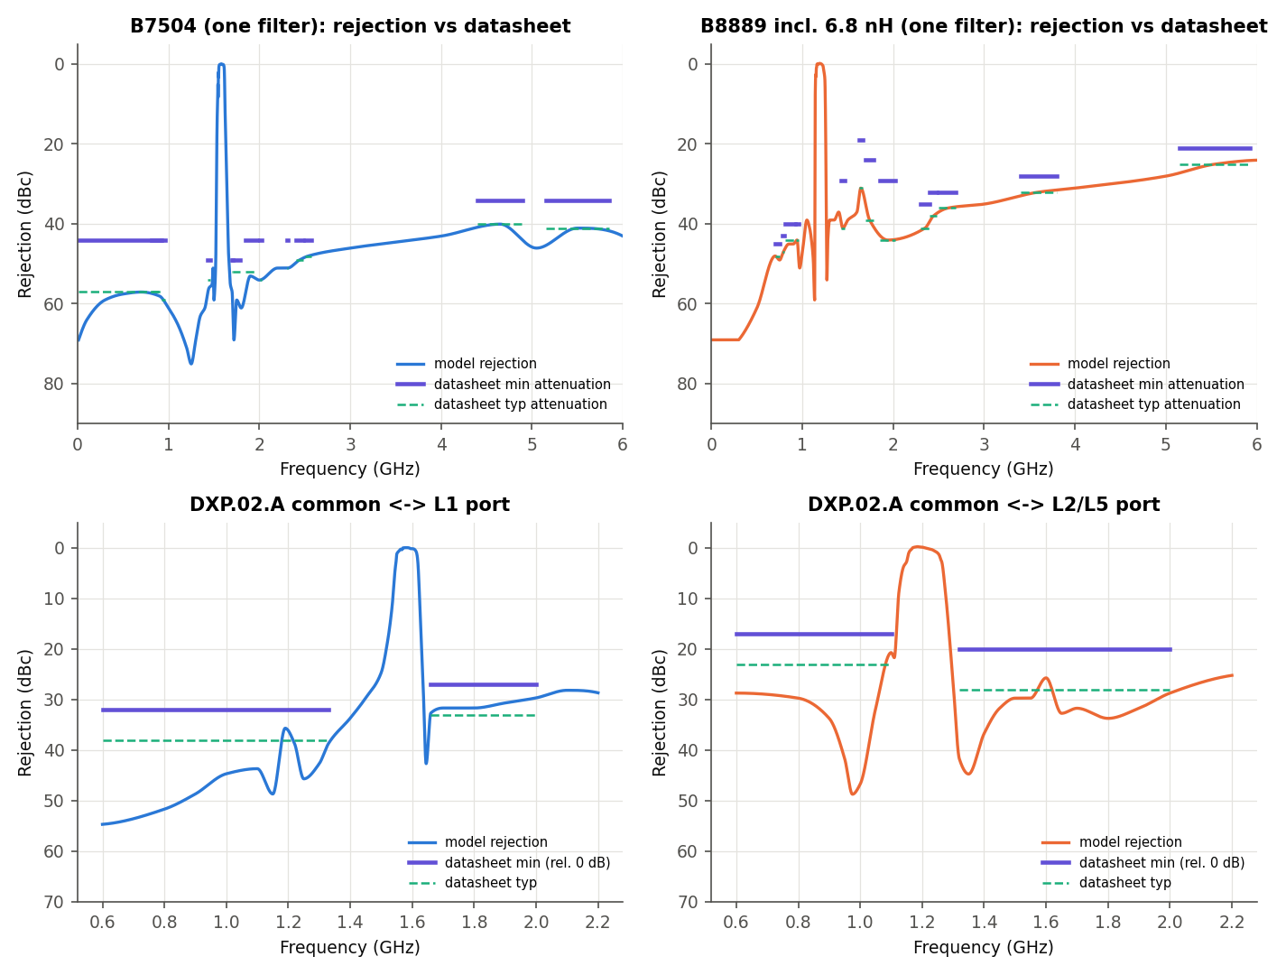
Figure - L-band filter rejection against the data-sheet limits (all met).
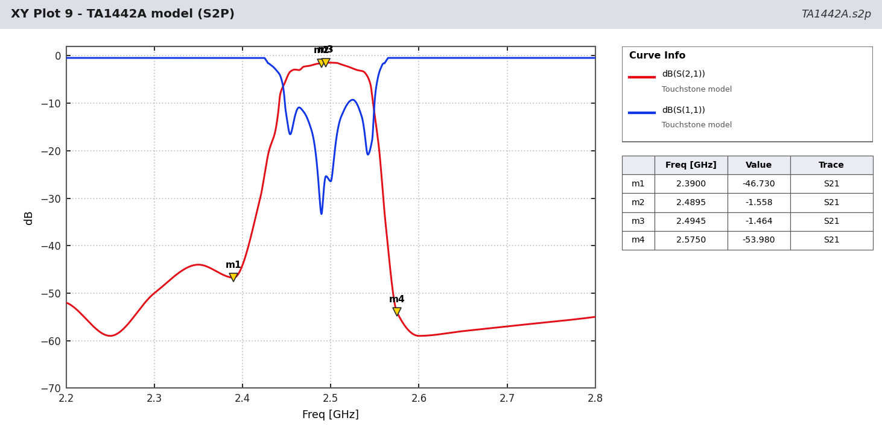
Figure - TA1442A model with the data-sheet VNA marker points (2390 / 2489.5 / 2494.5 / 2575 MHz).

8 Findings
- Noise figure is set by the hybrid and LNA 1: L1 0.74 dB, L5 0.59 dB, S 1.17 dB. The S-band hybrid (0.43 dB modelled) and the reference-design input match cost ~0.8 dB more than at L-band.
- Gain is high: 38.6 dB (L1), 42.0 dB (L5), 35.0 dB (S); worst case spread from data-sheet limits ~12 dB.
- S-band selectivity is the main risk: the TA1442A 3 dB bandwidth is ~62 MHz. A Wi-Fi channel 13 carrier at -10 dBm drives LNA 2 to +25.8 dBm (compressed, -6.2 dB back-off) and exceeds the TA1442A +10 dBm rating at SAW 2 by 15.8 dB; LTE B41 at 2506 MHz behaves the same (+26.3 dBm).
- L2/L5: DME/TACAN at 1150 MHz is passed by the B8889 lower skirt; -30 dBm gives +13.3 dBm at LNA 2 (above the B8889 +5 dBm rating).
- L1: Iridium at 1621 MHz is attenuated only ~11 dB per B7504; -20 dBm gives +12.0 dBm at LNA 2.
- Input match: L1 and E5b input VSWR 2.3-2.75 (LNA S11 reflected through the hybrid); S-band input match is good (VSWR 1.24) thanks to the reference-design input network.
- GLONASS G2 is outside the B8889 pass-band (gain falls 12 dB across G2).
- All stages unconditionally stable; three independent solvers agree to < 0.01 dB (L-band).

9 Actions / recommendations
- S-band: add a narrow pre-filter in front of LNA 1 (ceramic or cavity, <= 20 MHz, > 30 dB at 2472 and 2506 MHz), or replace the first TA1442A by a narrower NavIC S filter and move it ahead of LNA 1. Re-check NF (expect +1 dB).
- L2/L5: add a DME/L-band notch or pre-filter (> 30 dB at 960-1150 MHz). L1: steeper upper skirt for Iridium (e.g. RF360 B39162B2611P810 pre-LNA).
- Reduce gain to the receiver requirement (25-30 dB at the connector): one LNA per branch or a pad after LNA 2.
- Improve the L-band input match (Qorvo optimised-RL network or AN #18 two-step matching).
- Obtain measured S-parameter files: RF360 (B7504, B8889), Taoglas (HC125A, DXP.02.A), Tai-Saw (TA1442A), TTM (C2327J5003AHF), Qorvo (fine-step TQP3M9037 + low-band noise data). Confirm TA1442A is still in production (approval sheet dated 2011).
- Replace the ideal patch with the HFSS/measured antenna S-parameters; then axial ratio and gain/temperature can be assessed.
- Run the AEDT project (Scripts/aedt_circuit.py) on the licensed workstation to confirm in the company tool.

10 Parts and data used
Part | Maker | Function | Data used
TQP3M9037 | Qorvo | LNA, 6 used | S-parameter + noise tables (5 V), eval / reference designs
HC125A | Taoglas | L-band 3 dB hybrid, 2 used | typical table
B7504 | Qualcomm RF360 | L1 SAW, 2 used | spec table + digitized plots
B8889 | Qualcomm RF360 | L2/L5 SAW, 2 used (+2 x 6.8 nH each) | spec table + digitized plots
DXP.02.A | Taoglas | L-band diplexer / combiner, 1 used | spec table + digitized plots
C2327J5003AHF | TTM (Xinger) | S-band 3 dB hybrid, 1 used | spec table + digitized plots
TA1442A | Tai-Saw | 2492 MHz SAW, 2 used | spec table + digitized VNA plots
Patch elements | - | antenna (mentioned only) | ideal dual-feed RHCP source
Table 6 - Parts.
ID | Item | Assumption | How to close
A1 | Topology | Two branches (patch -> HC125A -> LNA -> SAW -> LNA -> SAW) combined by the DXP.02.A, as confirmed by the user 2026-10-31. Single chain is not possible: B7504 (L1) and B8889 (L2/L5) have disjoint pass-bands. | User decision
A2 | Antenna | Each patch is an ideal dual-feed RHCP source: lossless 90 deg splitter, 50 ohm feeds (PatchCP_ideal_RHCP_feed.s4p). LHCP port terminated at T0 (290 K) for noise. | Replace with measured/HFSS patch S-parameters
A3 | LNA noise below 1.5 GHz | Noise table starts at 1.5 GHz. NFmin 0.38-0.40 dB, Gopt = 0.15/14.1 deg, Rn = 0.08 ohm used at 0.6-1.2 GHz (bounded by the 50-ohm eval NF of 0.40 dB at 0.9 GHz and 0.36 dB at 1.7 GHz). | Ask Qorvo for low-band noise parameters
A4 | LNA bias | VDD = +5 V, 70 mA (user choice); S-parameters at device leads; eval-board bias network (100 pF DC blocks, 18 nH choke, 100 pF + 1 uF bypass). | Datasheet p.2, p.5
A5 | Parasitics | 100 pF 0402: ESL 0.25 nH, ESR 0.15 ohm; 18 nH 0603: Q = 40 at 1.4 GHz, 0.12 pF self-capacitance (SRF ~3.4 GHz); bypass ESL 0.4 nH. | Replace with vendor S-parameter models of the chosen parts
A6 | LNA interpolation | 200 MHz table interpolated with a cubic spline on dB magnitude and unwrapped phase. Linear interpolation changes in-band gain by up to 1.4 dB (heavi test) -> a real model uncertainty. | Download the Qorvo fine-step .s2p
A7 | LNA large-signal | OIP3/OP1dB at L-band interpolated from eval-board values at 0.9 and 1.7 GHz (34.4-34.9 dBm, 22-20.7 dBm). | Datasheet p.6
A8 | HC125A phase | Datasheet gives magnitudes and the coupled-vs-through phase difference (91.9-93.0 deg) only. Absolute through phase = -90 deg x f/1390 MHz; reflection and isolation phase offsets chosen to keep the 4-port passive (165 / 270 deg). | Measured .s4p from Taoglas
A9 | HC125A port mapping | 'Transmission' column = pin1->pin4 (direct, angle theta), 'Coupling' column = pin1->pin3 (theta-90), from the pin table p.7. Feeds on pins 3/4, LNA on pin 1, pin 2 terminated in 50 ohm. | Confirm with Taoglas
A10 | HC125A passivity | The 92 deg phase difference with 0.15-0.29 dB loss is slightly non-passive with arbitrary reflection phases; after the phase choice the matrix is scaled by <= 0.11 dB at the worst frequency. | -
A11 | HC125A out of band | Values held at the 1150/1630 MHz edge outside 1150-1630 MHz. Out-of-band rejection therefore comes from the SAWs/DXP only (conservative). | -
A12 | SAW phase | No measured phase in the datasheets. S21 phase = minimum-phase (Hilbert / real-cepstrum) reconstruction of the digitized magnitude; S11/S22 phase = S21 phase + 90 deg (lossless symmetric reciprocal condition). Group delay is therefore an estimate; ripple agrees with the brief (B7504 GD ripple 4 ns typ). | Use RF360 measured .s2p (available on rffe.qualcomm.com)
A13 | SAW reflection out of band | |S11| = 0.95 sqrt(1-|S21|^2) outside the plotted VSWR range (reflective SAW stop-band), blended over 4 MHz. | -
A14 | B8889 matching | The B8889 model includes the required 6.8 nH shunt inductors (datasheet curves are measured with them). | Datasheet p.6
A15 | DXP model | Digitized curves include the Taoglas eval-board matching (L2 4.3 nH, C1 1.5 pF, L1 4.7 nH, L3 3.3 nH, C2 1 pF). Reflection phase = dominant transmission phase + 90 deg. | Measured .s3p from Taoglas
A16 | Digitizing accuracy | Pass-band plots +/-0.3 dB, wide-band attenuation plots +/-2 dB, VSWR +/-0.1. | -
A17 | PCB | Interconnects ideal (zero length). 50 ohm lines on the real board add ~0.02-0.05 dB/cm loss and phase. | Add MSL models once the layout exists
A18 | Interferer levels | Interferer powers at the antenna feed (-10 dBm cellular UL, -20 dBm Iridium/Inmarsat UL, -30 dBm DME) are example values for a co-located handset/terminal. | Set from the product's EMC environment
A19 | Signal levels | Minimum received power (0 dBic antenna): GPS L1 C/A -128.5 dBm, L5 -127.9 dBm, L2C -130 dBm, GLONASS G1 -131 dBm (signal ICDs). | -
A21 | S-band topology | S-band patch (ideal dual feed) -> C2327J5003AHF -> TQP3M9037 -> TA1442A -> TQP3M9037 -> TA1442A -> separate S-band output (no diplexer). Antenna only mentioned, modelled as ideal RHCP source. | User request 2026-10-31
A22 | S-band LNA match | Qorvo 2300-2600 MHz reference design (2.7 nH shunt, 2.4 pF series, 5.6 nH choke); inductor Q 30-50 @2.5 GHz, ESL/ESR [ASSUMED]. | Datasheet p.10
A23 | C2327J5003AHF model | Magnitudes from excess IL, amplitude balance, isolation and input return loss (same RL assumed at all ports); coupled phase = direct + 90 deg - phase balance; reflection/isolation phases chosen for passivity over 2-3 GHz -> excess IL 0.43 dB vs 0.3 typ / 0.4 max (conservative). | Measured .s4p from TTM
A24 | TA1442A model | Digitized VNA plots p.3-4 with the printed marker values used exactly; S11 = S22 shape (markers differ by < 0.01); min-phase phase. | Measured .s2p from Tai-Saw
A25 | NavIC S signal | 2492.028 MHz, SPS BW 2.046 MHz, RS BW 16.5 MHz, minimum received power -132.3 dBm (0 dBic) used as reference values. | Verify against the IRNSS SPS ICD
A20 | Temperature | All data at 25 C typical. No temperature, part-to-part or aging spread is modelled. | -
Table 7 - Assumptions.
ID | Where | Finding
I1 | B7504 vs product brief | Datasheet p.7 lists 'Group delay typ 4.0 / max 15 ns' (GLONASS band); the product brief lists the same numbers as 'group delay ripple'. The model gives ~13 ns absolute delay and ~4-10 ns ripple, so the datasheet label should read 'ripple'.
I2 | DXP.02.A front page | Lists 'L2 1227.625 MHz'; GPS L2 is 1227.60 MHz.
I3 | DXP.02.A isolation row | 'Isolation (1574.22~1576.62 dB)' - unit should be MHz.
I4 | DXP.02.A pass-band claim | Text p.11: L2 pin covers '1164-1300 MHz'. Measured plot p.8: insertion loss >6 dB above ~1263 MHz, so GLONASS G2 upper half, B3 (1268.5) and E6 (1278.75) are not usable.
I5 | DXP.02.A return loss | Table p.4 band-2 RL typ -8 dB (max -6) vs. the plot p.6 showing 12-24 dB in the L2/L5 band; the plot is used.
I6 | DXP.02.A pin naming | Pin 5 is called 'GPS L2 Output' in the pin table but 'GPS L2/L5 OUT' on the symbol.
I7 | DXP.02.A RL sign | Return loss given as negative numbers with 'Max -6.0' - ambiguous min/max sense.
I8 | HC125A phase balance | Spec says 'Phase balance 90 degrees' with no tolerance; the typical table shows 91.9-93.0 deg (up to 3 deg off), which costs ~0.01 dB of axial-ratio/combining loss.
I9 | HC125A pin table vs table columns | Typical table uses 'Coupling/Transmission' and S11..S44 without stating which pins; the pin table uses 'Pin 1..4'. Mapping assumed (A9).
I10 | TQP3M9037 noise table | NFmin 0.40 dB at 1.5 GHz but 0.29 dB at 1.7 GHz (non-monotonic); Gopt angle jumps 85.8 -> 42.1 -> 157.4 deg between 2.4/2.5/2.6 GHz with |Gopt| ~0.02-0.08 (measurement scatter).
I11 | TQP3M9037 switching speed | Table p.2 note: switching speed with C1 = 10 pF; eval board default C1 = 100 pF (switching table p.5 shows both).
I12 | TQP3M9037 stability | 'Unconditionally stable' claim holds (K >= 1.01, mu >= 1.06 from the table) but the margin is only ~1 % at 50 MHz.
I13 | B8889 spec typo | Data sheet p.7 'Insertion attenuation' first row has no unit; 'linsertion loss' typo on B7504 p.7.
I14 | B8889 vs brief | Brief gives B8889 pass-band 1166-1228 MHz (62 MHz); the datasheet spec bands end at 1228.62 MHz. GLONASS G2 (1246-1256) is outside the B8889 pass-band (>4 dB at 1245 MHz) although the HC125A table and the DXP claim to cover it.
I15 | SDST vs. parts used | The automotive SAW selection table (Feb 2020) does not list B7504 or B8889; equivalent automotive parts are e.g. B39162B2611P810 (L1, 0.9 dB, pre-LNA) and B39122B2620P810 (E5b/L2).
I17 | DXP.02.A insertion loss | Table p.4: IL typ 3.8 dB (L1) / 4.2 dB (L2/L5); the measured plots p.7-8 show 3.3 dB / 3.1-3.2 dB at the band centres and reach 3.8 / 4.2 dB only at the band edges. The model follows the plots.
I18 | TA1442A bandwidth | Cover page 'BW = 5 MHz' is the specified band 2489.5-2494.5 MHz; the measured 3 dB bandwidth is ~62 MHz (about 2453-2537 MHz) and the filter passes Wi-Fi channel 13 and LTE B41/B7 almost unattenuated.
I19 | TA1442A VSWR | Spec VSWR typ 1.2 vs VNA markers 1.04-1.12 in the spec band (sample better than typ).
I20 | C2327J5003AHF note | Spec table footnote: 'values are for the case with shunt capacitor across differential lines' - not explained for a 4-port hybrid; no value given.
I21 | C2327J5003AHF phase balance | Spec typ 4 deg / max 8 deg vs plot ~2.5-3.2 deg over 2.4-2.6 GHz; broadband plot shows >= 20 deg above 4.4 GHz (part not usable there).
I22 | Two datasheet ages | TA1442A approval sheet is from 2011 (rev. 1): check the part is still in production before design-in.
I16 | AN #18 scope | AN #18 covers 315/434/868 MHz RKE receivers (TDA520x, ATA572x). Only its matching method applies here; its component values do not.
Table 8 - Data-sheet inconsistencies.
Simulation files: Touchstone/ (component models and simulated results), Scripts/ (Python models, PyAEDT script with designs FrontEnd_3port and SBand_2port), circuitRF/ (netlist), Extracted_Data/ (parameter tables, results).

