

Multi-band GNSS / NavIC Active Antenna - RF Front End
Design brief: architecture, simulated performance, filter rejection, interference (L1, L2/L5, NavIC S)
Doc. No.: ________ | Rev.: Draft A | 2026-10-31
RFM / Antenna Group, CRL-BG
Item | Entry
Prepared by | RFM / Antenna Group, CRL-BG
Prepared / Checked / Approved | ________ / ________ / ________
Basis | Manufacturer data sheets + circuit simulation (no hardware measurement yet)
Distribution | BEL internal only
Document control.

1 Key numbers
Band | MHz | Gain dB | NF dB | VSWR in | VSWR out | Ripple dB | IIP3 dBm | OP1dB dBm | C/N0 dB-Hz
L1 / E1 / B1C | 1575.42 | 38.6 | 0.74 | 2.29 | 1.47 | 0.34 | -7.9 | 16.8 | 44.8
B1I | 1561.10 | 37.7 | 0.74 | 1.49 | 1.35 | 0.51 | - | - | -
G1 | 1602.00 | 37.6 | 0.73 | 2.07 | 1.26 | 0.14 | - | - | -
L5 / E5a / B2a | 1176.45 | 42.0 | 0.59 | 1.63 | 1.42 | 1.14 | -11.6 | 17.4 | 45.5
E5b / B2b | 1207.14 | 41.6 | 0.60 | 2.75 | 2.17 | 0.42 | - | - | -
L2 | 1227.60 | 40.1 | 0.62 | 1.96 | 1.58 | 0.41 | -10.5 | 16.5 | 43.4
NavIC S | 2492.03 | 35.0 | 1.17 | 1.24 | 1.15 | 0.08 | -1.4 | 18.1 | 40.5
Table 1 - Simulated performance at 25 C (antenna feed RHCP -> RF output, 50 ohm).
Parameter | L-band | NavIC S
Stability | unconditional (mu >= 1.035) | unconditional (mu >= 1.053)
Reverse isolation | 65 / 67 dB | 58 dB
LHCP rejection / AR (hybrid) | 31.8 dB / 0.45 dB | 32.3 dB / 0.42 dB
Output noise power | -51.3 dBm | -59.7 dBm
Worst-case gain (data-sheet limits) | 33 - 45 dB | -
DC | 4 x TQP3M9037, 70 mA @ 5 V | 2 x TQP3M9037, 70 mA @ 5 V
Total DC | 420 mA @ +5 V = 2.1 W
Table 2 - System parameters.

2 Architecture
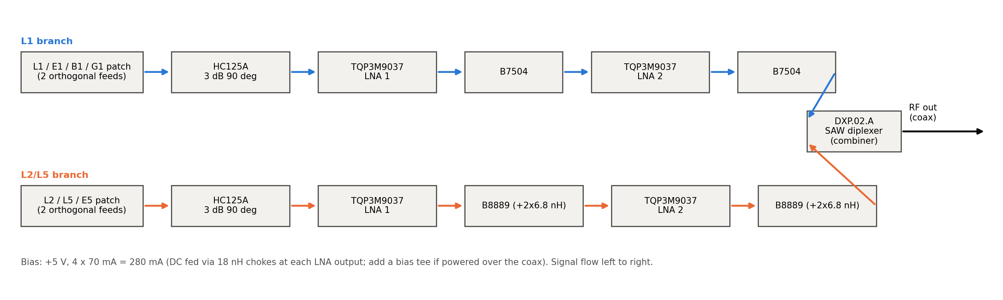
Figure 1 - L1 and L2/L5 chains, combined in the DXP.02.A.
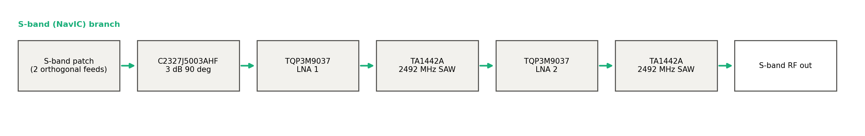
Figure 2 - NavIC S-band chain (separate output).
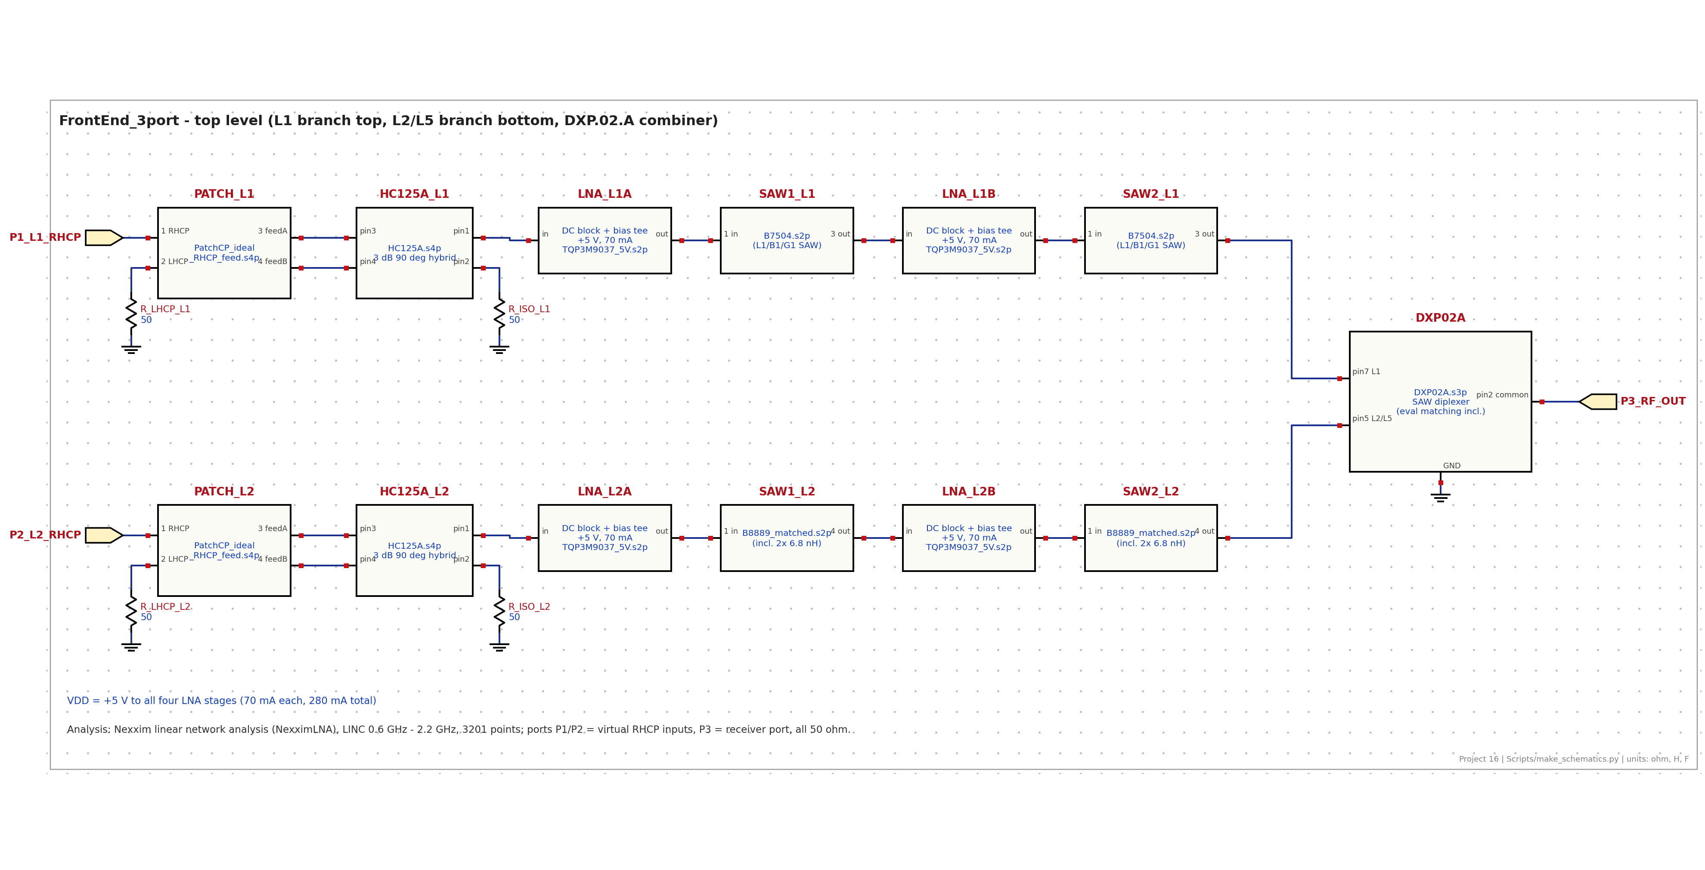
Figure 3 - L-band simulation schematic.
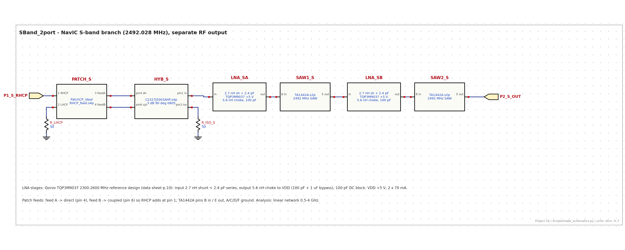
Figure 4 - S-band simulation schematic.
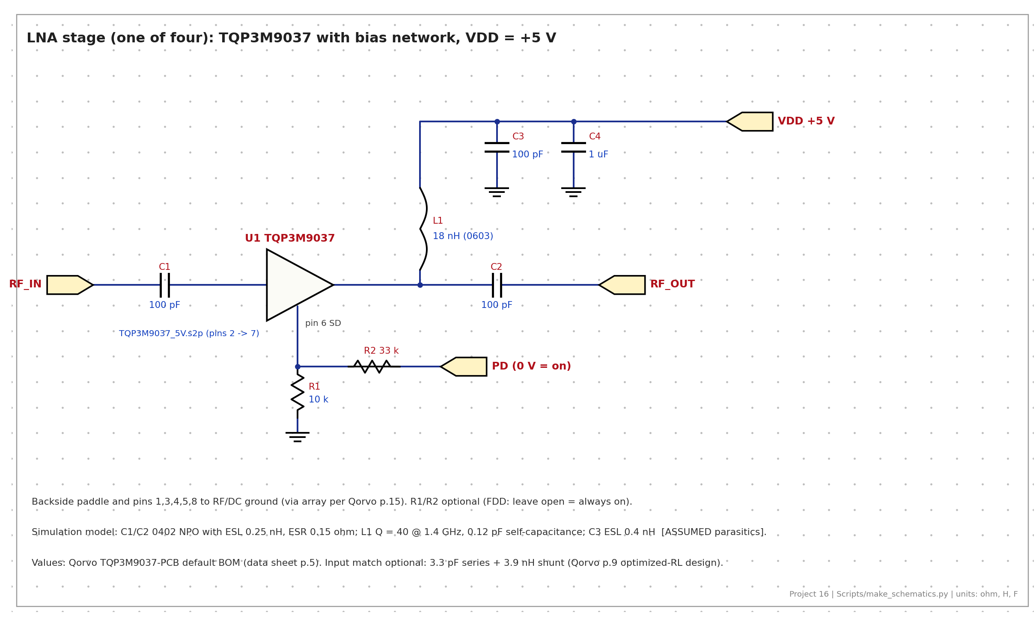
Figure 5 - LNA stage and bias network.

3 L-band results
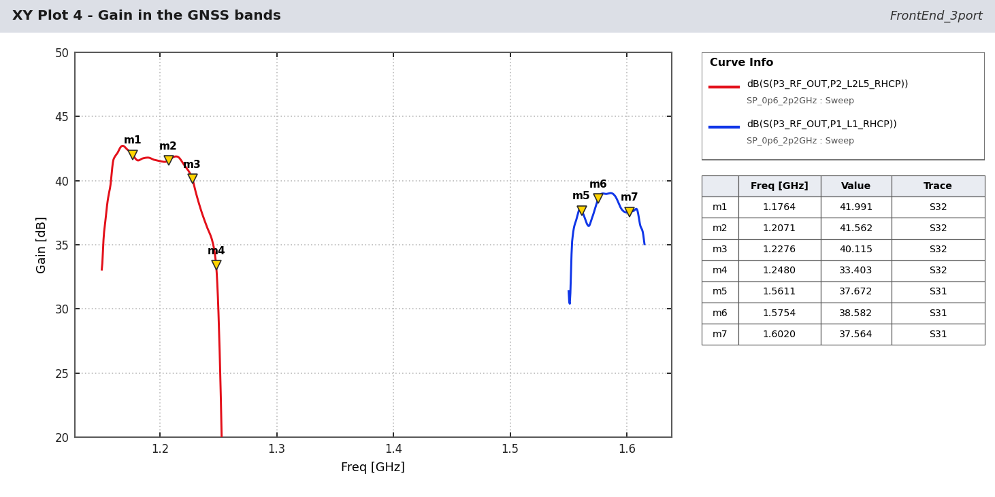
Figure - Gain.
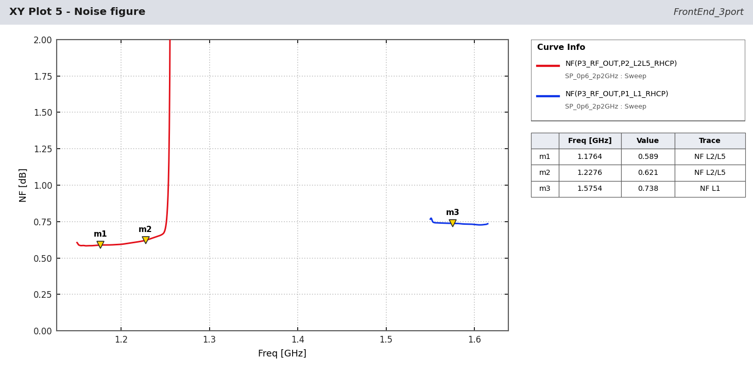
Figure - Noise figure.
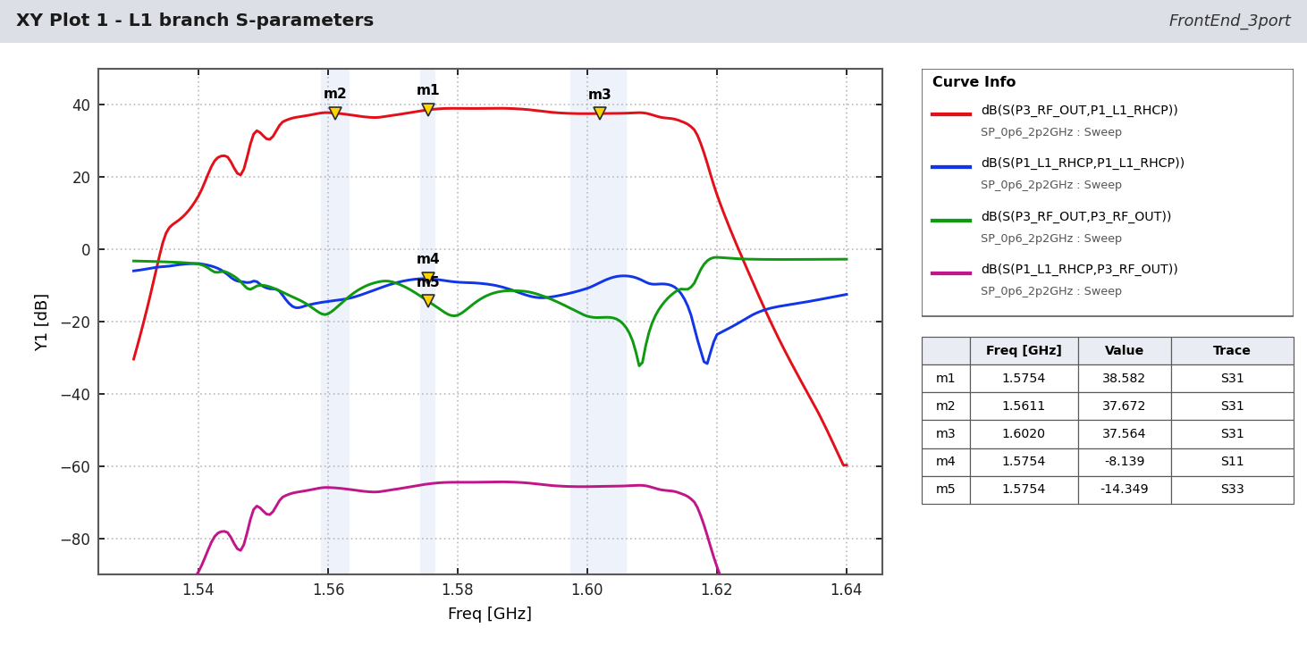
Figure - L1 branch S-parameters.
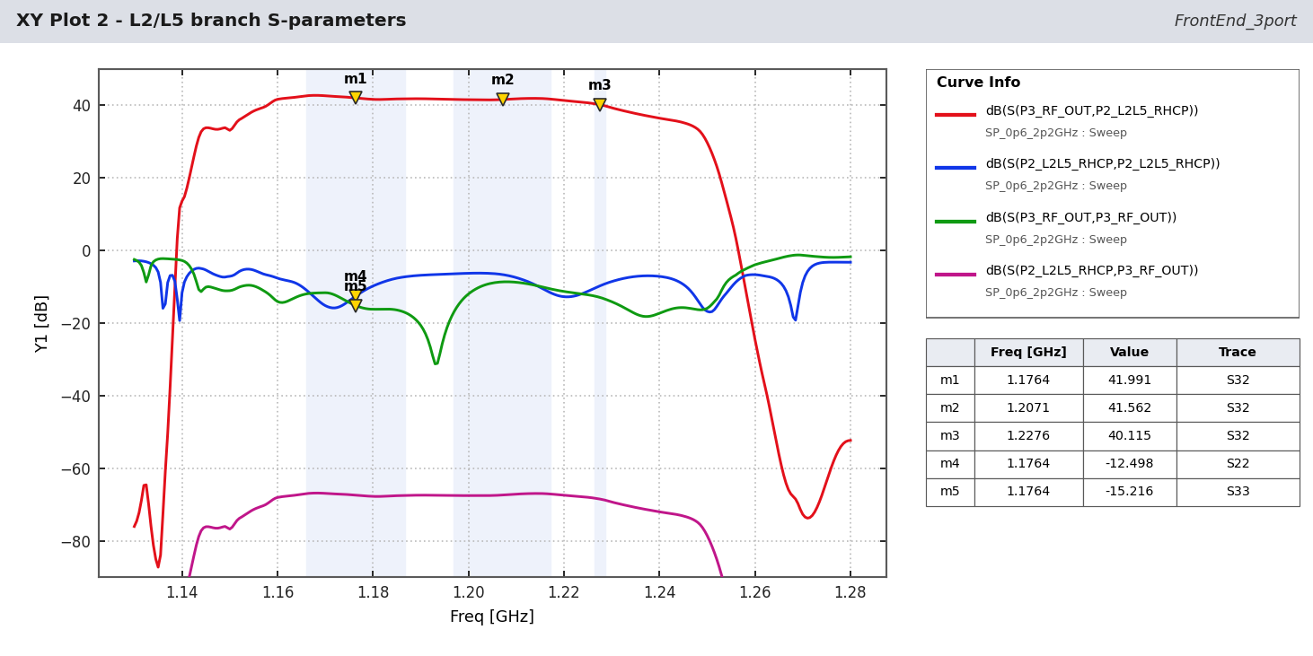
Figure - L2/L5 branch S-parameters.
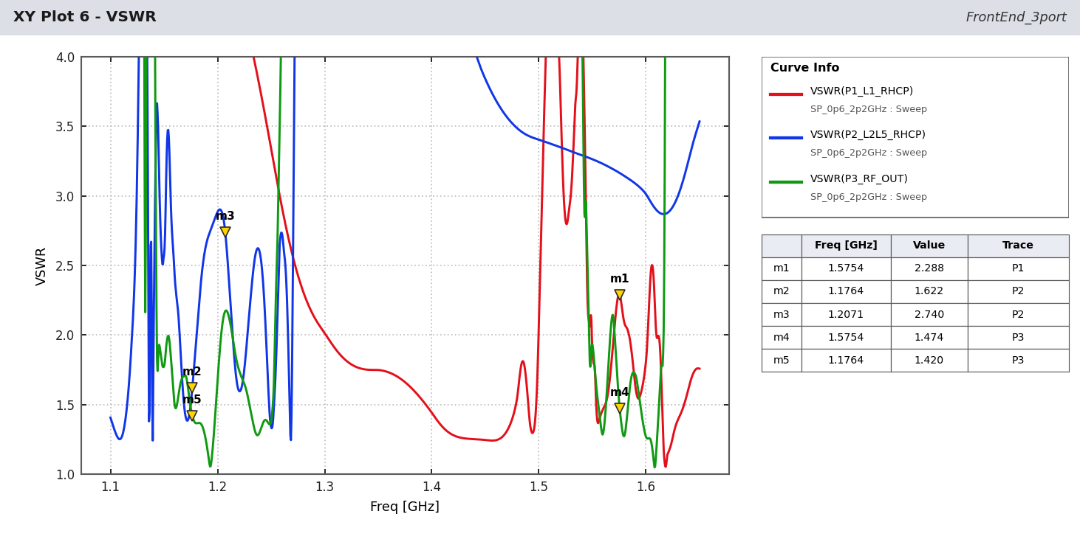
Figure - VSWR.
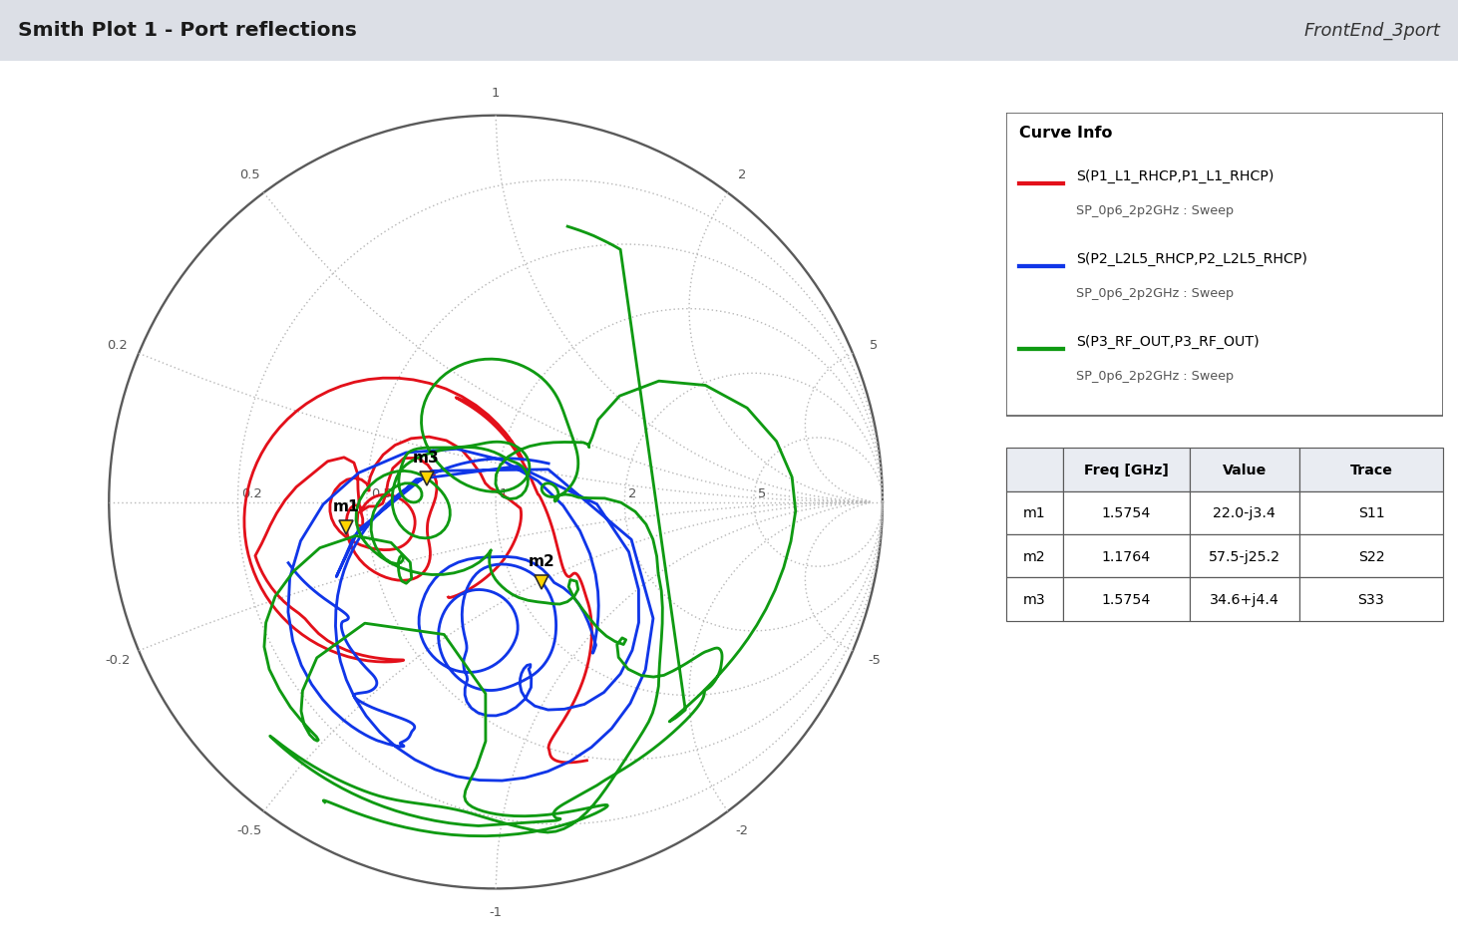
Figure - Port reflections.
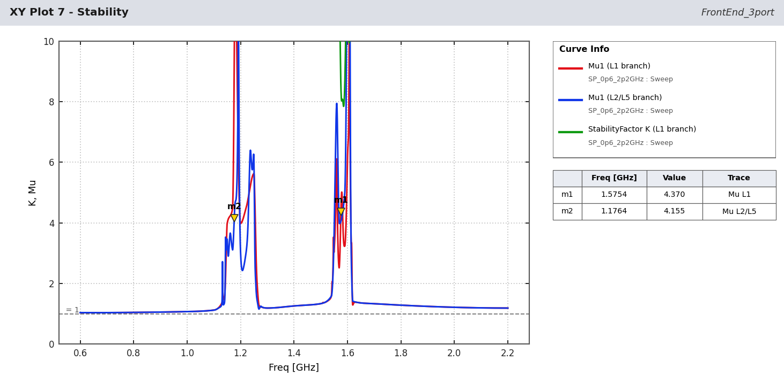
Figure - Stability.
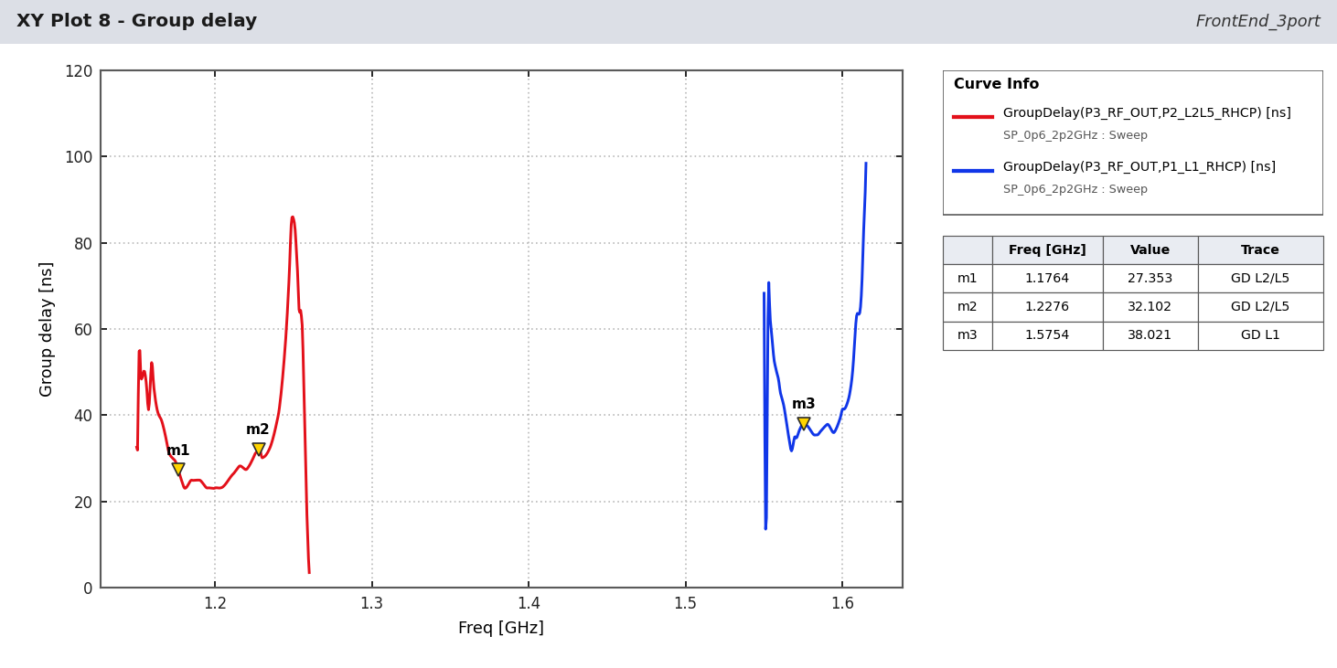
Figure - Group delay (estimate).
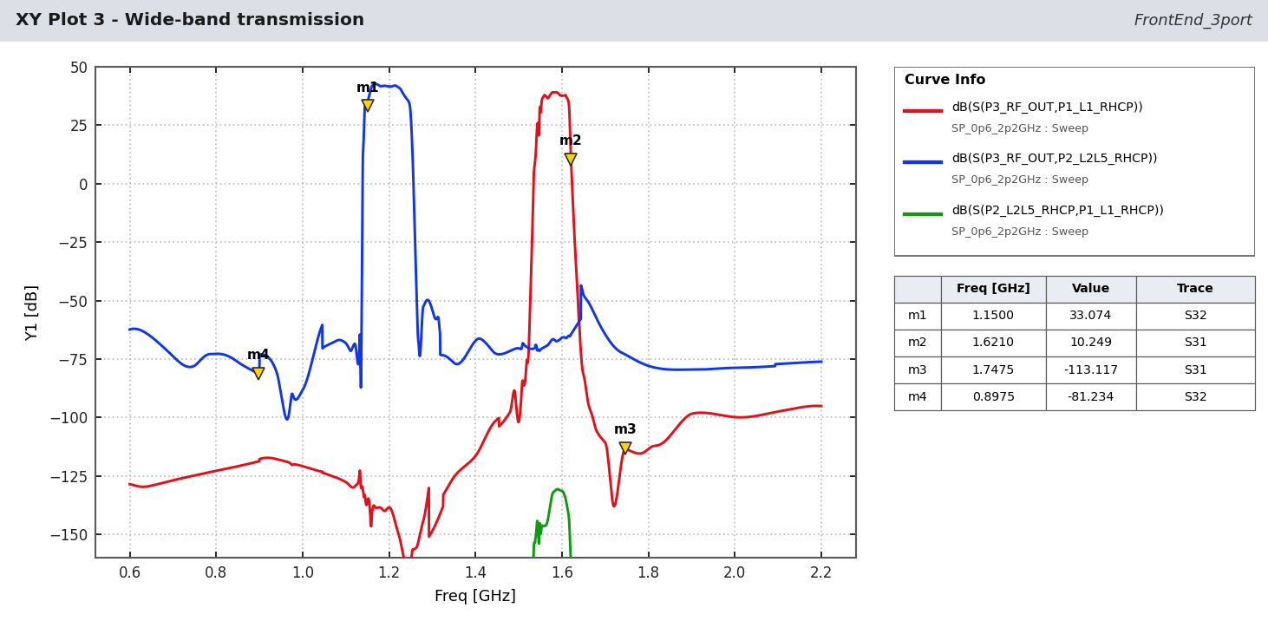
Figure - Wide-band transmission.

4 NavIC S-band results
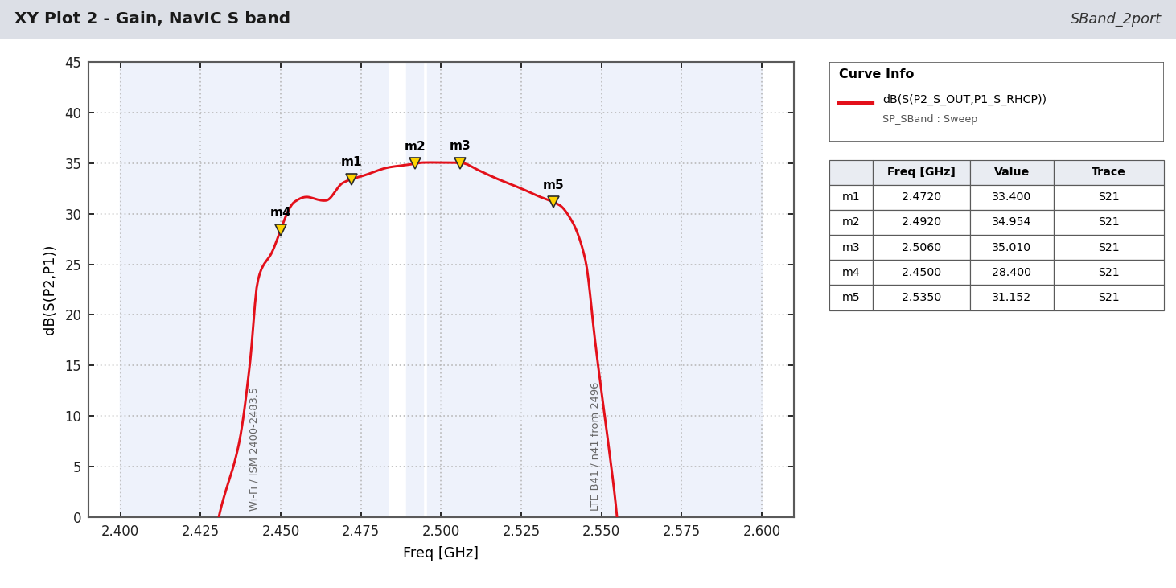
Figure - Gain.
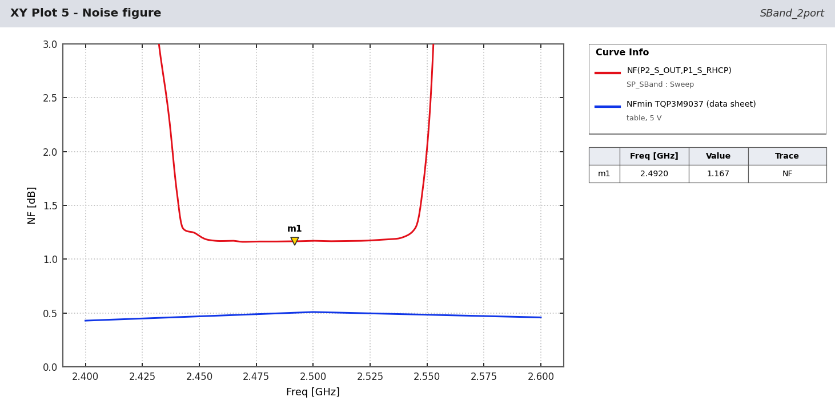
Figure - Noise figure.
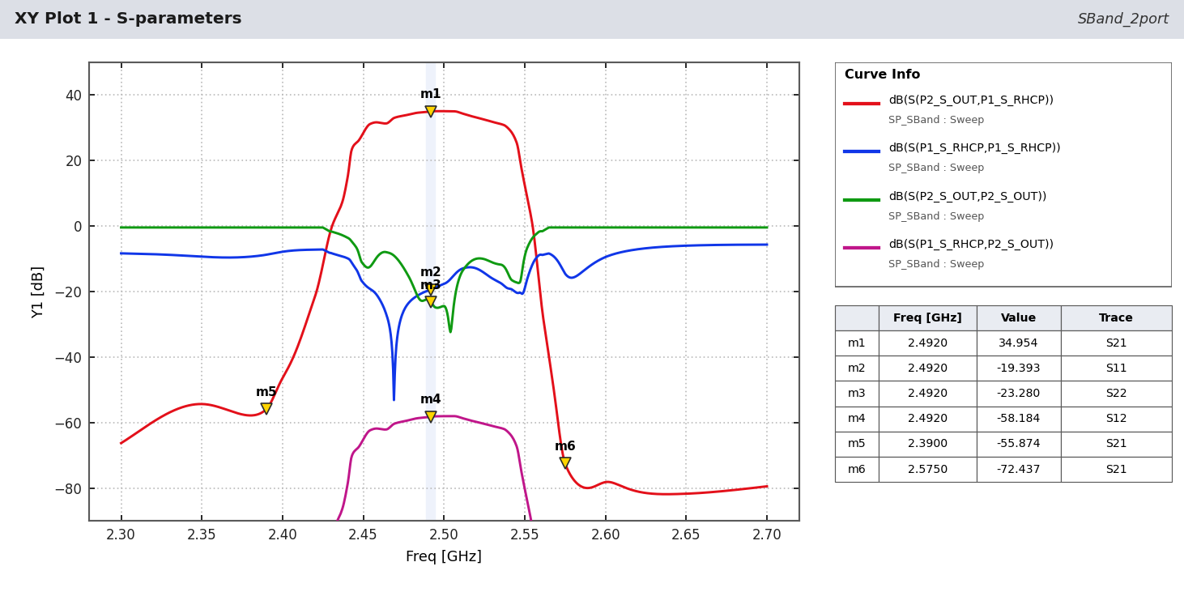
Figure - S-parameters.
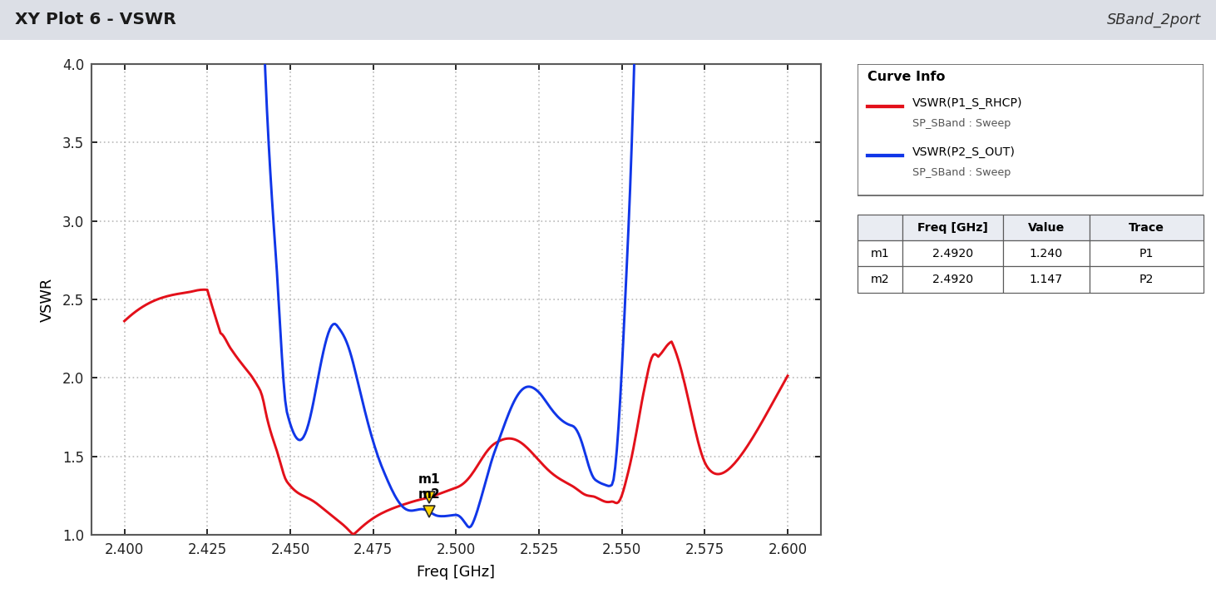
Figure - VSWR.
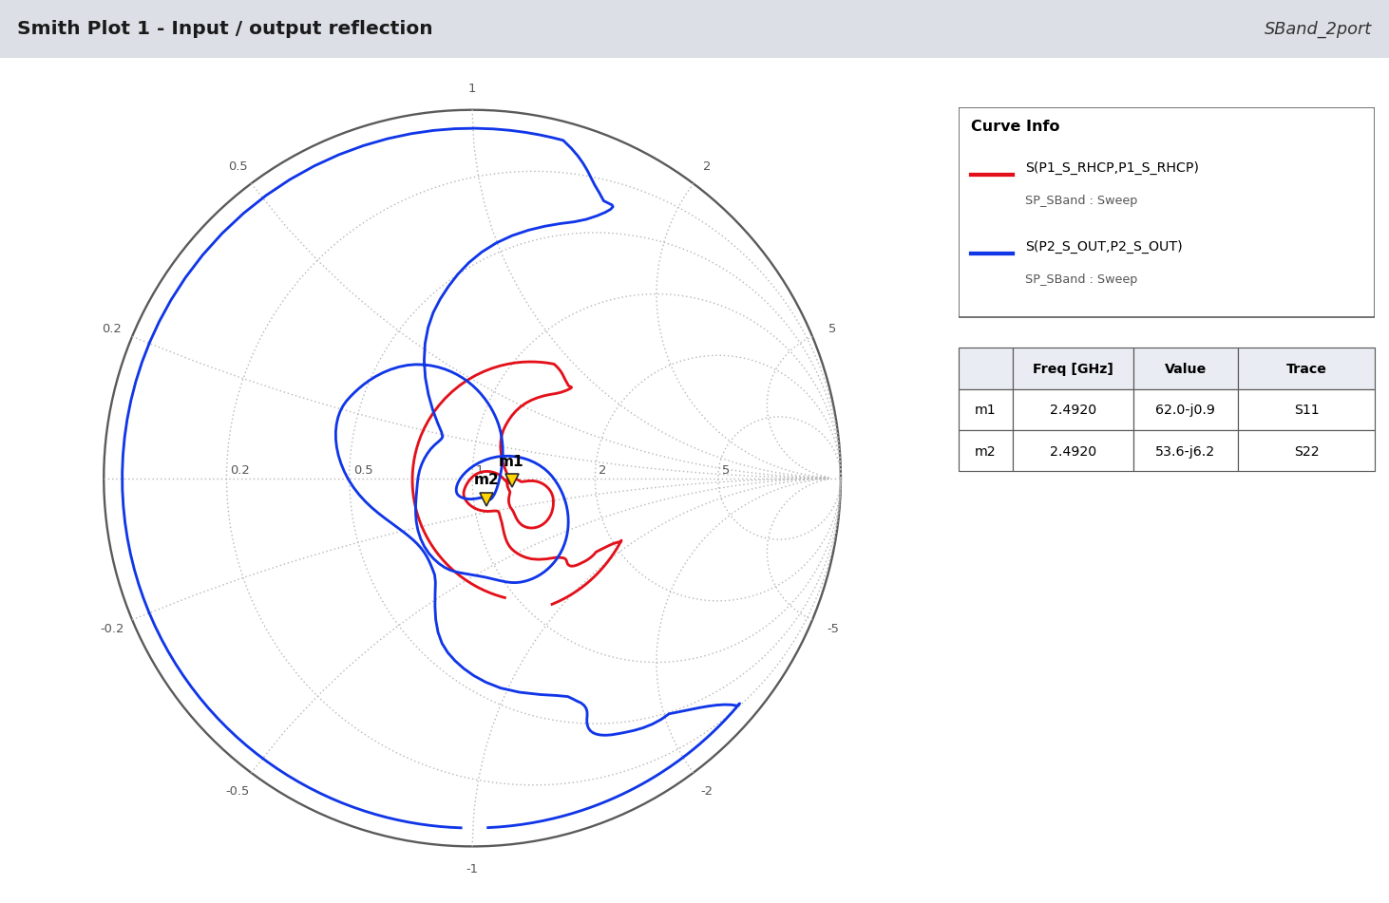
Figure - Reflections.
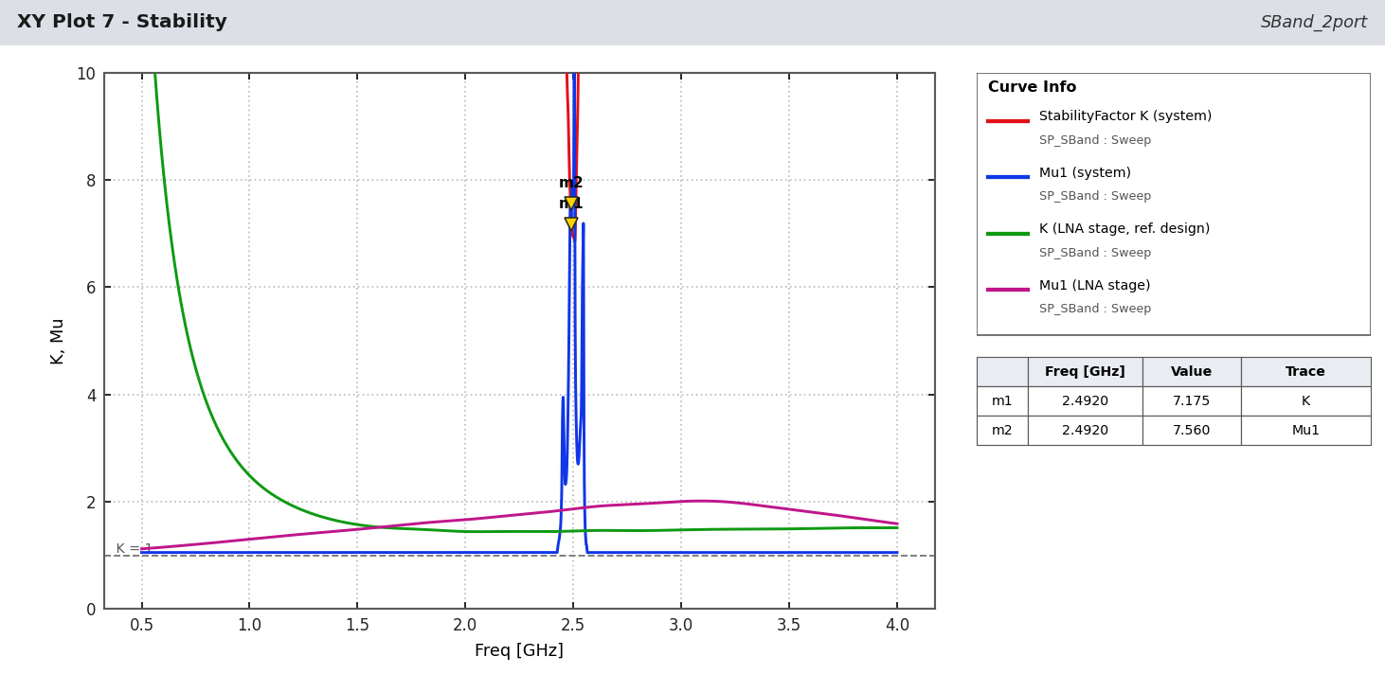
Figure - Stability.
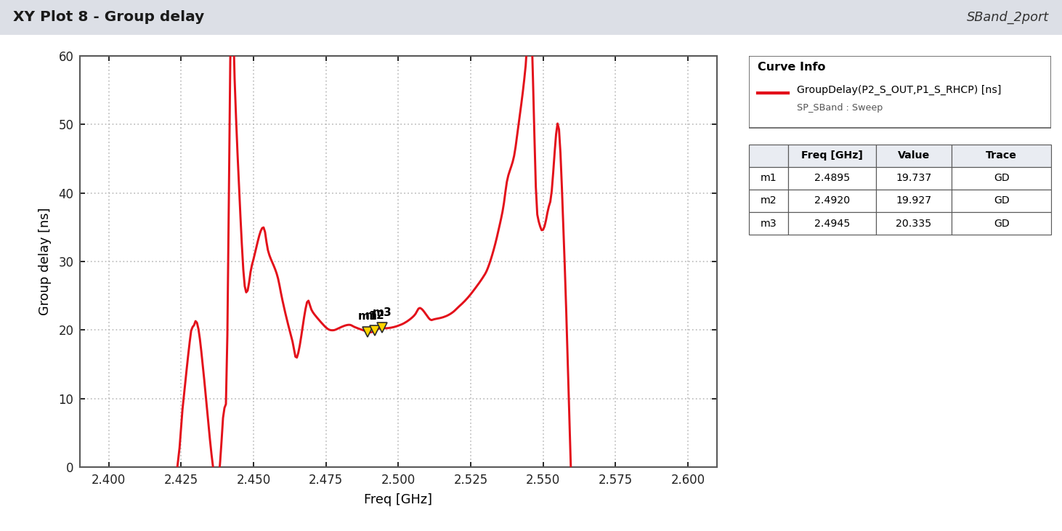
Figure - Group delay (estimate).
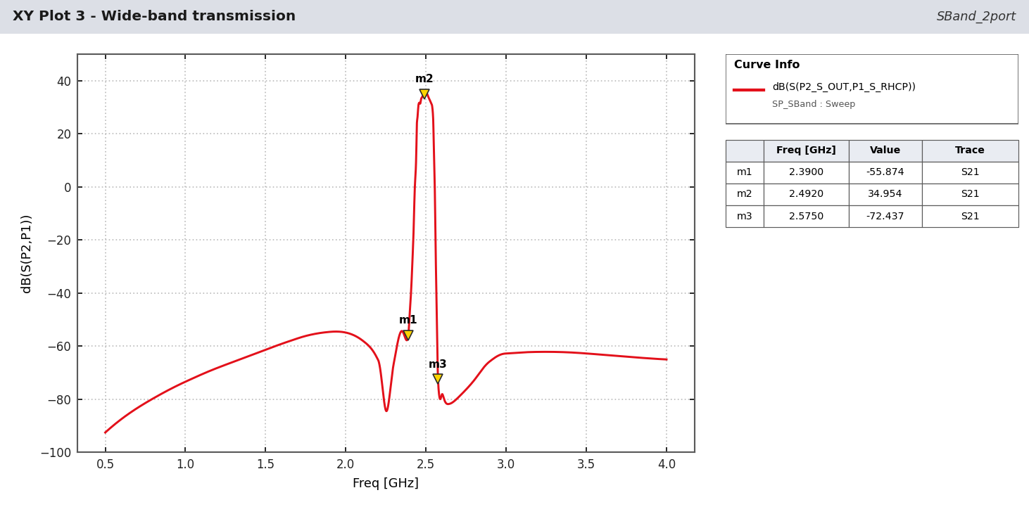
Figure - Wide-band transmission.

5 Filter rejection

5.1 L-band filters vs data-sheet limits
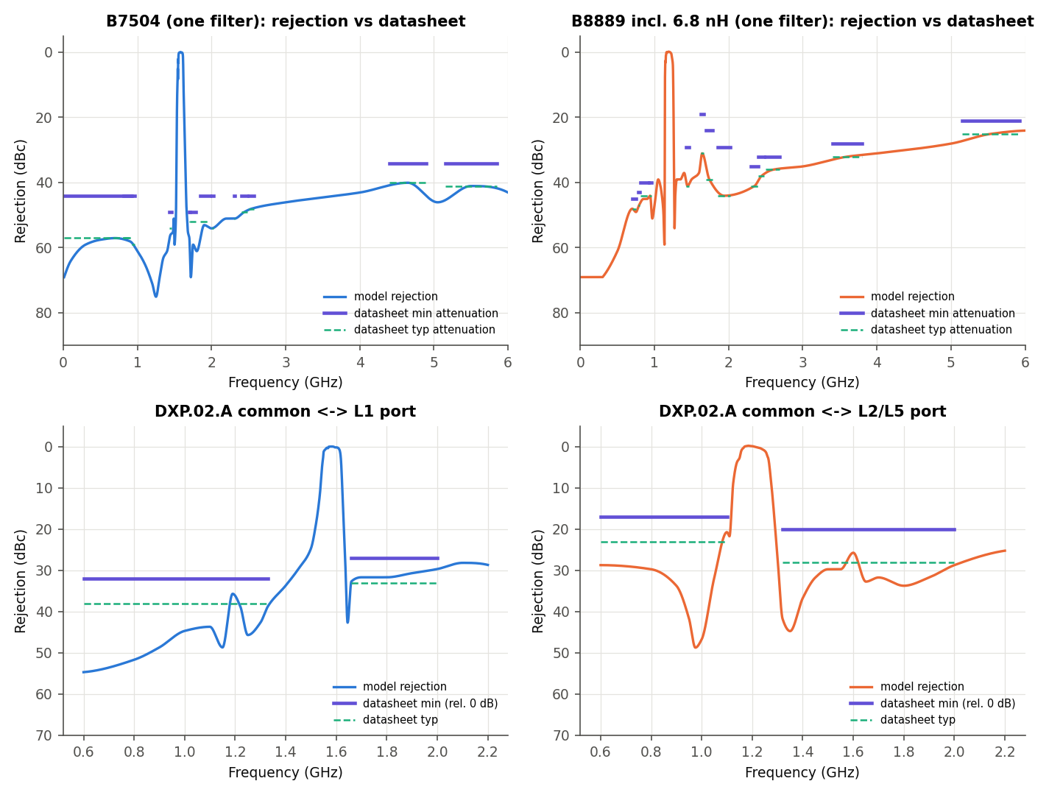
Figure - B7504, B8889 (+2 x 6.8 nH) and DXP.02.A paths vs data-sheet limits (all met).
Filter | Stop band (MHz) | Spec min dB | Spec typ dB | Model min dB | Margin dB
B7504 | 10-925 | 45 | 58 | 58.0 | 13.0
B7504 | 814-915 | 45 | 58 | 58.3 | 13.3
B7504 | 925-960 | 45 | 60 | 59.4 | 14.4
B7504 | 1427-1463 | 50 | 55 | 56.6 | 6.6
B7504 | 1695-1710 | 50 | 53 | 57.4 | 7.4
B7504 | 1710-1785 | 50 | 53 | 60.0 | 10.0
B7504 | 1850-1980 | 45 | 53 | 54.0 | 9.0
B7504 | 2010-2025 | 45 | 55 | 54.9 | 9.9
B7504 | 2305-2315 | 45 | 52 | 52.0 | 7.0
B7504 | 2401-2483 | 45 | 50 | 49.5 | 4.5
B7504 | 2500-2570 | 45 | 49 | 48.8 | 3.8
B7504 | 4400-4900 | 35 | 41 | 41.0 | 6.0
B7504 | 5150-5850 | 35 | 42 | 42.0 | 7.0
B8889 | 698-748 | 46 | 49 | 49.0 | 3.0
B8889 | 777-798 | 44 | 48 | 47.7 | 3.7
B8889 | 807-915 | 41 | 45 | 45.7 | 4.7
B8889 | 925-960 | 41 | 45 | 45.0 | 4.0
B8889 | 1427-1463 | 30 | 42 | 40.6 | 10.6
B8889 | 1626.5-1660.5 | 20 | 32 | 32.0 | 12.0
B8889 | 1695-1785 | 25 | 40 | 35.9 | 10.9
B8889 | 1850-2025 | 30 | 45 | 43.8 | 13.8
B8889 | 2300-2400 | 36 | 42 | 40.3 | 4.3
B8889 | 2400-2483 | 33 | 39 | 38.2 | 5.2
B8889 | 2500-2690 | 33 | 37 | 36.7 | 3.7
B8889 | 3400-3800 | 29 | 33 | 32.5 | 3.5
B8889 | 5150-5925 | 22 | 26 | 25.1 | 3.1
DXP L1 | 600-1330 | 32 | 38 | 39.0 | 3.7
DXP L1 | 1660-2000 | 27 | 33 | 33.0 | 2.7
DXP L2/L5 | 600-1100 | 17 | 23 | 24.0 | 3.7
DXP L2/L5 | 1320-2000 | 20 | 28 | 29.0 | 5.7
Table 3 - L-band filter compliance (worst point in each specified stop band).
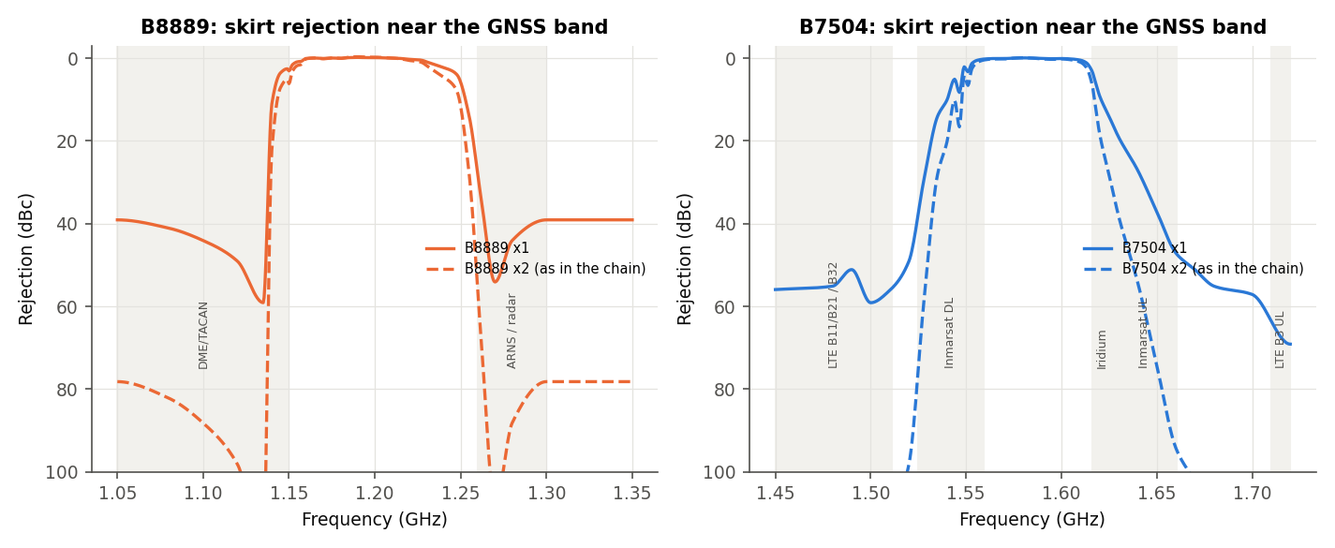
Figure - L-band SAW skirts next to the GNSS bands (one and two filters).

5.2 L1 chain
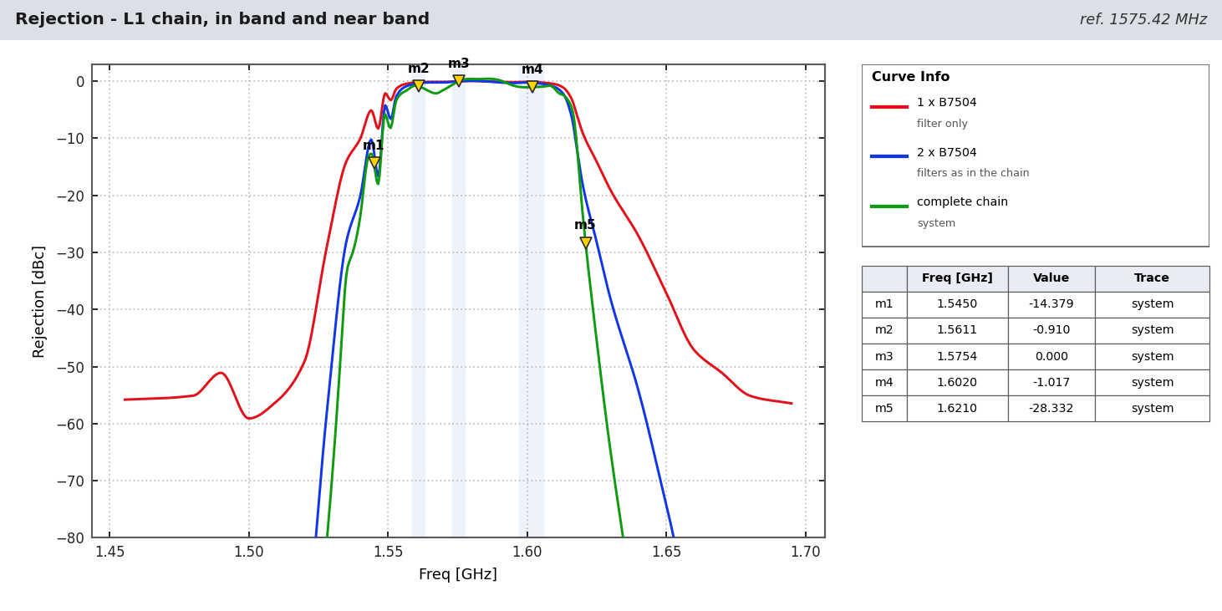
Figure - L1 chain: in band and near band (B1I, L1/E1, G1 shaded).
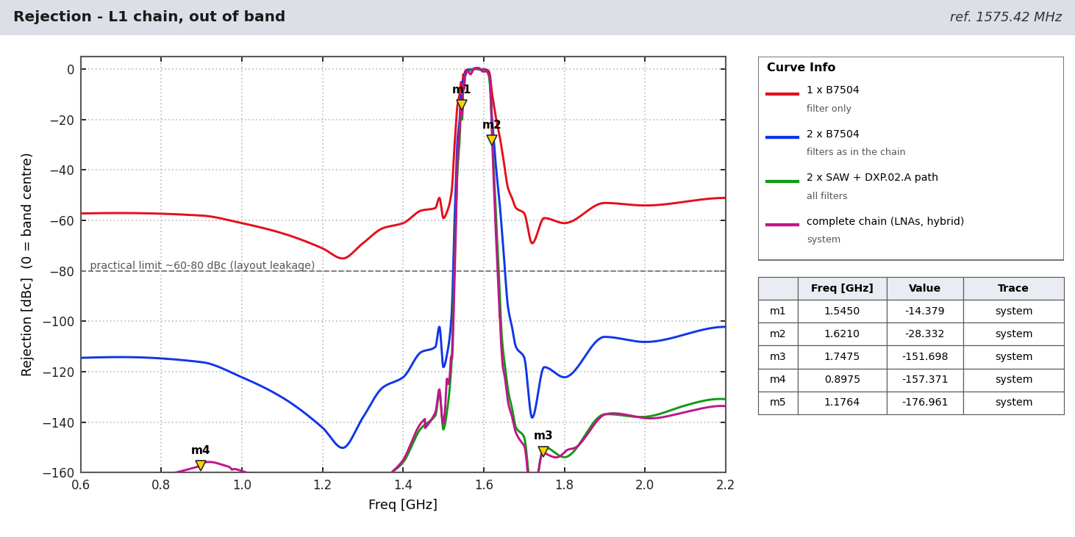
Figure - L1 chain: out of band, per filter stage.
MHz | Service / point | 1 SAW dBc | 2 SAW dBc | 2 SAW + DXP dBc | Complete chain dBc
787 | LTE B13/B14 UL | 57.3 | 114.6 | 166.6 | 161.9
897.5 | GSM-900 / LTE B8 UL | 58.1 | 116.2 | 164.9 | 157.4
1176.45 | L5 (other branch) | 69.5 | 139.0 | 178.2 | 177.0
1227.6 | L2 (other branch) | 73.8 | 147.6 | 188.0 | 192.5
1500 | L-band (LTE B11/B21) | 59.1 | 118.2 | 142.9 | 140.4
1530 | Inmarsat DL | 24.2 | 48.5 | 62.9 | 69.0
1545 | Inmarsat DL | 6.2 | 12.5 | 16.7 | 14.4
1550 | lower skirt | 2.7 | 5.4 | 6.7 | 7.2
1612 | upper skirt | 0.8 | 1.7 | 2.4 | 2.2
1616 | Iridium low | 3.1 | 6.2 | 7.8 | 4.7
1621 | Iridium | 10.3 | 20.5 | 26.4 | 28.3
1626.5 | Iridium / Inmarsat UL | 15.6 | 31.3 | 45.1 | 51.6
1643 | Inmarsat UL | 29.9 | 59.9 | 101.4 | 108.6
1660 | Inmarsat UL top | 47.1 | 94.2 | 126.9 | 131.7
1710 | LTE B3 UL low | 63.5 | 127.1 | 158.8 | 162.0
1747.5 | LTE B3 UL | 59.3 | 118.6 | 150.3 | 151.7
1842.5 | DCS-1800 DL | 58.0 | 116.0 | 147.4 | 147.9
1950 | LTE B1 UL | 53.6 | 107.2 | 137.4 | 137.0
2140 | LTE B1 DL | 51.8 | 103.5 | 131.7 | 134.6
2442 | Wi-Fi 2.4 GHz | 49.1 | 98.2 | - | -
5500 | Wi-Fi 5 GHz | 41.1 | 82.2 | - | -
Table 4 - L1 chain rejection (dBc rel. 1575.42 MHz; '-' = outside model range; practical limit ~60-80 dBc).

5.3 L2/L5 chain
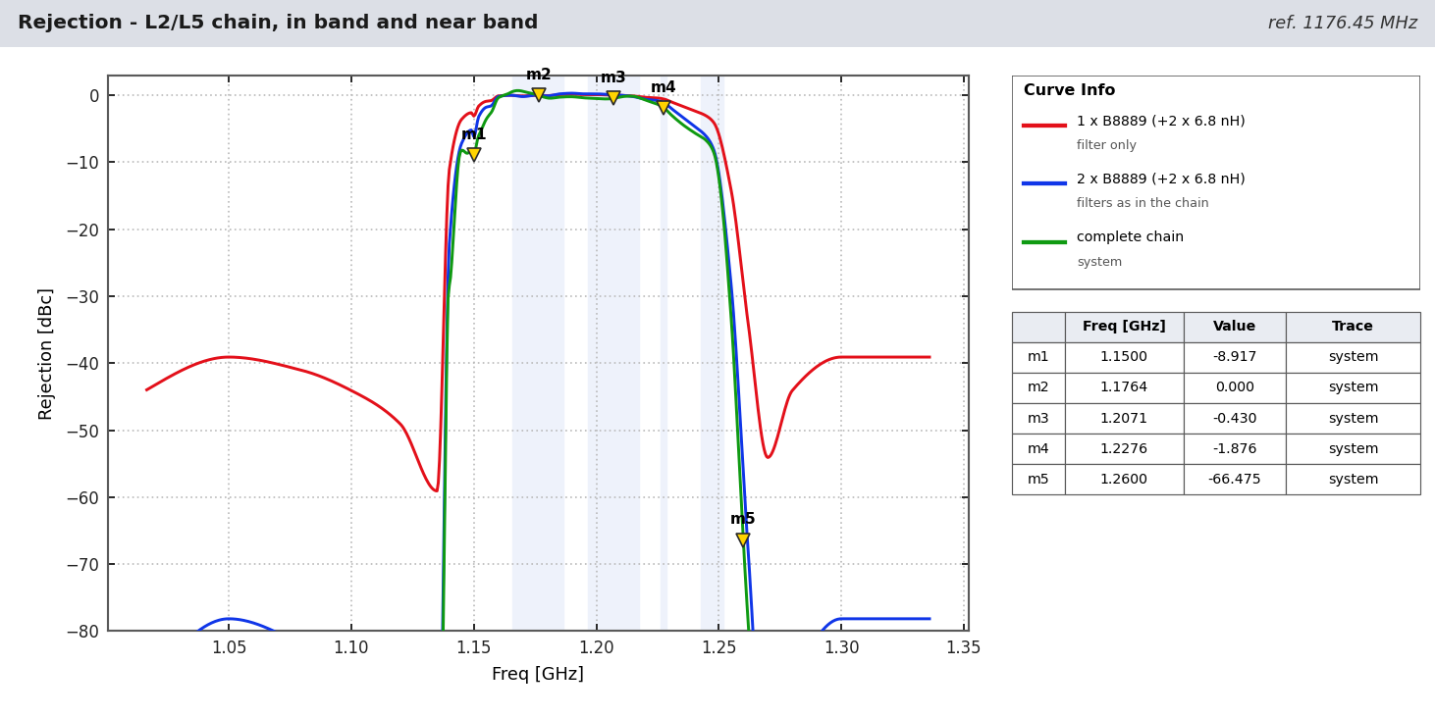
Figure - L2/L5 chain: in band and near band (L5/E5a, E5b, L2, G2 shaded).
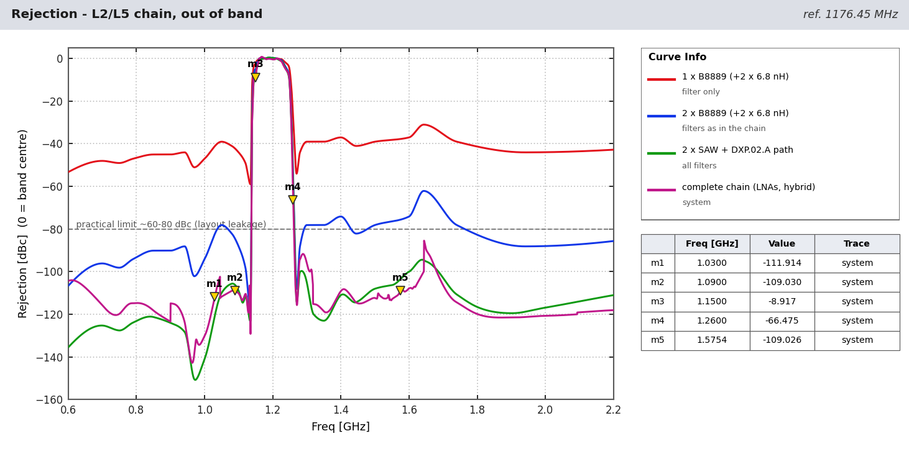
Figure - L2/L5 chain: out of band, per filter stage.
MHz | Service / point | 1 SAW dBc | 2 SAW dBc | 2 SAW + DXP dBc | Complete chain dBc
787 | LTE B13/B14 UL | 47.2 | 94.5 | 124.2 | 114.8
897.5 | GSM-900 / LTE B8 UL | 45.1 | 90.2 | 123.9 | 123.2
960 | DME/TACAN low | 49.0 | 98.1 | 143.2 | 141.4
1030 | SSR / IFF interrogation | 41.2 | 82.4 | 120.8 | 111.9
1090 | SSR / ADS-B reply | 42.4 | 84.7 | 106.3 | 109.0
1150 | DME top | 3.1 | 6.2 | 9.0 | 8.9
1160 | lower skirt | 0.1 | 0.2 | 0.9 | 0.4
1250 | upper skirt | 5.8 | 11.6 | 12.8 | 12.3
1260 | ARNS radar | 28.2 | 56.4 | 58.8 | 66.5
1300 | ARNS radar top | 39.1 | 78.2 | 105.0 | 96.0
1400 | L-band | 37.1 | 74.2 | 111.0 | 109.2
1575.42 | L1 (other branch) | 37.8 | 75.6 | 103.4 | 109.0
1621 | Iridium | 34.0 | 68.0 | 96.5 | 106.4
1710 | LTE B3 UL low | 36.7 | 73.4 | 105.3 | 109.2
1950 | LTE B1 UL | 44.1 | 88.2 | 118.5 | 121.2
2442 | Wi-Fi 2.4 GHz | 38.1 | 76.1 | - | -
5500 | Wi-Fi 5 GHz | 25.2 | 50.5 | - | -
Table 5 - L2/L5 chain rejection (dBc rel. 1176.45 MHz).
Path | At | Rejection (filters + DXP)
L1 branch | L5 1176.45 MHz | 178 dBc
L1 branch | L2 1227.60 MHz | 188 dBc
L2/L5 branch | L1 1575.42 MHz | 103 dBc
Table 6 - Cross-band rejection between the L-band branches at the combined output (model).
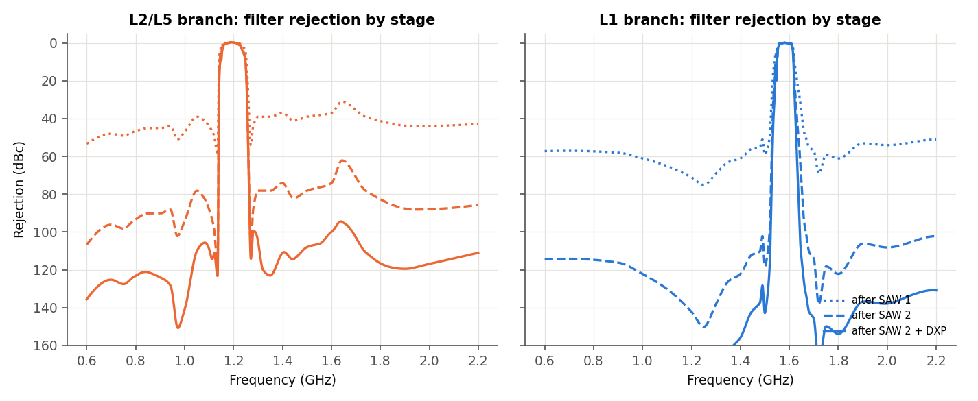
Figure - L-band cumulative filter rejection: SAW 1, SAW 2, SAW 2 + DXP.
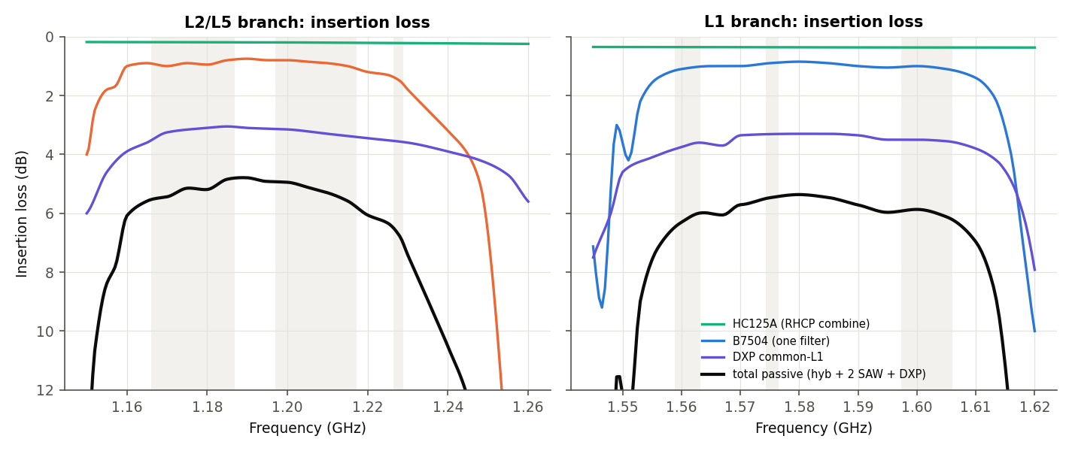
Figure - L-band in-band insertion loss: hybrid, one SAW, DXP path, total passive.
Chain | Band | 1 SAW IL dB | 2 SAW IL max dB | +DXP IL max dB | +DXP ripple dB | System ripple dB
L1 | B1I | 1.06 | 2.24 | 6.02 | 0.38 | 0.51
L1 | L1 C/A / E1 / B1C | 0.90 | 1.82 | 5.13 | 0.05 | 0.34
L1 | L1 wide (E1/B1C 4.092 MHz) | 0.90 | 1.86 | 5.18 | 0.13 | 0.79
L1 | G1 (FDMA) | 1.04 | 2.23 | 5.79 | 0.29 | 0.11
L2/L5 | L5 / E5a / B2a | 0.92 | 2.00 | 5.33 | 0.71 | 1.14
L2/L5 | E5b / B2b | 0.88 | 2.15 | 5.56 | 0.83 | 0.42
L2/L5 | L2 | 1.48 | 3.12 | 6.69 | 0.32 | 0.41
L2/L5 | G3 (CDMA) | 0.85 | 1.88 | 5.22 | 0.48 | 0.41
L2/L5 | G2 (FDMA) | 5.23 | 17.54 | 21.94 | 10.68 | 10.75
Table 7 - L-band in-band filter loss and ripple (G2 lies outside the B8889 pass-band).

5.4 NavIC S chain
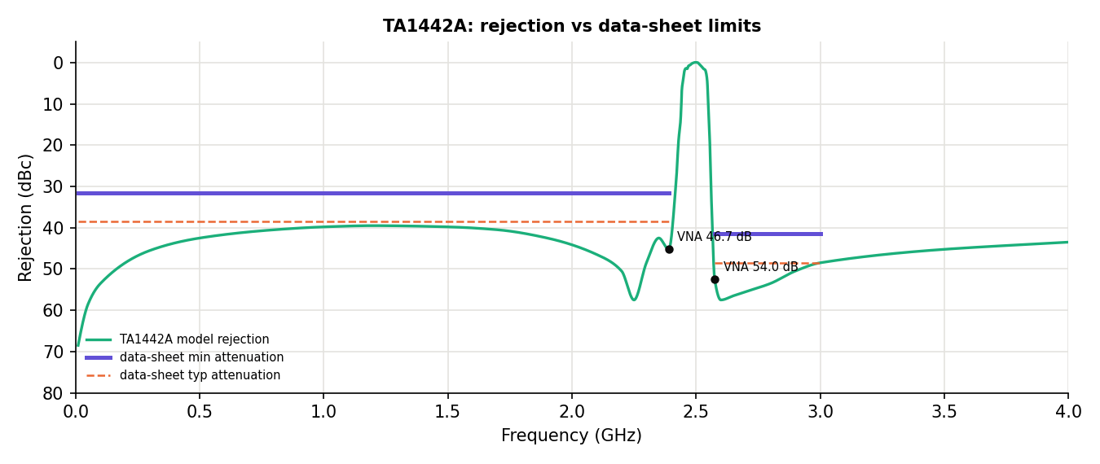
Figure - TA1442A vs data-sheet limits and VNA markers (met).
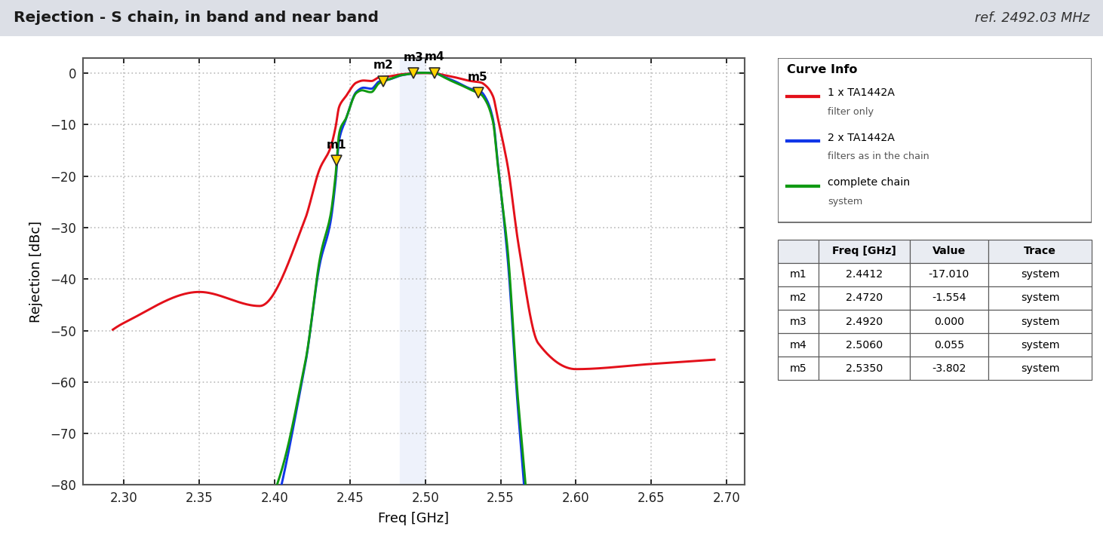
Figure - NavIC S chain: in band and near band.
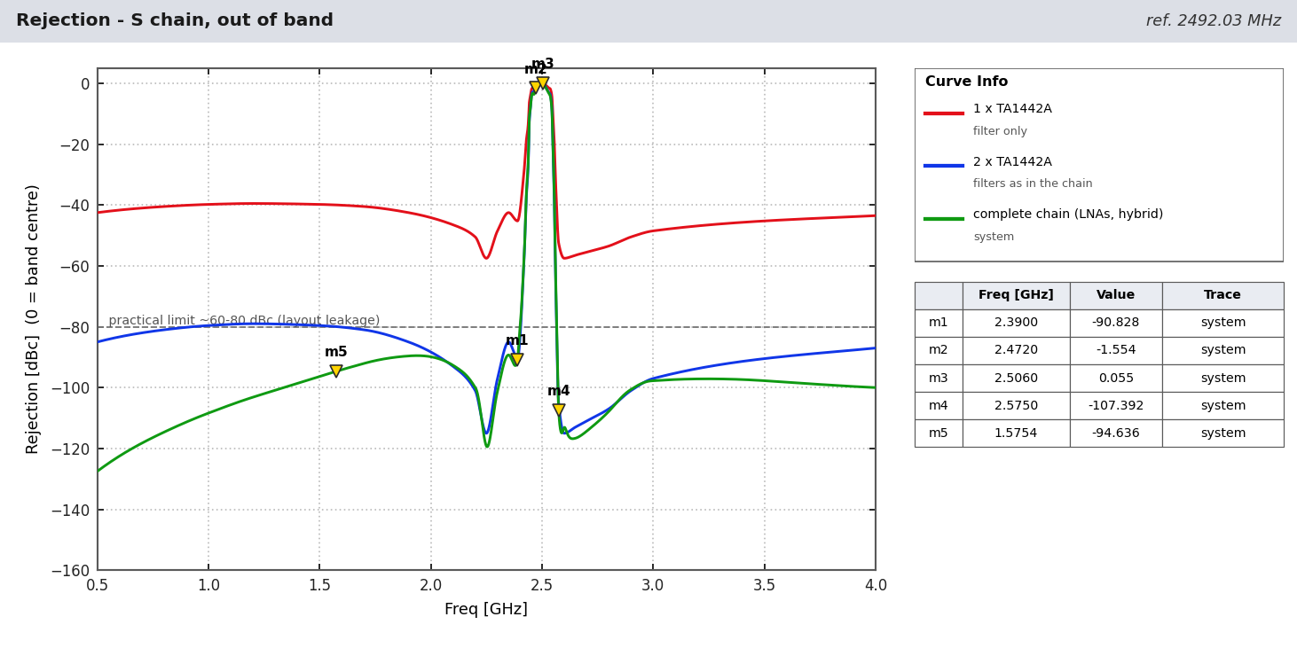
Figure - NavIC S chain: out of band, per filter stage.
MHz | Service / point | 1 SAW dBc | 2 SAW dBc | Complete chain dBc
1575.42 | GNSS L1 | 40.0 | 80.0 | 94.6
2110 | LTE B1 DL | 46.8 | 93.6 | 93.1
2350 | LTE B40 | 42.5 | 85.0 | 89.3
2390 | TA1442A spec point | 45.2 | 90.5 | 90.8
2412 | Wi-Fi ch 1 | 34.7 | 69.3 | 68.2
2441 | Bluetooth / ISM | 9.5 | 19.0 | 17.8
2450 | microwave oven | 3.2 | 6.5 | 6.6
2472 | Wi-Fi ch 13 | 0.7 | 1.4 | 1.6
2483.5 | ISM top / Globalstar | 0.2 | 0.4 | 0.4
2500 | Globalstar top | 0.0 | 0.0 | 0.0
2506 | LTE B41 / n41 | 0.0 | 0.0 | 0.0
2535 | LTE B7 UL | 1.7 | 3.4 | 3.8
2570 | LTE B7 UL top | 47.6 | 95.2 | 92.3
2575 | TA1442A spec point | 52.5 | 105.0 | 107.4
2593 | LTE B41 mid | 57.1 | 114.2 | 114.5
2655 | LTE B7 DL | 56.4 | 112.8 | 116.5
3500 | 5G n78 | 45.2 | 90.5 | 97.7
Table 8 - NavIC S chain rejection (dBc rel. 2492.028 MHz).
Band | 1 SAW IL dB | 2 SAW IL max dB | System ripple dB
NavIC S SPS (2.046 MHz) | 1.50 | 3.07 | 0.17
TA1442A spec band | 1.50 | 3.12 | 0.22
NavIC S RS (16.5 MHz) | 1.53 | 3.40 | 0.47
Table 9 - NavIC S in-band filter loss and ripple.

6 Interference
Chain | Interferer | MHz | At antenna dBm | LNA 2 out dBm | Status
L1 | Iridium | 1621 | -20 | 12.0 | near band - watch
L1 | LTE B3 UL | 1747.5 | -10 | -28.0 | OK
L2/L5 | DME / TACAN | 1150 | -30 | 13.3 | RISK - above B8889 rating
L2/L5 | GSM-900 | 897.5 | -10 | -6.6 | OK
S | Wi-Fi ch 13 | 2472 | -10 | 25.8 | RISK - LNA 2 compressed
S | LTE B41 | 2506 | -10 | 26.3 | RISK - LNA 2 compressed
S | LTE B7 UL | 2535 | -10 | 24.5 | RISK - LNA 2 compressed
S | 5G n78 | 3500 | -20 | -35.8 | OK
Table 10 - Interferer level at LNA 2 output (LNA OP1dB ~+20 dBm; B8889 +5 dBm, TA1442A +10 dBm max input).
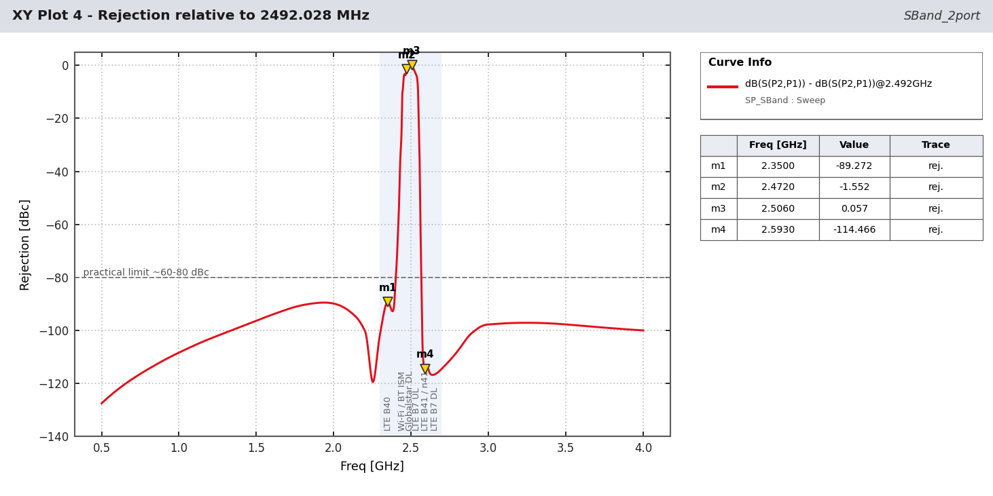
Figure - NavIC S chain rejection with the ISM / LTE bands.
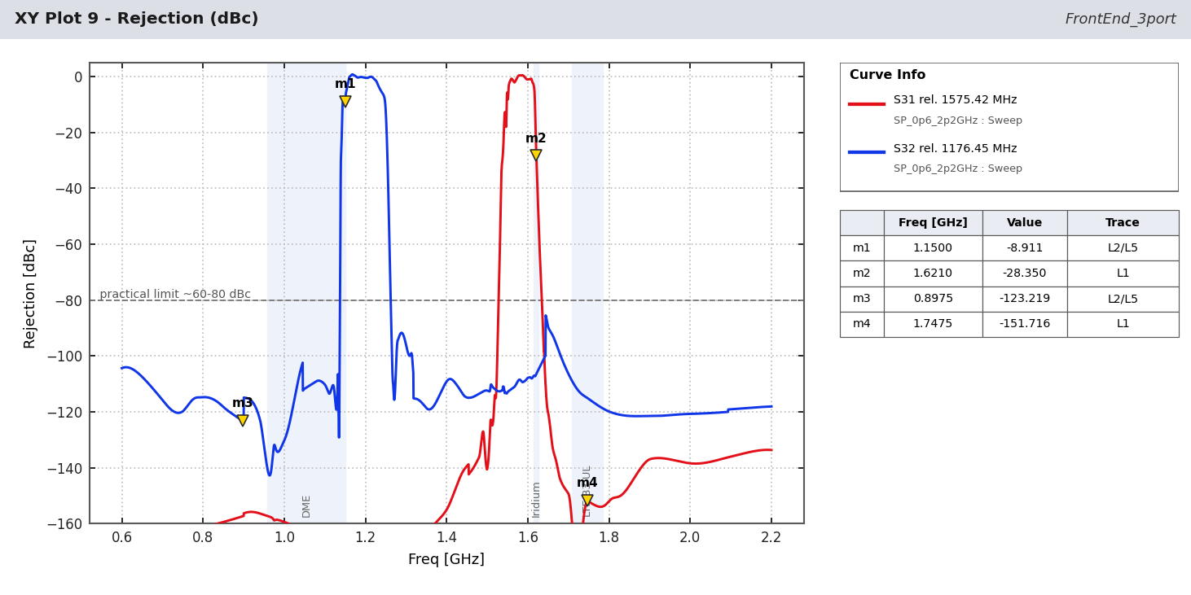
Figure - L-band chain rejection with DME / Iridium / LTE.

7 Cascade budgets
Stage | G dB | NF dB | Cum G | Cum NF | Cum IIP3 | Cum IP1dB | Signal dBm | Noise dBm
HC125A (RHCP combine) | -0.36 | 0.36 | -0.36 | 0.36 | - | - | -128.9 | -110.9
LNA1 TQP3M9037 + bias | 21.95 | 0.37 | 21.59 | 0.73 | 13.2 | 0.3 | -106.9 | -88.5
B7504 #1 | -0.89 | 0.89 | 20.70 | 0.74 | 13.2 | 0.3 | -107.8 | -89.4
LNA2 TQP3M9037 + bias | 21.95 | 0.37 | 42.65 | 0.74 | -7.9 | -20.8 | -85.8 | -67.5
B7504 #2 | -0.89 | 0.89 | 41.76 | 0.74 | -7.9 | -20.8 | -86.7 | -68.4
DXP.02.A (combiner) | -3.31 | 3.31 | 38.45 | 0.74 | -7.9 | -20.8 | -90.0 | -71.7
Cascade - L1 C/A (1575.42 MHz, 2.046 MHz).
Stage | G dB | NF dB | Cum G | Cum NF | Cum IIP3 | Cum IP1dB | Signal dBm | Noise dBm
HC125A (RHCP combine) | -0.19 | 0.19 | -0.19 | 0.19 | - | - | -128.1 | -100.9
LNA1 TQP3M9037 + bias | 23.61 | 0.39 | 23.41 | 0.58 | 11.2 | -0.9 | -104.5 | -76.9
B8889 #1 | -0.91 | 0.91 | 22.50 | 0.59 | 11.2 | -0.9 | -105.4 | -77.8
LNA2 TQP3M9037 + bias | 23.61 | 0.39 | 46.11 | 0.59 | -11.6 | -23.6 | -81.8 | -54.2
B8889 #2 | -0.91 | 0.91 | 45.20 | 0.59 | -11.6 | -23.6 | -82.7 | -55.1
DXP.02.A (combiner) | -3.14 | 3.14 | 42.06 | 0.59 | -11.6 | -23.6 | -85.8 | -58.2
Cascade - L5 (1176.45 MHz, 20.46 MHz).
Stage | G dB | NF dB | Cum G | Cum NF | Cum IIP3 | Cum IP1dB | Signal dBm | Noise dBm
HC125A (RHCP combine) | -0.22 | 0.22 | -0.22 | 0.22 | - | - | -130.2 | -110.9
LNA1 TQP3M9037 + bias | 23.39 | 0.40 | 23.17 | 0.61 | 11.4 | -0.7 | -106.8 | -87.1
B8889 #1 | -1.45 | 1.45 | 21.71 | 0.62 | 11.4 | -0.7 | -108.3 | -88.5
LNA2 TQP3M9037 + bias | 23.39 | 0.40 | 45.10 | 0.62 | -10.5 | -22.7 | -84.9 | -65.1
B8889 #2 | -1.45 | 1.45 | 43.65 | 0.62 | -10.5 | -22.7 | -86.4 | -66.6
DXP.02.A (combiner) | -3.56 | 3.56 | 40.09 | 0.62 | -10.5 | -22.7 | -89.9 | -70.2
Cascade - L2C (1227.60 MHz, 2.046 MHz).
Stage | G dB | NF dB | Cum G | Cum NF | Cum IIP3 | Cum IP1dB | Signal dBm | Noise dBm
C2327J5003AHF (RHCP combine) | -0.43 | 0.43 | -0.43 | 0.43 | - | - | -132.7 | -110.9
LNA1 TQP3M9037 (ref. design) | 19.17 | 0.73 | 18.73 | 1.16 | 16.3 | 1.9 | -113.6 | -91.0
TA1442A #1 | -1.50 | 1.50 | 17.23 | 1.18 | 16.3 | 1.9 | -115.1 | -92.5
LNA2 TQP3M9037 (ref. design) | 19.17 | 0.73 | 36.40 | 1.19 | -1.4 | -15.9 | -95.9 | -73.3
TA1442A #2 | -1.50 | 1.50 | 34.90 | 1.19 | -1.4 | -15.9 | -97.4 | -74.8
Cascade - NavIC S (2492.028 MHz, 2.046 MHz).
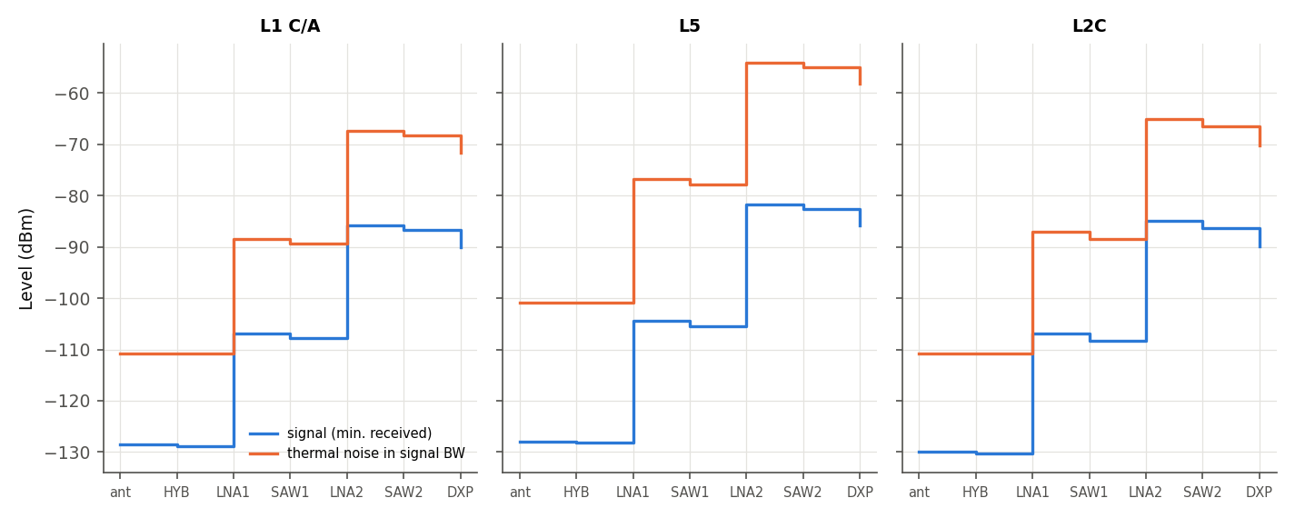
Figure - Level diagram (minimum signal and noise), L-band.

8 Actions
- NavIC S: narrow pre-filter (<= 20 MHz, > 30 dB at 2472 / 2506 MHz) before LNA 1.
- L2/L5: > 30 dB at 960-1150 MHz (DME) before LNA 1. L1: steeper upper skirt for Iridium.
- Reduce gain to 25-30 dB at the connector (one LNA per branch or a pad).
- Improve L1 / E5b input match (VSWR 2.3-2.75).
- Get measured S-parameters from the vendors; confirm TA1442A availability (2011 data sheet).
- Run the AEDT project on the licensed workstation; replace the ideal patch by HFSS data.

9 Parts
Part | Maker | Use | Qty
TQP3M9037 | Qorvo | LNA, 0.4 dB NF, 5 V / 70 mA | 6
HC125A | Taoglas | L-band 3 dB hybrid | 2
B7504 | Qualcomm RF360 | L1 SAW | 2
B8889 | Qualcomm RF360 | L2/L5 SAW (+2 x 6.8 nH) | 2
DXP.02.A | Taoglas | L-band diplexer (combiner) | 1
C2327J5003AHF | TTM / Xinger | S-band 3 dB hybrid | 1
TA1442A | Tai-Saw | 2492 MHz SAW | 2
Patch elements | - | antenna (ideal in simulation) | 3
Table 11 - Parts.

