Implement a program for retrieval of documents using inverted files.

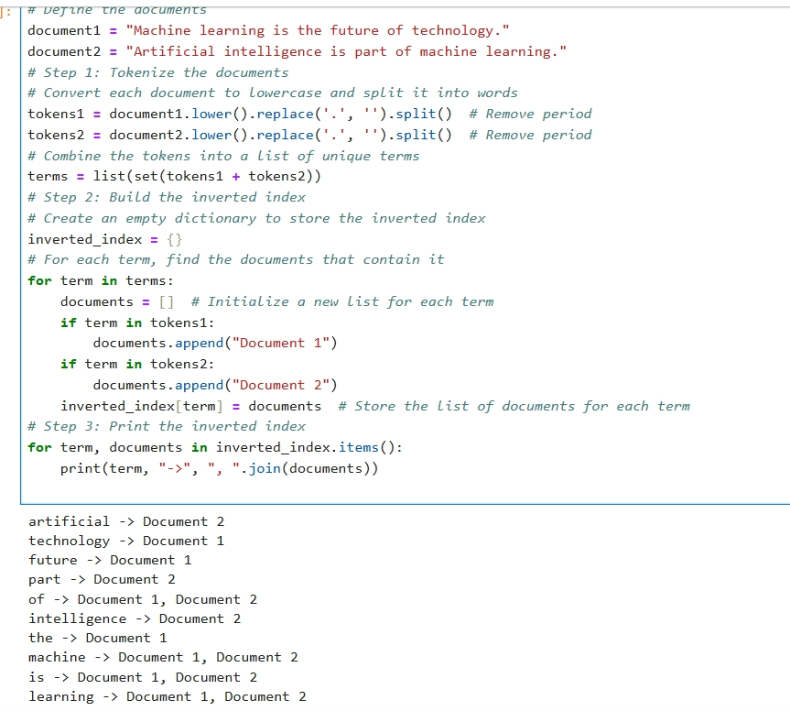

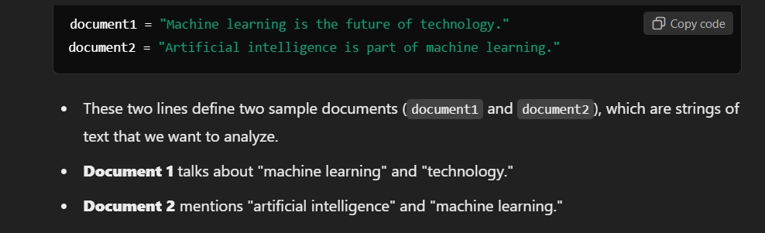

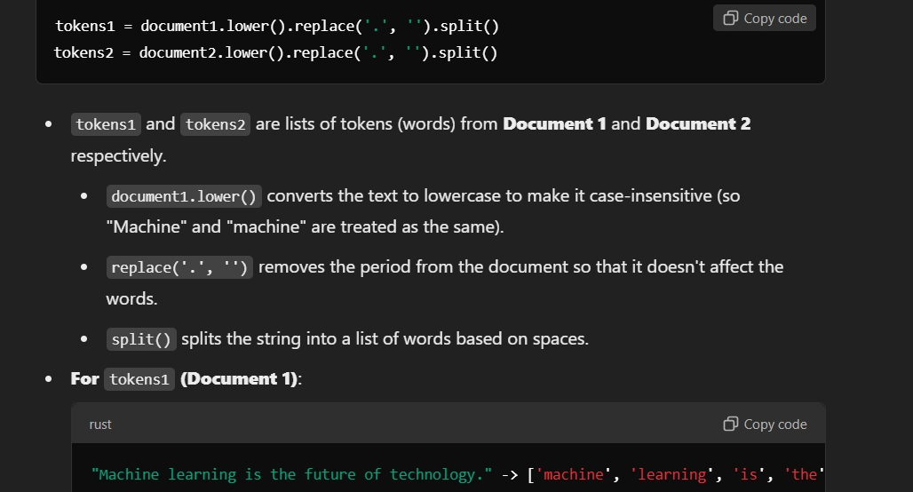



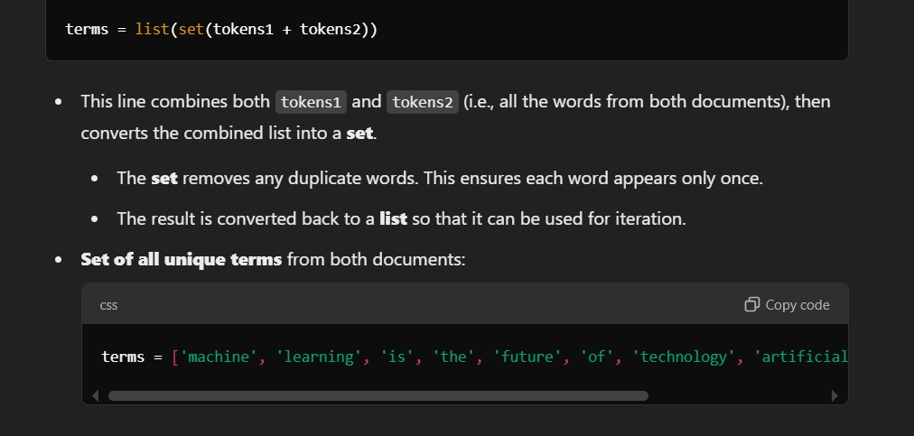

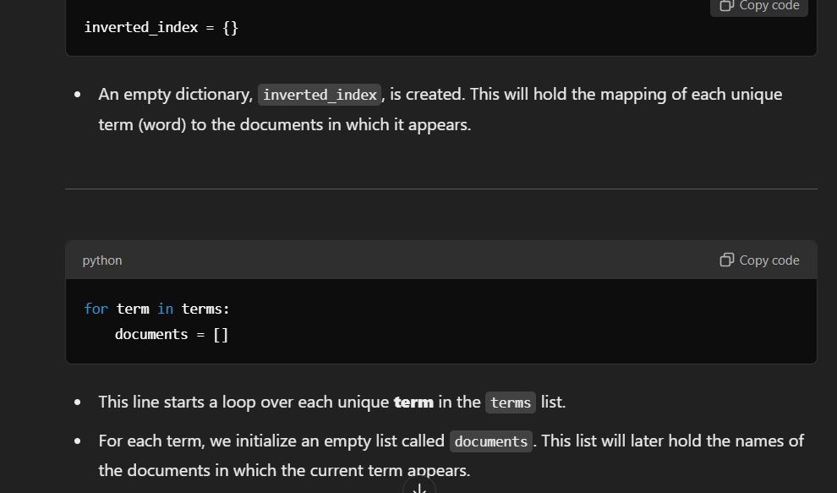

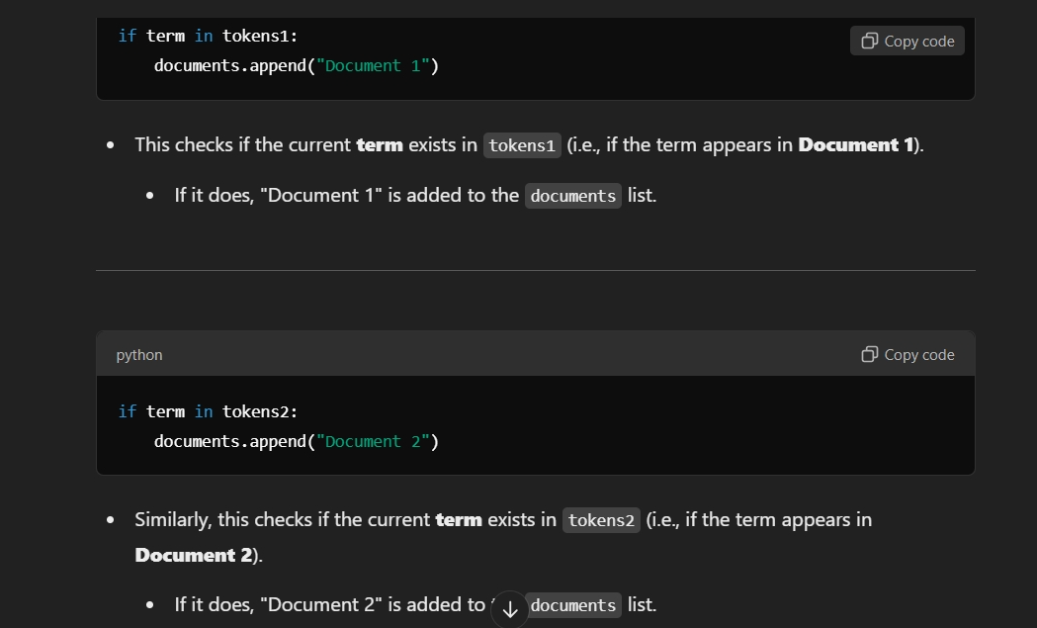

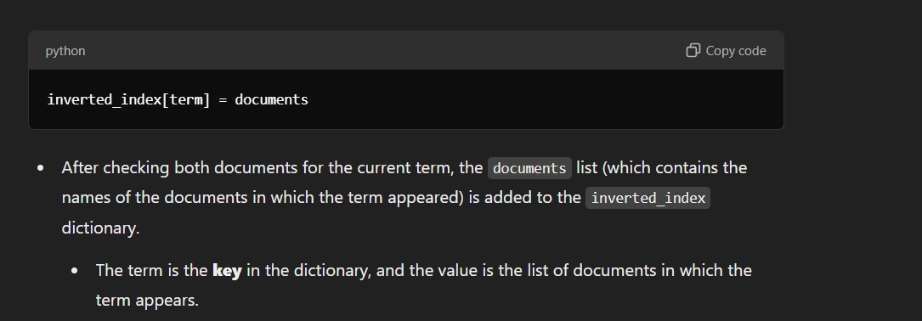

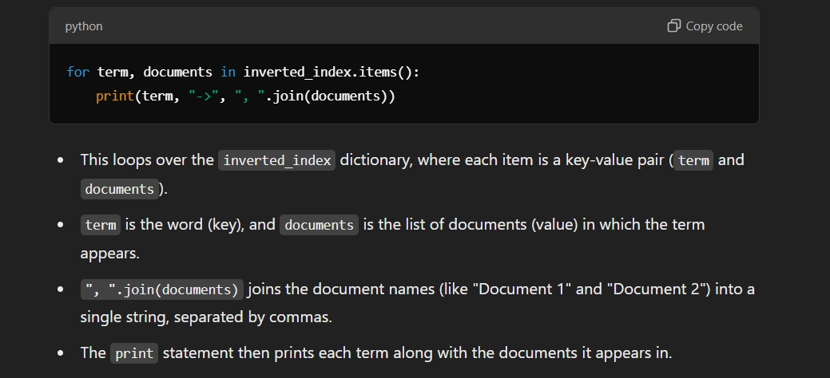

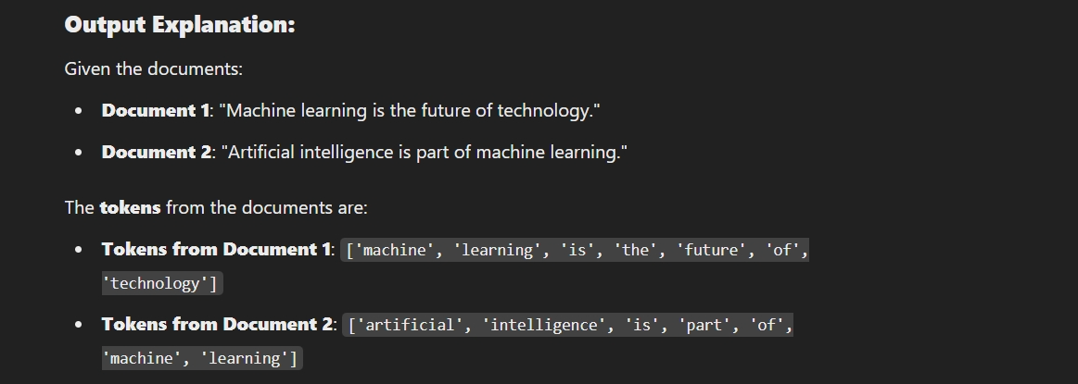

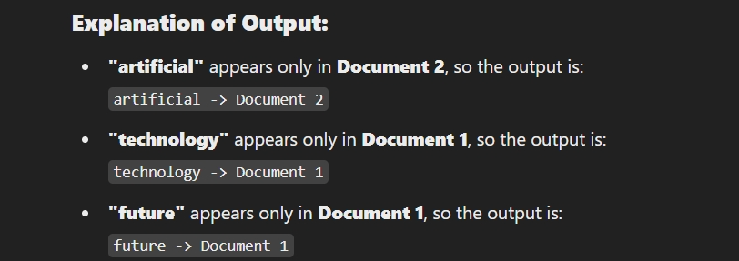

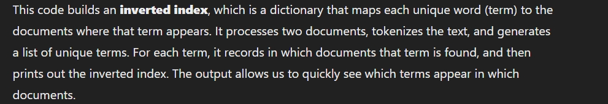



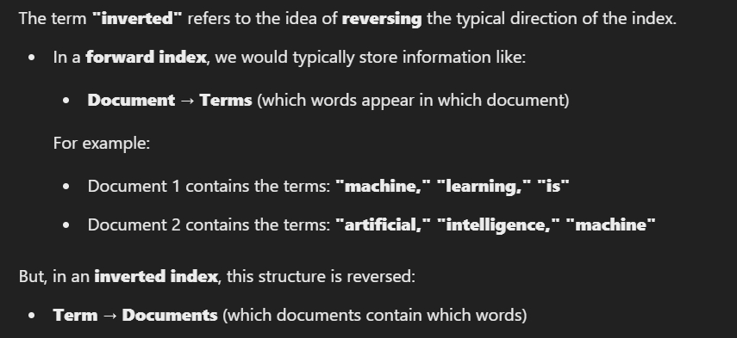

Its main parts are:

1. **Words or Terms**: The individual words from the documents, each listed once.

2. **Document IDs**: Unique numbers for each document to identify them.

3. **Posting Lists**: Lists of document IDs where each word appears.

4. **Word Count (Optional)**: Sometimes, the index also shows how many times each word appears in each document.

5. **Word Position (Optional)**: Sometimes, the index also notes exactly where each word appears in each document, which helps with finding exact phrases.

### Types of Inverted Indexes

1. **Token-Based Inverted Index**: Maps each word to its occurrences in a document

2. **Field-Based Inverted Index**:

- Separates the index by different fields within a document (e.g., title, body, author

3. **Positional Inverted Index**:

- In addition to mapping tokens to documents, it records the positions of each token within the document.Example:The word "machine" might appear at positions 1 and 7 in Document 1.

4. **Bi-Level Inverted Index**:Combines token-level and positional indexes to offer enhanced search capabilities with both high-speed term lookup and position-based retrieval.

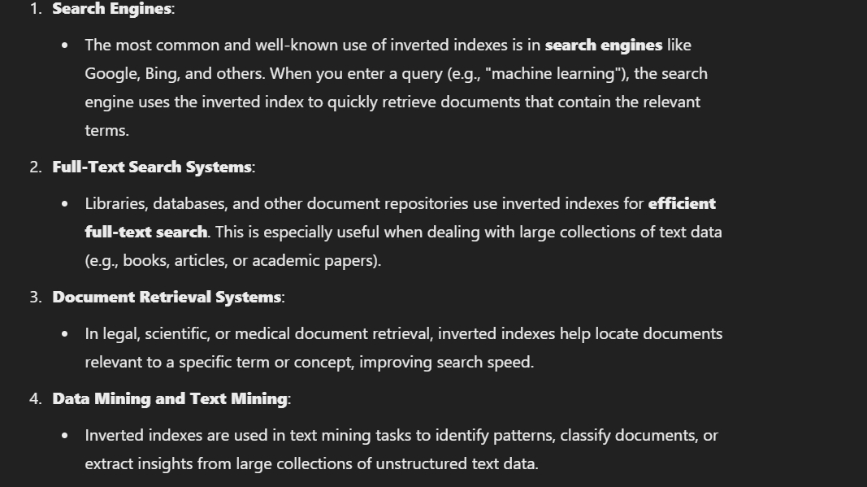

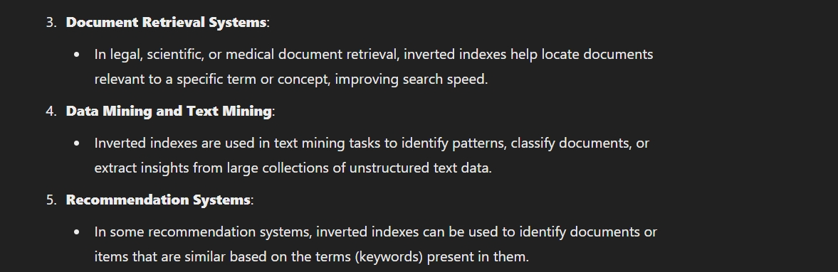

Natural Language Processing (NLP)**: Supports language processing tasks like finding word patterns, synonyms, or phrase matching.

5. **Spam Detection**: Helps detect patterns in text that indicate spam by analyzing term frequency and distribution across documents.

6. **Plagiarism Detection**: Quickly identifies duplicated content across large document collections by finding exact or near-exact matches in word sequences.