Customer Shopping Behavior Analysis (Using Python, MySQL, and Power BI)
1. Project Overview
This project focuses on analyzing customer shopping behavior using transactional retail data to uncover patterns that can support better business decision making. The analysis explores how customer demographics, purchasing habits, discounts, subscriptions, and product categories influence spending behavior.
The project follows an end-to-end data analytics workflow:
- Data cleaning and transformation using Python (Jupyter Notebook)
- Data storage and querying using MySQL
- Data visualization and insight generation using Power BI
The goal is to provide actionable insights that can help a retail business improve customer engagement, optimize marketing strategies, and increase revenue.
2. Business Problem Statement
A retail company seeks to gain deeper insight into how customers interact with its products and services. Management has observed variations in purchasing behavior across different customer groups and product categories but lacks clear data driven explanations for these trends.
Key challenges include:
- Identifying high value customers and loyal shoppers
- Understanding the impact of discounts and subscriptions on revenue
- Determining which products and categories perform best
- Analyzing how demographics such as age and gender affect spending behavior
Core Business Question
How can customer shopping data be leveraged to identify purchasing trends, improve customer retention, and optimize marketing and product strategies?
3. Project Objectives
The objectives of this project are to:
- Clean and prepare customer shopping data for analysis using Python
- Store structured data in a MySQL database for efficient querying
- Perform SQL analysis to answer real business questions
- Build an interactive Power BI dashboard to visualize insights
- Provide data-driven business recommendations
4. Dataset Description
- Total Records: 3,900 purchases
- Total Columns: 18
- Key Data Fields Include:
  - Customer demographics (Age, Gender, Location)
  - Purchase details (Item Purchased, Category, Purchase Amount, Season)
  - Shopping behavior (Discount Applied, Subscription Status, Review Rating)
  - Transaction behavior (Previous Purchases, Frequency of Purchases, Shipping Type)
Data Quality Notes
- Missing values were found in the Review Rating column
- Data types and column naming required standardization
5. Data Preparation & Cleaning (Python)
Data preparation was performed in Jupyter Notebook using Python.
Key Steps:
- Data Loading
Imported the dataset using pandas
- Initial Exploration
Used .info() and .describe() to understand structure and distributions
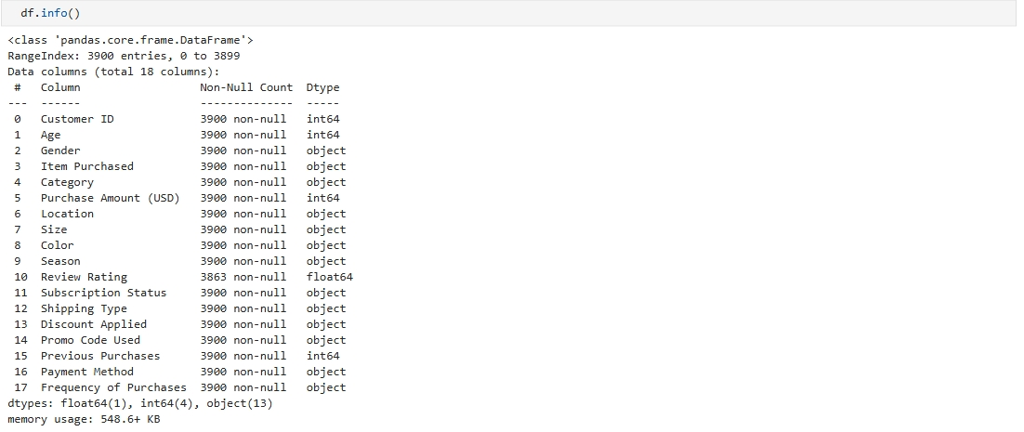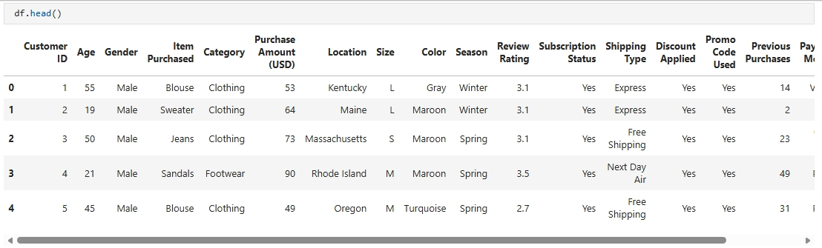

- Handling Missing Values
Missing review ratings were filled using the median rating per product category
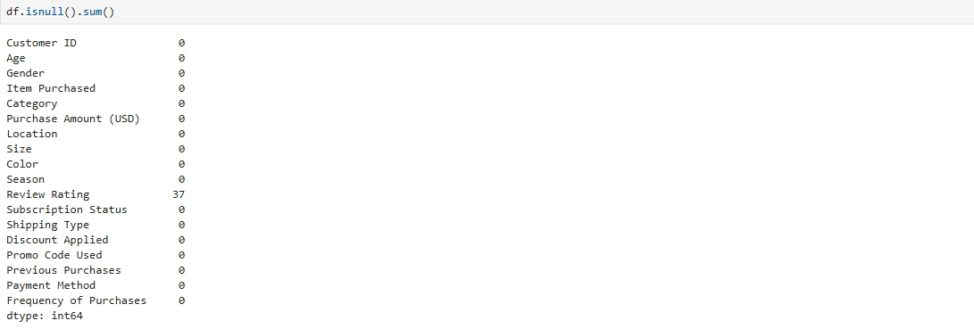
- Column Standardization
Converted column names to snake case for readability and consistency
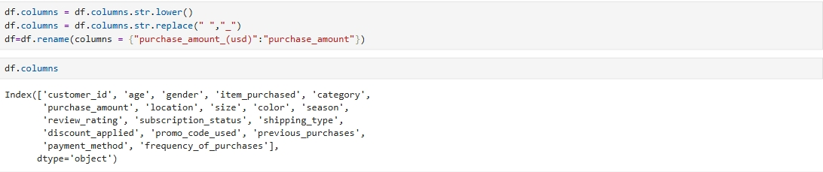
- Feature Engineering
Created an age group column to segment customers by age
Created derived fields to support customer segmentation and analysis
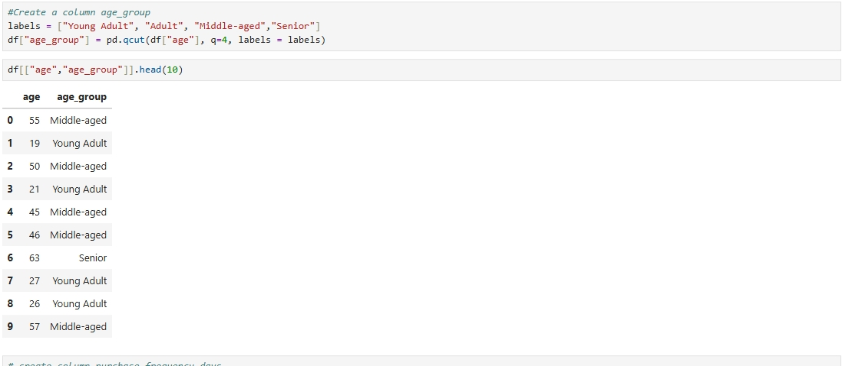
- Data Export
Cleaned data was exported from Python and saved for database loading
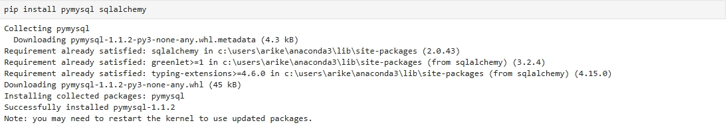
6. Database Integration (MySQL)
This project uses MySQL as the relational database system.
Steps Performed:
- Created a MySQL database for the project
- Defined tables to store cleaned customer shopping data
- Loaded the cleaned dataset into MySQL
- Verified successful data insertion using SQL queries
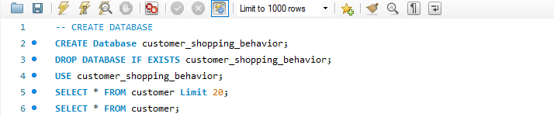
This database served as the foundation for all business focused SQL analysis and Power BI connectivity.
7. Data Analysis Using SQL (MySQL)
SQL queries were written in MySQL to answer important business questions.
Business Questions & Analysis:
- Revenue by Gender
Compared total revenue generated by male and female customers
- High Spending Discount Users
Identified customers who used discounts but still spent above the average purchase amount
- Top Rated Products
Calculated average review ratings to identify top performing products
- Shipping Type Comparison
Compared average purchase amounts for standard vs express shipping
- Subscribers vs Non-Subscribers
Analyzed spending behavior and total revenue across subscription status
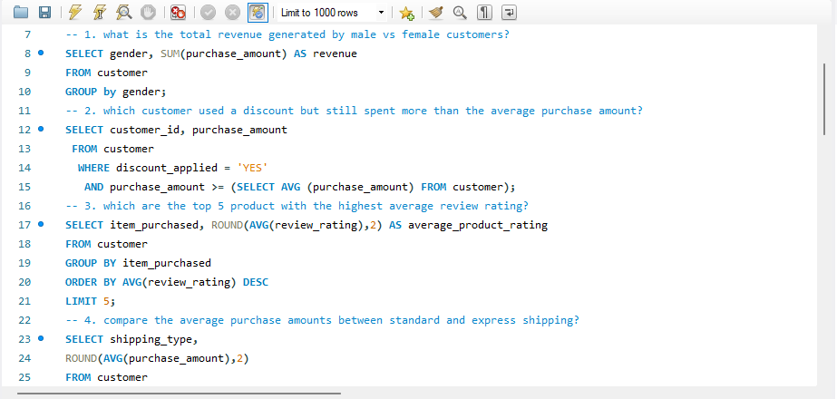
- Discount Dependent Products
Identified products most frequently purchased with discounts
- Customer Segmentation
Categorized customers into:
    - New customers
    - Returning customers
    - Loyal customers
based on purchase history
- Top Products per Category
Identified the most purchased products within each product category
- Repeat Buyers and Subscriptions
Examined whether customers with multiple purchases are more likely to subscribe
- Revenue by Age Group
Assessed which age groups contribute most to total revenue
8. Data Visualization and Dashboard Development (Power BI)
After completing data cleaning in Python and storing the processed data in MySQL, the final stage of the project focused on data visualization and insight communication using Power BI. An interactive dashboard titled “Customer Behavior Dashboard” was developed to enable stakeholders to explore customer shopping patterns and performance metrics intuitively.
Dashboard Overview
The dashboard provides a consolidated view of customer behavior, sales performance, and demographic insights. It is designed to answer key business questions at a glance while allowing users to filter and drill down into specific segments.
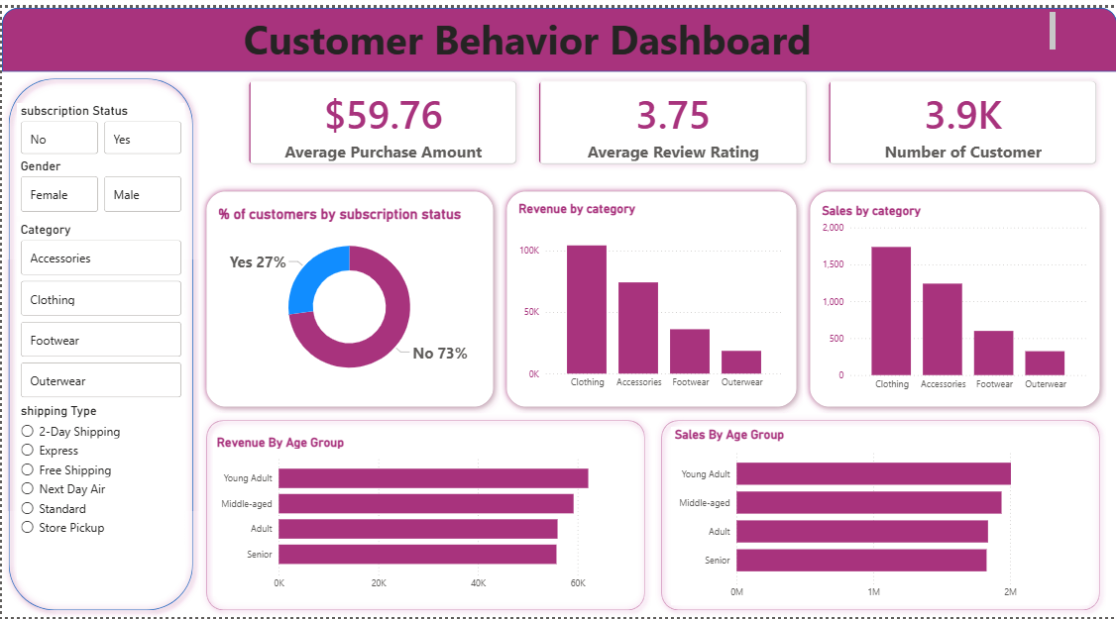
Key Performance Indicators (KPIs)
At the top of the dashboard, three key metrics summarize overall performance:
- Number of Customers (3.9K):
Displays the total number of unique customers captured in the dataset.
- Average Review Rating (3.75):
Indicates the overall customer satisfaction level based on product reviews.
- Average Purchase Amount ($59.76):
Shows the average spending per transaction, helping assess customer value.
These KPIs provide a quick snapshot of business health and customer engagement.
Subscription Status Analysis
A donut chart visualizes the percentage of customers by subscription status:
- 73% Non-Subscribers
- 27% Subscribers
This insight highlights a significant opportunity for the business to convert non subscribers into subscribers through targeted marketing and loyalty incentives.
Revenue and Sales Performance by Category
Two bar charts analyze product category performance:
- Revenue by Category
- Sales by Category
From the visuals:
- Clothing generates the highest revenue and sales volume.
- Accessories follow closely behind.
- Footwear and Outerwear contribute less comparatively.
This helps the business identify high performing categories and prioritize inventory, promotions, and marketing focus accordingly.
Revenue and Sales by Age Group
Horizontal bar charts display both Revenue by Age Group and Sales by Age Group:
- Young Adults contribute the highest revenue and number of sales.
- Middle aged customers also show strong purchasing behavior.
- Adults and Seniors contribute slightly less but remain important segments.
These insights support targeted demographic based marketing strategies.
Interactive Filters and Slicers
To enhance usability and interactivity, the dashboard includes multiple slicers:
- Subscription Status (Yes / No)
- Gender (Male / Female)
- Product Category
- Shipping Type
These slicers allow stakeholders to:
- Compare behavior across different customer segments
- Analyze how shipping preferences or subscriptions affect sales
- Explore category-specific performance dynamically
9. Key Insights
From the analysis and visualization, several important insights were identified:
- Loyal and repeat customers contribute significantly to total revenue
- Subscription customers tend to spend more on average
- Certain product categories drive most of the sales and revenue
- Discounts influence purchasing behavior but should be applied carefully
- Younger age groups are key revenue drivers
10. Business Recommendations
Based on the findings, the following recommendations are proposed:
- Improve Subscription Offers
Introduce exclusive benefits and promotions to convert more non subscribers into subscribers.
- Strengthen Customer Loyalty Programs
Reward repeat customers to encourage long term engagement.
- Optimize Discount Strategies
Use discounts strategically to boost sales without reducing profit margins unnecessarily.
- Focus on High Performing Categories
Allocate more marketing and inventory resources to top performing product categories.
- Target High Value Customer Segments
Design marketing campaigns focused on age groups and customer segments that generate the most revenue.
11. Tools and Technologies Used
- Python (Pandas, NumPy): Data cleaning and transformation
- Jupyter Notebook: Development and analysis environment
- MySQL: Data storage and SQL analysis
- Power BI: Data visualization and dashboard creation
12. Conclusion
This project demonstrates how customer shopping data can be transformed into meaningful business insights using Python, MySQL, and Power BI. By following a structured analytics workflow, the project highlights the importance of data driven decision making in improving customer engagement and business performance.
Overall, the analysis provides a strong foundation for understanding customer behavior and supports smarter marketing and product strategies.

