PROJECT REPORT

AI BASED LUNG ABNORMALITY
DETECTION SYSTEM

Multi-label chest X-ray classification with DenseNet121 and Grad-CAM,
and lung nodule segmentation with U-Net,
delivered through a secure web application
[INSERT: student name, register number, course, guide, department, institution, academic year]

ABSTRACT
Chest diseases such as pneumonia, pleural effusion, pneumothorax, cardiomegaly and lung nodules are among the most common reasons for medical consultation, and the chest X-ray is the first-line imaging test for them. Reporting these images is time-consuming, depends on the availability of expert radiologists and is subject to inter-observer variability. This project presents an AI Based Lung Abnormality Detection System that assists clinicians by automatically analysing chest images and presenting the result in a secure, easy-to-use web application.
The system is built around two deep-learning models. The first is a DenseNet121 network, initialised with ImageNet weights and trained by two-stage transfer learning on 191,027 frontal radiographs of the CheXpert data set, which predicts the probability of fourteen findings (for example Cardiomegaly, Lung Opacity, Edema, Pneumonia, Pneumothorax and Pleural Effusion) as a multi-label problem. A class-balanced focal loss, gradient clipping, data augmentation and per-label threshold selection are used to cope with the strong class imbalance, and Grad-CAM heatmaps show which image region supports the strongest prediction. The second model is a U-Net trained on 5,070 annotated CT slices to segment lung nodules; on a held-out test set of 507 images it achieved a Dice coefficient of 0.906, an Intersection over Union of 0.828, a precision of 0.908 and a recall of 0.904.
Both models are exposed as independent FastAPI inference services packaged with Docker. A Next.js application with PostgreSQL storage handles JWT-based authentication, patient records, image upload, parallel inference, severity grading, clinical follow-up suggestions, scan history, PDF report generation and an AI assistant that never receives patient-identifying data. The report describes the requirement analysis, system design, implementation, testing and results of the system and discusses its advantages, limitations and applications. The system is intended as a decision-support tool; final interpretation remains with the qualified clinician.
Keywords: chest X-ray, lung nodule, deep learning, DenseNet121, U-Net, Grad-CAM, multi-label classification, medical image segmentation, CheXpert, Next.js, FastAPI, decision support.

TABLE OF CONTENTS
1. INTRODUCTION 1
1.1 Background 1
1.2 Motivation 1
1.3 Overview of the Proposed System 2
1.4 Objectives 2
1.5 Scope of the Project 3
2. PROBLEM DEFINITION 4
2.1 Problem Statement 4
2.2 Existing System 4
2.3 Limitations of the Existing System 4
2.4 Proposed System 5
2.5 Objectives of the Proposed System 5
3. REQUIREMENT ANALYSIS 6
3.1 Literature Survey 6
3.2 Datasets Used 7
3.3 Functional Requirements 8
3.4 Non-Functional Requirements 9
3.5 Hardware Requirements 9
3.6 Software Requirements 10
3.7 Feasibility Study 10
4. SYSTEM DESIGN 12
4.1 Design Overview 12
4.2 System Architecture 12
4.3 Use Case Diagram 13
4.4 Data Flow Diagrams 13
4.5 Workflow and Sequence Diagrams 14
4.6 Database Design 16
4.7 Design of the Classification Model 17
4.8 Design of the Segmentation Model 18
4.9 Explainability Design 18
4.10 API Design 19
4.11 Security Design 20
4.12 User Interface Design 20
4.13 Deployment Design 20
5. IMPLEMENTATION 22
5.1 Development Environment 22
5.2 Data Preparation for the Classifier 22
5.3 Model Construction and Compilation 24
5.4 Training Procedure 25
5.5 Evaluation Procedure for the Classifier 26
5.6 Grad-CAM Implementation 27
5.7 Implementation of the U-Net 27
5.8 Inference Services 30
5.9 Implementation of the Web Application 31
5.10 Containerisation and Deployment 33
5.11 Application Screenshots 34
6. TESTING 37
6.1 Testing Strategy 37
6.2 Testing of the Machine-Learning Pipeline 37
6.3 Test Cases for the Application 38
6.4 Testing of the Inference Services 40
6.5 Performance Testing 40
6.6 Security Testing 40
7. RESULTS 41
7.1 Evaluation Metrics 41
7.2 Results of the DenseNet121 Classifier 41
7.3 Results of the U-Net Segmentation Model 43
7.4 System-level Results 48
7.5 Discussion 49
8. ADVANTAGES, DISADVANTAGES AND APPLICATIONS 51
8.1 Advantages 51
8.2 Disadvantages and Limitations 51
8.3 Applications 52
9. CONCLUSION 54
9.1 Summary 54
9.2 Objectives Achieved 54
9.3 Future Scope 54
9.4 Concluding Remarks 55
REFERENCES 56

1. INTRODUCTION

1.1 Background
Diseases of the chest are among the most common reasons for which patients seek medical care. Pneumonia, pulmonary edema, pleural effusion, pneumothorax, atelectasis, cardiomegaly and lung nodules all leave visible traces on a chest radiograph or a computed tomography (CT) scan, and the first diagnostic step for most patients with respiratory symptoms is imaging. The chest X-ray is the most widely used of these modalities because it is inexpensive, fast, involves a low radiation dose and is available in almost every hospital and diagnostic centre, including small clinics in semi-urban and rural areas.
Reading a chest radiograph is nevertheless a demanding task. Findings can be subtle, overlapping anatomical structures hide lesions, image quality varies with patient positioning and equipment, and the volume of studies that a radiologist must report in a day is large. Studies of reporting practice repeatedly show inter-observer variability, and fatigue is a recognised source of missed findings. In regions where the number of trained radiologists per head of population is small, a physician with no specialist training may have to interpret the image without a second opinion.
Over the last decade deep learning, and in particular convolutional neural networks (CNNs), has changed what is possible in medical image analysis. Large labelled chest X-ray collections such as CheXpert, ChestX-ray14 and MIMIC-CXR made it possible to train networks that match or approach radiologist-level performance on selected findings. In parallel, encoder-decoder architectures such as U-Net made accurate pixel-level segmentation of lesions practical even when only a few thousand annotated images are available. These advances motivate the present project: an end-to-end software system in which trained neural networks support the clinician at the point of care.

1.2 Motivation
Most published work on chest imaging stops at a trained model and a table of metrics inside a notebook. A model that cannot be reached by a doctor is of no clinical use, and a doctor cannot trust an output that is only a list of numbers. The motivation for this project is therefore twofold. The first part is to build models that are accurate enough to be useful, and the second part is to wrap those models in software that a clinician can actually operate: secure login, patient records, image upload, visual explanation of the model’s reasoning, an editable and printable report, and a history of previous studies.
Three practical observations shaped the work. First, a single chest X-ray frequently shows several co-existing findings, so the classification problem is multi-label rather than multi-class. Second, a probability score alone is not enough; the clinician needs to see where in the image the model is looking, which calls for explainable AI. Third, abnormalities such as lung nodules are best communicated by outlining them, which calls for segmentation in addition to classification. The system developed here combines all three ideas.

1.3 Overview of the Proposed System
The AI Based Lung Abnormality Detection System is a web application backed by two independently deployed deep-learning services. The first service hosts a DenseNet121 network that was trained on the CheXpert dataset to estimate the probability of fourteen chest findings from a frontal radiograph, and it also returns a Grad-CAM heatmap that highlights the image regions that drove the strongest prediction. The second service hosts a U-Net that was trained on an annotated CT data set to segment lung nodules and returns a mask overlay together with the estimated nodule area and a confidence value.
A Next.js application sits in front of the two services. It authenticates users with JSON Web Tokens, stores patients and scans in a PostgreSQL database, validates and forwards uploaded images to both models in parallel, applies a configurable decision threshold, converts the raw output into severity grades and clinical follow-up suggestions, produces a PDF report and offers an AI assistant that can explain a scan’s results in plain language. Both inference services are packaged in Docker containers so that they can be deployed on a server, a cloud container platform or a Hugging Face Space without changing the application.
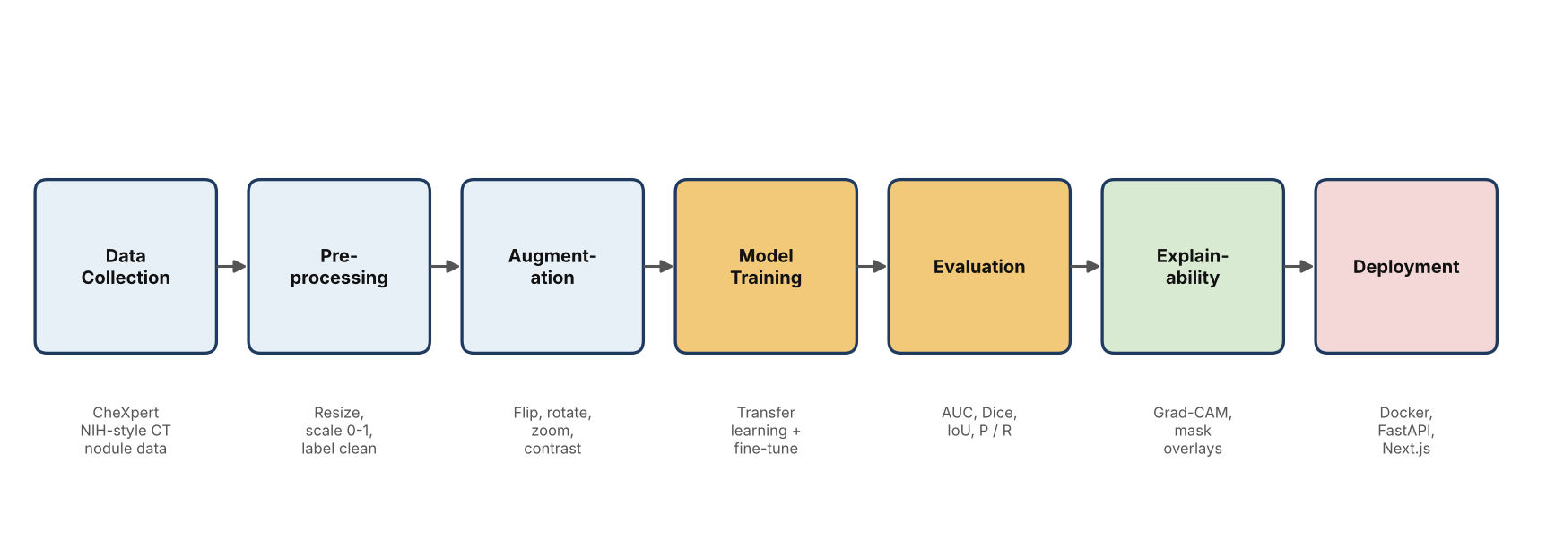
Figure 1.1: Overall methodology of the project from data to deployment

1.4 Objectives
The objectives of the project are as follows.
- To design and train a multi-label deep-learning classifier that detects fourteen chest findings from frontal chest X-ray images using transfer learning with DenseNet121.
- To design and train a U-Net segmentation model that localises lung nodules in CT images at pixel level.
- To provide visual explanations of the classifier’s decisions using Grad-CAM so that clinicians can verify that the model attends to clinically plausible regions.
- To build a secure, role-based web application for patient management, image upload, result display, report generation and scan history.
- To separate model inference from the web application by exposing each model through its own REST service, enabling independent scaling and replacement of models.
- To evaluate the models with appropriate metrics (AUC, precision, recall, Dice coefficient and Intersection over Union) and to document the strengths and limitations of the system.

1.5 Scope of the Project
The system accepts PNG and JPEG images of up to 20 MB, covers the fourteen CheXpert observation labels, and provides a segmentation overlay for nodules. It is designed as a clinical decision-support tool: it ranks findings, explains them and drafts a report, but it never replaces the judgement of a radiologist or physician, and every generated report carries a disclaimer to that effect. The system does not interface with PACS or DICOM servers in its present form, does not perform volumetric 3-D CT analysis and has not undergone clinical validation or regulatory approval. These boundaries are discussed again in Chapter 8 and Chapter 9.

2. PROBLEM DEFINITION

2.1 Problem Statement
Given a frontal chest radiograph of a patient, the system must estimate, for each of fourteen clinically relevant observations, the probability that the observation is present, must indicate visually which part of the image supports the most confident finding, must outline suspected lung nodules, and must make these results available to the treating doctor through a secure interface that also stores the patient’s history and produces a shareable report.
Formally, let x denote an input image. The classifier learns a function f(x) = (p₁, …, p₁₄) in which every pᵢ ∈ [0, 1] is the probability of the i-th finding. Because the findings are not mutually exclusive, each output is modelled as an independent Bernoulli variable, and the output layer therefore uses sigmoid activations rather than a softmax. The segmentation model learns a function g(c) that maps a CT slice c to a binary mask of the same size in which every pixel is labelled as nodule or background.

2.2 Existing System
In the conventional workflow a technician acquires the radiograph, the image is displayed on a viewing workstation, and a radiologist inspects it, dictates or types a report and sends it to the referring doctor. Where no radiologist is on site, the referring doctor reads the film personally or waits for a remote reporting service. Patient demographics, previous scans and reports are normally kept in separate systems or in paper files, so the clinician must collect the context manually.
Existing computer-aided detection tools tend to fall into one of two categories. Commercial products are accurate but costly, closed and bound to specific scanner vendors. Research prototypes are open but usually consist of a notebook or a command-line script that outputs probabilities without any user interface, user management, image storage or report.

2.3 Limitations of the Existing System
- Dependence on expert availability. Reporting turnaround is limited by the number of radiologists, and urgent findings such as pneumothorax can wait in a queue.
- Inter-observer variability and fatigue. Subtle opacities, small nodules and early effusions are missed or reported inconsistently between readers.
- No explanation for automated output. Many automated tools return a label or a score without showing the evidence, which makes clinicians reluctant to trust them.
- Single-task models. A classifier that only reports probabilities cannot outline a nodule, and a segmentation model cannot summarise the full set of thoracic findings.
- Fragmented records. Images, results, notes and reports are scattered, so longitudinal review of a patient is slow.
- Cost and lock-in. Proprietary solutions are expensive and difficult to adapt to the needs of a small hospital or to an academic setting.

2.4 Proposed System
The proposed system addresses these limitations by integrating three components in a single workflow. A DenseNet121 classifier provides a ranked list of fourteen findings with confidence scores. A Grad-CAM module draws a heatmap over the original image to show the evidence behind the top finding. A U-Net segmentation service highlights nodule regions and reports their relative area. A web application manages the doctors, the patients and the scans and produces a PDF report that combines the image, the heatmap, the mask, the probabilities, severity grades and follow-up suggestions.
Table 2.1: Comparison of the existing approach and the proposed system
Aspect | Existing approach | Proposed system
Reading of image | Manual, by one clinician | AI pre-read plus clinician confirmation
Findings covered | Depends on reader | 14 CheXpert labels + nodule segmentation
Explainability | None for automated tools | Grad-CAM heatmap and mask overlay
Records | Scattered files | Central patient and scan history
Report | Typed or dictated | Auto-drafted PDF with disclaimer
Deployment | Vendor-locked | Open, containerised microservices

2.5 Objectives of the Proposed System
The proposed system aims to shorten the time to a first preliminary interpretation, to draw the clinician’s attention to findings that deserve closer inspection, to make the reasoning of the model inspectable, and to keep every study and report in one searchable place. It is intended to support, not replace, the human reader, and its design reflects this: thresholds are configurable by the hospital, severity labels are advisory, and the report states clearly that confirmation by a qualified radiologist is required.

3. REQUIREMENT ANALYSIS

3.1 Literature Survey
Automated interpretation of chest radiographs has a long history, but progress accelerated after large labelled data sets became public. This section summarises the work that most directly influenced the design choices of the present project.

3.1.1 Chest X-ray datasets
Wang et al. released ChestX-ray14 with more than 100,000 frontal radiographs labelled for fourteen thoracic diseases by text-mining radiology reports. Irvin et al. introduced CheXpert, a data set of 224,316 radiographs from 65,240 patients in which each of fourteen observations is labelled as positive, negative or uncertain by an automated report labeller. The uncertainty labels are an important feature of CheXpert, and the authors compared several policies for handling them, such as treating them as zeros, ones or as a third class. Johnson et al. later published MIMIC-CXR with more than 370,000 images linked to free-text reports.

3.1.2 Deep networks for chest X-ray classification
Rajpurkar et al. trained CheXNet, a 121-layer DenseNet, on ChestX-ray14 and reported pneumonia detection that exceeded the average performance of a group of radiologists on the F1 metric. The result popularised DenseNet121 as the default backbone for chest radiography. Huang et al. had proposed DenseNet in 2017; every layer receives the feature maps of all preceding layers inside a dense block, which strengthens gradient flow, encourages feature reuse and keeps the parameter count low at roughly eight million for the 121-layer variant. These properties make DenseNet121 attractive for medical images where labelled data are limited.

3.1.3 Class imbalance and loss functions
Chest X-ray labels are heavily imbalanced: “No Finding”, “Lung Opacity” and “Support Devices” are frequent, while “Pneumothorax”, “Pleural Other” and “Lung Lesion” are comparatively rare. With ordinary binary cross-entropy a network can reduce its loss by predicting “absent” for rare labels. Lin et al. proposed focal loss, which multiplies the cross-entropy term by (1 − pₜ)^γ so that easy examples contribute little and the optimiser concentrates on hard, often rare, positives. The present project adopts a class-balanced focal loss for this reason.

3.1.4 Medical image segmentation
Ronneberger et al. introduced U-Net, a fully convolutional network with a contracting path that captures context and a symmetric expanding path that restores resolution, with skip connections that carry fine spatial detail from encoder to decoder. U-Net was designed for small biomedical data sets and remains the reference architecture for lesion segmentation. For the severe foreground-background imbalance typical of nodules, whose masks cover on average only about 1.5 percent of the image in the data used here, overlap-based losses such as the Dice loss, often combined with cross-entropy, are standard.

3.1.5 Explainable AI
Selvaraju et al. proposed Gradient-weighted Class Activation Mapping (Grad-CAM), which uses the gradients of a target class score with respect to the last convolutional feature maps to weight those maps and produce a coarse localisation heatmap. Because it requires no change to the architecture and no retraining, Grad-CAM has become the most widely used explanation method in medical imaging.
Table 3.1: Summary of the literature that informed the project
Work | Contribution | Relevance to this project
CheXpert (Irvin et al., 2019) | 224k radiographs, 14 labels, uncertainty labels | Training and validation data for the classifier
DenseNet (Huang et al., 2017) | Densely connected convolutional network | Backbone of the classifier
CheXNet (Rajpurkar et al., 2017) | DenseNet121 for pneumonia detection | Evidence for DenseNet121 in chest radiography
Focal loss (Lin et al., 2017) | Down-weights easy examples | Handles label imbalance
U-Net (Ronneberger et al., 2015) | Encoder-decoder with skip connections | Nodule segmentation model
Grad-CAM (Selvaraju et al., 2017) | Gradient-based class localisation | Explainability module

3.2 Datasets Used

3.2.1 CheXpert Small (classification)
The classifier was trained on the “CheXpert Small” version of the Stanford CheXpert data set, obtained through the Kaggle mirror ashery/chexpert. The small version contains JPEG images that have been down-sampled to roughly 320 pixels on the shorter side, which reduces storage and reading time considerably. The data consist of a training folder with train.csv and a validation folder with valid.csv. Every row has the image path, the patient’s sex and age, the view (frontal or lateral) and AP/PA orientation, and fourteen observation columns that hold 1.0 for positive, 0.0 for negative, −1.0 for uncertain and a blank for “not mentioned”.
Table 3.2: The fourteen CheXpert observation labels used by the classifier
# | Label | # | Label
1 | No Finding | 8 | Pneumonia
2 | Enlarged Cardiomediastinum | 9 | Atelectasis
3 | Cardiomegaly | 10 | Pneumothorax
4 | Lung Opacity | 11 | Pleural Effusion
5 | Lung Lesion | 12 | Pleural Other
6 | Edema | 13 | Fracture
7 | Consolidation | 14 | Support Devices

After removing lateral views, 191,027 frontal images remained in the training set. Blank and uncertain labels were both mapped to zero, a policy often called “U-Zeros”. This is a simple and widely used choice; it treats an uncertain mention as absent and therefore biases the model towards conservative predictions, which is a limitation that is discussed in Chapter 8.

3.2.2 Lung Nodule Dataset (segmentation)
The segmentation model was trained on the Kaggle “Lung Nodule Dataset” (ucimachinelearning/lung-nodule-dataset). The segmentation part of the archive pairs 5,070 CT images, stored as 256 × 256 PNG files, with annotation masks of identical size and file name. All 5,070 pairs matched, and 5,068 of the masks contain at least one annotated pixel; two masks are empty. The mean annotated area is 1.54 percent of the image, the median is 0.75 percent and the largest nodule covers 28.07 percent, which confirms that the foreground is small and highly variable in size.
Table 3.3: Summary of the two datasets
Property | CheXpert Small | Lung Nodule Dataset
Task | Multi-label classification | Binary segmentation
Modality | Frontal chest X-ray | CT slice
Samples used | 191,027 training images (frontal) | 5,070 image-mask pairs
Input size | 224 × 224 × 3 | 256 × 256 × 1
Target | 14 sigmoid probabilities | 256 × 256 binary mask
Split | Official train / validation | 80 / 10 / 10 (4,056 / 507 / 507)
Source | Kaggle: ashery/chexpert | Kaggle: ucimachinelearning/lung-nodule-dataset

3.3 Functional Requirements
The functional requirements of the application were derived from the roles of the two kinds of users, the administrator and the doctor.
Table 3.4: Functional requirements
ID | Requirement | Role
FR1 | Register, log in, log out and reset a forgotten password | All
FR2 | Create, search, view, update and delete patient records | Doctor, Admin
FR3 | Upload a PNG or JPEG chest image (maximum 20 MB) for a selected patient | Doctor
FR4 | Run DenseNet121 classification and display 14 probabilities with severity | Doctor
FR5 | Display the Grad-CAM heatmap over the original image | Doctor
FR6 | Run U-Net segmentation and display the nodule mask, area and confidence | Doctor
FR7 | Generate follow-up recommendations for findings above the threshold | Doctor
FR8 | Generate, download and print a PDF report | Doctor
FR9 | View the scan history of a patient | Doctor
FR10 | Ask a clinical AI assistant about a scan or about the application | Doctor
FR11 | Configure hospital name, AI threshold, signature, theme, notifications | Admin
FR12 | View dashboard statistics (patients, scans, activity) | Doctor, Admin

3.4 Non-Functional Requirements
- Performance. A prediction request that calls both models should return within the 60-second client timeout, and a typical inference on a CPU container should complete in a few seconds.
- Security. Passwords are stored only as bcrypt hashes; sessions use signed JWTs in HTTP-only cookies; every API route verifies the session; uploads are validated for type and size.
- Privacy. The AI assistant receives only the patient’s age, sex and model outputs. Name, phone number and address never leave the server.
- Reliability. Failures of an inference service are reported to the user with a clear message and do not corrupt stored data.
- Usability. The interface must be responsive, use clear colour-coded severity and display loading, empty and error states.
- Maintainability. Models are isolated behind REST interfaces so that a model can be replaced without touching the web application.
- Portability. The inference services run in Docker containers on any host with a container runtime.

3.5 Hardware Requirements
Table 3.5: Hardware used for training and recommended for deployment
Component | Training environment | Deployment (minimum)
GPU | 2 × NVIDIA RTX 4000 Ada, 20 GB each (DenseNet121); Tesla T4 15 GB (U-Net) | Optional; CPU inference is supported
CPU | 2 × Intel Xeon Silver 4410Y (48 threads) | 4 vCPU
RAM | 256 GB DDR5 | 8 GB (both TensorFlow services)
Storage | 1.9 TB (1.2 TB free) | 10 GB (images, models, containers)
Network | Local network with SSH access | Broadband / cloud network

3.6 Software Requirements
Table 3.6: Software stack
Layer | Technology
Operating system | Ubuntu 22.04 LTS (AI server), Windows 11 (development)
Language and runtime | Python 3.10, Node.js, TypeScript
Deep-learning framework | TensorFlow / Keras 2.20–2.21 with CUDA
Data and plotting | NumPy, pandas, scikit-learn, matplotlib, Pillow, OpenCV
Training environment | Jupyter notebooks, kagglehub, tmux, Google Colab (T4)
Inference services | FastAPI, Uvicorn, Docker, Docker Compose
Web frontend | Next.js 16 (App Router), React 19, Tailwind CSS, Framer Motion, Recharts
Forms and validation | React Hook Form, Zod
Backend | Next.js Route Handlers, Prisma ORM 5, jose (JWT), bcryptjs
Database and storage | PostgreSQL and object storage via Supabase
Reports | jsPDF
AI assistant | Groq API with the llama-3.3-70b-versatile model

3.7 Feasibility Study

3.7.1 Technical feasibility
All components rely on mature, open-source technology. Transfer learning with ImageNet weights makes it possible to train a competitive classifier with the available GPU server, the tf.data API streams the 191,027 training images without loading them into memory, and Docker packages the models for deployment on commodity hardware. The project is therefore technically feasible.

3.7.2 Economic feasibility
All frameworks and datasets are free to use for research. The only recurring costs are hosting for the web application, database and inference services, and the Groq API usage of the assistant, all of which have free or low-cost tiers suitable for a prototype. Compared with proprietary computer-aided detection products, the cost is very low.

3.7.3 Operational feasibility
The interface follows the workflow that clinicians already know: select a patient, upload an image, inspect results, print a report. No training in machine learning is needed. Because the output is advisory and visually explained, it fits into existing practice without changing responsibility for the diagnosis.

3.7.4 Legal and ethical considerations
Medical software that influences diagnosis is regulated in most countries. The system is presented as a research prototype for decision support and is not a certified medical device. Both public datasets are de-identified. A deployment with real patient data would require compliance with applicable data-protection law, ethics approval and clinical validation.

4. SYSTEM DESIGN

4.1 Design Overview
The design follows a service-oriented architecture with a strict separation of concerns. The web application is responsible for everything that concerns users and records: authentication, patient management, storage, orchestration, report generation and the assistant. Each neural network lives in its own stateless inference service whose only responsibility is to accept an image and return a structured JSON response. The services never touch the database, never authenticate users and never generate reports. This design makes it possible to retrain or replace a model, to scale the services independently of the web application and to run them on GPU hosts without moving the rest of the system.

4.2 System Architecture
Figure 4.1 shows the overall architecture. The browser communicates only with the Next.js server. The server’s API route handlers verify the JWT cookie, validate the request with Zod, call the DenseNet121 and U-Net services in parallel, upload the resulting images to object storage, persist the scan through Prisma, and return a single JSON response to the interface. A third external dependency, the Groq language-model API, is called only by the assistant route.
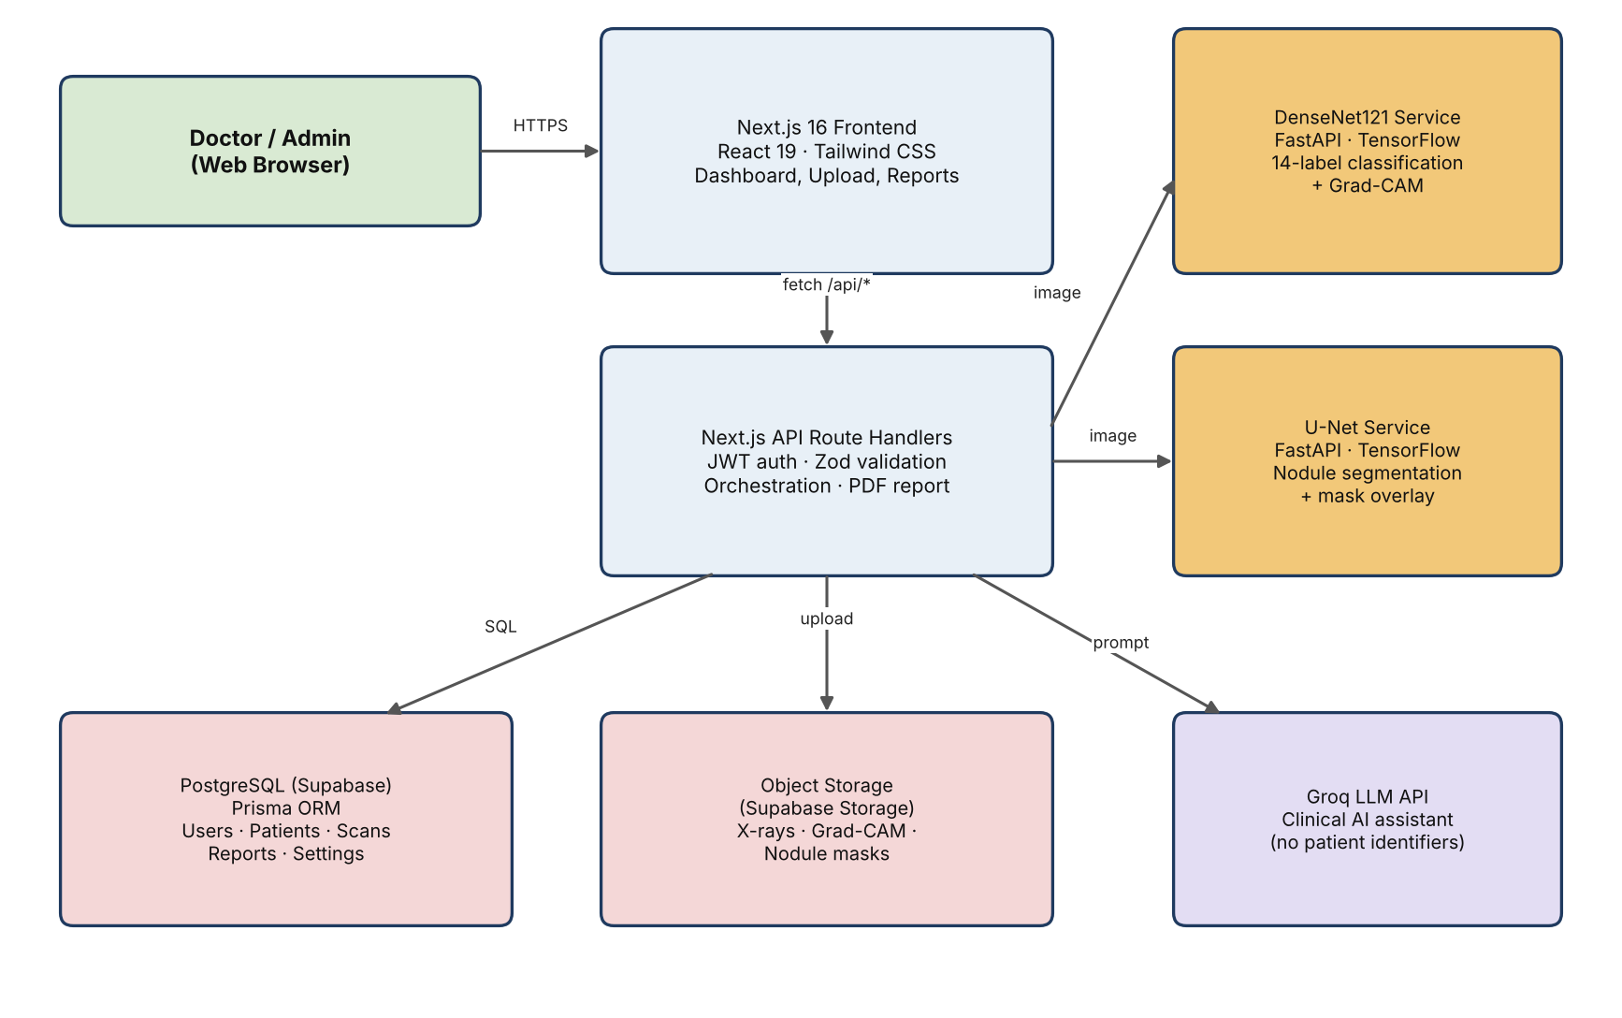
Figure 4.1: Overall system architecture
The architecture has four tiers. The presentation tier is the React interface rendered by Next.js. The application tier is the set of Route Handlers. The intelligence tier consists of the two FastAPI inference services. The data tier consists of PostgreSQL and object storage.

4.3 Use Case Diagram
Two actors use the system. A doctor registers and logs in, manages patients, uploads images, runs predictions, inspects the heatmap and mask, generates reports and consults the assistant. An administrator has the same access to patient data and in addition manages doctors, system settings such as the AI threshold and hospital details, and dashboard analytics.
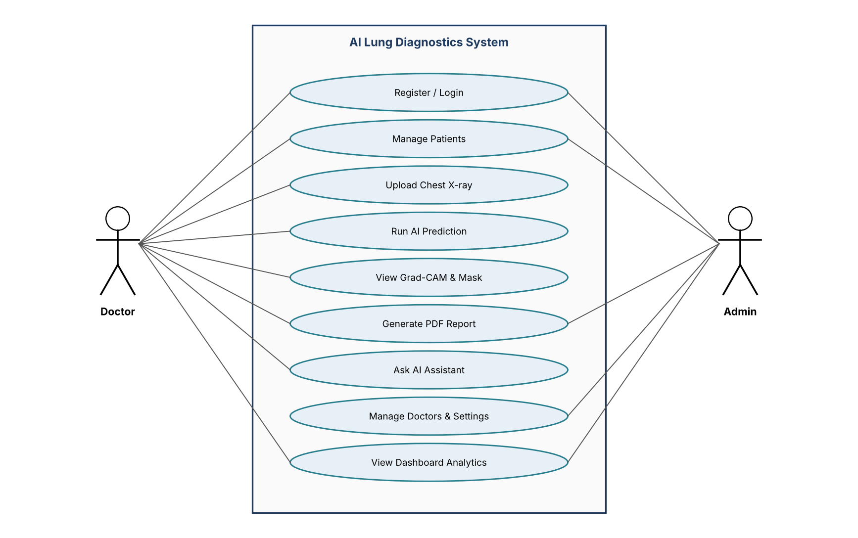
Figure 4.2: Use case diagram of the AI Lung Diagnostics system

4.4 Data Flow Diagrams

4.4.1 Level 0 (context diagram)
The context diagram treats the whole system as one process. The user supplies credentials, patient data and X-ray images and receives predictions and reports. The system exchanges images and probabilities with the AI inference services and records and files with the database and storage.
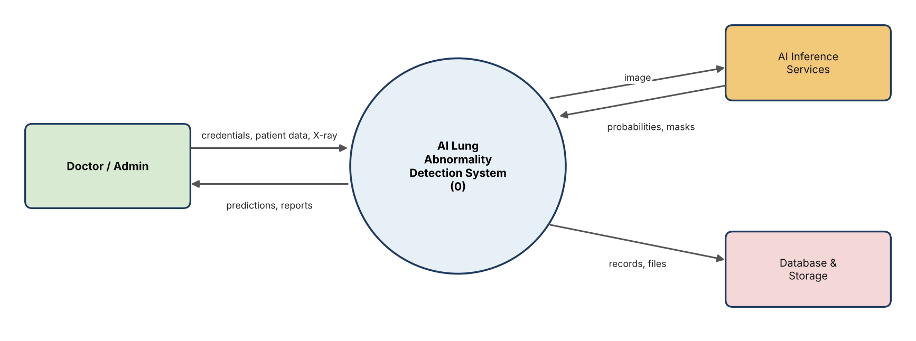
Figure 4.3: Level 0 data flow diagram (context diagram)

4.4.2 Level 1
At level 1 the system is divided into six processes: authentication (1.0), patient management (2.0), upload and validation (3.0), AI inference (4.0), report generation (5.0) and the AI assistant (6.0). Users are stored in data store D1, patients and scans in D2 and reports in D3.
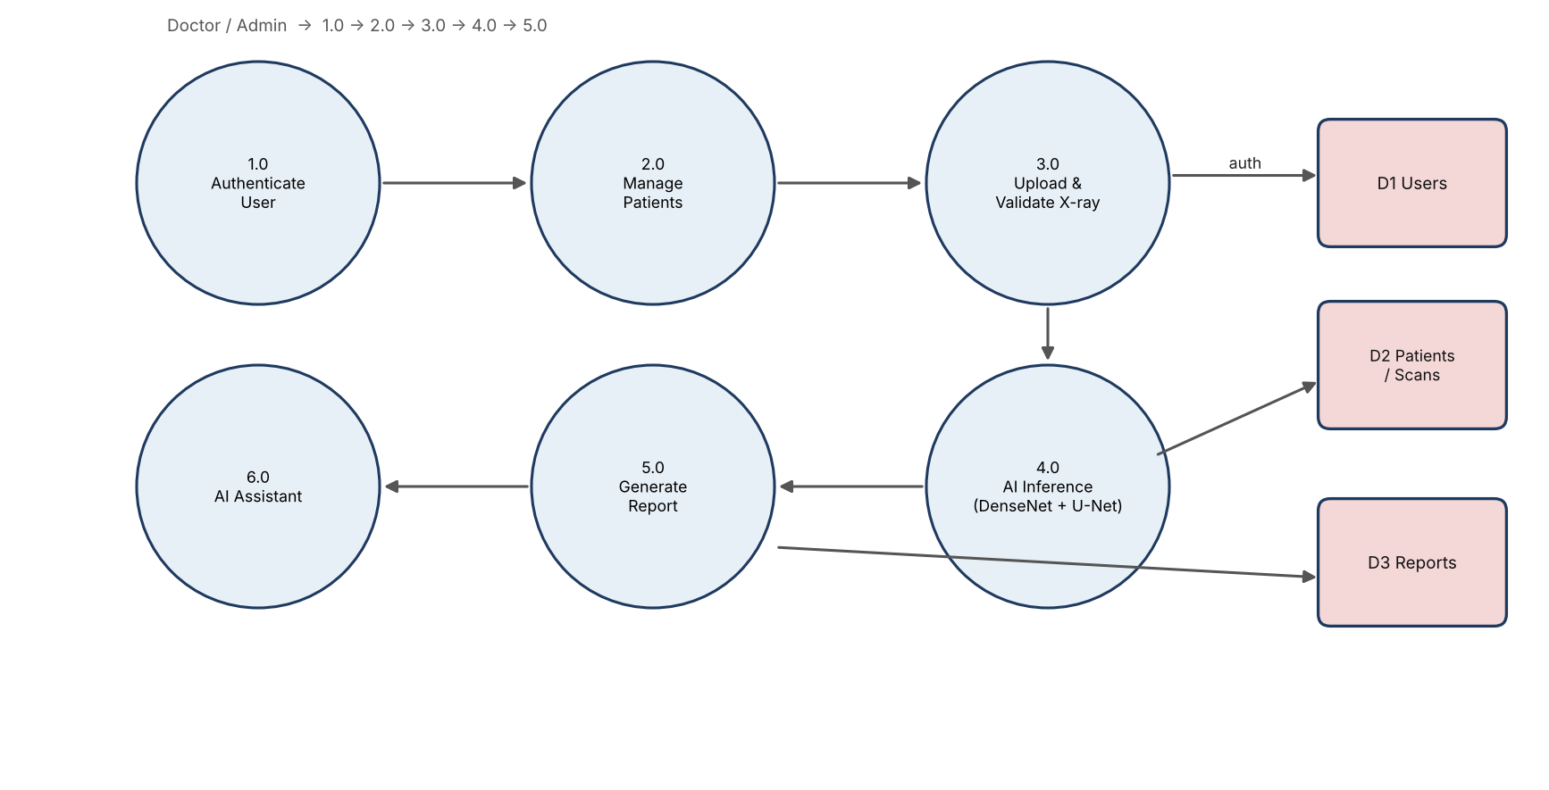
Figure 4.4: Level 1 data flow diagram

4.5 Workflow and Sequence Diagrams
Figure 4.5 shows the flowchart of a typical session. The upload step contains the only validation branch that is visible to the user: files that are not PNG or JPEG, or that exceed 20 MB, are rejected with an error message and no model is called.
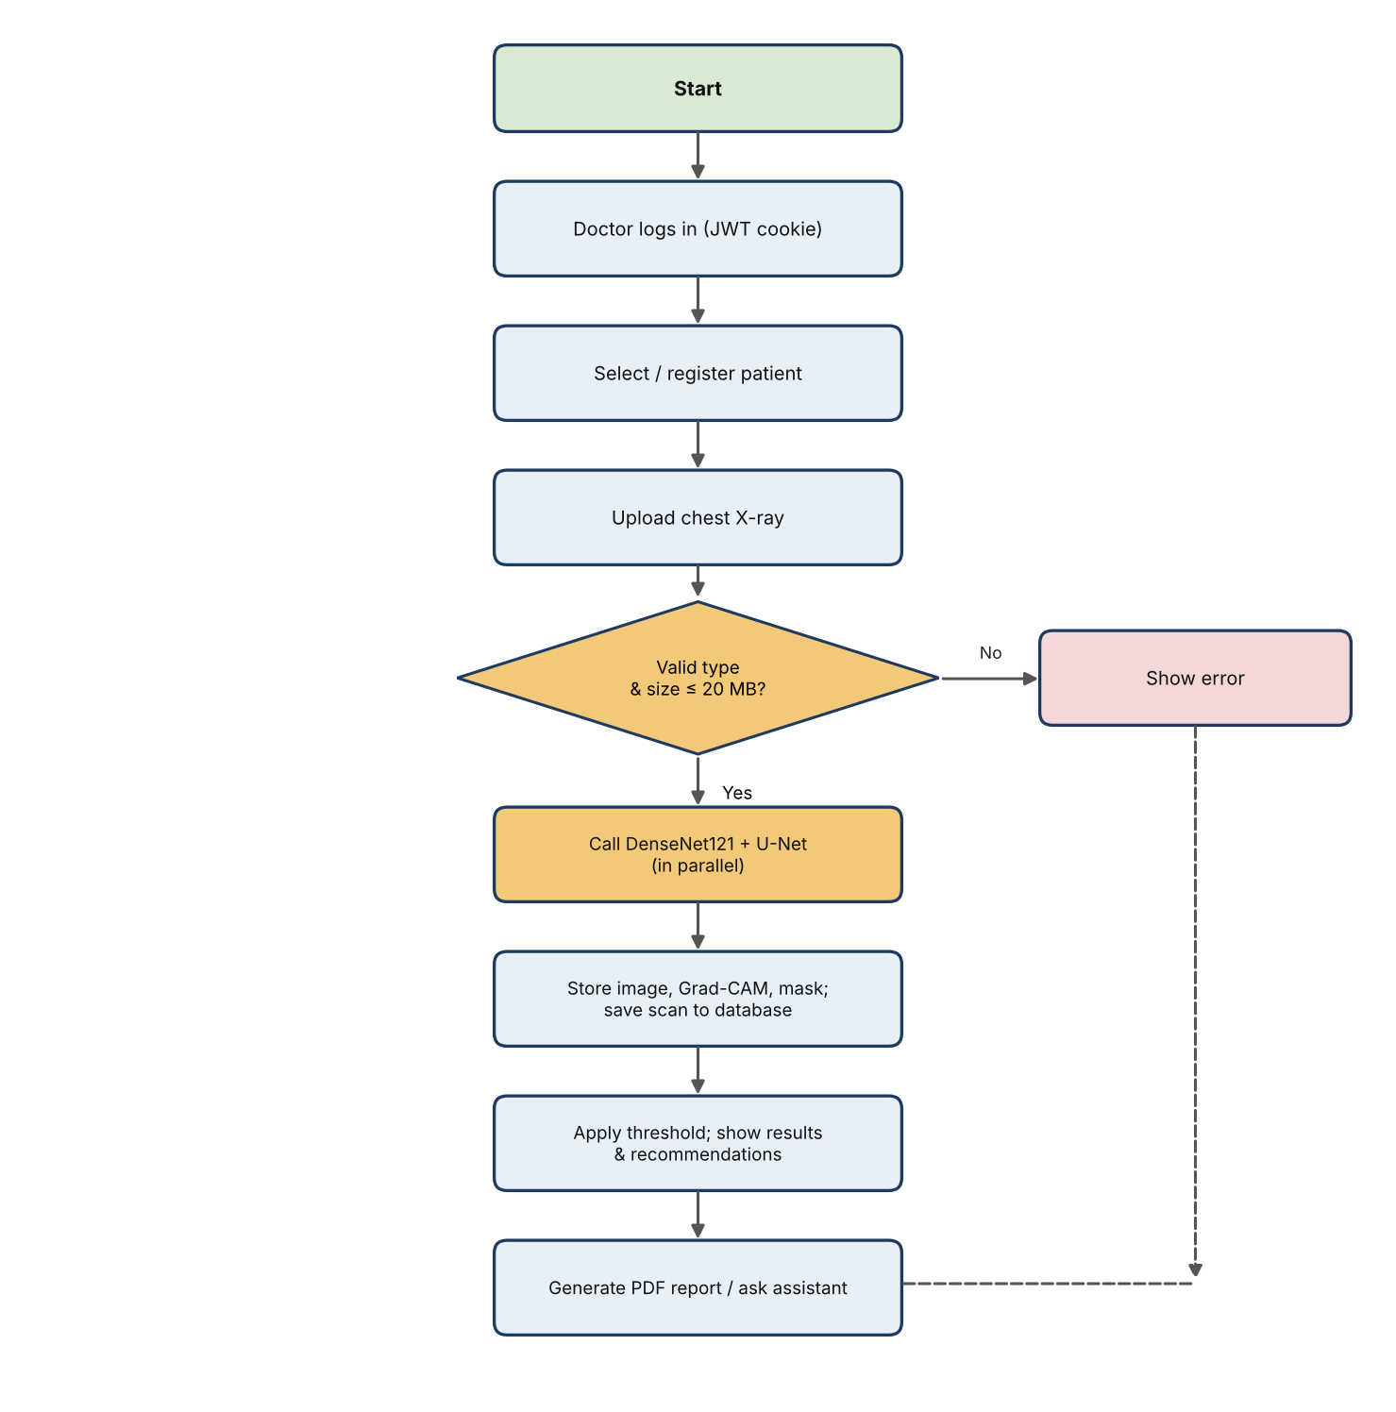
Figure 4.5: Flowchart of the prediction workflow
The sequence diagram in Figure 4.6 shows the interaction between components during a prediction. The two inference calls are issued concurrently with Promise.all, so the total latency is roughly the slower of the two rather than their sum.
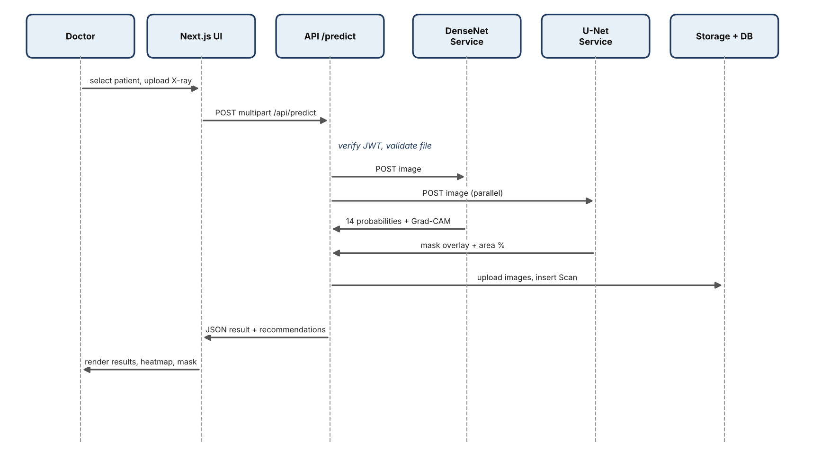
Figure 4.6: Sequence diagram of the prediction request

4.6 Database Design

4.6.1 Entity-relationship diagram
The relational schema has five entities. A User (administrator or doctor) performs many scans and creates many reports. A Patient has many scans. Each Scan belongs to one patient and one doctor and may produce many reports. A single Settings row holds hospital-wide configuration.
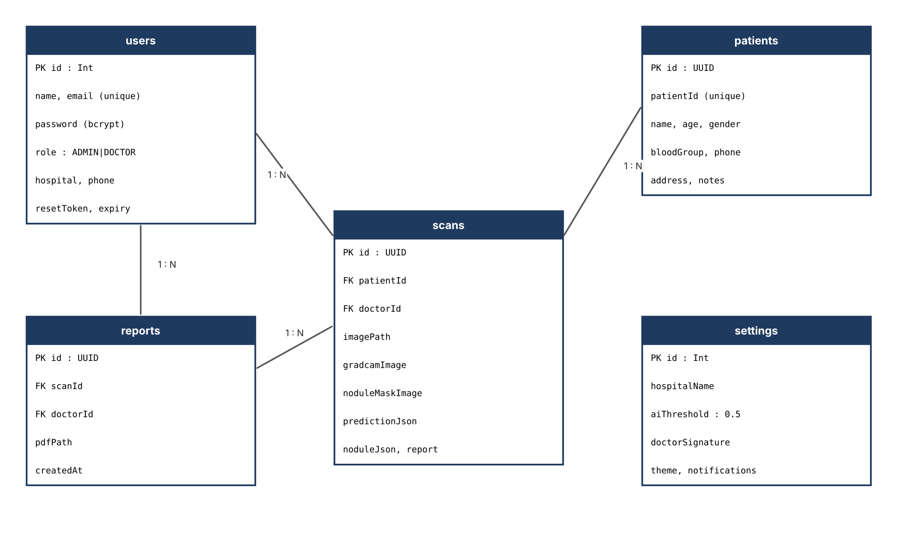
Figure 4.7: Entity-relationship diagram

4.6.2 Table descriptions
Table 4.1: Database tables
Table | Key columns | Description
users | id, name, email (unique), password, role, hospital, phone, resetToken, resetTokenExpiresAt | Accounts with bcrypt-hashed password and role ADMIN or DOCTOR
patients | id (UUID), patientId (unique), name, age, gender, bloodGroup, phone, address, notes | Demographic and clinical-note data for each patient
scans | id, patientId, doctorId, imagePath, gradcamImage, noduleMaskImage, predictionJson, noduleJson, report | One AI analysis of one uploaded image, with paths of derived images and JSON of model output
reports | id, scanId, doctorId, pdfPath, createdAt | Generated PDF reports linked to a scan
settings | id, hospitalName, hospitalAddress, aiThreshold, doctorSignature, theme, notifications | Global configuration; aiThreshold defaults to 0.5

Deleting a patient cascades to the patient’s scans, and deleting a scan cascades to its reports, so that no orphan records remain. The two connection strings in the Prisma datasource reflect a practical detail of the hosted database: the pooled connection (PgBouncer, transaction mode) is used at run time, whereas migrations use a direct session-mode connection.

4.7 Design of the Classification Model
The classifier is a DenseNet121 feature extractor initialised with ImageNet weights, followed by a custom head. The head consists of global average pooling, batch normalisation, a 512-unit ReLU layer with 40 percent dropout, a 256-unit ReLU layer with 30 percent dropout and a final 14-unit layer with sigmoid activation. The output layer is forced to float32 so that the sigmoid is computed with full precision when mixed-precision training is active.
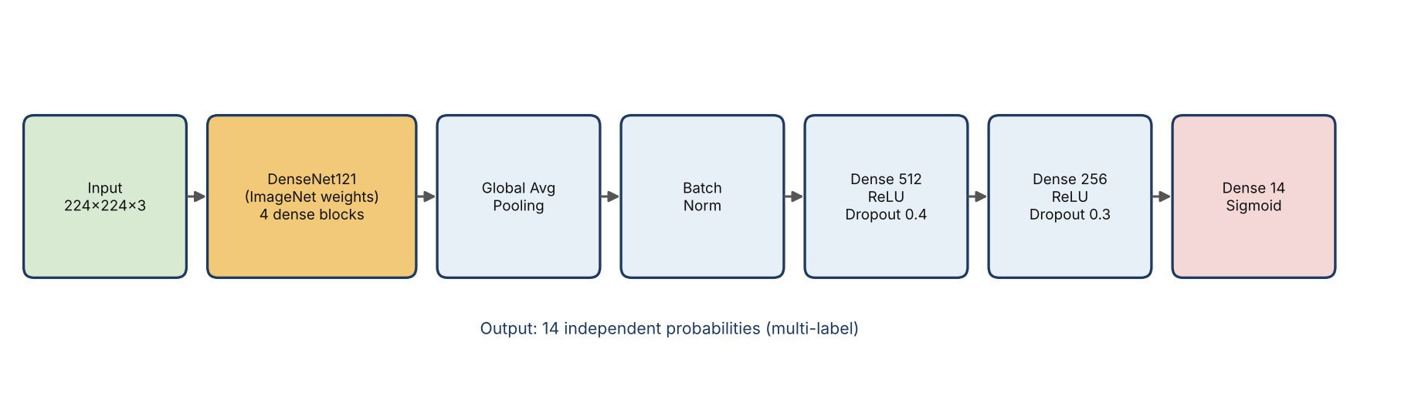
Figure 4.8: Architecture of the DenseNet121 classifier
DenseNet121 contains four dense blocks separated by transition layers. Inside a block every convolutional layer receives the concatenated feature maps of all earlier layers of the block. For a 224 × 224 input the last convolutional layer (named conv5_block16_concat in Keras) produces a 7 × 7 × 1024 feature map, which is both the input to global pooling and the layer used by Grad-CAM.
Table 4.2: Design choices of the classifier
Design choice | Value | Reason
Backbone | DenseNet121, ImageNet weights | Strong transfer-learning baseline for chest radiographs
Input | 224 × 224 × 3, scaled to [0, 1] | Native resolution of the backbone
Output | 14 sigmoid units | Independent multi-label probabilities
Loss | Binary focal cross-entropy, α = 0.25, γ = 2, class balancing | Mitigates label imbalance
Optimiser | Adam with gradient clipping (clipnorm = 1.0) | Stability and protection from exploding gradients
Training | Two stages: frozen backbone, then fine-tuning | Avoids destroying pre-trained features early
Regularisation | Dropout 0.4 / 0.3, batch normalisation, augmentation | Reduce over-fitting

4.8 Design of the Segmentation Model
The segmentation network is a classical U-Net built from Keras layers. Each encoder stage applies two 3 × 3 convolutions with batch normalisation and ReLU, followed by 2 × 2 max-pooling. The filter counts are 32, 64, 128 and 256, and a bottleneck with 512 filters connects the encoder and the decoder. Each decoder stage up-samples with a 2 × 2 transposed convolution, concatenates the matching encoder feature map through a skip connection and applies two convolutions. A final 1 × 1 convolution with sigmoid activation produces the mask. The model has 7,771,297 parameters (about 29.65 MB), of which 7,765,409 are trainable.
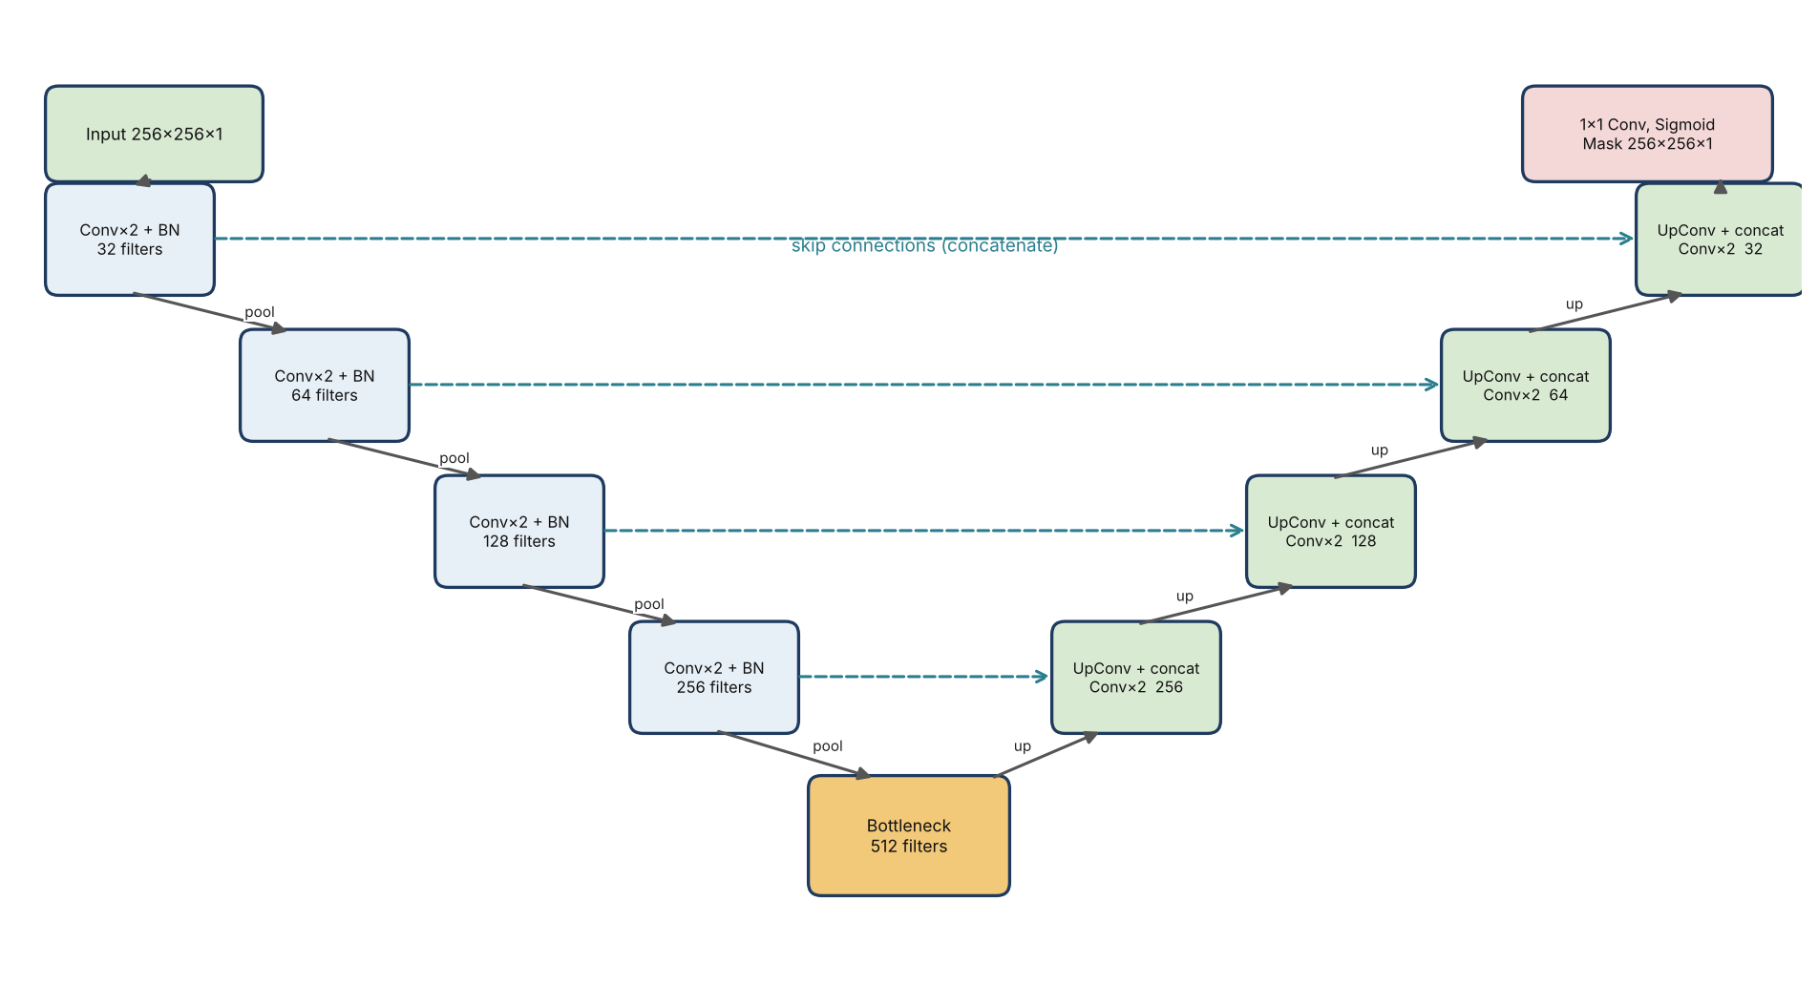
Figure 4.9: Architecture of the U-Net used for nodule segmentation
The loss is the sum of binary cross-entropy and the Dice loss. Cross-entropy gives stable gradients at the pixel level, while the Dice term directly optimises overlap and counters the imbalance between the small nodule region and the large background.
Dice = (2 * |A ∩ B| + ε) / (|A| + |B| + ε)
IoU = (|A ∩ B| + ε) / (|A ∪ B| + ε)
Loss = BCE(y, ŷ) + (1 − Dice(y, ŷ))
Segmentation metrics and loss (ε = 10⁻⁶ for numerical stability)

4.9 Explainability Design
Grad-CAM is implemented for the nested DenseNet121 backbone. Because the saved model wraps the backbone as a sub-model, the last convolutional layer cannot be fetched directly from the outer model. The design therefore builds two models: one from the backbone input to the last convolutional layer, and one that replays the remaining head layers on top of that feature map. Both are executed inside one gradient tape so that the gradient of the selected class score with respect to the feature maps can be computed. The pooled gradients weight the feature maps, which are summed, passed through ReLU, normalised and resized to the original image size. The heatmap is returned as a transparent RGBA PNG so that the browser can overlay it on the original X-ray and let the user control its opacity.
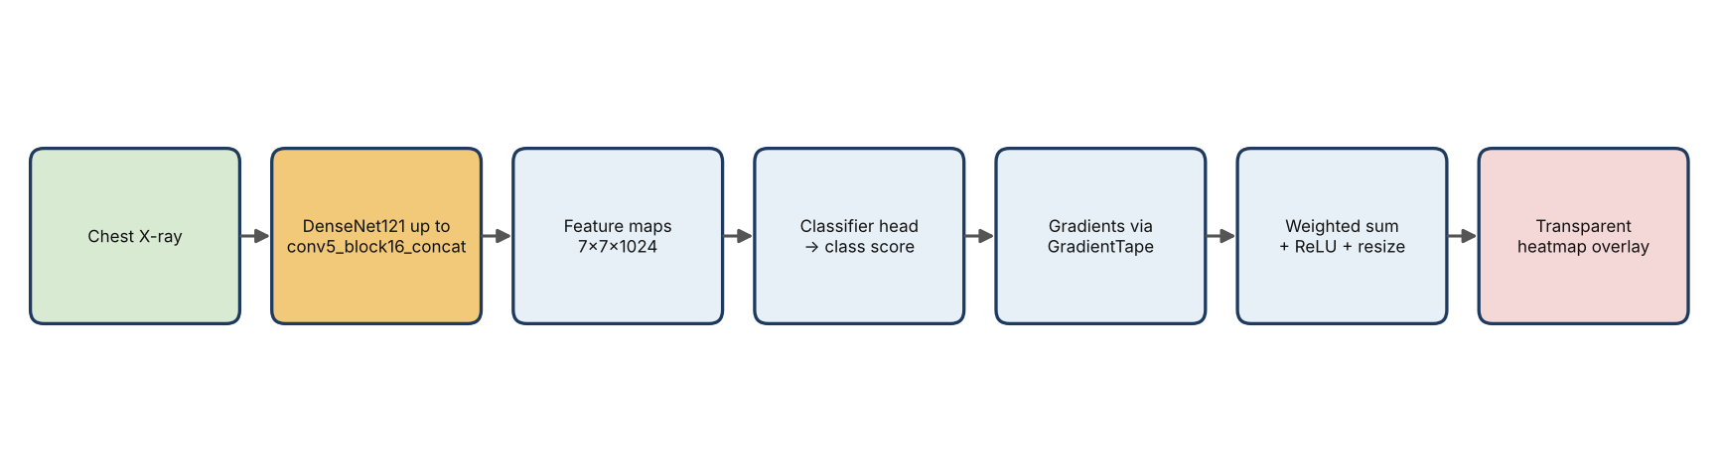
Figure 4.10: Grad-CAM computation pipeline

4.10 API Design
Table 4.3: API endpoints
Endpoint | Method | Purpose
/api/auth/register, /login, /logout, /me | POST / GET | Account creation, authentication, session lookup
/api/auth/forgot-password, /reset-password | POST | Password reset with expiring token
/api/patients, /api/patients/[id] | GET, POST, PUT, DELETE | Patient CRUD with search and pagination
/api/predict | POST (multipart) | Validate image, run both models, store scan
/api/scans/[id] | GET, PATCH | Retrieve or update a scan and its report text
/api/reports, /api/reports/[id] | GET, POST, DELETE | List, create and remove PDF reports
/api/dashboard | GET | Aggregate statistics
/api/settings | GET, PUT | Hospital settings and AI threshold
/api/assistant | POST | Clinical AI assistant (Groq)
DenseNet service: POST /predict | POST (multipart) | Returns predictions, Grad-CAM, inference time
U-Net service: POST /predict-nodule | POST (multipart) | Returns nodule flag, confidences, area %, mask overlay

The DenseNet service responds with a JSON object of the form {predictions: [{disease, confidence}, …], gradcam: <base64 PNG>, inference_time: <seconds>}. The U-Net service responds with {nodule_detected, max_confidence, mean_confidence, nodule_area_percentage, nodule_mask_overlay, inference_time}.

4.11 Security Design
- Authentication. Passwords are hashed with bcrypt. On login the server issues a JWT (HS256, 24-hour expiry) containing id, email, name and role, and stores it in an HTTP-only cookie so that client-side scripts cannot read it.
- Route protection. A proxy (middleware) redirects unauthenticated visitors from /dashboard routes to /login and redirects authenticated users away from the login and registration pages. Every API handler additionally verifies the cookie itself.
- Input validation. Zod schemas validate JSON bodies; file type and size are checked before any model is invoked.
- Data minimisation. The assistant receives only age and sex of the patient, never the name, phone number or address.
- Service isolation. CORS on the inference services can be restricted to the origin of the web application through the ALLOWED_ORIGIN variable, and the containers run as a non-root user.

4.12 User Interface Design
The interface uses a sidebar and top navigation layout. Public pages are the landing page, login, registration and password reset. After login the doctor sees the following pages: the dashboard with statistic cards and recent activity; the patient list with search, filtering, sorting and pagination; the patient detail page with history and previous scans; the new-patient form; the prediction page with an upload card, image preview, probability bars, severity badges, the Grad-CAM viewer and the nodule overlay; the reports page for viewing, downloading and printing; the assistant page; and the settings page. Reusable components such as probability bars, severity badges, empty states and loading skeletons give a consistent appearance and clear feedback.
Table 4.4: Severity grading used in the interface
Probability range | Severity label | Meaning
< 0.30 | Normal | Finding unlikely
0.30 – 0.49 | Mild | Low likelihood, monitor
0.50 – 0.69 | Moderate | Likely present
≥ 0.70 | Severe | High likelihood, prioritise review

4.13 Deployment Design
The two inference services are packaged as separate Docker images and started together with Docker Compose. The DenseNet service listens on container port 7860, which is the port that a Hugging Face Space expects, and is mapped to host port 8000. The U-Net service listens on port 8001. Both containers restart automatically unless stopped. The Next.js application can be hosted on any Node platform, and it reads the service addresses from the environment variables HUGGINGFACE_SPACE_URL and UNET_SERVICE_URL. When these variables are not set in development, the application returns simulated predictions so that the interface can be exercised without a running model; in production the application refuses to start inference without them.
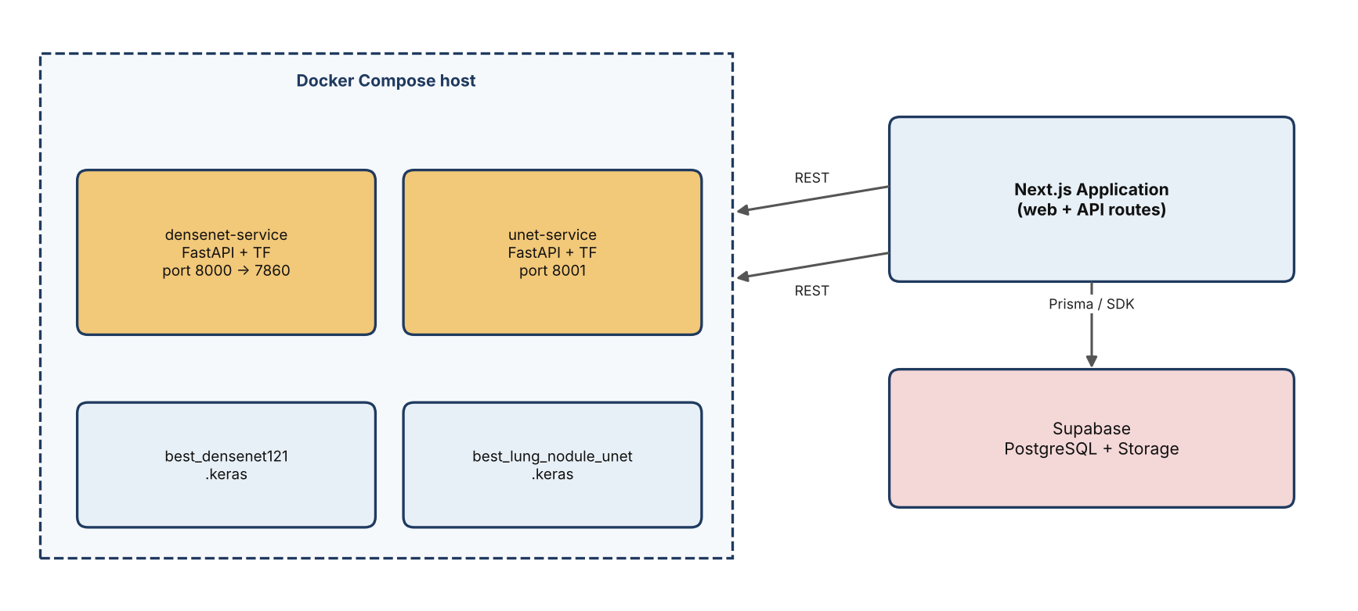
Figure 4.11: Deployment diagram

5. IMPLEMENTATION
The implementation has three parts: the training pipeline of the DenseNet121 classifier (Phases 1–8 of the project notebooks), the training pipeline of the U-Net, and the web application with its inference services. This chapter describes each part and quotes the key code.

5.1 Development Environment
Model development was carried out in Jupyter notebooks. The DenseNet121 experiments were run on a shared AI server (hostname MIPHI-AITPC) with two NVIDIA RTX 4000 Ada GPUs of 20 GB each, two Intel Xeon Silver 4410Y processors, 256 GB of RAM and Ubuntu 22.04. The server was reached over SSH using a dedicated key, and the notebooks were run inside an isolated Python virtual environment with TensorFlow 2.21 (installed with CUDA support), so that the packages of other users of the same account were not affected. Long runs were kept alive with tmux. The U-Net was trained on a single Tesla T4 GPU in Google Colab with TensorFlow 2.20. Source code of the phases was written as markdown specifications with embedded Python cells, and the master notebook was generated from them, which kept the documentation and the executable notebook consistent.
Table 5.1: Phases of the DenseNet121 notebook
Phase | Notebook content | Output
1 | Environment, dataset download, label cleaning, frontal filter | Clean data frames with absolute image paths
2 | tf.data pipeline, augmentation, batching, prefetching | train_ds and valid_ds
3 | DenseNet121 + custom head, compile with focal loss | Frozen-backbone model
4 | Two-stage training and fine-tuning with callbacks | best_densenet121.keras, training log
5 | ROC/AUC, classification report, confusion matrices, optimal thresholds | Summary CSV, optimal_thresholds.json
6 | Grad-CAM heatmaps | Overlay images
7 | Single-image inference, severity, structured report | Prediction function and report dictionary
8 | Deployment code for Hugging Face / Gradio / FastAPI | labels.py, predict.py, app.py, requirements.txt

5.2 Data Preparation for the Classifier

5.2.1 Loading and cleaning the labels
The data set is downloaded through the kagglehub library, which returns the cache path of the download. An earlier version of the notebook hard-coded a path under /root/.cache; because the AI server session runs as a normal user, the path is now taken from the return value of kagglehub.dataset_download, which removed a class of path errors. The two CSV files are read with pandas, the fourteen label columns are defined in a fixed order that matches the model’s output layer, missing values are replaced by 0, and uncertain values (−1) are also replaced by 0.
LABELS = ["No Finding", "Enlarged Cardiomediastinum", "Cardiomegaly",
"Lung Opacity", "Lung Lesion", "Edema", "Consolidation",
"Pneumonia", "Atelectasis", "Pneumothorax", "Pleural Effusion",
"Pleural Other", "Fracture", "Support Devices"]

train_df[LABELS] = train_df[LABELS].fillna(0).replace(-1, 0)
valid_df[LABELS] = valid_df[LABELS].fillna(0).replace(-1, 0)

# keep frontal views only
train_df = train_df[train_df["Frontal/Lateral"] == "Frontal"].reset_index(drop=True)
valid_df = valid_df[valid_df["Frontal/Lateral"] == "Frontal"].reset_index(drop=True)
Listing 5.1: Label cleaning and frontal filter (Phase 1)
Only frontal views are retained because the deployed system receives a single frontal image, and because mixing views would force the network to learn two different appearances for every finding. After filtering, 191,027 training images remain. The Kaggle mirror stores images under train/ and valid/ rather than under CheXpert-v1.0-small/, so the prefix is removed from every path and the dataset root is prepended to obtain an absolute path, and the existence of a sample file is verified before the pipeline is built.

5.2.2 Input pipeline
The tf.data API was used to avoid loading the data set into memory. File paths and 14-element label vectors are sliced into a dataset; a map function reads the JPEG, decodes it with three channels (the greyscale radiograph is replicated so that it matches the three-channel ImageNet input), resizes it to 224 × 224 and divides it by 255. The training branch then applies augmentation, shuffles, batches by 32, repeats and prefetches. The validation branch is identical except that augmentation and repetition are omitted.
def load_image(path, labels):
image = tf.io.read_file(path)
image = tf.image.decode_jpeg(image, channels=3)
image = tf.image.resize(image, (IMG_SIZE, IMG_SIZE))
image = tf.cast(image, tf.float32) / 255.0
return image, labels

data_augmentation = tf.keras.Sequential([
tf.keras.layers.RandomFlip("horizontal"),
tf.keras.layers.RandomRotation(0.05),
tf.keras.layers.RandomZoom(0.10),
tf.keras.layers.RandomContrast(0.10),
])

train_ds = train_ds.map(load_image, num_parallel_calls=AUTOTUNE)
train_ds = train_ds.map(preprocess_train, num_parallel_calls=AUTOTUNE)
train_ds = train_ds.shuffle(buffer_size=5000, seed=SEED)
train_ds = train_ds.batch(BATCH_SIZE).repeat().prefetch(AUTOTUNE)
Listing 5.2: tf.data pipeline (Phase 2)
Augmentation consists of horizontal flipping, rotation of up to about 18 degrees (a factor of 0.05 of a full turn), zoom of up to 10 percent and contrast variation of up to 10 percent. These operations are mild on purpose: a chest radiograph has a fixed anatomical orientation, so large rotations or vertical flips would create unrealistic images.

5.2.3 Shuffle buffer correction
The first version of the pipeline shuffled with a buffer as large as the data set. Since the shuffle buffer stores preprocessed samples, this meant holding all 191,027 images at 224 × 224 × 3 float32 (about 0.57 MB each, roughly 110 GB) in memory; the kernel process was observed using 142 GB before it was terminated, and every buffer refill took 90 to 100 seconds. Reducing the buffer to 5,000 samples, a standard value for image pipelines of this size, gave practically the same randomisation at a small fraction of the memory and time and removed the most likely cause of unstable runs. This is a useful lesson: the shuffle buffer is a memory budget, not just a statistical parameter.

5.3 Model Construction and Compilation
The classifier is built with the Keras functional API. The DenseNet121 backbone is created without its top classification layer, loaded with ImageNet weights and frozen. Its output feeds the custom head described in Section 4.7. The backbone is called with training=False so that its batch-normalisation layers stay in inference mode even later, when the upper layers are unfrozen for fine-tuning.
base_model = DenseNet121(include_top=False, weights="imagenet",
input_shape=(224, 224, 3))
base_model.trainable = False

inputs = Input(shape=(224, 224, 3))
x = base_model(inputs, training=False)
x = GlobalAveragePooling2D()(x)
x = BatchNormalization()(x)
x = Dense(512, activation="relu")(x)
x = Dropout(0.4)(x)
x = Dense(256, activation="relu")(x)
x = Dropout(0.3)(x)
outputs = Dense(NUM_CLASSES, activation="sigmoid",
name="predictions", dtype="float32")(x)
model = Model(inputs, outputs, name="DenseNet121_CheXpert")
Listing 5.3: Classifier architecture (Phase 3)
Compilation uses the Adam optimiser with a learning rate of 10⁻⁴ and gradient clipping at a norm of 1.0. The clipping was added after a run produced NaN losses: once a single bad gradient corrupts the weights, the damage persists for the remainder of training, and clipping is a cheap and standard defence. The loss is Keras’ BinaryFocalCrossentropy with class balancing, α = 0.25 and γ = 2.0. The metrics are binary accuracy, AUC, precision and recall.
model.compile(
optimizer=Adam(learning_rate=LEARNING_RATE, clipnorm=1.0),
loss=tf.keras.losses.BinaryFocalCrossentropy(
apply_class_balancing=True, alpha=0.25, gamma=2.0),
metrics=[tf.keras.metrics.BinaryAccuracy(name="binary_accuracy"),
tf.keras.metrics.AUC(name="auc", multi_label=True),
tf.keras.metrics.Precision(name="precision"),
tf.keras.metrics.Recall(name="recall")])
Listing 5.4: Compilation with class-balanced focal loss (Phase 3)
The reason for the focal loss became clear in the first full training run. With plain cross-entropy and one global threshold of 0.5, ten of the fourteen labels had zero precision and recall, even though the per-label AUC values showed that the network had learned useful ranking information. The cause was class imbalance: for a label such as pneumonia, which is positive in only a few percent of the images, always predicting “absent” is a cheap way to reduce the loss. The class-balanced focal loss weights hard and rare positives more heavily during both training stages.

5.4 Training Procedure

5.4.1 Two-stage transfer learning
Training proceeds in two stages. In the first stage the backbone is frozen and only the head is trained for 10 epochs at a learning rate of 10⁻⁴, so that the randomly initialised head learns to use the pre-trained features without disturbing them. In the second stage the last 100 layers of the backbone are unfrozen, the model is recompiled with a ten times smaller learning rate of 10⁻⁵, and training continues from epoch 10 up to a total of 25 epochs. Recompiling is necessary for the change of trainable layers to take effect, and the same focal loss must be repeated in the second compile call; compiling with the string “binary_crossentropy” at this point would silently undo the imbalance handling.
Table 5.2: Training configuration
Setting | Stage 1 (head) | Stage 2 (fine-tune)
Trainable layers | Custom head only | Head + last 100 backbone layers
Learning rate | 1 × 10⁻⁴ | 1 × 10⁻⁵
Epochs | 10 | up to 15 more (total 25)
Batch size | 32 | 32
Optimiser | Adam, clipnorm 1.0 | Adam, clipnorm 1.0
Loss | Binary focal cross-entropy | Binary focal cross-entropy
Early stopping | val_auc, patience 5, restore best weights | same
LR reduction | val_loss, factor 0.2, patience 2, min 10⁻⁷ | same

5.4.2 Callbacks
Four callbacks supervise the training. EarlyStopping monitors validation AUC and restores the best weights after five epochs without improvement. ReduceLROnPlateau multiplies the learning rate by 0.2 after two epochs without improvement of the validation loss. ModelCheckpoint saves the model with the best validation AUC to best_densenet121.keras, which is the file used for deployment. CSVLogger writes one row per completed epoch to training_log.csv, which is also the most reliable way to check progress during a non-interactive run, because the progress bar of a headless notebook execution is not written to the log in real time.

5.4.3 Multi-GPU experiment
An attempt was made to use both GPUs with tf.distribute.MirroredStrategy. Three consecutive runs failed with distributed-iterator errors (an “Invalid incarnation id” error), NaN loss and impossible recall values above 1.0, which points to corrupted metric aggregation across replicas. The strategy was removed and training returned to a single GPU, with which the original run had completed cleanly. The shuffle buffer problem described earlier was a plausible contributor, so multi-GPU training remains a candidate for future work once the single-GPU pipeline is confirmed stable.

5.4.4 Mixed precision and performance flags
Mixed-precision computation (bfloat16 activations with float32 variables) and XLA compilation were enabled to speed up training on the Ada GPUs, and steps_per_execution was raised to reduce Python overhead. Because the final sigmoid layer should be evaluated with full precision, the output layer is explicitly kept in float32, as recommended in the Keras mixed-precision guide. The compile call must repeat these flags when the model is recompiled for fine-tuning.

5.5 Evaluation Procedure for the Classifier
Phase 5 evaluates the best checkpoint on the validation split. For each label the receiver operating characteristic (ROC) curve and the area under it (AUC) are computed with scikit-learn, and a summary table is exported as CSV. Because AUC does not depend on a threshold, it is the primary measure of the model’s ranking quality. For threshold-dependent measures the notebook prints a classification report, per-label confusion matrices and the subset accuracy.
Since a single threshold of 0.5 is poorly suited to labels with very different prevalence, the notebook also computes an optimal threshold per label. For each label the precision-recall curve of the validation predictions is evaluated, the F1 score is computed at every candidate threshold, and the threshold that maximises F1 is chosen. If a label has no positive example in the validation split, the default of 0.50 is used. The thresholds are saved to optimal_thresholds.json and are loaded by the Grad-CAM and inference phases.
for i, disease in enumerate(LABELS):
precision, recall, thresholds = precision_recall_curve(y_true[:, i], y_pred[:, i])
f1 = 2 * precision * recall / (precision + recall + 1e-8)
best_threshold = thresholds[np.argmax(f1[:-1])] # default 0.50 if no positives
optimal_thresholds[disease] = float(best_threshold)

json.dump(optimal_thresholds, open("saved_models/optimal_thresholds.json", "w"))
Listing 5.5: Per-label threshold selection (Phase 5, abridged)

5.6 Grad-CAM Implementation
The Grad-CAM module lives in the inference service. Its constructor locates the nested backbone, builds the two partial models and keeps them in memory, so that each request only needs one forward and backward pass. The function compute_heatmap evaluates the head inside a GradientTape, takes the gradient of the selected output with respect to the 7 × 7 × 1024 feature map, averages it over the spatial axes to obtain one weight per channel, forms the weighted sum of channels, applies ReLU and normalises to the range 0–1.
def build_gradcam_models(model):
backbone, idx = _find_backbone(model)
last_conv = backbone.get_layer("conv5_block16_concat")
conv_output_model = Model(backbone.input, last_conv.output)

classifier_input = tf.keras.Input(shape=last_conv.output.shape[1:])
x = classifier_input
for layer in model.layers[idx + 1:]:
x = layer(x)
return conv_output_model, Model(classifier_input, x)

def compute_heatmap(conv_model, clf_model, image_array, pred_index=None):
with tf.GradientTape() as tape:
conv_outputs = conv_model(image_array)
tape.watch(conv_outputs)
predictions = clf_model(conv_outputs)
if pred_index is None:
pred_index = int(tf.argmax(predictions[0]))
class_channel = predictions[:, pred_index]
grads = tape.gradient(class_channel, conv_outputs)
pooled = tf.reduce_mean(grads, axis=(0, 1, 2))
heatmap = tf.squeeze(conv_outputs[0] @ pooled[..., tf.newaxis])
return (tf.maximum(heatmap, 0) / (tf.reduce_max(heatmap) + 1e-8)).numpy()
Listing 5.6: Grad-CAM for the nested DenseNet121 model (gradcam.py, abridged)
The heatmap is then colourised with the JET colour map and resized to the size of the original image. The activation drives both colour and alpha channel, so low-activation regions are fully transparent and the PNG can be layered over the radiograph in the browser. An initial implementation failed because model.get_layer("conv5_block16_concat") does not exist on the outer model; the nested-model solution above removed the need for any change to the trained network.

5.7 Implementation of the U-Net

5.7.1 Data pipeline
The CT images and masks are matched by file name. A set intersection confirmed that all 5,070 file names exist in both directories. The data frame of paths is split randomly with a fixed seed into 80 percent training (4,056), 10 percent validation (507) and 10 percent test (507) samples. Images are decoded as one channel, resized to 256 × 256 with bilinear interpolation and scaled to [0, 1]. Masks are resized with nearest-neighbour interpolation, which prevents the creation of intermediate grey values, and every positive pixel is set to 1. The training pipeline shuffles, applies augmentation (random horizontal flip applied identically to the image and the mask, small brightness and contrast changes applied to the image only), batches by 16 and prefetches; loading 20 batches took 1.5 seconds.
def load_mask(mask_path):
mask = tf.io.read_file(mask_path)
mask = tf.image.decode_png(mask, channels=1)
mask = tf.image.resize(mask, [256, 256], method="nearest")
mask = tf.cast(mask, tf.float32)
return tf.cast(mask > 0, tf.float32) # any annotation pixel -> 1
Listing 5.7: Mask loading (U-Net notebook)
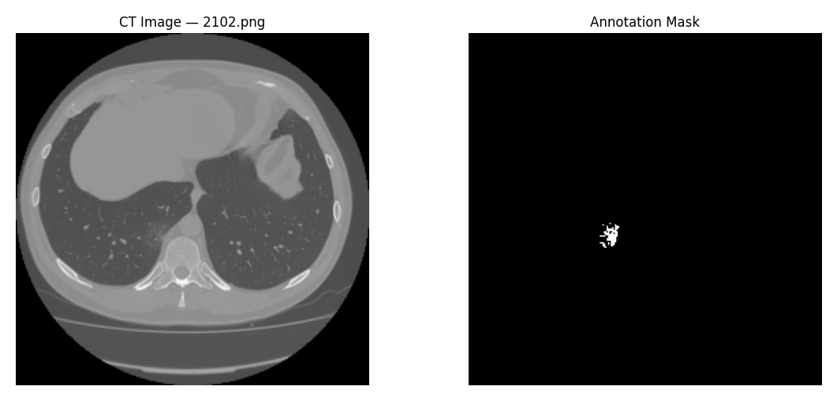
Figure 5.1: Sample CT slice and its annotation mask from the training data
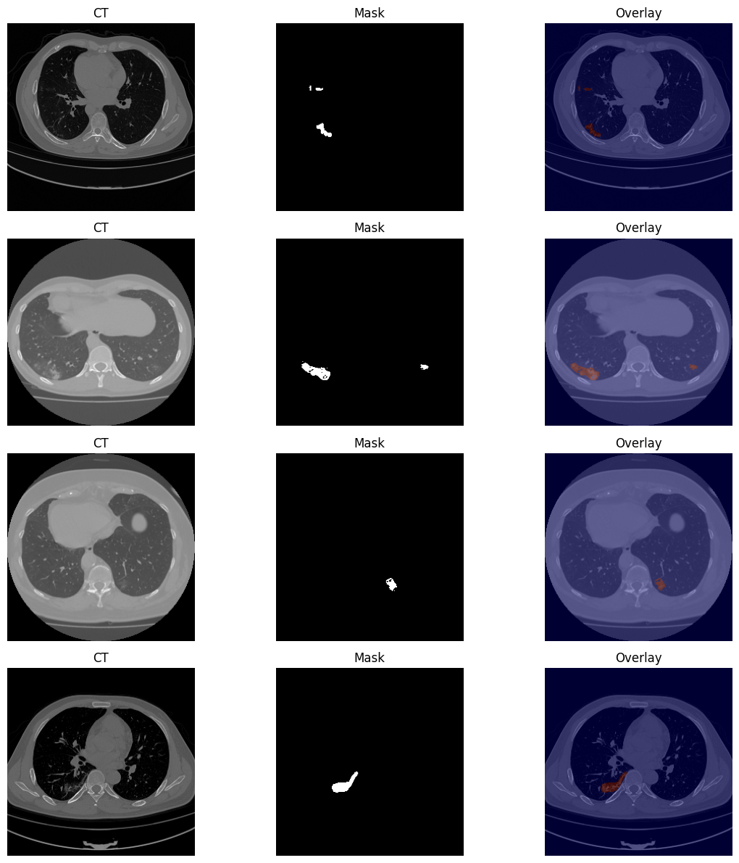
Figure 5.2: Augmented training batch showing CT, mask and overlay

5.7.2 Model, loss and metrics
def conv_block(inputs, filters):
x = layers.Conv2D(filters, 3, padding="same", kernel_initializer="he_normal")(inputs)
x = layers.BatchNormalization()(x); x = layers.Activation("relu")(x)
x = layers.Conv2D(filters, 3, padding="same", kernel_initializer="he_normal")(x)
x = layers.BatchNormalization()(x); return layers.Activation("relu")(x)

def decoder_block(inputs, skip_features, filters):
x = layers.Conv2DTranspose(filters, 2, strides=2, padding="same")(inputs)
x = layers.Concatenate()([x, skip_features])
return conv_block(x, filters)

def bce_dice_loss(y_true, y_pred):
return bce(y_true, y_pred) + dice_loss(y_true, y_pred)
Listing 5.8: U-Net building blocks and loss (abridged)
Before training, the untrained network was tested on one batch to verify the shapes: the output was 256 × 256 × 1 with values between 0.41 and 0.67, an initial loss of 1.676, a Dice coefficient of 0.043 and an IoU of 0.021, which are the values that are expected from random weights and confirm that the pipeline and loss are wired correctly.
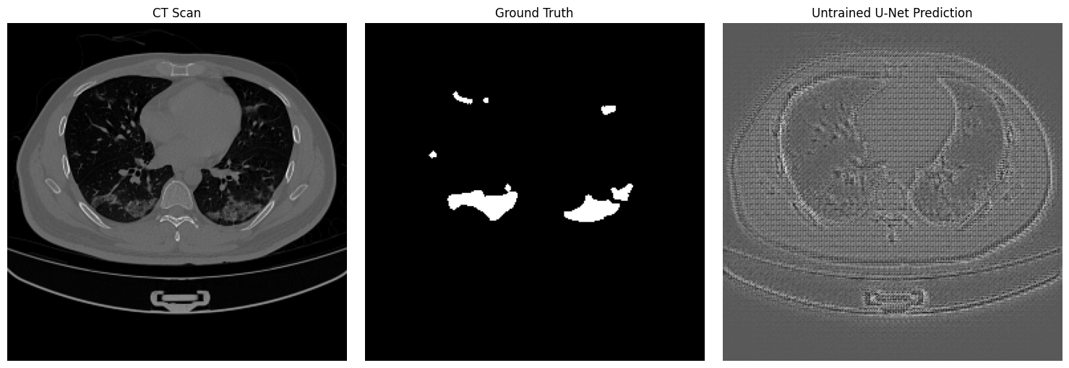
Figure 5.3: CT slice, ground truth and the output of the untrained U-Net (sanity check)

5.7.3 Training
The U-Net was trained for up to 30 epochs with Adam at a learning rate of 10⁻⁴ and a batch size of 16. Callbacks monitored the validation Dice coefficient: ModelCheckpoint kept the best model, EarlyStopping with a patience of 8 epochs would have stopped training when no improvement occurred, ReduceLROnPlateau halved the learning rate after 3 epochs without improvement, and CSVLogger recorded the history. One epoch took roughly 83 seconds on the T4. The best validation Dice of 0.8879 was reached in the last epoch (epoch 30), so the training had not yet saturated when the epoch budget ended.

5.8 Inference Services

5.8.1 DenseNet121 service
The DenseNet121 service is a FastAPI application. At start-up it loads best_densenet121.keras once and builds the Grad-CAM models. The POST /predict endpoint validates the content type (PNG, JPEG), rejects files larger than 20 MB, opens the image with Pillow, converts it to RGB, resizes it to 224 × 224 and divides it by 255. The saved model contains no rescaling layer, so this division must happen in the service; ImageNet mean/standard-deviation normalisation is deliberately not applied because training used a plain 0–1 rescale. The service then predicts, chooses the label with the highest probability as the Grad-CAM target, generates the overlay and returns the JSON response.
def run_inference(image):
start = time.perf_counter()
original_size = image.size
x = load_and_preprocess(image) # (1, 224, 224, 3)
raw = _model.predict(x, verbose=0)[0]
predictions = [{"disease": l, "confidence": float(c)} for l, c in zip(LABELS, raw)]
top = int(raw.argmax())
heatmap = compute_heatmap(_conv_output_model, _classifier_model, x, pred_index=top)
gradcam = heatmap_to_transparent_overlay(heatmap, target_size=original_size)
return {"predictions": predictions, "gradcam": gradcam,
"inference_time": round(time.perf_counter() - start, 3)}
Listing 5.9: DenseNet121 inference function (inference.py)

5.8.2 U-Net service
The U-Net service follows the same pattern. It converts the upload to greyscale, resizes it to 256 × 256, scales it to [0, 1] and predicts a probability map. From the map it computes the maximum and mean probability and the percentage of pixels above 0.5; a nodule is reported as detected only if the maximum probability is at least 0.5 and the area is at least 0.1 percent of the image, which suppresses isolated noisy pixels. A semi-transparent red overlay of the thresholded mask is blended onto the original image, resized to its original dimensions and returned as a base64 PNG.
mask = np.squeeze(pred_mask)
max_confidence = float(np.max(mask))
mean_confidence = float(np.mean(mask))
nodule_area_pct = round(float(np.sum(mask > 0.5)) / mask.size * 100.0, 2)
nodule_detected = bool(max_confidence >= 0.5 and nodule_area_pct >= 0.1)
Listing 5.10: Nodule detection rule (unet-service/app.py)

5.9 Implementation of the Web Application

5.9.1 Project structure
The application is a Next.js project that uses the App Router. Pages are under src/app, API route handlers under src/app/api, reusable interface components under src/components (for example the probability bar, severity badge, heatmap viewer, upload card and patient card), service modules under src/services (Hugging Face client, U-Net client, Groq client, PDF generator and storage), and helpers under src/lib and src/utils.

5.9.2 Authentication and authorisation
Login looks up the user by e-mail, compares the supplied password with the stored bcrypt hash and, if valid, signs a JWT and sets it as an HTTP-only, SameSite=Lax cookie that lasts 24 hours and is marked secure in production. The identical error message “Invalid credentials” is returned for an unknown e-mail address and for a wrong password so that the endpoint does not reveal which e-mails exist.
const token = await signToken({ id: user.id, email: user.email,
role: user.role, name: user.name });
response.cookies.set("auth_token", token, {
httpOnly: true,
secure: process.env.NODE_ENV === "production",
sameSite: "lax",
maxAge: 60 * 60 * 24,
path: "/",
});
Listing 5.11: Session cookie (api/auth/login/route.ts)
A request proxy defines the protected route prefix /dashboard and the authentication routes /login, /register and /forgot-password. Visitors without a valid token are redirected to /login, and signed-in users who open an authentication route are redirected to /dashboard. Password reset uses a random token with an expiry time stored on the user record.

5.9.3 The prediction route
The /api/predict route is the core of the application. After checking the session it reads the multipart form, verifies that an image and a patient identifier are present, checks the MIME type and the 20 MB limit, and loads the patient. It reads the configured AI threshold from the settings table and then calls both inference services concurrently. The resulting images are uploaded to Supabase Storage in parallel, the scan is stored with the probability map and the nodule result serialised as JSON, and the response contains the stored scan, the combined inference time and a list of recommendations.
[denseNetInference, unetInference] = await Promise.all([
runInference(file),
runUNetInference(file),
]);

[imagePath, gradcamUrl, noduleMaskUrl] = await Promise.all([
uploadScanImage(file),
denseNetInference.gradcam ? uploadGradcamImage(denseNetInference.gradcam) : null,
unetInference.noduleMaskOverlay ? uploadNoduleMaskImage(unetInference.noduleMaskOverlay) : null,
]);

const scan = await db.scan.create({ data: {
patientId, doctorId: user.id, imagePath,
gradcamImage: gradcamUrl, noduleMaskImage: noduleMaskUrl,
predictionJson: JSON.stringify(denseNetInference.predictions),
noduleJson: JSON.stringify(unetInference) } });
Listing 5.12: Parallel inference and persistence (api/predict/route.ts, abridged)
If either service fails, the route answers with HTTP 502 and a descriptive message and nothing is stored, so partial scans cannot occur. In development, when the service URLs are not configured, the clients return clearly marked simulated predictions.

5.9.4 Recommendations and severity
The recommendation helper filters the predictions that reach the configured threshold (excluding “No Finding”), sorts them by probability and maps each finding to an advisory follow-up note, for example “Consider CT chest for further evaluation” for lung opacity or consolidation, “Consider echocardiography” for cardiomegaly and “Urgent clinical evaluation required” for pneumothorax. If no finding exceeds the threshold the message is “No significant abnormalities detected. Routine follow-up recommended.” The notes are advisory and are never presented as a diagnosis.

5.9.5 PDF report generation
Reports are generated in the browser with jsPDF on an A4 page. The header carries the hospital name, the report title and the date; the body contains the patient block (name, patient ID, age, sex, blood group, phone), the original image next to the Grad-CAM visualisation, the U-Net nodule assessment (detection flag, confidences and area), a table of all fourteen probabilities with severity, the recommendations, the doctor’s notes and signature, and a standard disclaimer stating that the report was generated with a decision-support system, that it is intended to assist and not replace clinical judgement, and that all findings must be confirmed by a qualified radiologist or physician. Images are loaded through a canvas so that cross-origin storage URLs can be embedded.

5.9.6 AI assistant
The assistant is a chat interface backed by the /api/assistant route. The request body is validated with Zod (at most 20 messages of at most 4,000 characters). The system prompt defines the assistant as a clinical decision-support helper that explains findings, confidence scores, Grad-CAM and segmentation, never gives a definitive diagnosis, declines unrelated questions and admits when it lacks data. When a scan is selected, the route appends the ranked probabilities, the threshold, the nodule result and only the patient’s age and sex to the system prompt, then calls the Groq chat completions API with the llama-3.3-70b-versatile model at temperature 0.3 and a 30-second timeout.

5.9.7 Seed data and settings
A seed script creates one administrator and several doctor accounts with passwords hashed at bcrypt cost 12, and a default settings row (AI threshold 0.5, light theme, notifications on). The default password is read from the SEED_DEFAULT_PASSWORD environment variable and the demo accounts must be changed or removed before any real deployment.

5.10 Containerisation and Deployment
Each inference service has its own Dockerfile based on python:3.10-slim. The Dockerfile installs the two system libraries that OpenCV needs at run time (libgl1 and libglib2.0-0), installs the Python requirements first to benefit from layer caching, copies the application and the model file, creates a non-root user and starts Uvicorn. Docker Compose builds and runs both services and restarts them automatically.
services:
densenet-service:
build: { context: ./huggingface-space, dockerfile: Dockerfile }
container_name: densenet-inference-service
ports: ["8000:7860"]
restart: unless-stopped

unet-service:
build: { context: ./unet-service, dockerfile: Dockerfile }
container_name: unet-nodule-inference-service
ports: ["8001:8001"]
environment:
- UNET_MODEL_PATH=best_lung_nodule_unet.keras
restart: unless-stopped
Listing 5.13: Docker Compose services (abridged)
The web application is deployed separately and configured with the environment variables DATABASE_URL, DIRECT_URL, JWT_SECRET, HUGGINGFACE_SPACE_URL, UNET_SERVICE_URL, the Supabase credentials and GROQ_API_KEY. Secrets are never committed to the source repository.

5.11 Application Screenshots
This section shows the running application, captured from the local development build with demonstration data. The login page is the entry point of the system; users must authenticate before any dashboard page can be opened.
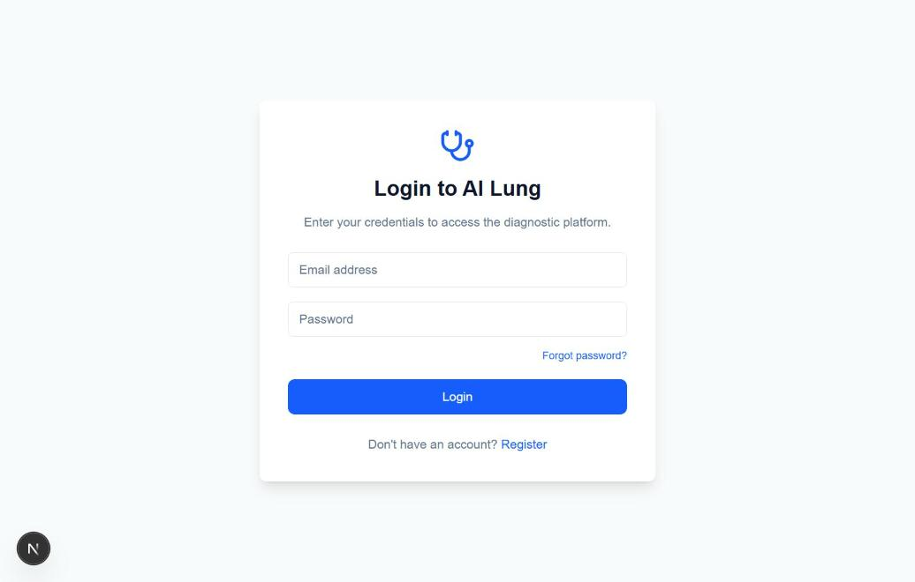
Figure 5.4: Login page of the application
After login the doctor reaches the dashboard, which is intended to display statistic cards, the disease distribution chart and recent activity.
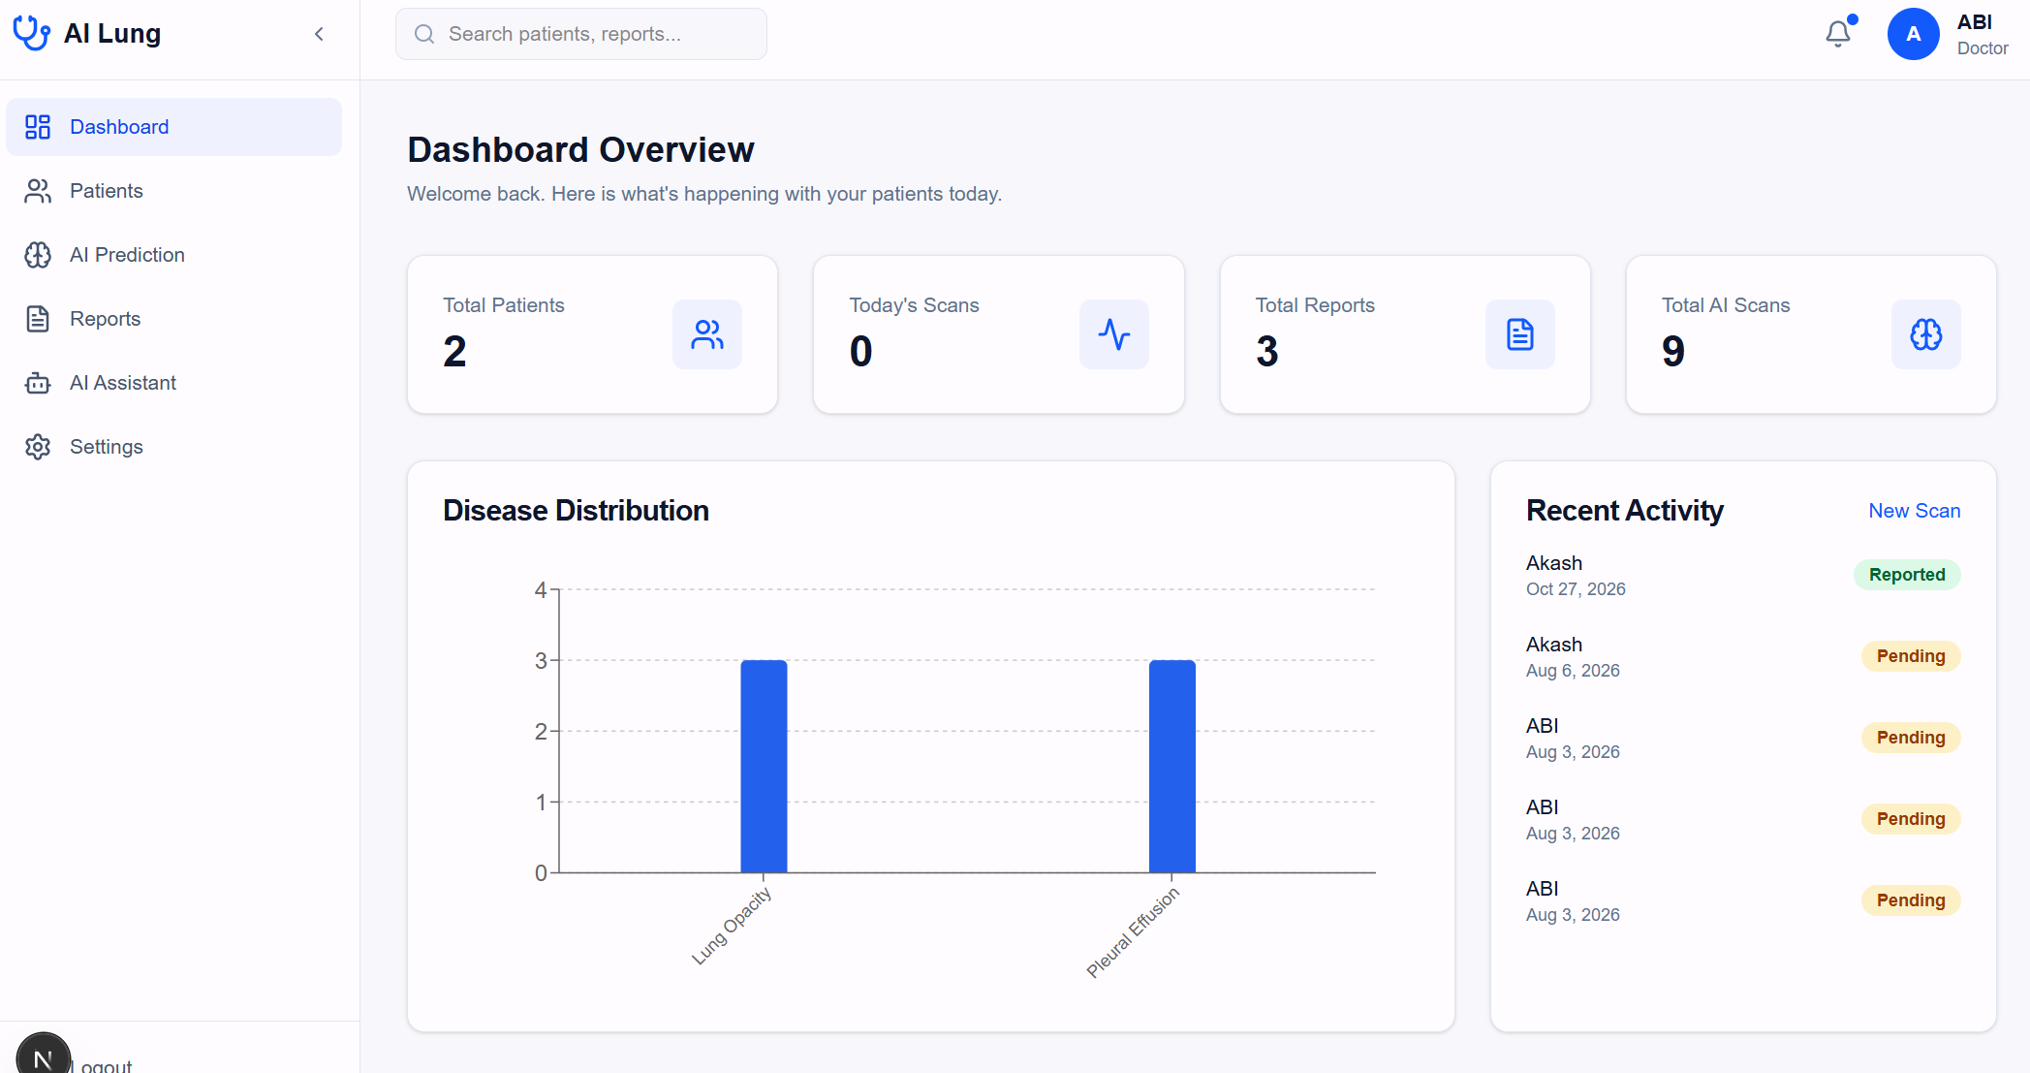
Figure 5.5: Doctor dashboard
The patient list supports search by name, identifier or phone number, filtering by gender and sorting. Each card shows the age, sex, phone number and the number of scans stored for the patient.
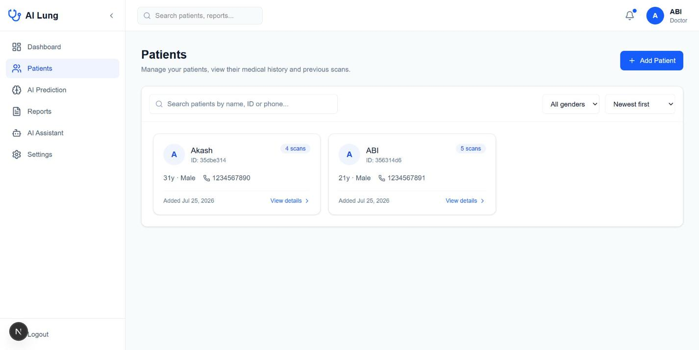
Figure 5.6: Patient management page
The patient detail page shows the demographics and medical notes and a chronological scan and prediction history with thumbnails; from here the doctor can reopen the AI predictions of an earlier scan, ask the assistant about it or start a new prediction.
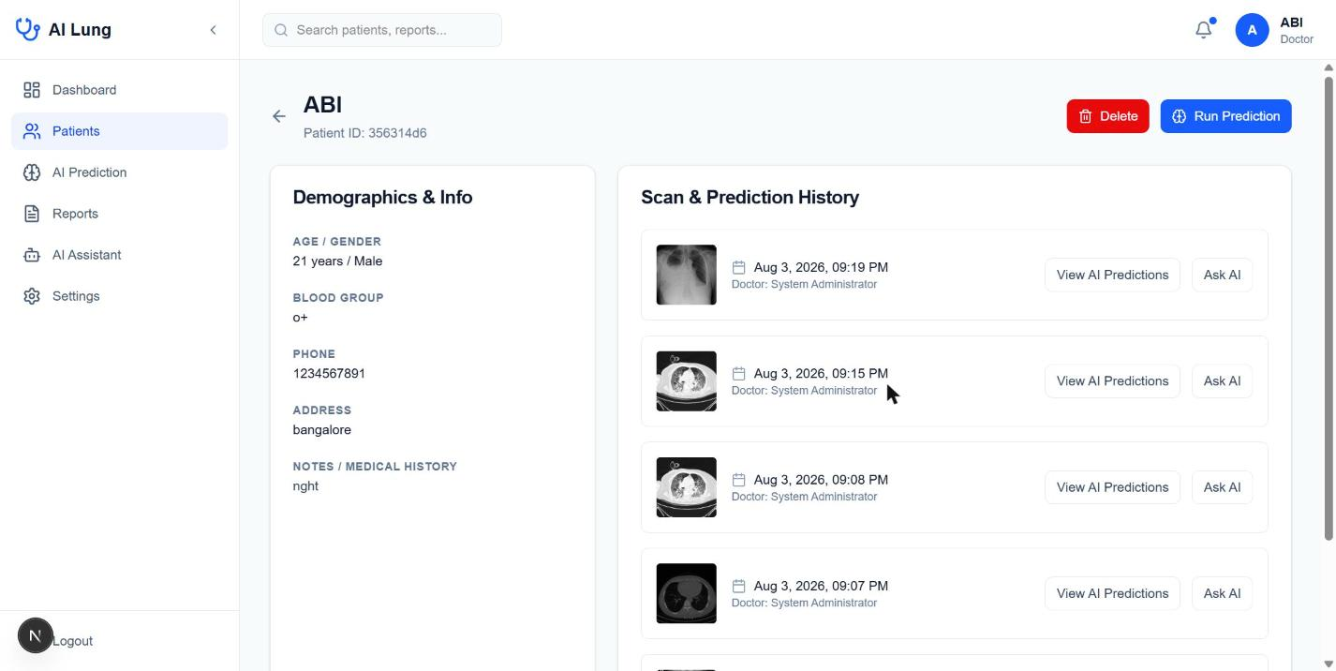
Figure 5.7: Patient details with scan and prediction history
The prediction page lets the doctor search for a patient and upload a chest image by drag and drop or file browser; PNG and JPEG files of up to 20 MB are accepted, and the Run AI Prediction button becomes active when both a patient and an image have been selected.
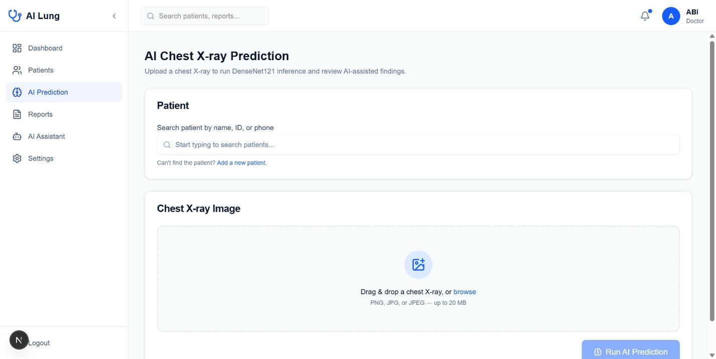
Figure 5.8: AI prediction page: patient selection and image upload
Reports generated for scans are listed on the reports page with the patient, the identifier, the generation date and the reviewing doctor. Each report can be viewed (and printed) or downloaded as a PDF file.
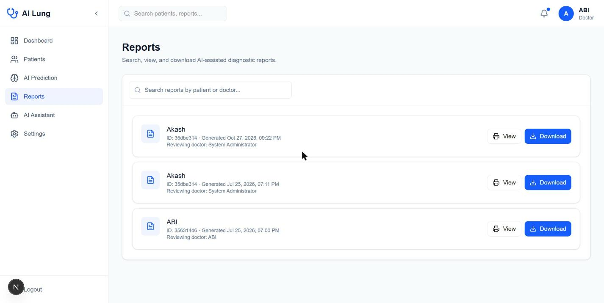
Figure 5.9: Reports page listing the generated PDF reports
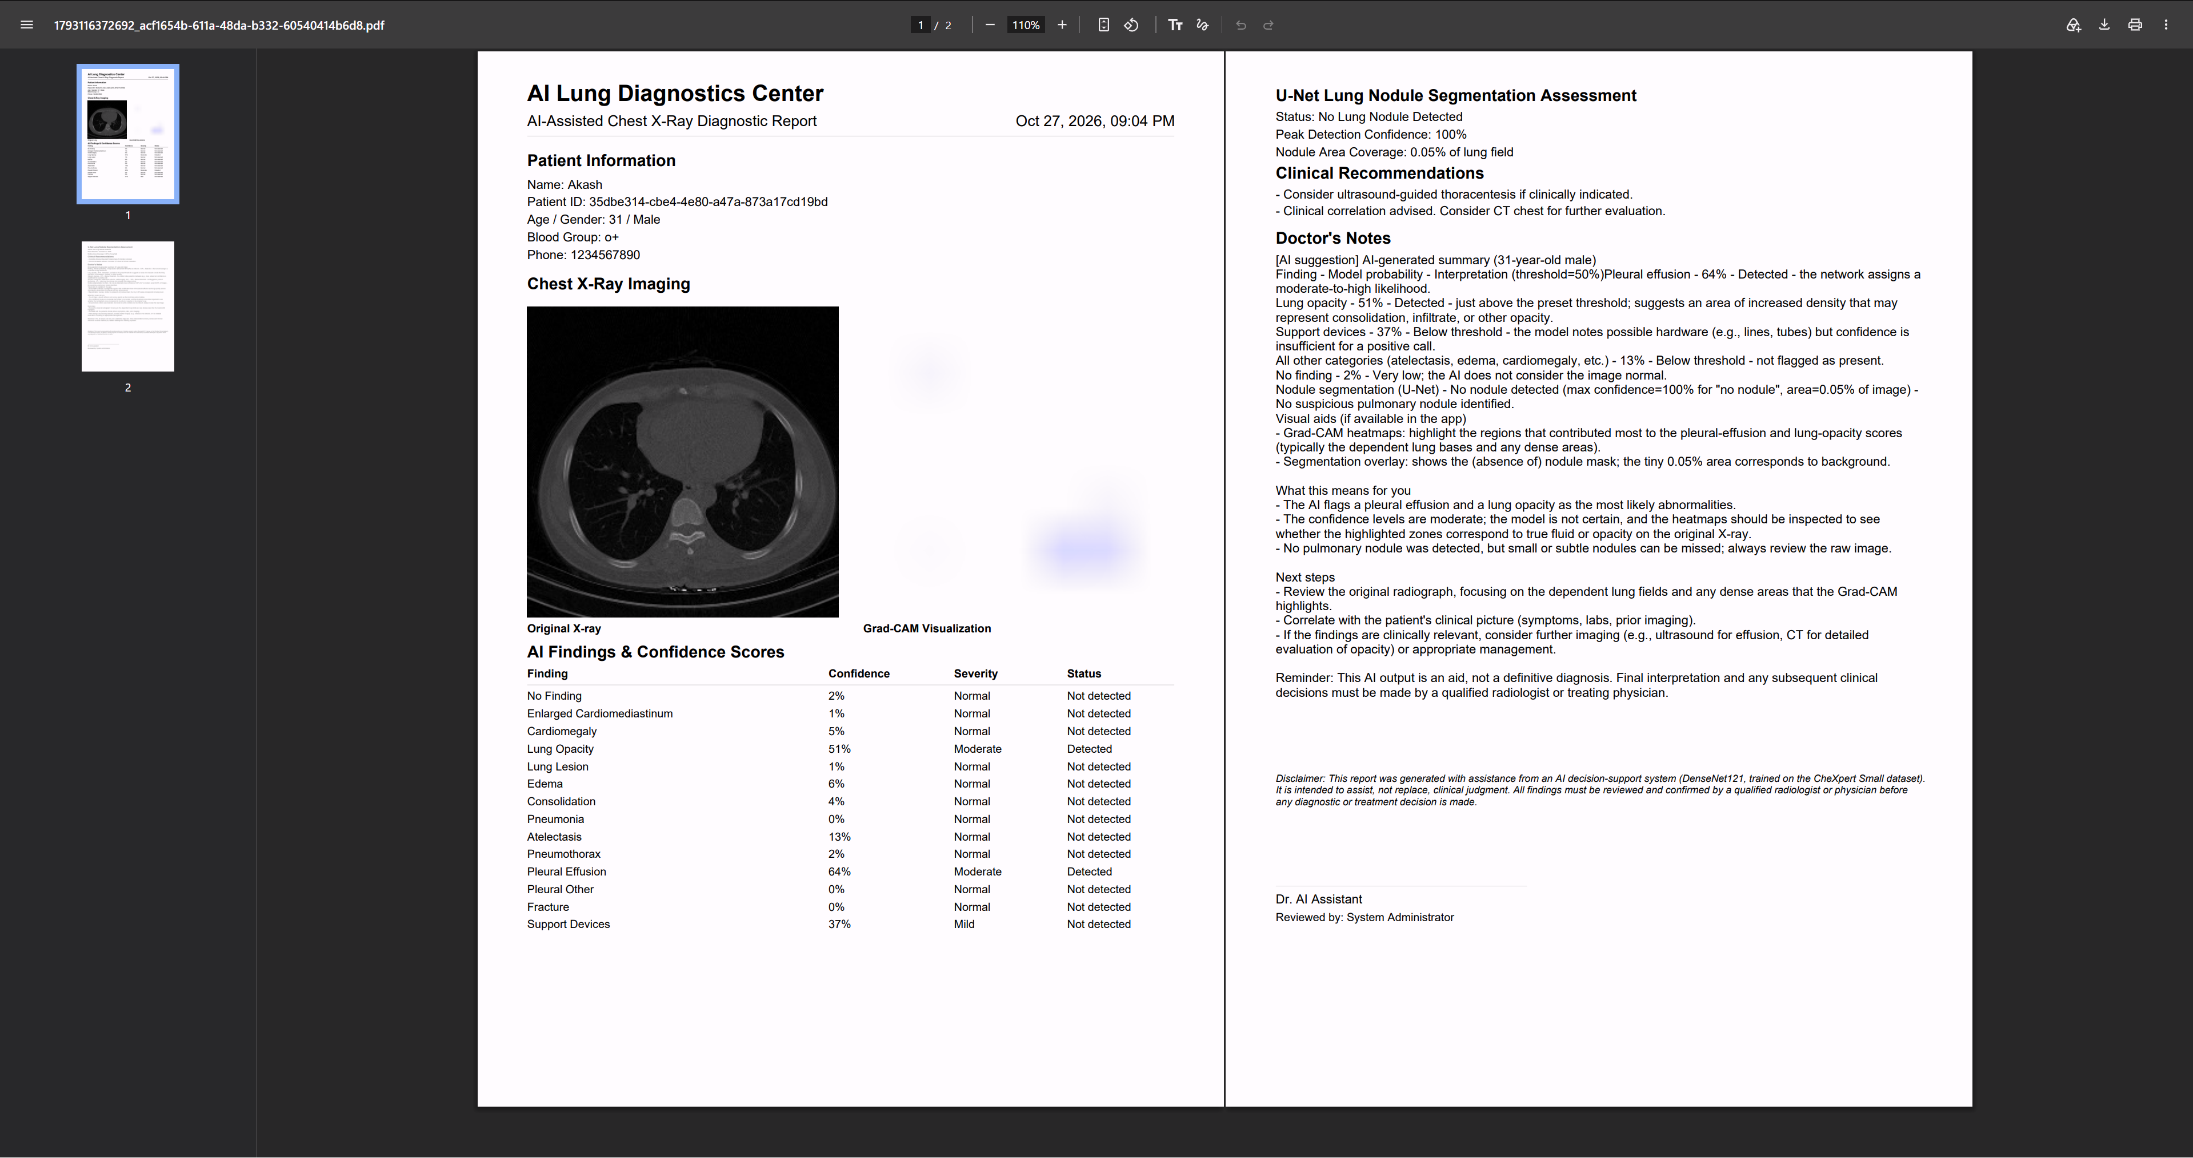
Figure 5.10: Generated PDF report
The assistant page offers a chat interface with example questions and a reminder that the answers are AI-generated guidance that must be confirmed by a qualified radiologist.
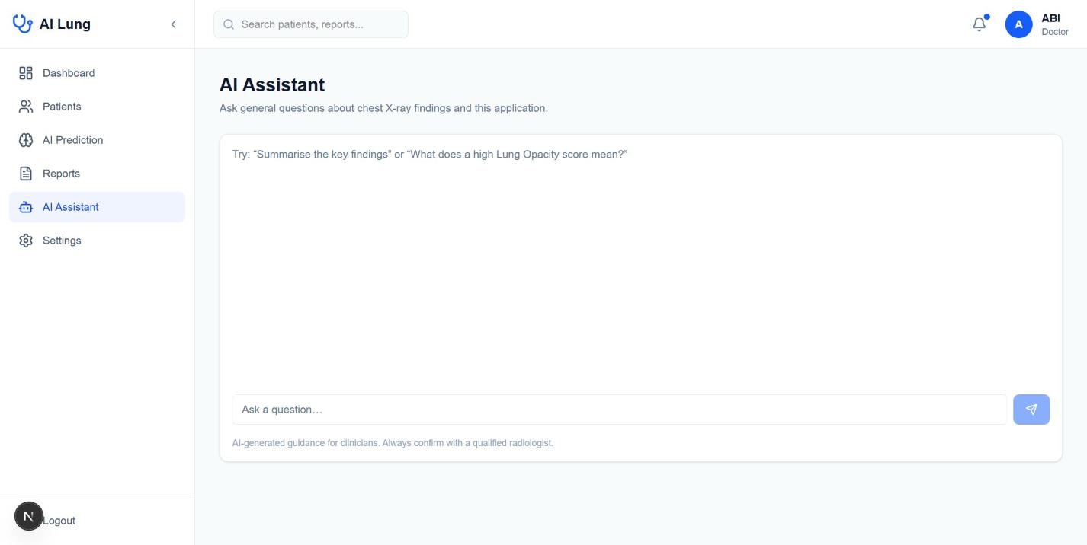
Figure 5.11: AI assistant chat interface

6. TESTING

6.1 Testing Strategy
Testing was organised in four layers that correspond to the layers of the system: validation of the machine-learning models, unit-level checks of the data pipeline and helper functions, integration testing of the API routes with the inference services, and system testing of the complete workflow through the user interface. In a machine-learning project the first layer is the most important, because a defect in the data pipeline, such as a wrong scaling factor or a label order mismatch, does not raise an error but silently degrades accuracy.
Table 6.1: Levels of testing
Level | What is tested | Method
Model validation | Generalisation of classifier and segmenter | Held-out validation / test sets, AUC, Dice, IoU
Data pipeline | Shapes, ranges, label alignment, augmentation | Assertions and visual checks in the notebooks
Unit | Severity grading, recommendation logic, preprocessing | Isolated function tests with known inputs
Integration | API routes, inference services, database, storage | HTTP requests with valid and invalid payloads
System | End-to-end clinical workflow | Manual scenario testing in the browser
Security | Authentication, authorisation, input validation | Requests without cookie, malformed files

6.2 Testing of the Machine-Learning Pipeline

6.2.1 Data pipeline checks
Each notebook phase ends with verification cells. For the classifier, the first batch of the training dataset was drawn and its shapes were asserted to be (32, 224, 224, 3) for images and (32, 14) for labels; pixel values were checked to lie in [0, 1]; the labels of a sample image were printed next to the image to confirm that the label vector and the picture belong together; and the time to read five batches was measured to detect input-pipeline bottlenecks. A missing-value check on the label columns confirmed that all NaN values had been replaced.
For the U-Net, the image and mask directories were compared and all 5,070 file names were found in both. Mask arrays were inspected and found to contain several grey values (0, 12, 17, 21 and 255), which is why the loader binarises every positive pixel. A batch of augmented samples was visualised as CT, mask and overlay to confirm that the same geometric transformation is applied to image and mask and that photometric changes affect only the image. The pixel statistics of one batch (1.58 percent nodule, 98.42 percent background) agree with the data-set average of 1.54 percent and illustrate the severe class imbalance.

6.2.2 Sanity check of the untrained network
Before training, the U-Net was run on a single batch. The output had the correct shape, its values lay in the open interval (0, 1) and the loss, Dice and IoU were at the levels expected for random weights (1.676, 0.043 and 0.021). Starting values that are very different from these would have pointed to a wrong loss or a wrong output activation.

6.2.3 Regression lessons from earlier runs
Several defects were found by observing failed or abnormal runs, and the corresponding fixes were added as permanent checks in the notebooks.
Table 6.2: Defects found during model development
Observation | Cause | Fix
Kernel killed at 142 GB RAM, slow epochs | Shuffle buffer equal to the whole training set | Buffer size set to 5,000
10 of 14 labels with 0 precision and recall | Class imbalance and a global 0.5 threshold | Class-balanced focal loss; per-label optimal thresholds
NaN loss during training | Exploding gradient corrupting weights | Adam with clipnorm = 1.0
Error when reading last conv layer for Grad-CAM | Backbone nested inside the outer model | Build conv-output and classifier sub-models
Dataset path not found on server | Hard-coded /root cache path | Use the path returned by kagglehub
“Invalid incarnation id”, recall > 1.0 | Distributed iterator and metric aggregation with MirroredStrategy | Reverted to single-GPU training

6.3 Test Cases for the Application
The test cases below follow the behaviour that is implemented in the source code. The Status column is left for the tester to complete when the case is executed against the deployed build.
Table 6.3: Authentication and patient management test cases
ID | Test case | Input | Expected result | Status
TC01 | Login with valid credentials | Registered e-mail and correct password | HTTP 200, auth_token cookie set (HTTP-only), redirect to /dashboard | [ ]
TC02 | Login with wrong password | Valid e-mail, wrong password | HTTP 401 “Invalid credentials”, no cookie | [ ]
TC03 | Login with unknown e-mail | Unregistered e-mail | HTTP 401 with the same message as TC02 | [ ]
TC04 | Login with empty fields | Empty e-mail or password | HTTP 400 “Email and password are required” | [ ]
TC05 | Open dashboard without login | GET /dashboard with no cookie | Redirect to /login | [ ]
TC06 | Open /login while logged in | GET /login with valid cookie | Redirect to /dashboard | [ ]
TC07 | Expired or tampered token | Modified cookie value | Treated as unauthenticated; redirect to /login | [ ]
TC08 | Create patient | Valid name, age, sex, phone, address | Patient stored with unique patientId | [ ]
TC09 | Search patients | Part of a patient’s name | Only matching patients listed, paginated | [ ]
TC10 | Delete patient | Existing patient with scans | Patient and its scans and reports removed (cascade) | [ ]

Table 6.4: Prediction workflow test cases
ID | Test case | Input | Expected result | Status
TC11 | Predict without session | POST /api/predict, no cookie | HTTP 401 Unauthorized | [ ]
TC12 | Predict without image | Form with patientId only | HTTP 400 “Image is required” | [ ]
TC13 | Predict without patient | Form with image only | HTTP 400 “Patient ID is required” | [ ]
TC14 | Unsupported file type | GIF, PDF or DICOM file | HTTP 400 “Only PNG, JPG, and JPEG formats are supported” | [ ]
TC15 | File over limit | Image larger than 20 MB | HTTP 400 “File size must be less than 20 MB” | [ ]
TC16 | Unknown patient | Non-existent patient id | HTTP 404 “Patient not found” | [ ]
TC17 | Valid chest X-ray | PNG/JPEG frontal radiograph | HTTP 201, 14 probabilities, Grad-CAM image, nodule result, recommendations | [ ]
TC18 | Inference service down | DenseNet or U-Net service stopped | HTTP 502 with message; no scan stored | [ ]
TC19 | Inference timeout | Service slower than 60 s | Error “AI inference timed out” | [ ]
TC20 | Threshold change | Admin sets threshold to 0.30 | More findings listed as detected; recommendations updated | [ ]
TC21 | Healthy image | Radiograph with no abnormality | “No Finding” dominant; “No significant abnormalities detected” | [ ]
TC22 | Corrupt image | Text file renamed to .png | Service responds 400 “not a valid image” | [ ]

Table 6.5: Reporting, assistant and usability test cases
ID | Test case | Input | Expected result | Status
TC23 | Generate PDF report | Open a scan and click Download | A4 PDF with patient data, images, findings table, disclaimer | [ ]
TC24 | Add doctor notes | Notes text on the report | Notes appear in the PDF and are saved with the scan | [ ]
TC25 | Assistant, valid question | “Explain the Grad-CAM for this scan” | Plain-language answer; reminder that a clinician must confirm | [ ]
TC26 | Assistant, off-topic question | Unrelated question | Polite refusal | [ ]
TC27 | Assistant, too many messages | More than 20 messages | HTTP 400 “Invalid request” | [ ]
TC28 | Assistant privacy | Inspect request sent to Groq | No name, phone or address in the prompt | [ ]
TC29 | Forgot password | Registered e-mail | Reset token stored with expiry; reset link works once | [ ]
TC30 | Responsive layout | Phone and tablet widths | No horizontal scrolling; navigation collapses | [ ]

6.4 Testing of the Inference Services
Each service exposes a health endpoint (GET /) that returns the service name and, for the U-Net, whether the model has been loaded. The services were exercised with the interactive API documentation that FastAPI generates and with scripted multipart requests. The checks included a valid radiograph, an oversized file, a wrong content type, a corrupt image and concurrent requests. The services return HTTP 400 for invalid uploads and HTTP 500 with the error text for failures during inference, and the web application maps these to a clear message for the user.

6.5 Performance Testing
Every response of the DenseNet service contains the measured inference time, and the U-Net service does likewise, which gives a direct performance measurement for each request. The web application adds the two values to display the total AI time. The input pipeline benchmark of the U-Net notebook (20 batches of 16 images in 1.5 seconds) shows that the data loader is not a bottleneck, and each training epoch of the U-Net took about 83 seconds on a T4 GPU.

6.6 Security Testing
Security testing concentrated on the three routes of attack that are most relevant to this kind of application. First, access control: all /dashboard pages and all API routes are requested without a cookie and with a modified cookie, and each must be refused. Second, upload handling: files with the wrong type, wrong size or corrupt content must be rejected before inference. Third, data leakage: the prompt sent to the language-model API must contain only the age and sex of the patient. Passwords are never returned by any API, and error messages do not distinguish between an unknown user and a wrong password.

7. RESULTS
This chapter reports the results of the two models. The U-Net results are taken directly from the executed training and evaluation notebook. The DenseNet121 results come from the evaluation summary (evaluation_results.csv) of the classifier notebook; items that need the training log or the per-label thresholds are marked as slots to be completed.

7.1 Evaluation Metrics
Classifier. The area under the ROC curve (AUC) measures how well the predicted probabilities rank positive images above negative ones, independently of any threshold. Precision is TP/(TP+FP), recall is TP/(TP+FN) and F1 is their harmonic mean; these depend on the chosen threshold. Because the data are imbalanced, accuracy alone is misleading and is therefore not used as the main measure.
Segmenter. The Dice coefficient, 2|A∩B|/(|A|+|B|), and the Intersection over Union (IoU), |A∩B|/|A∪B|, measure the overlap between predicted and annotated nodule pixels. Pixel-level precision and recall give the proportion of predicted pixels that are correct and the proportion of annotated pixels that are found.

7.2 Results of the DenseNet121 Classifier

7.2.1 Per-disease AUC
Table 7.1 lists the per-label results of the evaluation notebook (evaluation_results.csv) on the validation split. AUC is threshold-independent, whereas precision, recall and F1 were computed with the fixed threshold of 0.50. The AUC of Fracture is empty because the validation split contains no positive example of this label, so the ROC curve is undefined.
Table 7.1: Per-label validation results of the DenseNet121 classifier at a fixed threshold of 0.50 (source: evaluation_results.csv)
Label | AUC | Precision | Recall | F1
No Finding | 0.866 | 0.000 | 0.000 | 0.000
Enlarged Cardiomediastinum | 0.631 | 0.000 | 0.000 | 0.000
Cardiomegaly | 0.735 | 0.000 | 0.000 | 0.000
Lung Opacity | 0.840 | 0.000 | 0.000 | 0.000
Lung Lesion | 0.299 | 0.000 | 0.000 | 0.000
Edema | 0.835 | 0.000 | 0.000 | 0.000
Consolidation | 0.816 | 0.000 | 0.000 | 0.000
Pneumonia | 0.613 | 0.000 | 0.000 | 0.000
Atelectasis | 0.678 | 0.000 | 0.000 | 0.000
Pneumothorax | 0.705 | 0.000 | 0.000 | 0.000
Pleural Effusion | 0.832 | 1.000 | 0.031 | 0.061
Pleural Other | 0.861 | 0.000 | 0.000 | 0.000
Fracture | n/a (no positives) | 0.000 | 0.000 | 0.000
Support Devices | 0.734 | 1.000 | 0.061 | 0.114
Mean (13 labels with AUC) | 0.727 | 0.143 | 0.007 | 0.012

The mean AUC over the thirteen labels for which it is defined is 0.727. Six labels reach an AUC of at least 0.80: No Finding (0.866), Pleural Other (0.861), Lung Opacity (0.840), Edema (0.835), Pleural Effusion (0.832) and Consolidation (0.816). Cardiomegaly (0.735), Support Devices (0.734), Pneumothorax (0.705) and Atelectasis (0.678) are moderate, Enlarged Cardiomediastinum (0.631) and Pneumonia (0.613) are weak, and Lung Lesion (0.299) is below chance. The validation split of CheXpert is small and contains only a handful of positive examples for rare labels, so the AUC of such labels is estimated very imprecisely and the below-chance value for Lung Lesion should not be over-interpreted; it does, however, show that the classifier cannot be relied upon for this label.
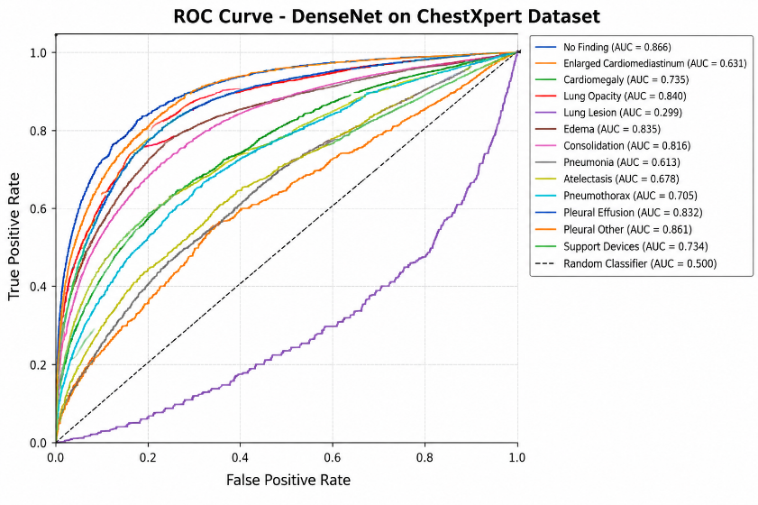
Figure 7.1: ROC curves of the fourteen labels

7.2.2 Effect of thresholds
The table above also illustrates the difference between ranking quality and threshold-dependent measures. With the single cut-off of 0.50, precision and recall are zero for twelve of the fourteen labels; only Pleural Effusion and Support Devices produce any positive prediction at all, and then with a recall of only 3 and 6 percent. An earlier run had already shown the same pattern (zero precision and recall for ten of fourteen labels). Because the AUC values are still reasonable for many labels, the cause is not an absence of learned signal but the position of the threshold: for imbalanced labels the predicted probabilities rarely exceed 0.50 (this is typical of focal-loss and heavily imbalanced training). Choosing the F1-maximising threshold for each label on the validation data (Section 5.5) addresses this and is the recommended operating mode for the classifier.

7.2.4 Grad-CAM visualisation
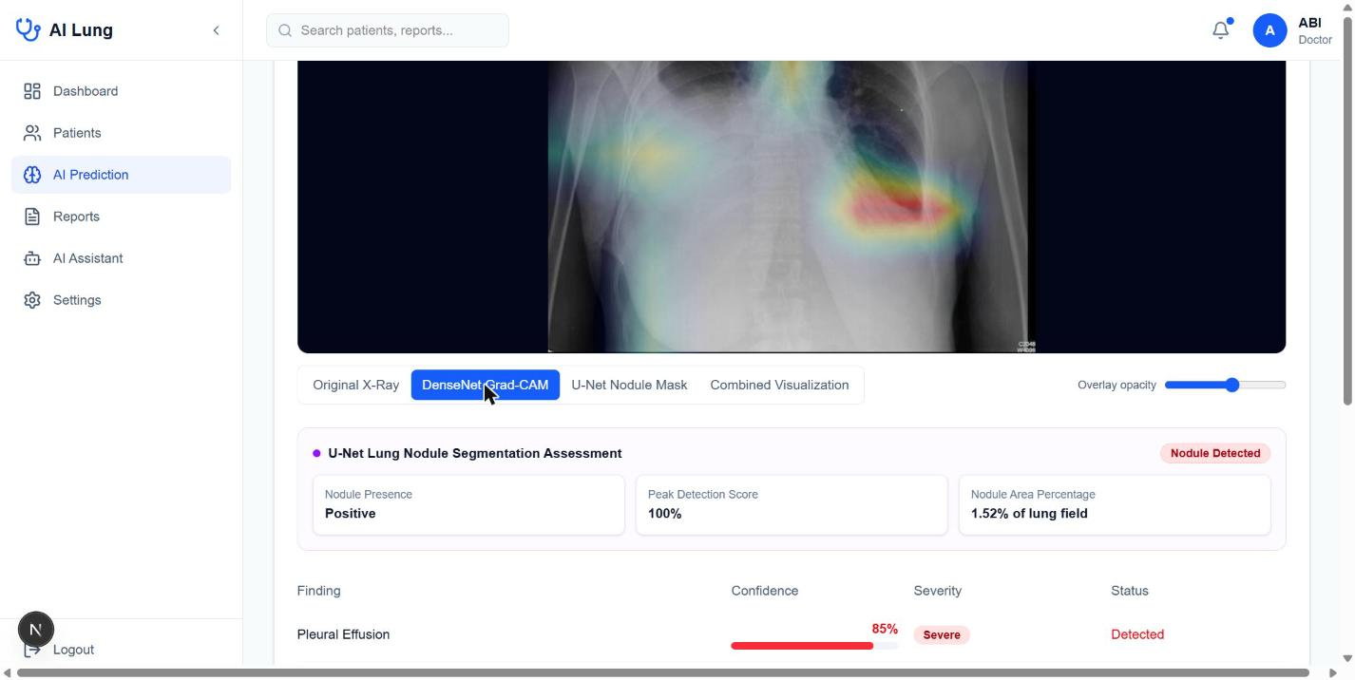
Figure 7.3: Grad-CAM view in the web application for a frontal chest X-ray (strongest activation over the left lower lung zone; the opacity of the overlay can be adjusted)
In a well-trained model the heatmap for a finding such as cardiomegaly should cover the cardiac silhouette, that for pleural effusion should fall on the costophrenic angles, and that for a lung opacity should be located over the lung fields. Heatmaps that highlight the corners of the image, text markers or support devices instead are a warning sign of shortcut learning. Such inspection is the main reason why Grad-CAM is built into the clinical workflow.

7.3 Results of the U-Net Segmentation Model

7.3.1 Training curves
The figure below shows the training and validation curves over the 30 epochs. The loss decreases and the Dice and IoU increase smoothly on both the training and the validation data, and the validation curves follow the training curves closely, which shows that the model does not over-fit despite the modest data-set size. Validation precision and recall fluctuate more from epoch to epoch (for example the dip around epoch 20), which is normal for a validation set of only 507 images. The final training epoch reached a Dice of 0.9105, an IoU of 0.8465, a precision of 0.9215 and a recall of 0.9190 on the training data, and the best validation Dice of 0.8879 was recorded at epoch 30. Because the best value is still in the final epoch, more epochs would probably improve the result slightly.
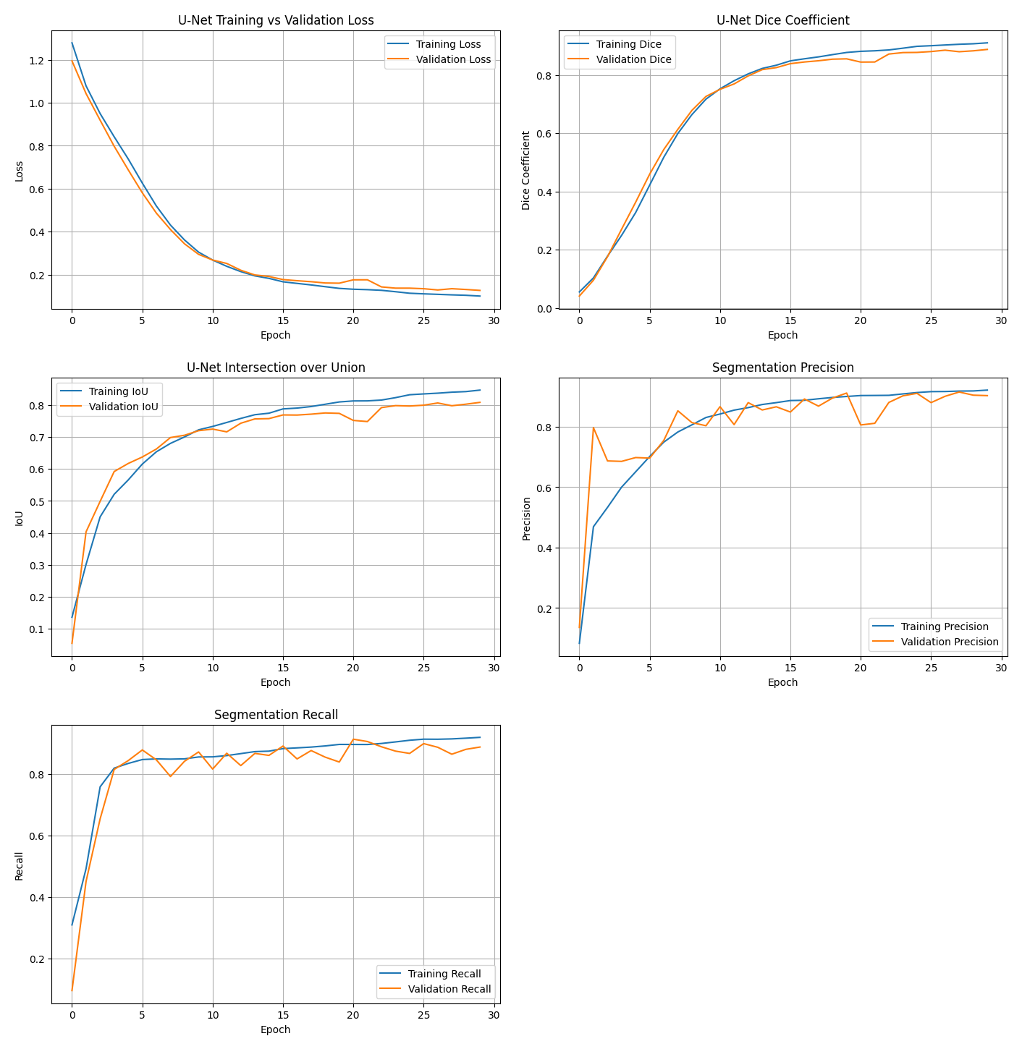
Figure 7.4: U-Net training and validation curves: loss, Dice coefficient, IoU, precision and recall

7.3.2 Validation and test results
Table 7.3: U-Net results on the validation and test sets
Metric | Validation (507 images) | Test, threshold 0.50 | Test, threshold 0.35
Dice coefficient | 0.8879 | 0.8981 | 0.9060
IoU | 0.8082 | 0.8243 | 0.8282
Precision | 0.9032 | 0.9139 | 0.9077
Recall | 0.8875 | 0.8975 | 0.9043
Loss (BCE + Dice) | 0.1269 | 0.1157 | –

On the 507 held-out test images, evaluated with the default threshold of 0.5 inside the Keras evaluation loop, the model obtains a Dice coefficient of 0.8981 and an IoU of 0.8243. Test performance is slightly higher than validation performance, which is within the normal variation expected for two random 10 percent splits and gives no indication of leakage or over-fitting. Precision and recall are well balanced (0.914 and 0.898), so the model neither over-segments nor under-segments systematically.

7.3.3 Threshold optimisation
The sigmoid output was thresholded at values between 0.20 and 0.80 in steps of 0.05 and the pooled Dice was calculated on the full test set. The curve is very flat: the Dice varies only between 0.9033 and 0.9060 over the whole range, which shows that the predicted probabilities are strongly bimodal, with most pixels close to either 0 or 1. The best value was obtained at a threshold of 0.35 with a Dice of 0.9060.
Table 7.4: Test-set Dice at different segmentation thresholds
Threshold | Dice | Threshold | Dice
0.20 | 0.9057 | 0.55 | 0.9055
0.25 | 0.9058 | 0.60 | 0.9053
0.30 | 0.9060 | 0.65 | 0.9051
0.35 | 0.9060 | 0.70 | 0.9045
0.40 | 0.9059 | 0.75 | 0.9039
0.45 | 0.9057 | 0.80 | 0.9033
0.50 | 0.9056

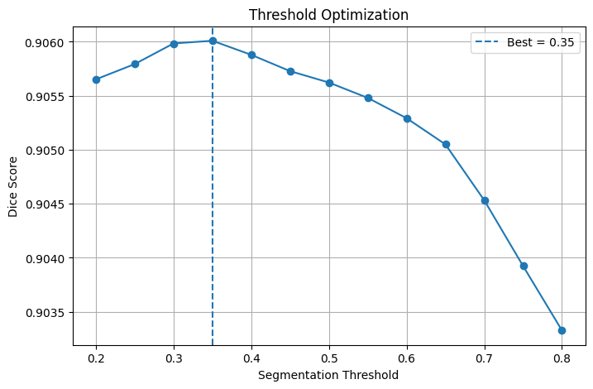
Figure 7.5: Dice score as a function of the segmentation threshold (best = 0.35)

7.3.4 Final test performance
Table 7.5: Final U-Net test results
Metric | Value
Pooled Dice coefficient | 0.9060
Pooled IoU | 0.8282
Pixel precision | 0.9077
Pixel recall | 0.9043
Mean per-image Dice | 0.8185
Median per-image Dice | 0.8921
Mean per-image IoU | 0.7280
Median per-image IoU | 0.8053
Selected threshold | 0.35

The pooled Dice (0.906) is higher than the mean per-image Dice (0.819) because pooling over all pixels weights large nodules more heavily, and large nodules are segmented more accurately than small ones. The median per-image Dice of 0.892 is higher than the mean, which indicates a skewed distribution: most images are segmented very well, but a small number of failures with Dice close to zero pull the mean down.
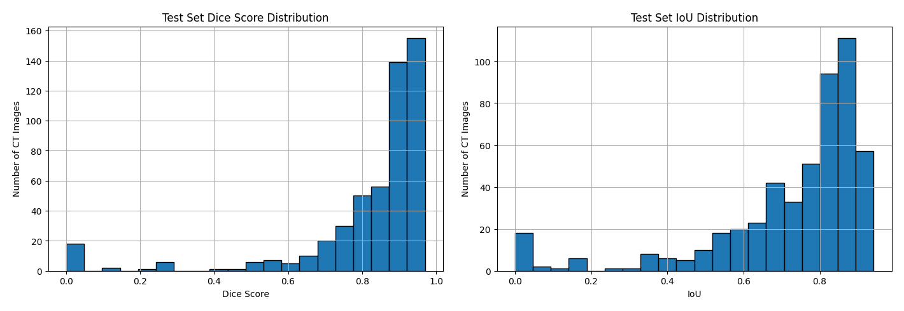
Figure 7.6: Distribution of per-image Dice score (left) and IoU (right) on the test set

7.3.5 Qualitative results
The next figure shows the CT slice, the ground-truth mask, the predicted probability map, the binary prediction and the overlay for validation images. The predicted outlines follow the annotated boundaries closely, and the probability map is sharp at the edges of the nodule.
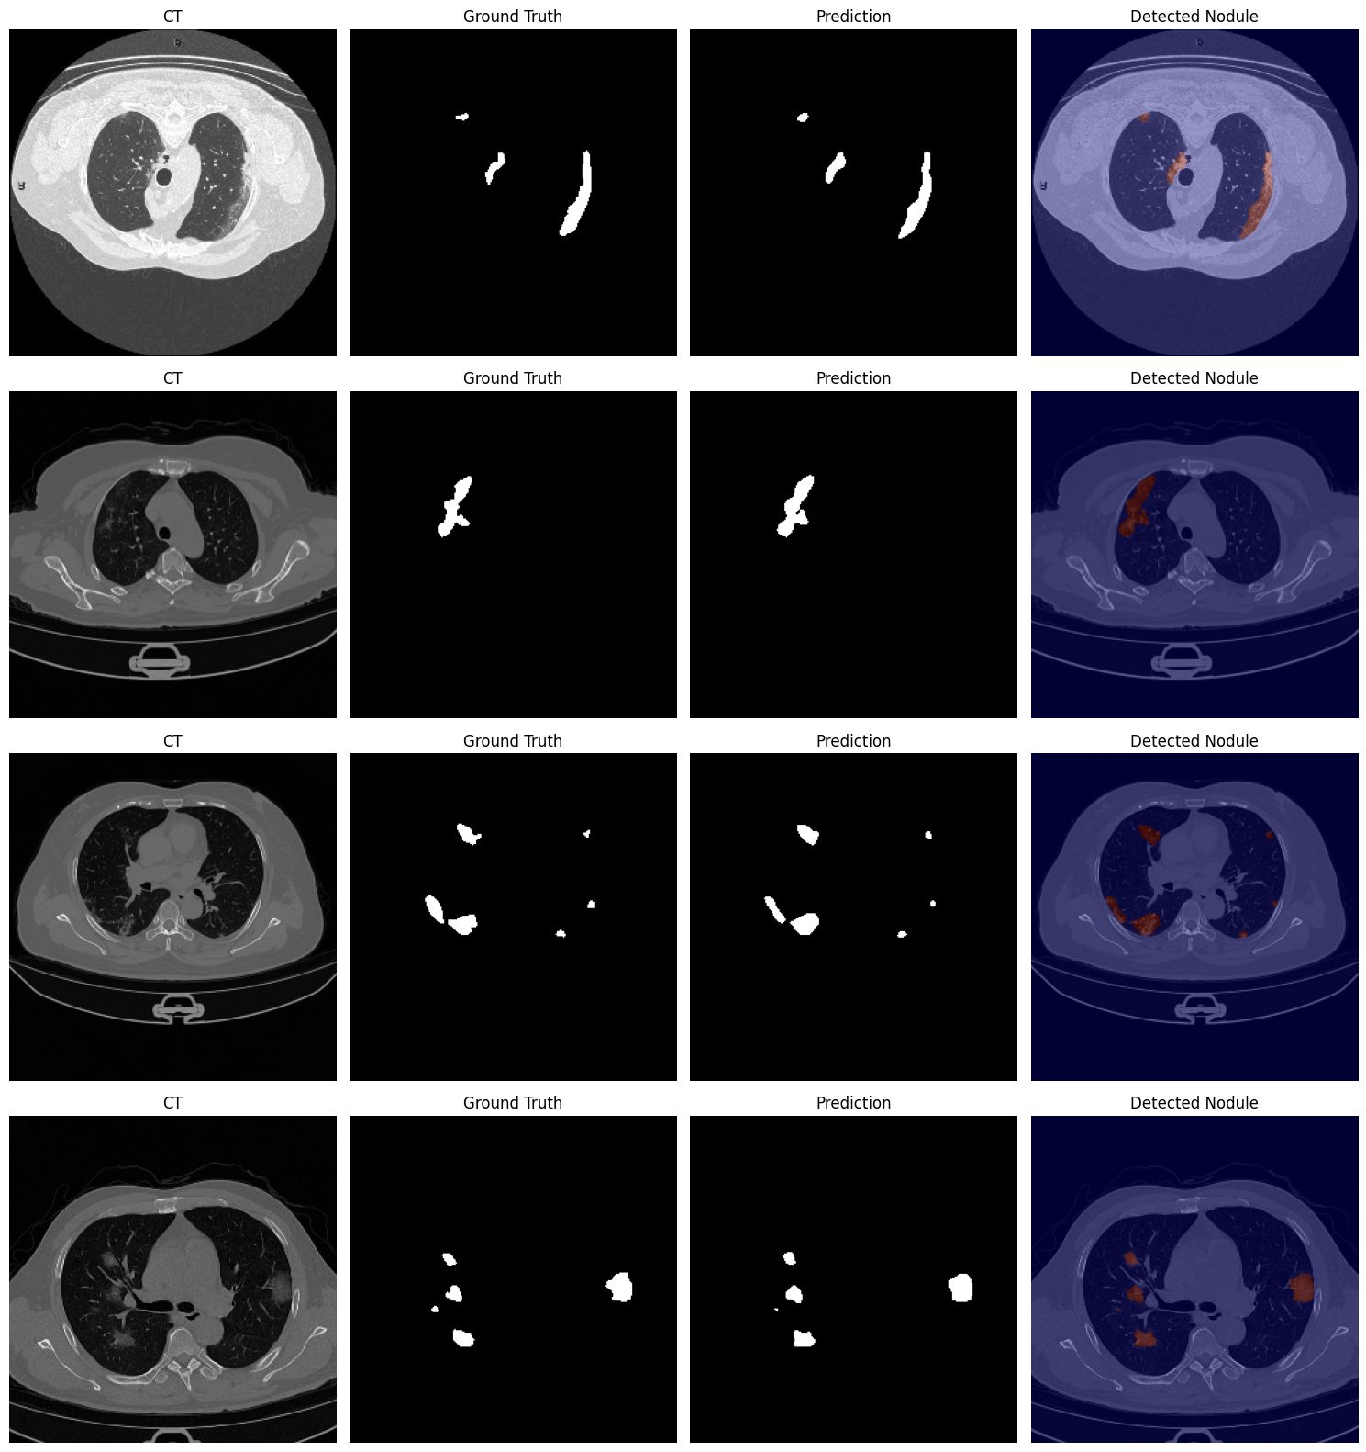
Figure 7.7: Validation examples: CT, ground truth, prediction and detected nodule overlay
The best test image reached a Dice of 0.9701 and an IoU of 0.9419. Typical results lie between 0.75 and 0.93; five randomly selected test images had Dice values of 0.7500, 0.9264, 0.0000, 0.9344 and 0.9097.
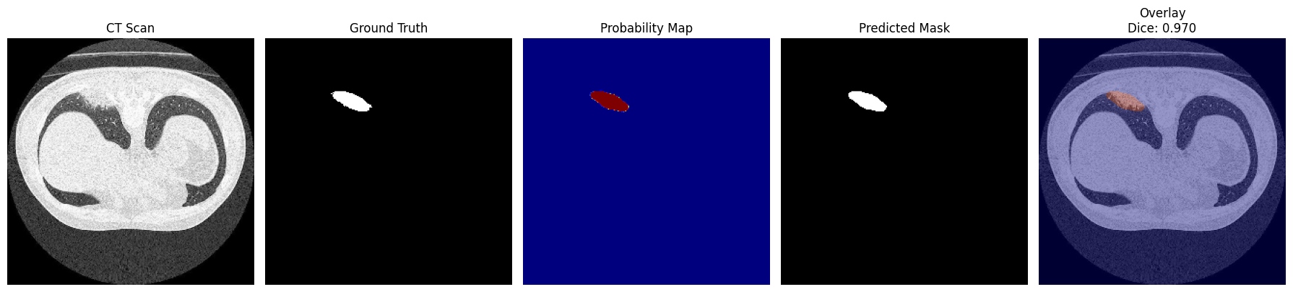
Figure 7.8: Best test prediction (Dice 0.970, IoU 0.942)
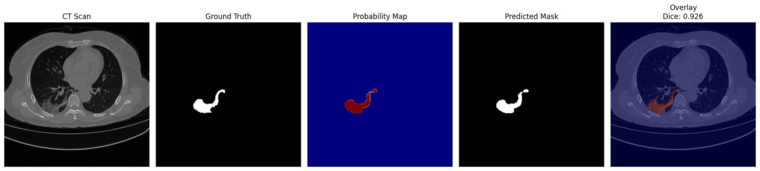
Figure 7.9: A typical test prediction (Dice 0.926)

7.3.6 Error analysis
The worst test predictions had a Dice of 0.0000, which means that the model missed the annotated nodule completely (this happened for the worst case, test image 206, and for one of the five randomly selected samples, image 139). Failure cases of this type are typical for very small nodules whose area is a few pixels, where a one-pixel boundary error produces a large relative error and where low contrast makes the nodule hard to distinguish from vessels. This is also consistent with the median nodule coverage of only 0.75 percent. The cases are an argument for keeping the clinician in the loop and for reporting the maximum and mean confidence rather than a bare yes or no.
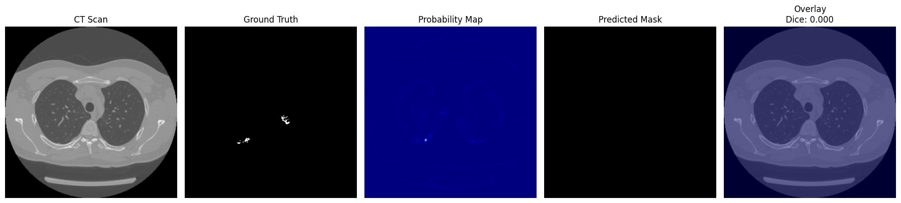
Figure 7.10: Worst test prediction (Dice 0.000): the nodule is missed

7.4 System-level Results
The integrated system implements the complete workflow end to end. A doctor signs in, registers a patient, uploads an image and receives within the same page the fourteen probabilities, colour-coded severity badges, the Grad-CAM overlay, the nodule mask overlay with area and confidence values, and a list of recommendations. The scan, the overlays and the probabilities are stored and are shown again in the patient’s history. A PDF report is produced with one click, and the assistant can answer questions about the displayed scan. Both models are invoked in parallel from the server, so the waiting time is determined by the slower of the two.
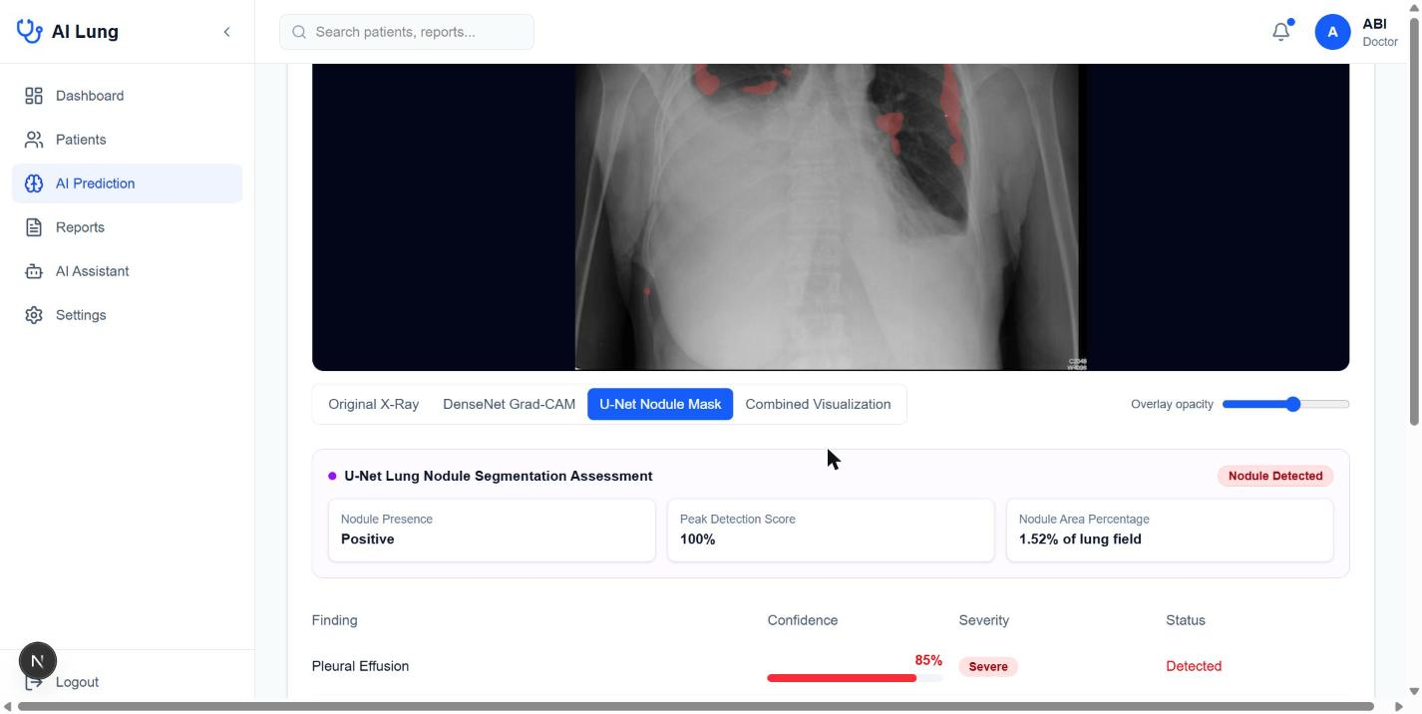
Figure 7.11: Prediction result: U-Net nodule mask overlay with the nodule assessment (presence, peak detection score, area percentage)
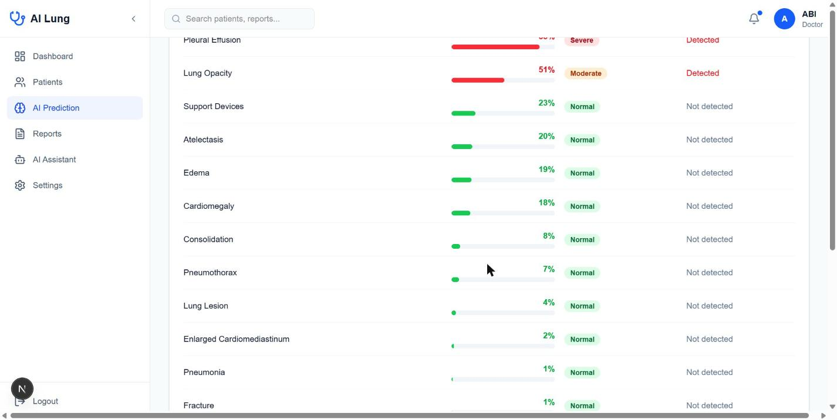
Figure 7.12: Prediction result: fourteen findings with confidence bars, severity badges and detection status at a threshold of 50 percent
For this example scan the application reported pleural effusion with a confidence of 85 percent (severe) and lung opacity with 51 percent (moderate) as detected findings at the 50 percent threshold, while the remaining findings, such as support devices (23 percent), atelectasis (20 percent), edema (19 percent) and cardiomegaly (18 percent), stayed below the threshold. The U-Net assessment flagged a nodule with an area of 1.52 percent of the image.

7.5 Discussion
The segmentation results are strong and consistent: a Dice coefficient above 0.89 on every split, a flat threshold curve, and balanced precision and recall. The classifier is a harder problem (mean validation AUC 0.727, and no usable operating point at the default 0.50 threshold), because chest radiograph labels extracted from reports are noisy, the uncertain labels were mapped to zero, and several findings are inherently ambiguous on a projection image. The fact that the first training run showed useful AUC values but poor threshold-based metrics motivated the focal loss and the per-label thresholds, and these are the elements that carry the most weight in the interpretation of the classifier’s results.
Two practical points deserve attention. First, the web application currently applies a single, administrator-defined threshold (default 0.5) to the probabilities returned by the classifier service, whereas the notebooks compute per-label optimal thresholds; loading optimal_thresholds.json in the application would make the displayed decisions consistent with the evaluation. Second, the U-Net was trained on CT slices of 256 × 256 pixels, and its use on arbitrary uploaded images assumes that the input resembles the training modality. These points are listed in the limitations in the next chapter.

8. ADVANTAGES, DISADVANTAGES AND APPLICATIONS

8.1 Advantages
- Two complementary AI tasks in one workflow. The system combines multi-label classification of fourteen thoracic findings with pixel-level nodule segmentation, which gives both a broad screening view and a precise localisation.
- Explainability. Grad-CAM heatmaps and mask overlays let the clinician check what the network is looking at, which builds trust and exposes shortcut learning.
- Fast first reading. Both models are called concurrently, and the result is available within seconds, which can help to prioritise urgent studies.
- Modular, replaceable models. Each model is an independent REST service in a Docker container. A new model can be dropped in without touching the web application, and the services can be scaled independently on GPU hosts.
- Complete clinical workflow. Authentication, patient records, scan history, recommendations, PDF reports and a conversational assistant are provided, which makes the system usable as an application rather than a model demonstration.
- Careful handling of class imbalance. Class-balanced focal loss and per-label threshold selection address the weakness that most affects rare but serious findings.
- Privacy-aware design. Secrets stay on the server, passwords are hashed, cookies are HTTP-only and the language model never receives identifying data.
- Low cost and open technology. All components are open-source or have free tiers, and the system can run on modest hardware because inference does not require a GPU.
- Transparent for the user. Severity badges, confidence percentages and a standard disclaimer make clear that the output is advisory.

8.2 Disadvantages and Limitations
- No clinical validation. The models were evaluated on public research data only. Prospective validation on local hospital images, with radiologist-confirmed ground truth, has not been performed, and the system is not a certified medical device.
- Label noise in CheXpert. The training labels were extracted automatically from reports, so some are wrong. Uncertain labels were mapped to zero (the U-Zeros policy), which can bias the classifier towards under-calling findings.
- Dataset bias and generalisation. CheXpert was collected at a single institution in the United States. Differences in equipment, patient population and disease prevalence can reduce accuracy at other sites, including Indian hospitals.
- Modest classifier performance. On the validation split the mean AUC of the classifier is 0.727, and at the default threshold of 0.50 only two labels produce any positive prediction. The classifier is therefore suitable as a ranking and screening aid with tuned thresholds, not as a stand-alone detector.
- Rare labels remain hard. Findings such as pneumothorax, pleural other and lung lesion have few positive examples, and a high AUC does not guarantee useful precision at the operating point.
- Modality mismatch for the nodule model. The U-Net was trained on 256 × 256 CT slices. Applying it to plain chest radiographs is not what it was trained for and its output on such images should be treated with caution; a dedicated radiograph nodule data set would be needed for that use.
- Two-dimensional analysis only. The system processes single images; it does not use patient history, prior images, lateral views or 3-D CT volumes.
- Small nodules are missed. Nodule segmentation shows failures for very small lesions (Dice 0 on the worst test images).
- Threshold inconsistency. The web application uses one global threshold, while the evaluation notebooks derive optimal per-label thresholds.
- Dependence on external services. The assistant needs the Groq API and internet access, and large language models can produce incorrect text; the assistant is therefore restricted by its system prompt and labelled advisory.
- Automation bias. Clinicians may over-trust a confident-looking AI output; this is a human-factors risk that the interface mitigates but cannot remove.
- Format restrictions. Only PNG and JPEG images are accepted. DICOM files must be converted first, which discards metadata and bit depth.

8.3 Applications

8.3.1 Clinical decision support
In a hospital, the system can act as a second reader. It can flag studies with likely pneumothorax, large effusions or consolidations so that they are reported first, and it can draw the reader’s attention to subtle opacities that might otherwise be overlooked.

8.3.2 Screening in primary care and rural clinics
Where no radiologist is available, a general practitioner can use the tool to obtain a structured preliminary interpretation, decide whether to refer the patient, and attach a report to the referral. Because the services run on modest hardware, they can be deployed in a district hospital or a mobile screening unit.

8.3.3 Teleradiology and referral
The standard report with the original image, heatmap and findings table can be sent to a remote specialist, who can confirm or correct the result quickly.

8.3.4 Medical education and training
Students can see how a network reasons by comparing the heatmap with their own reading, and can use the stored scans of a teaching case to study how probabilities change with the threshold.

8.3.5 Research and benchmarking
Because the models sit behind a REST interface, researchers can swap in new architectures, compare them with the same interface and data store, and collect doctor feedback.

8.3.6 Occupational and public health screening
The approach can be extended to workers exposed to dust or chemicals, and to population screening programmes for tuberculosis and other chest disease, subject to proper validation.
Table 8.1: Application settings of the system
Setting | Role of the system | Key requirement
Hospital radiology | Triage and second reader | Integration with PACS, validation
Primary-care clinic | Preliminary interpretation | Simple interface, referral report
Teleradiology | Pre-annotated studies | Secure transfer, audit trail
Teaching institution | Explainable demonstrations | Case library
Research group | Benchmark platform | Replaceable models

9. CONCLUSION

9.1 Summary
This project designed, trained, evaluated and deployed an AI-based system for detecting lung abnormalities in medical images. Two deep-learning models form its core. A DenseNet121 classifier, trained with transfer learning on the CheXpert data set, produces probabilities for fourteen chest findings and an explanatory Grad-CAM heatmap. A U-Net, trained on 5,070 annotated CT slices, segments lung nodules and reaches a test Dice coefficient of 0.906 and an IoU of 0.828 with balanced precision (0.908) and recall (0.904). Around the models a complete web application was built with Next.js, PostgreSQL and Docker-packaged inference services, providing secure login, patient management, scan history, recommendations, PDF reports and a privacy-conscious AI assistant.
The development process produced several practical lessons that are of value beyond this project: the shuffle buffer is a memory budget; a global 0.5 threshold is inappropriate for imbalanced multi-label problems; gradient clipping protects mixed-precision training; Grad-CAM must be adapted to nested Keras models; and separating inference from the application makes models replaceable and deployment flexible.

9.2 Objectives Achieved
Table 9.1: Achievement of the project objectives
Objective | Status
Multi-label classifier for 14 findings (DenseNet121) | Implemented and deployed as a service
Nodule segmentation with U-Net | Implemented; Dice 0.906 and IoU 0.828 on the test set
Explainability with Grad-CAM | Implemented and integrated in the interface and report
Secure role-based web application | Implemented (JWT cookie, bcrypt, route protection)
Separate inference services | Implemented with FastAPI and Docker Compose
Report generation and history | Implemented (PDF reports, scan history)
Evaluation with appropriate metrics | Segmentation complete; classifier AUC table included (mean AUC 0.727), optimal thresholds and curves to be added

9.3 Future Scope
- Clinical validation. Evaluate the system prospectively on hospital images against radiologist reports, with sensitivity and specificity per finding and a reader study.
- Use of per-label thresholds in the application. Load optimal_thresholds.json in the inference service so that decisions in the interface match the evaluation.
- Better handling of uncertainty labels. Compare U-Ones, U-MultiClass and soft-label strategies with the U-Zeros policy used here, and train with a higher-resolution input (320 × 320 or more).
- Ensembles and newer backbones. Test EfficientNet, ConvNeXt or vision transformers, and ensembles with test-time augmentation.
- Radiograph nodule data. Train a segmentation or detection model on chest radiographs with nodule annotations, and extend to 3-D CT volumes with a 3-D U-Net.
- Calibration and uncertainty. Add temperature scaling or Monte-Carlo dropout so that probabilities are well calibrated and uncertain cases are flagged.
- DICOM and PACS integration. Accept DICOM directly, preserve metadata and connect to hospital PACS through DICOMweb.
- Multi-GPU and faster training. Retry distributed training once the single-GPU pipeline is stable, and export models to ONNX or TensorRT for faster inference.
- Multilingual reports. Generate reports and assistant responses in regional languages.
- Audit and compliance. Add audit logs, role-specific permissions, encryption at rest and a consent workflow for data protection compliance.
- Continuous learning. Collect doctor corrections (with consent) to monitor performance drift and to retrain periodically.

9.4 Concluding Remarks
The project shows that a clinically oriented application can be built around open data, open frameworks and modest hardware, and that explainability, careful treatment of imbalance and a clear separation of concerns are as important to such a system as the accuracy of the network itself. The system is intended as a decision-support tool that helps a clinician to read an image faster and with more information, and the final judgement and responsibility remain with the qualified medical professional.

REFERENCES
[1] Irvin, J., Rajpurkar, P., Ko, M., et al. (2019). CheXpert: A large chest radiograph dataset with uncertainty labels and expert comparison. Proceedings of the AAAI Conference on Artificial Intelligence, 33(01), 590–597.
[2] Huang, G., Liu, Z., van der Maaten, L., and Weinberger, K. Q. (2017). Densely connected convolutional networks. Proceedings of the IEEE Conference on Computer Vision and Pattern Recognition (CVPR), 4700–4708.
[3] Rajpurkar, P., Irvin, J., Zhu, K., et al. (2017). CheXNet: Radiologist-level pneumonia detection on chest X-rays with deep learning. arXiv:1711.05225.
[4] Wang, X., Peng, Y., Lu, L., Lu, Z., Bagheri, M., and Summers, R. M. (2017). ChestX-ray8: Hospital-scale chest X-ray database and benchmarks on weakly-supervised classification and localization of common thorax diseases. CVPR, 2097–2106.
[5] Johnson, A. E. W., Pollard, T. J., Berkowitz, S. J., et al. (2019). MIMIC-CXR, a de-identified publicly available database of chest radiographs with free-text reports. Scientific Data, 6, 317.
[6] Ronneberger, O., Fischer, P., and Brox, T. (2015). U-Net: Convolutional networks for biomedical image segmentation. Medical Image Computing and Computer-Assisted Intervention (MICCAI), LNCS 9351, 234–241.
[7] Selvaraju, R. R., Cogswell, M., Das, A., Vedantam, R., Parikh, D., and Batra, D. (2017). Grad-CAM: Visual explanations from deep networks via gradient-based localization. IEEE International Conference on Computer Vision (ICCV), 618–626.
[8] Lin, T.-Y., Goyal, P., Girshick, R., He, K., and Dollár, P. (2017). Focal loss for dense object detection. ICCV, 2980–2988.
[9] Deng, J., Dong, W., Socher, R., Li, L.-J., Li, K., and Fei-Fei, L. (2009). ImageNet: A large-scale hierarchical image database. CVPR, 248–255.
[10] Kingma, D. P., and Ba, J. (2015). Adam: A method for stochastic optimization. International Conference on Learning Representations (ICLR).
[11] Milletari, F., Navab, N., and Ahmadi, S.-A. (2016). V-Net: Fully convolutional neural networks for volumetric medical image segmentation. International Conference on 3D Vision (3DV), 565–571.
[12] Abadi, M., Barham, P., Chen, J., et al. (2016). TensorFlow: A system for large-scale machine learning. 12th USENIX Symposium on Operating Systems Design and Implementation (OSDI), 265–283.
[13] Chollet, F., et al. (2015). Keras. https://keras.io
[14] Ioffe, S., and Szegedy, C. (2015). Batch normalization: Accelerating deep network training by reducing internal covariate shift. ICML, 448–456.
[15] Srivastava, N., Hinton, G., Krizhevsky, A., Sutskever, I., and Salakhutdinov, R. (2014). Dropout: A simple way to prevent neural networks from overfitting. Journal of Machine Learning Research, 15, 1929–1958.
[16] Kaggle dataset: CheXpert (mirror of CheXpert-v1.0-small), ashery/chexpert. https://www.kaggle.com/datasets/ashery/chexpert
[17] Kaggle dataset: Lung Nodule Dataset, ucimachinelearning/lung-nodule-dataset. https://www.kaggle.com/datasets/ucimachinelearning/lung-nodule-dataset
[18] Next.js documentation. Vercel Inc. https://nextjs.org/docs
[19] Prisma ORM documentation. https://www.prisma.io/docs
[20] FastAPI documentation. https://fastapi.tiangolo.com
[21] Jones, M., Bradley, J., and Sakimura, N. (2015). JSON Web Token (JWT). RFC 7519, Internet Engineering Task Force.

