Software Requirements Specification
For
Customer Relationship Management System
Version 1.0 Approved
Prepared by: Sanvi Kumari
HCL Training
Date: - 02/01/2026
Submitted in partial fulfillment
Of the requirements of
Software Engineering(Agile Methodology)
Table of Contents
- Abstract
- Introduction
  - Introduction
  - Problem Identification
  - Need of the Project
  - Project Scheduling
  - Objectives
- Software Requirement Specification
  - Purpose
  - Scope
  - Hardware Requirement / Software Requirement
  - Tools
  - Software Process Model
- System Design
  - Data Dictionary
  - ER Diagram
  - Data Flow Diagram (DFD)
  - System Flow Chart / Object Diagram / Class Diagram / State Diagram / Activity Diagram / Use Case Diagram
- Implementation
  - Program Code
  - Output Screens
- Testing
  - Test Data
  - Test Result
- User Manual
  - How to Use Project Guidelines
  - Screen Layouts and Description
- Project Applications and Limitations
- Conclusion and Future Enhancement
- Bibliography and References

1 . Abstract
TheCustomer Relationship Management (CRM) System is a web-based application designed to manage a company’s interactions with current and potential customers. The system centralizes customer information, including personal details, contact information, purchase history, and communication logs. It aims to improve customer service, streamline sales and marketing processes, and provide data-driven insights for decision- making.
Modern businesses face challenges in handling customer data manually or through scattered tools. Manual systems lead to inefficiencies, delayed responses, and poor customer experience. The CRM system solves these issues by providing a unified platform for storing, tracking, and analyzing customer information. Sales and marketing teams can efficiently manage leads, track opportunities, schedule follow-ups, and monitor campaign effectiveness.
The system offers features such as customer management, lead and opportunity tracking, sales pipeline management, marketing campaign monitoring, reporting, and role-based access. Admin users can manage system users and permissions, ensuring data security. The system is accessible via web browsers and is designed to be user-friendly, secure, and scalable. The CRM system will improve operational efficiency by automating repetitive
tasks, maintaining accurate records, and providing actionable insights through reports and analytics. It reduces data redundancy and allows organizations to maintain stronger relationships with their customers, resulting in increased satisfaction and revenue growth.
The project will be implemented using a modular approach, allowing future enhancements such as integration with third-party email services, mobile application support, and advanced analytics using AI. By providing a structured and centralized approach to customer management, the CRM system becomes a vital tool for business growth and customer satisfaction.
2. Introduction

2.1 Introduction
A Customer Relationship Management (CRM) system is a software application that helps organizations manage their interactions with existing and potential customers. In today’s competitive business environment, maintaining good relationships with customers is crucial for business growth, customer satisfaction, and long-term profitability.The CRM system centralizes all customer information, including personal details, contact information, purchase history, communication logs, and preferences. By having a unified platform, organizations can avoid data redundancy, reduce errors, and ensure timely follow-ups with clients.The system is designed to streamline the work of sales, marketing, and customer support teams. Sales executives can track leads and opportunities, marketing teams can manage campaigns and analyze customer responses, and support staff can quickly access customer history to resolve issues efficiently.
Moreover, the CRM system provides reporting and analytics features that allow management to make data-driven decisions, improve business strategies, and identify potential areas for growth. It is a scalable, secure, and user-friendly platform that adapts to organizational needs and ensures enhanced customer engagement and satisfaction.
In summary, the CRM system acts as a bridge between a company and its customers, ensuring smooth communication, effective relationship management, and increased business efficiency.

2.2 Problem Identification
Many organizations today face significant challenges in managing their customer interactions effectively. Traditional methods, such as maintaining customer data in spreadsheets, paper files, or disconnected software, lead to inefficiencies, delays, and errors.
Some common problems include:
- Data Redundancy and Inconsistency: Customer information is often duplicated across multiple systems, leading to inconsistent records.
- Difficulty in Tracking Leads and Opportunities: Without a centralized system, sales teams struggle to monitor the progress of leads, follow-ups, and potential deals.
- Poor Customer Communication: Delays in responding to customer queries or complaints can negatively impact customer satisfaction and loyalty.
- Inefficient Reporting: Generating sales, marketing, or customer activity reports manually is time-consuming and prone to errors.
- Limited Insights for Decision-Making: Lack of analytical tools prevents management from making informed business decisions and identifying growth opportunities.
These problems result in lost sales opportunities, reduced efficiency, and a poor customer experience. The need for an automated, centralized, and user-friendly CRM system is essential to overcome these challenges, streamline business processes, and ensure better customer relationship management.

2.3 Need of the Project
The need for a Customer Relationship Management (CRM) system arises from the challenges organizations face in efficiently managing customer interactions and data. In a competitive business environment, maintaining strong relationships with customers is critical for growth, retention, and profitability.
The project is necessary to:

Conduct meetings with stakeholders to gather functional and non-functional
requirements.
Study existing manual systems and processes.
Finalize the Software Requirements Specification (SRS) document.
The
Customer Relationship Management (CRM) system
project will be executed in
multiple phases over a total duration of
weeks
9
. Each phase has specific tasks,
milestones, and dependencies to ensure smooth and systematic development.
1
.
Centralize Customer Data:
Consolidate all customer information in a single

platform, eliminating duplication and reducing errors.
2
.
Enhance Sales Efficiency:
Track leads, opportunities, and follow-ups systematically,

ensuring that sales teams can focus on converting prospects into customers.
3
.
Improve Customer Service:
Provide quick access to customer history, queries, and

complaints, enabling faster and more effective responses.
.
4
Streamline Marketing Efforts:
Plan, execute, and monitor marketing campaigns

while analyzing customer responses for better targeting.
.
5
Enable Data-Driven Decisions:
Generate detailed reports and analytics, helping

management identify trends, forecast sales, and optimize strategies.
6
.
Increase Customer Satisfaction:
By automating repetitive tasks and ensuring timely

communication, the CRM system helps in maintaining a positive customer
experience.
Project Phases and Key Activities:
Requirement Analysis (1 Week):
2.4
Project Scheduling


Milestone:
Testing (2 Weeks):
Milestone:

System Design (2 Weeks):
Milestone:
Implementation / Coding (3 Weeks):
Milestone:

Deployment & Documentation (1 Week):
CompletionofSRS document by the end of Week 1.
Conduct unit testing, integration testing, and system testing.
Perform performance and security testing.
Fix all identified bugs and ensure the system meets the requirements.
Completionof testing by theend of Week 8.
Deploy the CRM system on a web server.
Prepare user manuals, help guides, and project documentation.
Conduct final review and acceptance testing.
Milestone:
Final deployment and project submission by the end of Week 9.
Create system architecture, database schema, data flow diagrams (DFDs), and
class diagrams.
Design user interface layouts and plan module interactions.
Review and approval of the design by stakeholders.

Completion of system design by the end of Week 3.
Develop core modules such as Customer Management, Lead Tracking, Sales,
Marketing, and Reporting.
Integrate modules with the database.
Perform unit testing concurrently with coding to identify and fix issues early.

Completion of coding by the end of Week 6.
2.5
Objectives


Improve customer satisfaction and loyalty through timely responses, personalized
services, and consistent communication.
Increase sales conversion rates by monitoring leads and managing opportunities
efficiently.
The
Customer Relationship Management (CRM) system
is designed to streamline
customer management, improve business processes, and provide actionable insights. The
objectives of the project can be classified into
functional, business, technical,
operational, and user-oriented objectives
as follows:
Maintain a centralized and structured database of all customers, including personal
details, contact information, purchase history, and communication logs.
Enable tracking of leads, opportunities, and sales pipelines to optimize the sales
process.
Automate marketing campaigns and monitor customer engagement for improved
targeting and ROI.
Provide role-based access to users, ensuring that Admin, Sales, and Marketing teams
can access appropriate functionalities.
Generate detailed reports and dashboards on sales, leads, marketing campaigns, and
customer interactions for better analysis.
Enable real-time notifications for follow-ups, tasks, and reminders to prevent delays
in customer interactions.
Provide search, filter, and sort functionalities for efficient retrieval of customer and
sales data.
Business Objectives:
Functional Objectives:

Develop a secure system with password-protected login, encryption of sensitive
customer data, and role-based access control.
Ensure system reliability and availability by designing a robust architecture and
database management system.
Make the system web-based and responsive so it can be accessed on desktops,
laptops, and mobile devices.
Support interoperability with other software tools such as email, calendar, and
reporting tools for seamless workflow integration.
Minimize time spent on repetitive tasks such as data entry, follow-ups, and report
generation through automation.
Provide a system that is easy to maintain and update with minimal downtime.
Enable quick onboarding for new users with simple, intuitive, and user-friendly
interfaces.
Reduce manual errors, duplication of data, and inefficiencies in business processes.
Support strategic decision-making by providing analytics, trends, and insights from
customer data. Enable business scalability by supporting future integrations with AI
tools,
mobile
applications,
or
third-party
services.
Improve
overall
organizational
productivity
and
coordination
between
Sales,
Marketing,
and
Customer
Support
teams.
Technical Objectives:
Operational Objectives:
User-Oriented Objectives:

The main goals of the CRM system are:
Allow easy navigation and access to customer, sales, and marketing data.
Provide visual dashboards for quick insights and status updates.
Facilitate better collaboration among team members through shared data, notes, and
updates.
Ensure customization options for reporting, notifications, and user preferences to
match individual roles and needs.
Centralized Customer Management:
Maintain comprehensive customer records
including personal details, contact information, purchase history, and communication
logs in a single system.
Sales and Lead Tracking:
Monitor and manage leads, opportunities, and the sales

pipeline to improve conversion rates and revenue generation.
Marketing Automation:
Plan, execute, and analyze marketing campaigns efficiently

by tracking customer responses and engagement.
The purpose of the
Customer Relationship Management (CRM) system
is to provide a
centralized,
secure,
and
efficient
platform
to
manage
customer
interactions,
improve
business
processes,
and
enhance
overall
organizational
productivity.
The
system
is
designed
to
help
businesses
store,
organize,
and
retrieve
customer
information
in
a
structured manner while facilitating communication between sales, marketing, and support
teams.
3
. Software Requirement Specification
Purpose
3.1

In essence, the CRM system is intended to act as a
strategic tool for businesses
to
enhance customer relationships, improve operational efficiency, and support long-term
growth.
Reporting and Analytics:
Provide actionable insights through dashboards and
detailed reports to help management make informed decisions.
Secure Access and Role Management:
Ensure data security through role-based
permissions, encryption, and secure login mechanisms.
Operational Efficiency:
Reduce time spent on manual tasks such as follow-ups,
report generation, and data entry, allowing teams to focus on value-driven activities.
Future Scalability:
Provide a flexible architecture that allows for future integration
with AI tools, mobile applications, and third-party services.
The
Customer Relationship Management (CRM) system
is designed to centralize
customer information and streamline business processes for sales, marketing, and support
teams. The system will allow organizations to manage customer details, track leads and
opportunities, monitor sales activities, and run marketing campaigns efficiently. It will
also generate reports and dashboards to provide insights into customer interactions, sales
performance, and campaign effectiveness. Admin users will have control over user
management and role-based access, ensuring security and proper data handling. The
system will be web-based, user-friendly, and scalable, capable of handling an increasing
number of customers and transactions. Features such as mobile access, AI-powered
analytics, and third-party integrations are not included in the initial version but can be
added in future enhancements. Overall, the CRM system will improve operational

3.2
Scope

The

access.
Web Browsers:
Google Chrome, Mozilla Firefox, or Microsoft Edge for seamless
user interaction.
Development Tools / IDEs:
Eclipse or Visual Studio Code for coding and project

development.
minimum software requirements
include:
Operating System:
Windows 10 or Linux (Ubuntu) to support both personal

computers and servers.
Database Management System:
MySQL or Oracle for storing, retrieving, and

managing customer information securely.
Web Server:
Apache Tomcat or XAMPP to host the CRM application for online

efficiency, enhance customer satisfaction, and support informed decision-making within
the organization.
The
Customer Relationship Management (CRM) system
is designed to run efficiently
on standard hardware and software configurations to ensure accessibility and smooth
performance for users. The
minimum hardware requirements
include a processor
equivalent to
Intel i3 or higher
, a minimum of
GB RAM
4
,
GB of storage
100
, and a
reliable
internet connection
to access the web-based system. These specifications ensure
that the system can handle multiple users, process customer data efficiently, and generate
reports without delays.
Hardware Requirement / Software Requirement
3.3


These tools collectively provide a

ensuring that the CRM system is

These hardware and software requirements ensure that the CRM system operates

and securely
, supports
multi-user access
, and provides

reporting
. Proper configuration of these resources is essential for maximizing system
performance, maintaining data integrity, and ensuring a smooth user experience.
The development of the
Customer Relationship Management (CRM) system
requires
various tools to ensure efficient coding, design, testing, and project management. The
tools include:
Programming Languages:
Java for backend development and HTML, CSS,
JavaScript for frontend development, ensuring a responsive and interactive interface.
Database Management:
MySQL or Oracle for storing, retrieving, and managing

customer information securely and efficiently.
Design Tools:
Draw.io or Lucidchart for creating ER diagrams, DFDs, class

diagrams, and workflow visualizations.
Version Control:
Git and GitHub for source code management, tracking changes,

and collaborative development.
Testing Tools:
Manual testing and browser-based testing tools to verify

functionalities, performance, and user interface reliability.
Development Environment:
IDEs such as Eclipse or Visual Studio Code to provide

a complete coding and debugging environment.
,

. Using the

structured and efficient development environment
secure, reliable, maintainable, and scalable
reliably

fast data processing and
Tools
3.4

right combination of programming, database, design, and testing tools also helps the
project stay organized, reduces errors, and improves overall productivity.
In this approach, the development is divided into
multiple sprints
, with each sprint
focusing on specific modules such as Customer Management, Lead Tracking, Sales,
Marketing, and Reporting. Each sprint includes
design, coding, and testing
, allowing

early detection of errors and providing the flexibility to make changes based on

stakeholder feedback. Agile also emphasizes

and users
, ensuring that functional and business objectives are aligned throughout the

project lifecycle.
Iterative and incremental development to deliver functional modules progressively.
Continuous testing and quality assurance to identify and fix issues early.
Regular stakeholder reviews and feedback to refine requirements and design.
Flexibility to accommodate changing requirements or new features during
development.
Focus on delivering a usable system after each sprint to enable early adoption and
testing.
The
Customer Relationship Management (CRM) system
will be developed using the
Agile Software Development Model
. Agile is chosen because it allows iterative
development, continuous testing, and frequent feedback from stakeholders, which ensures
that the system meets user requirements effectively and efficiently.
Key features of the Agile model for this CRM project include:
collaborationamongdevelopers,testers,

3.5
Software Process Model
Using the Agile model ensures that the CRM system is reliable, scalable, and adaptable while meeting all functional and non-functional requirements. This approach also reduces development risk, improves project visibility, and enhances customer satisfaction by involving end-users throughout the development process.

4. System Design
The system design phase defines how the CustomerRelationshipManagement(CRM) system will be structured to meet the requirements outlined in the SRS. It includes detailed descriptions of data, relationships, workflows, and system modules. Proper design ensures efficient coding, easy maintenance, and smooth operation of the system.

4.1 Data Dictionary
A Data Dictionary provides a detailed description of all the data elements used in the CRM system. It defines data types, size, description, and purpose for each element.
Below is an example of the key data elements:
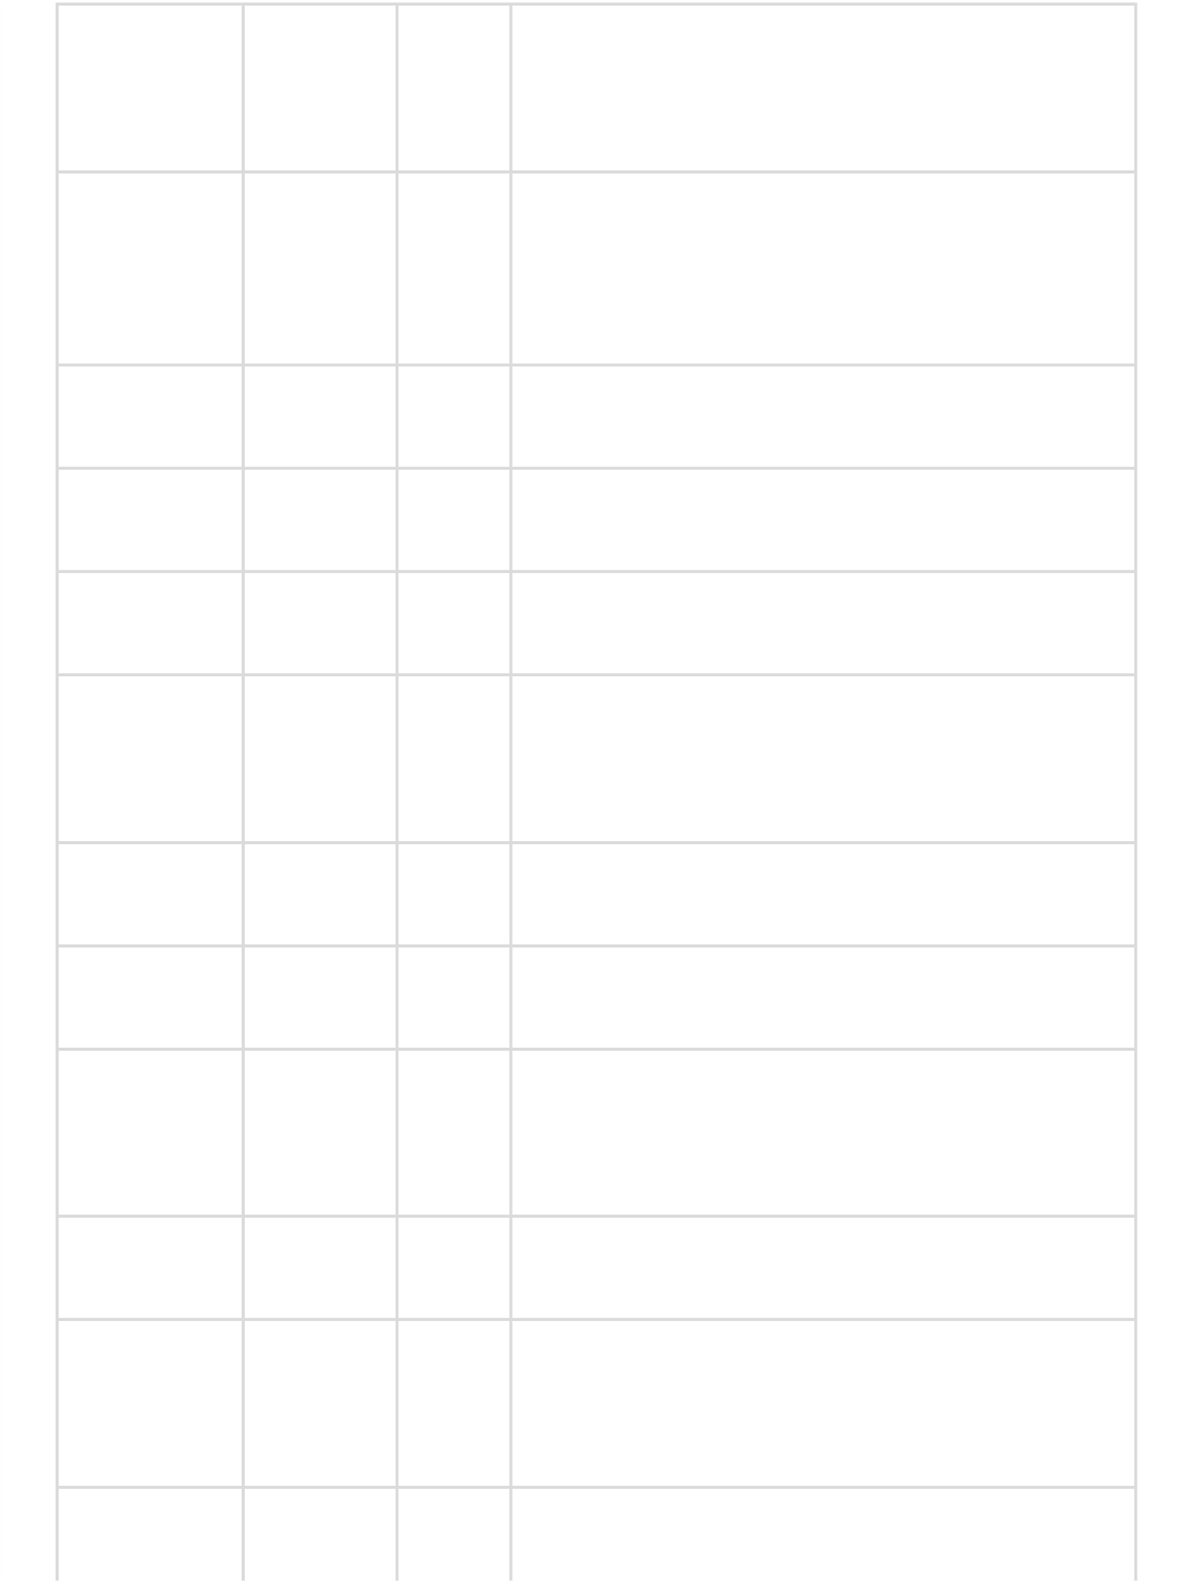
Email
UserID
LeadID
SalesID
Address
PhoneNu
mber
Data
Element
Customer
ID
LeadStatu
s
Campaign
ID
LastName
FirstName
Data
Type
Integer
Integer
Integer
Integer
Integer
Varchar
Varchar
Varchar
Varchar
Varchar
Varchar
10
50
50
15
10
20
10
10
10
100
150
Size
Description / Purpose
Customer’s last name
Customer’s first name
Customer’s email address
Customer’s postal address
Customer’s contact number
Unique identifier for system users
Status of the lead (New, Contacted,
Converted)
Unique identifier for each sales lead
Unique identifier for each customer
Unique identifier for each marketing
campaign
Unique identifier for each sales record
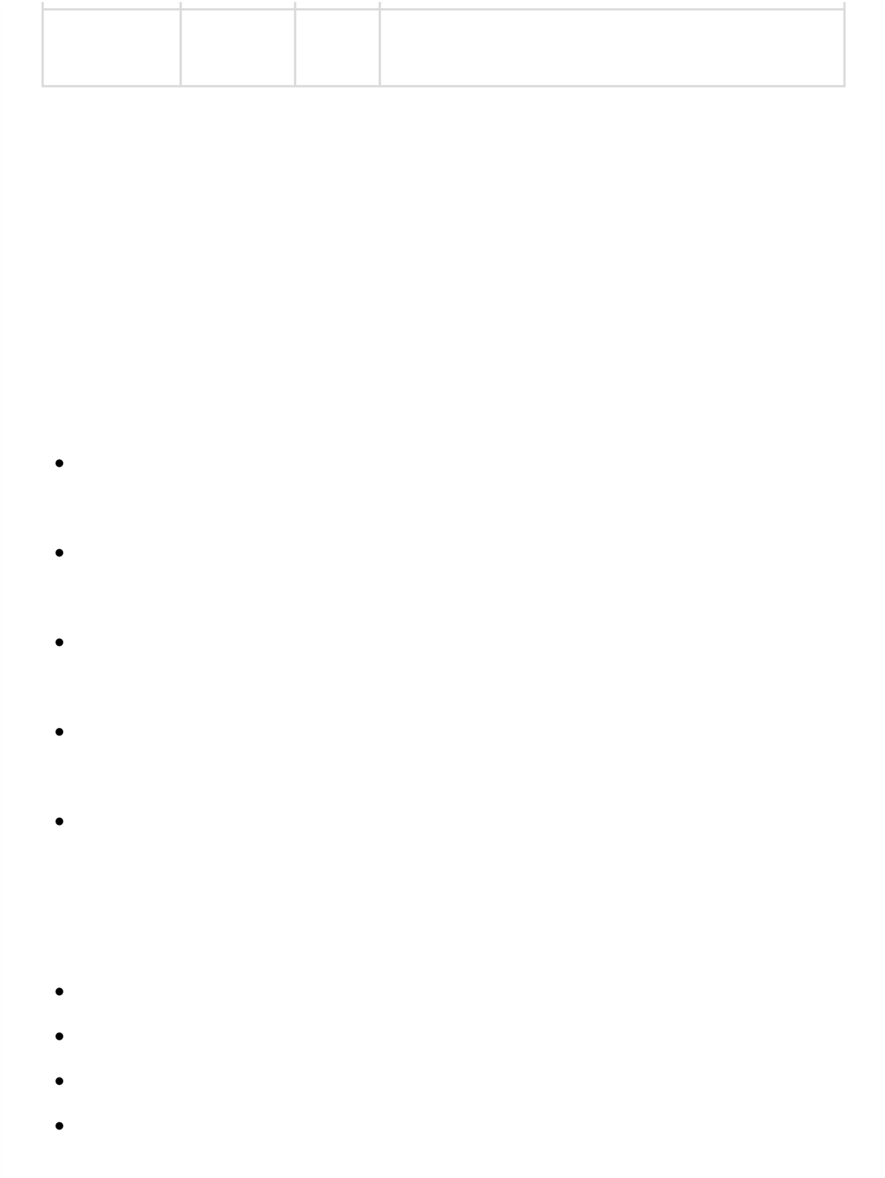
Role
Varchar
20
4.2
ER Diagram (Entity-Relationship Diagram
)
User role (Admin, Sales, Marketing)
This dictionary ensures that

confusion and errors during development.
One customer can have multiple leads (1:N).
One lead can generate multiple sales (1:N).
Users manage multiple leads, sales, and campaigns (1:N).
Campaigns can target multiple customers and vice versa (M:N).
The
ER Diagram
of the CRM system represents the main data entities and their
relationships. The primary entities are

, avoiding

Customer:
Stores personal and contact information (CustomerID, Name, Email,
Phone, Address).
Lead:
Tracks potential customers and their progress (LeadID, Status, Source,

CustomerID).
Sales:
Records sales transactions linked to leads and customers (SalesID, Date,

Amount, CustomerID, LeadID).
Campaign:
Stores marketing campaign details (CampaignID, Name, Start/End Date,

TargetAudience).
User:
Represents system users with roles like Admin, Sales, and Marketing (UserID,

Username, Role).
Relationships:
allteammembers understand the data structure
Customer, Lead, Sales, Campaign, and User
.
The ER diagram visually shows these entities as rectangles, attributes as ovals, and relationships as diamonds, with proper cardinality, making the system structure clear for development and implementation.
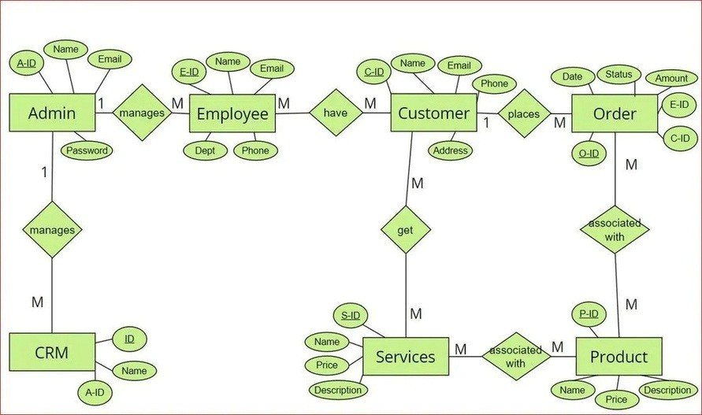

4.3 DFD (Data Flow Diagram)
The Data Flow Diagram (DFD) illustrates how data moves within the CRM system and how it is processed to achieve the required outputs.
At Level 0 (Context Level), the CRM system interacts with external entities such as Users (Admin, Sales Executive, Marketing Executive) and external systems like email or reporting tools. It shows the system as a single process that receives input data and provides outputs like reports and notifications.
At Level 1, the system is broken down into key processes: Customer Management, Lead Tracking, Sales Management, Campaign Management, and Reporting & Analytics. Data flows between these processes and data stores such as Customer Data, Lead Data, Sales Data, Campaign Data, and User Data.
The DFD clearly depicts how information is collected, updated, and accessed, ensuring that all system processes are efficiently organized and that the flow of data is smooth, secure, and reliable.
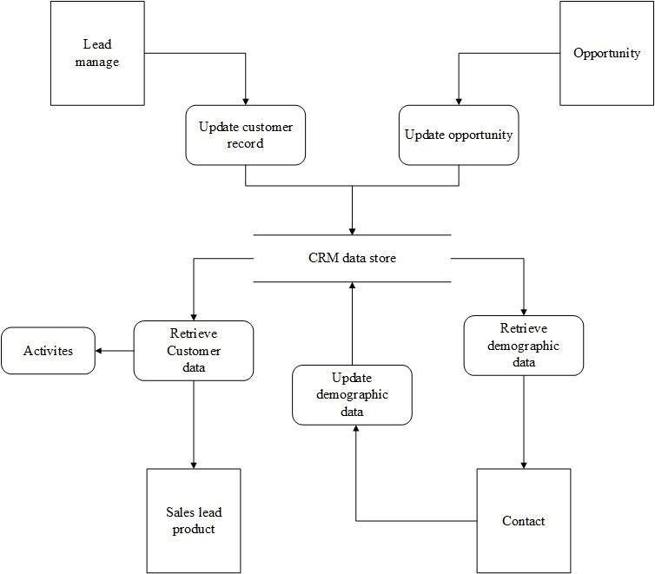

5. Implementation
The implementation phase of the CRM system involves converting the system design into a functional application. This includes writing code for all modules, integrating the database, implementing business logic, and testing to ensure correct functionality. The system is developed using Java for backend, HTML/CSS/JavaScript for frontend, and MySQL for database management.

5.1 Program Code
The program code of the CRM system is organized into modular components to ensure maintainability, scalability, and clarity. Each module corresponds to a specific functionality of the system, allowing independent development, testing, and integration. The system is developed using Java for backend logic, JDBC for database connectivity, and HTML/CSS/JavaScript for the frontend interface.

Project Structure
CRM_Project/
│
├── src/
│ ├── Main.java
│ ├── DatabaseConnection.java
│ ├── Customer.java
│ ├── Lead.java
│ ├── Sales.java
│ ├── User.java
│ ├── CRMOperations.java
│
└── lib/
└── mysql-connector-java.jar

1. Database Setup (MySQL)
CREATE DATABASE crm_system;
USE crm_system;
CREATE TABLE users (
userID INT PRIMARY KEY AUTO_INCREMENT,
username VARCHAR(50) NOT NULL,
password VARCHAR(50) NOT NULL,
role VARCHAR(20) NOT NULL
);
CREATE TABLE customers (
customerID INT PRIMARY KEY AUTO_INCREMENT,
firstName VARCHAR(50),
lastName VARCHAR(50),
email VARCHAR(100),
phone VARCHAR(15)
);
CREATE TABLE leads (
leadID INT PRIMARY KEY AUTO_INCREMENT,
customerID INT,
status VARCHAR(20),
assignedTo INT,
FOREIGN KEY (customerID) REFERENCES customers(customerID),
FOREIGN KEY (assignedTo) REFERENCES users(userID)
);
CREATE TABLE sales (
salesID INT PRIMARY KEY AUTO_INCREMENT,
customerID INT,
leadID INT,
amount DOUBLE,
salesDate DATE,
FOREIGN KEY (customerID) REFERENCES customers(customerID),
FOREIGN KEY (leadID) REFERENCES leads(leadID)
);

2. Database Connection (DatabaseConnection.java)
import java.sql.*; public class DatabaseConnection {
private static final String URL = "jdbc:mysql://localhost:3306/crm_system";
private static final String USER = "root"; // your DB username
private static final String PASSWORD = ""; // your DB password public static Connection getConnection() {
try {
Connection conn = DriverManager.getConnection(URL, USER, PASSWORD);
return conn;
} catch (SQLException e) {
System.out.println("Connection Failed: " + e.getMessage());
return null;
}
}
}

3. Customer Module (Customer.java)
public class Customer {
private int customerID;
private String firstName, lastName, email, phone;
public Customer(int customerID, String firstName, String lastName, String email, String phone) {
this.customerID = customerID;
this.firstName = firstName;
this.lastName = lastName;
this.email = email;
this.phone = phone;
}
public Customer(String firstName, String lastName, String email, String phone) {
this.firstName = firstName;
this.lastName = lastName;
this.email = email;
this.phone = phone;
}
public int getCustomerID() { return customerID; }
public String getFirstName() { return firstName; }
public String getLastName() { return lastName; }
public String getEmail() { return email; }
public String getPhone() { return phone; }
}

4. User Module (User.java)
public class User {
private int userID;
private String username, password, role; public User(int userID, String username, String password, String role) {
this.userID = userID;
this.username = username;
this.password = password;
this.role = role;
}
public int getUserID() { return userID; }
public String getUsername() { return username; }
public String getRole() { return role; }
}

5. Lead Module (Lead.java)
public class Lead {
private int leadID, customerID, assignedTo;
private String status;
public Lead(int leadID, int customerID, String status, int assignedTo) {
this.leadID = leadID;
this.customerID = customerID;
this.status = status;
this.assignedTo = assignedTo;
}
public int getLeadID() { return leadID; }
public int getCustomerID() { return customerID; }
public int getAssignedTo() { return assignedTo; }
public String getStatus() { return status; }
}

6. Sales Module (Sales.java)
import java.sql.Date; public class Sales {
private int salesID, customerID, leadID;
private double amount;
private Date salesDate;
public Sales(int salesID, int customerID, int leadID, double amount, Date salesDate) { this.salesID = salesID;
this.customerID = customerID;
this.leadID = leadID;
this.amount = amount;
this.salesDate = salesDate;
}
public int getSalesID() { return salesID; }
public int getCustomerID() { return customerID; }
public int getLeadID() { return leadID; }
public double getAmount() { return amount; }
public Date getSalesDate() { return salesDate; }
}

7. CRM Operations (CRMOperations.java)
import java.sql.*;
import java.util.Scanner; public class CRMOperations {
private Scanner sc = new Scanner(System.in);
// Add Customer
public void addCustomer() {
System.out.print("First Name: "); String fname = sc.nextLine();
System.out.print("Last Name: "); String lname = sc.nextLine();
System.out.print("Email: "); String email = sc.nextLine(); System.out.print("Phone: "); String phone = sc.nextLine(); try {
Connection conn = DatabaseConnection.getConnection();
String query = "INSERT INTO customers (firstName,lastName,email,phone) VALUES (?,?,?,?)"; PreparedStatement ps = conn.prepareStatement(query);
ps.setString(1, fname);
ps.setString(2, lname);
ps.setString(3, email);
ps.setString(4, phone);
ps.executeUpdate();
System.out.println("Customer Added Successfully!");
} catch (SQLException e) {
System.out.println("Error: " + e.getMessage());
}
}
// Display Customers
public void viewCustomers() {
try {
Connection conn = DatabaseConnection.getConnection();
Statement stmt = conn.createStatement();
ResultSet rs = stmt.executeQuery("SELECT * FROM customers"); System.out.println("CustomerID | FirstName | LastName | Email | Phone");
while(rs.next()) {
System.out.println(rs.getInt("customerID") + " | " + rs.getString("firstName") + " | " + rs.getString("lastName") + " | " + rs.getString("email") + " | " + rs.getString("phone"));
}
} catch(SQLException e) {
System.out.println("Error: " + e.getMessage());
}
}
// More methods for Leads, Sales, Users can be added similarly
}

8. Main Class (Main.java)
import java.util.Scanner; public class Main {
public static void main(String[] args) {
CRMOperations crm = new CRMOperations(); Scanner sc = new Scanner(System.in);
int choice;
do {
System.out.println("\n--- CRM SYSTEM ---");
System.out.println("1. Add Customer");
System.out.println("2. View Customers");
System.out.println("0. Exit"); System.out.print("Enter choice: ");
choice = sc.nextInt();
sc.nextLine(); // consume newline switch(choice) {
case 1: crm.addCustomer(); break;
case 2: crm.viewCustomers(); break;
case 0: System.out.println("Exiting..."); break;
default: System.out.println("Invalid Choice!"); break;
}
} while(choice != 0);
}
}

5.2
Output Screens
0
. Exit
. Add Lead
3
. Add Sales
5
Enter choice:
. View Sales
6
. View Leads
4
. Add Customer
1
. View Customers
2
---
CRM SYSTEM
---
When the program starts, the

Enter Customer First Name: Seetu
Enter Customer Last Name: Sharma
Enter Customer Email: seetu@gmail.com
Users select options by entering the corresponding number.
The menu repeats after each action for seamless workflow.

allows users to navigate through different modules:
The
CRM system output screens
provide a user-friendly interface for interacting with customer data, leads,
sales, campaigns, and reports. Even though the current system is
console-based
, the outputs are structured and
easy to navigate.
a) Add Customer:
main menu
. Main Menu / Dashboard
1
. Customer Management Screens
2

Assign to UserID: 2
Enter Customer ID: 1
1
| 1 | New | SalesExec
1
Lead Added Successfully!
2
| 2 | Contacted | SalesExec
2
Customer Added Successfully!
Enter Customer Phone: 9876543210
LeadID | CustomerID | Status | AssignedTo
3
| Priya | Singh | priya@gmail.com |
9988776655
2
| Rahul | Mehta | rahul@gmail.com |
9123456789
1
| Seetu | Sharma | seetu@gmail.com |
9876543210
CustomerID | FirstName | LastName | Email | Phone
Enter Lead Status (New/Contacted/Converted): New
Tracks potential customers and the progress of leads.
This shows all customers stored in the database in a clean tabular format.
a) Add Lead:
a) Add Sales:
b) View Leads:
b) View Customers:
3
. Lead Management Screens
4
. Sales Management Screens

Enter Lead ID: 1
Enter Customer ID: 1
---
SALES REPORT
---
Enter Sale Amount: 5000
Sale Recorded Successfully!
1
| 1 | 1 |
5000.0 | 2026-01-08
2
| 2 | 2 |
7500.0 | 2026-01-08
Campaign Added Successfully!
Enter Campaign Name: New Year Promo
Enter End Date (YYYY-MM-DD): 2026-01-31
Enter Start Date (YYYY-MM-DD): 2026-01-01
SalesID | CustomerID | LeadID | Amount | SalesDate
CampaignID | Name | StartDate | EndDate | TargetAudience
1
| New Year Promo | 2026-01-01 | 2026-01-31 | All Customers
Monitors marketing campaigns and customer engagement.
Displays all completed sales and links them to leads and customers.
b) View Sales:
a) Add Campaign:
b) View Campaigns:
6
. Reports Screen
5
. Campaign Management Screens

The table below shows

2
| Rahul Mehta | 1 |
7500.0
1
| Seetu Sharma | 2 |
5000.0
Generates

Can later be expanded to

CustomerID | CustomerName | Total Leads | Total Sales

used to validate the system:

for management decisions.

with charts or tables in GUI/web versions.
The
testing phase
ensures that the CRM system works correctly, meets all functional requirements, and is free
from errors. Both
unit testing
(testing individual modules) and
integration testing
(testing combined modules)
are performed. The system is tested using
sample test data
to verify that customer management, lead tracking,
sales processing, campaign management, and reporting work as expected.
sample test data
sales,leads,and campaign reports
graphical dashboards
6
. Testing
6.1
Test Data
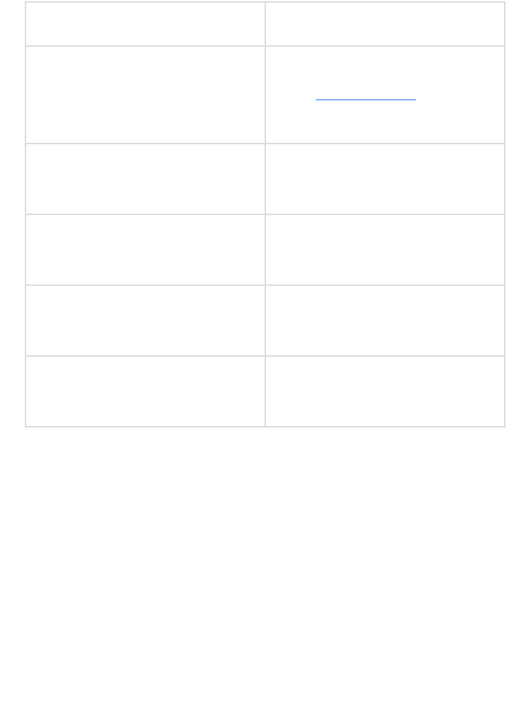
User
Sales
Lead
Module
Customer
Campaign
Input Data Example
CustomerID: 1, Status: New,
AssignedTo: 2
Username: Admin, Password:
admin123, Role: Admin
Name: New Year Promo, StartDate:
2026-01-01
, EndDate
: 2026-01-31
CustomerID: 1, LeadID: 1, Amount:
5000
, SalesDate
: 2026-01-08
FirstName: Seetu, LastName: Sharma,
Email:
seetu@gmail.com
, Phone:
9876543210
6.2
Test Result
The table below summarizes the

results after testing the sample data
:
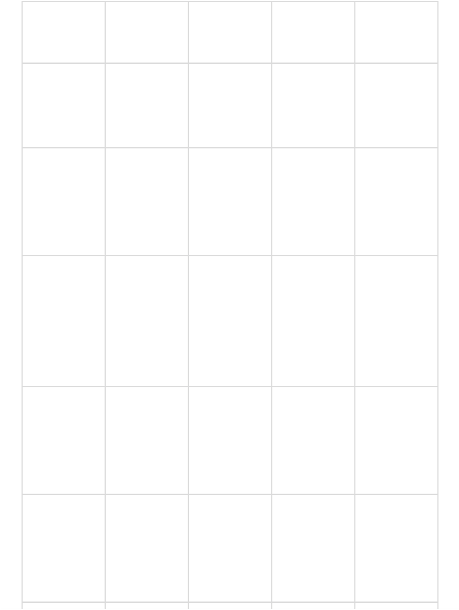
Sales
Lead
Lead
Module
Customer
Customer
Add new
customer
View all
customers
Test Case
Description
Add new lead
Add new sale
View all leads
Expected
Result
Display all
customers in
tabular
format
Customer is
added to the
database
Lead is
stored with
correct
customer and
status
Display all
leads with
status and
assigned user
Sale
recorded
and
linked
to
lead
and
customer
Leads
displayed
Customer
added
Customers
displayed
Sale added
Lead added
Actual Result
Pass
Pass
Pass
Pass
Pass
Status
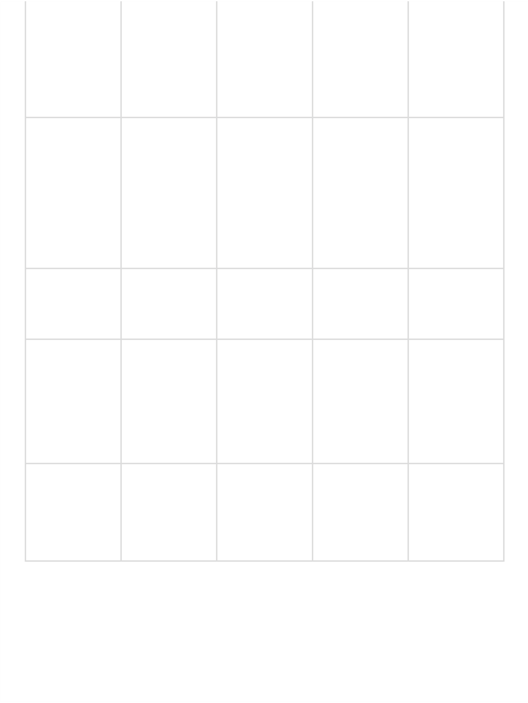
Sales
Reporting
Campaign
Campaign
User
Management
Add new
user
Add new
campaign
View sales
View
campaigns
Generate
sales report
Campaign
stored with
dates and

target

audience
Display all
campaigns
User stored
with correct
role
Display sales
records in
tabular
format
Correct
totals per
customer and
lead
Sales
displayed
Report
generated
Campaign
added
User added
Campaigns
displayed
Pass
Pass
Pass
Pass
Pass
7
. User Manual

guides users on how to operate the CRM system efficiently. It covers

, along with descriptions of each screen.
The
User Manual
module navigation,andfunctionality
installation, login,


7.1
How to Use Project Guidelines
Screen Layouts and Description
7.2
1.

2.

3.

4.

5.

. Add Lead
3
. Add Sales
5
4
. View Leads
1
. Add Customer
. View Customers
2
---
CRM SYSTEM
---
Run Main.java to start the CRM system.
The system will display the

with module options.

from the main menu to close the program safely.
Enter username and password to login (role-based access: Admin, Sales, Marketing).
Admin can access all modules, Sales and Marketing have restricted access.
Select module by entering the corresponding number from the main menu.
Follow prompts to
add, view, or edit data
in each module (Customer, Lead, Sales, Campaign,
Reporting).
Install
on your system.
Install

and create the database crm_system with required tables (users, customers,

leads, sales, campaigns).
Include
mysql-connector-java.jar
in your project classpath for JDBC connectivity.
Compile the project using your preferred IDE (Eclipse, IntelliJ, NetBeans) or via command line.
Navigating Modules:
Running the System:
1
. Main Menu / Dashboard
Installation & Setup:
Java JDK
MySQLServer
Exiting the System:
Choose the
Exit option (0)
Main Menu / Dashboard
Logging In (Optional in advanced version):
6. View Sales
0. Exit
Enter choice:
Description: Provides easy navigation to all modules. Users select options by entering the corresponding number.
2. Customer Management Screens Add Customer:
Enter Customer First Name:
Enter Customer Last Name:
Enter Customer Email:
Enter Customer Phone:
Customer Added Successfully!
Description: Allows adding a new customer with basic contact details.
View Customers:
CustomerID | FirstName | LastName | Email | Phone
1 | Seetu | Sharma | seetu@gmail.com | 9876543210
Description: Displays all customer records in a tabular format.
3. Lead Management Screens Add Lead:
Enter Customer ID:
Enter Lead Status (New/Contacted/Converted):
Assign to UserID:
Lead Added Successfully!
Description: Captures lead details and assigns them to a sales executive.
View Leads:
LeadID | CustomerID | Status | AssignedTo
1 | 1 | New | SalesExec1
Description: Displays all leads with status and assigned user.
4. Sales Management Screens Add Sale:
Enter Customer ID:
Enter Lead ID:
Enter Sale Amount:
Sale Recorded Successfully!
Description: Records a sale, links it to the lead and customer, and updates the database.
View Sales:
SalesID | CustomerID | LeadID | Amount | SalesDate
1 | 1 | 1 | 5000.0 | 2026-01-08
Description: Displays all sales records for management analysis.
5. Campaign Management Screens Add Campaign:
Enter Campaign Name:
Enter Start Date (YYYY-MM-DD):
Enter End Date (YYYY-MM-DD):

1.

2.

3.

---
SALES REPORT
---
1
| Seetu Sharma | 2 |
5000.0
Campaign Added Successfully!
CustomerID | CustomerName | Total Leads | Total Sales

Displays all campaigns in a tabular format.
CampaignID | Name | StartDate | EndDate | TargetAudience
1
| New Year Promo | 2026-01-01 | 2026-01-31 | All Customers
Stores all customer information in a centralized database.
Helps track customer interactions and history for better service.
Manages potential customers and tracks the status of leads.
Assigns leads to sales executives for follow-ups and conversions.
Records sales transactions and links them with customers and leads.
Provides detailed reports to monitor sales performance.

Adds a marketing campaign and stores campaign duration and target audience.
The Customer Relationship Management (CRM) system is designed to help businesses manage their
interactions, sales, leads, and marketing campaigns
efficiently. The main applications include:
Description:
Description:
. Reports Screen
6
View Campaigns:
Lead Tracking:
Sales Management:
Customer Management:
customer

. Project Applications and Limitations
8
Applications of the CRM System
- Reporting and Analytics:
Generates reports on sales, leads, and campaigns.
Supports data-driven decision making for business growth.
- User Management:
Role-based access control for Admin, Sales, and Marketing executives.
- Integration and Expansion:
Can be extended to web-based or GUI-based systems.
Supports integration with email systems, mobile apps, or analytics tools.
Limitations of the CRM System
While the CRM system provides essential features for managing customers and sales, there are some limitations:

- Console-based Interface:
4.

Helps plan and track marketing campaigns.
Monitors campaign effectiveness and customer engagement.
Campaign Management:
The current version is text-based, which is less visually interactive compared to GUI or web-based systems.
- Limited Scalability:
Designed for small to medium-sized businesses; large enterprises may need more advanced features.
- No Real-time Notifications:
Currently, the system does not provide real-time alerts or notifications for leads, sales, or campaigns.
- No Mobile Access:
The system cannot be accessed on mobile devices in the current version.
- Manual Data Entry:
All data must be entered manually; no automated data import from other sources.
- Basic Reporting:
Reports are text-based; advanced analytics, charts, and dashboards are not included in the console version.

9. Conclusion and Future Enhancement

Conclusion
The Customer Relationship Management (CRM) system is designed to efficiently manage customer interactions, leads, sales, and marketing campaigns in a centralized manner. The system provides easyaccess to customer data, tracks leads, monitors sales, and generates reports, helping businesses make informed decisions and improve productivity.
The implementation of this CRM ensures better organization, improved customer satisfaction, and streamlined workflows. Even in its console-based form, the system effectively demonstrates core CRM functionalities, modular design, and database integration, making it a solid foundation for further development.

Future Enhancements
Although the current system fulfills essential CRM requirements, there are several potential enhancements to make it more robust, scalable, and user-friendly:
- GUI / Web-based Interface:
Upgrade from console-based to graphical interface using Java Swing, JavaFX, or web technologies like HTML/CSS/JavaScript.
- Mobile Application:
Develop an Android/iOS app for on-the-go access, allowing sales and marketing executives to update data remotely.
- Real-time Notifications & Alerts:
Add email or push notifications for lead follow-ups, sales updates, and campaign reminders.
- Advanced Analytics & Dashboards:
Integrate charts, graphs, and performance dashboards for better visualization of sales, leads, and campaigns.
- Data Import/Export:
Enable importing customer data from CSV/Excel files and exporting reports for external use.
- AI Integration:
Incorporate AI-based lead scoring, predictive analysis, and customer behavior insights to improve conversion rates.
- Role-based Access & Security Enhancements:
Implement advanced security measures and detailed permissions for large organizations.

10. Bibliography & References
The following books, websites, and online resources were referred to during the design and implementation of the Customer Relationship Management (CRM) system:
Books:
- Pressman, Roger S. Software Engineering: A Practitioner’s Approach, 9th Edition, McGraw-Hill, 2020.
- Sommerville, Ian. Software Engineering, 10th Edition, Pearson, 2016.
- Elias M. Awad. Management Information Systems: Managing the Digital Firm, 6th Edition, Pearson, 2012. 4. Laudon, Kenneth C., and Jane P. Laudon. Management Information Systems: Managing the Digital Firm,
15th Edition, Pearson, 2021.
5. Hoffer, Joseph A., et al. Modern Database Management, 13th Edition, Pearson, 2020.
Websites & Online Resources:
- Oracle Documentation – https://docs.oracle.com
- W3Schools – https://www.w3schools.com
- GeeksforGeeks – https://www.geeksforgeeks.org
- TutorialsPoint – https://www.tutorialspoint.com
- Stack Overflow – https://stackoverflow.com

