Software Requirements Specification
for
Customer Relationship Management
Version 1.0 approved
Prepared by Shaloni Mishra
HCL Training
08/01/2026
Submitted in partial fulfillment
Of the requirements of
Software Engineering (Agile Methodology)

Abstract
In today’s digital era, the travel and tourism industry has rapidly shifted towards online platforms to provide fast, reliable, and convenient services to users. A Travel Booking Platform is a web-based application designed to help users plan, search, compare, and book travel-related services such as flights, hotels, buses, holiday packages, and car rentals from a single inteface. The main objective of this project is to simplify the travel planning process by offering an integrated and user-friendly system that saves time and effort for travelers.
The proposed Travel Booking Platform allows users to create accounts, search for available travel options based on their preferences, compare prices, and make secure online bookings. The system provides real-time information on availability, pricing, and offers, enabling users to make informed decisions. It also includes features such as booking history, cancellation options, payment integration, and customer support, which enhance the overall user experience. Administrators can manage travel listings, update prices, monitor bookings, and generate reports through an admin dashboard.
This platform reduces the dependency on traditional travel agents and manual booking processes, which are often time-consuming and prone to errors. By automating booking and payment processes, the system improves accuracy, transparency, and efficiency. The platform also benefits service providers by giving them a wider reach and better management of their services.
The Travel Booking Platform is developed using modern web technologies to ensure scalability, security, and performance. It can be accessed from anywhere at any time, making it highly convenient for users. Overall, this project demonstrates how technology can transform the travel industry by providing a seamless, reliable, and efficient solution for both travelers and service providers. The system aims to enhance customer satisfaction and contribute to the growth of digital tourism services.

TABLE OF CONTENTS
2. Introduction
2.1 Introduction
2.2 Problem Identification
2.3 Need of the Project
2.4 Project Scheduling
2.5 Objectives
3. Software Requirement Specification (SRS)
3.1 Purpose
3.2 Scope
3.3 Hardware Requirements (Minimum)
3.4 Software Requirements (Minimum)
3.5 Tools Used
3.6 Software Process Model
4. System Design
4.1 Data Dictionary
4.2 Entity Relationship (ER) Diagram
4.3 Data Flow Diagram (DFD)
4.4 Use Case Diagram
4.5 Class Diagram
4.6 Activity Diagram / State Diagram (if required)
5. Implementation
5.1 Program Code
5.2 Output Screens
6. Testing
6.1 Test Data
6.2 Test Cases
6.3 Test Results
7. User Manual
7.1 How to Use the Project
7.2 Screen Layout and Description
8. Applications and Limitations
9. Conclusion and Future Enhancements
10. Bibliography & References
2.1 Introduction
In the present digital age, software applications play a vital role in automating tasks and improving efficiency. Many traditional systems rely on manual processes, which are time-consuming, less accurate, and difficult to manage. To overcome these limitations, automated systems are widely adopted.
This project focuses on developing a simple and efficient system that helps users manage information effectively. The system reduces manual work, improves data accuracy, and provides quick access to information. It is designed with a user-friendly interface to ensure ease of use.Overall, the project aims to provide a reliable and scalable solution that enhances productivity and supports better decision-making.
2.2 Problem identification
Traditional systems often rely on manual processes, which are time- consuming, error-prone, and inefficient. For example, in travel booking, users need to visit multiple sources to check availability, compare prices, and make reservations.Manual handling also makes it difficult to manage data, track bookings, and update information quickly. Users expect fast, reliable, and secure services, which traditional methods cannot provide.
Therefore, there is a need for an automated and user-friendly system that simplifies tasks, provides real-time information, and ensures accurate and efficient operations.
2.3 Need of the Project
With increasing travel demands, users require a system that is fast, reliable, and convenient. Traditional booking methods are slow, involve multiple steps, and often lead to errors or confusion.
An automated Travel Booking Platform is needed to provide real-time information, secure online transactions, and easy access to travel services from a single interface. It helps users save time, compare options, and make informed decisions.For service providers, the system simplifies management of bookings, pricing, and customer data, improving efficiency and reducing manual workload.Overall, the project enhances user experience and ensures smooth, error-free operations.

2.4 Project Scheduling
Project scheduling is the process of planning and organizing tasks to ensure timely completion of the project. For this Travel Booking Platform, the project is divided into multiple phases, each with specific tasks and timelines:
- Requirement Gathering & Analysis – Understanding user needs and defining system requirements.
- System Design – Preparing ER diagrams, DFDs, and designing the database structure.
- Development / Implementation – Writing code for the platform, integrating features, and building the interface.
- Testing – Performing unit testing, system testing, and fixing errors.
- Deployment & Documentation – Deploying the system and preparing project reports and manuals.

2.5 Objectives

The main objectives of the Travel Booking Platform project are:
- To develop a user-friendly platform for searching, comparing, and booking travel services like flights, hotels, buses, and holiday packages.
- To provide real-time availability and pricing information to help users make informed decisions.
- To automate booking and payment processes, reducing manual work and errors.
- To enable service providers to manage listings, bookings, and customer data efficiently.
- To enhance the overall user experience by offering a secure, fast, and reliable system accessible anytime and anywhere.

3.1 Purpose

To develop a centralized Travel Booking Platform for users to search, compare, and book travel services.

To provide real-time information about availability, pricing, and offers.

To allow secure online transactions for bookings and payments.

To reduce manual work for both users and service providers

To ensure easy access, reliability, and efficiency for all stakeholders.

3.2 Scope

The platform allows users to search, compare, and book flights, hotels, buses, and holiday packages.

Users can view real-time availability, pricing, and offers.

Enables secure online payment and instant booking confirmation.

Provides an admin panel to manage listings, update prices, and monitor bookings.

Helps service providers to organize and track customer data efficiently.

Reduces dependency on manual booking methods and improves overall efficiency.

The system is accessible anytime and anywhere via web browsers.

3.3 Hardware Requirements

Processor: Intel Core i3 or equivalent

RAM: 4 GB or more
- Hard Disk: 500 GB or more
- Monitor: 15-inch or higher
- Keyboard and Mouse: Standard input devices

3.4 Software Requirements (Minimum)
- Operating System: Windows 10 or higher / Linux
- Web Browser: Google Chrome, Mozilla Firefox, or Microsoft Edge
- Database Management System: MySQL / Oracle / PostgreSQL
- Server: Apache Tomcat / XAMPP / WAMP Server
- Programming Languages: HTML, CSS, JavaScript, PHP / Java
- IDE / Code Editor: Visual Studio Code, Eclipse, or NetBeans
3.5 Tools Used:
- Visual Studio Code: A lightweight and powerful code editor used for writing and managing code in languages like HTML, CSS, JavaScript, and PHP/Java.
- MySQL Workbench: A database management tool used to design, create, and manage the database for storing user and booking information.
- Google Chrome: A web browser used to test and access the web application for functionality and UI verification.
- Figma / Draw.io: Design tools used to create diagrams like ERD, DFD, flowcharts, and UI mockups for system planning and visualization.
- Postman: A tool used to test APIs and verify the correctness of data exchange between frontend and backend (if APIs are used).
3.6 Software Process Model:
- Requirement Analysis: Gather and analyze the functional and non-functional requirements of the system.
- System Design: Create ER diagrams, DFDs, class diagrams, and design the database structure.
- Implementation / Coding: Develop the platform using the chosen programming languages and tools.
- Testing: Perform unit testing, integration testing, and system testing to ensure the system works as expected.
- Deployment: Deploy the application for users and ensure it runs smoothly on the server.Maintenance: Provide updates and fixes after deployment for improved performance and reliability.

4.1 Data Dictionary
A Data Dictionary is a centralized repository that describes all the data elements used in the system, including their types, formats, and purpose. It helps in understanding how data is stored, processed, and accessed within the Travel Booking Platform. The data dictionary ensures consistency, reduces redundancy, and aids developers and testers in managing data effectively.

4.2 Entity Relationship (ER) Diagram
Key Entities and Relationships:
- User – Represents the person using the platform to book travel services.
- Booking – Stores information about each travel booking made by a user.
- Travel Service – Represents flights, hotels, buses, or holiday packages available for booking.
- Payment – Records payment details for bookings.
Relationships:
- A User can have multiple Bookings (1-to-many relationship).
- Each Booking is linked to a Travel Service (many-to-1 relationship).
- Each Booking has one Payment (1-to-1 relationship).

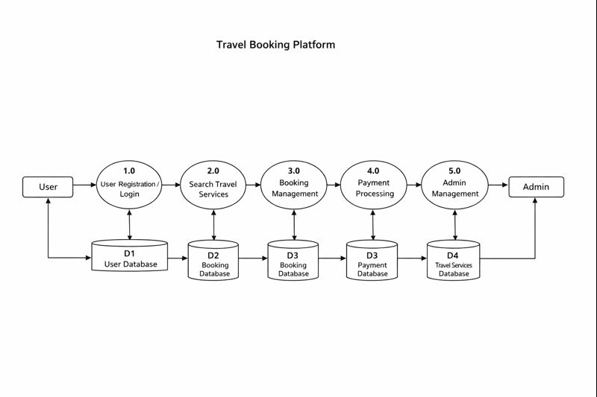

Program Code

User Module: Handles registration, login, and profile management.

Search Module: Allows users to search for flights, hotels, buses, and holiday packages.

Booking Module: Manages travel bookings and updates the booking database.

Payment Module: Processes online payments and updates payment status.

Admin Module: Allows admin to add/update/delete travel services and monitor bookings.

5.2 Output Screens

User Registration / Login Page – Allows users to create accounts or log in.

Search Page – Displays available flights, hotels, buses, or holiday packages.

Booking Confirmation Page – Shows booking details and status.

Payment Page – Provides secure payment options and confirmation.

Admin Dashboard – Allows admin to manage listings, bookings, and view reports.

6.1 Test Data

User Details: Sample names, emails, and passwords for registration and login testing.

Travel Services: Sample flights, hotels, buses, and holiday packages with prices and availability.

Booking Information: Test bookings with different travel types and dates.

Payment Data: Sample payment transactions (successful and failed) for testing payment module.Admin Data: Sample admin login credentials to test dashboard and management features.

6.2 Test Cases

User Registration Test: Verify new user can register with valid details.

Login Test: Check if registered users can log in successfully.

Search Test: Ensure users can search flights, hotels, buses, and packages correctly.

Booking Test: Verify booking details are saved correctly in the database.

Payment Test: Test successful and failed payment transactions.

Admin Test: Ensure admin can add, update, and delete travel services

.Data Validation Test: Check mandatory fields, data formats, and error messages.

6.3 Test Results

User Registration: Successfully registered all test users.

Login: Registered users logged in without errors.

Search Functionality: Displayed correct results for all travel services.Booking Process: Bookings were saved accurately in the database.

Payment Processing: Payments processed successfully; failed transactions handled correctly.

Admin Operations: Admin added, updated, and deleted services successfully.

Data Validation: All mandatory fields and input validations worked correctly.

7.1 How to Use the Project
- Step 1 – Open Application: Launch the platform in a web browser (e.g., Google Chrome).
- Step 2 – User Registration / Login: New users register; existing users log in using credentials.
- Step 3 – Search Travel Services: Select travel type (flight, hotel, bus, package) and enter travel details.
- Step 4 – Book Services: Choose the desired option and confirm the booking.
- Step 5 – Make Payment: Complete payment online to confirm the booking.
- Step 6 – View Booking: Users can check booking status and details in their account.
- Step 7 – Admin Management: Admin can log in to manage services, update listings, and monitor bookings.

8. Applications and Limitations
Applications:
- Online booking of flights, hotels, buses, and holiday packages.
- Secure online payments for bookings.
- Helps travel agencies and service providers manage listings and bookings.
- Provides real-time availability and pricing for users.
- Can be extended to mobile apps for on-the-go access.
Limitations:
- Requires internet connection to access the platform.
- Dependent on third-party payment gateways for online transactions.
- Limited by server capacity for handling large user traffic.
- Admin updates need to be manual, not automated.
- Users need basic computer skills to navigate the system.
- 9. Conclusion and Future Enhancements
Conclusion:
- Provides a simple, efficient, and secure platform for travel bookings.
- Reduces manual work and improves user and admin experience.
Future Enhancements:
- Develop a mobile app for on-the-go bookings.
- Add AI recommendations for personalized travel.
- Include multi-currency support.
- 10. Bibliography & References
- Pressman, R.S., Software Engineering – A Practitioner’s Approach.
- Date, C.J., Introduction to Database Systems.
- W3Schools: https://www.w3schools.com
- MySQL Documentation: https://dev.mysql.com/doc/
- Selenium Documentation: https://www.selenium.dev/documentation/
- Draw.io / Figma tutorials for diagrams and UI design.

