**Exercise 1: Complete below tasks as part of this exercise:**

1. **Setup a GitHub account and create one repository inside it named devopsdemo**

**Solution:**

1. **Open   in browser and click on signup:**

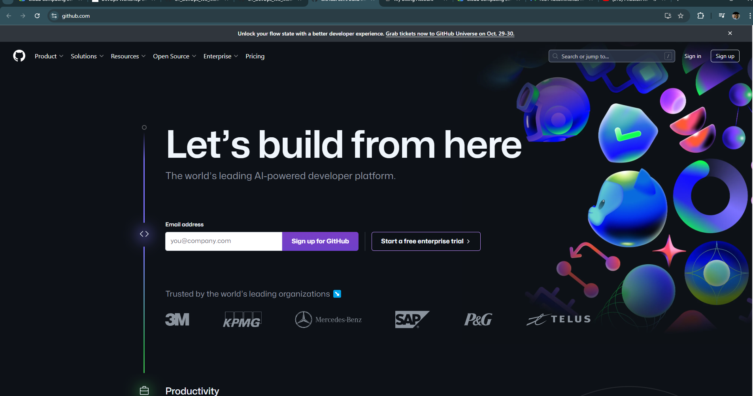

1. **Fill the form by choosing one username, entering email and password for the Github account. Solve the puzzle to verify the account.**

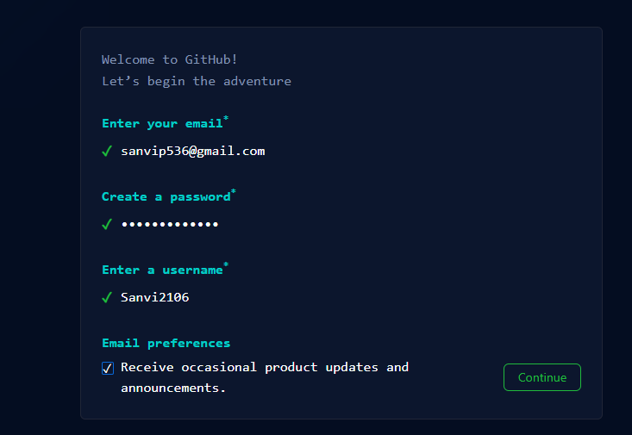

1. **Once all done, click on create account iv. You must receive email from Github for account verification with verification link. Complete the verification to complete registration process. v. Once registration is complete, login to the Github account and generate Personal Access Token next:**
2. **Generate Personal Access Token for authentication:**
3. In the upper-right corner of any page, click your profile photo, then click **Settings**.

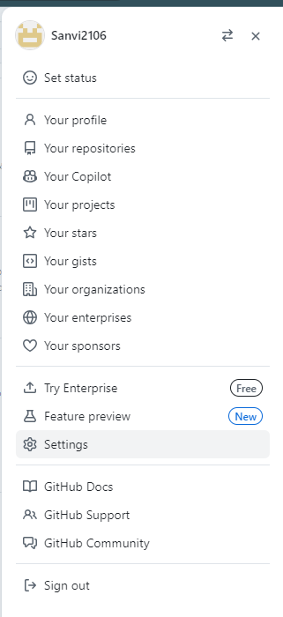

1. In the left sidebar, click **Developer settings**.

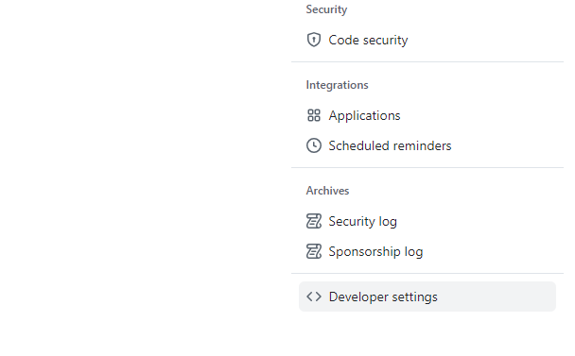

1. In the left sidebar, click **Personal access tokens**.

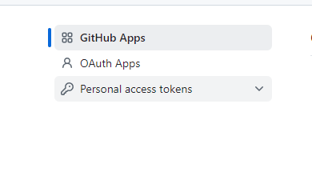

1. Click **Generate new token**.

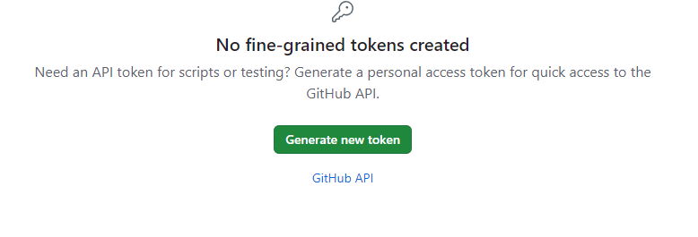

1. Give your token a descriptive name.

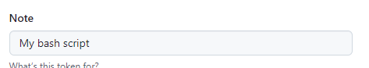

1. To give your token an expiration, select the **Expiration** drop-down menu, then click a default or use the calendar picker.

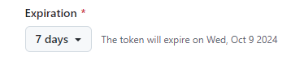

1. Select the scopes, or permissions, you'd like to grant this token. To use your token to access repositories from the command line, select **repo**.

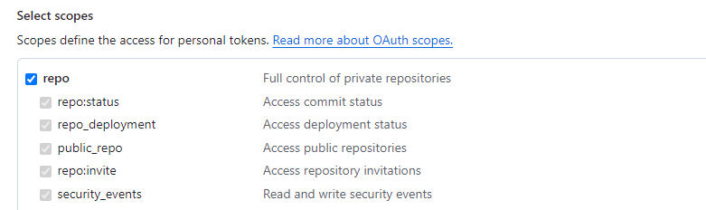

1. Click **Generate token**.

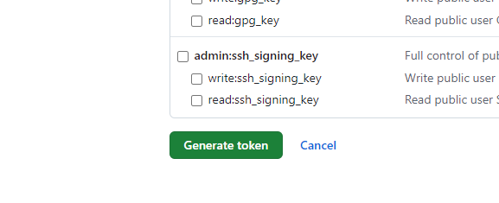

1. Create repository now by clicking on 'New repository':

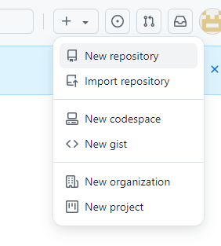

1. Fill the repo name as **devopsdemo** and click create repo as below:

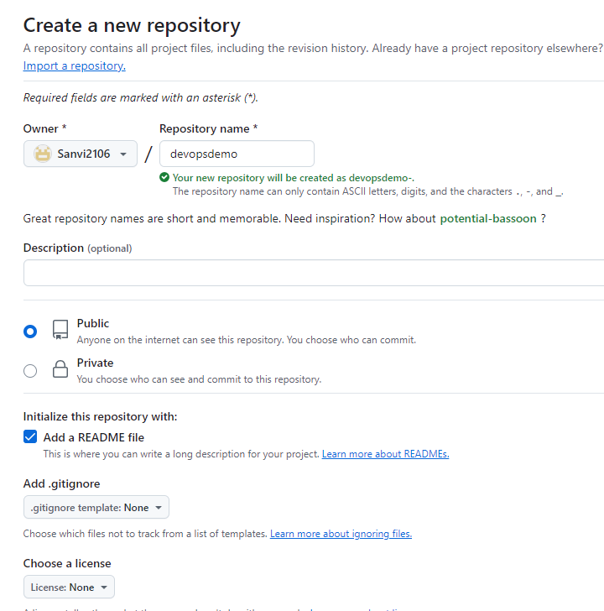

1. Once repo is created, you will see page like below:

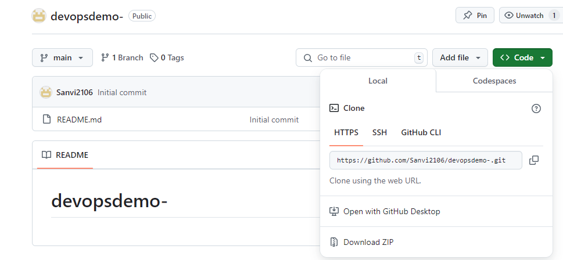

1. Copy the repo clone URL under code and go to **task B**.
2. Clone this repo 'devopsdemo' to your GCP compute instance

***Solution:***

Login to your Ubuntu GCP instance with ubuntu user and run below command to clone: Initialized empty Git repository in /home/ubuntu/git_demo/.git/

sudo su – ubuntu

git clone <https://github.com/vistasunil/devopsdemo.git>

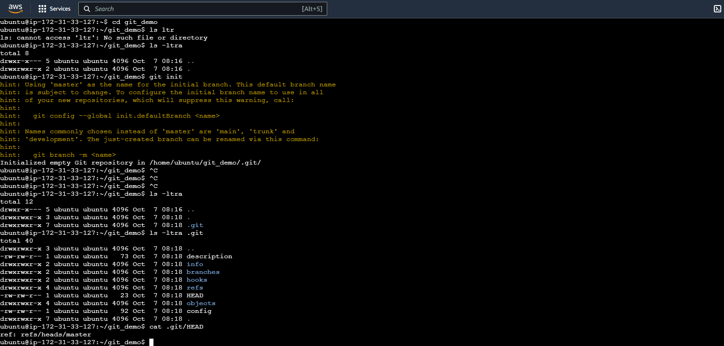

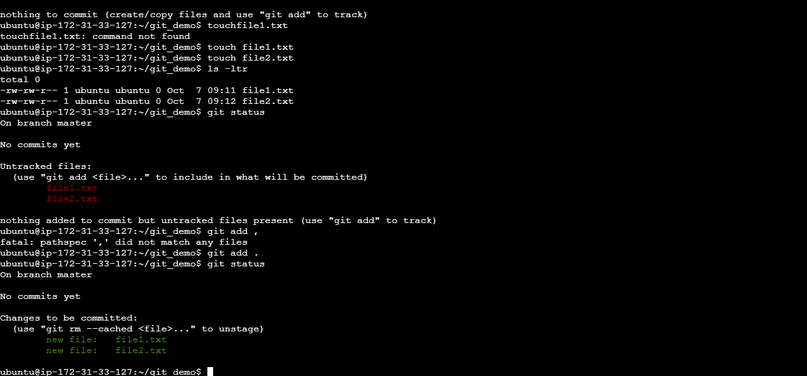

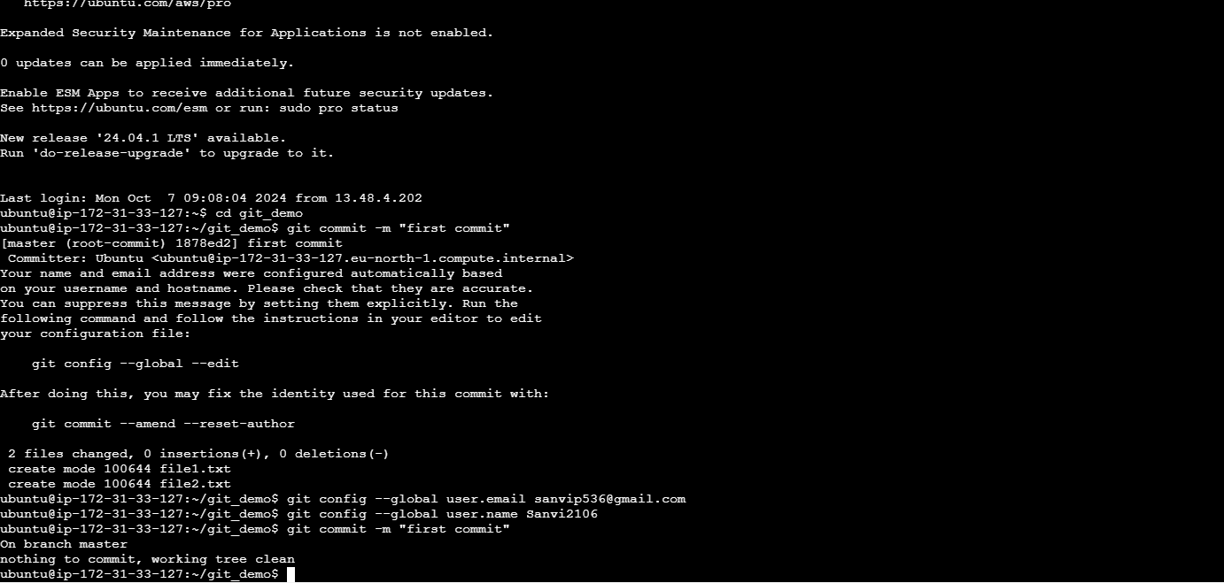

git push

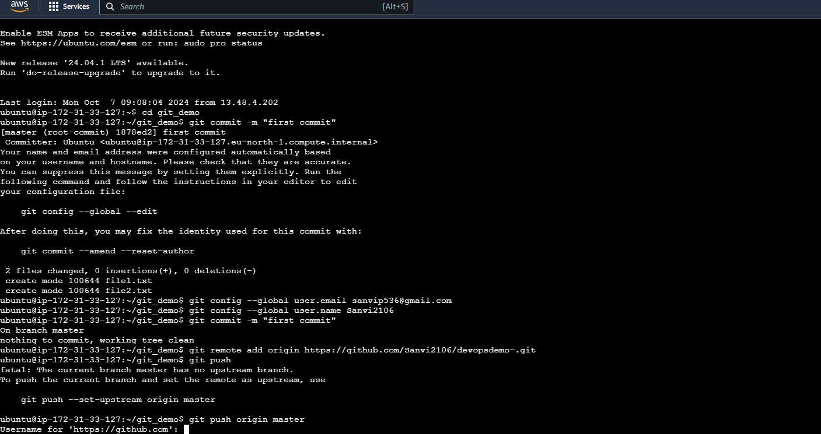

git clone <https://github.com/vistasunil/devopsdemo.git>

