a) Install docker on an Ubuntu GCP instance

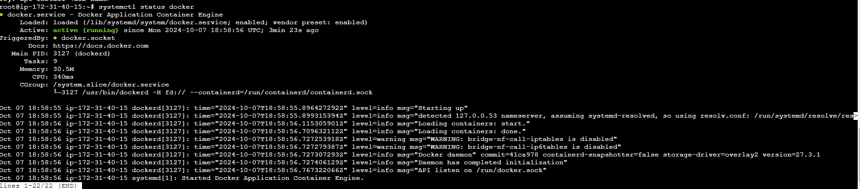

b) sudo usermod -a -G docker $USER

c) docker pull ubuntu

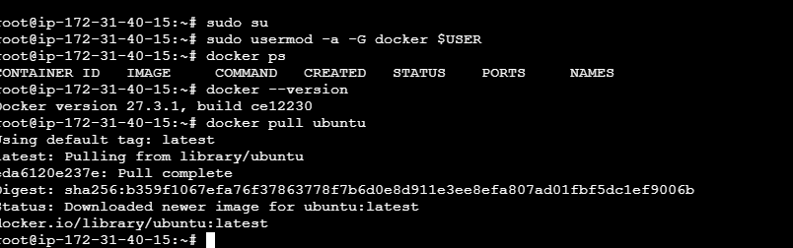

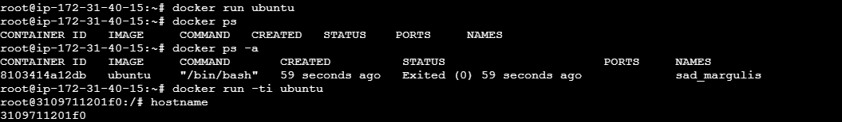

Container is running in background.



Docker execute command



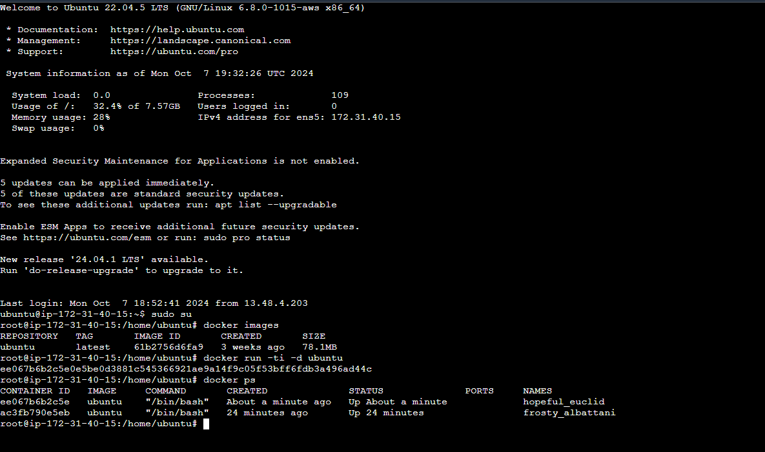



Docker images created:

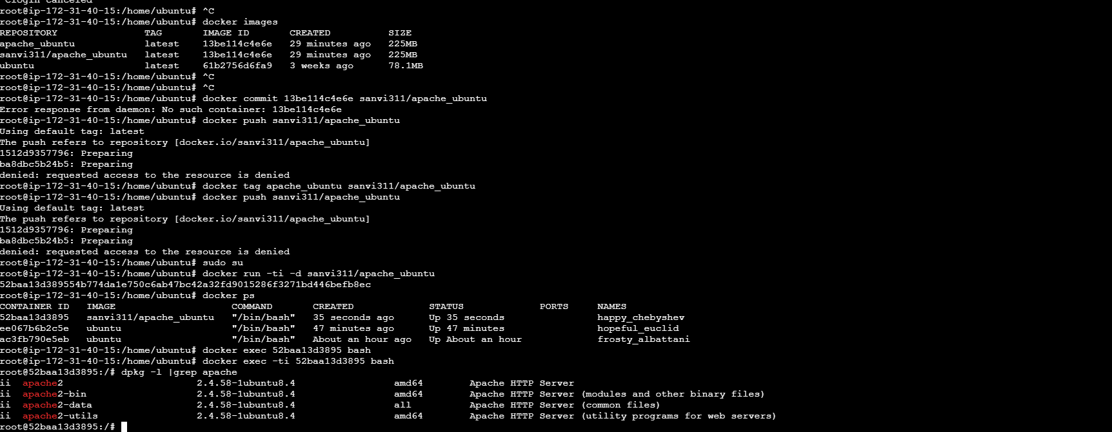

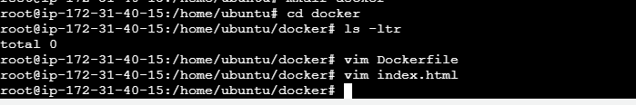

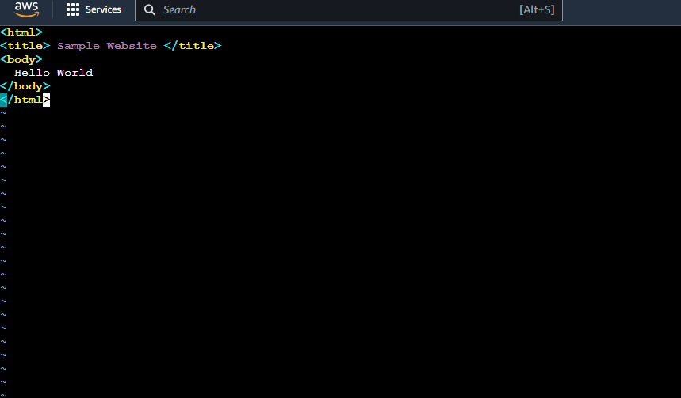

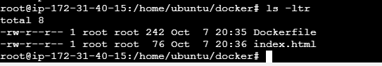

docker build . -t apache_ubuntu

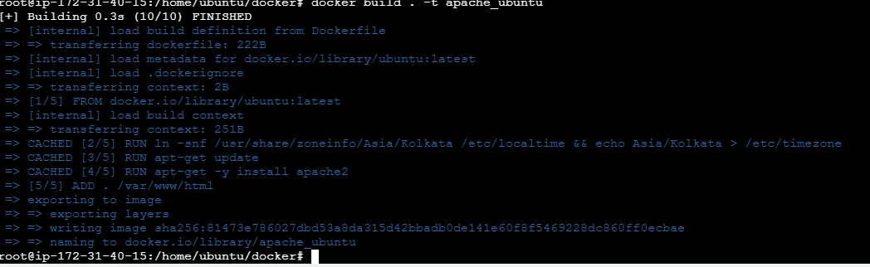

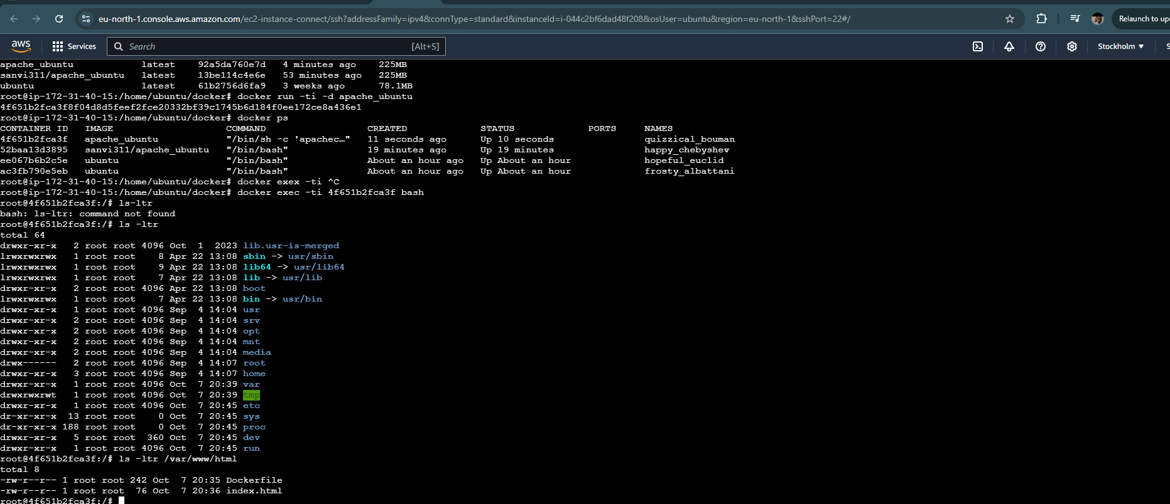

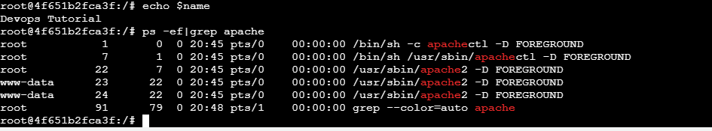

Apt-get install curl

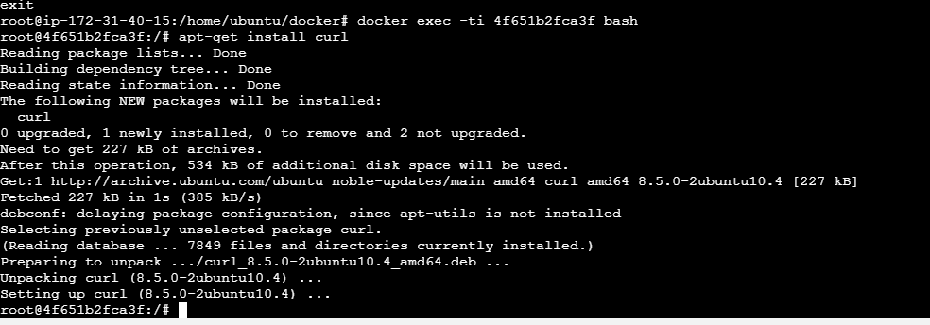

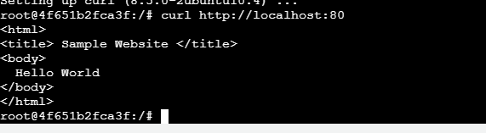

Navigate to the server IP address on port 81 (successfully logged in)

