INDEX

Sl. No. | Topics | Coverage
1 | Introduction | Introduction, scope, objectives, feasibility
2 | Literature Survey / Software and Hardware Tools | Existing systems, tools, technologies, hardware
3 | Project Design | Modules, architecture, interaction diagrams
4 | Database Design | ER design, relational structure, field summary
5 | Development / Implementation Stages | Phases followed to build the application
6 | Testing | Verification strategy, test evidence, test cases
7 | Results | Design screens, code excerpts, generated figures, observations
8 | Conclusion | Summary and future enhancement directions
9 | Bibliography & References | Repository and documentation references

1. INTRODUCTION

1.1 Introduction
Smart Grocery is a web-based grocery planning and inventory management system developed to help users organize their household items, track quantities, distinguish between pending and purchased goods, receive low-stock warnings, and take action on expiry-driven reminders. The project extends beyond a traditional list manager by introducing dashboard insights, a smart shopping queue, recommendation logic, and a dedicated administrative suite for oversight and reporting.
The backend uses Spring Boot and MySQL to provide a secure role-aware API, while the frontend uses React to create a user-friendly interface for both end users and administrators. The system is structured so that each user views only their own grocery data, while administrators can observe system-wide trends and operational states.

1.2 Scope
- User registration, login, and role-aware access using JWT tokens.
- Household inventory management with item name, category, quantity, purchase status, and expiry date.
- Dashboard summaries for total items, pending items, purchased items, low-stock items, and recommended actions.
- Automatic shopping queue generation using low-stock and near-expiry conditions.
- Administrative control over users, products, category names, catalog stock, purchase queues, and reports.

1.3 Objectives
- To simplify grocery planning and day-to-day household inventory tracking.
- To reduce stock-outs through low-stock alerts and recommendation rules.
- To improve expiry awareness for purchased items through dashboard reminders.
- To implement a secure multi-role full-stack application with a maintainable architecture.
- To provide administrative insight into products, categories, stock, and user activity.

1.4 Feasibility Study
Technical Feasibility:
The Smart Grocery system is technically feasible using modern full-stack web development technologies. The project is built using React and Vite for the frontend, Spring Boot for the backend, and MySQL for database management. These technologies are widely adopted, well-supported, and suitable for building a responsive and secure grocery management platform.
- Frontend: The frontend is built using React, Vite, Tailwind CSS, Axios, and React Router. These tools help create a responsive and interactive user interface for login, dashboard insights, inventory control, shopping suggestions, and admin management screens.
- Backend: The backend is powered by Spring Boot with Spring Security, validation, and JPA. It handles authentication, grocery CRUD operations, recommendation logic, expiry reminders, admin controls, and API routing in a structured and scalable manner.
- Database: MySQL is used for storing user accounts and grocery item records. Since it is a relational database management system, it can efficiently manage structured data and support future application growth.
- Security: Security is implemented using JWT-based authentication, password hashing, protected frontend routes, and role-based access control for normal users and administrators. These measures help protect user data and restrict sensitive operations to authorized roles.
Operational Feasibility:
The Smart Grocery system is operationally feasible because it is easy to use and accessible through a web browser. Users can manage groceries, track stock levels, and view expiry reminders without requiring special training. The admin module also centralizes monitoring tasks such as user management, product review, stock control, and reports.
Because the application is web-based, it can be accessed from standard computers and laptops in a simple local setup. This makes it practical for academic demonstration and convenient for day-to-day use.
Economic Feasibility:
From an economic point of view, Smart Grocery is cost-effective because it uses open-source technologies such as React, Spring Boot, MySQL, and related JavaScript and Java libraries. This reduces licensing costs while still providing a strong technical foundation for development and deployment.
- Development Costs: The primary cost of development is the time and effort required for design, coding, testing, and documentation. Since the tools used in the project are open source, no expensive software licenses are required.

2. LITERATURE SURVEY / SOFTWARE AND HARDWARE TOOLS

2.1 Literature Survey
Many grocery and home inventory applications currently available to users focus on simple list creation, shopping reminders, or individual purchase tracking. However, a gap remains between a basic grocery checklist and an application that actively helps users manage stock pressure, predict restocking needs, and notice expiring purchased goods in a structured way.
Existing systems often provide a clean user interface but lack a deeper operational model. Some tools support categories and quantities, but they do not transform that data into meaningful recommendations or separate user responsibilities from administrator oversight. Smart Grocery improves on these gaps by combining household inventory, recommendation logic, expiry reminders, and administrative analytics within one system.

2.1.1 Existing Systems and Solutions
Common market solutions include generic task managers, note-based grocery lists, and e-commerce shopping carts. These systems help users list what to buy, but usually do not treat groceries as a living inventory with lifecycle data such as quantities, purchase states, and expiry dates. They also rarely include a separate operational dashboard or an admin-oriented reporting interface.

2.1.2 Gaps in Existing Systems
The main gaps include weak decision support, little or no expiry intelligence, inconsistent stock awareness, and minimal separation between ordinary user workflows and system administration. Smart Grocery addresses these limitations through rule-driven shopping suggestions, category-aware stock visualization, kitchen reminders, and a multi-page admin suite.

2.1.3 Proposed Solution Overview
The proposed Smart Grocery solution is a browser-based platform where users can securely log in, maintain a grocery inventory, monitor stock conditions, and act on recommendations and reminders. Administrators can inspect broader platform activity, adjust catalog stock, complete purchase queues, rename categories, and review reports generated from the same shared data model.

2.2 Software and Hardware Tools
Category | Tools Used | Purpose
Frontend | React, Vite, Tailwind CSS, Axios, React Router | User interface, routing, styling, API communication
Backend | Spring Boot, Spring Security, Validation, JPA | REST API, authorization, validation, persistence
Database | MySQL | Storage of users and grocery items
Authentication | JWT | Secure token-based access control
Testing | JUnit, Spring test starters, ESLint | Backend verification and frontend static checks
Version Control | Git | Repository tracking and development workflow

- Java 21 or later is required to run the backend service.
- Node.js 20 or later is required to run the frontend development server.
- MySQL 8 or later is used for the persistent relational database.
- A standard personal computer and modern browser are sufficient for development and usage.

3. PROJECT DESIGN

3.1 Design Details of Modules
In this section, we will outline the project design, including the design details of the system modules and the architecture of the application. This section aims to provide a clear understanding of how the system is structured, both in terms of the backend and frontend, and how various components interact.
The Smart Grocery system is divided into several core modules. Each module serves a specific function to ensure the smooth operation of the system. The modules are as follows:
1. User Authentication Module
- Functionality: This module handles user login, registration, and role-aware access management.
- Components:
- Login Form: Allows users to enter their credentials using username or email and password.
- Registration Form: New users can register for the platform by providing username, email, and password.
- Token Management: Once a user logs in, a JWT token is issued and used for protected API access.
- Role Validation: The system distinguishes between normal users and administrators for route access.
- Technology: Spring Security, JWT, password hashing, React auth pages, and protected routes.
2. Home and Catalog Module
- Functionality: This module allows users to browse grocery catalog items, check availability, and quickly purchase items into their inventory.
- Components:
- Catalog Cards: Display item name, category, price, stock quantity, and availability state.
- Search and Filter: Allows users to filter catalog items by category and search keyword.
- Quick Buy Modal: Lets users purchase a catalog item directly with quantity and expiry preview.
- Home Summary: Shows pending, purchased, and currently available grocery counts.
- Technology: React components, Axios API calls, dynamic filters, and backend catalog endpoints.
3. Inventory Management Module
- Functionality: Manages grocery item creation, listing, updates, deletion, and purchased-state tracking.
- Components:
- Add Item Form: Allows users to enter item name, category, quantity, purchased state, and expected expiry.
- Inventory List View: Displays grocery items with quantity, category, status, and timestamps.
- Filter Controls: Supports search, category filtering, and purchased / pending filtering.
- Item Actions: Users can mark items as bought, move them back to pending, or delete them.
- Technology: GroceryController routes, GroceryService logic, JPA persistence, and React list management.
4. Dashboard and Recommendation Module
- Functionality: Provides users with an overview of grocery metrics, low-stock pressure, recommendations, and recent activity.
- Components:
- Summary Cards: Show total items, pending items, purchased items, and low-stock items.
- Smart Picks: Displays recommendation cards derived from prior purchase and low-stock conditions.
- Low-Stock Watchlist: Highlights pending items that require restocking soon.
- Recent Activity: Lists recent grocery actions and the current pending focus.
- Technology: Aggregated API calls, recommendation scoring, and dashboard-specific React sections.
5. Shopping List and Expiry Reminder Module
- Functionality: Handles automatic shopping suggestions and expiry-aware kitchen reminders for purchased items.
- Components:
- Shopping Queue: Builds a buy list from low-stock and near-expiry conditions.
- Priority Labels: Assigns HIGH, MEDIUM, or LOW priority to shopping suggestions.
- Expiry Alerts: Shows items expiring soon, expiring today, or already overdue.
- Acknowledge Action: Allows users to remove an expiry reminder by deleting the expired item.
- Technology: Expiry-date rules, shopping-list logic, dashboard reminders, and user-scoped API endpoints.
6. Admin Management and Reporting Module
- Functionality: The admin module allows the administrator to manage users, products, categories, purchase queues, stock levels, and reports.
- Components:
- Admin Dashboard: Displays total users, products, pending items, purchased items, categories, and low-stock counts.
- User Management: Admins can view users, update roles, and delete accounts with admin-safety rules.
- Product and Stock Management: Admins can edit product quantities, delete products, and restock catalog items.
- Purchase Queue and Reports: Admins can complete pending purchases and view category-wise reports and breakdowns.
- Technology: AdminController routes, AdminService aggregation logic, catalog stock state, and reporting endpoints.
Module | Responsibilities
Authentication Module | Registration, login, admin login, session token generation, route protection
Home and Catalog Module | Quick-buy flow, catalog browsing, availability display, search and category filters
Inventory Module | Add items, update quantities, search, filter, delete, purchase toggle, expiry preview
Dashboard Module | Summary metrics, smart picks, low-stock watchlist, pending focus, kitchen reminders
Shopping List Module | Auto-built queue from low stock and near-expiry inventory items
Admin Module | Users, dashboard, products, categories, purchase queue, stock controls, reports

3.2 Architecture Diagram
The architecture follows a client-server design. React pages issue API calls through Axios. Spring Boot controllers expose route contracts for authentication, grocery operations, and administrator workflows. Service classes implement business rules, such as stock thresholds, recommendations, expiry logic, and report aggregation. JPA repositories interact with MySQL for persistence. JWT and protected frontend routes enforce access control for user and admin roles.
The figures in this chapter summarize the application architecture, module interaction, and data flows between user actions and system services.

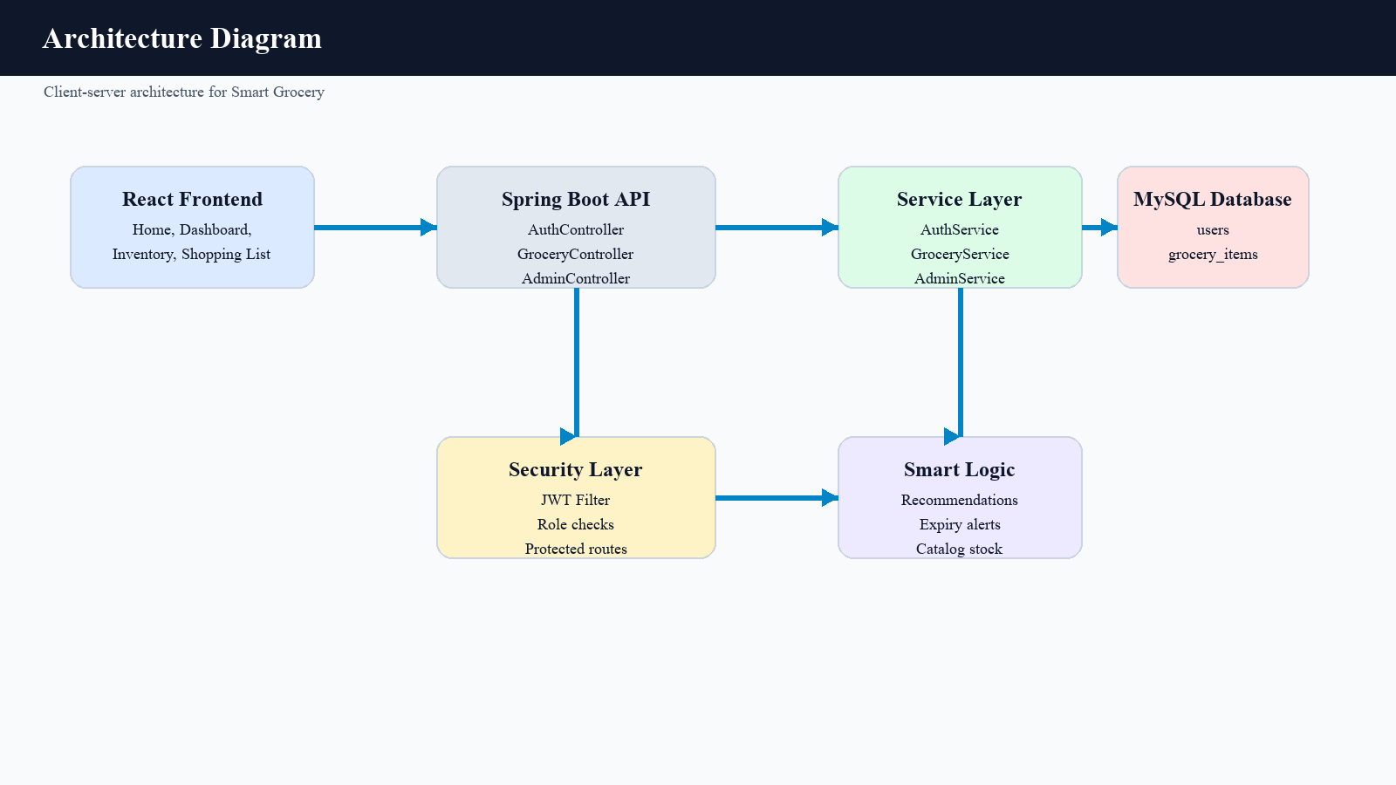
Figure 3.1: Architecture diagram showing the React frontend, Spring Boot controllers, service layer, security layer, smart logic, and MySQL persistence
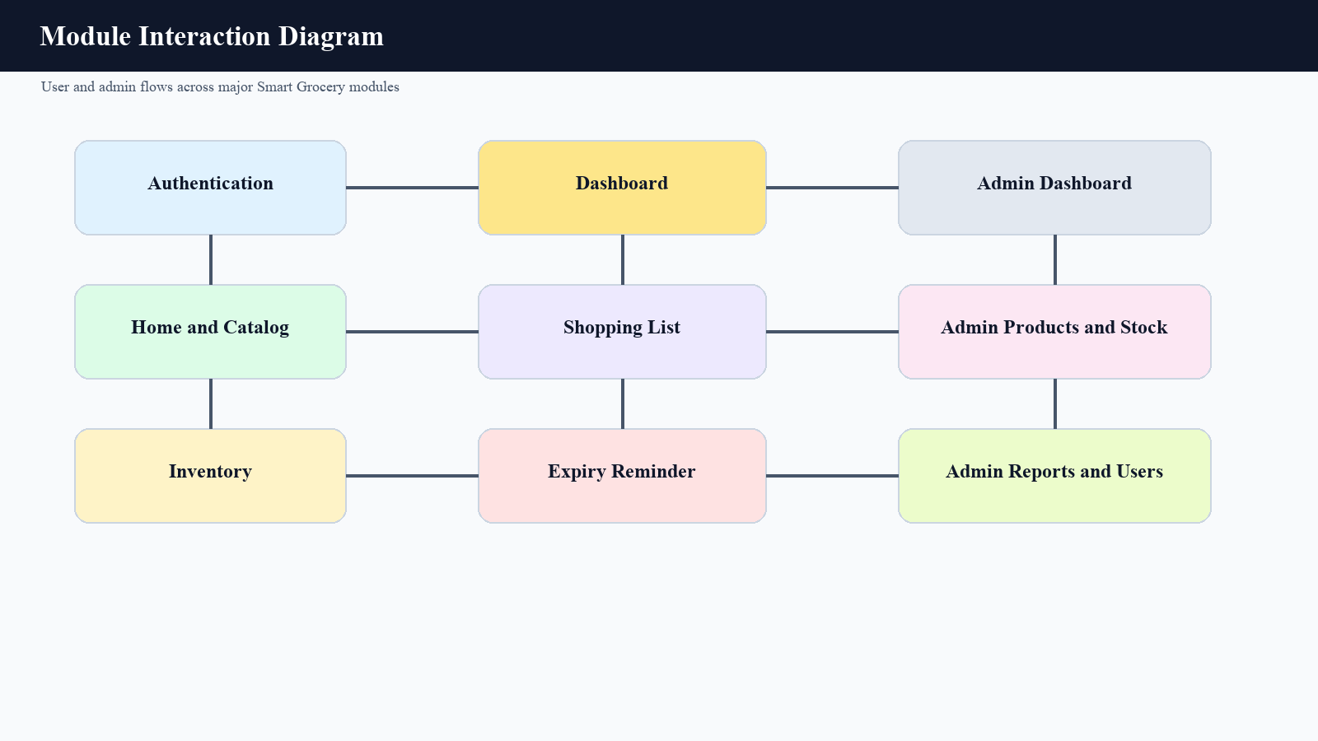
Figure 3.2: Module interaction diagram showing how user and admin pages map to major application responsibilities.

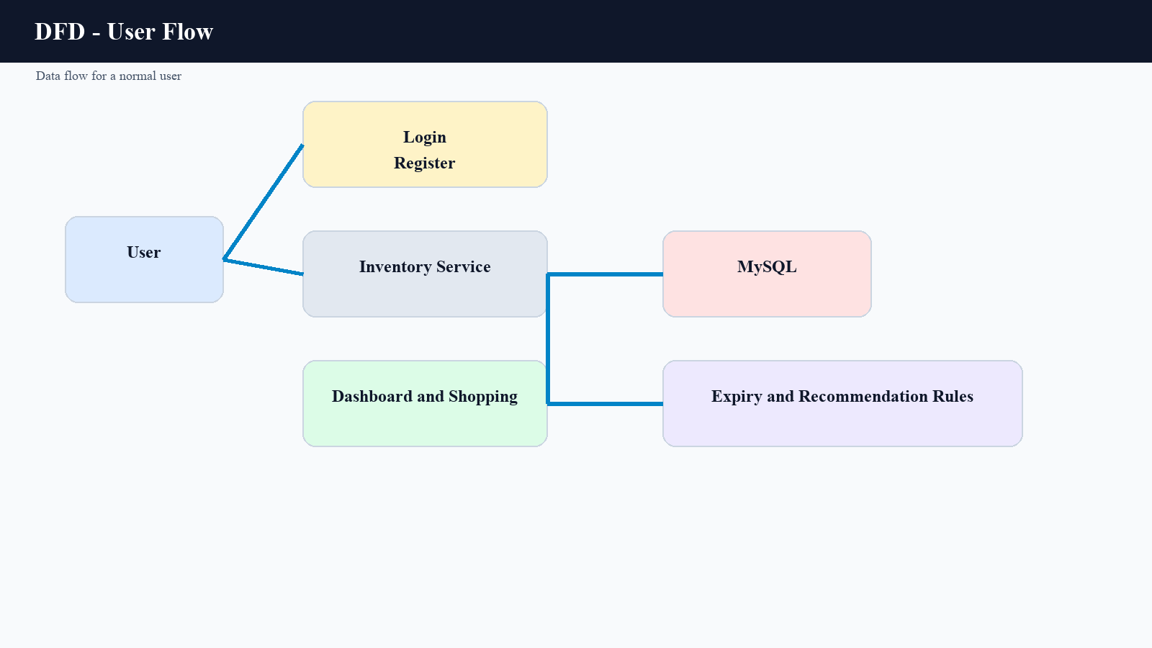 Figure 3.3: Data flow diagram for the normal user journey across authentication, inventory, dashboard, shopping, and smart logic.

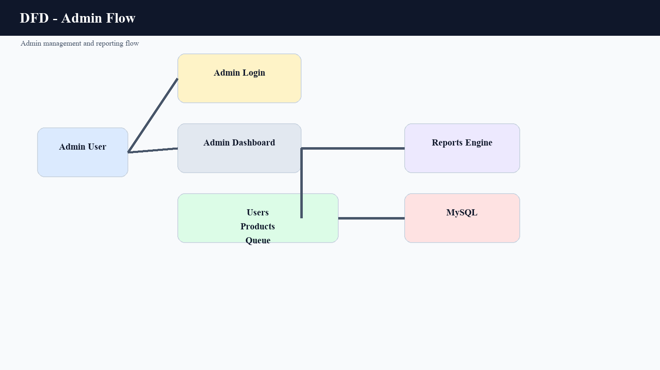
Figure 3.4: Data flow diagram for the administrator workflow across login, dashboard, queue handling, and reporting.4.1 E-R Diagrams / DFDs / Relational View

4. DATABASE DESIG
The current Smart Grocery project uses a focused relational model. The small number of core entities keeps the application maintainable while still supporting meaningful user isolation and analytics. A single user may own many grocery items, and each grocery item belongs to exactly one user. This relationship allows the application to provide user-scoped inventory management while still supporting platform-wide administrative reporting.
The grocery_items table stores fields that are directly relevant to business behavior, including quantity, purchase state, expiry date, and last purchase time. These fields power recommendations, low-stock alerts, shopping list generation, and kitchen reminder logic.
Entity | Important Fields | Remarks
users | id, username, email, password, role | Stores authenticated users and their authorization level
grocery_items | id, name, category, quantity, purchased, expiry_date, last_purchased_at, user_id | Stores household grocery inventory and workflow data

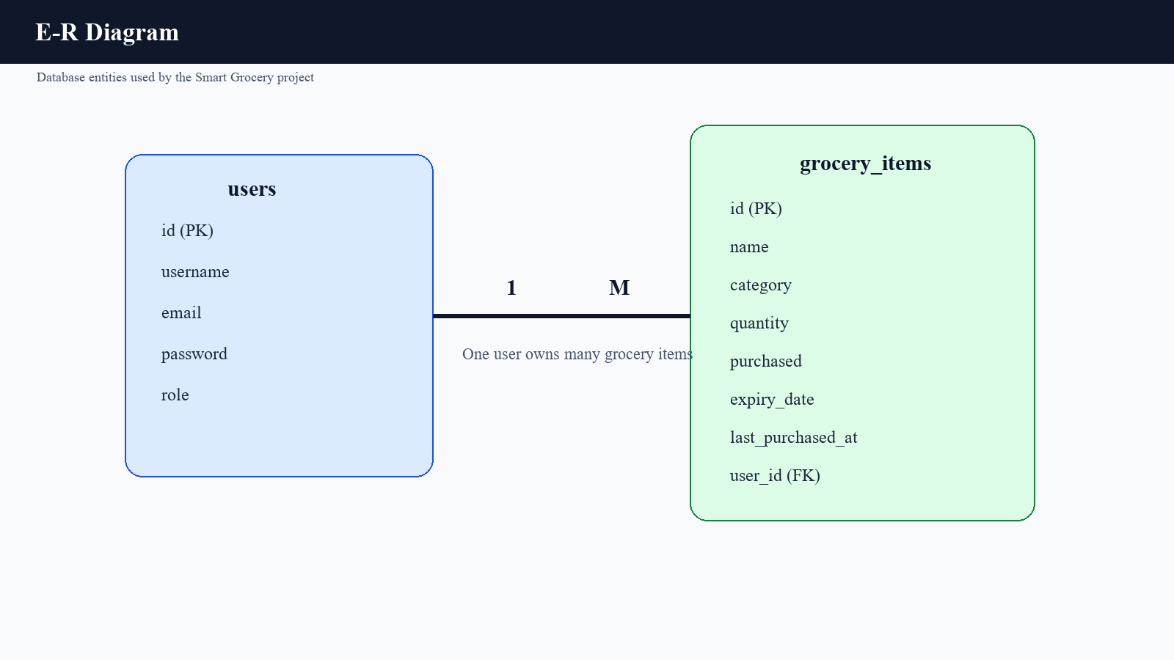
Figure 4.1: Entity relationship diagram representing users and grocery_items with a one-to-many association.
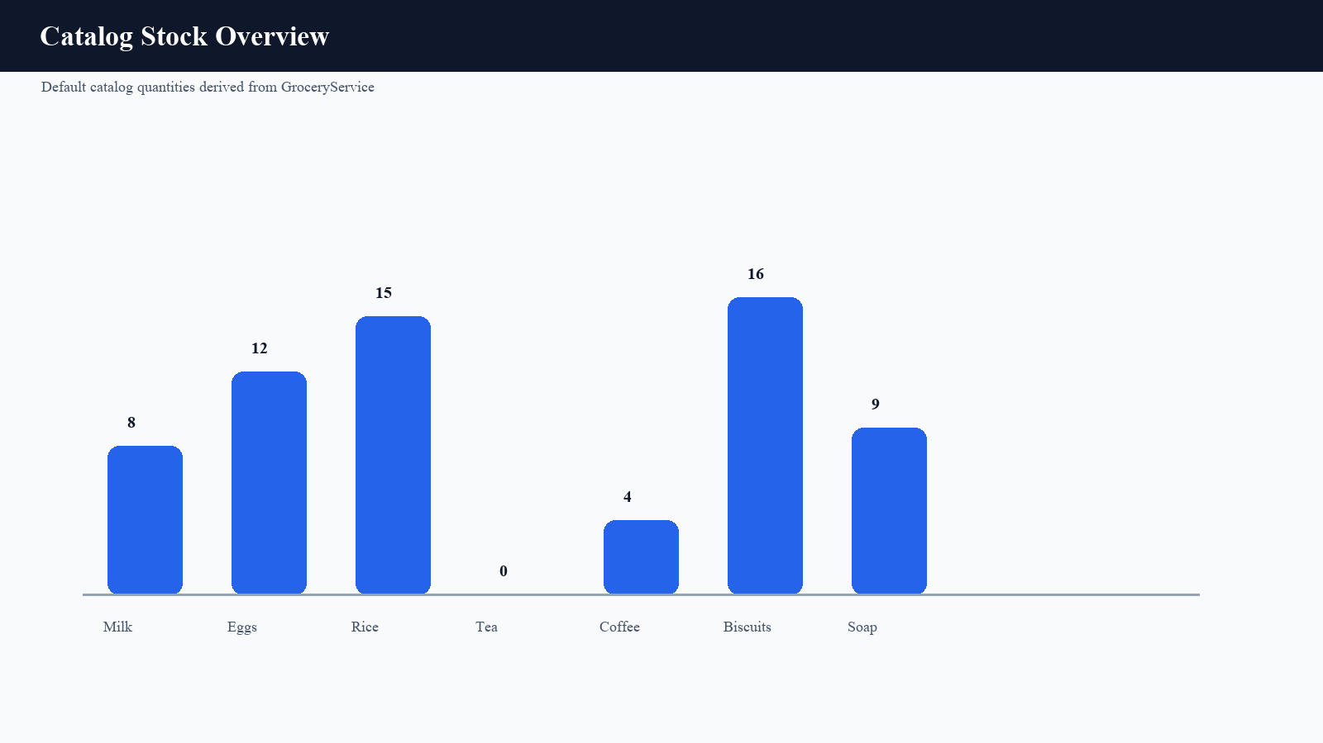
Figure 4.2: Sample chart derived from default catalog stock quantities defined in the service layer.

5. DEVELOPMENT / IMPLEMENTATION STAGES
The Smart Grocery project was implemented in structured stages so that the application could evolve from a basic authenticated CRUD system into a smarter inventory and reporting platform. The stages described below capture how the project can be presented academically while reflecting the current repository state.

5.1 Requirement Analysis
- Identified the need for user registration, login, and secure role-aware access.
- Defined grocery CRUD behavior with search, category filters, and purchase status.
- Planned dashboard insights, recommendations, shopping queue logic, and expiry reminders.
- Defined administrator operations for users, products, categories, stock, queues, and reports.

5.2 Environment Setup
- Configured the Spring Boot backend with MySQL, JWT secret, and CORS origin.
- Initialized the React frontend with Vite, Tailwind CSS, Axios, and React Router.
- Prepared repository scripts for frontend linting and backend Maven test execution.

5.3 Backend Development
Controller classes were created for authentication, grocery operations, and administrator features. Service classes were then introduced to isolate business logic. This includes password hashing, role resolution, recommendation scoring, catalog stock consumption, expiry-date derivation, and category-wise reporting.

5.4 Frontend Development
The frontend was split into focused pages so that users and admins have distinct shells and routes. The design emphasizes operational workflows rather than generic forms, with dedicated cards, queue views, summaries, and management panels for different tasks.

5.5 Integration and Validation
Axios is used to connect React pages to the backend API. Shared events are used to refresh dependent views when grocery data changes. Validation errors and authorization failures are converted into user-readable frontend messages, which helps keep the experience consistent across the app.

6. TESTING
Testing is an essential phase in software development because it verifies whether a system behaves as expected under realistic scenarios. The Smart Grocery project combines static frontend verification with backend test execution and documented workflow validation.

6.1 Types of Testing Performed
- Unit and service testing for backend business logic such as authentication and grocery rules.
- Controller testing for route-level behavior and validation handling.
- Frontend linting for code-quality and rule compliance.
- Manual workflow review through the route and UI design structure represented in the project.

6.2 Verification Results
Verification | Date | Result
Frontend lint (`npm run lint`) | 19 April 2026 | Passed
Frontend build (`npm run build`) | 19 April 2026 | Blocked in the current environment by a native Tailwind / Vite dependency loading issue
Backend tests (`.\mvnw.cmd test`) | 19 April 2026 | 50 tests executed with 1 failure, 0 errors, 0 skipped

6.3 Sample Test Cases
Test Case | Input / Condition | Expected Output | Status
User login | Valid username and password | JWT response and access to user routes | Passed
Admin login | Admin credentials | JWT response with ADMIN role | Passed
Low-stock queue generation | Pending item quantity <= threshold | Item appears in shopping list | Passed
Expiry reminder generation | Purchased item expiring soon | Reminder appears in dashboard | Passed
Role update guard | Attempt to remove last admin role | Conflict error returned | Passed
The frontend build result is preserved accurately in the report instead of being hidden. This is important in an academic submission because the report should reflect the actual observed environment rather than idealized behavior. In the current backend verification run, the failing test is `AuthControllerTest.registerRejectsInvalidPayload`, where the expected username validation message differs from the actual response. The lint result and the remaining backend tests nevertheless provide meaningful verification evidence.

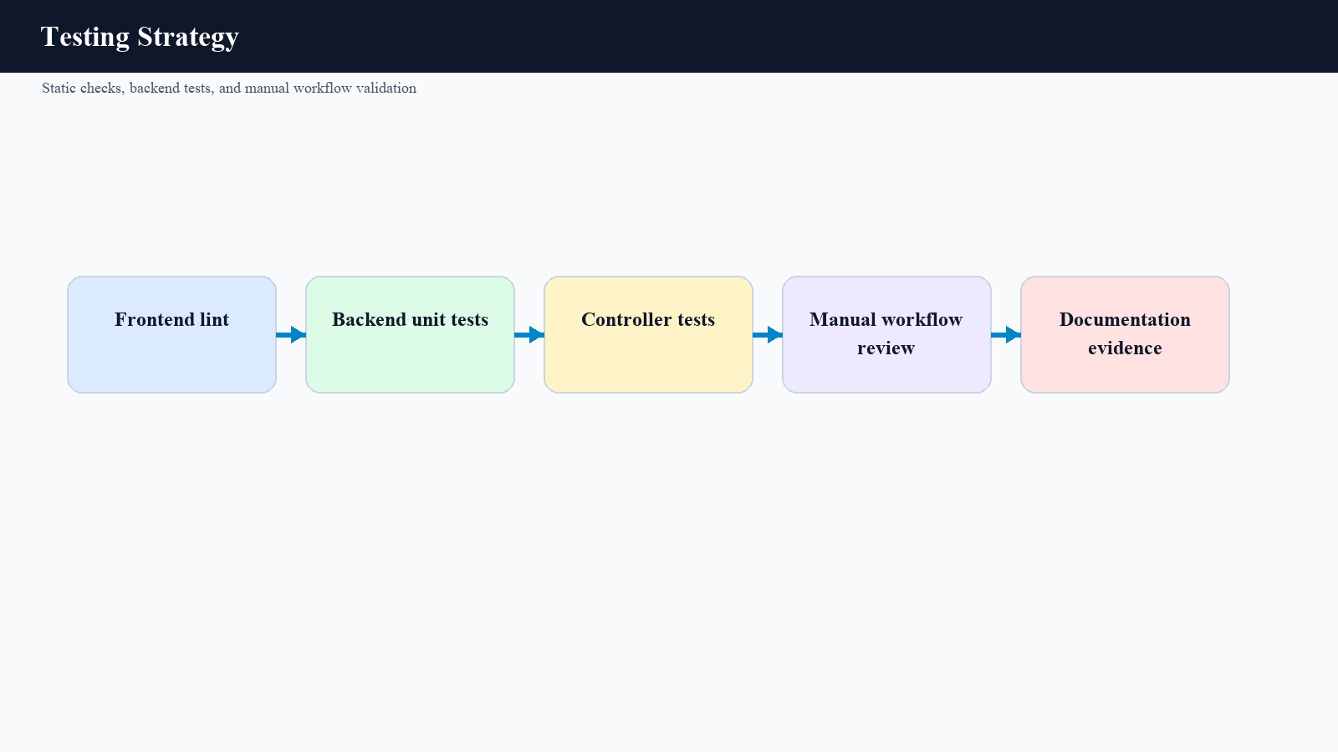
Figure 6.1: Testing strategy diagram summarizing linting, backend tests, controller tests, manual validation, and documentation evidence.

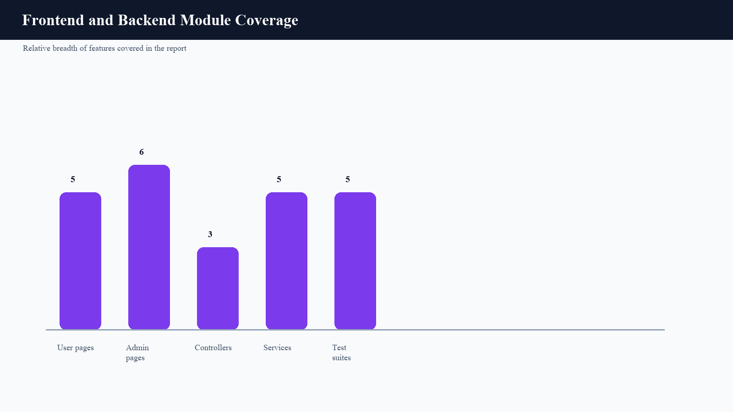
Figure 6.2: Chart showing the relative breadth of user pages, admin pages, controllers, services, and test suites covered in the report.

7. RESULTS

7.1 Result Summary
The Smart Grocery project delivers a complete user and administrator workflow. The resulting application is not limited to adding or deleting items; instead, it presents a structured household inventory experience with operational dashboards, category-aware filtering, recommendation logic, expiry reminders, shopping suggestions, and platform-wide administrative visibility.
In order to mirror the visual density of the sample report, this chapter documents the system through generated design-screen figures and representative code excerpts. Each figure highlights a major page or feature area from the project and is followed by a short academic description of its role.

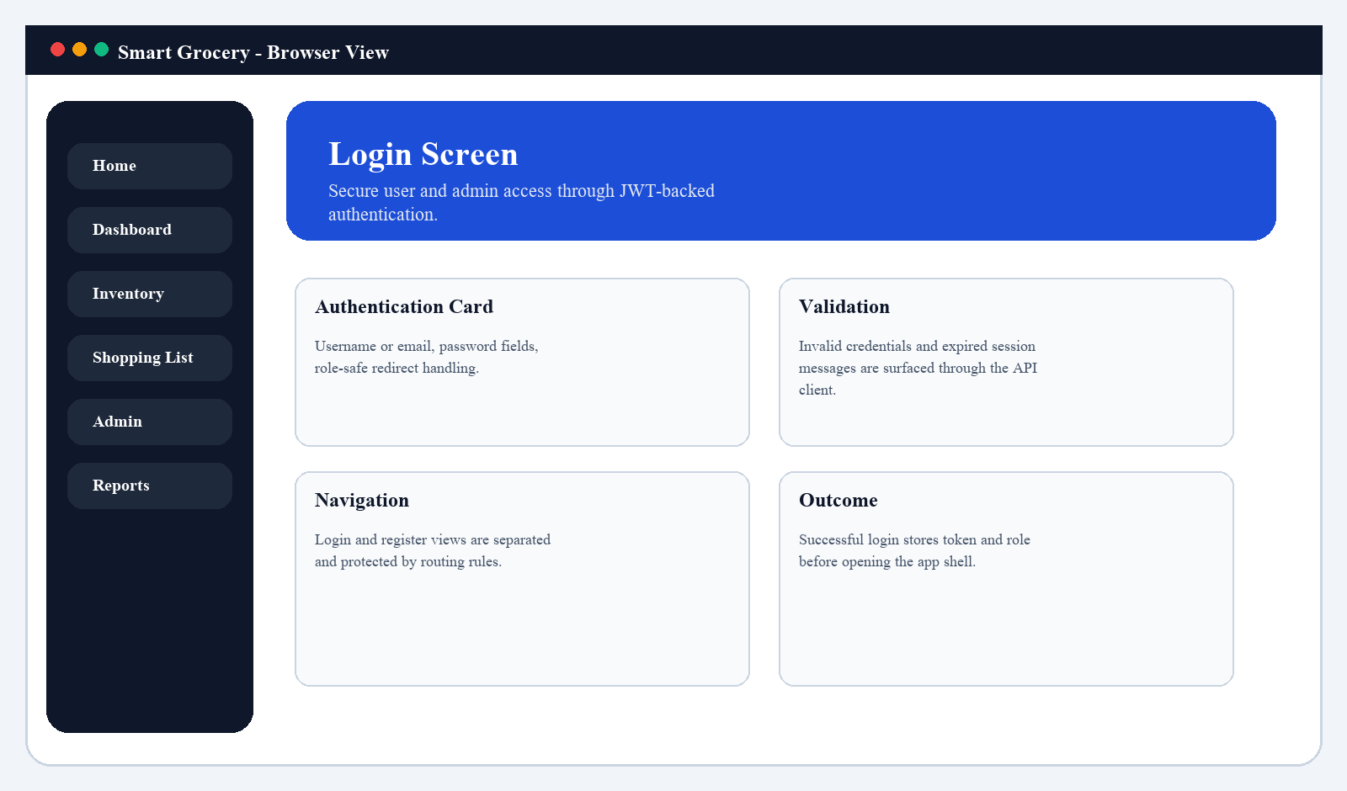
Figure 7.1: Login screen design showing secure authentication entry for Smart Grocery users and administrators.

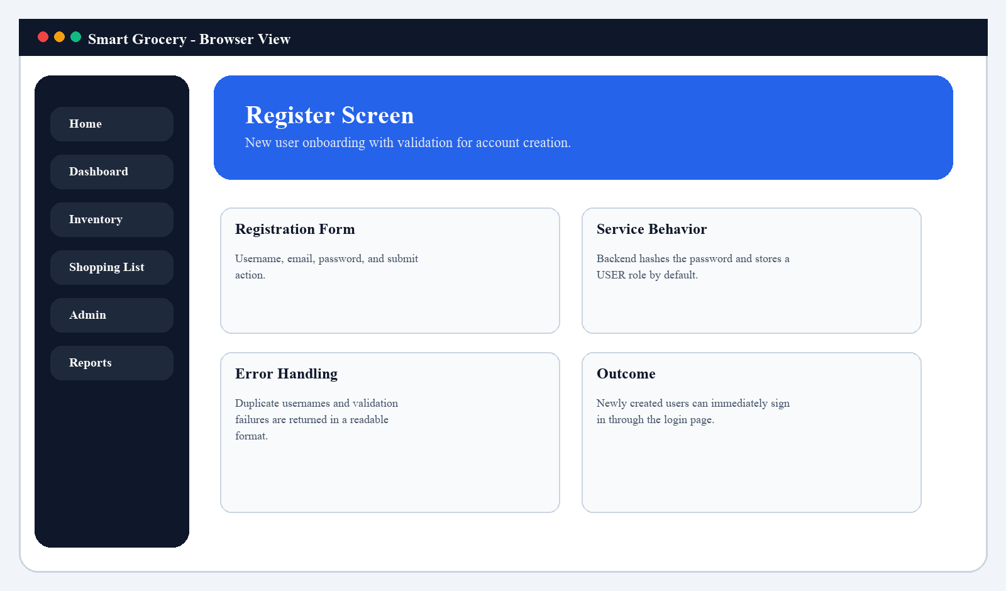
Figure 7.2: Registration screen design showing new user onboarding with validation-aware account creation.

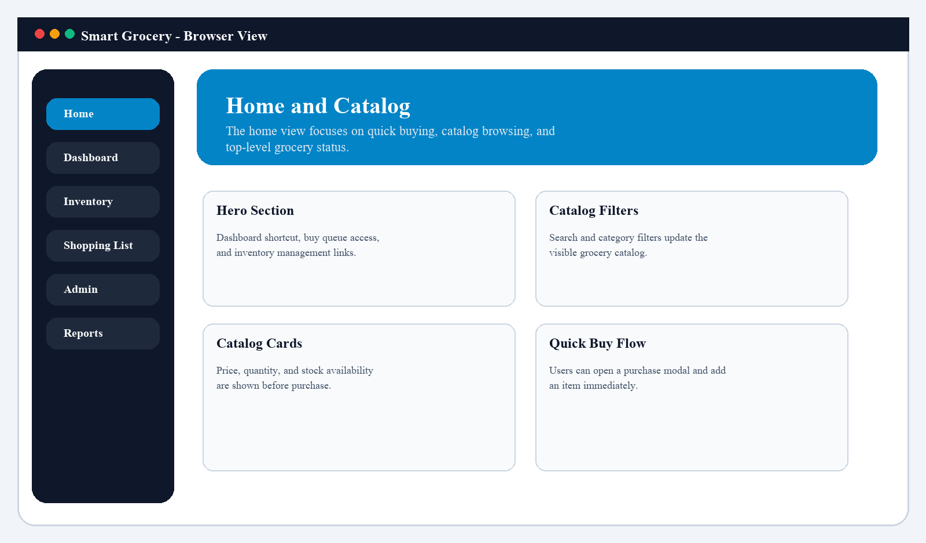
Figure 7.3: Home and catalog screen showing quick-buy options, availability, and top-level grocery navigation.

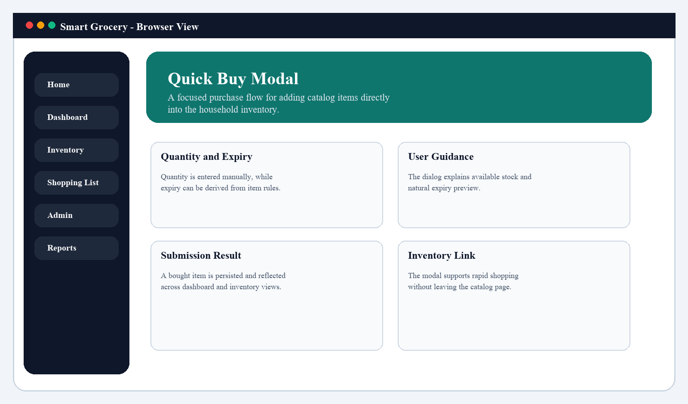
Figure 7.4: Quick-buy modal design illustrating quantity entry and expiry preview for direct purchase flow.

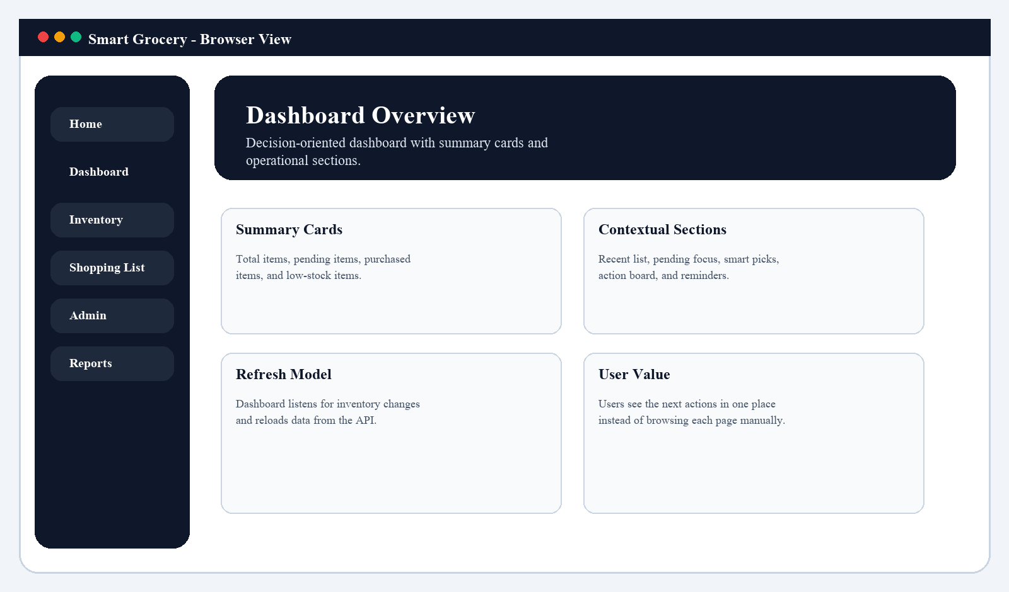
Figure 7.5: Dashboard overview screen with summary cards and action-focused sections.

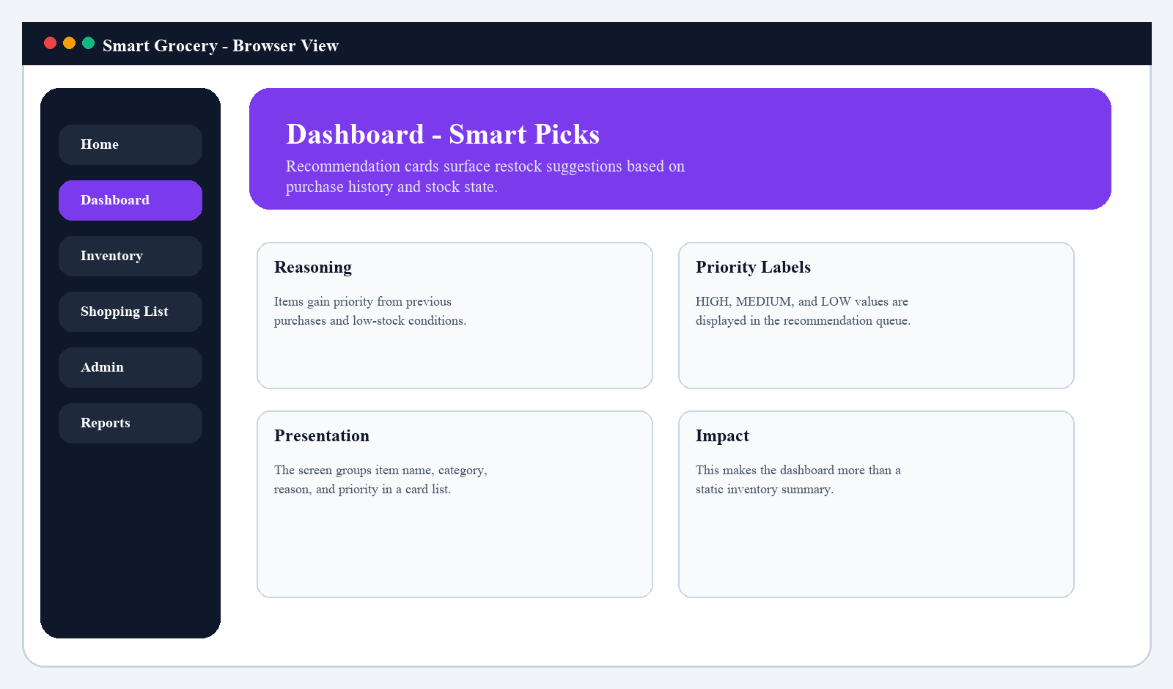
Figure 7.6: Smart picks screen showing recommendation cards with reasons and priority labels.

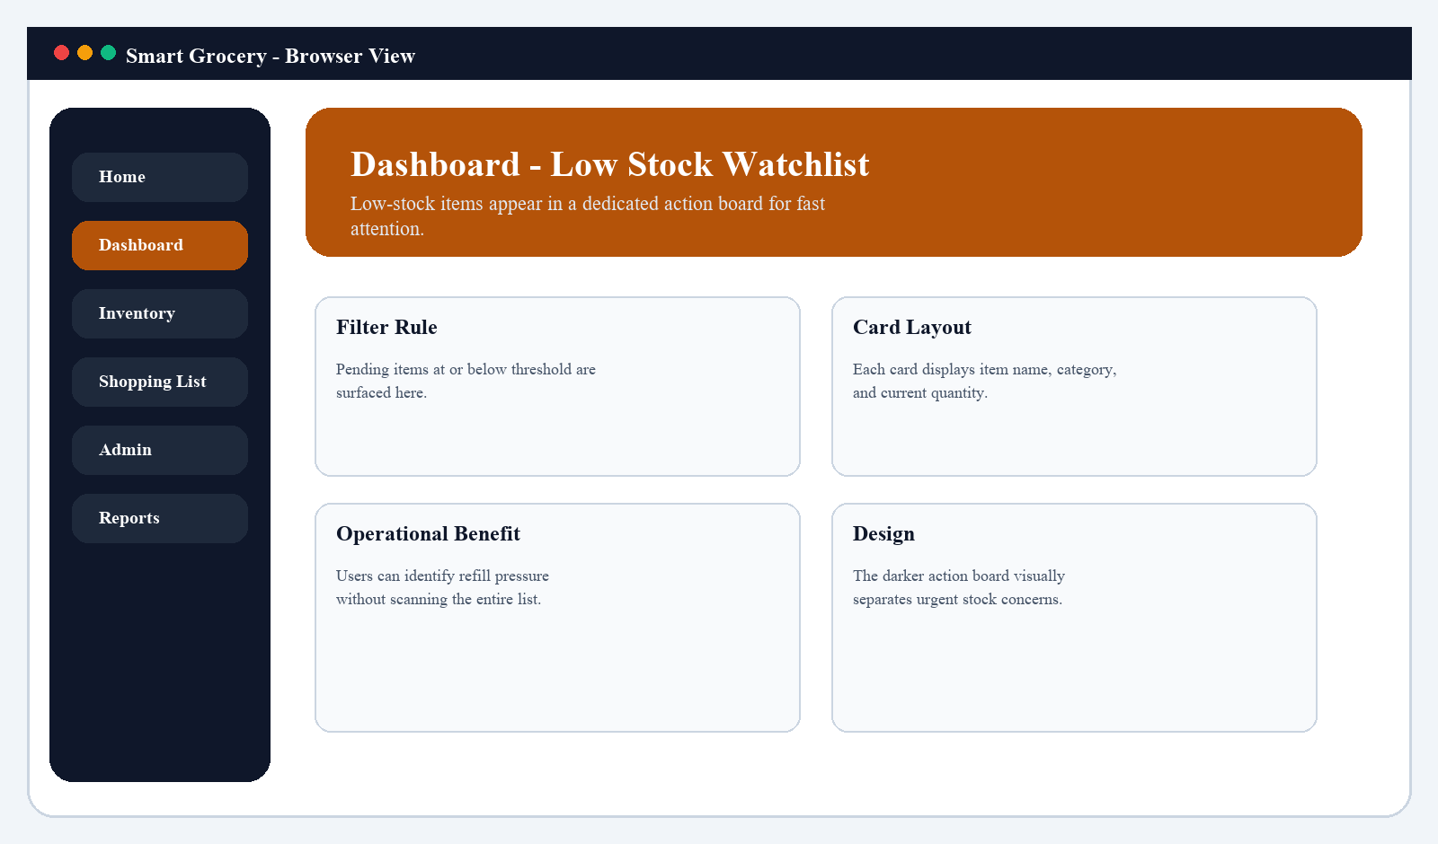
Figure 7.7: Low-stock watchlist showing urgent inventory items that need restocking.

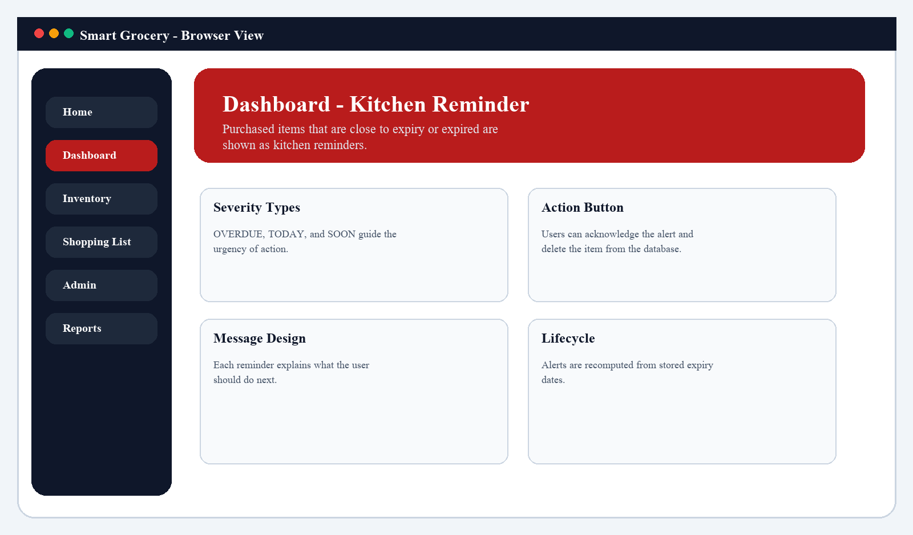
Figure 7.8: Kitchen reminder screen showing expiry-driven alerts for purchased items.

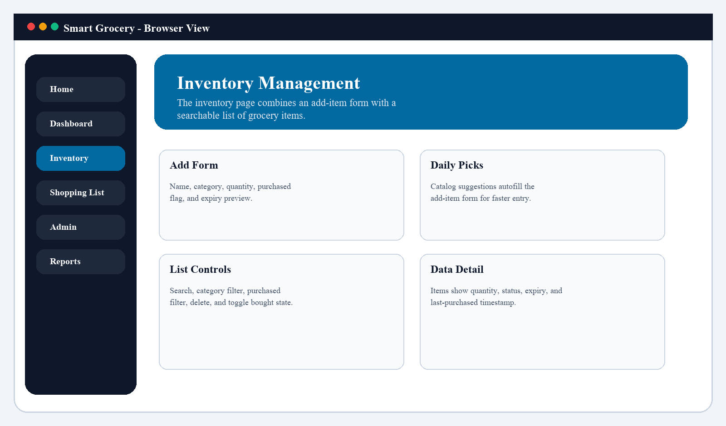
Figure 7.9: Inventory management screen combining item entry, filters, and item list controls.

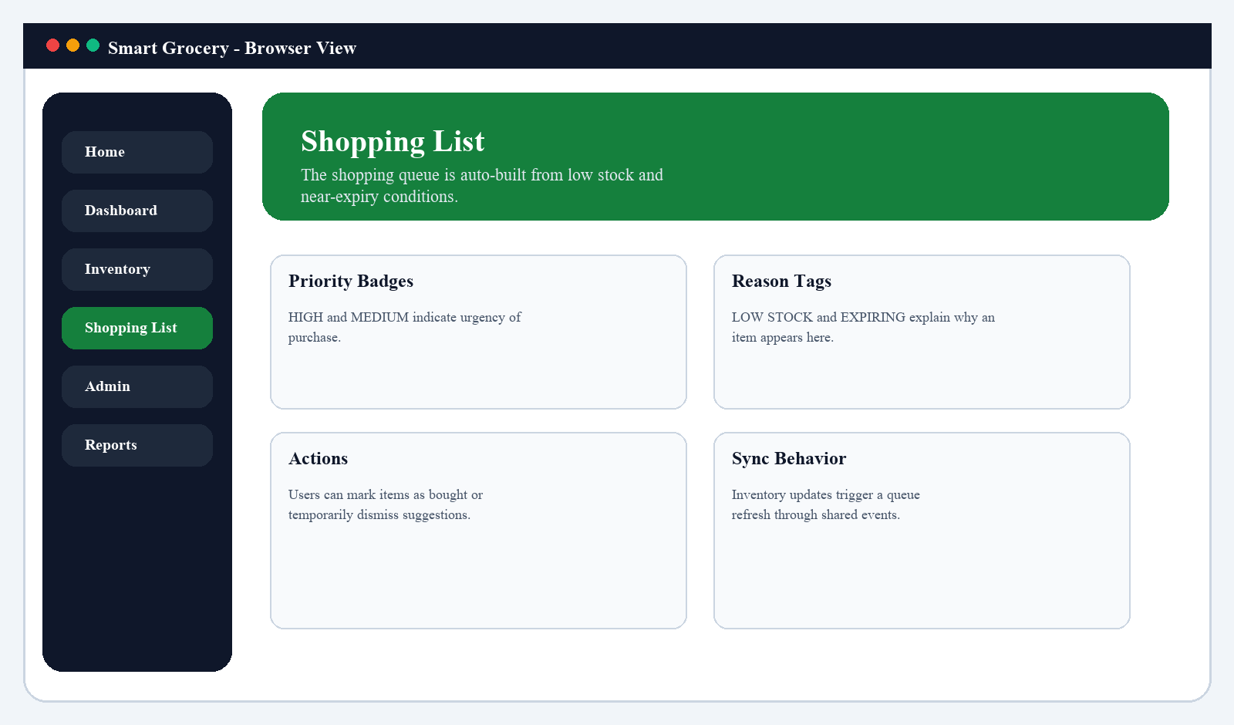
Figure 7.10: Shopping list screen generated from low-stock and near-expiry conditions.

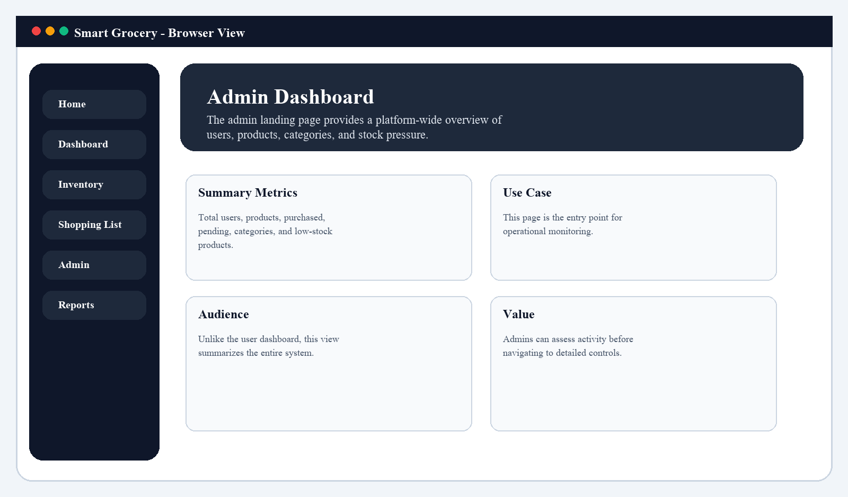
Figure 7.11: Admin dashboard screen showing system-wide counts and platform overview.

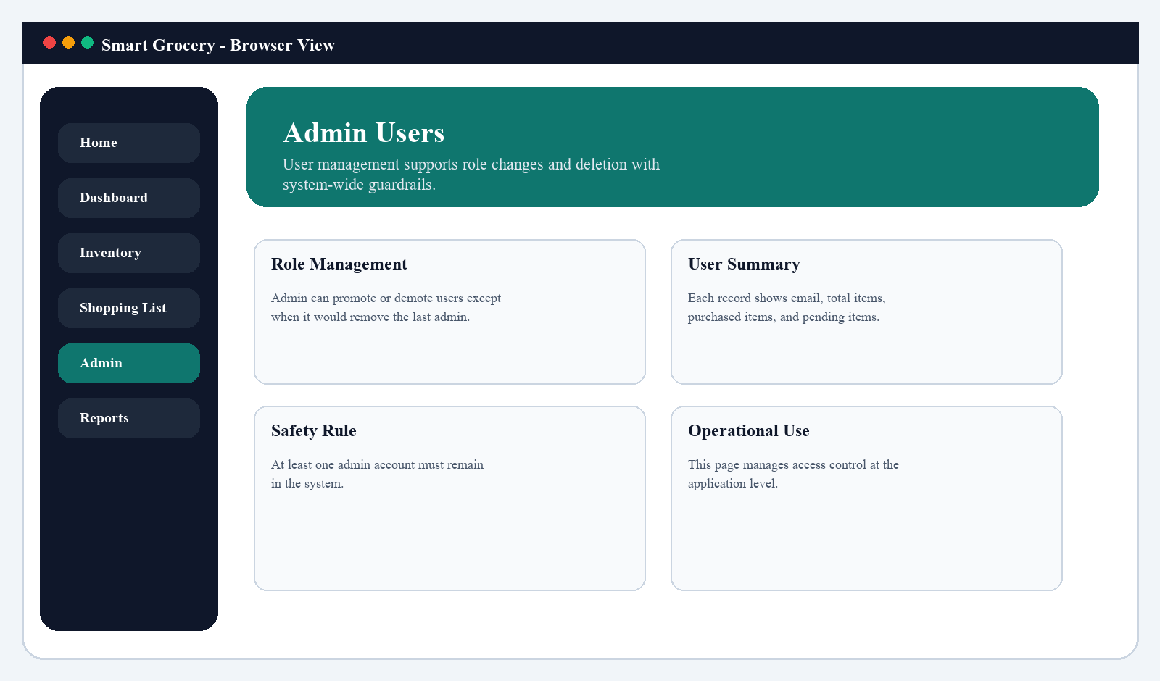
Figure 7.12: Admin users screen showing role management and user summary controls.

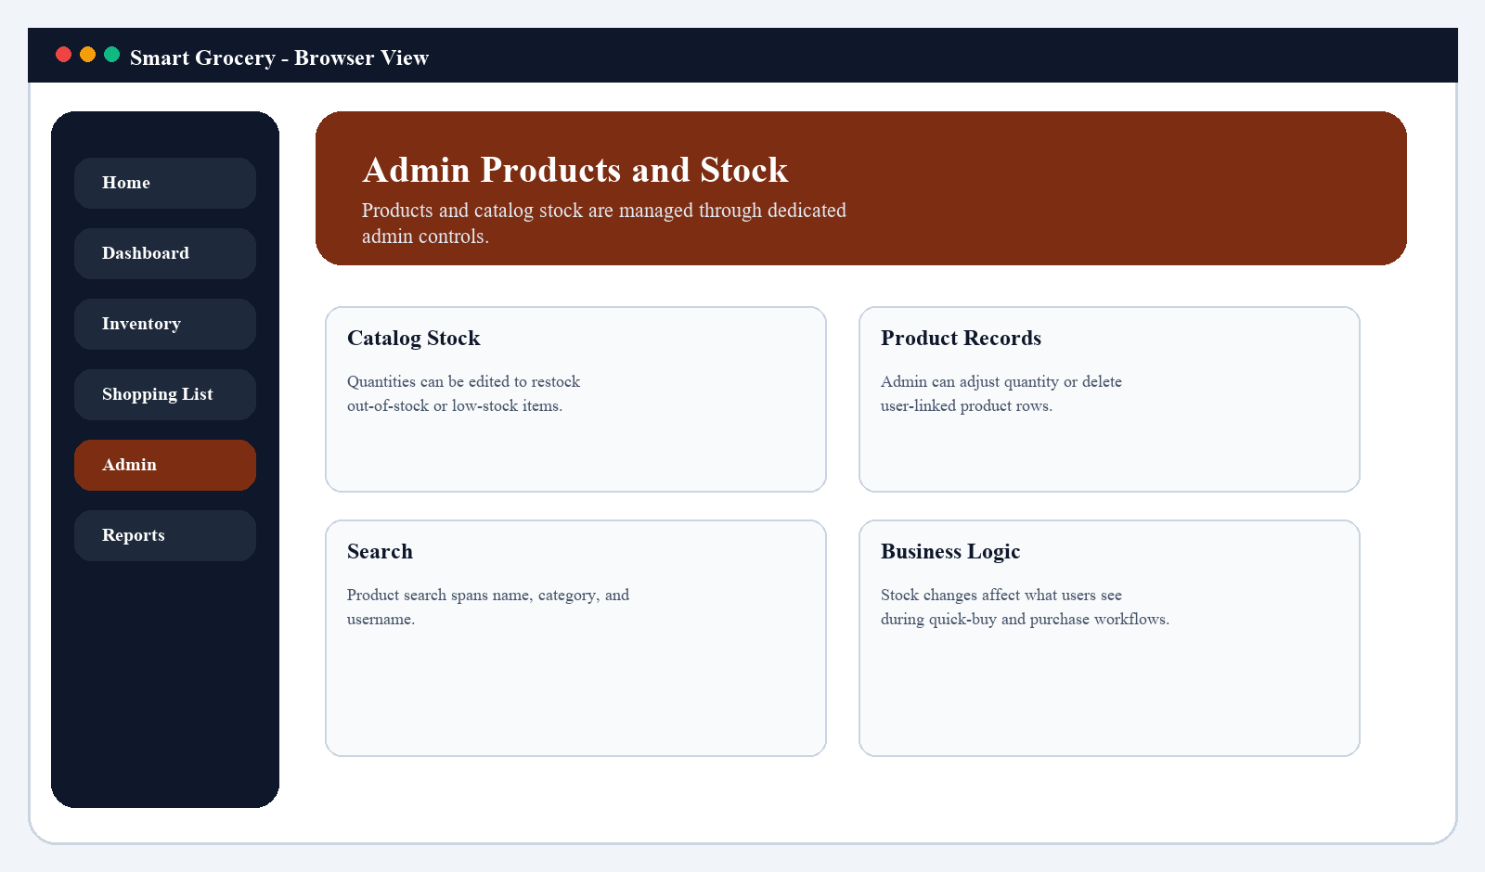
Figure 7.13: Admin products screen showing stock adjustments and product-level controls.

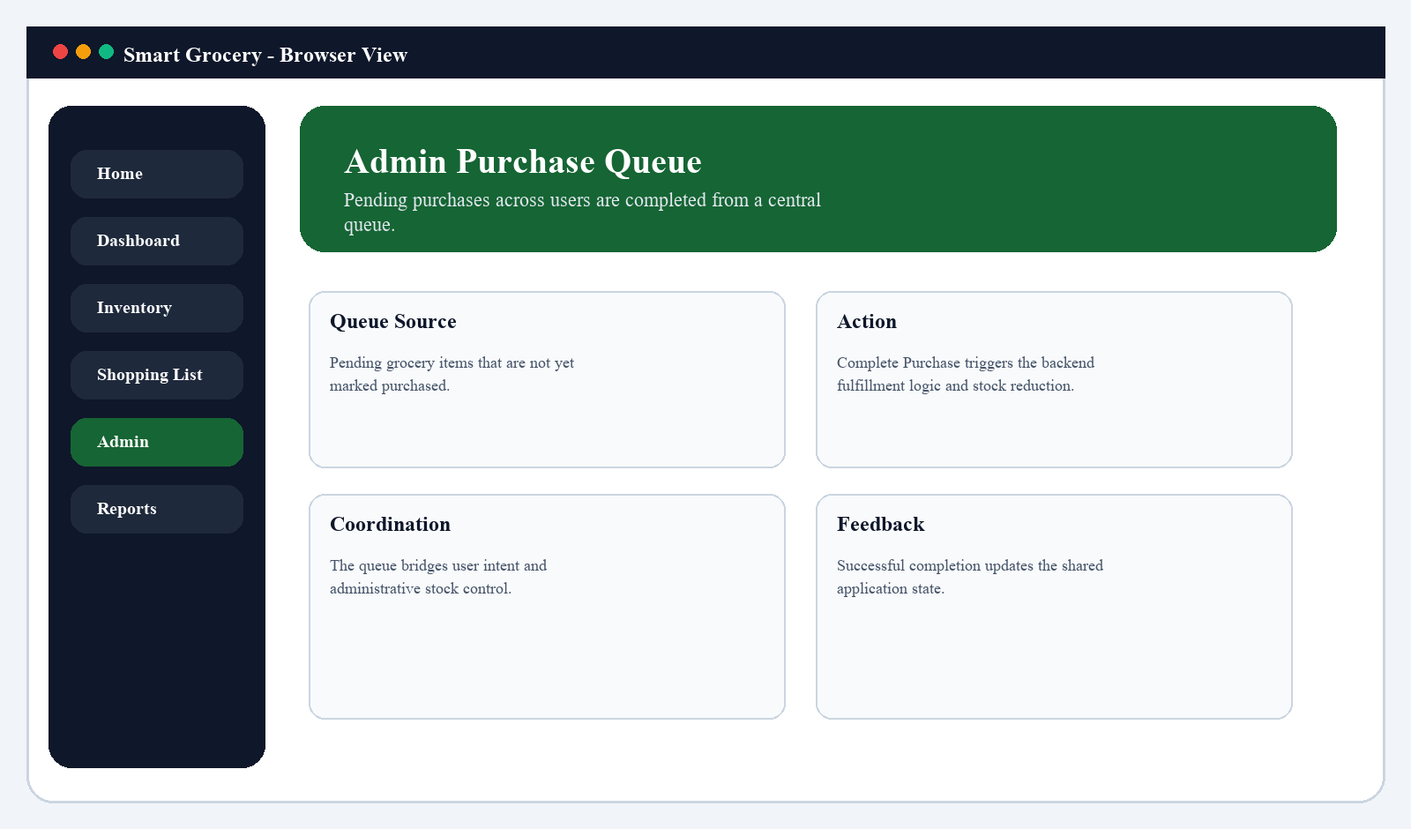
Figure 7.14: Admin purchase queue screen showing centralized completion of pending purchases.

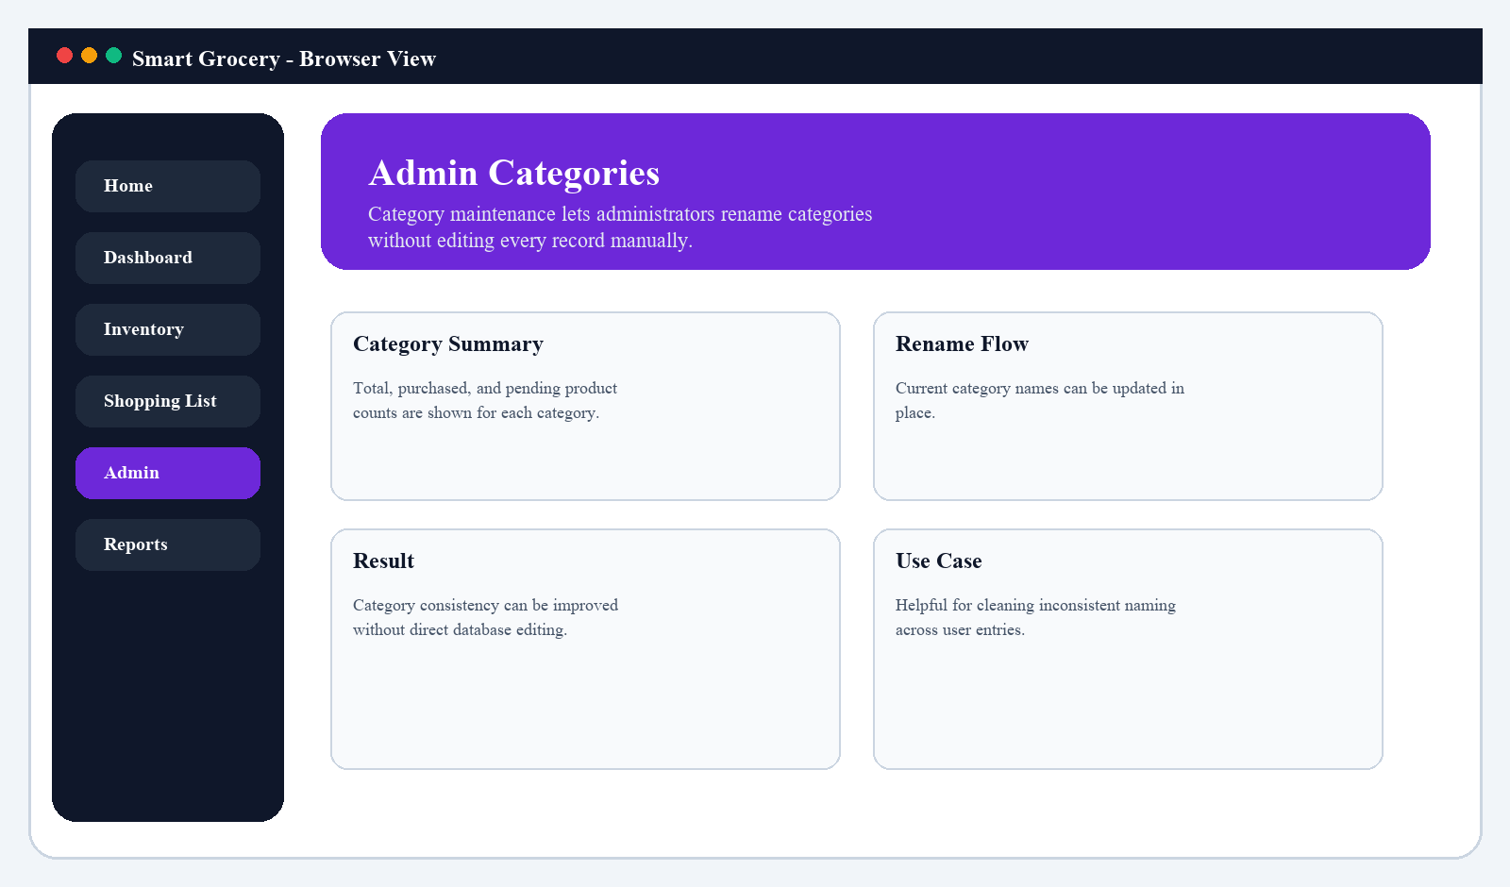
Figure 7.15: Admin categories screen showing rename controls and per-category summaries.

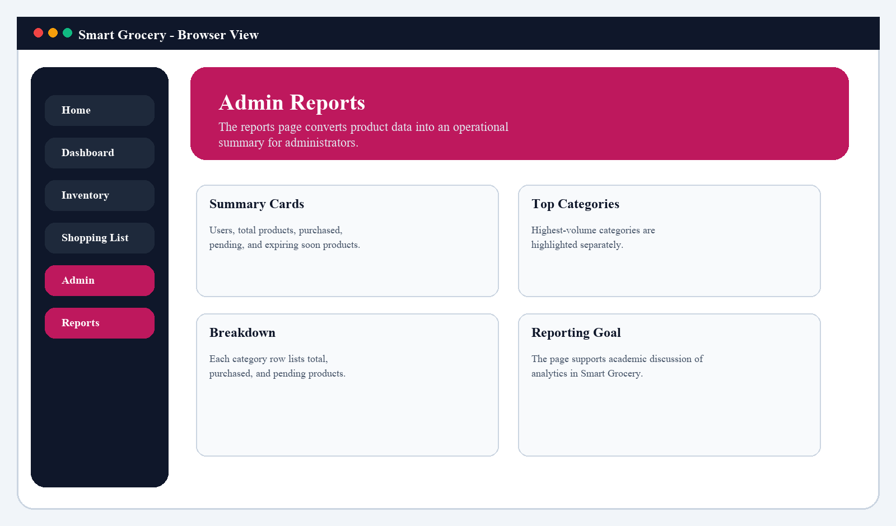
Figure 7.16: Admin reports screen showing operational reporting across users, products, and categories.

7.2 Observations from the Result Screens
The user-facing pages are organized around tasks rather than technical entities. The dashboard emphasizes action, while the inventory page emphasizes editing.
The home page behaves as a lightweight operational catalog rather than a static landing screen, which makes the project feel more product-oriented.
Administrator pages separate control concerns cleanly: users, products, stock, categories, purchase queue, and reports each get their own route and screen.
Expiry logic and shopping logic convert stored data into decision support, which improves the academic value of the project beyond CRUD.
Report-friendly figures can be mapped directly to repository pages, which makes the documentation more defensible in an academic review setting.

7.3 Sample Code and Implementation Evidence
AuthController.java excerpt
package com.example.backend.controller;
import jakarta.validation.Valid;
import org.springframework.beans.factory.annotation.Autowired;
import org.springframework.web.bind.annotation.*;
import com.example.backend.dto.*;
import com.example.backend.service.AuthService;
@RestController
@RequestMapping("/auth")
public class AuthController {
@Autowired
private AuthService authService;
@PostMapping("/register")
public String register(@Valid @RequestBody RegisterRequest request) {
return authService.register(request);
}
@PostMapping("/login")
public AuthResponse login(@Valid @RequestBody AuthRequest request) {
return authService.login(request);
}
@PostMapping("/admin/login")
public AuthResponse adminLogin(@Valid @RequestBody AuthRequest request) {

AuthService.java excerpt
@Autowired
private UserRepository userRepository;
@Autowired
private PasswordEncoder passwordEncoder;
@Autowired
private JwtUtil jwtUtil;
public String register(RegisterRequest request) {
String username = request.getUsername().trim();
String email = request.getEmail().trim().toLowerCase();
if (userRepository.findByUsername(username).isPresent()) {
throw new ConflictException("Username already exists");
}
User user = new User();
user.setUsername(username);
user.setEmail(email);
user.setPassword(passwordEncoder.encode(request.getPassword()));
user.setRole(UserRole.USER);
userRepository.save(user);
return "User registered successfully";
}
public AuthResponse login(AuthRequest request) {
User user = authenticate(request);
return new AuthResponse(jwtUtil.generateToken(user.getUsername()), user.getUsername(), resolveRole(user).name());
}
public AuthResponse loginAdmin(AuthRequest request) {
User user = authenticate(request);
if (resolveRole(user) != UserRole.ADMIN) {
throw new UnauthorizedException("Admin access is required");
}
return new AuthResponse(jwtUtil.generateToken(user.getUsername()), user.getUsername(), resolveRole(user).name());
}
private User authenticate(AuthRequest request) {

GroceryController.java excerpt
package com.example.backend.controller;
import com.example.backend.dto.CatalogItemResponse;
import com.example.backend.dto.ExpiryAlertResponse;
import com.example.backend.dto.GrocerySummaryResponse;
import com.example.backend.dto.RecommendationResponse;
import com.example.backend.dto.ShoppingItemDTO;
import com.example.backend.entity.GroceryItem;
import com.example.backend.service.GroceryService;
import jakarta.validation.Valid;
import org.springframework.beans.factory.annotation.Autowired;
import org.springframework.web.bind.annotation.*;
import java.security.Principal;
import java.util.List;
@RestController
@RequestMapping("/api/grocery")
public class GroceryController {
@Autowired
private GroceryService groceryService;
@GetMapping
public List<GroceryItem> getItems(
Principal principal,
@RequestParam(required = false) String category,
@RequestParam(required = false) String search,
@RequestParam(required = false) Boolean purchased
) {
return groceryService.getItemsByUsername(principal.getName(), category, search, purchased);
}
@GetMapping("/categories")
public List<String> getCategories(Principal principal) {
return groceryService.getCategories(principal.getName());
}
@GetMapping("/catalog")
public List<CatalogItemResponse> getCatalogItems(
Principal principal,
@RequestParam(required = false) String category,
@RequestParam(required = false) String search
) {
return groceryService.getCatalogItems(principal.getName(), category, search);
}
@GetMapping("/low-stock")
public List<GroceryItem> getLowStockItems(Principal principal) {
return groceryService.getLowStockItems(principal.getName());
}
@GetMapping("/shopping-list")
public List<ShoppingItemDTO> getShoppingList(Principal principal) {
return groceryService.getSmartShoppingList(principal.getName());
}
@GetMapping("/recommendations")
public List<RecommendationResponse> getRecommendations(Principal principal) {
return groceryService.getRecommendations(principal.getName());
}
@GetMapping("/expiry-alerts")
public List<ExpiryAlertResponse> getExpiryAlerts(Principal principal) {
return groceryService.getExpiryAlerts(principal.getName());
}
@GetMapping("/summary")
public GrocerySummaryResponse getSummary(Principal principal) {
return groceryService.getSummary(principal.getName());
}
@PostMapping
public GroceryItem addItem(Principal principal, @Valid @RequestBody GroceryItem item) {
return groceryService.addItem(principal.getName(), item);
}
@PutMapping("/{id}")
public GroceryItem updateItem(Principal principal, @PathVariable Long id, @Valid @RequestBody GroceryItem item) {
return groceryService.updateItem(principal.getName(), id, item);
}
@DeleteMapping("/{id}")
public String deleteItem(Principal principal, @PathVariable Long id) {
groceryService.deleteItem(principal.getName(), id);
return "Item deleted successfully";
}
@PostMapping("/{id}/acknowledge-expiry-alert")

GroceryService.java excerpt - inventory and summary logic
@Autowired
private GeminiCatalogService geminiCatalogService;
public List<GroceryItem> getItemsByUsername(String username) {
User user = getUser(username);
return groceryRepository.findByUserId(user.getId());
}
public List<GroceryItem> getItemsByUsername(String username, String category, String search, Boolean purchased) {
return getItemsByUsername(username).stream()
.filter(item -> matchesCategory(item, category))
.filter(item -> matchesSearch(item, search))
.filter(item -> matchesPurchased(item, purchased))
.toList();
}
public List<String> getCategories(String username) {
return java.util.stream.Stream.concat(
DEFAULT_CATALOG.stream().map(CatalogItemResponse::getCategory),
getItemsByUsername(username).stream().map(GroceryItem::getCategory)
)
.filter(Objects::nonNull)
.map(String::trim)
.filter(category -> !category.isBlank())
.distinct()
.sorted(String::compareToIgnoreCase)
.toList();
}
public List<CatalogItemResponse> getCatalogItems(String username, String category, String search) {
List<CatalogItemResponse> staticCatalog = DEFAULT_CATALOG.stream()
.filter(item -> matchesCatalogCategory(item, category))
.filter(item -> matchesCatalogSearch(item, search))
.sorted(Comparator.comparing(CatalogItemResponse::getCategory)
.thenComparing(CatalogItemResponse::getName))
.toList();
List<CatalogItemResponse> generatedCatalog = geminiCatalogService.getCatalogSuggestions(category, search)
.stream()
.filter(item -> matchesCatalogCategory(item, category))
.filter(item -> matchesCatalogSearch(item, search))
.toList();
Map<String, CatalogItemResponse> mergedCatalog = new LinkedHashMap<>();
java.util.stream.Stream.concat(staticCatalog.stream(), generatedCatalog.stream())
.forEach(item -> mergedCatalog.putIfAbsent(
item.getName().trim().toLowerCase() + "|" + item.getCategory().trim().toLowerCase(),
item
));
return mergedCatalog.values().stream()
.map(this::enrichCatalogItem)
.sorted(Comparator.comparing(CatalogItemResponse::getCategory)
.thenComparing(CatalogItemResponse::getName))
.toList();
}
public List<CatalogItemResponse> getCatalogStock() {
return DEFAULT_CATALOG.stream()
.map(this::enrichCatalogItem)
.sorted(Comparator.comparing(CatalogItemResponse::getCategory)
.thenComparing(CatalogItemResponse::getName))
.toList();
}
public CatalogItemResponse updateCatalogStock(String name, String category, int quantity) {
String normalizedName = name == null ? "" : name.trim();
String normalizedCategory = category == null ? "" : category.trim();
String key = catalogKey(normalizedName, normalizedCategory);
CatalogItemResponse matchingItem = DEFAULT_CATALOG.stream()
.filter(item -> catalogKey(item.getName(), item.getCategory()).equals(key))
.findFirst()
.orElseThrow(() -> new ResourceNotFoundException("Catalog item not found"));
catalogStockQuantities.put(key, Math.max(0, quantity));
return enrichCatalogItem(matchingItem);
}
public GroceryItem addItem(String username, GroceryItem item) {
User user = getUser(username);
item.setName(item.getName().trim());
item.setCategory(item.getCategory().trim());
if (item.isPurchased()) {
consumeCatalogStock(item.getName(), item.getCategory(), item.getQuantity());
}
item.setExpiryDate(resolveExpiryDate(item.getName(), item.getCategory(), item.isPurchased(), item.getExpiryDate()));
item.setUser(user);
updatePurchaseHistory(item, item.isPurchased());
return groceryRepository.save(item);
}
public List<GroceryItem> getLowStockItems(String username) {
return getItemsByUsername(username).stream()
.filter(item -> !item.isPurchased())
.filter(item -> item.getQuantity() <= LOW_STOCK_THRESHOLD)
.toList();
}
public List<ShoppingItemDTO> getSmartShoppingList(String username) {
LocalDate today = LocalDate.now();
Map<Long, ShoppingItemDTO> shoppingItems = new LinkedHashMap<>();
for (GroceryItem item : getItemsByUsername(username)) {
ShoppingItemDTO smartItem = mapToShoppingItem(item, today);
if (smartItem != null) {
shoppingItems.put(item.getId(), smartItem);
}
}
return shoppingItems.values().stream()
.sorted(Comparator.comparingInt(this::shoppingPriorityRank)
.thenComparing(ShoppingItemDTO::getName))
.toList();
}
public List<RecommendationResponse> getRecommendations(String username) {
Map<String, List<GroceryItem>> groupedItems = getItemsByUsername(username).stream()
.collect(Collectors.groupingBy(item -> item.getName().trim().toLowerCase() + "|" +
item.getCategory().trim().toLowerCase()));
return groupedItems.values().stream()

GroceryService.java excerpt - expiry and recommendation logic
GroceryItem item = groceryRepository.findById(id)
.orElseThrow(() -> new ResourceNotFoundException("Product not found"));
if (item.isPurchased()) {
throw new ConflictException("Item is already marked as purchased");
}
consumeCatalogStock(item.getName(), item.getCategory(), item.getQuantity());
item.setPurchased(true);
item.setExpiryDate(resolveExpiryDate(item.getName(), item.getCategory(), true, item.getExpiryDate()));
updatePurchaseHistory(item, true);
return groceryRepository.save(item);
}
public void deleteItem(String username, Long id) {
User user = getUser(username);
GroceryItem item = groceryRepository.findByIdAndUserId(id, user.getId())
.orElseThrow(() -> new ResourceNotFoundException("Item not found"));
groceryRepository.delete(item);
}
public void acknowledgeExpiryAlert(String username, Long id) {
User user = getUser(username);
GroceryItem item = groceryRepository.findByIdAndUserId(id, user.getId())
.orElseThrow(() -> new ResourceNotFoundException("Item not found"));
if (buildExpiryAlert(item) == null) {
throw new ConflictException("Item does not have an active expiry alert");
}
groceryRepository.delete(item);
}
private User getUser(String username) {
return userRepository.findByUsername(username)
.orElseThrow(() -> new ResourceNotFoundException("User not found"));
}
private RecommendationResponse buildRecommendation(List<GroceryItem> items) {
GroceryItem sample = items.get(0);
int score = items.stream().mapToInt(this::recommendationScore).sum();
if (score == 0) {
return null;
}
return new RecommendationResponse(
sample.getName(),
sample.getCategory(),
buildReason(items),
buildPriority(score)
);
}
private ExpiryAlertResponse buildExpiryAlert(GroceryItem item) {
if (!item.isPurchased() || item.getExpiryDate() == null) {
return null;
}
long daysUntilExpiry = ChronoUnit.DAYS.between(LocalDate.now(), item.getExpiryDate());
if (daysUntilExpiry < 0) {
return new ExpiryAlertResponse(
item.getId(),
item.getName(),
item.getCategory(),
item.getExpiryDate(),
"Expired. Remove it and buy fresh today.",
"OVERDUE"
);
}
if (daysUntilExpiry == 0) {
return new ExpiryAlertResponse(
item.getId(),
item.getName(),
item.getCategory(),
item.getExpiryDate(),
"Expires today. Use it in time or buy fresh today.",
"TODAY"
);
}
if (daysUntilExpiry == 1) {
return new ExpiryAlertResponse(
item.getId(),
item.getName(),
item.getCategory(),
item.getExpiryDate(),
"Expires in 1 day.",
"SOON"
);
}
if (daysUntilExpiry <= 3) {
return new ExpiryAlertResponse(
item.getId(),
item.getName(),
item.getCategory(),
item.getExpiryDate(),
"Should be used soon.",
"SOON"
);
}
return null;
}
private int recommendationScore(GroceryItem item) {
int score = 0;
if (item.isPurchased()) {
score += 3;
}
if (!item.isPurchased() && item.getQuantity() <= 1) {
score += 3;
} else if (!item.isPurchased() && item.getQuantity() <= LOW_STOCK_THRESHOLD) {
score += 2;
}
return score;
}
private String buildReason(List<GroceryItem> items) {
boolean hasPurchasedItem = items.stream().anyMatch(GroceryItem::isPurchased);
boolean hasLowStockItem = items.stream()
.anyMatch(item -> !item.isPurchased() && item.getQuantity() <= LOW_STOCK_THRESHOLD);
if (hasPurchasedItem && hasLowStockItem) {
return "Previously purchased and currently low in stock";
}
if (hasPurchasedItem) {
return "Previously purchased item you may need again";
}
return "Low stock item that should be restocked soon";
}
private String buildPriority(int score) {
if (score >= 5) {

AdminService.java excerpt
@Service
public class AdminService {
private final UserRepository userRepository;
private final GroceryRepository groceryRepository;
private final GroceryService groceryService;
public AdminService(UserRepository userRepository, GroceryRepository groceryRepository, GroceryService groceryService) {
this.userRepository = userRepository;
this.groceryRepository = groceryRepository;
this.groceryService = groceryService;
}
public AdminDashboardResponse getDashboard() {
List<User> users = userRepository.findAll();
List<GroceryItem> products = groceryRepository.findAll();
long purchasedProducts = products.stream().filter(GroceryItem::isPurchased).count();
long totalCategories = products.stream()
.map(GroceryItem::getCategory)
.filter(Objects::nonNull)
.map(String::trim)
.filter(category -> !category.isBlank())
.map(String::toLowerCase)
.distinct()
.count();
long lowStockProducts = products.stream()
.filter(item -> !item.isPurchased())
.filter(item -> item.getQuantity() <= 2)
.count();
return new AdminDashboardResponse(
users.size(),
products.size(),
purchasedProducts,
products.size() - purchasedProducts,
totalCategories,
lowStockProducts
);
}
public List<AdminUserSummaryResponse> getUsers() {
List<GroceryItem> products = groceryRepository.findAll();
return userRepository.findAll().stream()
.sorted(Comparator.comparing(User::getUsername, String.CASE_INSENSITIVE_ORDER))
.map(user -> {
long totalItems = products.stream()
.filter(item -> item.getUser() != null && item.getUser().getId() == user.getId())
.count();
long purchasedItems = products.stream()
.filter(item -> item.getUser() != null && item.getUser().getId() == user.getId())
.filter(GroceryItem::isPurchased)
.count();
return new AdminUserSummaryResponse(
user.getId(),
user.getUsername(),
user.getEmail(),
resolveRole(user).name(),
totalItems,
purchasedItems,
totalItems - purchasedItems
);
})
.toList();
}
public AdminUserSummaryResponse updateUserRole(Long id, AdminUserRoleUpdateRequest request) {
User user = userRepository.findById(id)
.orElseThrow(() -> new ResourceNotFoundException("User not found"));
UserRole nextRole;
try {
nextRole = UserRole.valueOf(request.getRole().trim().toUpperCase());
} catch (IllegalArgumentException exception) {
throw new ConflictException("Role must be USER or ADMIN");
}
if (resolveRole(user) == UserRole.ADMIN && nextRole == UserRole.USER
&& userRepository.countByRole(UserRole.ADMIN) <= 1) {
throw new ConflictException("At least one admin account must remain");
}
user.setRole(nextRole);
userRepository.save(user);
long totalItems = groceryRepository.findAll().stream()
.filter(item -> item.getUser() != null && item.getUser().getId() == user.getId())
.count();
long purchasedItems = groceryRepository.findAll().stream()
.filter(item -> item.getUser() != null && item.getUser().getId() == user.getId())
.filter(GroceryItem::isPurchased)
.count();
return new AdminUserSummaryResponse(
user.getId(),
user.getUsername(),
user.getEmail(),
nextRole.name(),
totalItems,
purchasedItems,
totalItems - purchasedItems
);
}
public void deleteUser(Long id) {
User user = userRepository.findById(id)
.orElseThrow(() -> new ResourceNotFoundException("User not found"));
if (resolveRole(user) == UserRole.ADMIN && userRepository.countByRole(UserRole.ADMIN) <= 1) {
throw new ConflictException("At least one admin account must remain");
}
groceryRepository.deleteByUserId(user.getId());
userRepository.delete(user);
}
public List<AdminProductResponse> getProducts() {
return groceryRepository.findAll().stream()
.sorted(Comparator.comparing(GroceryItem::getCategory, String.CASE_INSENSITIVE_ORDER)
.thenComparing(GroceryItem::getName, String.CASE_INSENSITIVE_ORDER))
.map(this::mapProduct)
.toList();
}
public AdminProductResponse updateProduct(Long id, GroceryItem request) {
GroceryItem item = groceryRepository.findById(id)
.orElseThrow(() -> new ResourceNotFoundException("Product not found"));
item.setName(request.getName().trim());
item.setCategory(request.getCategory().trim());
item.setQuantity(request.getQuantity());
item.setPurchased(request.isPurchased());
item.setExpiryDate(request.getExpiryDate());
groceryRepository.save(item);
return mapProduct(item);
}
public void deleteProduct(Long id) {
GroceryItem item = groceryRepository.findById(id)
.orElseThrow(() -> new ResourceNotFoundException("Product not found"));
groceryRepository.delete(item);
}
public List<AdminCategoryResponse> getCategories() {
return buildCategoryBreakdown(groceryRepository.findAll());
}
public List<AdminCategoryResponse> renameCategory(AdminCategoryRenameRequest request) {
String currentName = request.getCurrentName().trim();
String nextName = request.getNextName().trim();
if (currentName.equalsIgnoreCase(nextName)) {
throw new ConflictException("Choose a different category name");
}
List<GroceryItem> matchingItems = groceryRepository.findAll().stream()
.filter(item -> item.getCategory() != null && item.getCategory().equalsIgnoreCase(currentName))
.toList();
if (matchingItems.isEmpty()) {
throw new ResourceNotFoundException("Category not found");
}
matchingItems.forEach(item -> item.setCategory(nextName));
groceryRepository.saveAll(matchingItems);
return getCategories();
}
public List<AdminProductResponse> getPurchaseQueue() {
return groceryRepository.findAll().stream()
.filter(item -> !item.isPurchased())
.sorted(Comparator.comparing(GroceryItem::getCategory, String.CASE_INSENSITIVE_ORDER)
.thenComparing(GroceryItem::getName, String.CASE_INSENSITIVE_ORDER))
.map(this::mapProduct)

App.jsx routes excerpt
import { Navigate, Route, Routes } from 'react-router-dom'
import AdminShell from './components/AdminShell'
import AppShell from './components/AppShell'
import ProtectedRoute from './components/ProtectedRoute'
import AdminCategoriesPage from './pages/AdminCategoriesPage'
import AdminDashboardPage from './pages/AdminDashboardPage'
import AdminProductsPage from './pages/AdminProductsPage'
import AdminPurchaseQueuePage from './pages/AdminPurchaseQueuePage'
import AdminReportsPage from './pages/AdminReportsPage'
import AdminUsersPage from './pages/AdminUsersPage'
import AuthPage from './pages/AuthPage'
import DashboardPage from './pages/DashboardPage'
import HomePage from './pages/HomePage'
import InventoryPage from './pages/InventoryPage'
import ShoppingListPage from './pages/ShoppingListPage'
function App() {
return (
<Routes>
<Route path="/login" element={<AuthPage mode="login" />} />
<Route path="/register" element={<AuthPage mode="register" />} />
<Route element={<ProtectedRoute requiredRole="USER" redirectTo="/login" />}>
<Route element={<AppShell />}>
<Route path="/" element={<HomePage />} />
<Route path="/dashboard" element={<DashboardPage />} />
<Route path="/inventory" element={<InventoryPage />} />
<Route path="/shopping-list" element={<ShoppingListPage />} />
</Route>
</Route>
<Route element={<ProtectedRoute requiredRole="ADMIN" redirectTo="/login" />}>
<Route element={<AdminShell />}>
<Route path="/admin" element={<AdminDashboardPage />} />
<Route path="/admin/users" element={<AdminUsersPage />} />
<Route path="/admin/products" element={<AdminProductsPage />} />
<Route path="/admin/categories" element={<AdminCategoriesPage />} />

DashboardPage.jsx excerpt
import { useEffect, useState } from 'react'
import { Link, useLocation, useNavigate } from 'react-router-dom'
import { LayoutDashboard, ShoppingCart, AlertTriangle, Package, Lightbulb, Clock } from 'lucide-react'
import api, { getApiErrorMessage } from '../api/client'
const summaryCards = [
{ key: 'totalItems', label: 'Total Items', accent: 'from-sky-500 to-cyan-400', icon: Package },
{ key: 'pendingItems', label: 'Pending', accent: 'from-amber-500 to-orange-400', icon: Clock },
{ key: 'purchasedItems', label: 'Purchased', accent: 'from-emerald-500 to-lime-400', icon: ShoppingCart },
{ key: 'lowStockItems', label: 'Low Stock', accent: 'from-rose-500 to-pink-400', icon: AlertTriangle },
]
function DashboardPage() {
const location = useLocation()
const navigate = useNavigate()
const [summary, setSummary] = useState(null)
const [recommendations, setRecommendations] = useState([])
const [lowStockItems, setLowStockItems] = useState([])
const [expiryAlerts, setExpiryAlerts] = useState([])
const [myItems, setMyItems] = useState([])
const [error, setError] = useState('')
const [activeSection, setActiveSection] = useState('')
const [acknowledgingItemId, setAcknowledgingItemId] = useState('')
const dashboardSections = [
{ key: 'recommendations', label: 'Smart Picks', sublabel: 'Recommendation queue', icon: Lightbulb },
{ key: 'low-stock-watchlist', label: 'Action Board', sublabel: 'Low-stock watchlist', icon: AlertTriangle },
{ key: 'kitchen-reminders', label: 'Kitchen Reminder', sublabel: 'Expiry reminders', icon: Clock },
{ key: 'pending-focus', label: 'Pending Focus', sublabel: 'Items that still need action', icon: Package },
{ key: 'recent-list', label: 'Recent List', sublabel: 'Latest grocery activity', icon: ShoppingCart },
]
const formatExpiryDate = (value) => {
if (!value) {
return ''
}
return new Date(`${value}T00:00:00`).toLocaleDateString()
}
const fetchDashboardData = async () => {
const results = await Promise.allSettled([
api.get('/api/grocery/summary'),
api.get('/api/grocery/recommendations'),
api.get('/api/grocery/low-stock'),
api.get('/api/grocery/expiry-alerts'),
api.get('/api/grocery'),
])
const [summaryResult, recommendationsResult, lowStockResult, expiryAlertsResult, myItemsResult] = results
const failures = results.filter((result) => result.status === 'rejected')
return {
failures,
summary: summaryResult.status === 'fulfilled' ? summaryResult.value.data : undefined,
recommendations:
recommendationsResult.status === 'fulfilled' ? recommendationsResult.value.data : undefined,
lowStockItems: lowStockResult.status === 'fulfilled' ? lowStockResult.value.data : undefined,
expiryAlerts: expiryAlertsResult.status === 'fulfilled' ? expiryAlertsResult.value.data : undefined,
myItems: myItemsResult.status === 'fulfilled' ? myItemsResult.value.data : undefined,
}
}
const applyDashboardData = (data) => {
if (data.summary !== undefined) {
setSummary(data.summary)
}
if (data.recommendations !== undefined) {
setRecommendations(data.recommendations)
}
if (data.lowStockItems !== undefined) {
setLowStockItems(data.lowStockItems)
}
if (data.expiryAlerts !== undefined) {
setExpiryAlerts(data.expiryAlerts)
}
if (data.myItems !== undefined) {
setMyItems(data.myItems)
}
}
const setDashboardErrorFromFailures = (failures) => {
if (failures.length === 0) {
setError('')
return
}
if (failures.length === 5) {
setError(
getApiErrorMessage(
failures[0].reason,
'Unable to load dashboard data. Start the backend and login again.',
),
)
return
}
setError('Some dashboard sections are temporarily unavailable.')
}
useEffect(() => {
let cancelled = false
fetchDashboardData().then((data) => {
if (cancelled) {
return
}
applyDashboardData(data)
setDashboardErrorFromFailures(data.failures)
})
return () => {
cancelled = true
}
}, [])
useEffect(() => {
const sectionToOpen = location.state?.openSection
if (!sectionToOpen) {
return
}
setActiveSection(sectionToOpen)
navigate(location.pathname, { replace: true, state: {} })
}, [location.pathname, location.state, navigate])
useEffect(() => {
let cancelled = false
const handleDataChanged = async () => {
const results = await Promise.allSettled([
api.get('/api/grocery/summary'),
api.get('/api/grocery/recommendations'),
api.get('/api/grocery/low-stock'),
api.get('/api/grocery/expiry-alerts'),
api.get('/api/grocery'),
])
if (cancelled) {
return
}
const [summaryResult, recommendationsResult, lowStockResult, expiryAlertsResult, myItemsResult] = results
const failures = results.filter((result) => result.status === 'rejected')
if (summaryResult.status === 'fulfilled') {
setSummary(summaryResult.value.data)
}
if (recommendationsResult.status === 'fulfilled') {
setRecommendations(recommendationsResult.value.data)
}
if (lowStockResult.status === 'fulfilled') {
setLowStockItems(lowStockResult.value.data)
}
if (expiryAlertsResult.status === 'fulfilled') {
setExpiryAlerts(expiryAlertsResult.value.data)
}
if (myItemsResult.status === 'fulfilled') {
setMyItems(myItemsResult.value.data)
}
if (failures.length === 0) {
setError('')
return
}
if (failures.length === results.length) {
setError(
getApiErrorMessage(
failures[0].reason,
'Unable to load dashboard data. Start the backend and login again.',
),
)
return
}
setError('Some dashboard sections are temporarily unavailable.')
}
window.addEventListener('grocery-data-changed', handleDataChanged)
return () => {
cancelled = true
window.removeEventListener('grocery-data-changed', handleDataChanged)
}
}, [])
const recentItems = [...myItems]
.sort((first, second) => {
if (first.lastPurchasedAt && second.lastPurchasedAt) {
return new Date(second.lastPurchasedAt) - new Date(first.lastPurchasedAt)
}
if (second.lastPurchasedAt) {
return 1
}
if (first.lastPurchasedAt) {
return -1
}

InventoryPage.jsx excerpt
import { useEffect, useState } from 'react'
import { Search, Tag, Filter, Plus, Trash2, CheckCircle, Circle, Package } from 'lucide-react'
import api, { getApiErrorMessage } from '../api/client'
import { getNaturalExpiryDate } from '../utils/expiry'
const initialForm = {
name: '',
category: '',
quantity: 1,
purchased: false,
expiryDate: '',
}
const suggestionClasses =
'border-sky-100 hover:border-sky-300 hover:bg-sky-50/80'
const suggestionCardStyle = {
background:
'linear-gradient(145deg, rgba(14,165,233,0.12), rgba(255,255,255,0.94) 58%, rgba(16,185,129,0.08))',
}
function InventoryPage() {
const [items, setItems] = useState([])
const [categories, setCategories] = useState([])
const [catalogItems, setCatalogItems] = useState([])
const [form, setForm] = useState(initialForm)
const [filters, setFilters] = useState({ category: '', search: '', purchased: '' })
const [error, setError] = useState('')
const [loading, setLoading] = useState(false)
const naturalExpiryDate = form.purchased ? getNaturalExpiryDate(form.name, form.category) : null
const displayedExpiryDate = form.expiryDate || naturalExpiryDate || ''
const getExpectedExpiryDate = (item) =>
item.expiryDate || getNaturalExpiryDate(item.name, item.category) || ''
const formatExpiryDate = (value) => {
if (!value) {
return 'Select item details to preview expiry'
}
return new Date(`${value}T00:00:00`).toLocaleDateString()
}
const loadItems = async (currentFilters = filters) => {
setLoading(true)
setError('')
try {
const params = {}
if (currentFilters.category) {
params.category = currentFilters.category
}
if (currentFilters.search) {
params.search = currentFilters.search
}
if (currentFilters.purchased !== '') {
params.purchased = currentFilters.purchased
}
const { data } = await api.get('/api/grocery', { params })
setItems(data)
} catch (requestError) {
setError(getApiErrorMessage(requestError, 'Unable to load grocery items. Make sure the backend is running.'))
} finally {
setLoading(false)
}
}
const loadCategoryOptions = async () => {
try {
const { data } = await api.get('/api/grocery/categories')
setCategories(data)
} catch {
setCategories([])
}
}
const loadCatalogItems = async (category = '', search = '') => {
try {
const params = {}
if (category) {
params.category = category
}
if (search) {
params.search = search
}
const { data } = await api.get('/api/grocery/catalog', { params })
setCatalogItems(data)
} catch {
setCatalogItems([])
}
}
useEffect(() => {
const initializePage = async () => {
setLoading(true)
setError('')
try {
const [itemsResponse, categoriesResponse, catalogResponse] = await Promise.all([
api.get('/api/grocery'),
api.get('/api/grocery/categories'),
api.get('/api/grocery/catalog'),
])
setItems(itemsResponse.data)
setCategories(categoriesResponse.data)
setCatalogItems(catalogResponse.data)
} catch (requestError) {
setError(getApiErrorMessage(requestError, 'Unable to load grocery items. Make sure the backend is running.'))
setCategories([])
setCatalogItems([])
} finally {
setLoading(false)
}
}
initializePage()
}, [])
useEffect(() => {
const handleDataChanged = async () => {
setLoading(true)
setError('')
try {
const params = {}
if (filters.category) {
params.category = filters.category
}
if (filters.search) {
params.search = filters.search
}
if (filters.purchased !== '') {
params.purchased = filters.purchased
}
const [itemsResponse, categoriesResponse, catalogResponse] = await Promise.all([
api.get('/api/grocery', { params }),
api.get('/api/grocery/categories'),
api.get('/api/grocery/catalog'),
])
setItems(itemsResponse.data)
setCategories(categoriesResponse.data)
setCatalogItems(catalogResponse.data)
} catch (requestError) {
setError(getApiErrorMessage(requestError, 'Unable to load grocery items. Make sure the backend is running.'))
} finally {
setLoading(false)
}
}
window.addEventListener('grocery-data-changed', handleDataChanged)
return () => {
window.removeEventListener('grocery-data-changed', handleDataChanged)
}
}, [filters])
const handleFormChange = (event) => {
const { name, value, type, checked } = event.target
setForm((current) => ({
...current,
[name]: type === 'checkbox' ? checked : value,
}))
}
const handleFormPurchasedToggle = () => {
setForm((current) => ({
...current,
purchased: !current.purchased,
}))
}
const handleFilterChange = (event) => {
const { name, value } = event.target
const nextFilters = { ...filters, [name]: value }
setFilters(nextFilters)
loadItems(nextFilters)
}
const handleAddItem = async (event) => {
event.preventDefault()
setError('')
try {
await api.post('/api/grocery', {
...form,
quantity: Number(form.quantity),
expiryDate: displayedExpiryDate || null,
})
setForm(initialForm)
loadItems()
loadCategoryOptions()
} catch (requestError) {
setError(getApiErrorMessage(requestError, 'Could not save this buying item. Check the values and try again.'))
}
}
const handleCategorySelect = (event) => {
const nextCategory = event.target.value
setForm((current) => ({
...current,
category: nextCategory,
purchased: false,
expiryDate: '',
}))
loadCatalogItems(nextCategory, form.name)
}
const handleNameInput = (event) => {
const nextName = event.target.value
setForm((current) => ({
...current,
name: nextName,
purchased: false,
expiryDate: '',
}))
loadCatalogItems(form.category, nextName)
}
const handleCatalogPick = (catalogItem) => {
setForm((current) => ({
...initialForm,
quantity: current.quantity,
name: catalogItem.name,
category: catalogItem.category,
}))
}
const handleTogglePurchased = async (item) => {
setError('')
const nextPurchased = !item.purchased
const nextExpiryDate = nextPurchased ? item.expiryDate || null : null
try {
await api.put(`/api/grocery/${item.id}`, {
...item,
purchased: nextPurchased,
expiryDate: nextExpiryDate,
})
loadItems()
} catch (requestError) {
setError(getApiErrorMessage(requestError, 'Could not update item status.'))
}
}
const handleDelete = async (id) => {
setError('')

ShoppingListPage.jsx excerpt
import { useEffect, useState } from 'react'
import api, { getApiErrorMessage, getShoppingList } from '../api/client'
const DISMISSED_ITEMS_STORAGE_KEY = 'smart-grocery-shopping-list-dismissed'
const LOW_STOCK_THRESHOLD = 2
const formatDateLabel = (value) => {
if (!value) {
return 'Not set'
}
return new Date(`${value}T00:00:00`).toLocaleDateString()
}
const getPriorityBadgeClasses = (priority) => {
if (priority === 'HIGH') {
return 'bg-rose-100 text-rose-800 border border-rose-200'
}
if (priority === 'MEDIUM') {
return 'bg-amber-100 text-amber-800 border border-amber-200'
}
return 'bg-emerald-100 text-emerald-800 border border-emerald-200'
}
const shoppingHeroStyle = {
background:
'linear-gradient(135deg, rgba(16,185,129,0.2), rgba(255,255,255,0.92) 55%, rgba(14,165,233,0.14))',
}
function ShoppingListPage() {
const [items, setItems] = useState([])
const [dismissedItemIds, setDismissedItemIds] = useState([])
const [loading, setLoading] = useState(false)
const [error, setError] = useState('')
const [updatingItemId, setUpdatingItemId] = useState('')
const loadShoppingItems = async () => {
setLoading(true)
setError('')
try {
const data = await getShoppingList()
setItems(data)
} catch (requestError) {
setError(getApiErrorMessage(requestError, 'Unable to load the smart shopping list.'))
} finally {
setLoading(false)
}
}
useEffect(() => {
try {
const stored = localStorage.getItem(DISMISSED_ITEMS_STORAGE_KEY)
if (stored) {
const parsed = JSON.parse(stored)
if (Array.isArray(parsed)) {
setDismissedItemIds(parsed.filter((id) => typeof id === 'number'))
}
}
} catch {
setDismissedItemIds([])
}
}, [])
useEffect(() => {
loadShoppingItems()
}, [])
useEffect(() => {
const handleDataChanged = () => {
loadShoppingItems()
}
window.addEventListener('grocery-data-changed', handleDataChanged)
return () => window.removeEventListener('grocery-data-changed', handleDataChanged)
}, [])
const handleDismissItem = (itemId) => {
setDismissedItemIds((current) => {
const next = Array.from(new Set([...current, itemId]))
localStorage.setItem(DISMISSED_ITEMS_STORAGE_KEY, JSON.stringify(next))
return next
})
}
const handleRestoreDismissed = () => {
localStorage.removeItem(DISMISSED_ITEMS_STORAGE_KEY)
setDismissedItemIds([])
}
const handleMarkPurchased = async (item) => {
const shouldIncreaseQuantity = Number(item.quantity) <= LOW_STOCK_THRESHOLD
const nextQuantity = shouldIncreaseQuantity ? LOW_STOCK_THRESHOLD + 1 : Number(item.quantity) || 1
setError('')
setUpdatingItemId(item.itemId)
try {
await api.put(`/api/grocery/${item.itemId}`, {
name: item.name,
category: item.category,
quantity: nextQuantity,
purchased: true,
expiryDate: item.expiryDate || null,
})
await loadShoppingItems()
window.dispatchEvent(new Event('grocery-data-changed'))
} catch (requestError) {
setError(getApiErrorMessage(requestError, 'Could not mark this item as purchased.'))
} finally {
setUpdatingItemId('')
}
}
const visibleItems = items.filter((item) => !dismissedItemIds.includes(item.itemId))
return (
<div className="space-y-6">
<section
className="rounded-4xl border border-emerald-100 p-6 shadow-[0_20px_80px_rgba(15,23,42,0.08)]"
style={shoppingHeroStyle}
>
<p className="text-sm font-semibold uppercase tracking-[0.35em] text-sky-700">
Buy Queue
</p>
<h2 className="mt-4 max-w-3xl text-4xl font-semibold tracking-tight text-slate-950">
Auto-built from low stock and near-expiry items.
</h2>
<p className="mt-4 max-w-2xl text-sm text-slate-600 sm:text-base">
Items show here when quantity is low or expiry is within the next 2 days. Mark them as
bought to update inventory immediately, or dismiss items from this view.
</p>
</section>
{error && (
<div className="rounded-[28px] border border-rose-200 bg-rose-50 px-5 py-4 text-sm text-rose-700">
{error}
</div>
)}
<section className="rounded-4xl border border-white/60 bg-white/80 p-6 shadow-[0_15px_50px_rgba(15,23,42,0.08)]">
<div className="flex flex-wrap items-center justify-between gap-3">
<div>
<p className="text-sm font-semibold uppercase tracking-[0.3em] text-slate-500">
Buy Suggestions
</p>
<p className="mt-2 text-sm text-slate-500">
{visibleItems.length} active suggestions
</p>
</div>
{dismissedItemIds.length > 0 && (
<button
type="button"
onClick={handleRestoreDismissed}
className="rounded-full border border-slate-200 bg-white px-4 py-2 text-sm font-semibold text-slate-700 transition hover:border-slate-300 hover:bg-slate-50"
>
Restore dismissed ({dismissedItemIds.length})
</button>
)}
</div>
<div className="mt-6 space-y-4">
{loading && (
<p className="rounded-3xl border border-dashed border-slate-200 bg-slate-50 px-4 py-6 text-sm text-slate-500">
Loading smart shopping suggestions...
</p>
)}
{!loading && visibleItems.length === 0 && (
<p className="rounded-3xl border border-dashed border-slate-200 bg-slate-50 px-4 py-6 text-sm text-slate-500">
You're all set. No items need restocking.
</p>
)}
{!loading &&
visibleItems.map((item) => {
const isExpiring = item.reasons?.includes('EXPIRING')
const isLowStock = item.reasons?.includes('LOW_STOCK')
return (
<article
key={item.itemId}
className={`rounded-3xl border px-5 py-4 ${
isExpiring
? 'border-sky-200 bg-sky-50'
: 'border-slate-100 bg-slate-50'
}`}
>
<div className="flex flex-wrap items-center justify-between gap-3">
<div>
<p className="text-lg font-semibold text-slate-900">{item.name}</p>
<p className="text-sm text-slate-500">

AdminProductsPage.jsx excerpt
import { useEffect, useMemo, useState } from 'react'
import api, { getApiErrorMessage } from '../api/client'
function AdminProductsPage() {
const [products, setProducts] = useState([])
const [catalogStock, setCatalogStock] = useState([])
const [search, setSearch] = useState('')
const [error, setError] = useState('')
const [savingProductId, setSavingProductId] = useState(null)
const [savingCatalogKey, setSavingCatalogKey] = useState('')
const loadProducts = async () => {
try {
const [{ data: productsData }, { data: catalogStockData }] = await Promise.all([
api.get('/api/admin/products'),
api.get('/api/admin/catalog-stock'),
])
setProducts(productsData)
setCatalogStock(catalogStockData.map((item) => ({
...item,
draftQuantity: item.availableQuantity ?? 0,
})))
} catch (requestError) {
setError(getApiErrorMessage(requestError, 'Unable to load product data.'))
}
}
useEffect(() => {
let cancelled = false
Promise.all([api.get('/api/admin/products'), api.get('/api/admin/catalog-stock')])
.then(([productsResponse, catalogStockResponse]) => {
if (!cancelled) {
setProducts(productsResponse.data)
setCatalogStock(catalogStockResponse.data.map((item) => ({
...item,
draftQuantity: item.availableQuantity ?? 0,
})))
}
})
.catch((requestError) => {
if (!cancelled) {
setError(getApiErrorMessage(requestError, 'Unable to load product data.'))
}
})
return () => {
cancelled = true
}
}, [])
const handleDelete = async (id) => {
setError('')
try {
await api.delete(`/api/admin/products/${id}`)
await loadProducts()
} catch (requestError) {
setError(getApiErrorMessage(requestError, 'Unable to delete product.'))
}
}
const filteredProducts = useMemo(() => {
const query = search.trim().toLowerCase()
if (!query) {
return products
}
return products.filter((product) =>
[product.name, product.category, product.username].some((value) =>
value?.toLowerCase().includes(query),
),
)
}, [products, search])
const handleProductQuantityChange = (id, value) => {
setProducts((current) => current.map((product) => (
product.id === id
? { ...product, quantity: value }
: product
)))
}
const handleCatalogQuantityChange = (name, category, value) => {
setCatalogStock((current) => current.map((item) => (
item.name === name && item.category === category
? { ...item, draftQuantity: value }
: item
)))
}
const handleSaveProductQuantity = async (product) => {
setError('')
setSavingProductId(product.id)
try {
await api.put(`/api/admin/products/${product.id}`, {
...product,
quantity: Number(product.quantity),
})
await loadProducts()
} catch (requestError) {
setError(getApiErrorMessage(requestError, 'Unable to update product quantity.'))
} finally {
setSavingProductId(null)
}
}
const handleSaveCatalogQuantity = async (item) => {
const stockKey = `${item.category}-${item.name}`
setError('')
setSavingCatalogKey(stockKey)
try {
await api.put('/api/admin/catalog-stock', {
name: item.name,
category: item.category,
quantity: Number(item.draftQuantity),
})
await loadProducts()
} catch (requestError) {
setError(getApiErrorMessage(requestError, 'Unable to update catalog stock.'))
} finally {
setSavingCatalogKey('')
}
}
return (
<div className="space-y-6">
<section className="rounded-4xl border border-white/70 bg-white/80 p-6 shadow-[0_18px_60px_rgba(15,23,42,0.08)]">
<p className="text-sm font-semibold uppercase tracking-[0.32em] text-sky-700">Manage Products</p>
<h2 className="mt-2 text-3xl font-semibold tracking-tight text-slate-950">All grocery products</h2>
<p className="mt-3 max-w-3xl text-sm text-slate-500">
Admin controls store stock. Users can see stock state, but only admin can restock items
or change catalog quantity.
</p>
<input
value={search}
onChange={(event) => setSearch(event.target.value)}
className="mt-5 w-full rounded-2xl border border-slate-200 bg-white px-4 py-3 text-sm outline-none transition focus:border-sky-500"
placeholder="Search by product, category, or user"
/>
</section>
{error && <div className="rounded-3xl border border-rose-200 bg-rose-50 px-4 py-3 text-sm text-rose-700">{error}</div>}
<section className="rounded-4xl border border-white/70 bg-white/85 p-6 shadow-[0_18px_60px_rgba(15,23,42,0.08)]">
<div className="flex items-center justify-between gap-4">
<div>
<p className="text-sm font-semibold uppercase tracking-[0.3em] text-emerald-700">Catalog Stock</p>
<h3 className="mt-2 text-2xl font-semibold tracking-tight text-slate-950">Restock and set quantity</h3>
</div>
<p className="text-sm text-slate-500">
Two items start out of stock. Set quantity above `0` to restock them.
</p>
</div>
<div className="mt-6 grid gap-4 md:grid-cols-2 xl:grid-cols-3">
{catalogStock.map((item) => {
const stockKey = `${item.category}-${item.name}`
const isSavingCatalog = savingCatalogKey === stockKey
return (
<article key={stockKey} className="rounded-3xl border border-slate-200 bg-slate-50/90 p-5">
<div className="flex items-center justify-between gap-3">
<div>
<h4 className="text-lg font-semibold text-slate-950">{item.name}</h4>
<p className="mt-1 text-xs uppercase tracking-[0.22em] text-slate-500">{item.category}</p>
</div>
<span className={`rounded-full px-3 py-1 text-xs font-semibold uppercase tracking-[0.18em] ${
item.availability === 'OUT_OF_STOCK'
? 'bg-rose-50 text-rose-700'
: item.availability === 'LOW_STOCK'
? 'bg-amber-50 text-amber-700'
: 'bg-emerald-50 text-emerald-700'
}`}>
{item.availability.replaceAll('_', ' ')}
</span>
</div>
<p className="mt-4 text-sm text-slate-500">Current store quantity</p>
<div className="mt-2 flex items-center gap-3">
<input
type="number"
min="0"
value={item.draftQuantity}
onChange={(event) => handleCatalogQuantityChange(item.name, item.category, event.target.value)}
className="w-full rounded-2xl border border-slate-200 bg-white px-4 py-3 text-sm outline-none transition focus:border-sky-500"
/>
<button
type="button"
onClick={() => handleSaveCatalogQuantity(item)}
disabled={isSavingCatalog}
className="rounded-full border border-emerald-200 bg-emerald-50 px-4 py-3 text-sm font-semibold text-emerald-700 transition hover:border-emerald-300 hover:bg-emerald-100 disabled:cursor-not-allowed disabled:opacity-60"
>
{isSavingCatalog ? 'Saving...' : 'Save'}
</button>
</div>
</article>
)
})}
</div>
</section>
<div className="grid gap-4">
{filteredProducts.map((product) => (
<article key={product.id} className="rounded-3xl border border-white/70 bg-white/85 p-5">
<div className="flex flex-col gap-4 lg:flex-row lg:items-center lg:justify-between">
<div>
<div className="flex flex-wrap items-center gap-3">

AdminReportsPage.jsx excerpt
import { useEffect, useState } from 'react'
import api, { getApiErrorMessage } from '../api/client'
function AdminReportsPage() {
const [report, setReport] = useState(null)
const [error, setError] = useState('')
useEffect(() => {
api.get('/api/admin/reports')
.then(({ data }) => setReport(data))
.catch((requestError) => {
setError(getApiErrorMessage(requestError, 'Unable to load reports.'))
})
}, [])
const summaryCards = report
? [
['Users', report.totalUsers],
['Products', report.totalProducts],
['Purchased', report.purchasedProducts],
['Pending', report.pendingProducts],
['Expiring Soon', report.expiringSoonProducts],
]
: []
return (
<div className="space-y-6">
<section className="rounded-4xl border border-white/70 bg-white/80 p-6 shadow-[0_18px_60px_rgba(15,23,42,0.08)]">
<p className="text-sm font-semibold uppercase tracking-[0.32em] text-sky-700">Reports / Analytics</p>
<h2 className="mt-2 text-3xl font-semibold tracking-tight text-slate-950">Operational reporting</h2>
</section>
{error && <div className="rounded-3xl border border-rose-200 bg-rose-50 px-4 py-3 text-sm text-rose-700">{error}</div>}
<section className="grid gap-4 md:grid-cols-2 xl:grid-cols-5">
{summaryCards.map(([label, value]) => (
<article key={label} className="rounded-3xl border border-white/70 bg-white/85 p-5">
<p className="text-xs font-semibold uppercase tracking-[0.28em] text-slate-500">{label}</p>
<p className="mt-4 text-3xl font-semibold text-slate-950">{value}</p>
</article>
))}
</section>
{report && (
<section className="grid gap-6 xl:grid-cols-2">
<article className="rounded-4xl border border-white/70 bg-white/85 p-6">
<p className="text-sm font-semibold uppercase tracking-[0.28em] text-slate-500">Top Categories</p>
<div className="mt-4 space-y-3">
{report.topCategories.map((category) => (
<div key={category.name} className="rounded-2xl bg-slate-50 px-4 py-3 text-sm text-slate-700">
{category.name}: {category.totalProducts} items
</div>
))}
</div>
</article>
<article className="rounded-4xl border border-white/70 bg-white/85 p-6">
<p className="text-sm font-semibold uppercase tracking-[0.28em] text-slate-500">Category Breakdown</p>
<div className="mt-4 space-y-3">
{report.categoryBreakdown.map((category) => (
<div key={category.name} className="rounded-2xl bg-slate-50 px-4 py-3 text-sm text-slate-700">
{category.name}: {category.totalProducts} total | {category.purchasedProducts} purchased | {category.pendingProducts} pending
</div>
))}
</div>
</article>
</section>
)}
</div>
)
}
export default AdminReportsPage

7.4 Discussion of Results
The final system demonstrates that a grocery management project can be elevated from a checklist tool into a richer inventory application by connecting stored item data to actionable rules.
The repository shows a clear separation between authentication behavior, grocery item workflows, and admin-level operational management, which helps both maintainability and documentation quality.
The React pages make the project more report-friendly because each major use case appears as a dedicated screen that can be described independently in the results chapter.
The service layer carries most of the intelligence of the application, especially recommendation scoring, expiry derivation, stock consumption, and report aggregation.
The existence of passing backend tests and a clean frontend lint run provides meaningful quality evidence to accompany the design and results sections.

8. CONCLUSION
Smart Grocery demonstrates a practical full-stack solution for modern grocery planning and household inventory management. The project combines secure authentication, role-aware access, persistent inventory data, low-stock identification, shopping suggestions, expiry reminders, and administrative analytics into one integrated application. The result is more capable than a traditional grocery checklist because the stored data is continuously transformed into decision-support information.
From an academic perspective, the project is valuable because it covers frontend development, backend API design, database modeling, security, validation, business logic, testing, and documentation. Future enhancements could include notification delivery, richer analytics, barcode integration, automated screenshot capture, and production deployment support.

9. BIBLIOGRAPHY & REFERENCES
- Smart Grocery repository source code in S:\Smart_Grocery.
- Spring Boot documentation for web, security, validation, and JPA.
- React documentation.
- React Router documentation.
- Axios documentation.
- MySQL documentation.
- JWT library documentation and related authentication references.

