Name:Sanwitha

AI ASSISTED CODING ASSIGNMENT-9.5

Hallticket No: 203A52L09
Batch: 50
Assignment Number: 9.5(Present assignment number)/24(Total number of assignments) Lab Experiment: Documentation Generation -Automatic documentation and code comments

Lab Objectives
- To understand automatic documentation generation.
- To generate code comments and docstrings using AI tools.
- To learn the importance of documentation in software development.

Lab Outcomes
- Students will be able to generate documentation automatically for code.
- Students will be able to add clear comments and docstrings to programs.
- Students will be able to improve code readability and maintainability using documentation.

Problem 1: String Utilities Function

Consider the following Python function: def reverse_string(text):
return text[::-1]

Task:

- Write documentation in:

  - (a) Docstring

  - (b) Inline comments
  - (c) Google-style documentation
- Compare the three documentation styles.

Recommend the most suitable style for a utility-based string library.

Prompt: # Generate a Docstring Inline comments Google-style documentation to the reversing a string function.
Code:
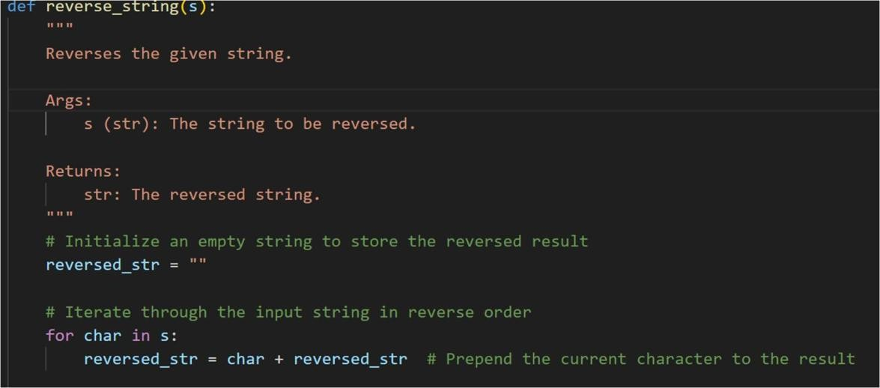
Output:
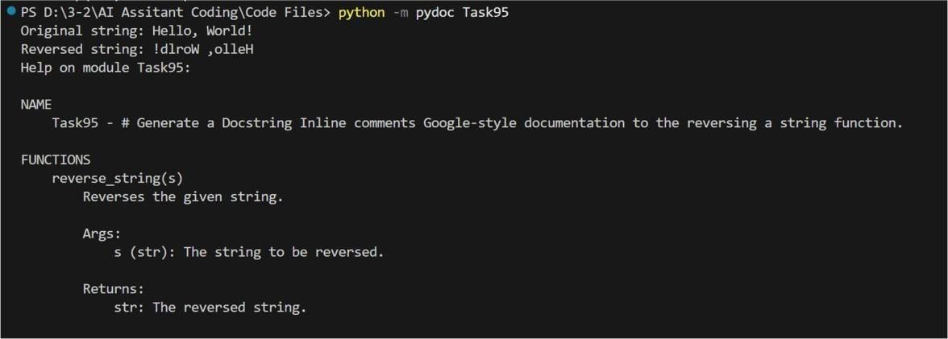
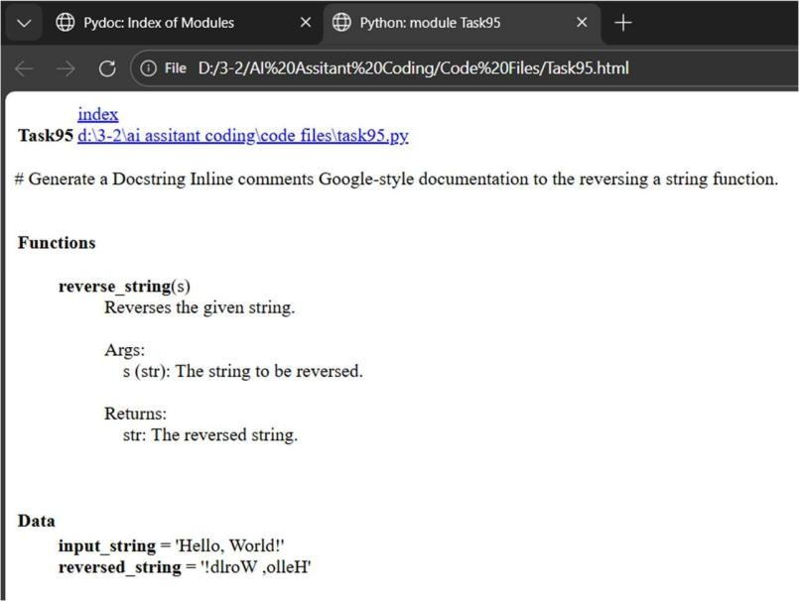

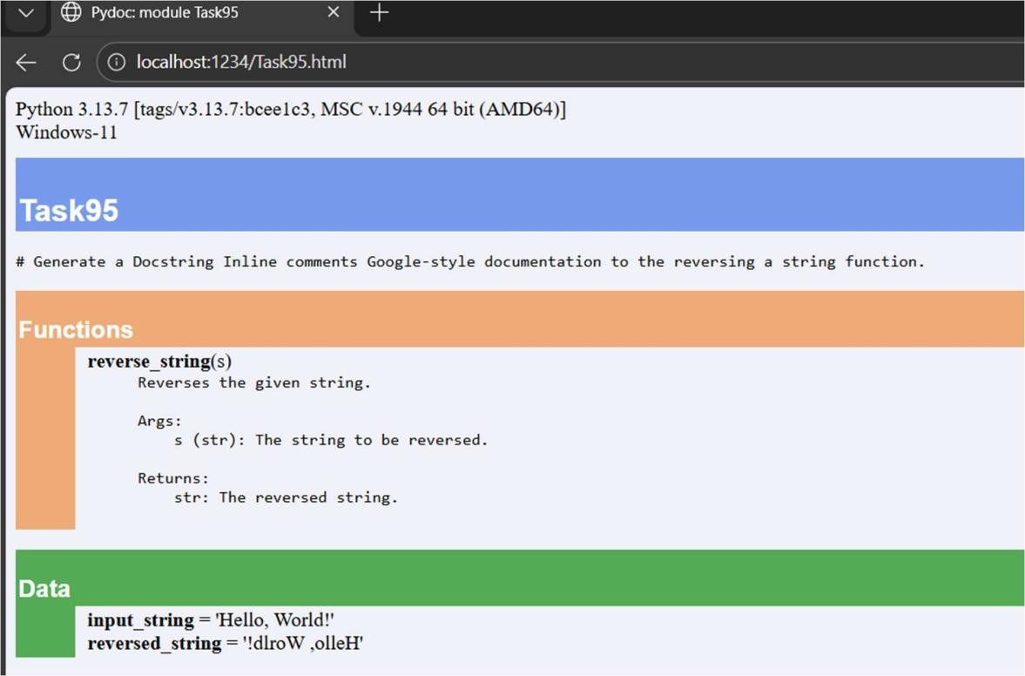

Problem 2: Password Strength Checker
Consider the function:
def check_strength(password): return len(password) >= 8

Task:
- Document the function using docstring, inline comments, and Google style.
- Compare documentation styles for security-related code.
- Recommend the most appropriate style.
Prompt: generate a 1. Document the function using docstring, inline comments, and Google style 2. Compare documentation styles for security-related code. for Password Strength Checker function
Code:

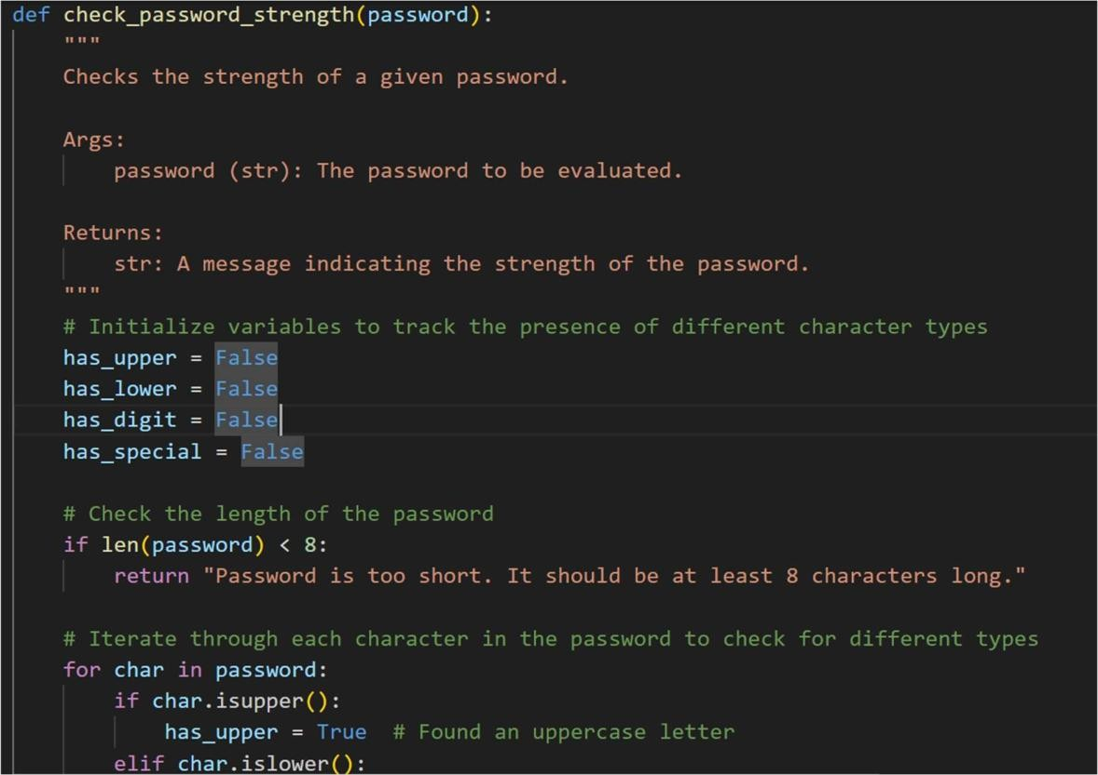
Output:
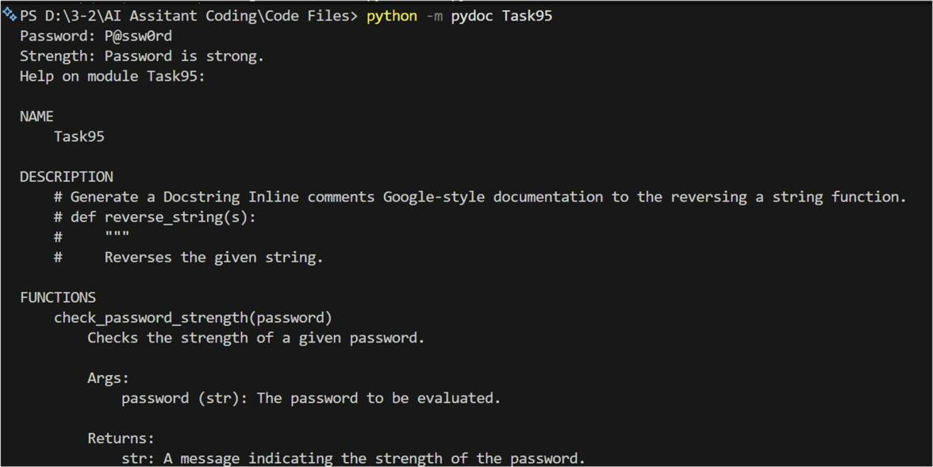

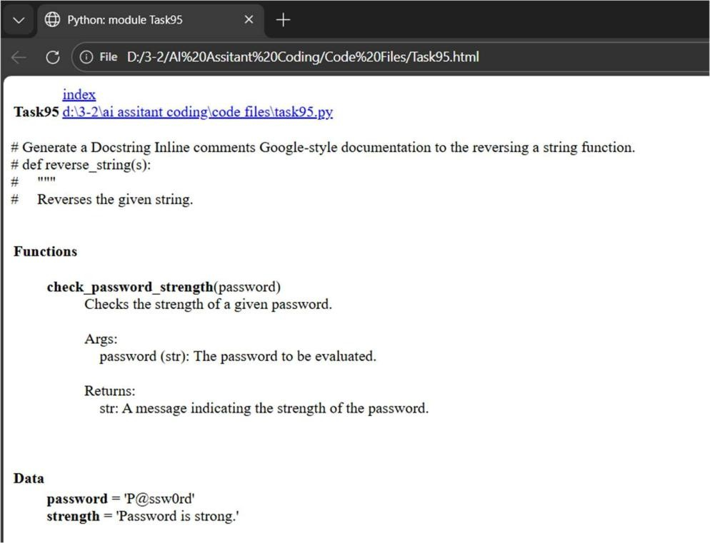

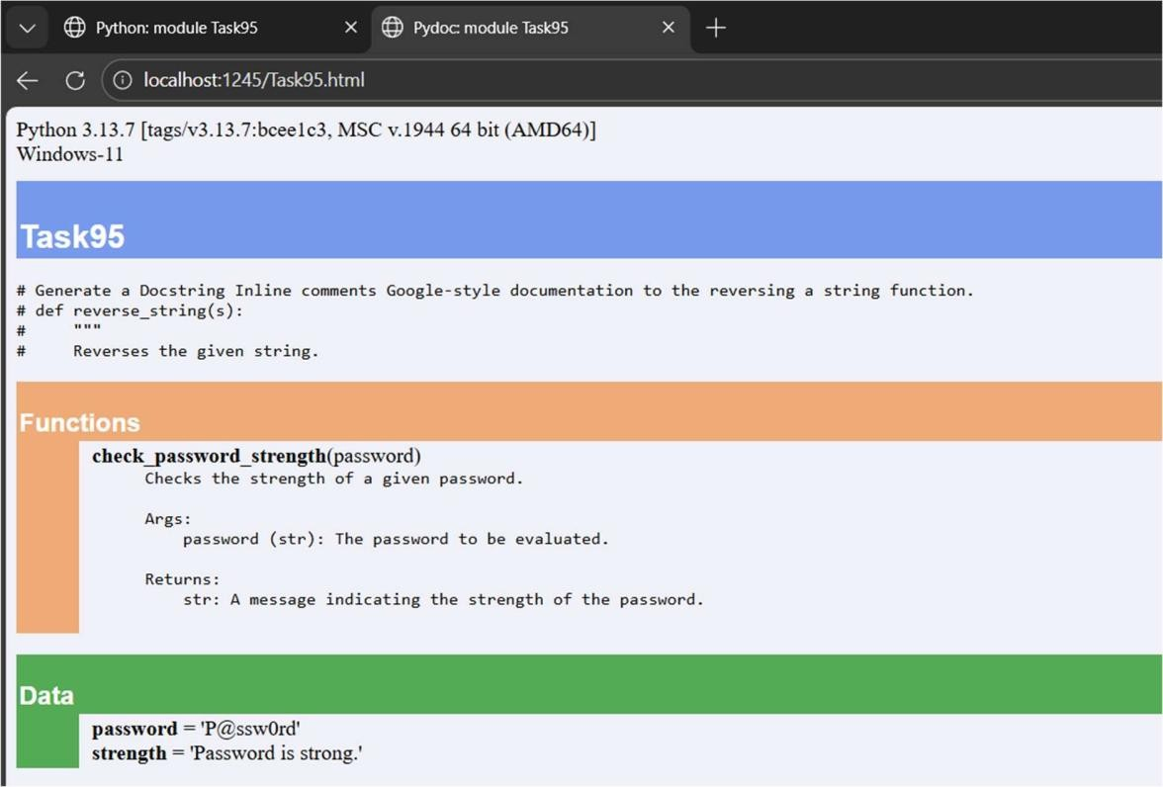

Problem 3: Math Utilities Module Task:
- Create a module math_utils.py with functions:
  - square(n)
  - cube(n)
  - factorial(n)
- Generate docstrings automatically using AI tools.
- Export documentation as an HTML file.
Prompt: # Generate a 1. Create a module math_utils.py with functions:,square(n),cube(n),factorial(n),
# Generate docstrings automatically Code:
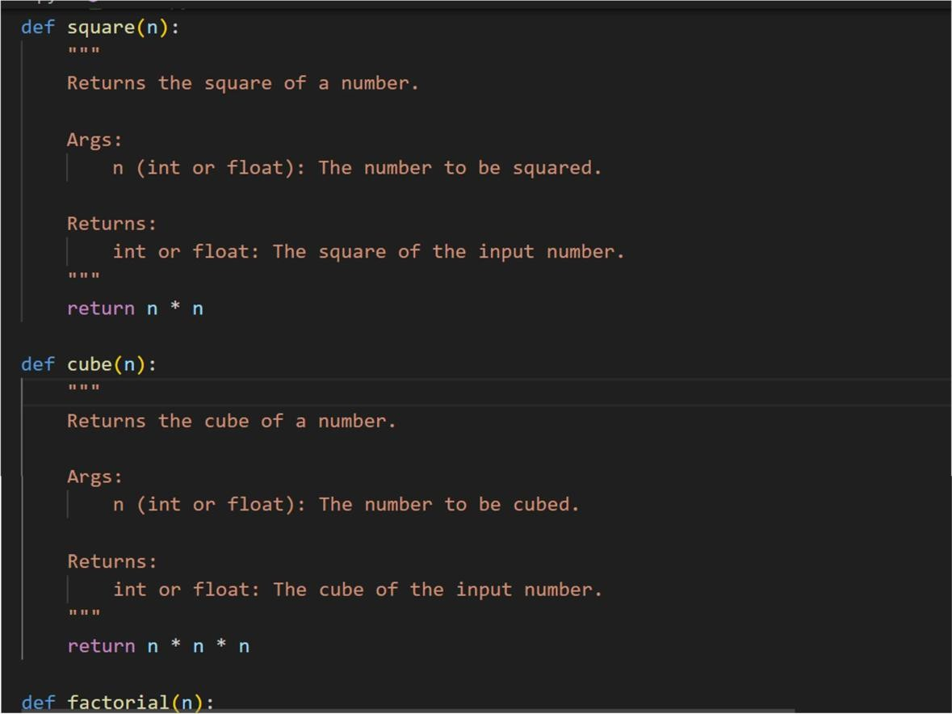
Output:

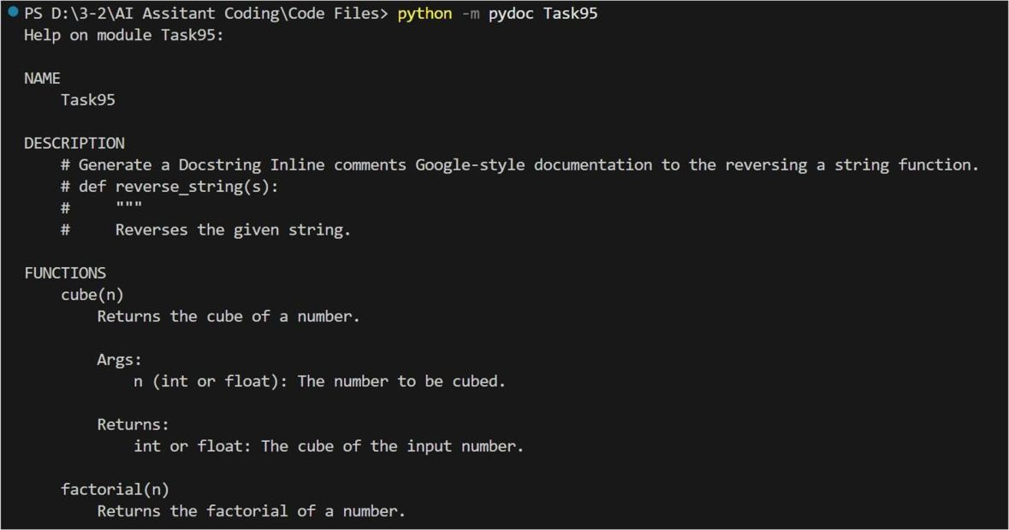
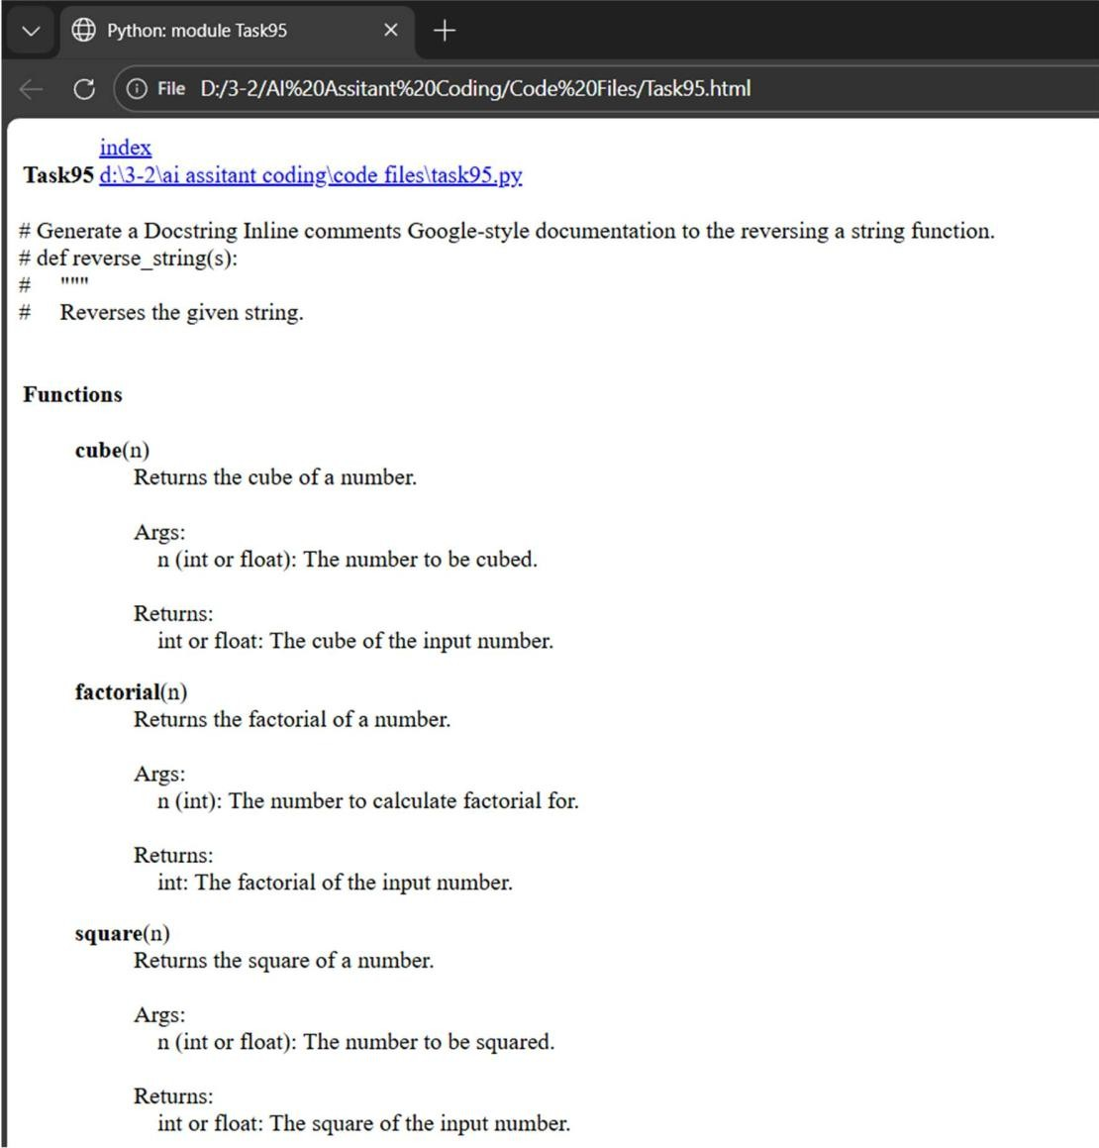

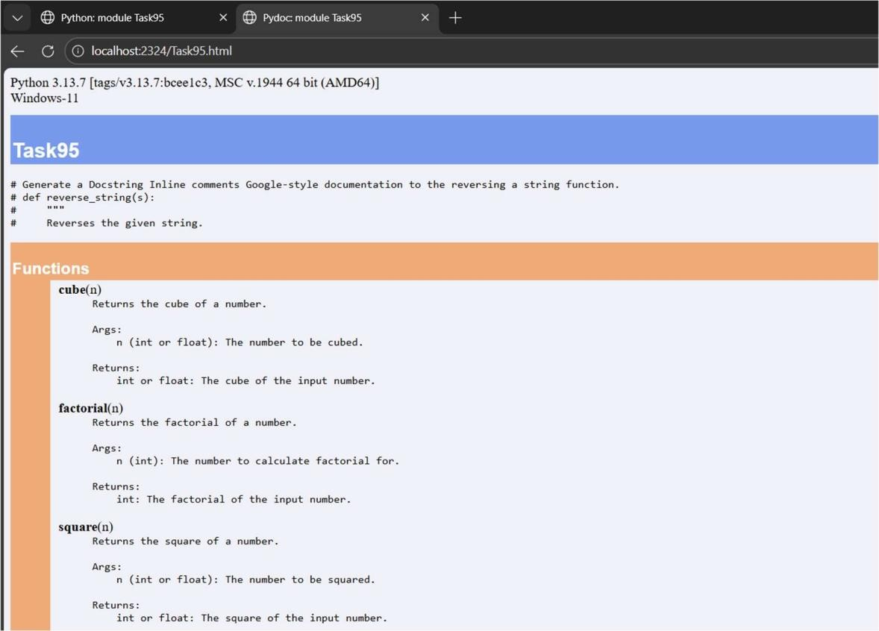

Problem 4: Attendance Management Module Task:
- Create a module attendance.py with functions:
  - mark_present(student)
  - mark_absent(student)
  - get_attendance(student)
- Add proper docstrings.
- Generate and view documentation in terminal and browse Prompt: Generate 1.Create a module attendance.py with functions:mark_present(student),mark_absent(student),
# get_attendance(student) 3.Generate and view documentation

Code:
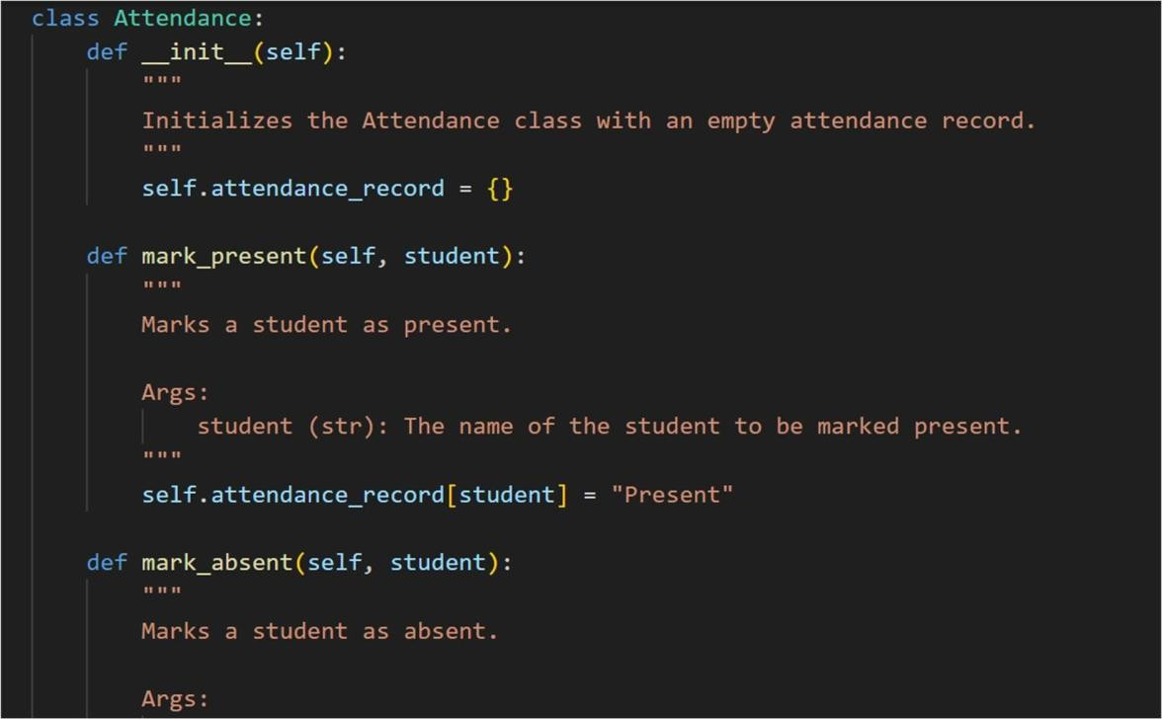
Output:
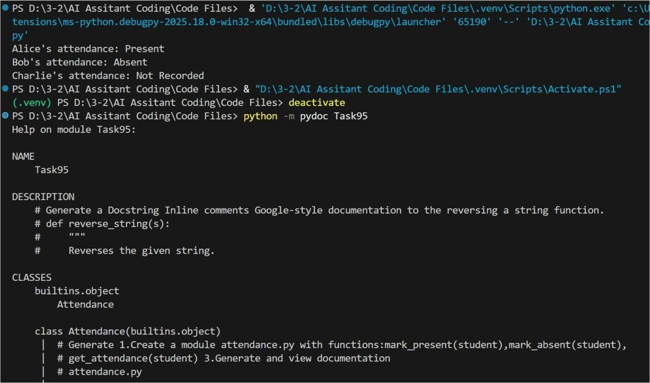

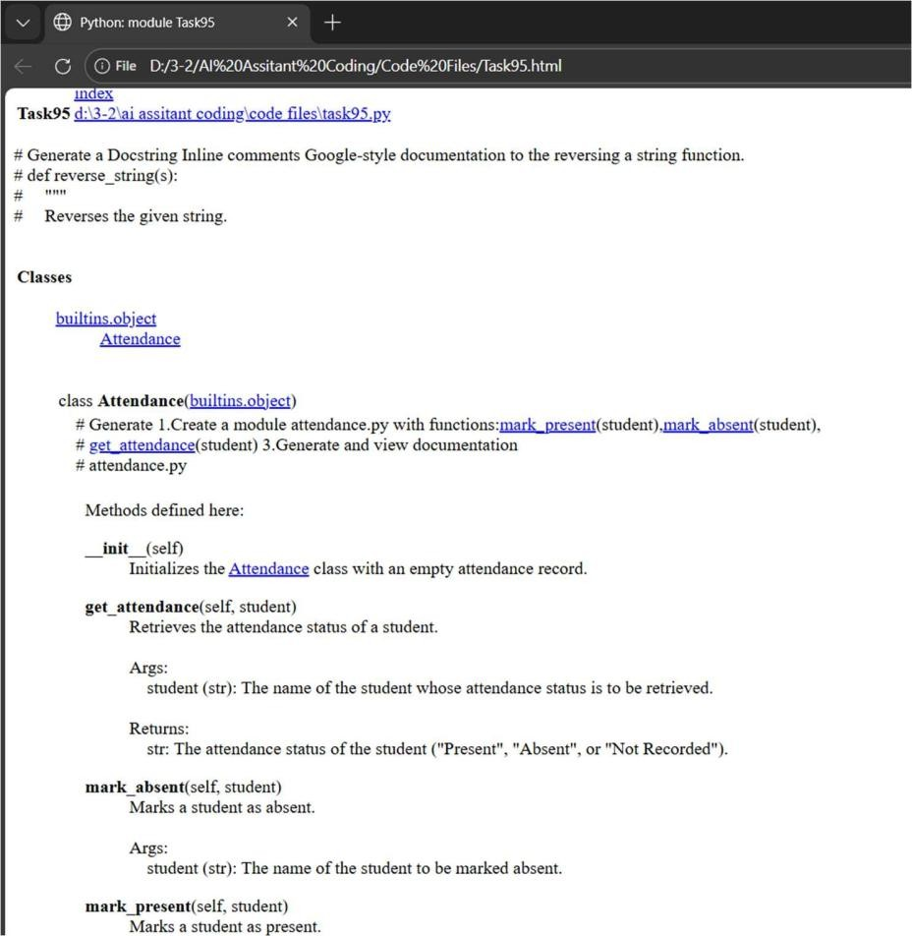
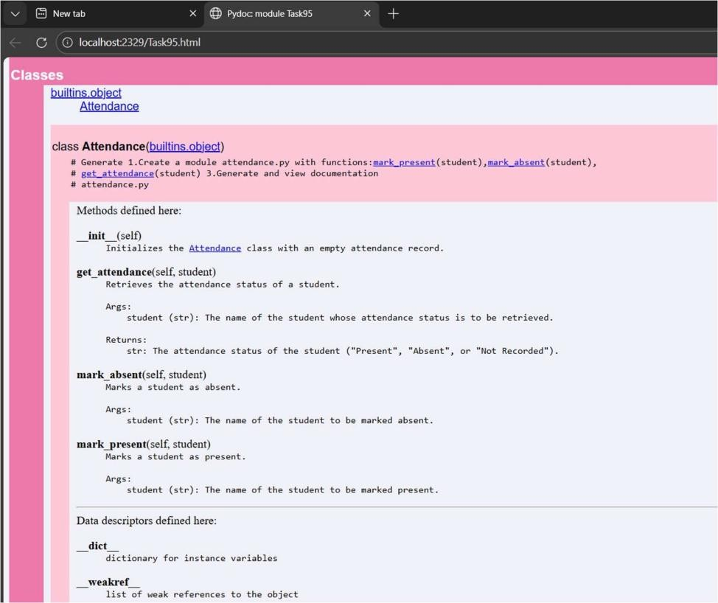

Problem 5: File Handling Function
Consider the function:
def read_file(filename):
with open(filename, 'r') as f: return f.read()

Task:
- Write documentation using all three formats.
- Identify which style best explains exception handling.
- Justify your recommendation.
Prompt: Generate a code with def read_file(filename):,with open(filename, 'r') as f:,return f.read(). Generate documentation using all three formats.2. Identify which style best explains exception handling.
Code:
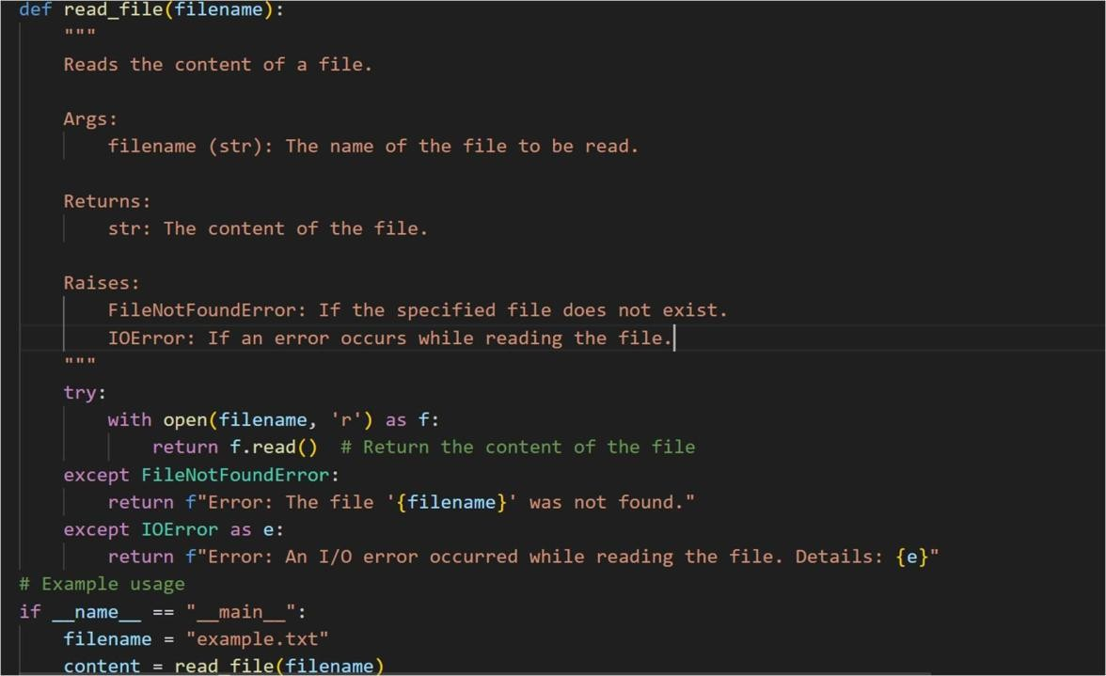
Output:

