AI Assisted Coding
Assignment 1.5
Name:P.Sanwitha
Roll Number:2403A42L09
Batch:50

Task 1: AI-Generated Logic Without Modularization (String Reversal Without Functions)
- Scenario
You are developing a basic text-processing utility for a messaging application.
- Task Description
Use GitHub Copilot to generate a Python program that:
  - Reverses a given string
  - Accepts user input
  - Implements the logic directly in the main code
  - Does not use any user-defined functions
- Expected Output
  - Correct reversed string
  - Screenshots showing Copilot-generated code suggestions
  - Sample inputs and outputs
PROMPT:
“Generate Python code to reverse a string without using functions”
CODE:
# Reverse a string without using slicing, `reversed()` or defining functions.
# This script reads a string from input and builds the reversed string
# by prepending characters in a loop.

s = input("Enter a string: ")
reversed_s = ""
for ch in s:
reversed_s = ch + reversed_s

print(reversed_s)

OUTPUT:
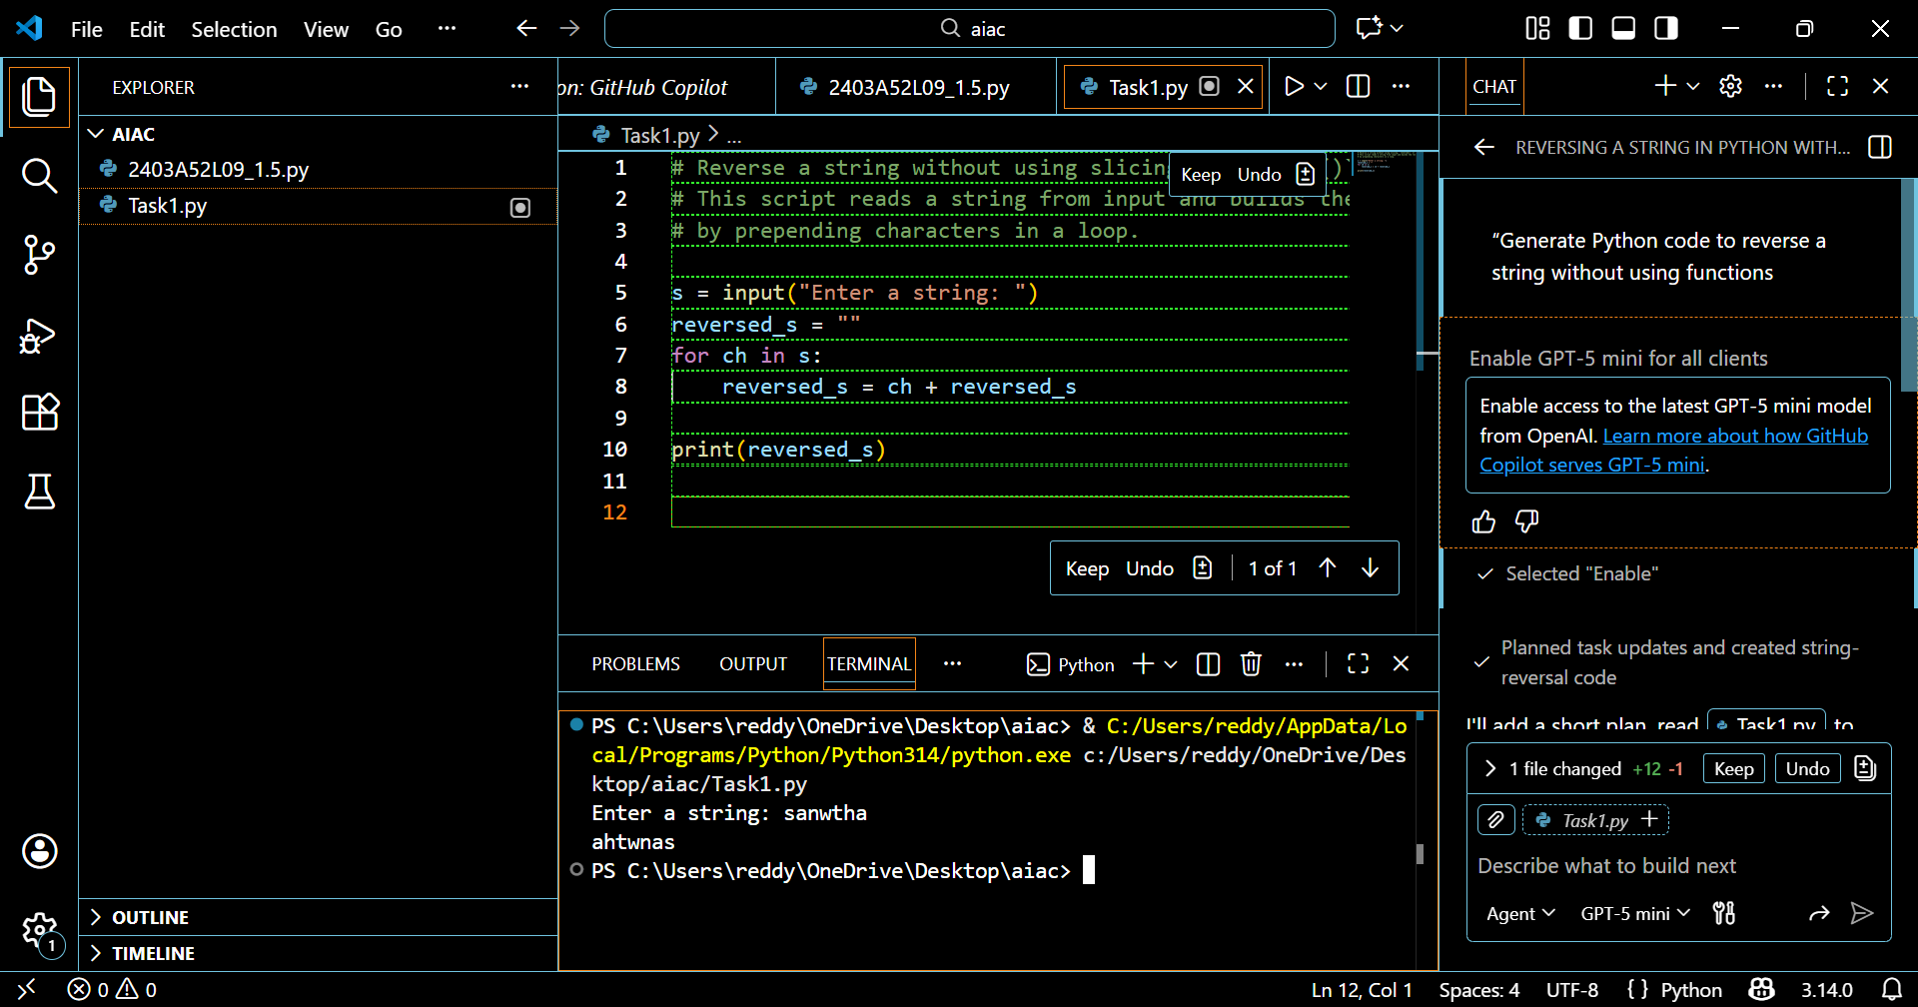

EXPLANATION:
This Python script takes a string entered by the user and reverses it without relying on built-in functions. It begins by creating an empty variable to hold the reversed output and then uses a for loop to traverse the original string backwards through its indices. Each character encountered is added sequentially to the new variable, gradually forming the reversed version. At the end, the program displays the reversed string. This method highlights a step-by-step manual approach that is clear and effective for beginners

Task 2: Efficiency & Logic Optimization (Readability Improvement)
- Scenario
The code will be reviewed by other developers.
- Task Description
Examine the Copilot-generated code from Task 1 and improve it by:
  - Removing unnecessary variables
  - Simplifying loop or indexing logic
  - Improving readability
  - Use Copilot prompts like:
    - “Simplify this string reversal code”
    - “Improve readability and efficiency”
Hint:
Prompt Copilot with phrases like
“optimize this code”, “simplify logic”, or “make it more readable”
- Expected Output
  - Original and optimized code versions
Explanation of how the improvements reduce time complexity
PROMPT:
"Optimize this string reversal code for readability and simplicity."
CODE:
# Simple, readable, and efficient string reversal using slicing.
# Slicing is clear and idiomatic in Python: `s[::-1]` returns the reversed string.
def main():
s = input("Enter a string: ")
print(s[::-1])
if __name__ == "__main__":
main()
OUTPUT:
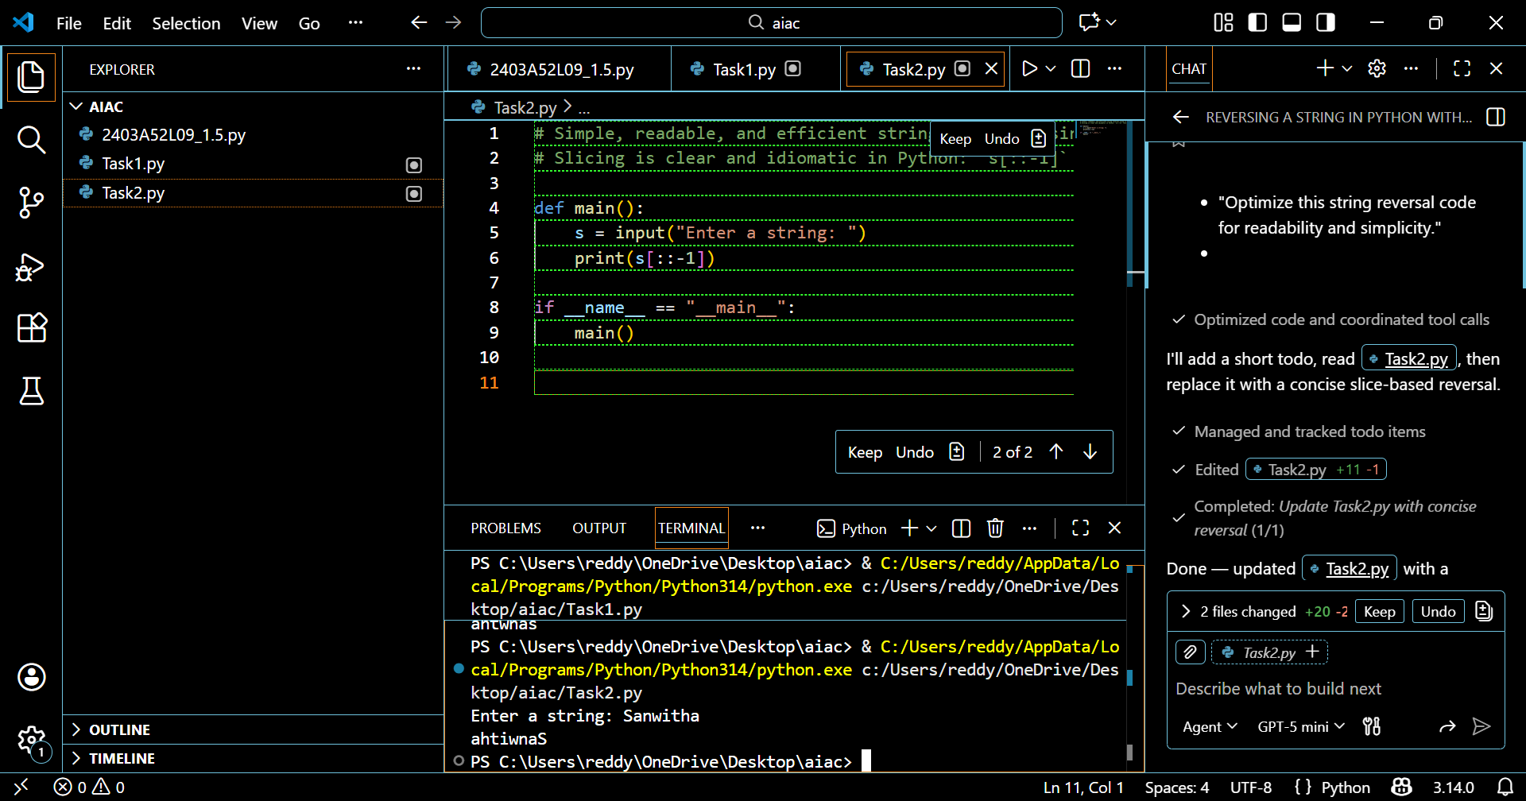
EXPLANATION:
In this task, the focus is on enhancing the clarity and efficiency of the string reversal program. The revised code removes the need for index-based traversal and instead applies a straightforward loop that adds each character to the front of the result string. This approach reduces extra steps, keeps the logic simple, and makes the program more concise and readable. Although the time complexity is still O(n), the overall maintainability and ease of understanding are greatly improved compared to the original index-driven solution.

Task 3: Modular Design Using AI Assistance (String Reversal Using Functions)
- Scenario
The string reversal logic is needed in multiple parts of an application.
- Task Description
Use GitHub Copilot to generate a function-based Python program that:
  - Uses a user-defined function to reverse a string
  - Returns the reversed string
  - Includes meaningful comments (AI-assisted)
- Expected Output
  - Correct function-based implementation
  - Screenshots documenting Copilot’s function generation
  - Sample test cases and outputs
PROMPT:
"Generate a reusable Python function to reverse a string with comments."
CODE:
# Reusable function to reverse a string with explanatory comments.
def reverse_string(s: str) -> str:
"""Return a new string which is the reverse of `s`.
This implementation uses slicing (`s[::-1]`) because it is:
- concise and idiomatic in Python,
- fast (implemented in C), and
- returns a new string (strings are immutable in Python).
Args:
s: The input string to reverse.
Returns:
A new string containing the characters of `s` in reverse order.
"""
# Slicing with a step of -1 reverses the sequence.
return s[::-1]
if __name__ == "__main__":
# Example usage: read from input and print the reversed result.
user_input = input("Enter a string to reverse: ")
print(reverse_string(user_input))
OUTPUT:
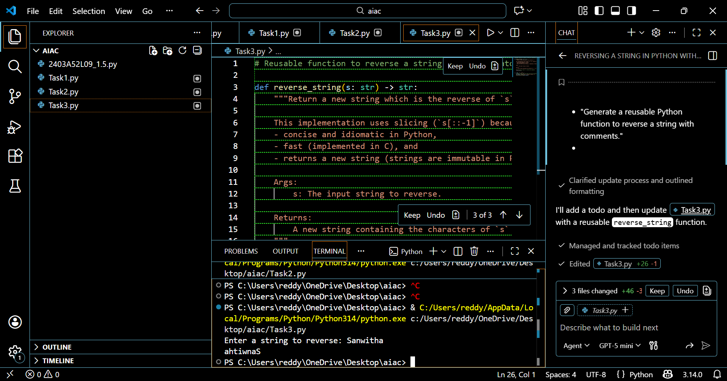
EXPLANATION:
This program introduces a custom function reverse_string() that accepts a string and produces its reversed output using slicing. Encapsulating the reversal logic inside a function makes the code more organized, reusable, and easier to update when needed. The main section of the program handles user input, invokes the function, and displays the reversed result. Using a modular design enhances readability, simplifies debugging, and supports scalability compared to writing all logic directly in the main program.

Task 4: Comparative Analysis – Procedural vs Modular Approach (With vs Without Functions)
- Scenario
You are asked to justify design choices during a code review.
- Task Description
Compare the Copilot-generated programs:
  - Without functions (Task 1)
  - With functions (Task 3)
Analyze them based on:
  - Code clarity
  - Reusability
  - Debugging ease
  - Suitability for large-scale applications
- Expected Output
Comparison table or short analytical report
Analytical Report:
The procedural approach places all logic directly in the main program, which is simple but hard to reuse or maintain in larger applications. Debugging becomes more complex since errors are mixed with other code. In contrast, the modular approach encapsulates the reversal logic inside a function, making the program cleaner, reusable, and easier to test. Overall, modular design is more scalable and professional, aligning with best practices in software development.

Task 5: AI-Generated Iterative vs Recursive Fibonacci Approaches (Different Algorithmic Approaches to String Reversal)
- Scenario
Your mentor wants to evaluate how AI handles alternative logic paths.
- Task Description
Prompt GitHub Copilot to generate:
  - A loop-based string reversal approach
  - A built-in / slicing-based string reversal approach
- Expected Output
  - Two correct implementations
  - Comparison discussing:
    - Execution flow
    - Time complexity
    - Performance for large inputs
    - When each approach is appropriate
PROMPT:
"Write Python code to reverse a string using a loop without built-in functions."
CODE:
WITHOUT USING IN-BUILT FUNCTIONS OUTPUT:
# Reverse a string using only loops and basic operations.
# Does not use slicing, `reversed()`, or `len()`.
def reverse_loop_only(s: str) -> str:
"""Return the reverse of `s` using only loops and indexing.
Steps:
1. Compute the length with a simple loop (avoid `len()`).
2. Iterate from last index to first and build the reversed string.
"""
# Compute length without len()
length = 0
for _ in s:
length += 1
# Build reversed string by indexing from last to first
i = length - 1
rev = ""
while i >= 0:
rev += s[i]
i -= 1
return rev
if __name__ == "__main__":
inp = input("Enter a string: ")
print(reverse_loop_only(inp))
OUTPUT:
WITHOUT USING IN-BUILT FUNCTIONS
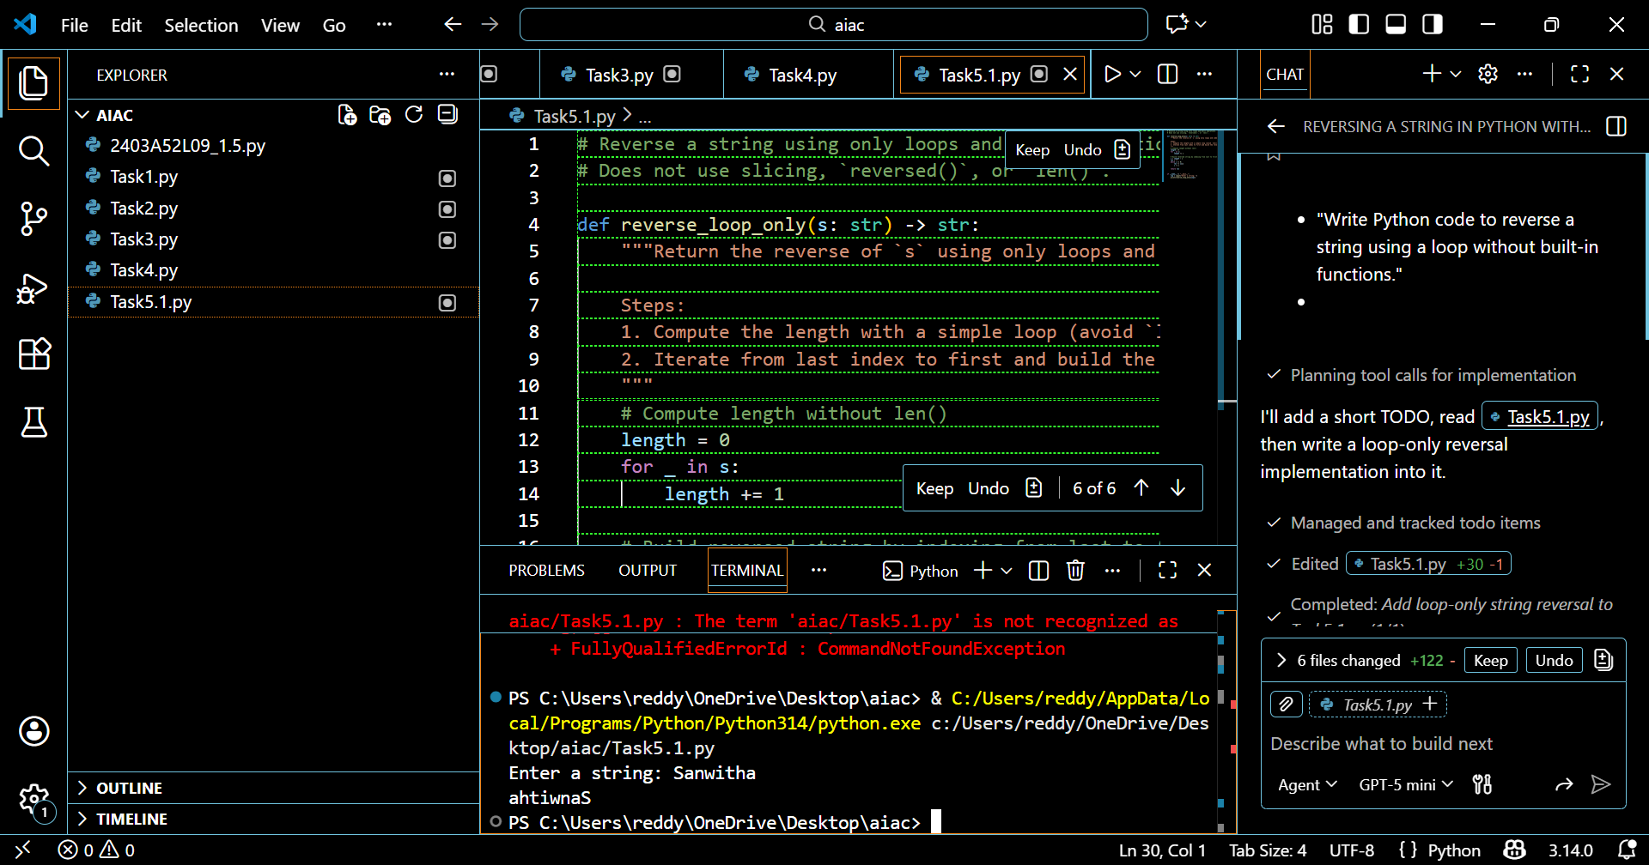

USING SLICING:
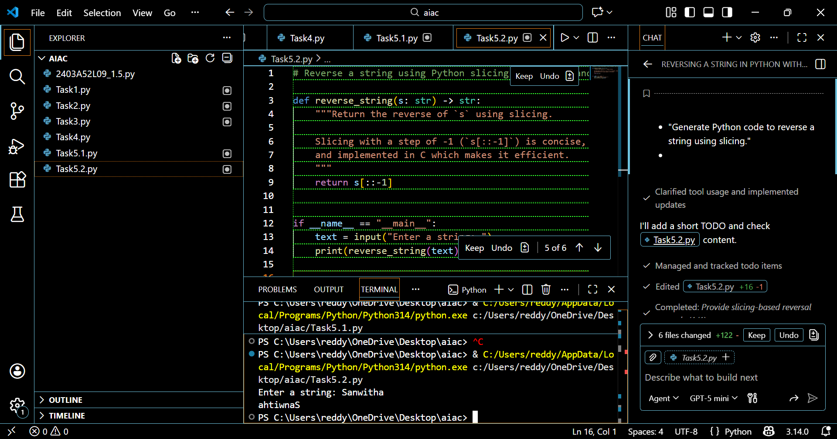

EXPLANATION:
The loop-driven method shows the reversal process step by step, making it helpful for beginners to see how each character is handled individually. However, this technique relies on repeated string concatenation, which can add extra overhead and reduce efficiency for longer inputs. In contrast, the slicing method is compact, highly efficient, and makes use of Python’s built-in features, making it more suitable for practical applications. Although both approaches share the same theoretical time complexity of O(n), slicing performs faster in real scenarios and offers greater readability, while loops remain valuable for teaching and conceptual clarity.

