AI Assistance coding
Assignment-3.5
Name: P.Sanwitha
Hall Ticket Number: 2403A52L09
Batch: 50
TASK-1:
Zero-Shot Prompting (Leap Year Check)
Write a zero-shot prompt to generate a Python function that checks
whether a given year is a leap year.
Week2 -
Task:
• Record the AI-generated code.
• Test with years like 1900, 2000, 2024.
• Identify logical flaws or missing conditions.
PROMPT:
“Create a Python function that takes a year as input and determines whether it is a leap year according to the Gregorian calendar rules.”
OUTPUT:
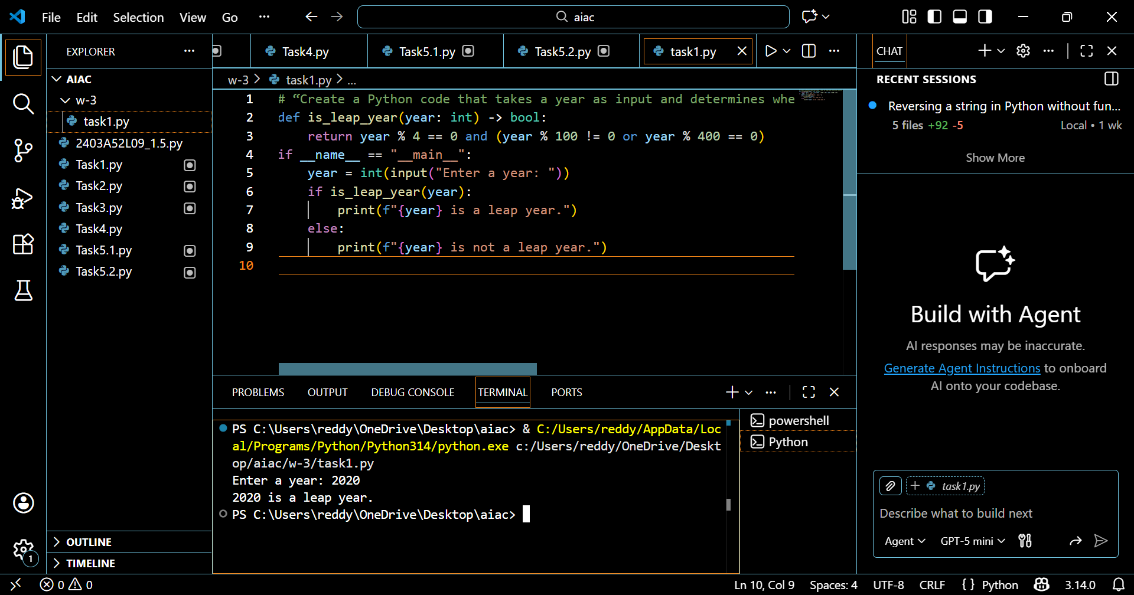
EXPLANATION:
In zero-shot prompting, the AI receives no examples and must rely entirely on its general knowledge. The initial logic often checks only whether the year is divisible by 4, which is insufficient. According to the correct leap year rules, a year must be divisible by 4, but century years must also be divisible by 400. This means 2000 is a leap year, while 1900 is not. By adding conditions for divisibility by 100 and 400, the function becomes logically correct and handles all edge cases accurately.

Task-2:
One-Shot Prompting (GCD of Two Numbers)
Write a one-shot prompt with one example to generate a Python
function that finds the Greatest Common Divisor (GCD) of two numbers.
Example:
Input: 12, 18 → Output: 6
Task:
• Compare with a zero-shot solution.
• Analyze algorithm efficiency.
PROMPT:
“Write a Python function to calculate the Greatest Common Divisor (GCD) of two numbers.”
OUTPUT:
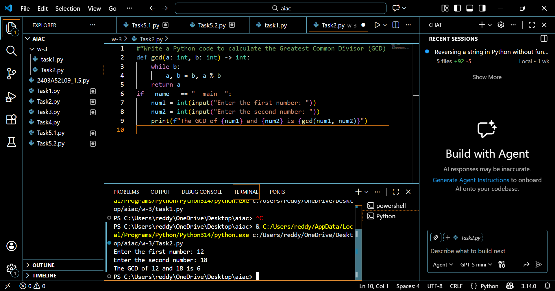
EXPLANATION:
The one-shot prompt provides a single example, which helps guide the AI toward an efficient solution. The AI correctly applies the Euclidean Algorithm, which finds the GCD by repeatedly replacing the larger number with the remainder until one number becomes zero. Compared to a zero-shot approach that might use brute-force divisor checking, this method is significantly faster and more efficient, especially for large numbers.
Task-3:
Few-Shot Prompting (LCM Calculation)
Write a few-shot prompt with multiple examples to generate a Python
function that computes the Least Common Multiple (LCM).
Examples:
• Input: 4, 6 → Output: 12
• Input: 5, 10 → Output: 10
• Input: 7, 3 → Output: 21
Task:
• Examine how examples guide formula selection.
• Test edge cases.
PROMPT:
“Write a Python function to compute the Least Common Multiple (LCM) of two numbers.”
OUTPUT:
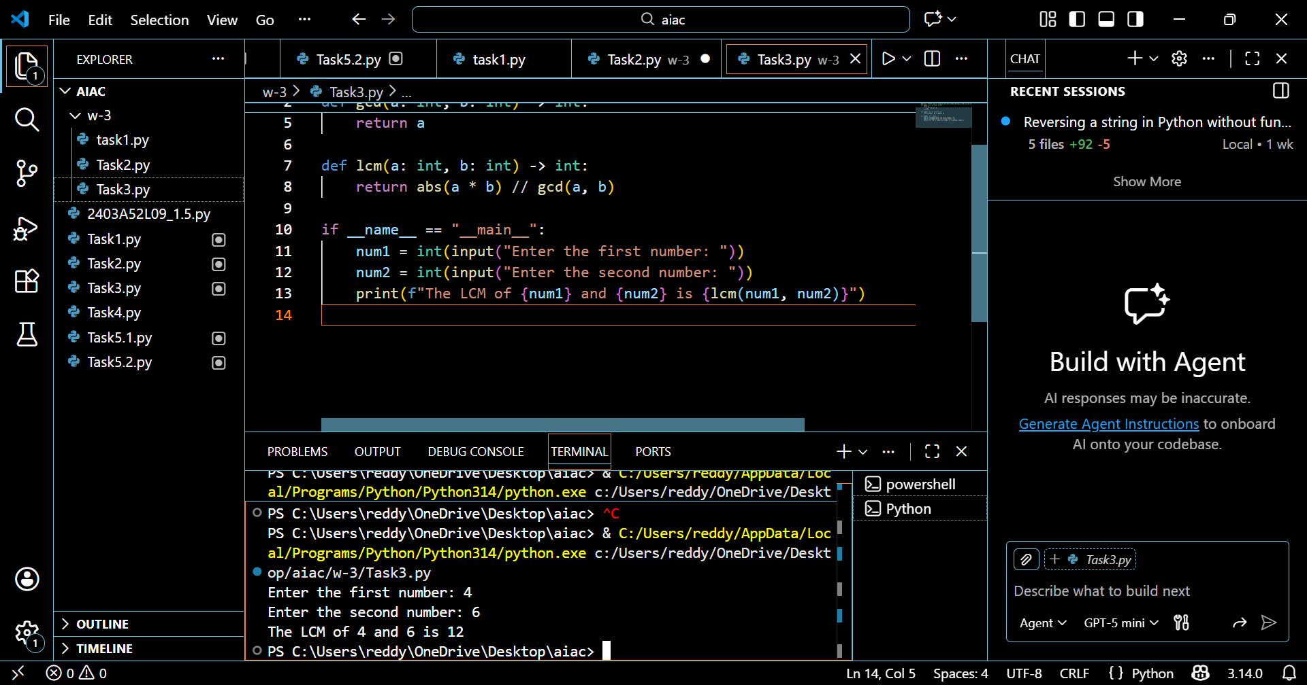
EXPLANATION:
With multiple examples, the AI clearly identifies the mathematical relationship between LCM and GCD. Instead of using trial-and-error methods, the AI applies the formula
LCM = (a × b) // GCD(a, b).
This approach is efficient and reliable. Testing edge cases such as when one number is zero helps ensure the function behaves correctly under all conditions.

Task-4:
Zero-Shot Prompting (Binary to Decimal Conversion)
Write a zero-shot prompt to generate a Python function that converts a
binary number to decimal.
Task:
• Test with valid and invalid binary inputs.
• Identify missing validation logic.
PROMPT:
“Develop a Python function that converts a binary number entered by the user into its decimal equivalent.”
OUTPUT:
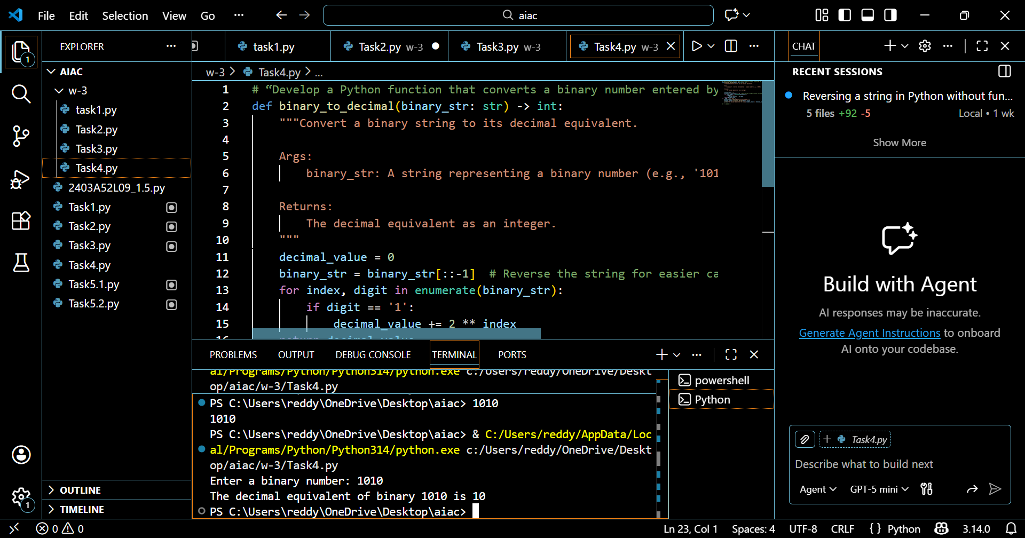

EXPLANATION:
The zero-shot solution typically uses Python’s built-in int(binary, 2) method, which correctly converts valid binary numbers into decimal form. While this works for inputs like 1010, it fails for invalid inputs containing digits other than 0 and 1. Since no validation is included, the program may raise errors. Adding input validation improves reliability and makes the function more user-friendly.

Task-5:
One-Shot Prompting (Decimal to Binary Conversion)
Write a one-shot prompt with an example to generate a Python function
that converts a decimal number to binary.
Example:
Input: 10 → Output: 1010
Task:
• Compare clarity with zero-shot output.
• Analyze handling of zero and negative numbers.
PROMPT:
“Write a Python function that converts a decimal number into binary.”
OUTPUT:
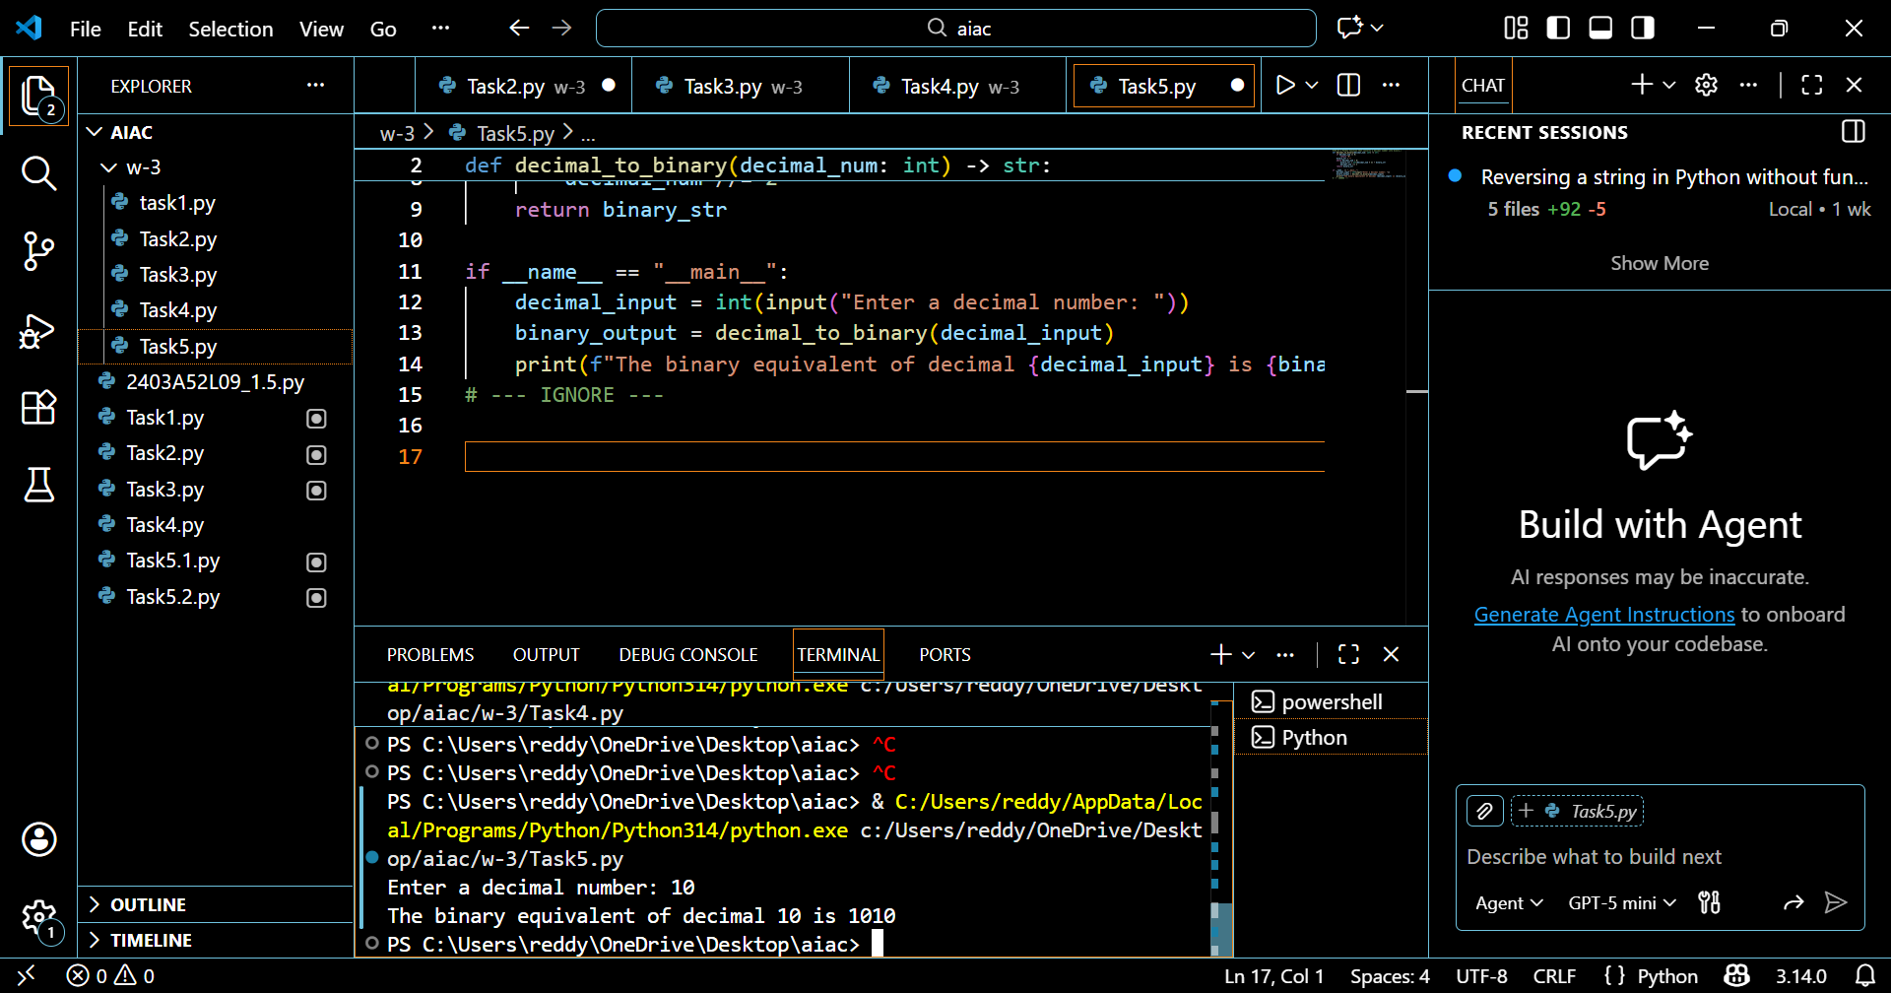

EXPLANATION:
The example in the one-shot prompt guides the AI toward using Python’s built-in bin() function. This approach simplifies the solution and ensures correctness for positive numbers and zero. However, negative numbers may produce unexpected output without additional handling. Adding conditional logic for negative values improves clarity and correctness compared to a zero-shot response.

Task-6:
Few-Shot Prompting (Harshad Number Check)
Write a few-shot prompt to generate a Python function that checks
whether a number is a Harshad (Niven) number.
Examples:
• Input: 18 → Output: Harshad Number
• Input: 21 → Output: Harshad Number
• Input: 19 → Output: Not a Harshad Number
Task:
• Test boundary conditions.
• Evaluate robustness
PROMPT:“Write a Python function to check whether a number is a Harshad (Niven) number.”
OUTPUT: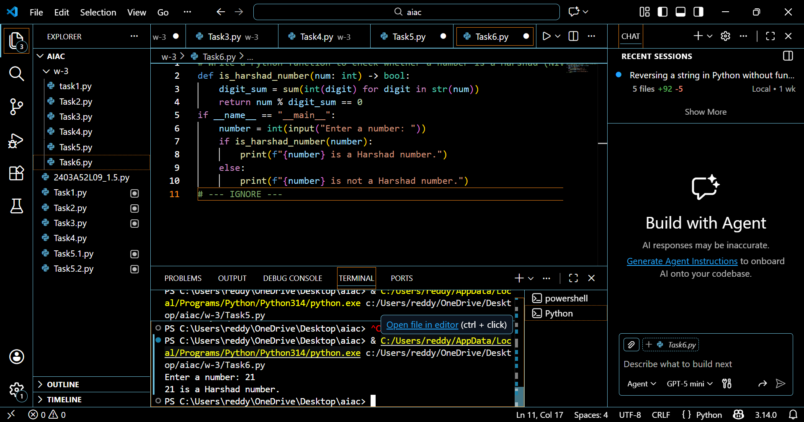

EXPLANATION:
The few-shot examples help the AI understand that a Harshad number is divisible by the sum of its digits. The function correctly computes the digit sum and checks divisibility. However, when the input is zero, division by zero can occur. Adding a special condition for zero increases robustness and ensures the program handles boundary cases safely.

