ASSIGNMENT-11.3
Name: P.Sanwitha
Ht.no: 2403A52L09
Batch: 50
Task 1: Smart Contact Manager (Arrays & Linked Lists)
Scenario
SR University’s student club requires a simple Contact Manager Application to store members’ names and phone numbers. The system should support efficient addition, searching, and deletion of contacts.

Prompt:
Write a python program to Create a Contact Manager using list and linked list with add, search, and delete functions.
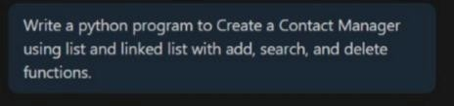

Code:

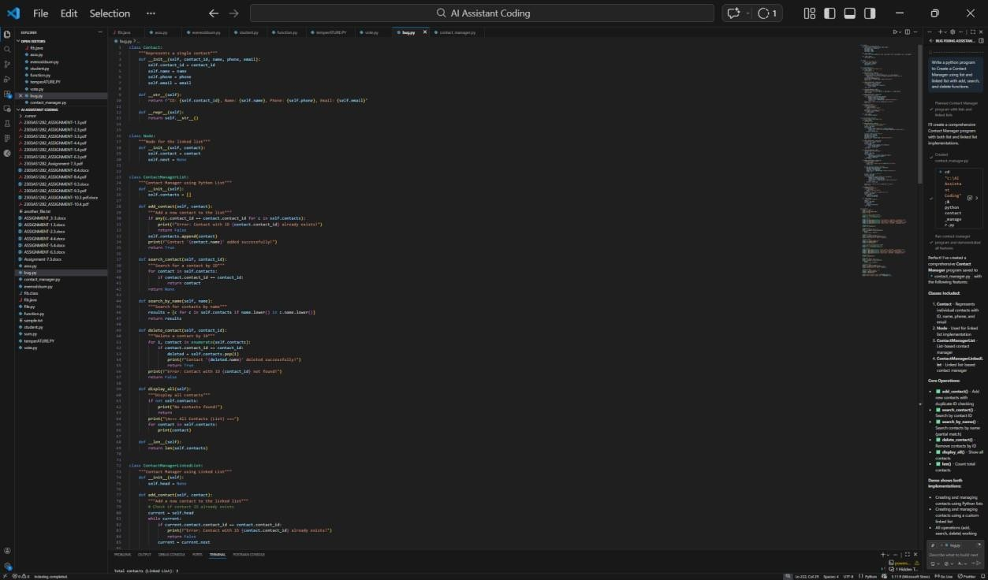
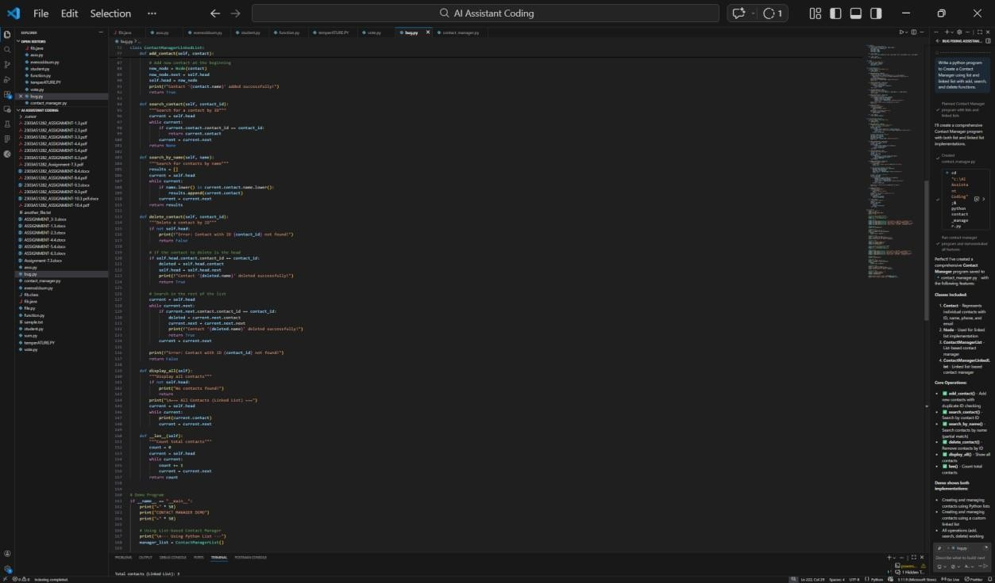

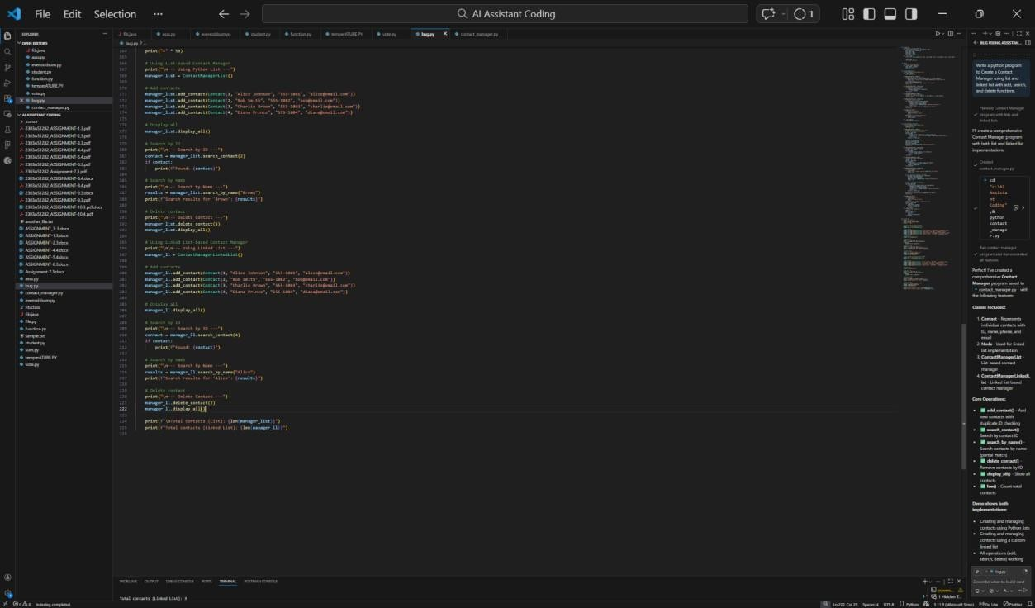

Output:
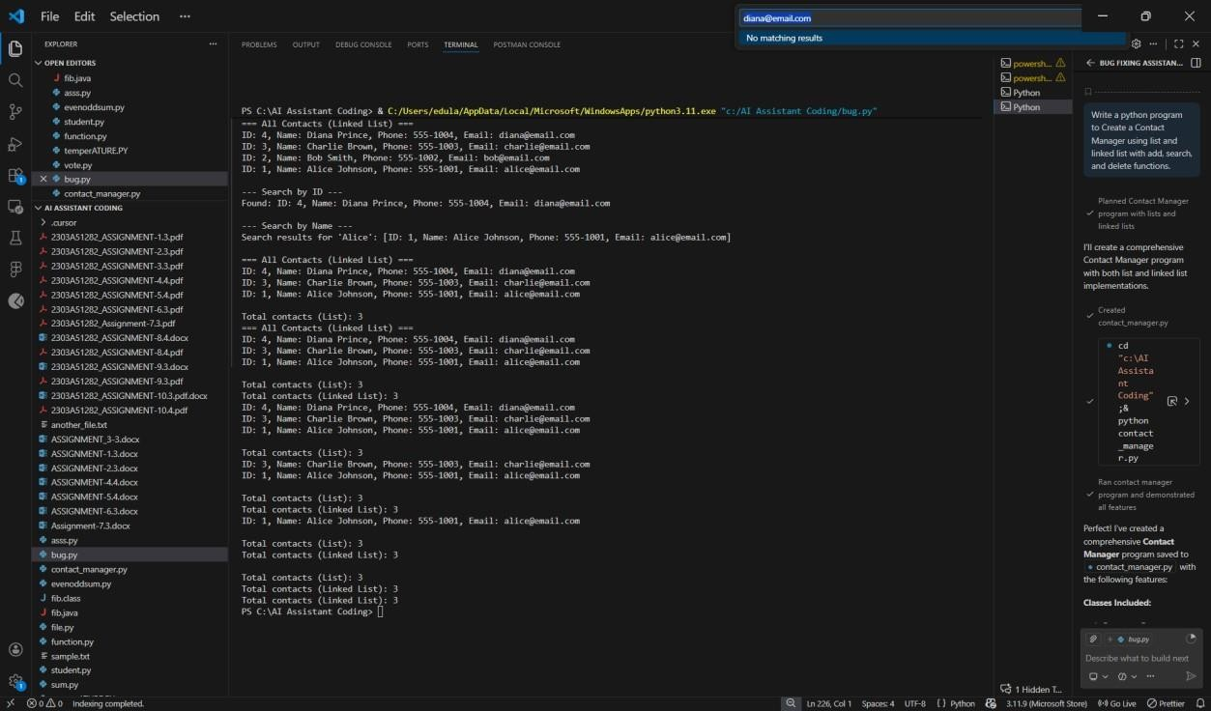

Explanation:
- In an array, adding at the end is fast, but inserting in the middle is slow because elements must shift.

- In a linked list, insertion is fast because no shifting is needed.
- Searching takes the same time in both (you must check each element).
- Deleting in an array is slower due to shifting elements.
- Linked list is better for frequent insertions and deletions.

Task 2: Library Book Search System (Queues & Priority Queues)
Scenario
The SRU Library manages book borrow requests. Students and faculty submit requests, but faculty requests must be prioritized over student requests. Prompt:
Write a Python program for a library book request system.First, make a normal queue where requests are handled in the order they come.Then, make another version where faculty requests are given first priority
over student requests.Include functions to add a request and remove a request.

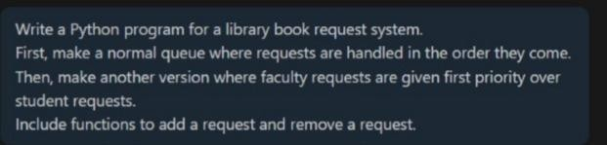

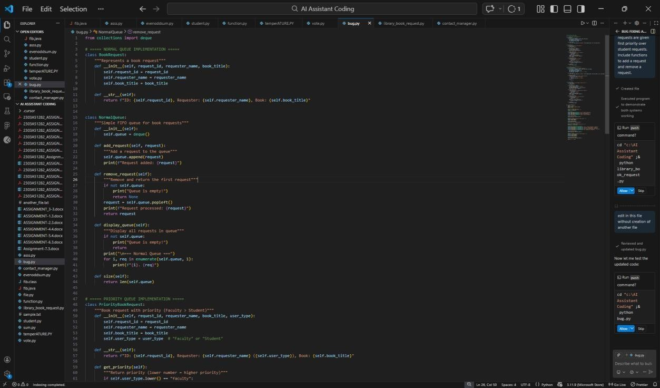
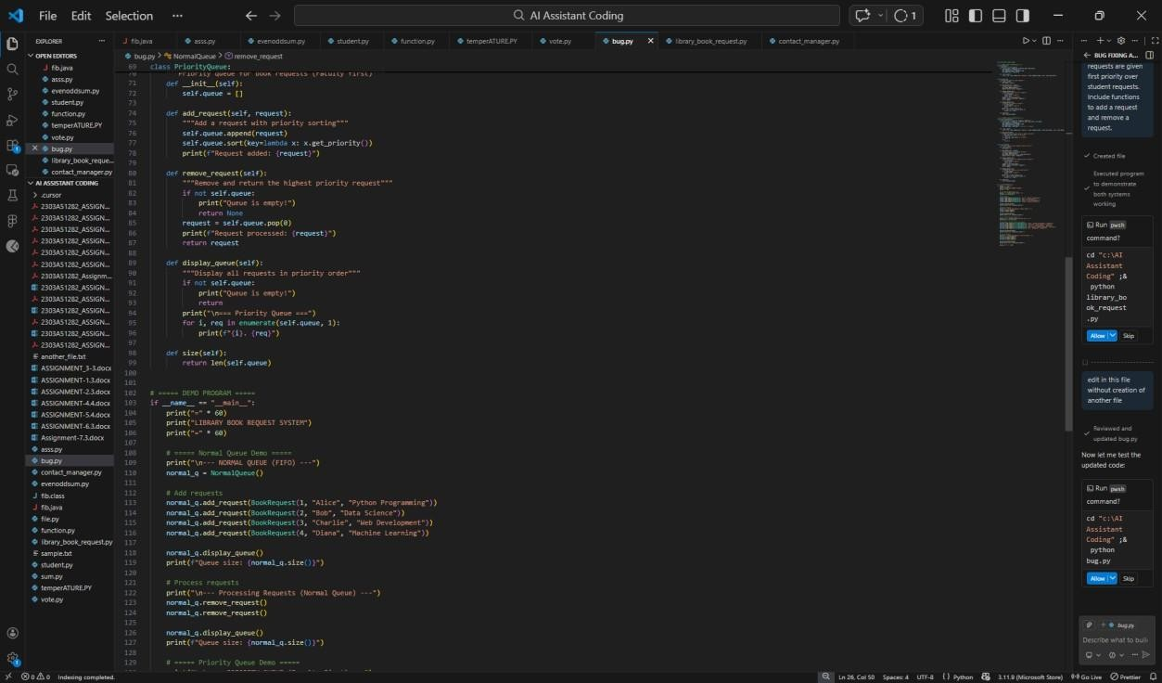
Code:

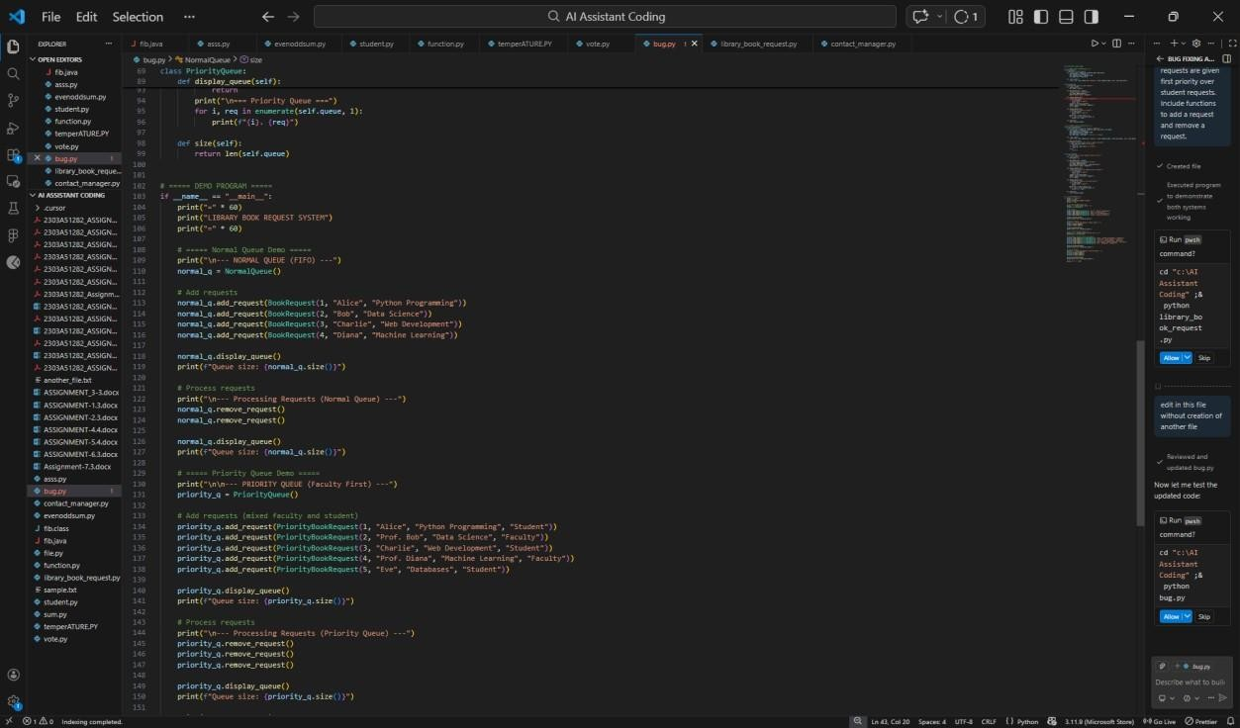

Output:
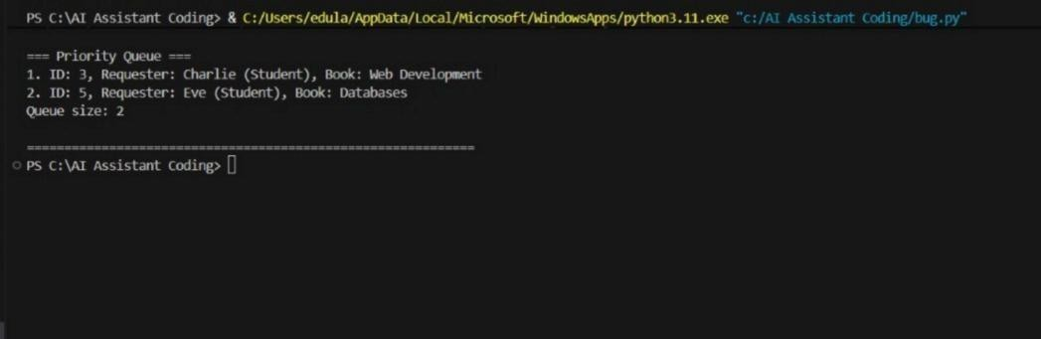

Explanation:
- Queue (FIFO) → First request comes, first served.(If a student requests first, they get the book first.)
- Priority Queue → Faculty requests are served before students, even if they come later.
- enqueue() → Adds a request to the system.

- dequeue() → Removes and processes the next request.

Task 3: Emergency Help Desk (Stack Implementation) Scenario
SR University’s IT Help Desk receives technical support tickets from students and staff. While tickets are received sequentially, issue escalation follows a Last-In, First-Out (LIFO) approach.

Prompt:
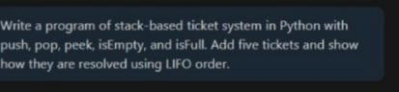
Write a program of stack-based ticket system in Python with push, pop, peek, isEmpty, and isFull. Add five tickets and show how they are resolved using LIFO order.

Code:

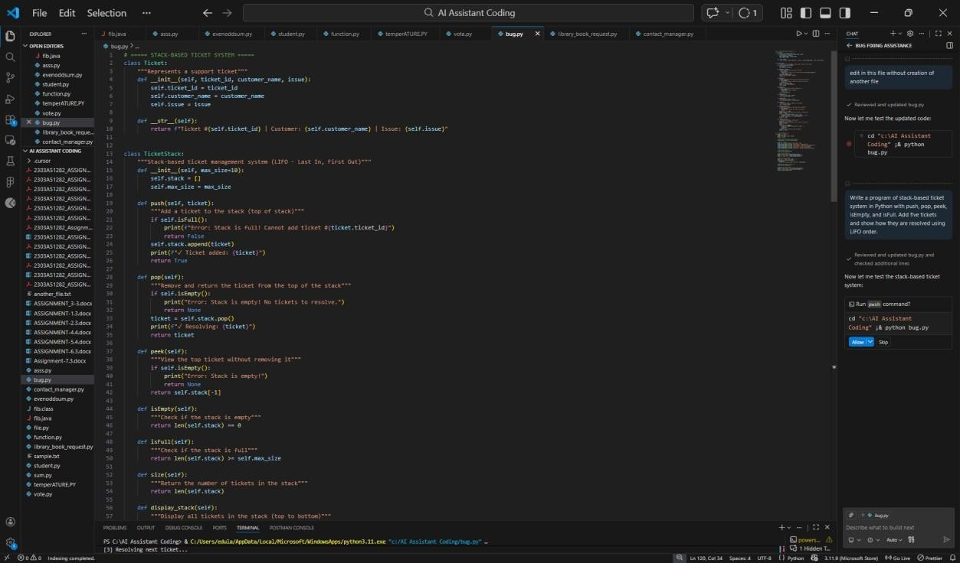
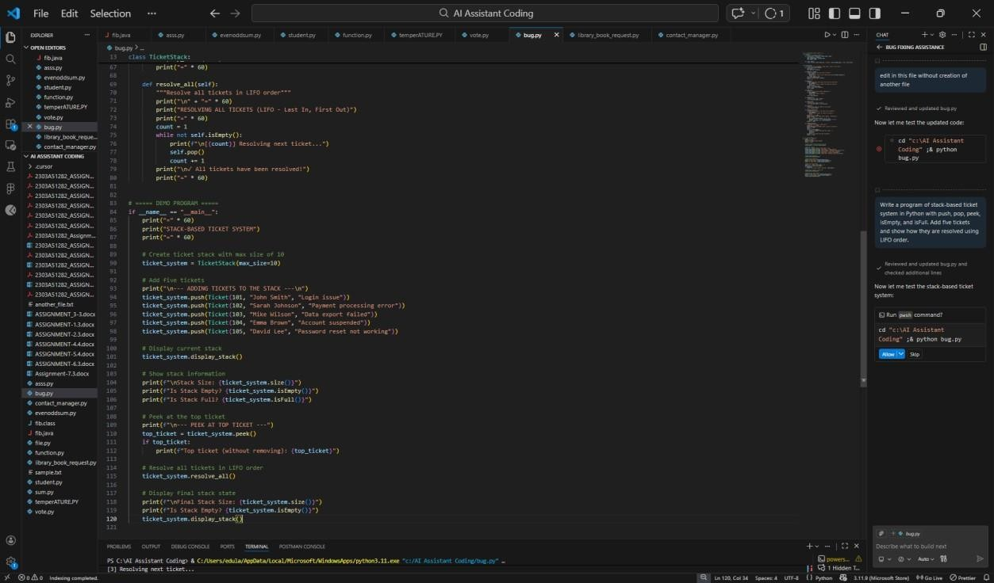

Output:

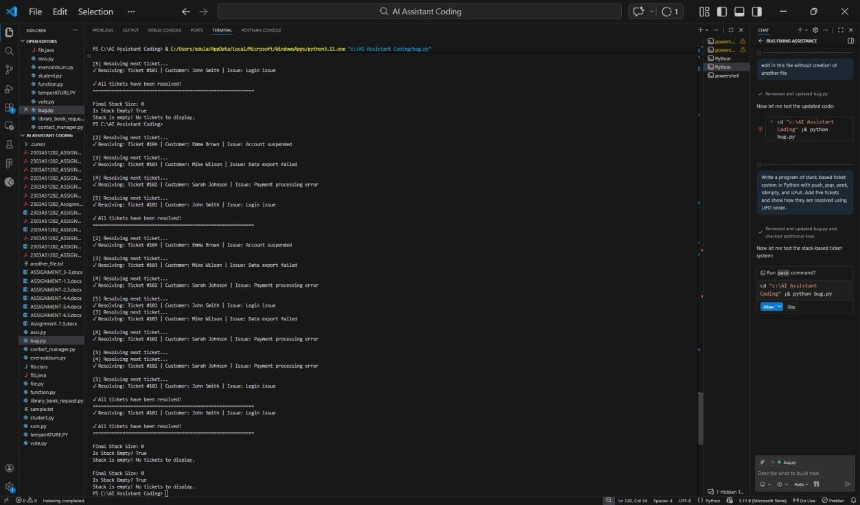

Explanation:
The program uses a stack to manage help desk tickets. A stack works in last in, first solved order.
When a new ticket is raised, it is added to the top. When solving a ticket, the most recent one is handled first.
The program can also check if there are no tickets left or if the stack is full.

Task 4: Hash Table Objective
To implement a Hash Table and understand collision
handling.

Prompt:
Write a Python program to create a Hash Table.

Add methods to insert, search, and delete data. Handle collisions using chaining (store multiple values in a list at the same index).
Add comments to explain the code and show example usage.
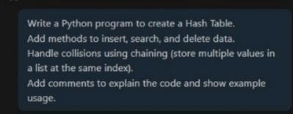

Code:
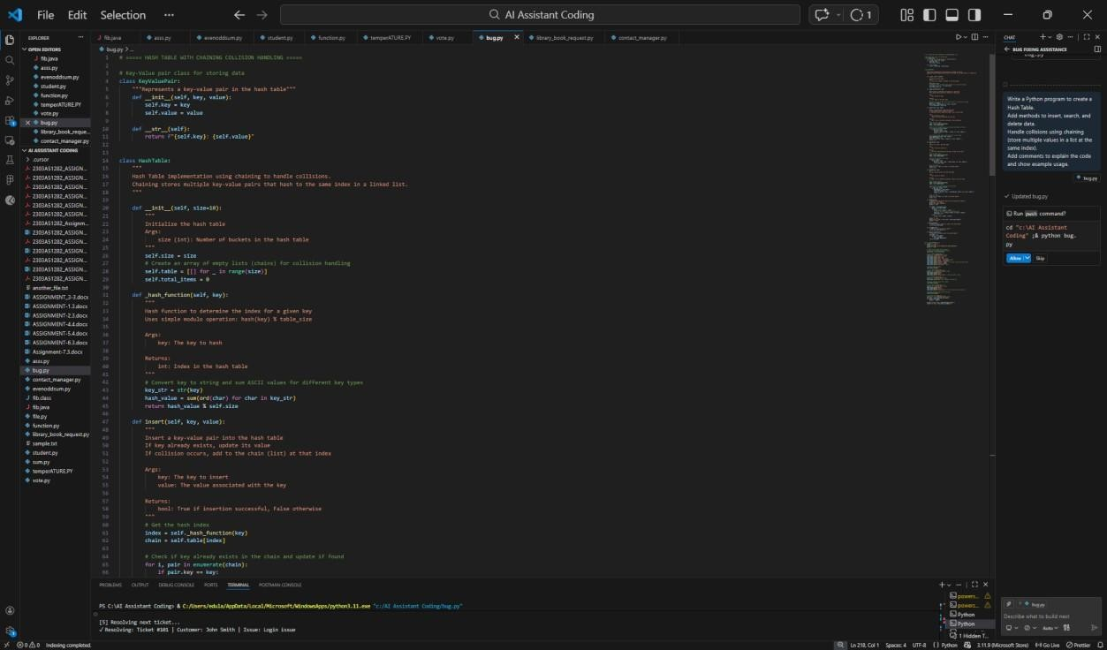

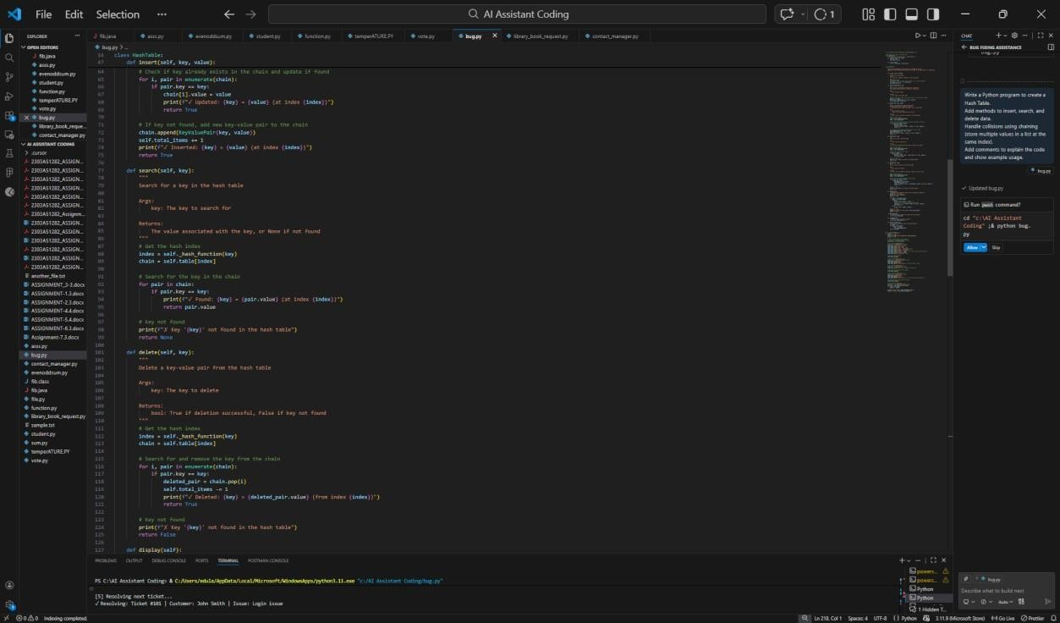
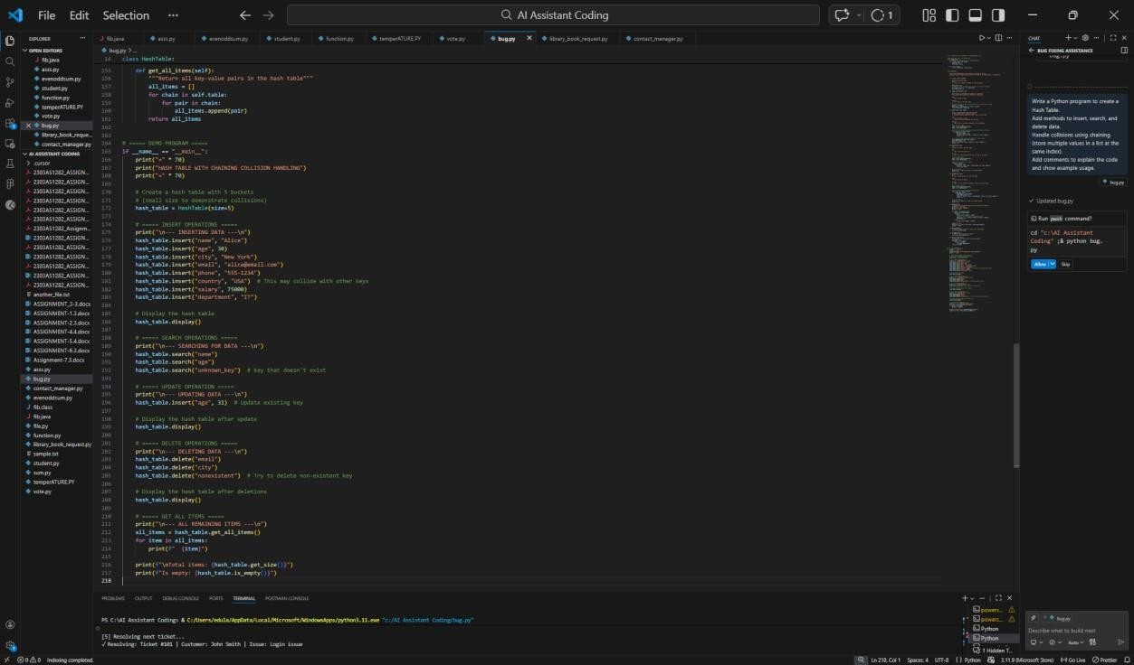

Output:

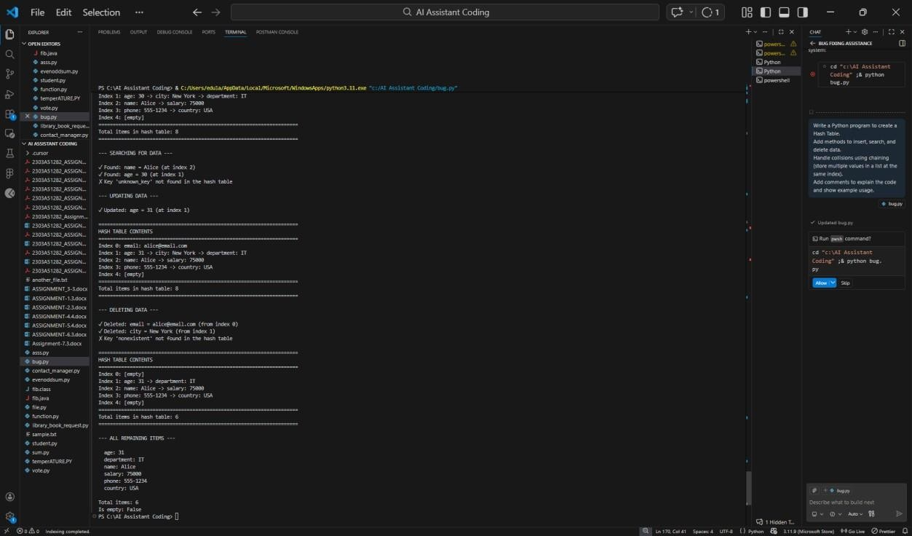

Explanation:
- A Hash Table stores data using a key and value.
- A hash function decides where to store the data.
- Sometimes two keys go to the same place. This is called a collision.
- To solve collisions, we use chaining, meaning we store multiple items in a list at the same index.
- The program should allow adding, finding, and removing data correctly.

Task 5: Real-Time Application Challenge Scenario
Design a Campus Resource Management System with the following features:
- Student Attendance Tracking
- Event Registration System

- Library Book Borrowing
- Bus Scheduling System
- Cafeteria Order Queue Prompt:
Create a Campus Resource Management System in Python.For each feature (Attendance, Event
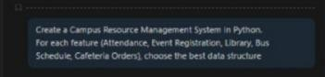
Registration, Library, Bus Schedule, Cafeteria Orders), choose the best data structure

Code:
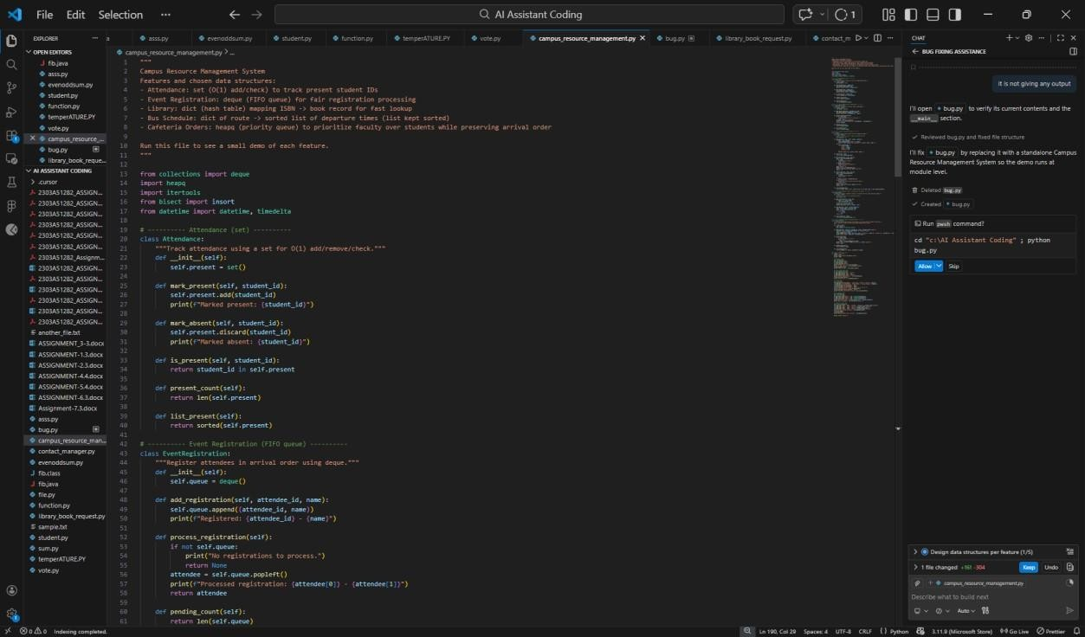

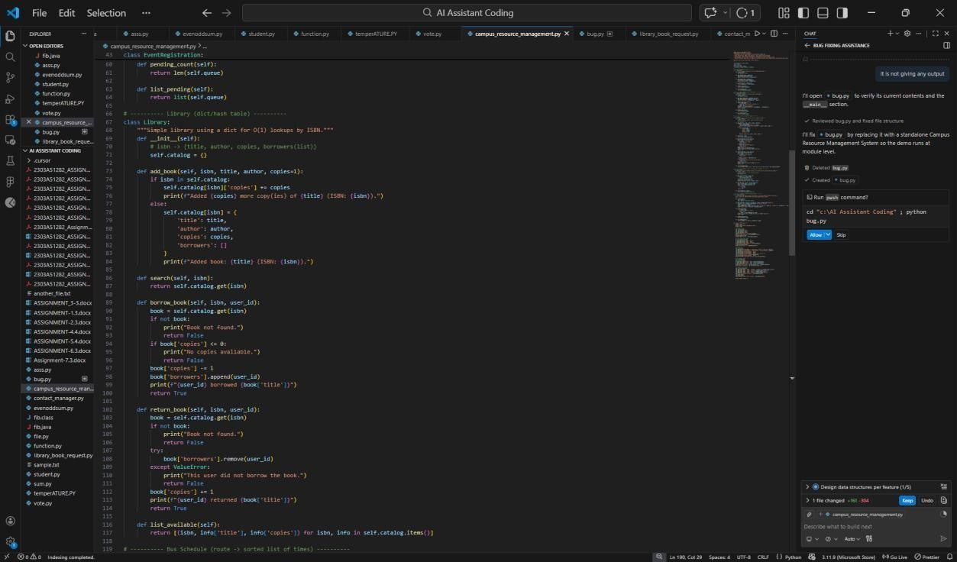
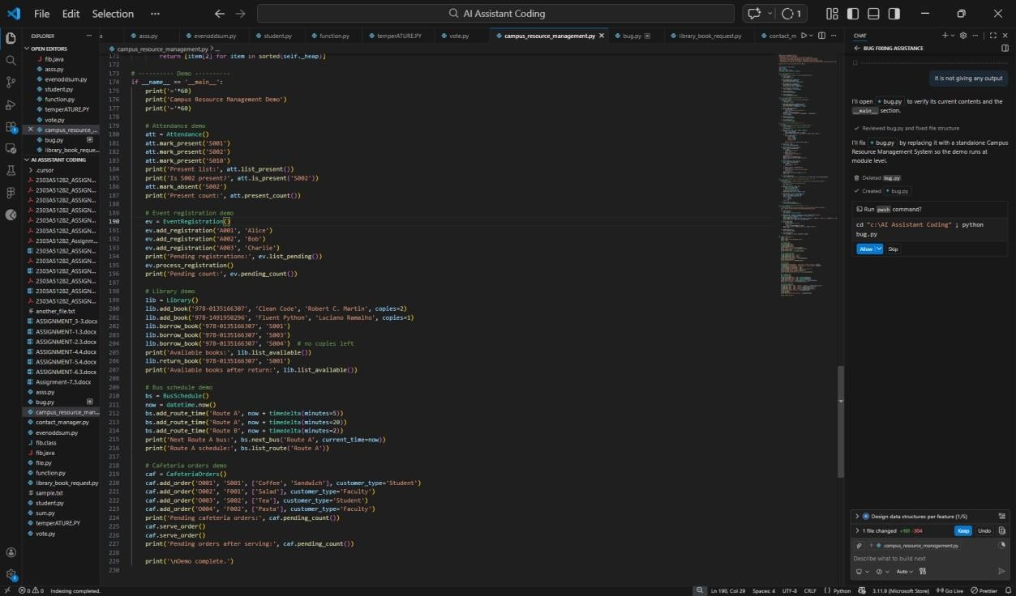

Output:

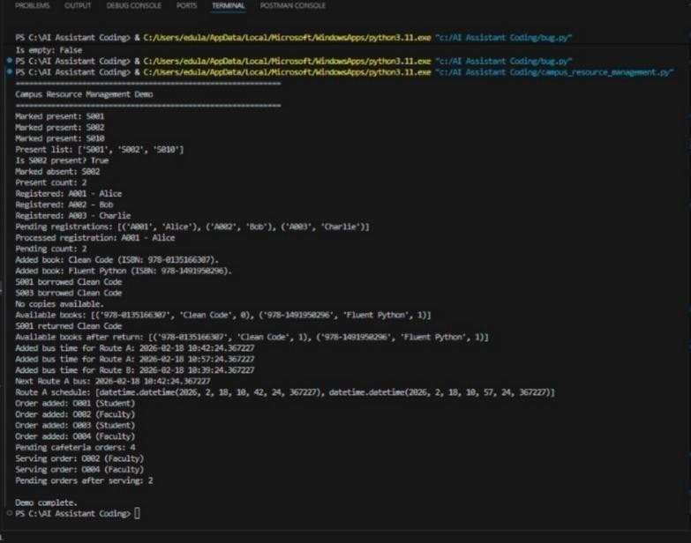

Explanation:
Library Book Borrowing using a queue:
- The queue stores student names who request a book.
- When a student requests a book, we use enqueue() to add them to the queue.
- When a book becomes available, we use dequeue() to give it to the first student in line.
- This ensures fairness because the first requester gets the book first.

