AI ASSISTANCE CODING
Assignment-2.5
NAME:P.Sanwitha
ROLL NO:2403A52L09
BATCH-50

Task 1: Refactoring Odd/Even Logic (List Version)
❖ Scenario:
You are improving legacy code.
❖ Task:
Write a program to calculate the sum of odd and even numbers in a list,
then refactor it using AI.
❖ Expected Output:
❖ Original and improved code

PROMPT:
“Refactor the loop-based odd/even sum logic into a cleaner Python function using list comprehensions.”

CODE AND OUTPUT:
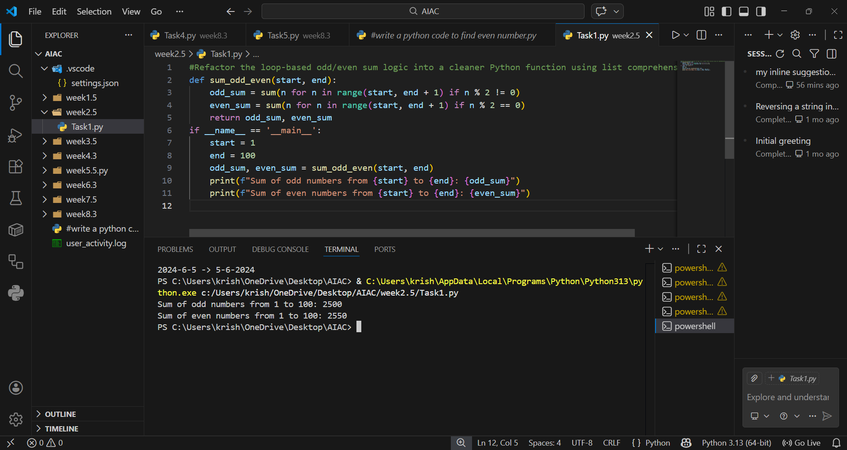

EXPLANTION:
The original code uses explicit loops and conditionals to separate odd and even sums. The refactored version leverages Python’s list comprehensions and sum() for concise, readable logic. This reduces boilerplate code and improves maintainability.

Task 2: Area Calculation Explanation
❖ Scenario:
You are onboarding a junior developer.
❖ Task:
Ask Gemini to explain a function that calculates the area of different
shapes.
❖ Expected Output:
➢ Code
➢ Explanation
PROMPT:
“Gemini, generate a python code and explain how this function calculates the area of different shapes.”
CODE:
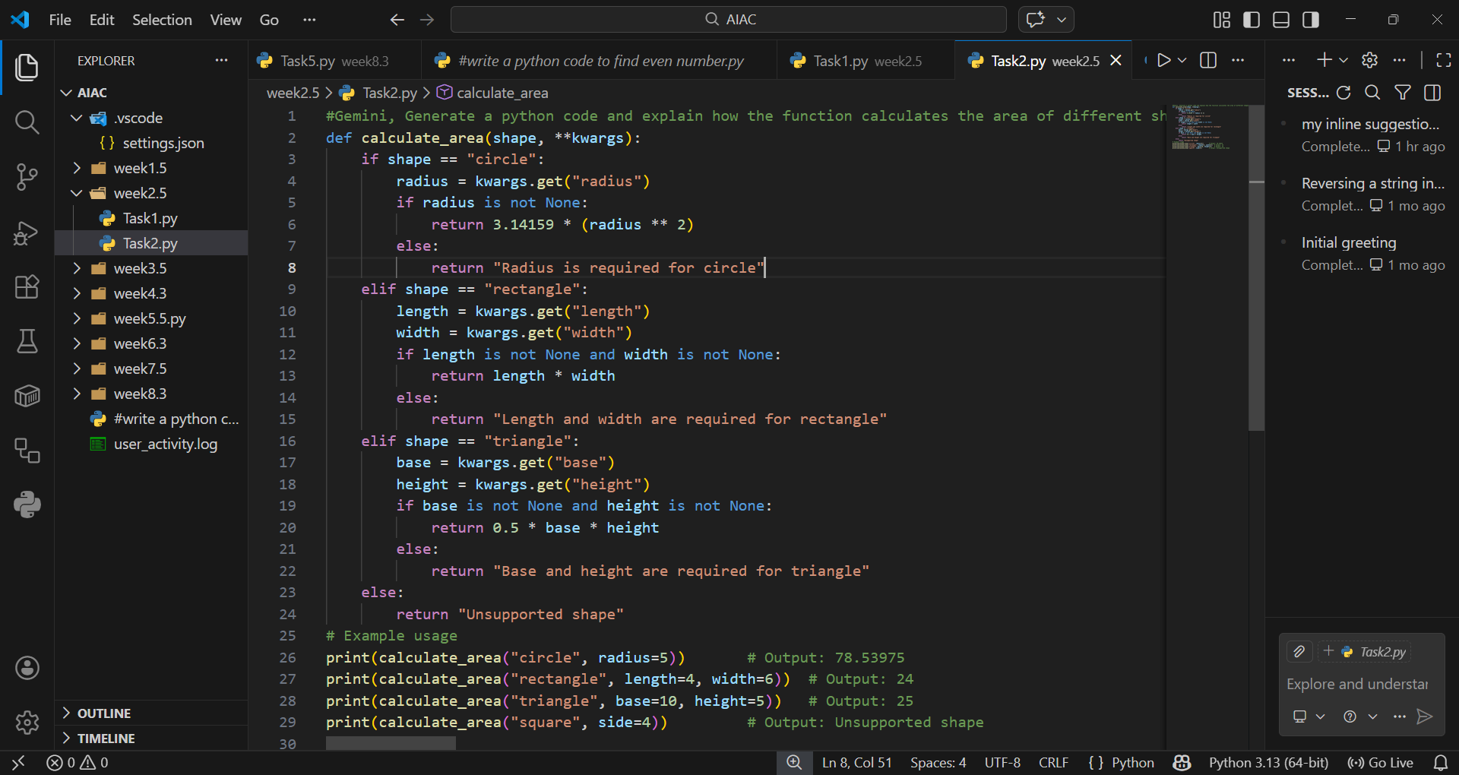

OUTPUT:
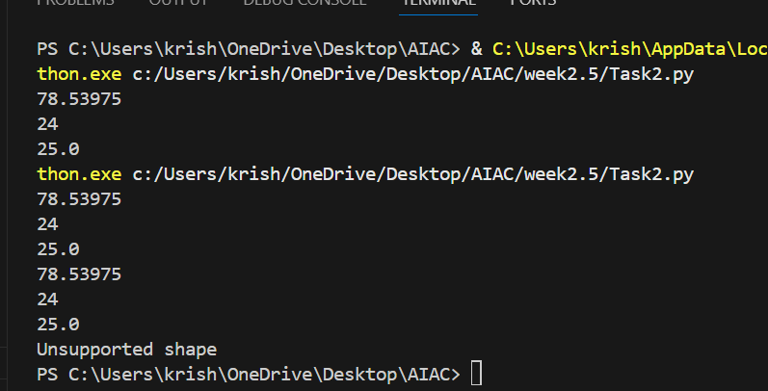

EXPLANATION:
The function uses a parameter shape to decide which formula to apply. For a circle, it multiplies π by the radius squared. For a rectangle, it multiplies length by width. For a triangle, it uses half the product of base and height. This approach centralizes multiple shape calculations into one function, making it flexible and easy to extend.
Task 3: Prompt Sensitivity Experiment
❖ Scenario:
You are testing how AI responds to different prompts.
❖ Task:
Use Cursor AI with different prompts for the same problem and observe
code changes.
❖ Expected Output:
➢ Prompt list
➢ Code variations
PROMPT:
“Write a Python factorial function with error handling for negative inputs.”

CODE AND OUTPUT:
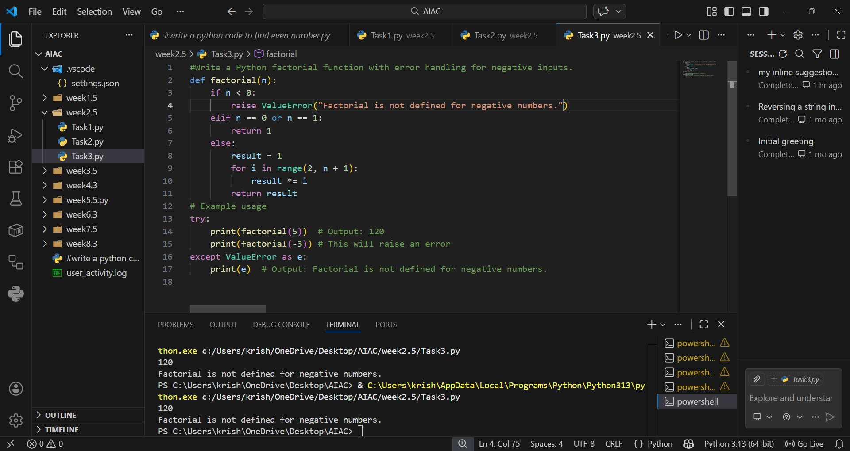

EXPLANTION:
Different prompts lead AI to generate different implementations of the same logic. Adding constraints like “error handling” or “iteration” changes the structure of the code. This demonstrates how prompt wording directly influences AI output.

Task 4: Tool Comparison Reflection
❖ Scenario:
You must recommend an AI coding tool.
❖ Task:
Based on your work in this topic, compare Gemini, Copilot, and Cursor AI
for usability and code quality.
❖ Expected Output:
Short written reflection
EXPLANATION:
Based on experimentation, Gemini excels at detailed explanations and teaching-oriented outputs, making it ideal for onboarding or documentation. Copilot integrates seamlessly into VS Code, providing inline suggestions and quick completions that boost productivity during active coding. Cursor AI is highly responsive to prompt variations, showing flexibility in generating multiple code styles. Overall, Gemini is best for learning and clarity, Copilot for real-time coding assistance, and Cursor AI for experimentation with prompt-driven variations.

