AI ASSISTED CODING
ASSIGNMENT-5.5
NAME:P.Sanwitha
ROLL NO:2403A52L09
BATCH-50

Task Description #1 (Transparency in Algorithm Optimization)
Task: Use AI to generate two solutions for checking prime numbers:
- Naive approach(basic)
- Optimized approach
Prompt:
# “Generate Python code for two prime-checking methods andexplain how the optimized version improves performance.”
Expected Output:
- Code for both methods.
- Transparent explanation of time complexity.
- Comparison highlighting efficiency improvements.
PROMPT:
“Generate Python code for two prime-checking methods and explain how the optimized version improves performance.”
OUTPUT: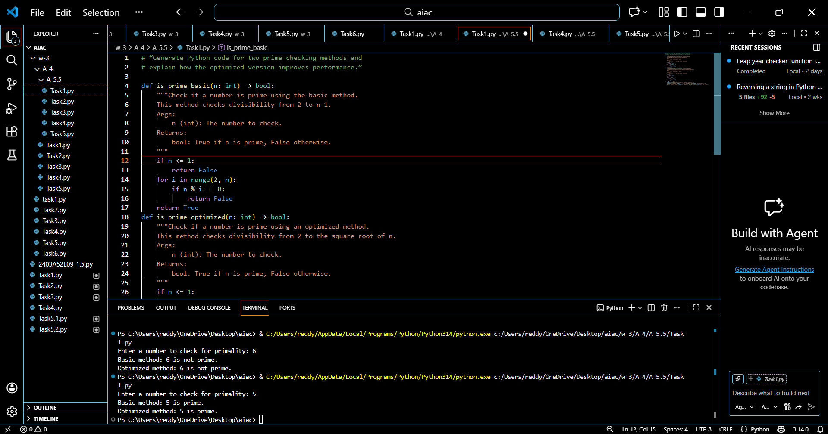
EXPLANATION:
The naive prime-checking approach checks whether a number is divisible by every integer from 2 to n−1. This results in a time complexity of O(n), making it inefficient for larger numbers. In contrast, the optimized method improves performance by checking divisibility only up to the square root of the number and by ignoring even numbers. This reduces the time complexity to O(√n). The comparison clearly shows that optimizing the algorithm significantly reduces the number of computations and improves execution speed.
Task Description #2 (Transparency in Recursive Algorithms)
Objective: Use AI to generate a recursive function to calculate Fibonacci numbers.
Instructions:
- Ask AI to add clear comments explaining recursion.
- Ask AI to explain base cases and recursive calls.
Expected Output:
- Well-commented recursive code.
- Clear explanation of how recursion works.
- Verification that explanation matches actual execution.
PROMPT:
“Generate a recursive Fibonacci function with clear comments and explain the base cases and recursive calls.”

OUTPUT:
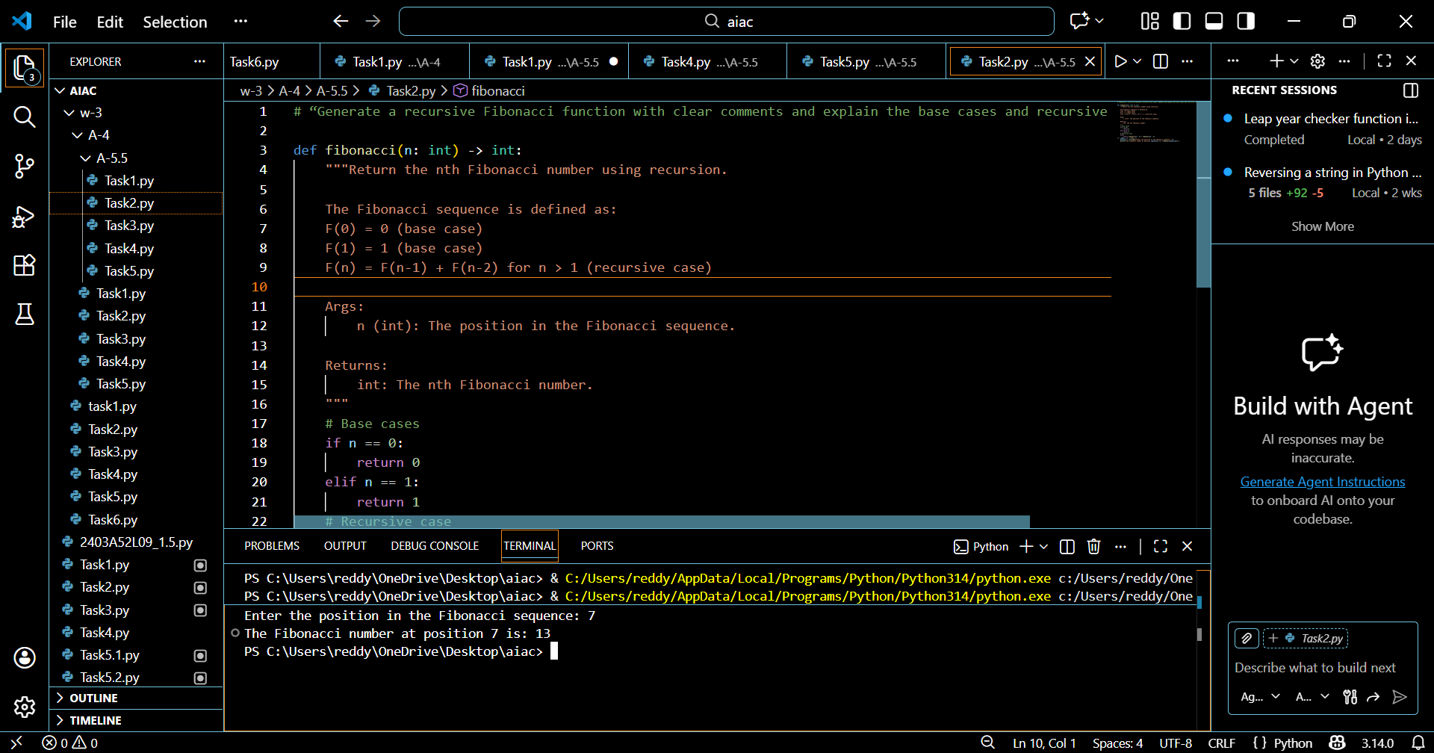
EXPLANATION:
Recursion solves a problem by repeatedly dividing it into smaller, similar problems until a terminating condition is reached. The base cases f(0)=0 and f(1)=1 prevent endless recursion by defining when the function should stop. Each recursive call contributes to building the final result incrementally. Proper comments help clearly illustrate the flow of recursive calls, making the logic easier to understand and follow.
Task Description #3 (Transparency in Error Handling)
Task: Use AI to generate a Python program that reads a file and processes data.
Prompt:
“Generate a Python program that reads a file with proper error handling and explain each exception.”
Expected Output:
- Code with meaningful exception handling.
- Clear comments explaining each error scenario.
- Validation that explanations align with runtime behavior.
PROMPT:
“Generate code with proper error handling and clear explanations for each exception. Generate Python program that reads a file and processes data.”

OUTPUT:
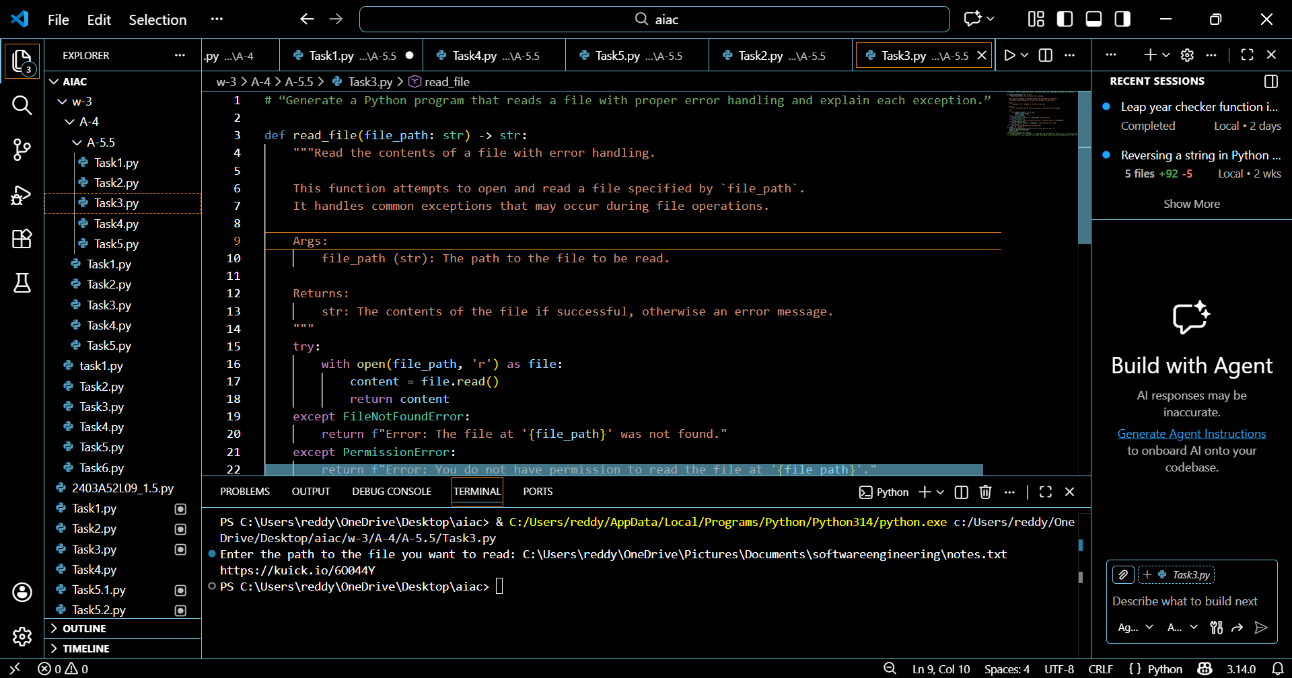
EXPLANATION:
The program applies try–except blocks to manage errors like missing files, access permission problems, or incorrect file paths. Each possible exception is handled with a clear explanation, which prevents the program from terminating abruptly. This transparent approach to error handling enhances both the reliability of the program and the overall user experience.
Task Description #4 (Security in User Authentication)
Task: Use an AI tool to generate a Python-based login system.
Analyze: Check whether the AI uses secure password handling practices.
Expected Output:
- Identification of security flaws (plain-text passwords, weak validation).
- Revised version using password hashing and input validation.
- Short note on best practices for secure authentication
PROMPT:
“Generate a Python-based login system and analyze security weaknesses.”

OUTPUT:
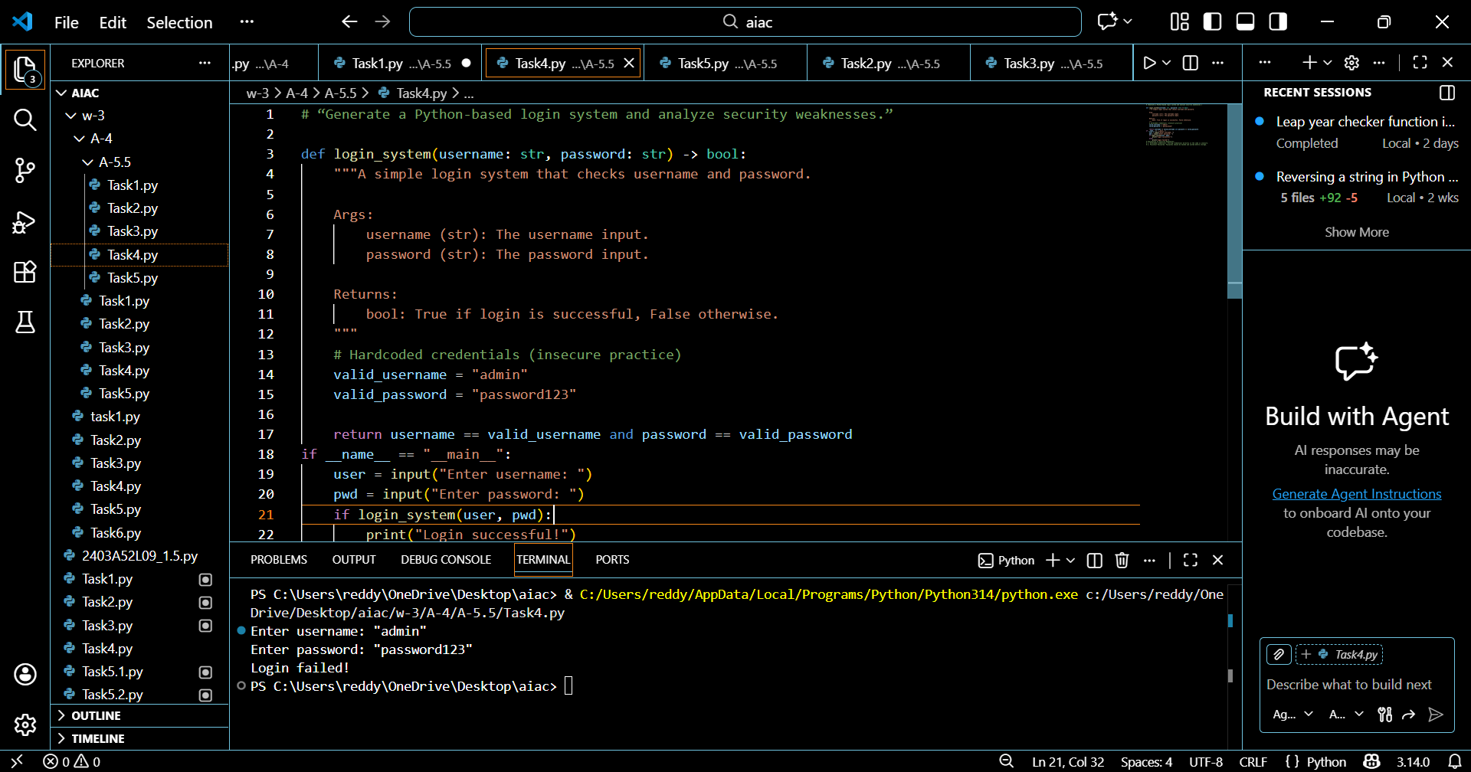
EXPLANATION:
Storing passwords in plain text is unsafe because it directly exposes confidential information. The enhanced version improves security by applying password hashing and validating user input, which helps protect user credentials. Secure authentication practices highlight the need to keep user data safe and to prevent unauthorized access to the system.
Task Description #5 (Privacy in Data Logging)
Task: Use an AI tool to generate a Python script that logs user activity (username, IP address, timestamp).
Analyze: Examine whether sensitive data is logged unnecessarily or insecurely.
Expected Output:
- Identified privacy risks in logging.
- Improved version with minimal, anonymized, or masked logging.
- Explanation of privacy-aware logging principles.
PROMPT:
“Generate a Python script that logs user activity and analyze privacy risks.”

OUTPUT:
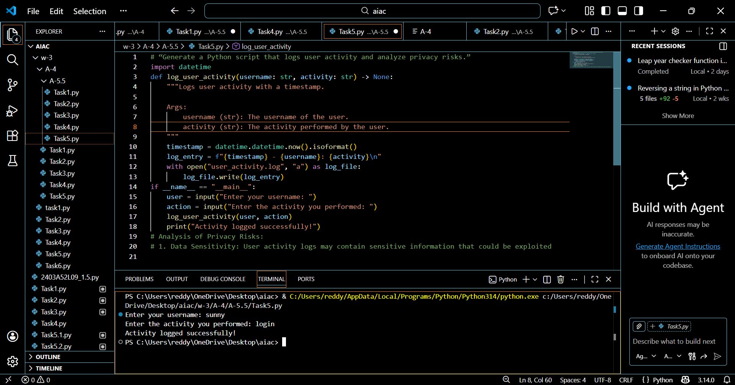
EXPLANTION:
Recording sensitive information like usernames or IP addresses can lead to privacy concerns if the data is exposed. The improved approach limits data collection by anonymizing details or logging only what is essential. Privacy-conscious coding focuses on gathering minimal required information, which helps safeguard user identities and uphold ethical standards.

