Game Design Document

Fill up the following document

1. Write the title of your project.

Fight against covid

1. What is the goal of the game?

The goal of the game is that the character has to center of the maze while dodging the obstacles on the way

1. Write a brief story of your game.

The story is about the current situation of a common man who is fighting against the pandemic. The game is designed to explain the condition one must go through to save his near and dear ones,in order to reach an oxygen cylinder, he needs to fight the corona viruses which are everywhere in the form of obstacles and vaccines are the life saviors on the other hand.

1. Which are the playing characters of this game?

* Playing characters are the ones who respond to the user based on the input from the user.
* Cars, monkeys, dinos, wizards, etc., are the playing characters in the game.

|  |  |  |
| --- | --- | --- |
| Number | Character Name | What can this character do? |
| 1 | Common man | Move around I the maze |
| 2 | viruses | They are eveywhereand can kill the man |
| 3 | vaccine | On reching the vaccines the man can save his life |
| 4 | Oxygen cylinder | Ultimate goal of the man to reach that |
| 5 |  |  |
| 6 |  |  |
| 7 |  |  |
| 8 |  |  |

1. Which are the Non-Playing Characters of this game?

* Non-Playing characters are the ones that don't have an action or behavior when the user interacts with the game.
* Hurdles, stones, bananas, coins, etc., are non-playing characters in the game.

|  |  |  |
| --- | --- | --- |
| Number | Character Name | What can this character do? |
| 1 |  |  |
| 2 |  |  |
| 3 |  |  |
| 4 |  |  |
| 5 |  |  |
| 6 |  |  |
| 7 |  |  |
| 8 |  |  |

Draw your imagination of this game. What does this game look like?

* Draw the game either on your computer or on paper.
* Add images of the game scenes to show each of the playing and non-playing characters at least once.

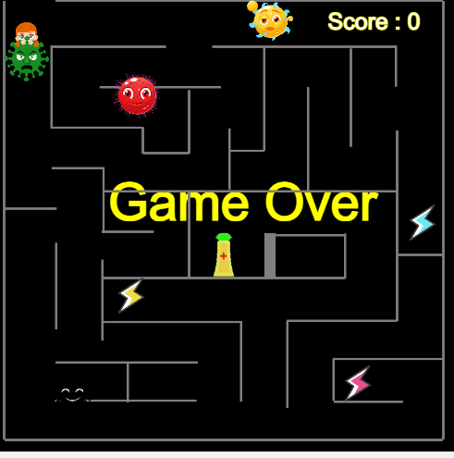

How do you plan to make your game engaging?

It has a very strong and thought provoking story which envolves chance vs skill.The game also has adaptivity in the form of the oxygen cylinder being placed exactly in the middle of the maze .We have balance in the form of vaccines which could save the persons life in the form of feedback we have scoreboard and sounds