Contents
Trees 1
Binary Trees 3
Binary Search Tree (BST): 4
BST Big O 4
BST - Constructor 6
BST - insert 7
BST – contains/lookup 9
Recursive BST: 10
contains 10
Insert 11
Minimum value – helper function 12
delete 13
BST Traversal 14
BFS: Breadth First Search 14
DFS – pre-order 15
DFS – post-order 16
DFS – In-order 17

Trees
LL is a special case of tree that doesn’t fork.
A tree can fork many times.
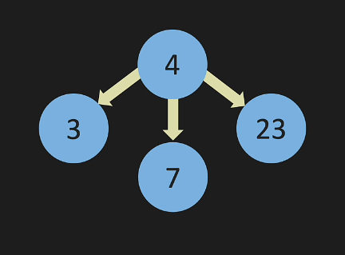
Trees that fork twice are binary trees that we will be focusing on.
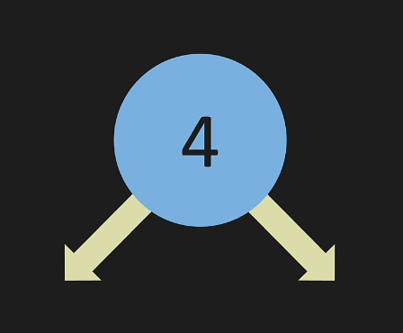

Common terminology general to trees:
Parent Node:
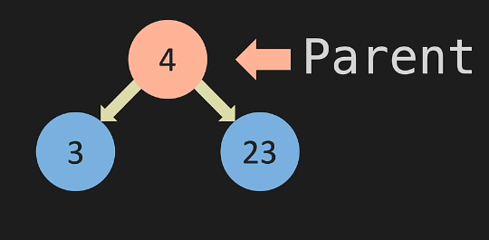
Child nodes:
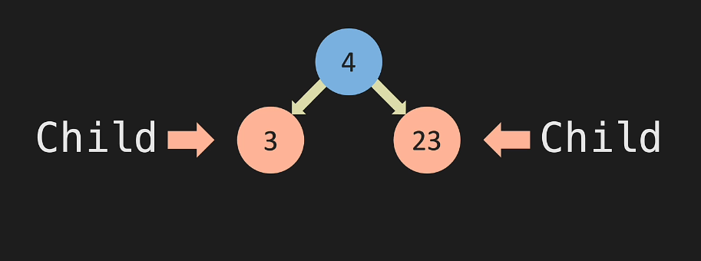
These 2 child nodes are siblings as they share the same parent node

Every node can have only one parent node
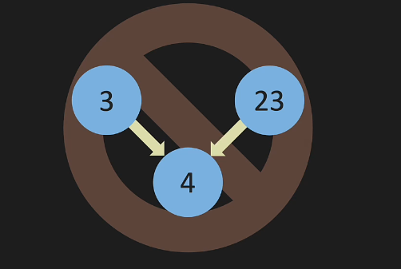

Nodes with no children are called leaf nodes
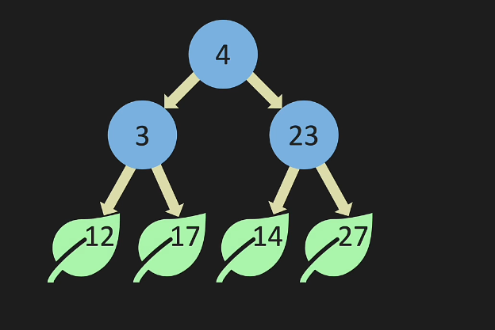

Binary Trees
Full Tree – Either has 0 nodes or 2 nodes
Perfect Tree – The height of the tree has all nodes at that level
Complete tree – Filling the tree from left to right with no gaps
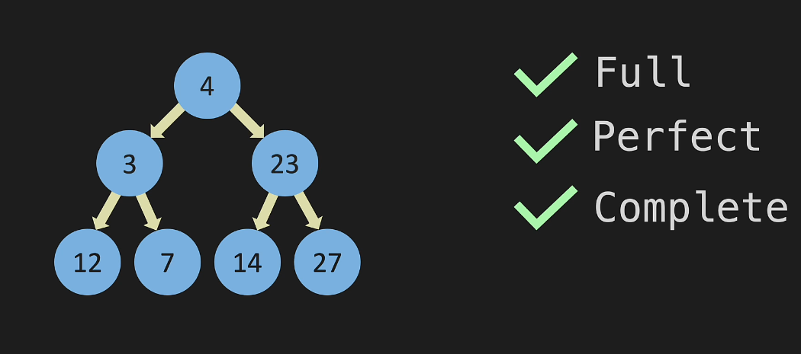
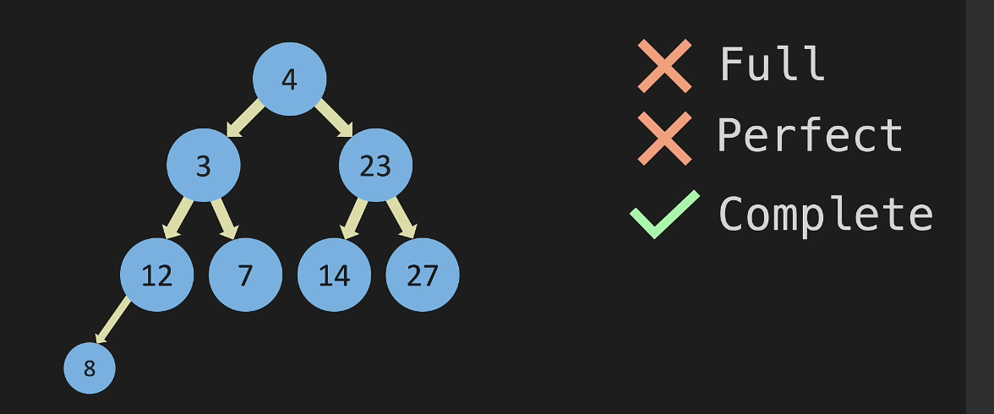
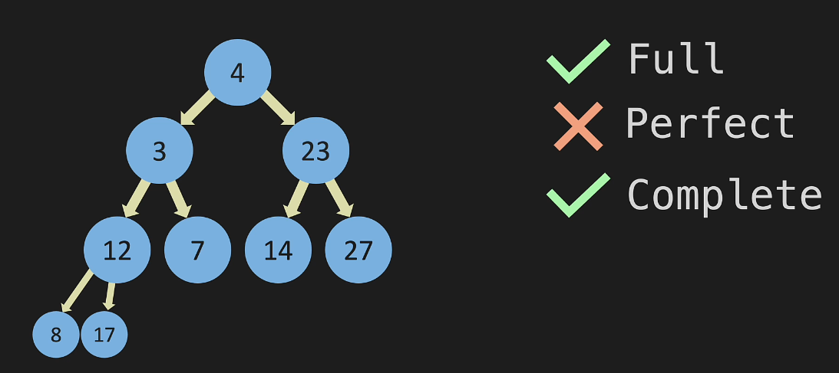
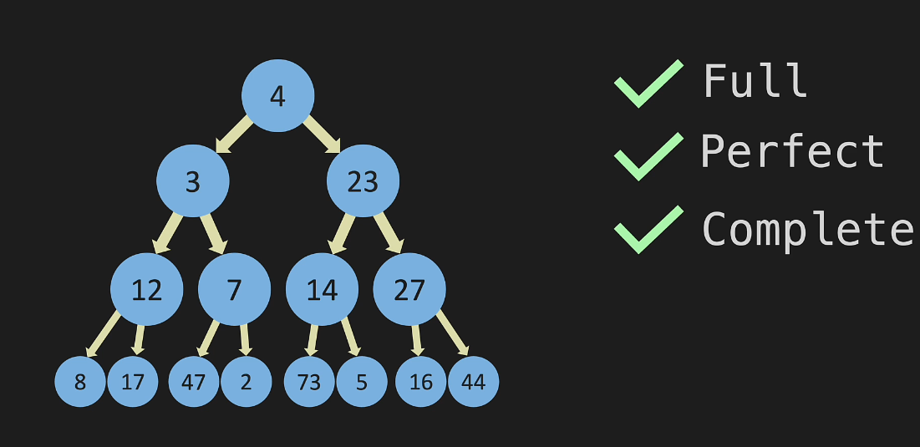

Binary Search Tree (BST):
For any given node,
- the value on it’s left with be smaller than the value of the node.
- the value on it’s right will be greater than the value of the node.

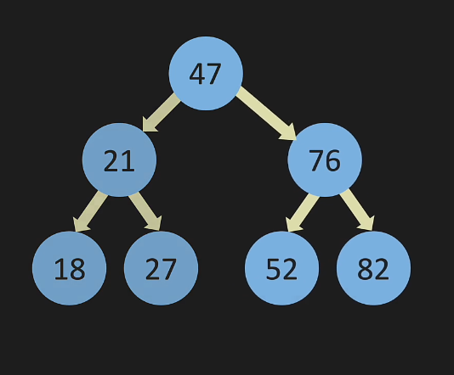

BST Big O
As the level of the tree increases to say n, the total number of nodes is 2^n -1
When n = 1
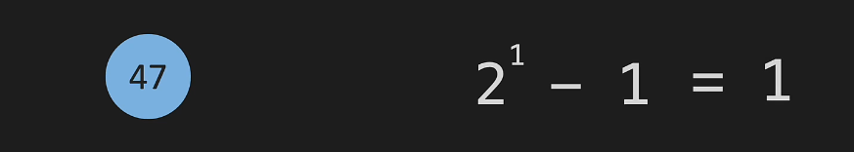
When n = 2
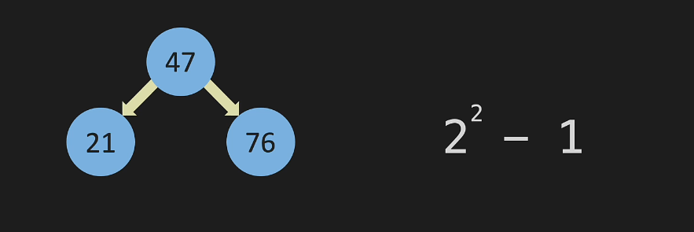
When n = 3
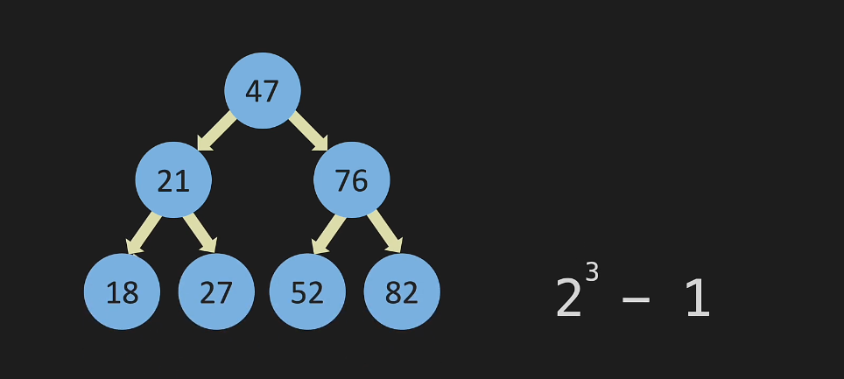

When n = 4
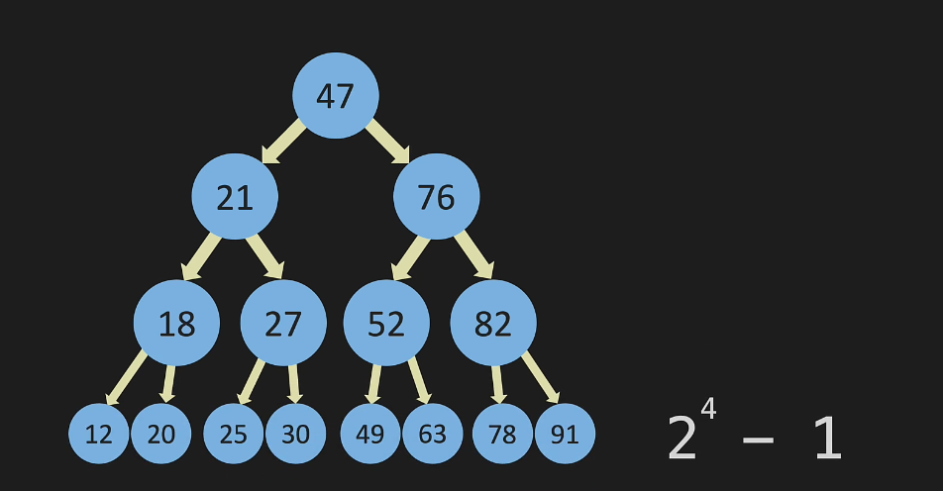
For insert, lookup and remove in the best and average case we need to run log(n) operations
In the worst case, the tree doesn’t fork at all
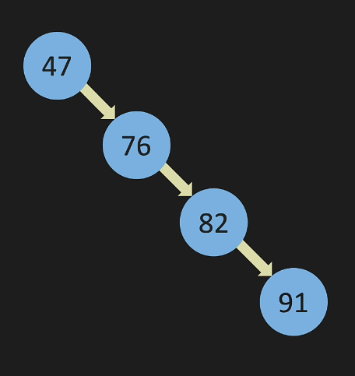
And this is equivalent to Linked List
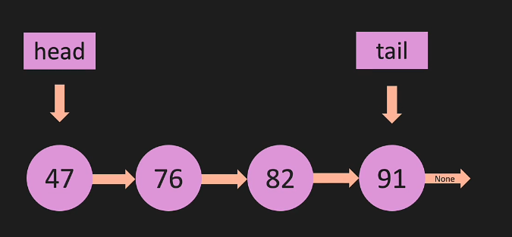
So, the worst case of tree is same as LL
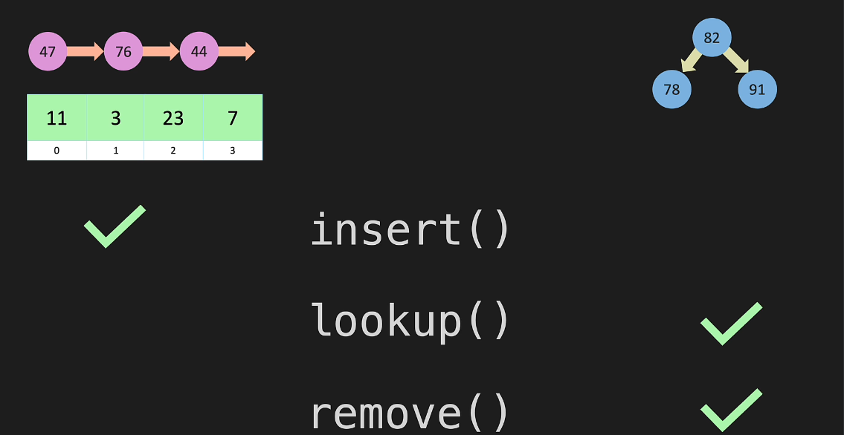

Operation | BST (Best and Avg case) | LL (Worst case)
Lookup | O (log n) | O (n)
Insert | O (log n) | O (1)
Remove | O (log n) | O (n)

BST - Constructor
- class Node:
- def __init__(self, value):
- self.value = value
- self.left = None
- self.right = None

- class BinarySearchTree:
- def __init__(self):
- self.root = None

The Node Class
This class is used to create nodes, which are the basic units in the tree. Each node will have a value and links to its left and right child nodes.
- def __init__(self, value): This is the constructor method that gets called when a new Node object is created.
- self.value = value; Stores the value of the node. This value is passed in when you create the node.
- self.left = None; Initializes the left child of the node as None. This means it doesn't have a left child yet.
- self.right = None; Initializes the right child of the node as None. This means it doesn't have a right child yet.

The BinarySearchTree Class
This class is used to create a Binary Search Tree, which will be made up of Node objects.
- def __init__(self):This is the constructor method that gets called when a new BinarySearchTree object is created.
- self.root = None; Initializes the root of the tree as None. This means the tree is empty to start with.
When you first create a BinarySearchTree, it won't have any nodes. You'll use methods like insert and contains to add nodes and check for values in the tree.

BST - insert
- def insert(self, value):
- new_node = Node(value)
- if self.root is None:
- self.root = new_node
- return True
- temp = self.root
- while (True):
- if new_node.value == temp.value:
- return False
- if new_node.value < temp.value:
- if temp.left is None:
- temp.left = new_node
- return True
- temp = temp.left
- else:
- if temp.right is None:
- temp.right = new_node
- return True
- temp = temp.right

Create New Node
The code new_node = Node(value) creates a new node with the value you want to insert.
Is the Tree Empty?
The line if self.root is None: checks if the tree is empty.
If it's empty, self.root = new_node makes the new node the root of the tree.
Start at Root
temp = self.root sets a temporary variable, temp, to the root so we can start there.
Loop Until Spot Found
while(True): makes a loop that will keep going until it finds the right spot for the new node.
Duplicate Check
if new_node.value == temp.value: checks for duplicate values.
If a duplicate is found, it exits by returning False.
Should We Go Left?
if new_node.value < temp.value: checks if the new value is less than the current node's value.
Insert to the Left
if temp.left is None: checks if the left child spot is empty.
If so, temp.left = new_node puts the new node there.
Move Left and Continue
temp = temp.left means, if the left spot isn't empty, move left and continue looking.
Or Should We Go Right?
If the new node's value is greater, the code moves to the else: part.
Insert to the Right
if temp.right is None: checks if the right child spot is empty.
If so, temp.right = new_node puts the new node there.
Move Right and Continue
temp = temp.right means, if the right spot isn't empty, move right and continue looking.

Omega (best case) and Theta (average case) are both (log n). However, worst case is O(n) and Big O measures worst case. The typically treat Binary Search Trees as O(log n) but technically they are O(n)

BST – contains/lookup

- def contains(self, value):
- temp = self.root
- while (temp is not None):
- if value < temp.value:
- temp = temp.left
- elif value > temp.value:
- temp = temp.right
- else:
- return True
- return False

- Start at the Root:
  - temp = self.root
  - temp starts at the root of the tree.
- Loop Until End or Value Found:
  - while (temp is not None):
  - Keep checking as long as we have a node to look at.
- Is Value Less than Current Node?:
  - if value < temp.value:
  - If so, we should go left.
- Move to Left Child:
  - temp = temp.left
  - We move to the left child of the current node.
- Is Value Greater than Current Node?:
  - elif value > temp.value:
  - If so, we should go right.
- Move to Right Child:
  - temp = temp.right
  - We move to the right child of the current node.
- Value Found:
  - else:
  - If it's not less or greater, it must be equal. We found it!
- Return True:
  - return True
  - We found the value, so we return True.
- End of Loop - Value Not Found:
  - If we reach the end of the loop, the value was not found in the tree.
- Return False:
  - return False
  - We didn't find the value, so we return False.

In summary, the contains method starts at the root and moves through the tree, going left or right depending on the value. It returns True if it finds the value and False if it doesn't.

Recursive BST:

contains
- def __r_contains(self, current_node, value):
- if current_node == None:
- return False
- if value == current_node.value:
- return True
- if value < current_node.value:
- return self.__r_contains(current_node.left, value)
- if value > current_node.value:
- return self.__r_contains(current_node.right, value)

- def r_contains(self, value):
- return self.__r_contains(self.root, value)

The r_contains method takes a value as input and returns True if the value is found in the binary search tree, and False otherwise. It does this by calling a private recursive helper method called __r_contains.
The __r_contains method takes two arguments: a current_node representing the node in the binary search tree that is currently being searched, and the value that is being searched for. It recursively searches the binary search tree for the value starting from the current_node. If the value is found, it returns True. If the value is not found and current_node is None, it returns False. If the value is not equal to the current_node value, it determines whether to search the left or right subtree based on whether the value is less than or greater than the current_node value, respectively. It then calls itself recursively with the appropriate child node and the value.
The r_contains method simply calls the __r_contains method with the root node of the binary search tree and the value that is being searched for, and returns the output of the __r_contains method.

Insert
- def __r_insert(self, current_node, value):
- if current_node == None:
- return Node(value)
- if value < current_node.value:
- current_node.left = self.__r_insert(current_node.left, value)
- if value > current_node.value:
- current_node.right = self.__r_insert(current_node.right, value)
- return current_node

- def r_insert(self, value):
- if self.root == None:
- self.root = Node(value)
- self.__r_insert(self.root, value)

The r_insert method and its helper method __r_insert are used to insert values into a binary search tree (BST) using a recursive approach. Here's an explanation of the provided code:

- __r_insert method: This is a private helper method for the r_insert method. It takes two arguments - the current node and the value to be inserted. The method is recursive and works as follows: a. If the current node is None, it means the value can be inserted at this position. A new node with the given value is created and returned. b. If the value is less than the current node's value, the method is called recursively on the left child of the current node. c. If the value is greater than the current node's value, the method is called recursively on the right child of the current node. d. Finally, the current node is returned.
- r_insert method: This is the public method to insert a value into the binary search tree. If the root is None, it creates a new node with the given value and sets it as the root. Then it calls the __r_insert helper method with the root and the value as arguments.

Minimum value – helper function

- def min_value(self, current_node):
- while current_node.left is not None:
- current_node = current_node.left
- return current_node.value

This code defines a method called min_value that finds the minimum value in a binary search tree (BST) starting from a given node (current_node). The method takes one argument, current_node, which is the node from where the search for the minimum value begins.
In a BST, the left subtree contains only nodes with values less than the parent node's value, and the right subtree contains only nodes with values greater than the parent node's value. Therefore, the minimum value in a BST is located in the leftmost node of the tree.
The method works as follows:

- It starts with a while loop that continues as long as current_node.left is not None. This means that the loop continues as long as there is a left child for the current node.
- Inside the loop, the method updates the current_node to its left child (current_node.left). This means that the method keeps traversing the left subtree of the BST to find the leftmost node.
- Once the loop ends, it means that the current_node has no left child, which implies that the current node is the leftmost node in the tree, and thus contains the minimum value.
- Finally, the method returns the value of the current node, which is the minimum value in the BST starting from the given node.

delete
- def __delete_node(self, current_node, value):
- if current_node == None:
- return None
- if value < current_node.value:
- current_node.left = self.__delete_node(current_node.left, value)
- elif value > current_node.value:
- current_node.right = self.__delete_node(current_node.right, value)
- else:
- if current_node.left == None and current_node.right == None:
- return None
- elif current_node.left == None:
- current_node = current_node.right
- elif current_node.right == None:
- current_node = current_node.left
- else:
- sub_tree_min = self.min_value(current_node.right)
- current_node.value = sub_tree_min
- current_node.right = self.__delete_node(current_node.right, sub_tree_min)
- return current_node

- def delete_node(self, value):
- self.root = self.__delete_node(self.root, value)

This code implements a binary search tree (BST), which is a binary tree data structure where each node has at most two child nodes, arranged in a way that the value of the node to the left is less than or equal to the parent node, and the value of the node to the right is greater than or equal to the parent node.
The delete_node method is a public method to delete a node with a given value from the BST.
The actual deletion logic is implemented in the private method __delete_node.
The logic of the __delete_node method is as follows:
- If the current node is empty (None), it means the node with the given value is not found, so return None.
- If the value to delete is less than the current node's value, search in the left subtree.
- If the value to delete is greater than the current node's value, search in the right subtree.
- If the value to delete is equal to the current node's value, we have found the node to delete. There are three cases: a. If the node has no children, remove the node by returning None. b. If the node has only a left child or only a right child, remove the node by returning the existing child. c. If the node has both children, find the minimum value in the right subtree, replace the current node's value with that minimum value, and then delete the minimum value node in the right subtree.

The reason we use self.root = self.__delete_node(self.root, value) instead of self.__delete_node(self.root, value) is to update the tree's root node after deletion.
This is necessary if the root node is the one being deleted or if its value is replaced with the minimum value from its right subtree.
By assigning the result of self.__delete_node(self.root, value) to self.root, we ensure that the root node is updated accordingly, maintaining the integrity of the tree structure.

BST Traversal

BFS: Breadth First Search
It is done row by row
- def BFS(self):
- current_node = self.root
- queue = []
- results = []
- queue.append(current_node)

- while len(queue) > 0:
- current_node = queue.pop(0)
- results.append(current_node.value)
- if current_node.left is not None:
- queue.append(current_node.left)
- if current_node.right is not None:
- queue.append(current_node.right)
- return results

The BFS method performs a Breadth-First Search traversal of the binary search tree.
The method starts at the root of the tree and adds it to a queue data structure.
Then, the method loops over the elements in the queue, removing the first element in the queue, appending its value to a results list, and adding its left and right child (if they exist) to the queue.
The method continues this process until the queue is empty, at which point it returns the results list containing the values of all nodes in the binary search tree in breadth-first order.
The BFS method uses a queue to keep track of the nodes to visit in a first-in, first-out (FIFO) order, which is the main characteristic of the BFS algorithm.
The method removes the first element in the queue using the pop(0) method, which ensures that the next element to be visited is always the one that was added first.
The BFS algorithm traverses the tree level-by-level, visiting all nodes at a particular level before moving on to the next level. The BFS method in this implementation achieves this by using a queue to keep track of nodes that have been visited, but not processed, in the order they were visited.

DFS – pre-order

- def dfs_pre_order(self):
- results = []
- def traverse(current_node):
- results.append(current_node.value)
- if current_node.left is not None:
- traverse(current_node.left)
- if current_node.right is not None:
- traverse(current_node.right)
- traverse(self.root)
- return results

The dfs_pre_order method in the BinarySearchTree class performs a Depth-First Search traversal of the binary search tree in pre-order. The pre-order traversal visits the current node first, then the left child, and then the right child.
The method starts by creating an empty list called results that will be used to store the values of the visited nodes. Then, the method defines a nested function called traverse that takes a current_node argument. The traverse function appends the value of the current_node to the results list, and then recursively calls itself to traverse the left child and the right child (if they exist) in pre-order.
The method then calls the traverse function with the root node of the tree to start the pre-order traversal. The traverse function recursively visits each node in the tree in pre-order, appending the value of each visited node to the results list. Finally, the dfs_pre_order method returns the results list, which contains the values of all nodes in the binary search tree in pre-order.
The DFS algorithm uses recursion to visit each node in the tree. In this implementation, the traverse function takes a current_node argument and appends the value of the node to the results list. Then, the function recursively calls itself to traverse the left and right child of the current node. The recursive calls continue until there are no more nodes to visit, and the results list is returned with the values of all visited nodes.

DFS – post-order

- def dfs_post_order(self):
- results = []
- def traverse(current_node):
- if current_node.left is not None:
- traverse(current_node.left)
- if current_node.right is not None:
- traverse(current_node.right)
- results.append(current_node.value)
- traverse(self.root)
- return results

The dfs_post_order method in the BinarySearchTree class performs a Depth-First Search traversal of the binary search tree post-order. The post-order traversal visits the left child first, then the right child, and finally the current node.
The dfs_post_order method starts by creating an empty list called results that will be used to store the values of the visited nodes. Then, the method defines a nested function called traverse that takes a current_node argument. The traverse function recursively calls itself to traverse the left child of the current_node, then recursively calls itself to traverse the right child of the current_node, and finally appends the value of the current_node to the results list.
The method then calls the traverse function with the root node of the tree to start the post-order traversal. The traverse function recursively visits each node in the tree post-order, appending the value of each visited node to the results list after visiting its children. Finally, the dfs_post_order method returns the results list, which contains the values of all nodes in the binary search tree post-order.

DFS – In-order
- def dfs_in_order(self):
- results = []
- def traverse(current_node):
- if current_node.left is not None:
- traverse(current_node.left)
- results.append(current_node.value)
- if current_node.right is not None:
- traverse(current_node.right)
- traverse(self.root)
- return results

The dfs_in_order method performs a Depth-First Search traversal of the binary search tree in-order. The in-order traversal visits the left child first, then the current node, and then the right child.
The method starts by creating an empty list called results that will be used to store the values of the visited nodes. Then, the method defines a nested function called traverse that takes a current_node argument. The traverse function recursively calls itself to traverse the left child of the current_node, appends the value of the current_node to the results list, and then recursively calls itself to traverse the right child of the current_node (if it exists).
The method then calls the traverse function with the root node of the tree to start the in-order traversal. The traverse function recursively visits each node in the tree in-order, appending the value of each visited node to the results list. Finally, the dfs_in_order method returns the results list, which contains the values of all nodes in the binary search tree in-order.
The DFS algorithm uses recursion to visit each node in the tree. In this implementation, the traverse function takes a current_node argument and recursively visits the left and right child of the current node in-order. The recursive calls continue until there are no more nodes to visit, and the results list is returned with the values of all visited nodes.

Binary Search Tree

Binary Tree

TREE

