List: Index get O(1), new elements hard to add as memory may not be free in the next contiguous space.
LL: Can add as many elements, but to get elements O(n)
Enters Hash Map:
Hash Tables store key-value pairs
In built hash table in python is Dictionary.
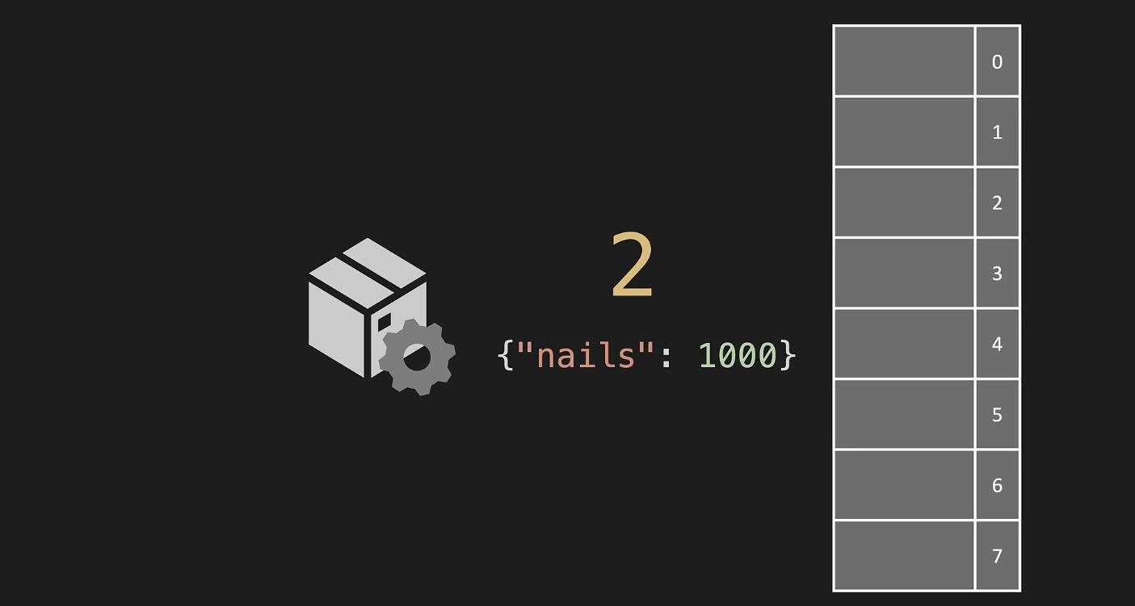
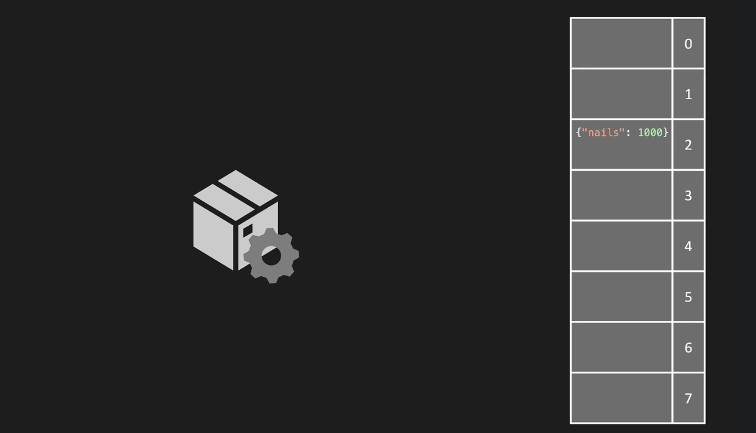

Hash Table Properties:
One-way: From “nails” key we can get “2” index but not the other way around. That is from 2 we cannot get nails.
Deterministic: Nails key will always give 2 index based on the hashing logic defined.

A Basic Hashing Logic:
def __hash(self, key):
my_hash = 0
for letter in key:
my_hash = (my_hash + ord(letter) * 23) % len(self.data_map)
return my_hash
For the given key, calculate its ascii format, multiply with a prime number in this case 23, and apply modulus of the length of data_map which should also preferably be a prime number. Less collisions occur for prime numbers.
In this case, the size of data map is set to 7 and modulo gives remainder on division, So the results will be between 0-6, that are the indices of the data_map as well

Constructor:
- def __init__(self, size = 7):
- self.data_map = [None] * size

Collisions:
Separate Chaining: If 2 keys get same index, then store both of them at that index inside a list.
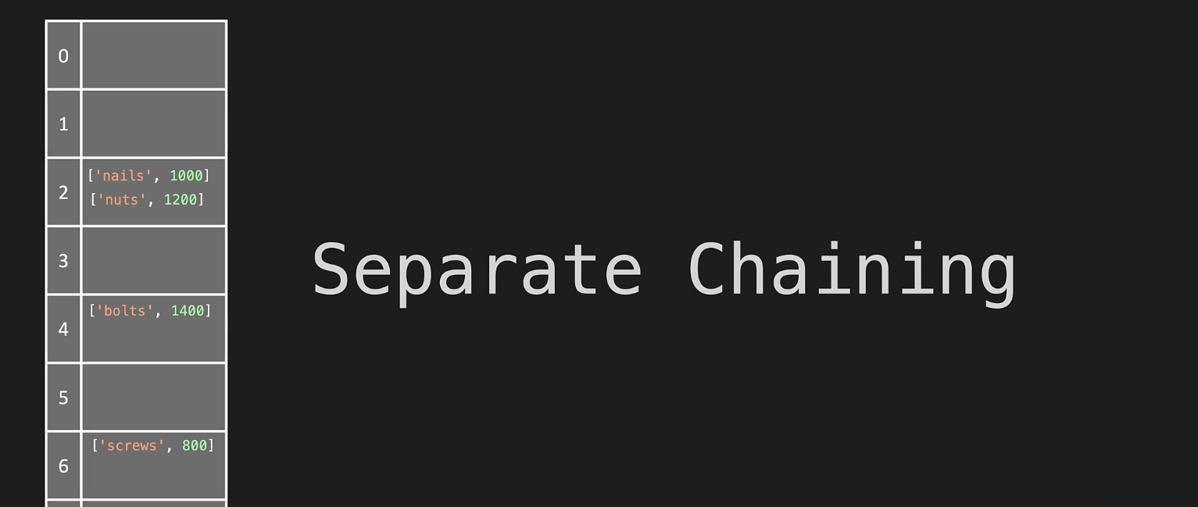
Chaining can be done using a list or a linked list:
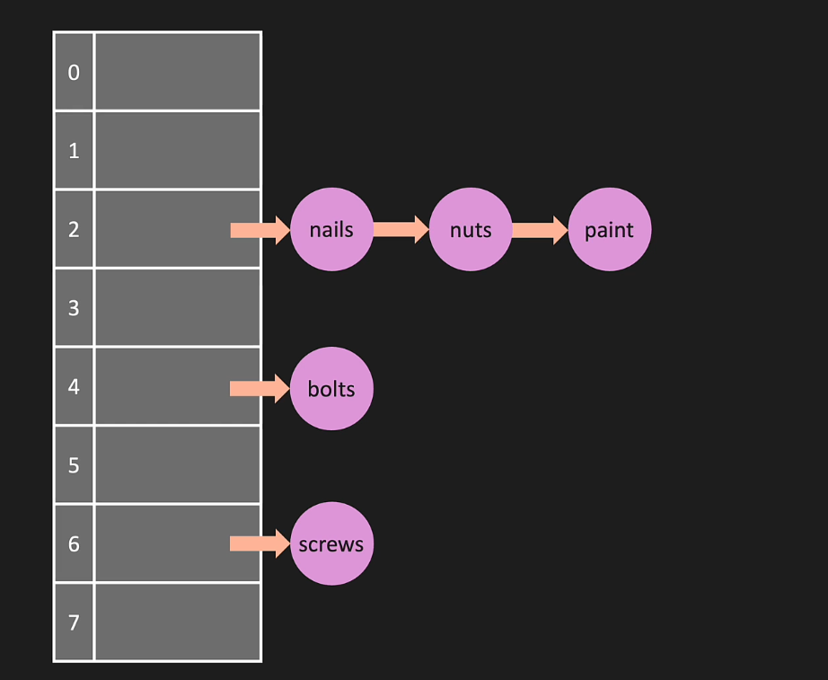

Open Addressing: If a given index already has a key, then put the current key at another open address. One way to do this is to linearly find next empty space (Linear Probing)
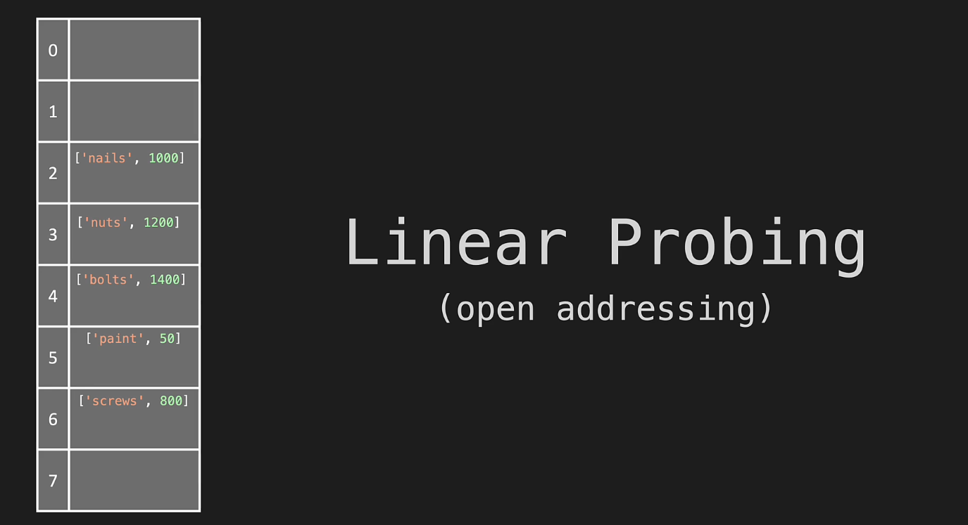

Big O
Hashing: the hash logic just runs a single operation, so O(1)
Setting: From hash we get the index, then we just append the key-pair at the calculated index, no loops. So, O(1)
Getting the key: O(1), the list isn’t too long, as the hash logic tries to distribute values well. If the list is too long then O(n), but that doesn’t happen.
Getting the value: O(n) Looking up a value in a Hash Table is not O(1)

Note:

- Both Insert and Lookup by key in a Hash Table is O(1)
- Binary Search Trees are sorted which makes them better at searching for all values that fall within a range. So hash tables are not always better, even though insert and lookup is O(1)

Set Item:
- def set_item(self, key, value):
- index = self.__hash(key)
- if self.data_map[index] == None:
- self.data_map[index] = []
- self.data_map[index].append([key, value])
The set_item method takes a key and a value and adds them to the hash table. It computes the index in the hash table for the key using the __hash method, which is a private method that computes a hash code for the key.
The method then checks whether the bucket at the index is empty. If it is, it initializes the bucket to an empty list. This is necessary because we want to store a list of [key, value] pairs at each bucket in the hash table, and if the bucket is initially None, we can't append to it.
Finally, the method appends the [key, value] pair to the bucket at the index, so that the key-value mapping is stored in the hash table.

- def get_item(self, key):
- index = self.__hash(key)
- if self.data_map[index] is not None:
- for i in range(len(self.data_map[index])):
- if self.data_map[index][i][0] == key:
- return self.data_map[index][i][1]
- return None

Get Item:
The get_item method takes a key as input and returns the value associated with that key in the hash table.
First, the method calculates the hash value of the input key using the __hash method and stores it in the index variable.
If the hash value in the data_map attribute at the given index is not None, the method checks if the key exists in the list of key-value pairs stored at that hash value in the data_map.
To do this, the method iterates over the list of key-value pairs stored at that hash value by using a for loop that iterates over the range of the length of the list.
Then, the method checks if the key matches the first element of the key-value pair at the current index of the list.
If there is a match, the method returns the value associated with that key in the key-value pair.
If no match is found in the list, the method returns None.

All Keys:
- def keys(self):
- all_keys = []
- for i in range(len(self.data_map)):
- if self.data_map[i] is not None:
- for j in range(len(self.data_map[i])):
- all_keys.append(self.data_map[i][j][0])
- return all_keys
The keys() method works by iterating through the hash table's data map and checking if each index contains data. If there is data at an index, it means that the list at that index can contain key-value pairs. The method then iterates through the key-value pairs at that index and appends the key to a list of all the keys in the hash table.
Once all the keys have been appended to the list, it is returned. This is a list of all the keys present in the hash table.
The time complexity of the keys() method is O(n), where n is the number of elements in the hash table. This is because we need to iterate through all elements in the hash table to retrieve all the keys.

