Graphs
Graph -> Vertex + Edges
Edges can be weighted or unweighted
Edges can be bidirectional or unidirectional
They can be stored as adjacency matrix or adjacency list

Adjacency Matrix
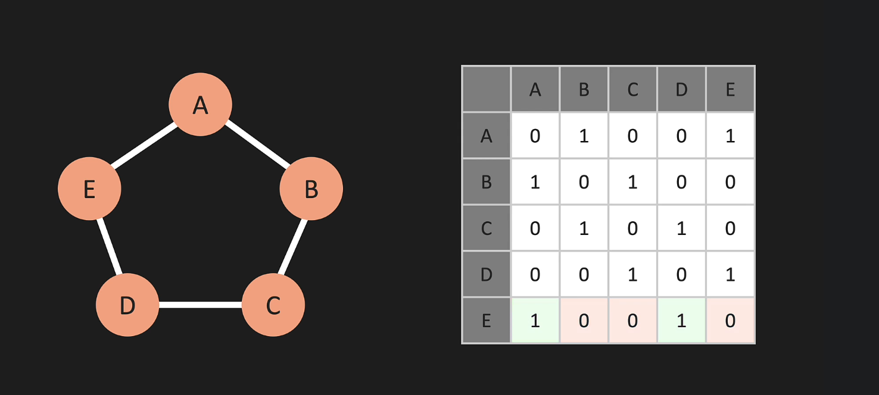
The rows are the vertices and the columns has 1 set for the vertices that the row vertex has an edge with.
There are no self-edges here, so the diagonal is 0
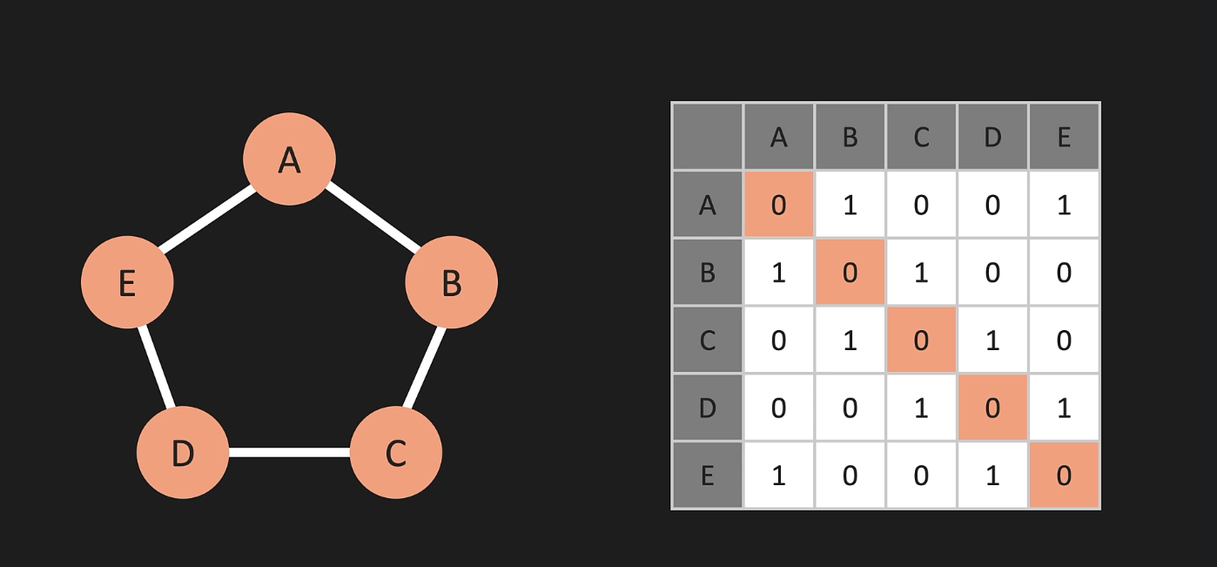
The graph is bi-directional, so the matrix is symmetric about the diagonal
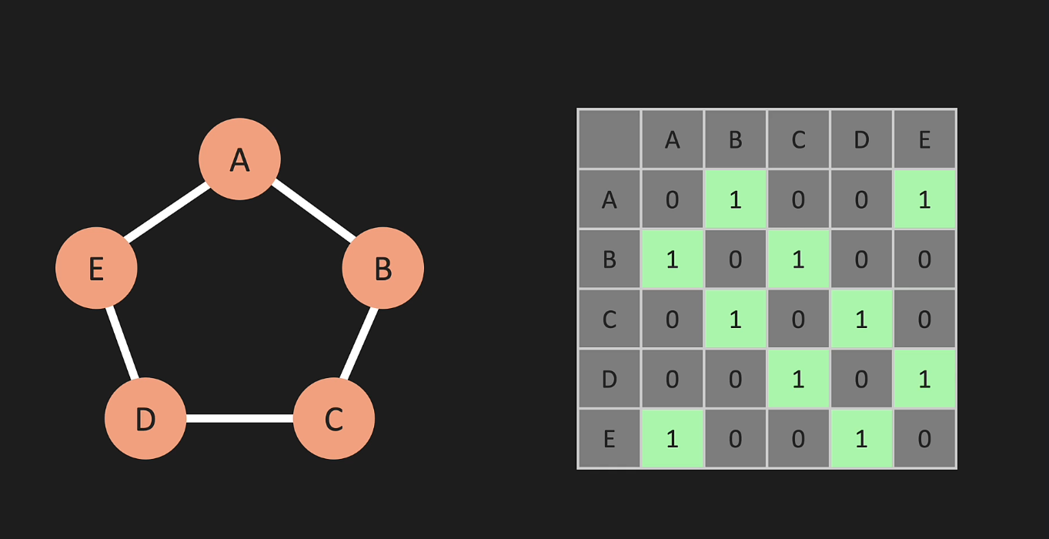
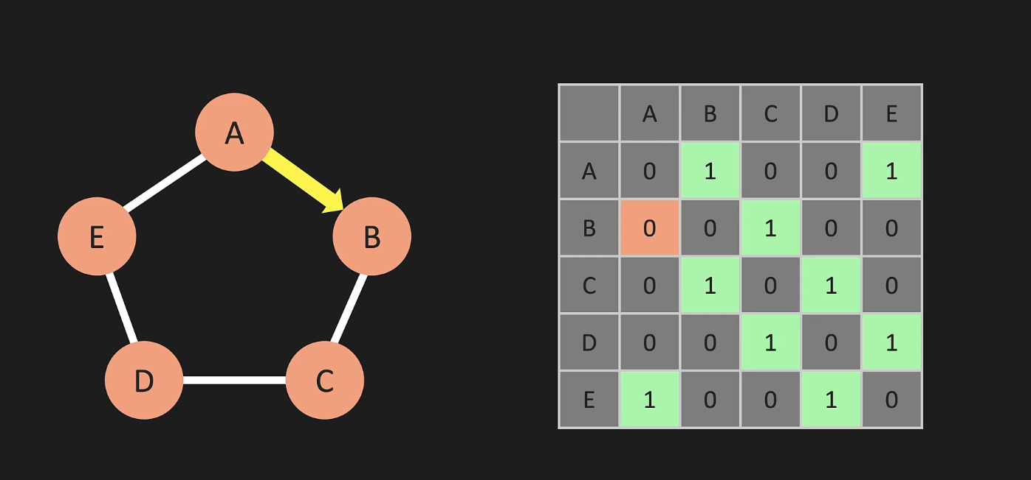
If the edges are weighted, replace 1 with the weights
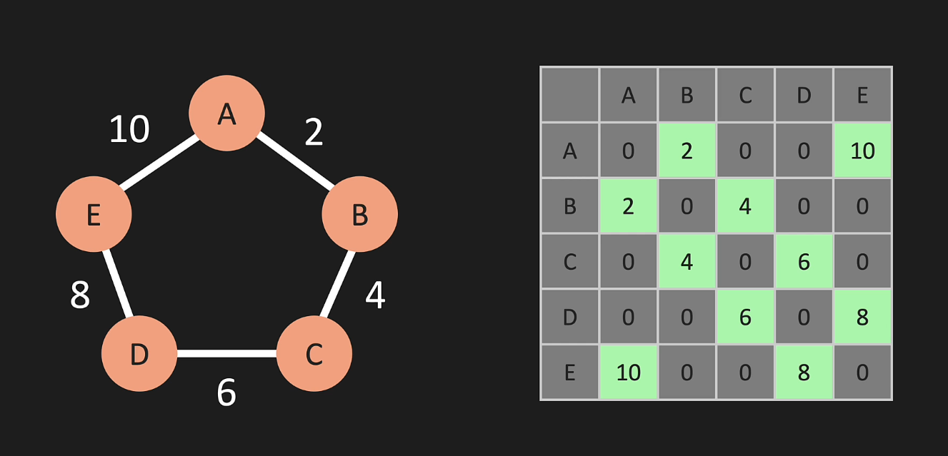

Adjacency List
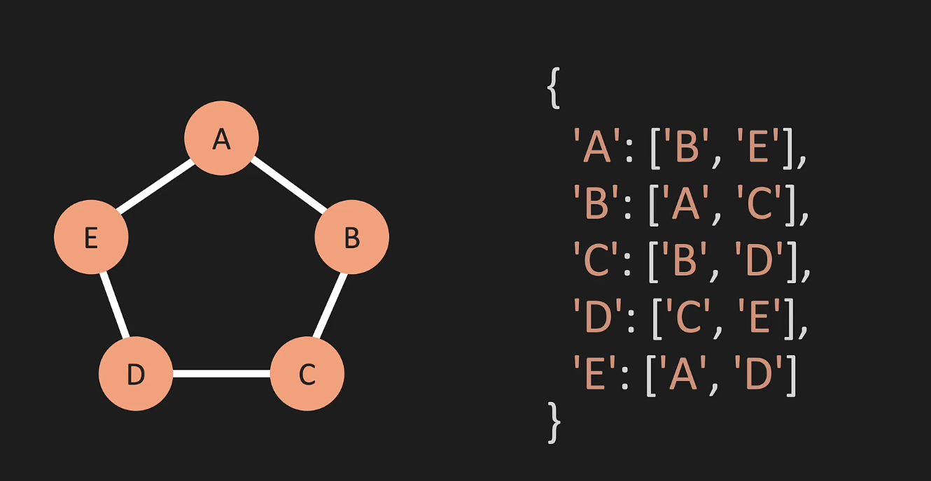

Big-O (Adjacency Matrix vs Adjacency list)
Creating the data structure
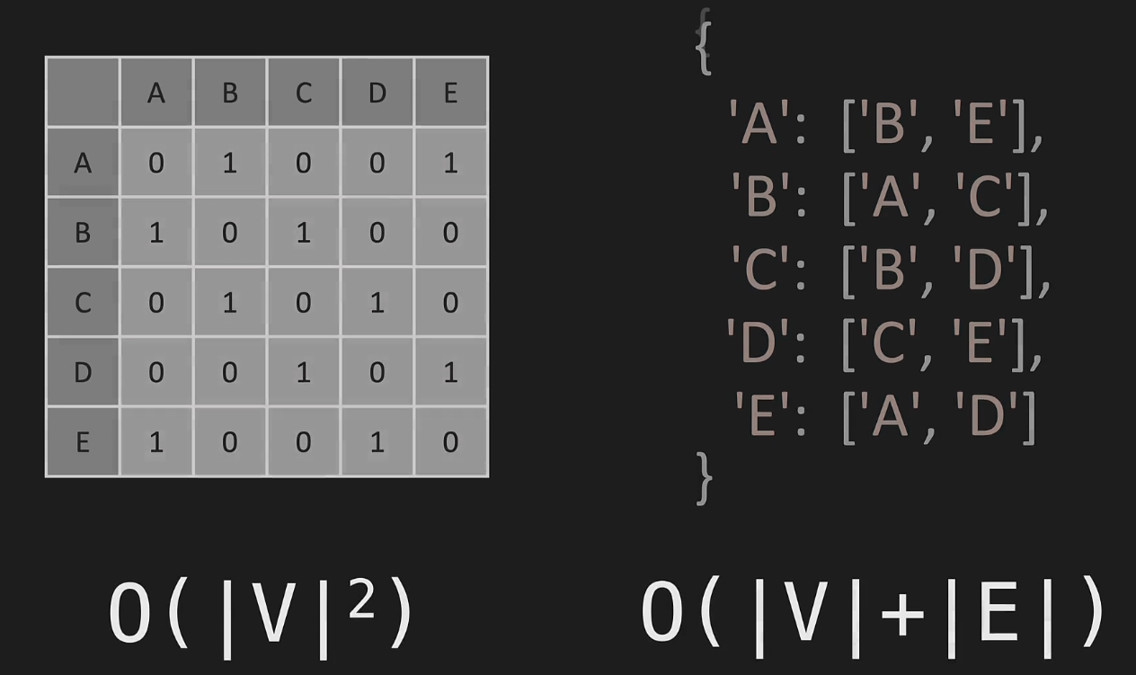

Adding a new vertex F, with no edges:
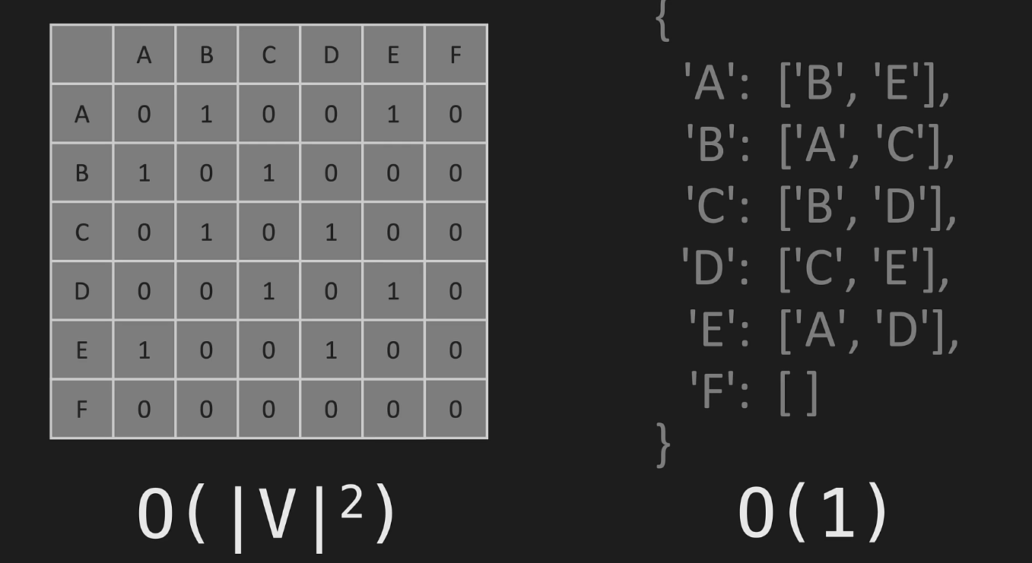
Matrix needs to be re-written with the new row and column
List needs to add a new key in the dictionary

Adding Edges for the new vertex
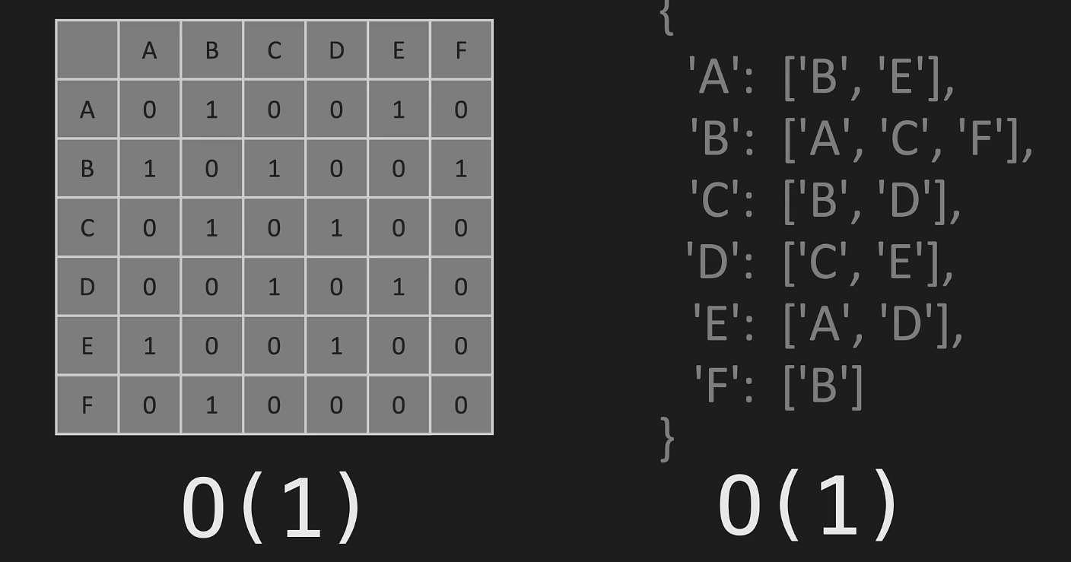
Bidirectional edge between B and E
Matrix - Just need to update the correct index in the matrix
List - append to the correct key’s list

Removing the edge
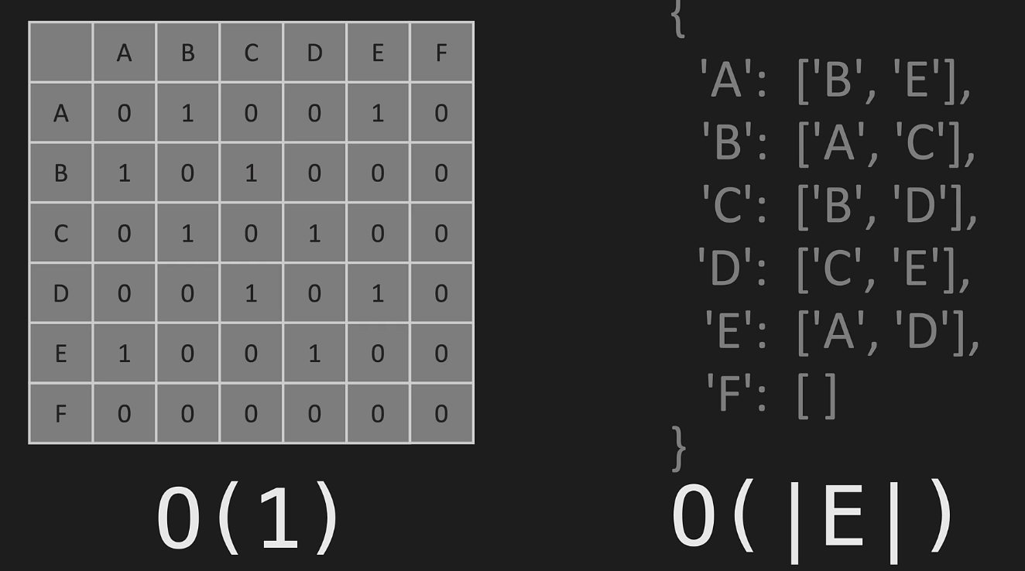
Matrix – update the correct index
List – Find the edge in the list of the key and then remove. Worst case need to traverse the whole list of E edges

Removing the Vertex
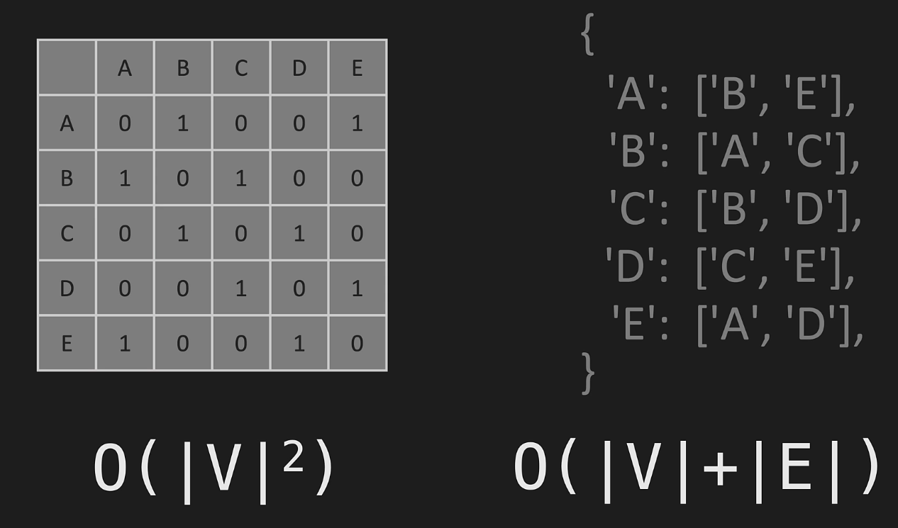
Rewriting the matrix and the list
Add Vertex
- def add_vertex(self, vertex):
- if vertex not in self.adj_list:
- self.adj_list[vertex] = []
- return True
- return False

The method takes a parameter vertex, which is the new vertex to be added to the graph.
The method first checks if the vertex parameter is not already in the adj_list dictionary. If it is not in the dictionary, the method adds the vertex as a new key in the adj_list with an empty list as its value by setting self.adj_list[vertex] = []. The method then returns True to indicate that the vertex was successfully added to the graph.
If the vertex parameter already exists in the adj_list dictionary, the method does not add a new vertex and returns False to indicate that the vertex was not added to the graph.
Overall, this method ensures that the graph is not created with duplicate vertices and returns a boolean value to indicate whether the vertex was successfully added or not.

Add Edge
- def add_edge(self, v1, v2):
- if v1 in self.adj_list and v2 in self.adj_list:
- self.adj_list[v1].append(v2)
- self.adj_list[v2].append(v1)
- return True
- return False

The purpose of this method is to add a new edge between two vertices in the graph's adjacency list. The method takes two parameters v1 and v2, which are the vertices that the edge should be added between.
The method first checks if both v1 and v2 are present in the adj_list dictionary by checking if they are keys in the dictionary using the in keyword.
If both vertices are present in the dictionary, the method appends v2 to the list of adjacent vertices for v1 using the append() method on the adj_list[v1] list. It then appends v1 to the list of adjacent vertices for v2 using the append() method on the adj_list[v2] list. This updates the adjacency list of both vertices to include the new edge.
The method then returns True to indicate that the edge was successfully added to the graph. If either v1 or v2 is not in the adj_list dictionary, the method does not add the edge and returns False to indicate that the edge was not added to the graph.
Overall, this method ensures that the graph is only updated with valid edges between existing vertices, and it returns a boolean value to indicate whether the edge was successfully added or not.

Remove edge
- def remove_edge(self, v1, v2):
- if v1 in self.adj_list and v2 in self.adj_list:
- try:
- self.adj_list[v1].remove(v2)
- self.adj_list[v2].remove(v1)
- except ValueError:
- pass
- return True
- return False

The method takes two parameters v1 and v2, which are the vertices that the edge should be removed between.
The method first checks if both v1 and v2 are present in the adj_list dictionary by checking if they are keys in the dictionary using the in keyword.
If both vertices are present in the dictionary, the method attempts to remove v2 from the list of adjacent vertices for v1 using the remove() method on the adj_list[v1] list. It then attempts to remove v1 from the list of adjacent vertices for v2 using the remove() method on the adj_list[v2] list. This updates the adjacency list of both vertices to remove the specified edge.

Remove Vertex
- def remove_vertex(self, vertex):
- if vertex in self.adj_list:
- for other_vertex in self.adj_list[vertex]:
- self.adj_list[other_vertex].remove(vertex)
- del self.adj_list[vertex]
- return True
- return False

The remove_vertex method removes a vertex from the graph along with all edges connected to it. The method takes a single parameter, vertex, which is the name of the vertex to be removed.
The method first checks whether the vertex to be removed is actually in the graph by checking if it is a key in the adj_list dictionary.
If the vertex is in the graph, it then loops over all vertices that are adjacent to the vertex to be removed using a for loop. For each adjacent vertex, it then removes the vertex to be removed from the list of adjacent vertices by calling the remove() method on the adj_list[other_vertex] list. This step ensures that all edges connected to the vertex being removed are also removed from the graph.
After removing all the edges, the method removes the vertex itself from the adj_list dictionary using the del statement.
Finally, it returns True to indicate that the vertex was successfully removed from the graph.
If the vertex is not in the graph, the method returns False to indicate that no removal occurred.

