Heaps
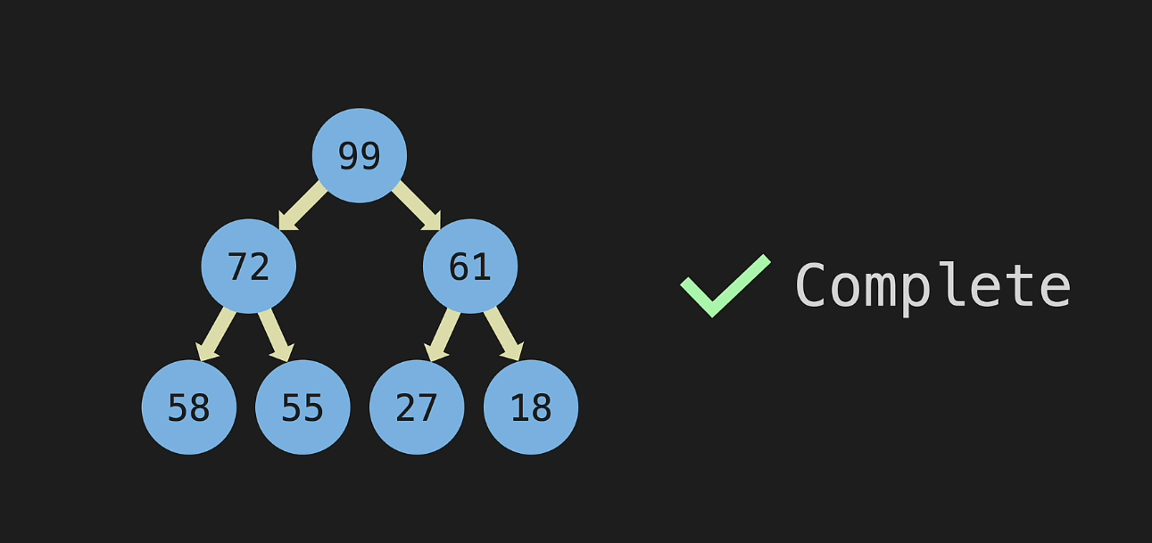
It is a binary tree.
It is complete, i.e. we start filling the nodes at a level from left without gaps moving towards right.
There are 2 types: max heap and min heap
Max heap: the parent node has a value greater than its children
Min heap: the parent node has a value smaller than its children
Heaps are good to keep track of the largest/smallest value stored and is not good for search like BST because, in the above picture, 72 can be swapped with 61 and it won’t make a difference. Similarly, 55 can be swapped with 61 and it will still be a valid max heap.
Stored in a list, preferably starting from index 1 as it makes the math easy.
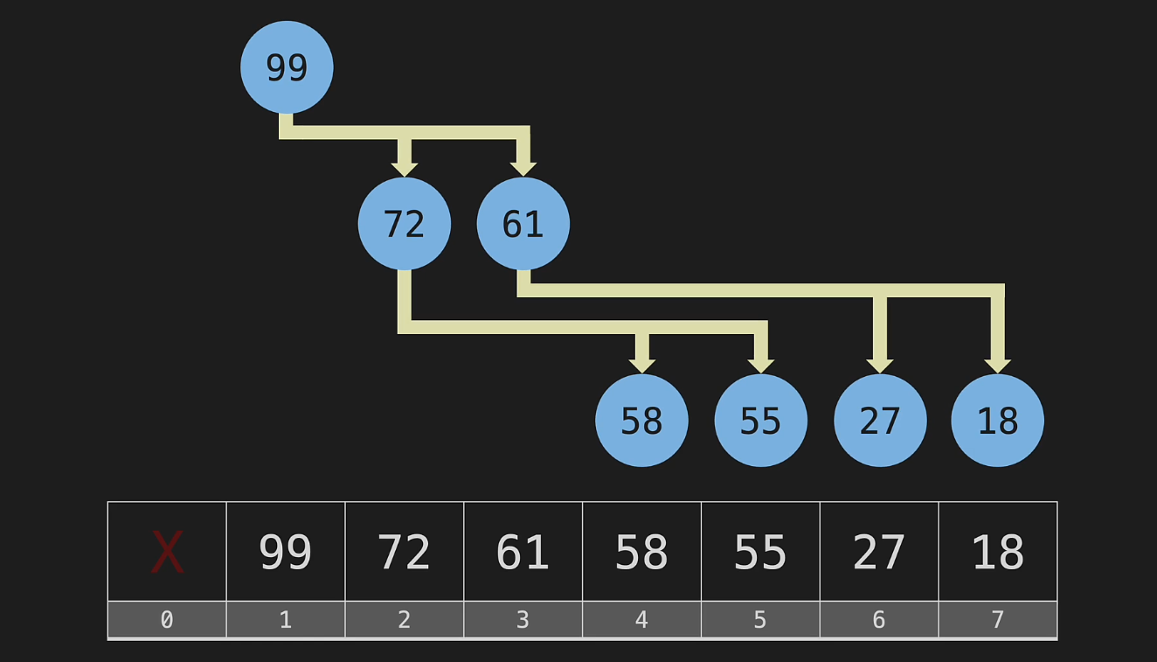
Formula to find index of children of a given node:
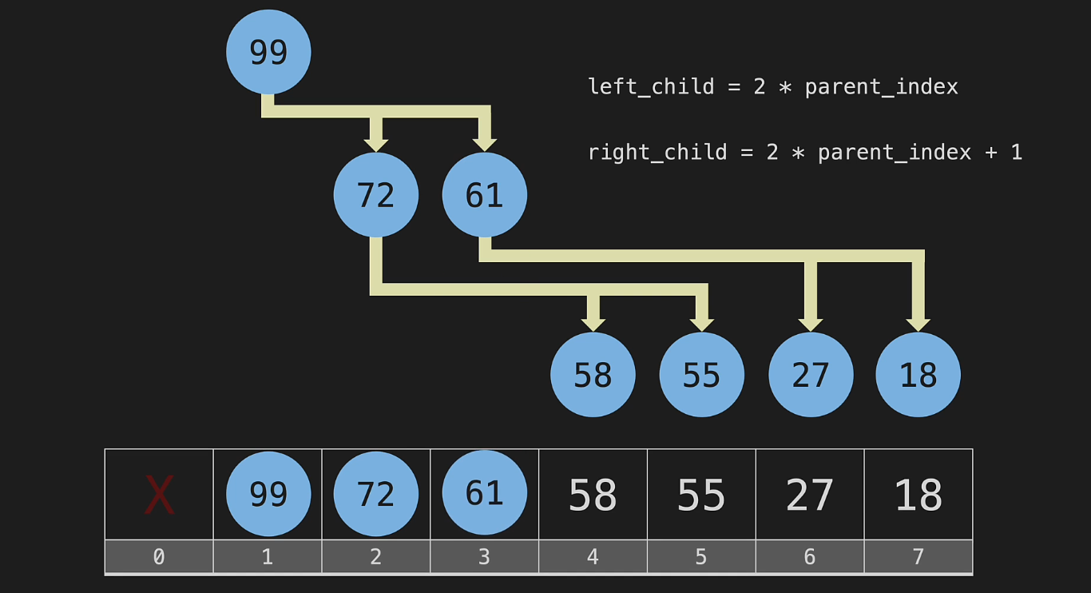

Formula to find parent of a node:
Divide index with 2. Discard decimal values.
Eg 6/2 is 3, 7/2 is 3.5 -> 3, parent of 6 and 7 is 3

Priority Queue, which data structure to use?
LL
List
HT
BST – O(
Heap – O(logn)

