Flow Control
Stop and Wait Protocol | Stop and Wait ARQ
It assumes that the communication channel is perfect and noise free. | It assumes that the communication channel is imperfect and noisy.
Data packet sent by the sender can never get corrupt. | Data packet sent by the sender may get corrupt.
There is no concept of negative acknowledgements. | A negative acknowledgement is sent by the receiver if the data packet is found to be corrupt.
There is no concept of time out timer. | Sender starts the time out timer after sending the data packet.
There is no concept of sequence numbers. | Data packets and acknowledgements are numbered using sequence numbers.

Aspect/Property | Stop and Wait ARQ | Go Back N | Selective Repeat | Remarks
Efficiency | 1 / (1+2a) | N / (1+2a) | N / (1+2a) | Go back N and Selective Repeat gives better efficiency than Stop and Wait ARQ.
Window Size | Sender Window Size = 1  Receiver Window Size = 1 | Sender Window Size = N  Receiver Window Size = 1 | Sender Window Size = N  Receiver Window Size = N | Buffer requirement in Selective Repeat is very large.  If the system does not have lots of memory, then it is better to choose Go back N.
Minimum number of sequence numbers required | 2 | N+1 | 2 x N | Selective Repeat requires large number of bits in sequence number field.
Retransmissions required if a packet is lost | Only the lost packet is retransmitted | The entire window is retransmitted | Only the lost packet is retransmitted | Selective Repeat is far better than Go back N in terms of retransmissions required.
Bandwidth Requirement | Bandwidth requirement is Low | Bandwidth requirement is high because even if a single packet is lost, entire window has to be retransmitted.  Thus, if error rate is high, it wastes a lot of bandwidth. | Bandwidth requirement is moderate | Selective Repeat is better than Go back N in terms of bandwidth requirement.
CPU usage | Low | Moderate | High due to searching and sorting required at sender and receiver side | Go back N is better than Selective Repeat in terms of CPU usage.
Level of difficulty in Implementation | Low | Moderate | Complex as it requires extra logic and sorting and searching | Go back N is better than Selective Repeat in terms of implementation difficulty.
Acknowledgements | Uses independent acknowledgement for each packet | Uses cumulative acknowledgements (but may use independent acknowledgements as well) | Uses independent acknowledgement for each packet | Sending cumulative acknowledgements reduces the traffic in the network but if it is lost, then the ACKs for all the corresponding packets are lost.
Type of Transmission | Half duplex | Full duplex | Full duplex | Go back N and Selective Repeat are better in terms of channel usage.

2. Error Control
CRC - Cycle Redundancy Check
Rules for CRC
Rule-01:

- It should not be divisible by x.
- This condition guarantees that all the burst errors of length equal to the length of polynomial are detected.

Rule-02:

- It should be divisible by x+1.
- This condition guarantees that all the burst errors affecting an odd number of bits are detected.

Important Notes-

If the CRC generator is chosen according to the above rules, then-
- CRC can detect all single-bit errors
- CRC can detect all double-bit errors provided the divisor contains at least three logic 1’s.
- CRC can detect any odd number of errors provided the divisor is a factor of x+1.
- CRC can detect all burst error of length less than the degree of the polynomial.
- CRC can detect most of the larger burst errors with a high probability.
Refer Formula Notes

Access Control
CSMA/CD
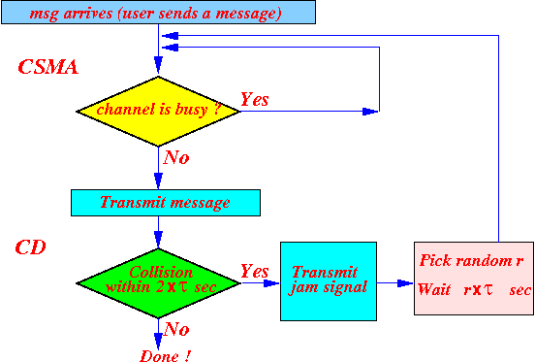

Switching

Routing

IPv4
216.27.61.137 = 11011000.00011011.00111101.10001001

Classes
Class A
2^8 is 256 Networks
2^24 is 1, 67, 77, 216 hosts/subnets
24+8=32
Used for large organizations, e.g., CISCO.
x.x.x.x/8 – default mask of 8-bits in Network.
1st bit is ﬁxed to 0 and 2 special addresses are ﬁxed (first and last),
- therefore 2^7 (8-1 as first bit is fixed) Networks
- 2^24– 2 hosts (-2 for start and end address)
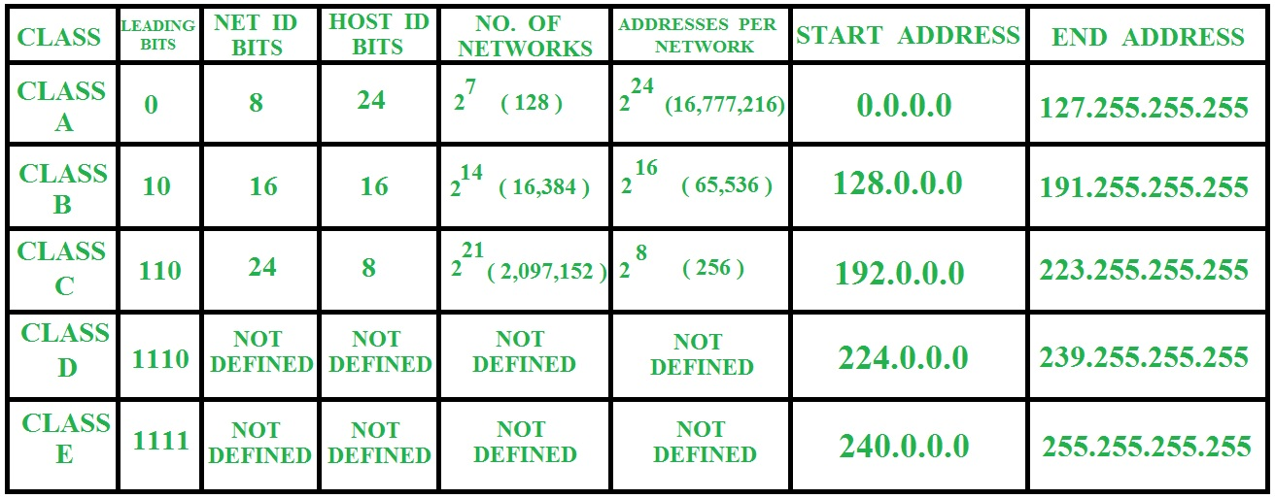
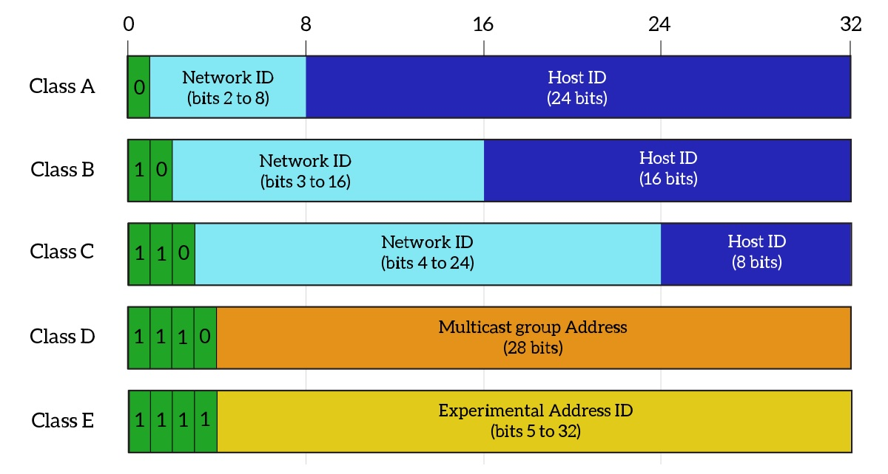

Subnetting

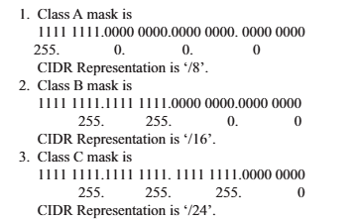

First Address/ Network Address
The ﬁrst address in the block can be found by setting the (32-n) right most bits in the binary notation of the address to Zeros.
Alternatively, the ﬁrst address can be found by ANDing the given address with the mask.
Address: 11010001.00010001.00100110.00101000
Mask : 11111111.11111111.11111111.11110000

Last address/Broadcast Address/Limited Broadcast Address
The last address in the block can be found by setting the (32 – n) right most bits in the binary notation of the address to 1’s.
Another way to ﬁnd the last address is by OR-ing the given address with the complement of the mask.

Total Number of Addresses
The number of addresses in the block is the difference between the last and ﬁrst address.
It can be found using formula 2^(32-n)
The number of addresses can also be found by complementing the mask, interpreting it as a decimal number, and adding 1 to it.
Mask Complement:
00000000.00000000.00000000.00001111
Number of addresses: 15 + 1 = 16
(complement of a number is found by changing each 1 to 0 and each 0 to 1)
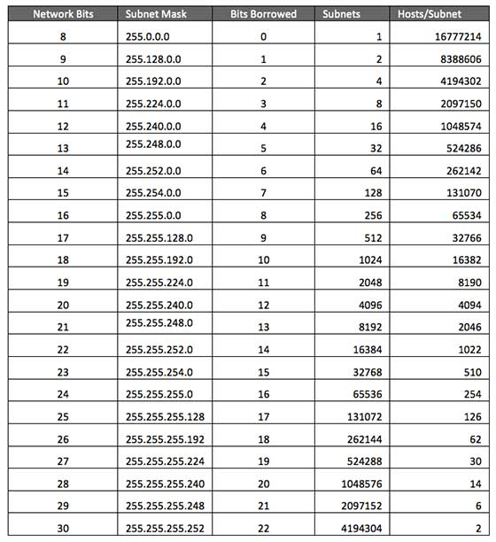

IPv4 Header

TCP

Application Layer
 | DNS | HTTP | SMTP | POP | FTP
Stateful / Stateless | Stateless | Stateless | Stateless | Stateful | Stateful
Transport Protocol Used | UDP | TCP | TCP | TCP | TCP
Connectionless / Connection Oriented | Connectionless | Connectionless | Connection Oriented | Connection Oriented | Connection Oriented
Persistent / Non-persistent | Non-persistent | HTTP 1.0 is non-persistent.  HTTP 1.1 is persistent. | Persistent | Persistent | Control connection is persistent.  Data connection is non-persistent.
Port Number Used | 53 | 80 | 25 | 110 | 20 for data connection.  21 for control connection.
In band / Out-of-band | In band | In band | In band | In band | Out-of-band

Network Security

