Stack:
LIFO – Last In, First Out

Used in web browser, to go the previous sites

Data structure that can be used
- List: pop and push on the end O(1)
- LinkedList: pop and push on the beginning O(1)
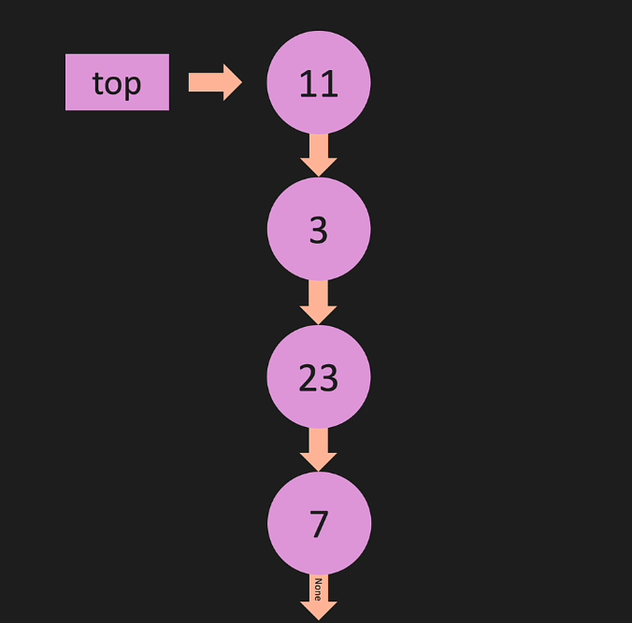
Stack: Constructor
Create a Stack class that represents a last-in, first-out (LIFO) data structure using a linked list implementation.
The Stack class should contain the following components:
- A Node class, which serves as the building block for the linked list. The Node class should have an __init__ method that initializes the following attributes:
  - value: The value of the node.
  - next: A reference to the next node in the list, initialized to None.
- The Stack class should have an __init__ method that initializes the stack with a single node, using the given value. The __init__ method should perform the following tasks:
  - Create a new instance of the Node class using the provided value.
  - Set the top attribute of the Stack class to point to the new node.
  - Initialize a height attribute for the Stack class, which represents the current number of nodes in the stack, and set it to 1.

Stack: Push
Implement the push method for the Stack class that adds a new node with a given value to the top of the stack.
The method should perform the following tasks:
- Create a new instance of the Node class using the provided value.
- Set the next attribute of the new node to point to the current top node.
- Update the top attribute of the Stack class to point to the new node.
- Increment the height attribute of the Stack class by 1.
- def push(self, value):
- new_node = Node(value)
- new_node.next = self.top
- self.top = new_node
- self.height += 1

Stack: Pop
Implement the pop method for the Stack class that removes the top node from the stack and returns it.
The method should perform the following tasks:
- If the stack is empty (i.e., the height is 0), return None.
- Store a reference to the current top node in a temporary variable, temp.
- Update the top attribute of the Stack class to point to the next node in the stack.
- Set the next attribute of the removed node (stored in the temporary variable) to None.
- Decrement the height attribute of the Stack class by 1.
- Return the removed node (stored in the temporary variable).

Queue:
FIFO: First in, First out

Enqueue

Dequeue


Data Structure usable:
List:
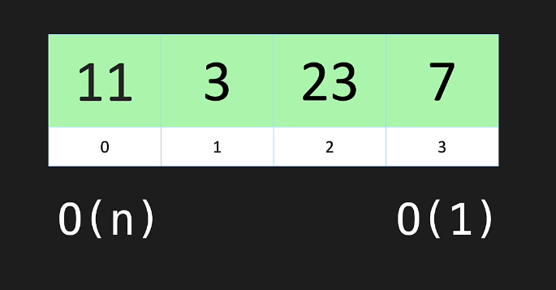

LinkedList:
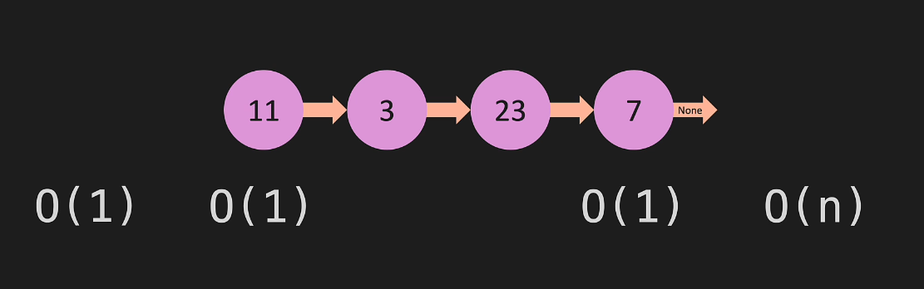

Enqueue from last and dequeue from first
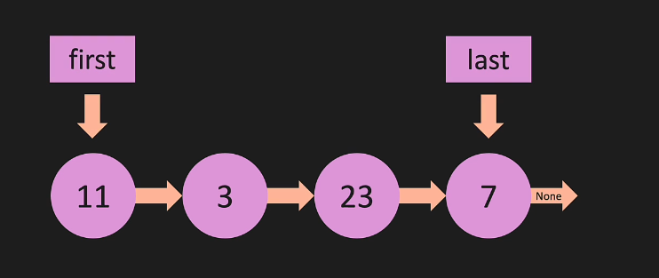
Queue: Constructor
Create a Queue class that represents a first-in, first-out (FIFO) data structure using a linked list implementation.
The Queue class should contain the following components:
- A Node class, which serves as the building block for the linked list. The Node class should have an __init__ method that initializes the following attributes:
  - value: The value of the node.
  - next: A reference to the next node in the list, initialized to None.
- The Queue class should have an __init__ method that initializes the queue with a single node, using the given value. The __init__ method should perform the following tasks:
  - Create a new instance of the Node class using the provided value.
  - Set the first attribute of the Queue class to point to the new node.
  - Set the last attribute of the Queue class to point to the new node.
  - Initialize a length attribute for the Queue class, which represents the current number of nodes in the queue, and set it to 1.

Queue: Enqueue
Implement the enqueue method for the Queue class that adds a new node with a given value to the end of the queue.
The method should perform the following tasks:
- Create a new instance of the Node class using the provided value.
- If the queue is empty (i.e., self.first is None), set the first and last attributes of the Queue class to point to the new node.
- If the queue is not empty, perform the following steps:
  - Set the next attribute of the current last node to point to the new node.
  - Update the last attribute of the Queue class to point to the new node.
- Increment the length attribute of the Queue class by 1.

Queue: Dequeue
Implement the dequeue method for the Queue class that removes the first node from the queue and returns it.
The method should perform the following tasks:
- If the queue is empty (i.e., the length is 0), return None.
- Store a reference to the current first node in a temporary variable, temp.
- If the queue has only one node (i.e., the length is 1), set both the first and last attributes of the Queue class to None.
- If the queue has more than one node, perform the following steps:
  - Update the first attribute of the Queue class to point to the next node in the queue.
  - Set the next attribute of the removed node (stored in the temporary variable) to None.
- Decrement the length attribute of the Queue class by 1.
- Return the removed node (stored in the temporary variable).

