PROJECT REPORT

ON

**STUDENT REGISTRATION SYSTEM**

*Submitted to*

**NMAM INSTITUTE OF TECHNOLOGY, NITTE**

(Off-Campus Centre, Nitte Deemed to be University, Nitte - 574 110, Karnataka, India)

In partial fulfilment of the requirements for the award of the degree of

**Bachelor of Technology**

in

**INFORMATION SCIENCE AND ENGINEERING**

By

**SAANVI U NNM22IS133**

**SANYA SHRESTA JATHANNA NNM22IS141**

Under the guidance of

**Dr.Ravi B.**

Associate Professor

2023 - 2024



**Department of Information Science & Engineering**

### CERTIFICATE

This is to certify that **Ms. SAANVI U(NNM22IS133) and Ms. SANYA SHRESTA JATHANNA** **(NNM22IS141)** of II-year B.Tech., a bonafide student of NMAM Institute of Technology, Nitte, has carried out project on **“STUDENT REGISTRATION SYSTEM”** as part of the **Python Programming Fundamentals(IS2155-1)** course during 2023-24, fulfilling the partial requirements for the award of degree of Bachelor of Technology in Information Science and Engineering at NMAM Institute of Technology, Nitte.

..………………………...........

Signature of Course Instructor

Dr.Ravi B

Associate Professor

**ABSTRACT**

The Student Registration System is a Python-based application built using the Tkinter library for graphical user interface (GUI) development. It allows users to manage student information, including registration details, personal information, and parent details. The system provides functionalities for adding, searching, updating, and deleting student records, along with features for uploading profile pictures. Data is stored in an Excel spreadsheet format for easy access and management.

In addition to its core functionalities, the Student Registration System offers a user-friendly interface with intuitive navigation, making it accessible to users with varying levels of technical expertise. It incorporates error handling mechanisms to ensure data integrity and smooth operation. The system also includes security features to protect sensitive information, such as user authentication and authorization controls. Furthermore, it allows for customization to accommodate specific requirements or preferences, enabling seamless integration into various educational institutions or settings. With its comprehensive features and flexibility, the Student Registration System serves as a valuable tool for efficiently managing student information and enhancing administrative processes.

**LIST OF CONTENTS**

|  |  |
| --- | --- |
| **CONTENTS** | **PAGE NO.** |
| 1. **INTRODUCTION** | **1** |
| **2. ANALYSIS & REQUIREMENT SPECIFICATION** | **2** |
| **2.1 Purpose** | **2** |
| **2.2 Scope** | **2** |
| **3. IMPLEMENTATION** | **3-5** |
| **4. RESULTS** | **6** |
| **5. OUTPUT (Snapshots)** | **7-12** |
| **6. CONCLUSION** | **13** |
| **REFERENCES** |  |

**CHAPTER 1 INTRODUCTION**

The Student Registration System aims to streamline the process of managing student data within educational institutions. With a user-friendly interface, the system enables administrators to efficiently handle student information, ensuring accuracy and accessibility. The application automates tasks such as generating registration numbers, capturing essential details like name, date of birth, class, gender, and more. Additionally, it allows for the inclusion of parent information, enhancing communication and coordination between the school and parents/guardians.

The Student Registration System serves as a comprehensive solution to streamline the management of student data within educational institutions. Its user-friendly interface empowers administrators to efficiently handle student information, fostering accuracy and accessibility across all aspects of the registration process. By automating tasks such as generating registration numbers and capturing essential details like name, date of birth, class, and gender, the system significantly reduces the time and effort required for data entry and verification. Moreover, its capability to include parent information facilitates improved communication and coordination between the school and parents/guardians, thereby enhancing the overall efficiency and effectiveness of administrative operations.

**CHAPTER 2 ANALYSIS & REQUIREMENT SPECIFICATION**

**2.1 Purpose**

The primary purpose of the Student Registration System is to simplify the management of student records. By digitizing the registration process, the system reduces paperwork, minimizes errors, and enhances data organization. It provides administrators with a centralized platform to store and retrieve student information promptly. Moreover, the system offers functionalities to update and search for student records efficiently, facilitating timely updates and retrieval of relevant data. Overall, the purpose is to improve administrative efficiency, data accuracy, and user experience in handling student registration tasks.

**2.2 Scope**

The scope of the Student Registration System encompasses various aspects of student data management within educational institutions. It caters to tasks related to registering new students, updating existing records, searching for specific student details, and managing parent information. The system allows for customization to suit the specific requirements of different educational institutions, including schools, colleges, and universities. While the current implementation focuses on basic functionalities, the system can be extended to incorporate additional features such as attendance tracking, fee management, and academic performance monitoring. Additionally, the system provides flexibility for future enhancements and integration with other educational management systems.

Top of Form

**CHAPTER 3 IMPLEMENTATION**

**3.11 Module Explanation**

**Technologies Used:**

Student Registration System is built using Python and Tkinter for GUI development, along with other libraries like openpyxl for Excel file handling and PIL (Pillow) for image processing.

IDE used: IDLE Python 3.12 64-bit

**Libraries imported:**

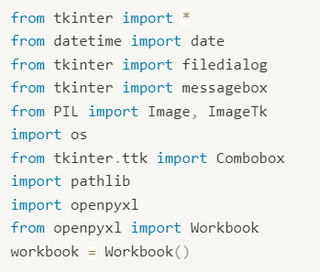

**Widgets Used(GUI Components):**

1. Labels: Used to display static text such as headings, instructions, and descriptions.
2. Entry: Used for single-line text input by the user, such as registration number, date, name, and date of birth.
3. Button: Used to trigger actions or functions, such as searching, updating, saving, resetting, and exiting.
4. Radiobutton: Used to present a set of mutually exclusive options, such as gender selection (Male/Female).
5. Combobox: Used to present a dropdown list of options, such as selecting the student's class.
6. Frame: Used to organize and group related widgets together, providing structure and visual separation.
7. Image: Used to display images within the GUI, such as logos and profile pictures.
8. LabelFrame: Similar to a Frame but with an added border and title, used to group related widgets with a title for better organization**.**

**Functionality Overview:**

* Registration of new students and Exit feature

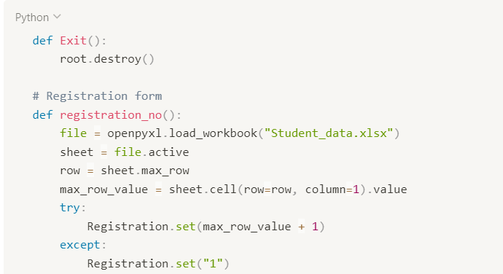

* Updating existing student records
* Uploading and displaying profile pictures
* Handling parent/guardian information
* Automatic generation of registration numbers
* Data validation and error handling
* Searching for specific student details

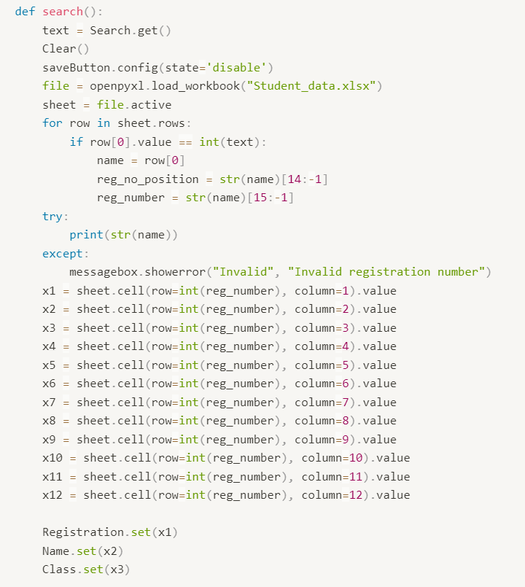

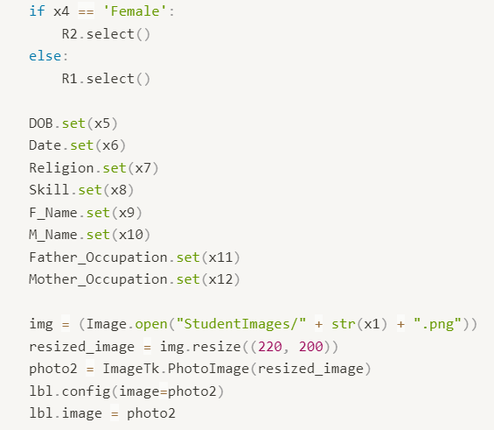

**CHAPTER 4 RESULTS**

1. Streamlined Data Management: The system simplifies student registration and data management tasks, ensuring accuracy and efficiency.

2. User-Friendly Interface: A visually appealing interface built with Tkinter offers easy navigation and accessibility for administrators.

3. Automation of Tasks: Tasks such as generating registration numbers and storing records in Excel format are automated, reducing manual errors and saving time.

4. Improved Communication: Inclusion of parent/guardian details facilitates better communication between the institution and parents/guardians.

5. Centralized Record Keeping: The system provides a centralized platform for storing and retrieving student records, ensuring data consistency and easy access.

6. Customization and Scalability: The system is customizable to meet specific institutional needs and can be scaled up for additional features or integrations.

7. Enhanced Administrative Efficiency: By streamlining processes and automating tasks, the system improves administrative efficiency and productivity.

8. Positive User Experience: The user-friendly interface, automation features, and robust data management contribute to a positive user experience for administrators.

9. Potential for Future Enhancements: The system serves as a foundation for future enhancements, allowing for the integration of additional features as educational needs evolve.

10. Overall Impact: The implementation of the Student Registration System leads to improved administrative efficiency, data accuracy, and user satisfaction within educational institutions.

**CHAPTER 5 OUTPUT**

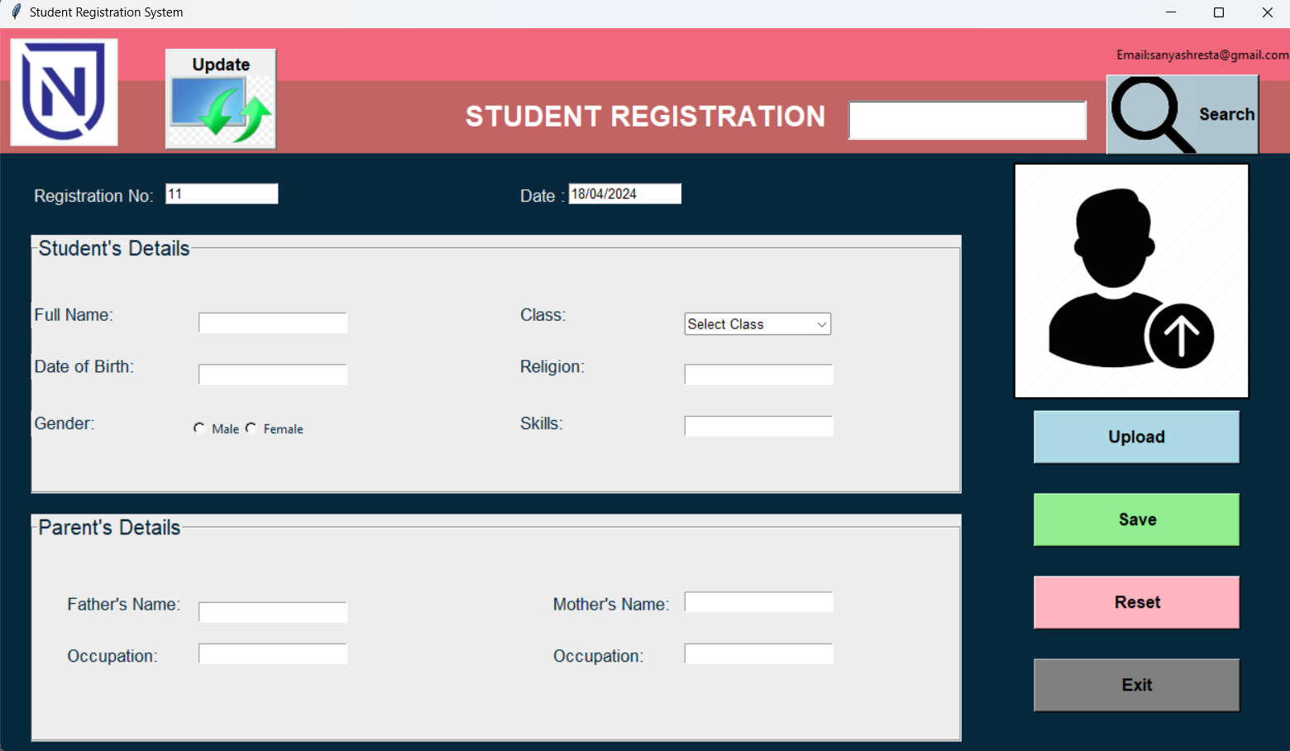

**UPLOAD IMAGE**

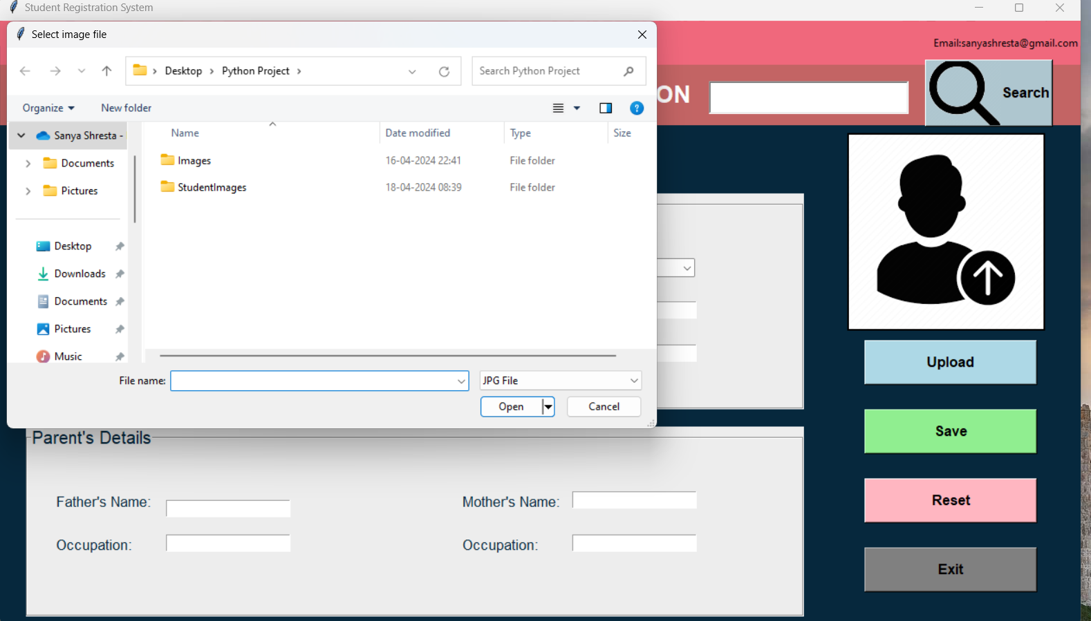

**REGISTER NEW STUDENT**

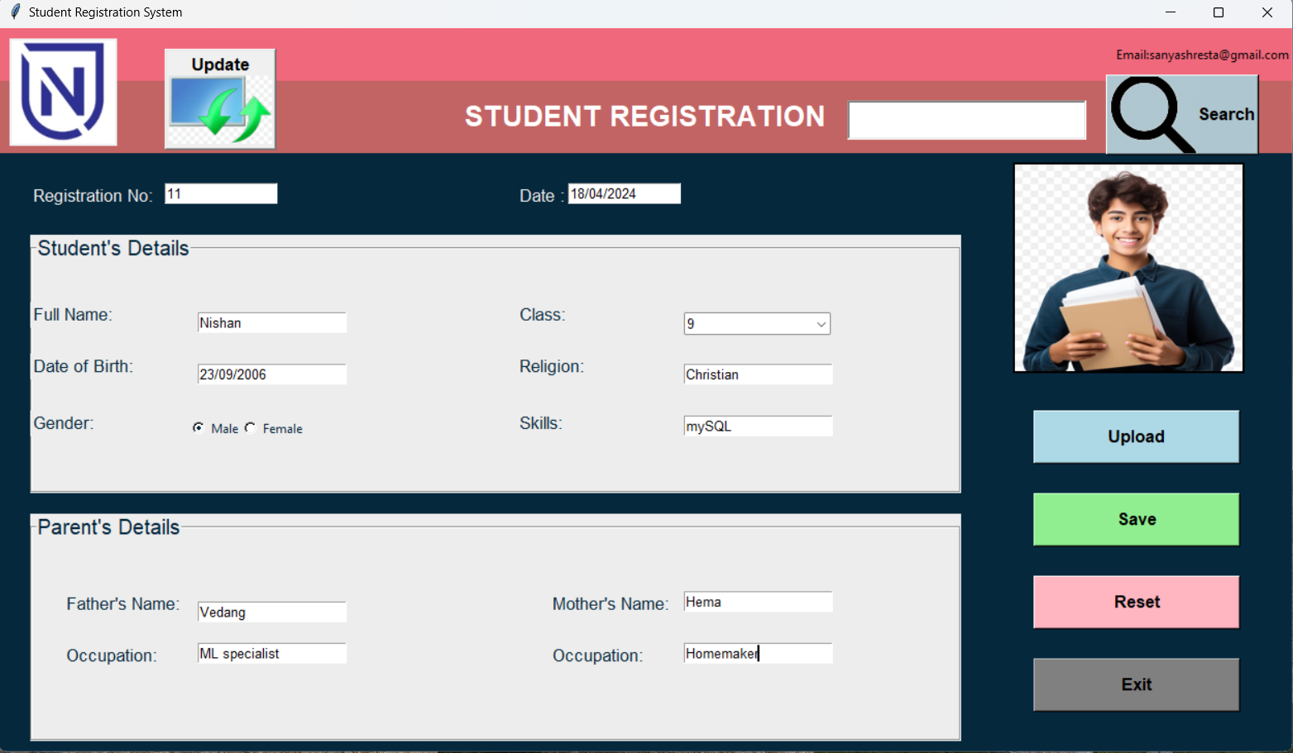

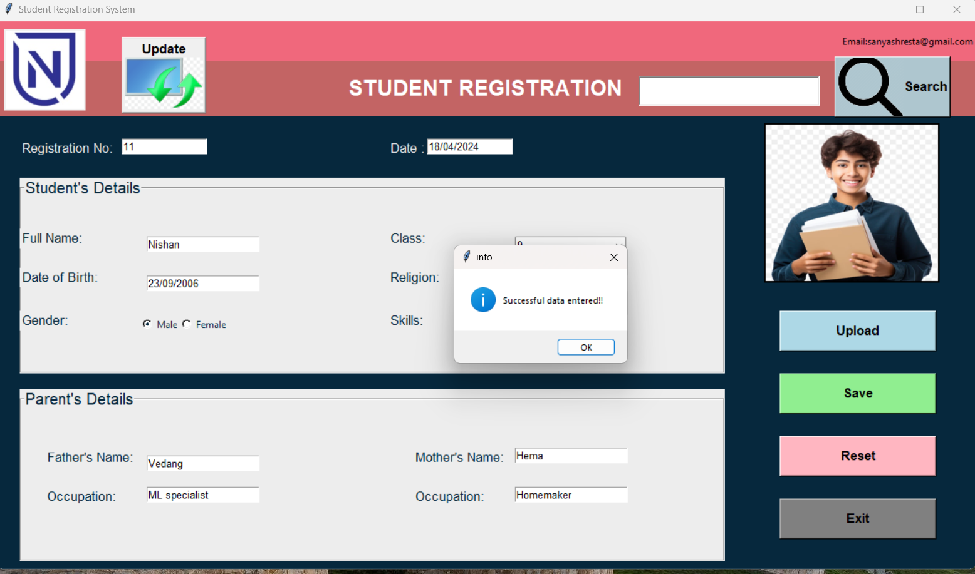

**DATA SEARCH**

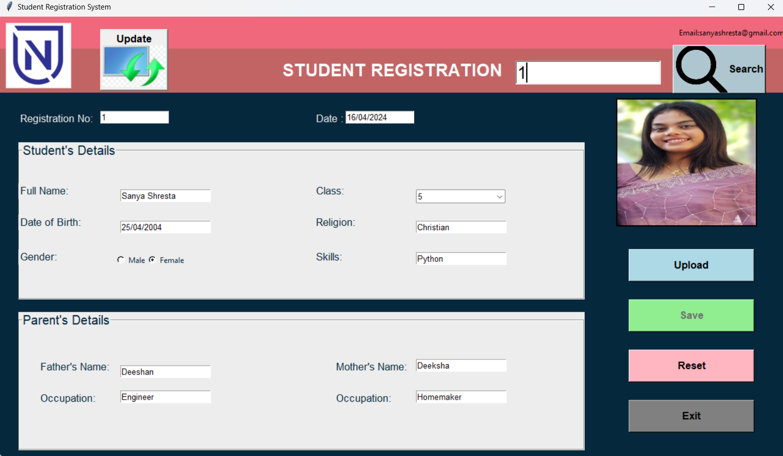

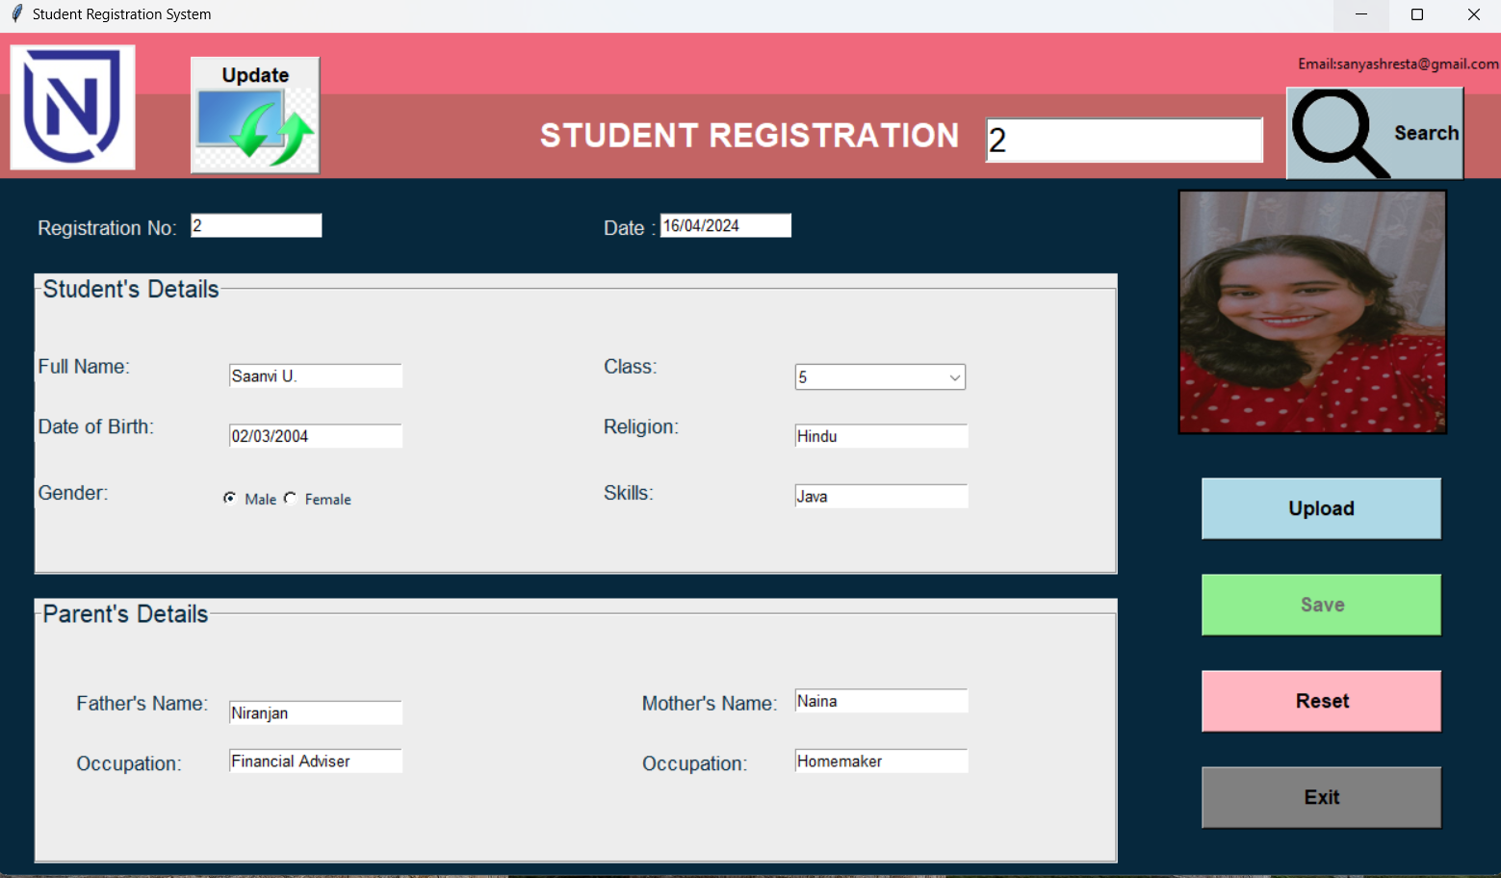

**Update Data**

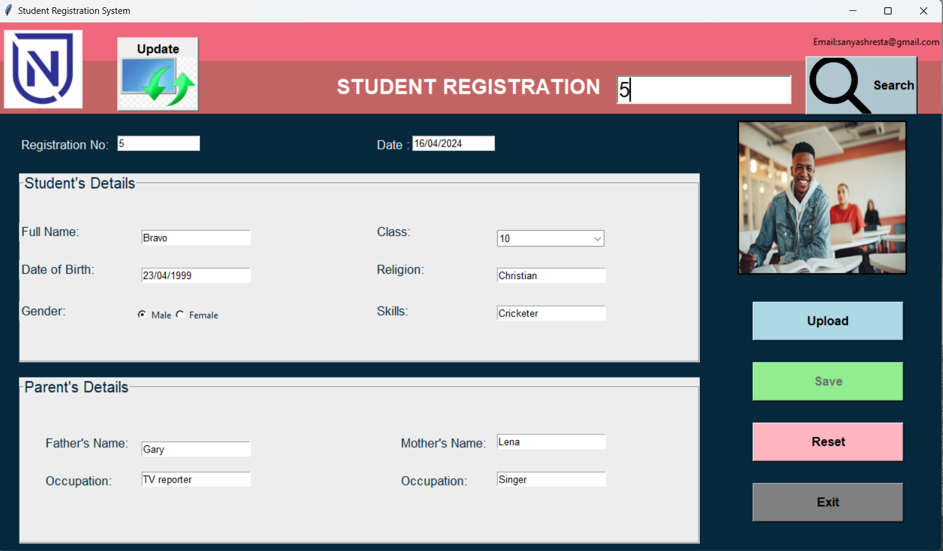

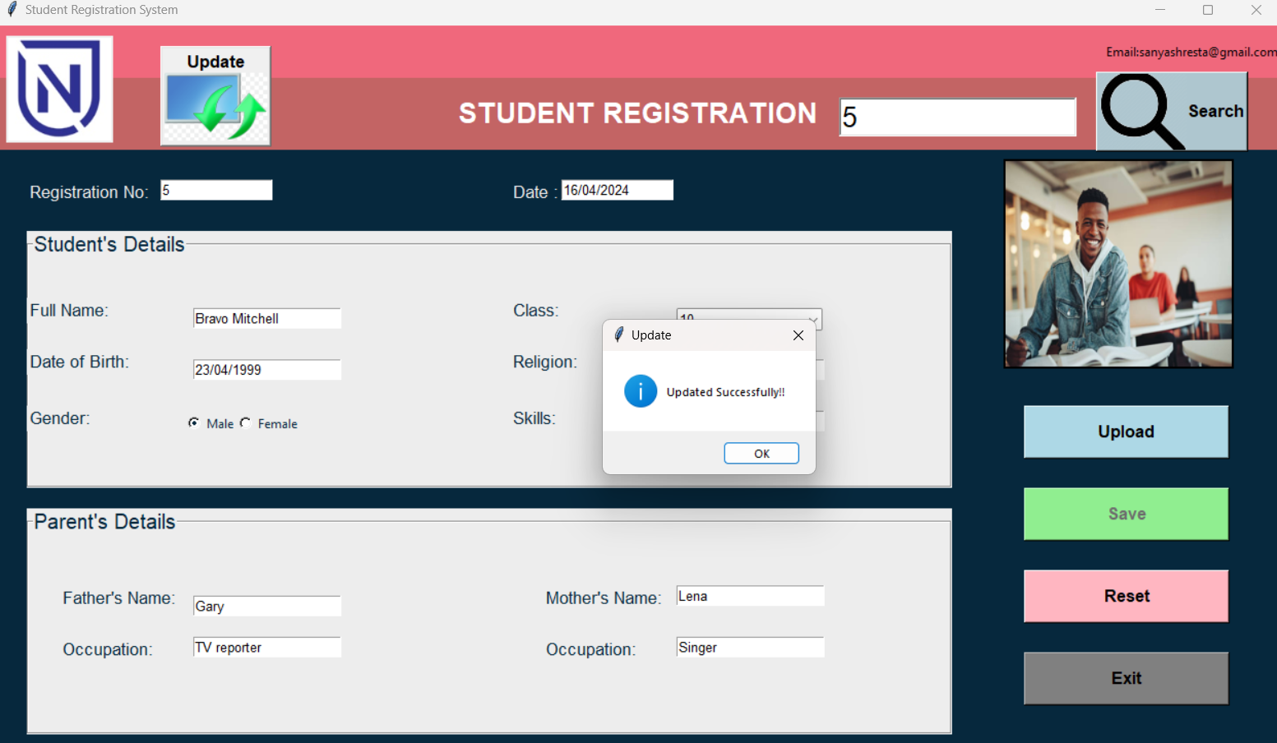

**RESET DATA**

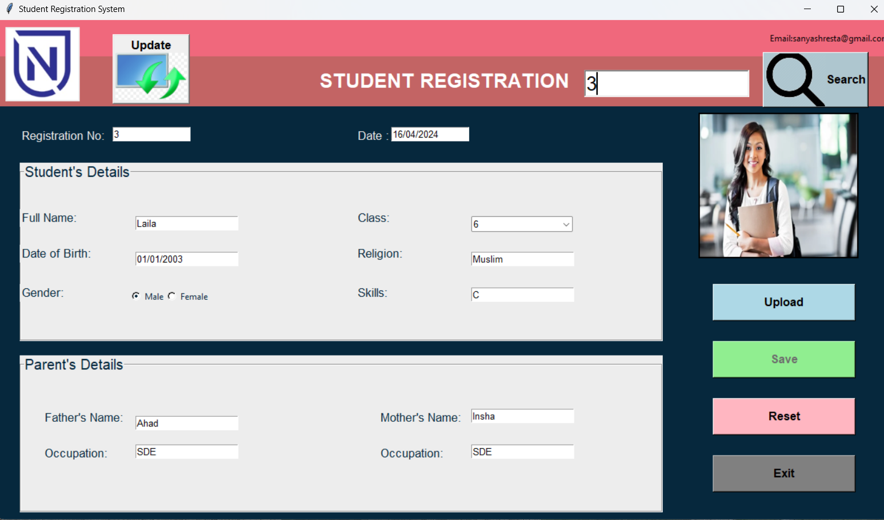

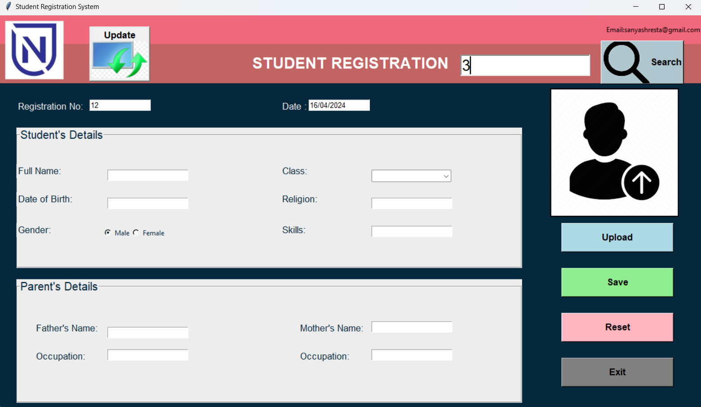

**DATA GETS STORED IN AN EXCEL SHEET(Local Database)**

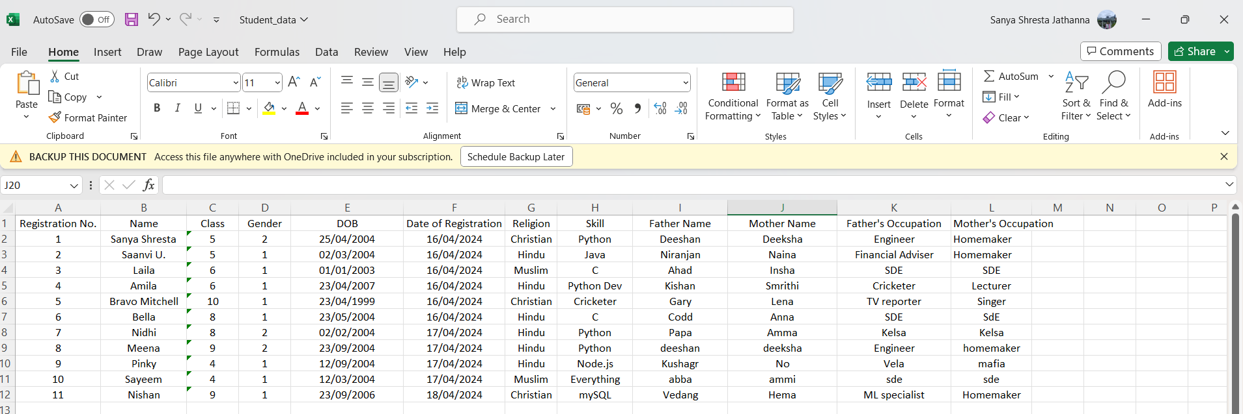

**CHAPTER 6 CONCLUSION**

In conclusion, the Student Registration System presents a robust solution for managing student data within educational institutions. By leveraging Python and Tkinter for GUI development, the system provides administrators with an intuitive platform for efficiently handling registration, updating, and retrieval of student records.

The implementation of the system showcases the effective utilization of various technologies, including openpyxl for Excel file handling and PIL (Pillow) for image processing. These technologies enable automation of tasks such as generating registration numbers, validating input data, and uploading profile pictures, thereby enhancing administrative efficiency and accuracy.

The user-friendly interface, coupled with functionalities such as search, update, and data validation, ensures a positive user experience for administrators and stakeholders involved in student management. Furthermore, the system's scalability and customization capabilities allow for adaptation to the specific needs of different educational institutions.

Overall, the Student Registration System contributes to streamlined administrative processes, improved data management, and enhanced communication between the institution and parents/guardians. As educational institutions continue to evolve, the system stands ready to accommodate future enhancements and integrations, reaffirming its significance in modern educational administration.

Top of Form

**REFERENCES**

[1] <https://youtu.be/JUGEkFDeuwg?feature=shared>

[2] <https://youtu.be/Vacelq18pnY?feature=shared>

[3] <https://youtu.be/1srjYwYYWgk?feature=shared>

[4] Learn Python Programming(2nd Edition) By Fabrizio Romano

[5] <https://www.w3schools.com/python/>