POWER BI PROJECT

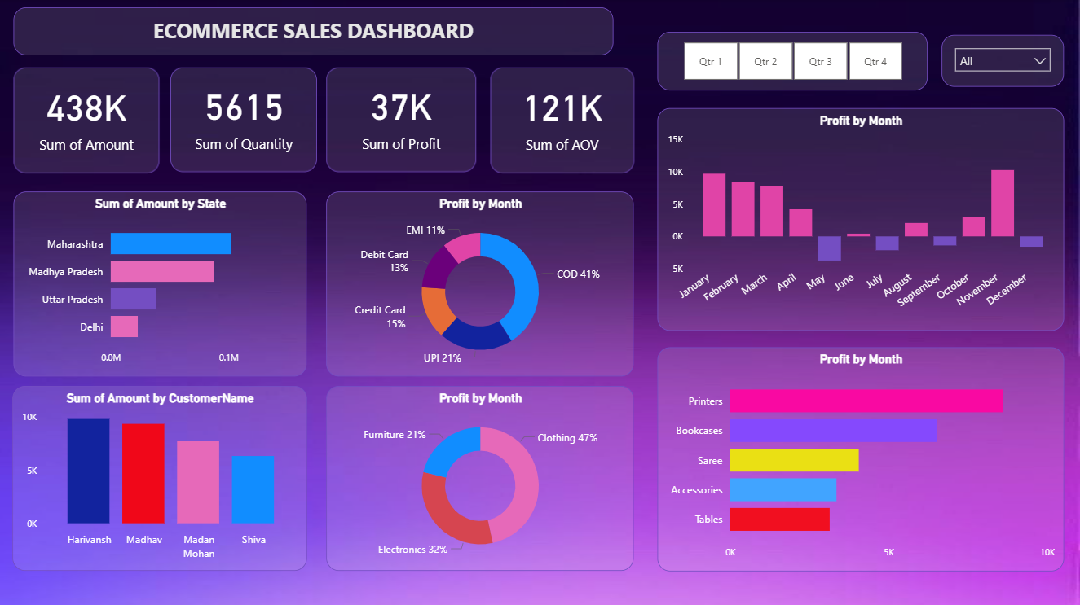

E-commerce Sales Analysis Dashboard | Power BI :
- Designed an interactive Power BI dashboard to analyze sales, profit, AOV, and customer trends
- Performed category-wise, state-wise, and monthly profit analysis using DAX measures
- Implemented slicers and filters to enable dynamic business insights
- Identified top-performing products, regions, and payment methods to support decision-making
Key Insights :
- Generated 438K in total sales revenue with 37K overall profit, indicating stable performance with scope for optimization.
- Identified Clothing as the highest-profit category, contributing nearly half of total profits, followed by Electronics and Furniture.
- Discovered Cash on Delivery (COD) as the most dominant payment mode, accounting for the largest share of profit, reflecting customer payment preferences.
- Found Maharashtra as the top-performing state in terms of sales revenue, highlighting strong regional demand concentration.
- Analyzed monthly profit trends, revealing seasonal fluctuations and loss-making periods during mid-year months.
- Recognized the impact of high-value customers on overall revenue, emphasizing the importance of customer segmentation for targeted business strategies.
Business Recommendation :
- Optimizing inventory and promotional strategies during low-profit months and encouraging digital payment methods could help improve overall profitability.

