TATA MOTORS Operations Portal
Project Implementation Report
React + Google Apps Script + Google Sheets | 15 June 2026
Idea in one line: replace manual shop-wise production reporting with a web portal that collects shift data once, calculates KPIs automatically, and generates meeting-ready Google Sheet outputs.

1. Project Idea and Need
Plant operations meetings need accurate shift-wise production, downtime, loss, and reliability data. The existing workflow was Excel-oriented, which meant repeated manual entry, formula risk, and slower admin review. The project idea was to keep the familiarity of Excel/Google Sheets for managers, while giving shop representatives a guided digital form for daily submission.
- Shop representatives enter production, downtime, failure count, hourly actuals, and loss details.
- Fixed shop values such as cycle time, shift timing, QR, and targets are controlled in code.
- The backend converts raw submissions into Loss Report, Meeting Report, and Analytical Sheet outputs.

2. How We Thought Through the Implementation
The implementation follows the real plant-meeting workflow: collect data at the source, calculate KPIs consistently, preserve raw data, and present outputs in a format that operations teams can use directly. React supports fast forms and dashboards; Apps Script sits directly on Google Sheets and automates reports without a separate server.
Step | Stage | What happens
1 | Shop representative | Logs in and enters shift-wise production, downtime, failure count, hourly actuals, and loss details.
2 | React frontend | Validates shift/date rules, calculates capacity, net downtime, OE, line efficiency, MTTR, MTBF, and performs optimistic local update.
3 | Apps Script API | Receives saveReport request, locks the script, saves or updates raw rows, and returns confirmed JSON.
4 | Google Sheets | Keeps Main Data as the hidden database and rebuilds Meeting Report, Loss Report, and Analytical Sheet as visible outputs.
5 | Admin review | Admin views dashboards, exports workbook, checks missing uploads, and receives reminders/daily Excel reports.

3. Technical Stack and Usage
React + Vite is used for the portal, Recharts for analytics, lucide-react for icons, xlsx for workbook export, localStorage for cached settings, Google Apps Script for the API layer, and Google Sheets for storage plus visible meeting/analytical outputs.

4. Main Code Screenshots
The following screenshots show only the main implementation areas: KPI calculation, validated submission/sync, and backend sheet generation.
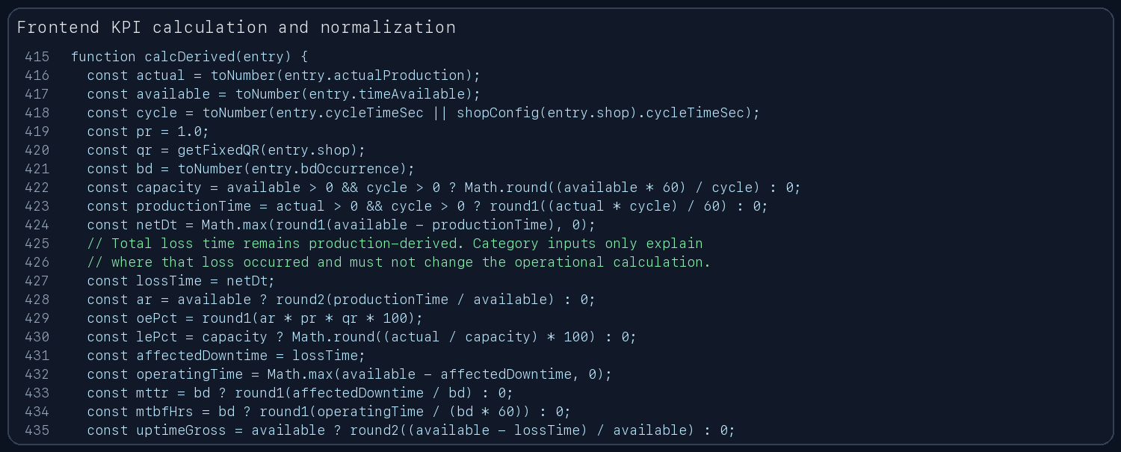
Code screenshot 1: frontend calculation of capacity, downtime, OE, line efficiency, MTTR, and MTBF.
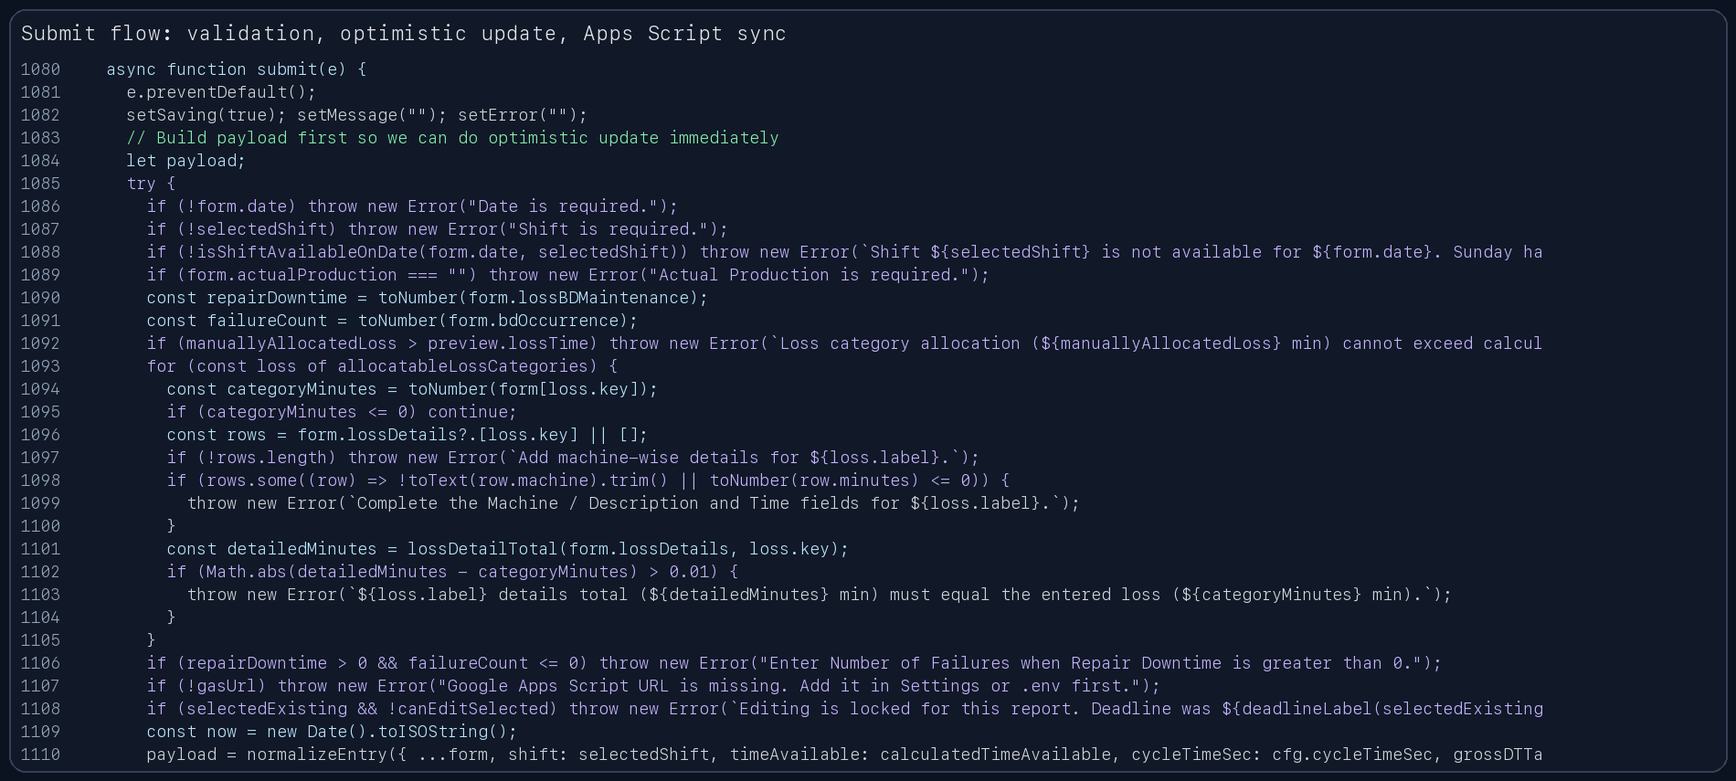
Code screenshot 2: submission flow with validation, optimistic UI update, and Google Sheets sync.

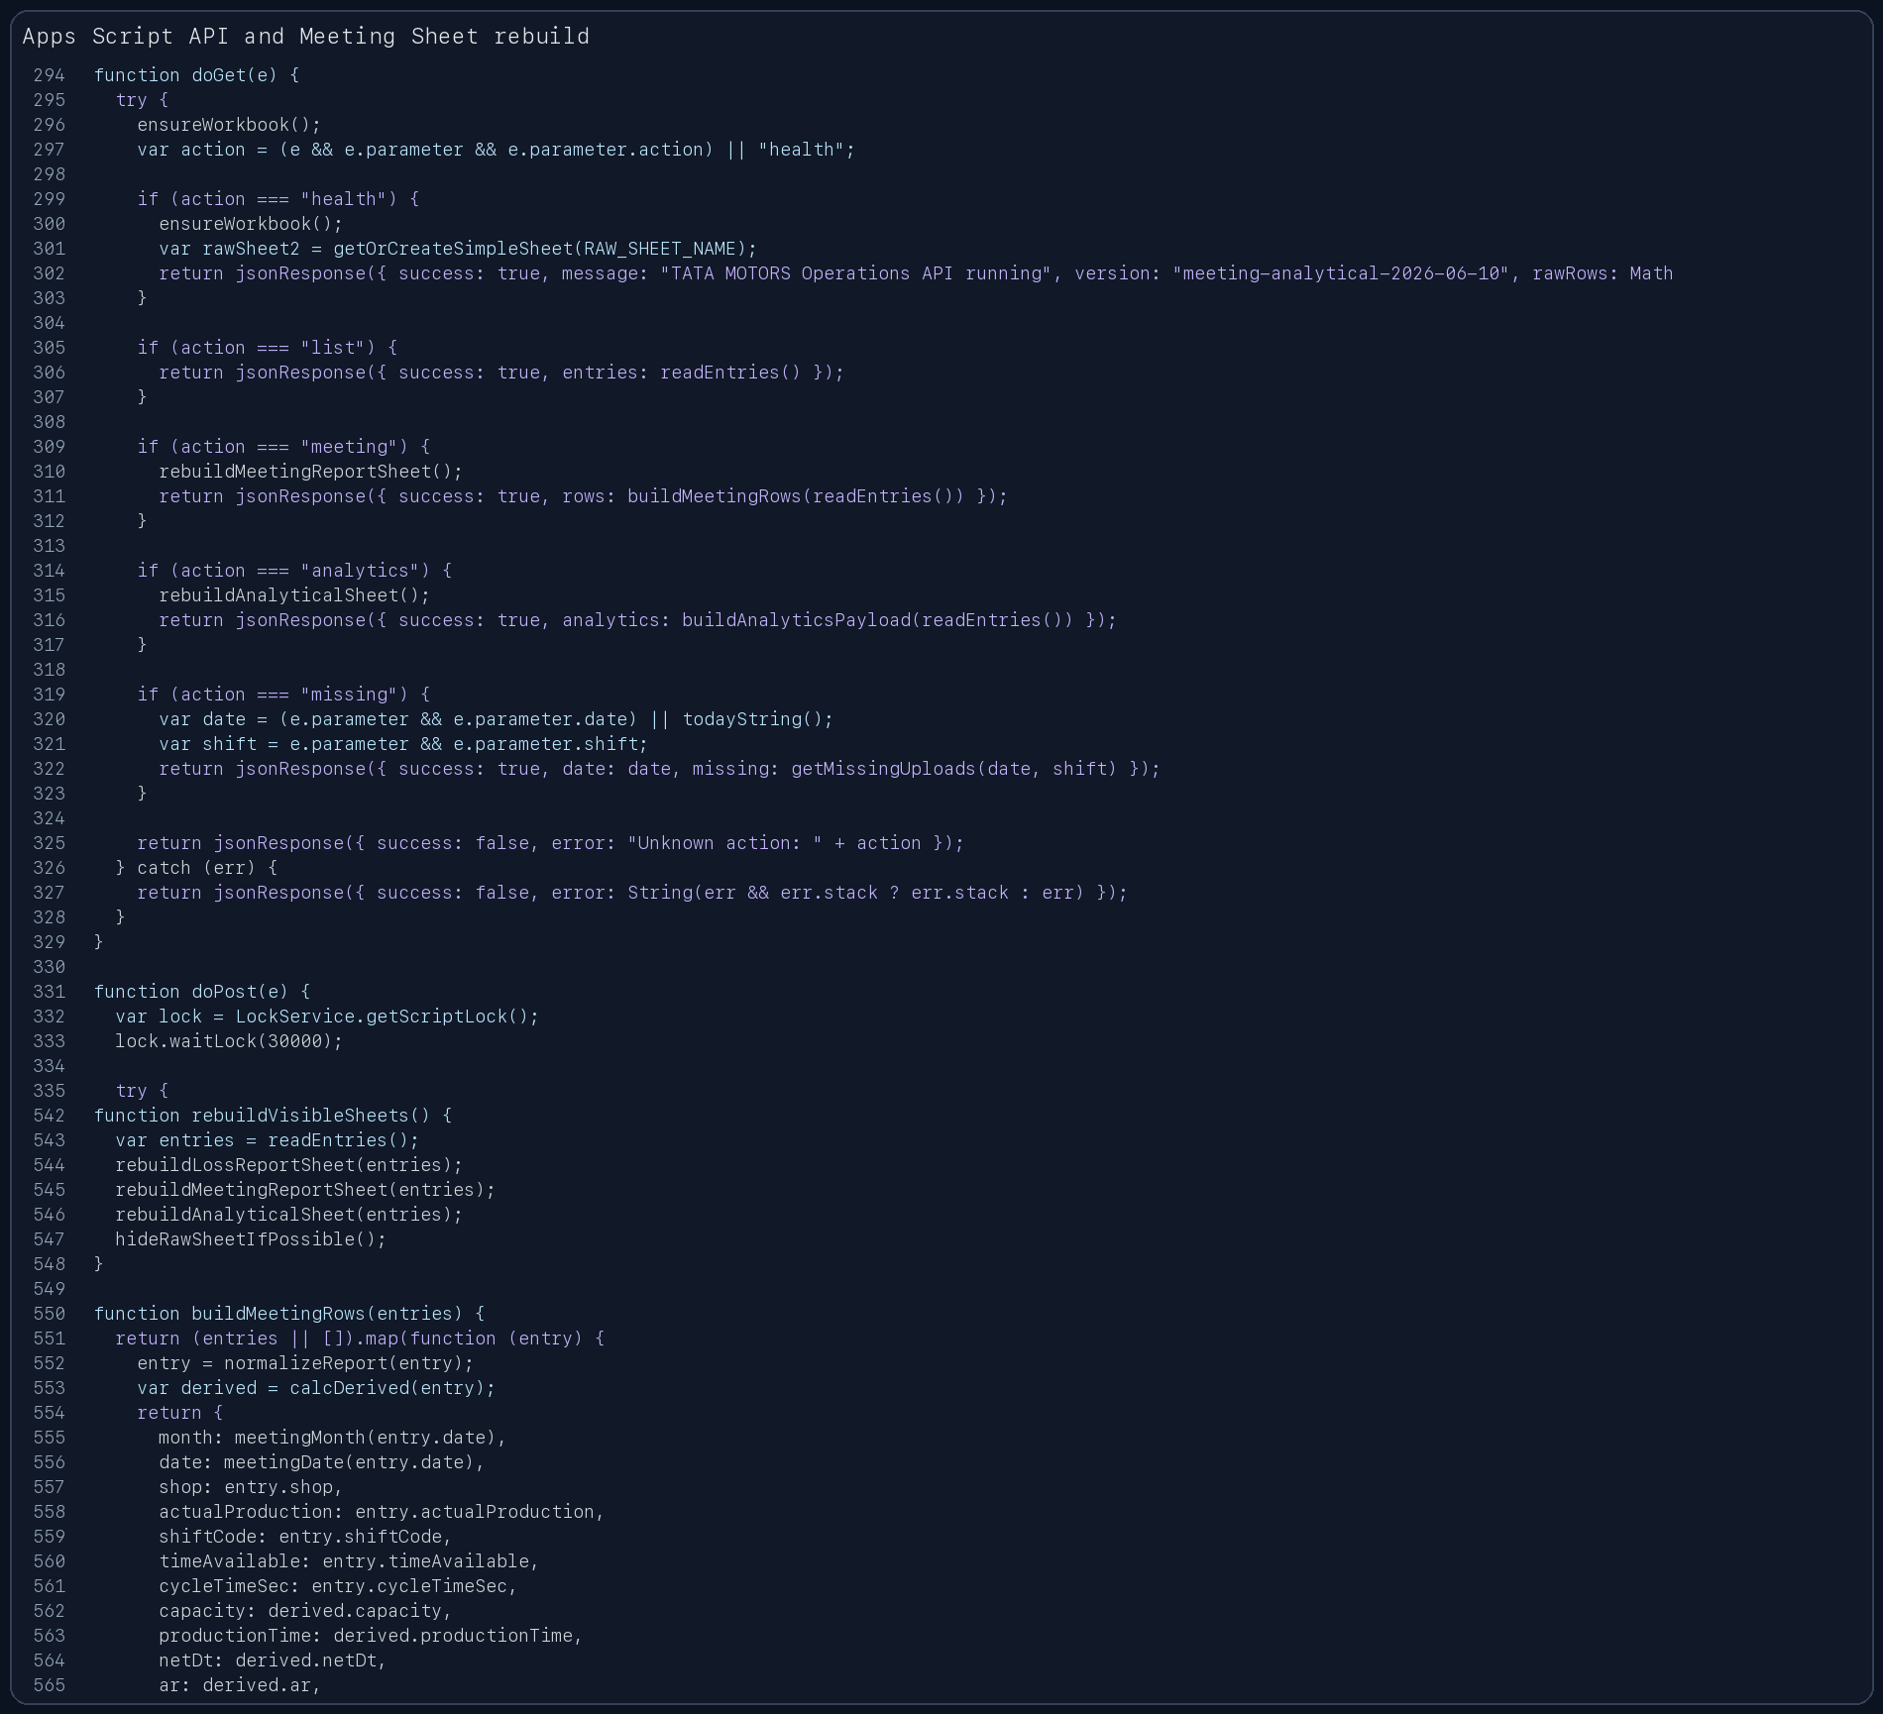
Code screenshot 3: Apps Script endpoints and visible sheet rebuilding logic.

5. Output Screenshots
The output screenshots show the working portal screens after data is available: the shop input form, the Data Store table, the block-style Loss and Meeting Data view, and the final Meeting Sheet export view.
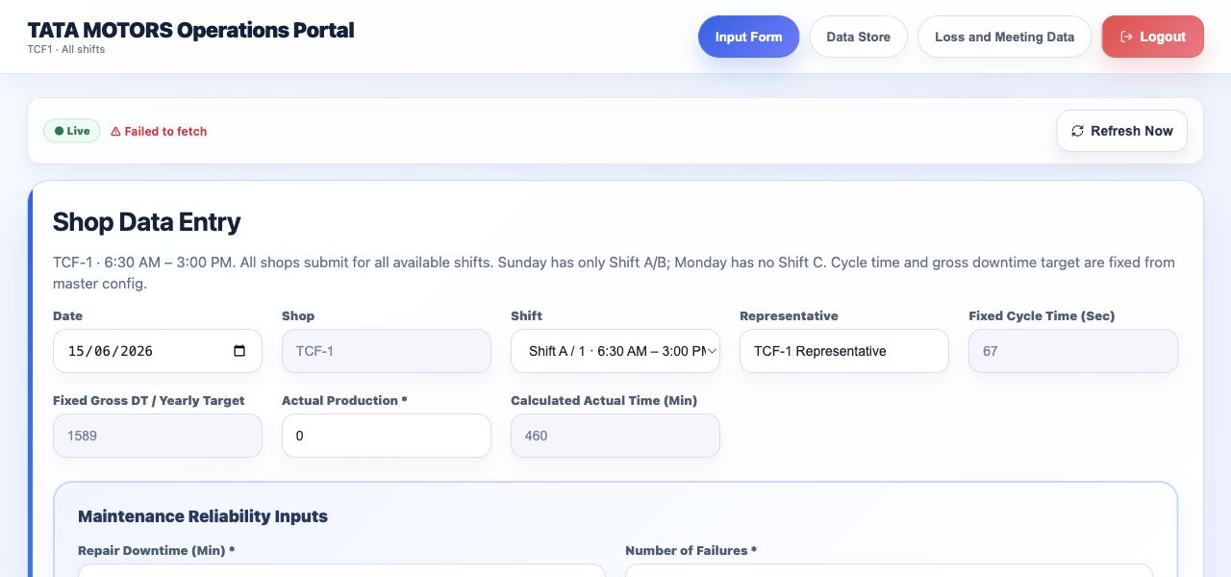
Output screenshot 1: shop data-entry form with fixed configuration and calculated actual time.
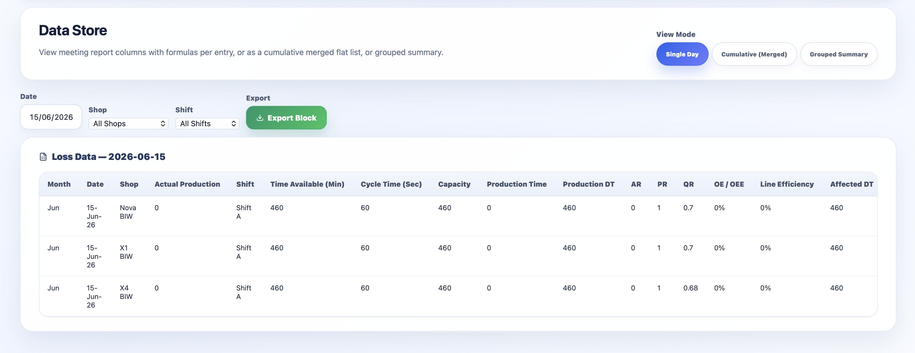
Output screenshot 2: Data Store view showing calculated production, downtime, AR, PR, QR, OE, and line efficiency columns.
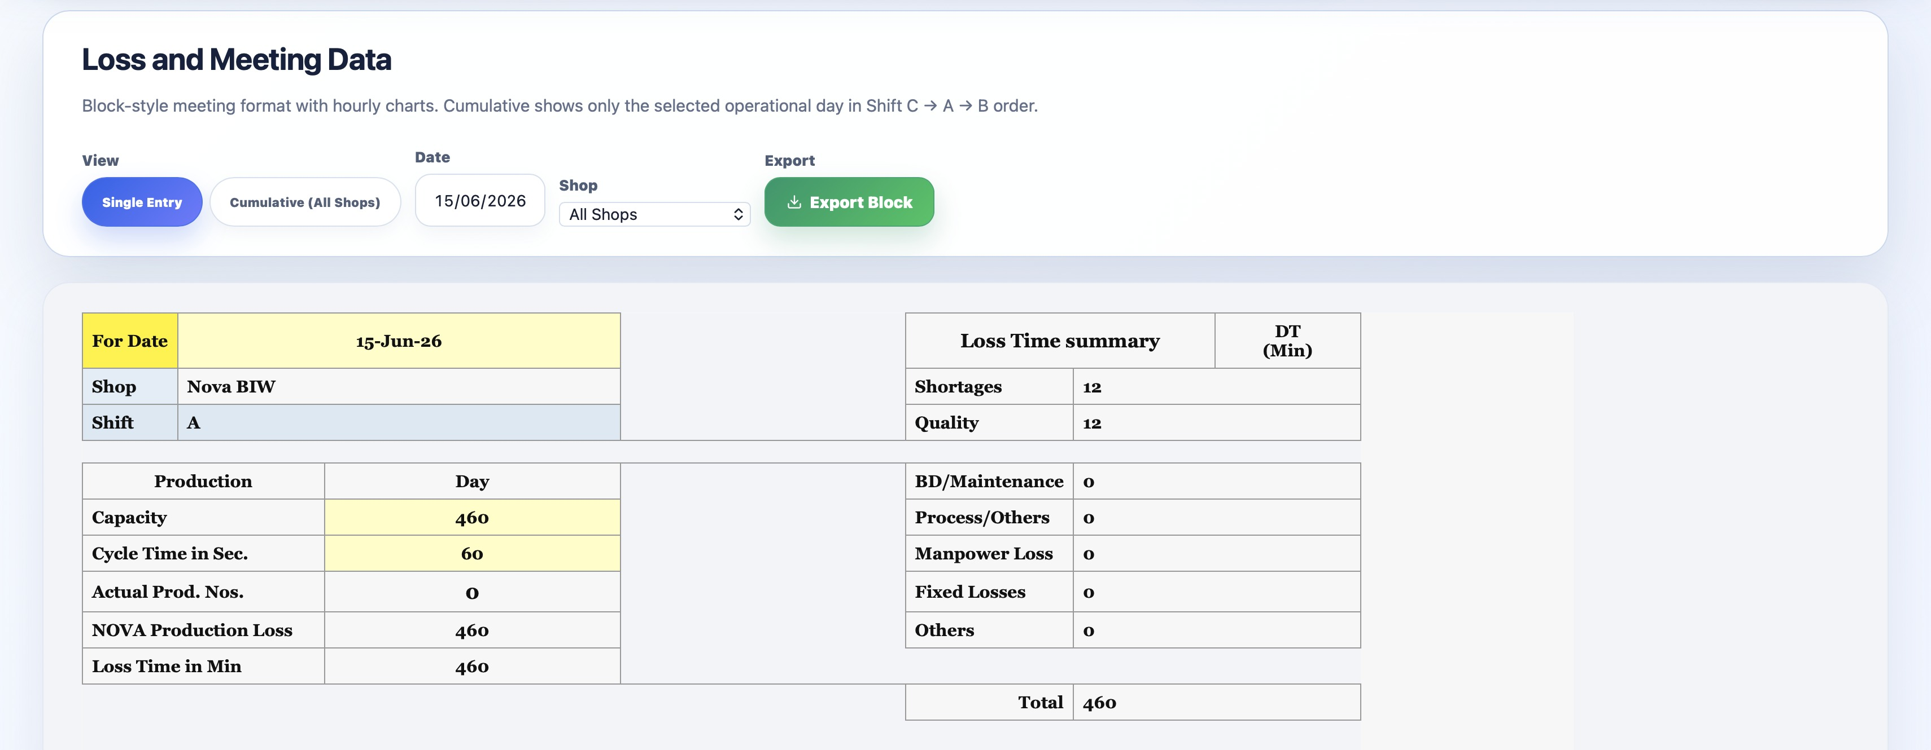
Output screenshot 3: Loss and Meeting Data single-entry block showing production and loss-time summary.
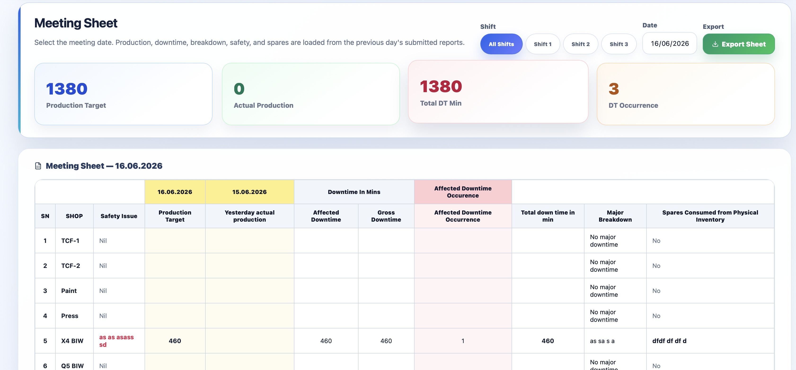
Output screenshot 4: Meeting Sheet view with production target, actual production, downtime, occurrence cards, and meeting table.

6. Final Summary
- The project combines a structured web form with spreadsheet-native reporting, so shop users and admin users both get a familiar workflow.
- Calculations are centralized, which improves consistency across shop entries, dashboard views, and generated meeting reports.
- The hidden Main Data sheet works as the database, while rebuilt visible sheets serve as presentation-ready outputs.
- Automation through Apps Script triggers supports missing-upload reminders and daily Excel report emails.

