1. **Are the HTML tags and elements the same thing?**

No, HTML tags and elements not the same things because HTML tags are define the start and end element, and elements consist of the opening tag, content &closing tag

Example:-

<h1>Hiiii</h1>

In the example ‘<h1>’ is opening tag, ‘Hiiii’ is content & ‘</h1>’ is closing tag. 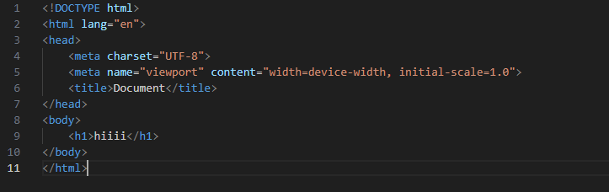

1. **What are tags and attributes in HTML?**

* HTML tag are use before and after elements

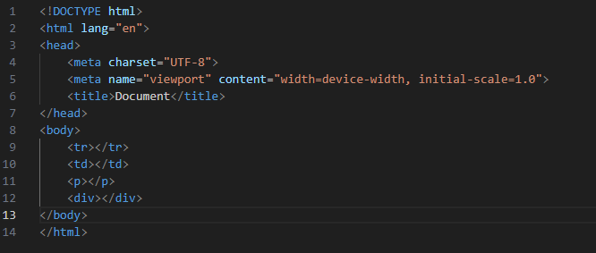

* HTML attributes are provides information of html elements.

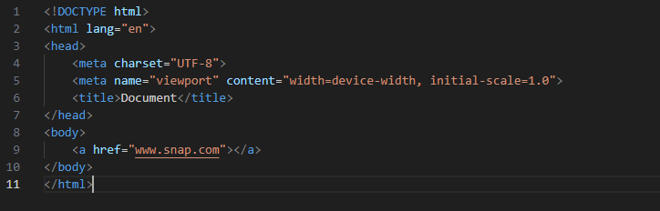

1. **What are void elements in HTML? With example.**

Void elements means those elements which don’t have closing tag. They don’t contain any content. They have made to serve to specific purpose, they self-close and don’t

* <br>
* <img>
* <input>

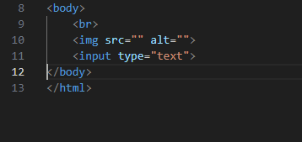

1. **What are HTML Entities? With example.**

HTML entities are the special codes used to reserved characters and symbols. like (&), (<), (>), (;)

Example :- ‘&it;’ , ‘&amp;’

1. **What are different types of lists in HTML? With Example.**

In the HTML are used to the set of group in name, value & items

* Three types of list

1. Ordered list
2. Unordered list
3. Definition list

**Ordered list –**

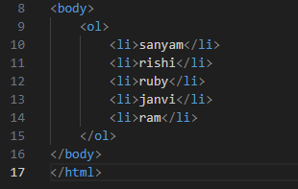 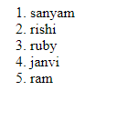

**Unordered list-**

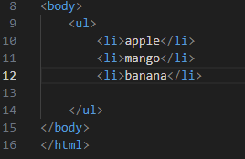 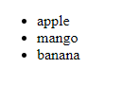

**Definition list –**

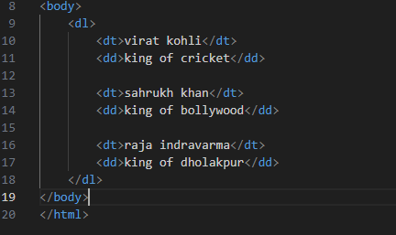

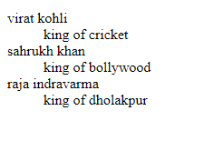

1. **What is the ‘class’ attribute in HTML? With example.**

The ‘class’ attribute is mostly used in HTML to define the class of HTML element. It is used to connect CSS class with HTML element.

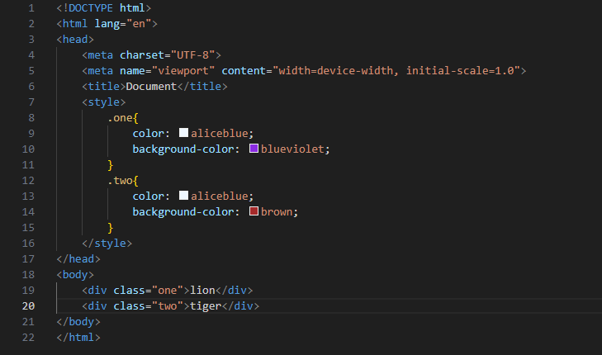



1. **What is the difference between the ‘id’ attribute and the ‘class’ attribute of HTML elements? With example.**

**Id**: The ‘id’ attribute is used to uniquely identify a single element on a page. Each ‘id’ within a document must be unique. It is often used when you want to apply unique style to a specific element. In CSS, you reference an ‘id’ name (ex- #sanyam)

**Class:** the ‘class’ attribute is not required to be unique. Multiple elements on a page can share the same class. It is used to apply styles or script to multiple elements that share a common design. In CSS, you reference a ‘class’ name (ex- .sanyam)

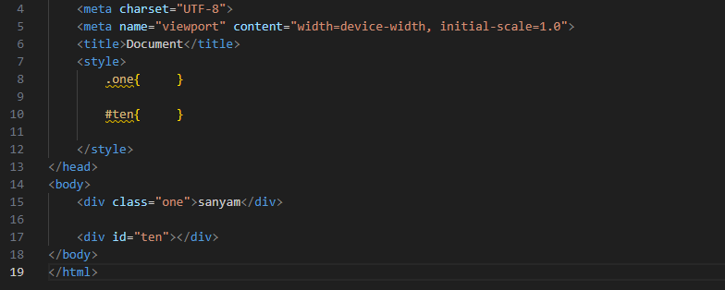

1. **What are the various formatting tags in HTML?**

HTML provides various formatting tags to structure & style content.

**Ex:-**

**1.Heding tags:** <h1></h1>  
 TO  
 <h6></h6>

**2.Paragraph tag:**<p>

**3.Line Break tag:**<br>

**4.Bold tag:** <b> or <strong>

**5.Italic tag:** <i> or <em>

**6.Underline tag:**<u>

**7.Ordered List Tag:**<ol>

**8.Unordered List Tag:**<ul>

**9.List Item Tag:** <li>

1. **How is Cell Padding different from Cell Spacing? With Example.**

**cell padding** is a specifies amount between the border of table and its contents.

**Cell spacing** is a space between the content in table.

**Cell padding:**

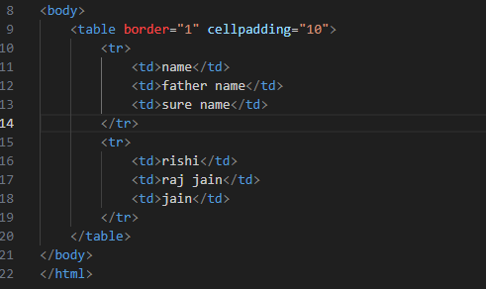

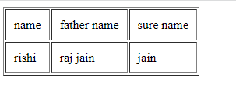

**Cell spacing:**

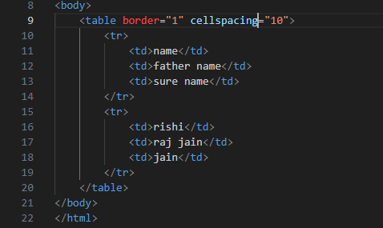

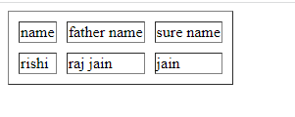

1. **How can we club two or more rows or columns into a single row or column in an HTML table? With Example.**

Use **rows-pan** and **cols-pan** attribute element we joint two or more rows or columns into a single row or column in html table.

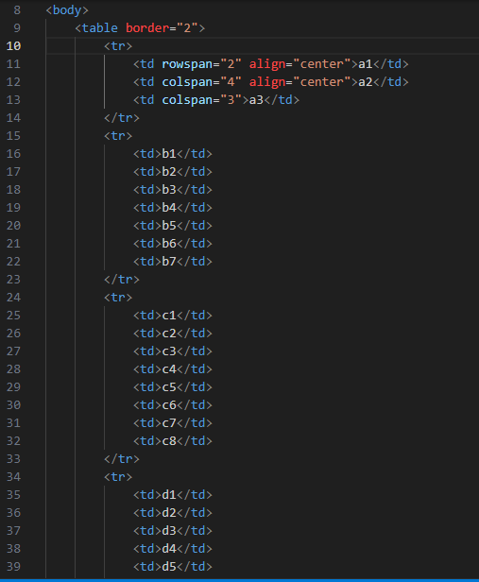

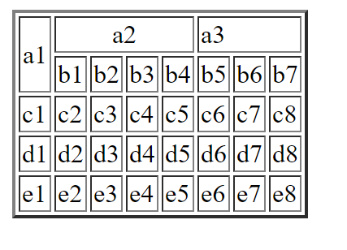

1. **What is the difference between a block-level element and an inline element?**

**Block element** cover space left to right as far as it can go.

**Inline element** only cover the space is bounded the tags.

**Block element:**

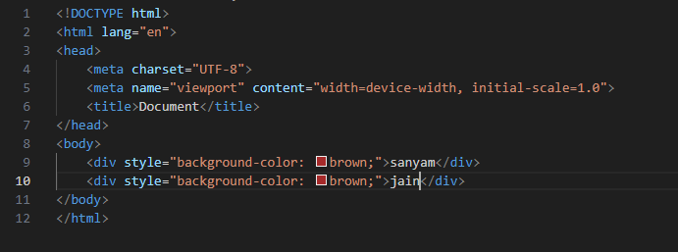



**Inline element:**

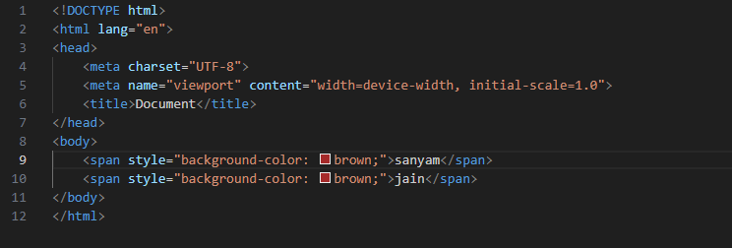

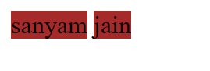

1. **How to create a Hyperlink in HTML? With Example.**

The <a> tag is use for Hyperlink, which use output page to link page

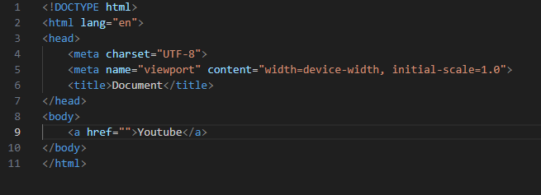

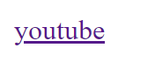

1. **What is the use of an iframe tag? With Example.**

Iframe tag is use to embed another doc. Within current HTML.

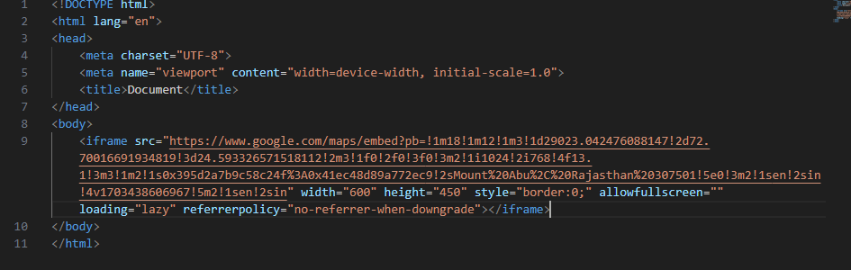

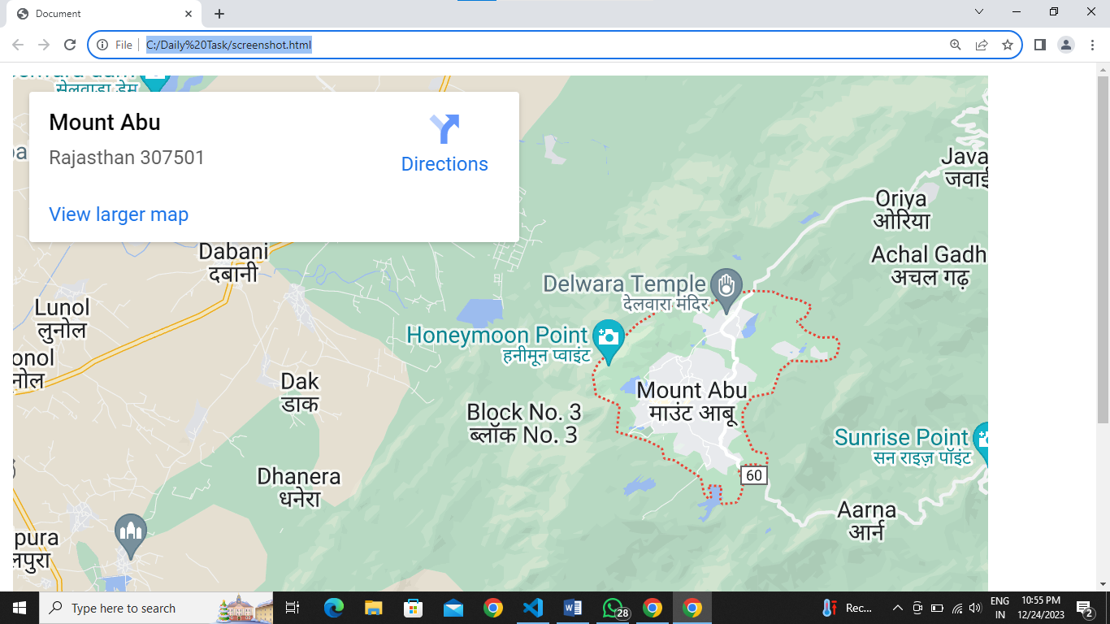

1. **What is span tag? With example.**

The span tag is a inline element.

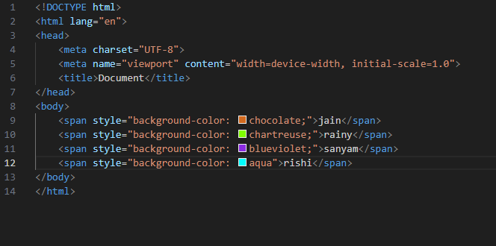

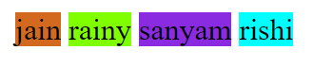

1. **How to insert a picture into a background image of a web page? With Example.**

Use to the background image in <div>tag and make a new <div> tag in image tag.

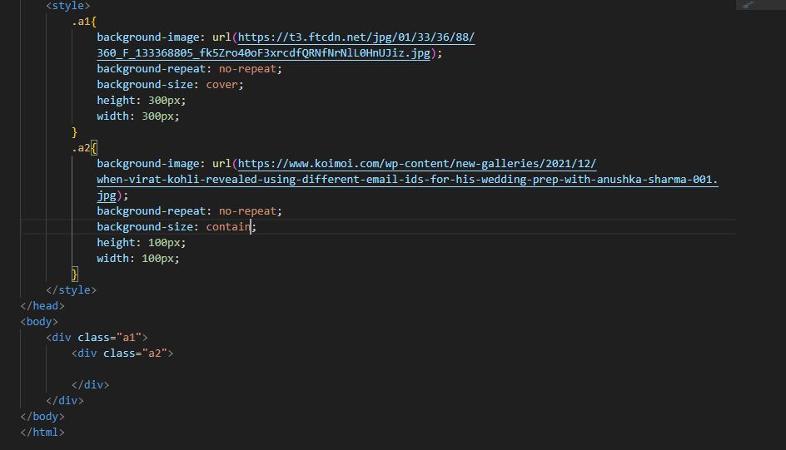



1. **How are active links different from normal links?**

**Active links** are currently functional and lead to live pages and **Normal links** can refer to any link functional or broken.

**Normal links**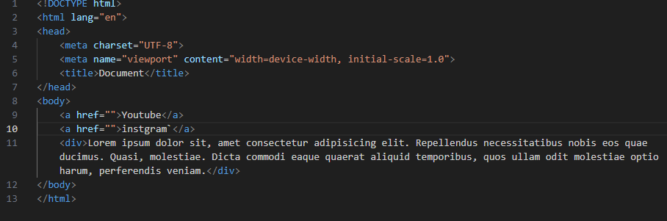

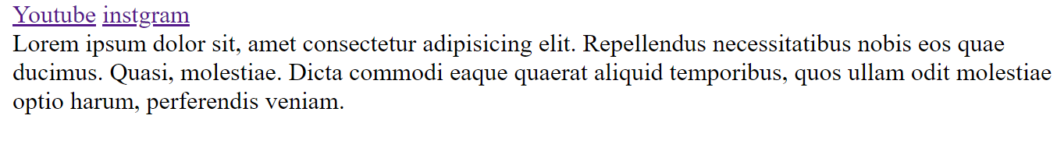

**Active links**

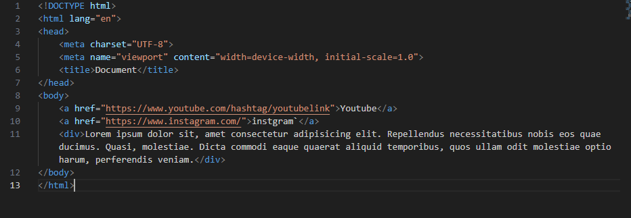

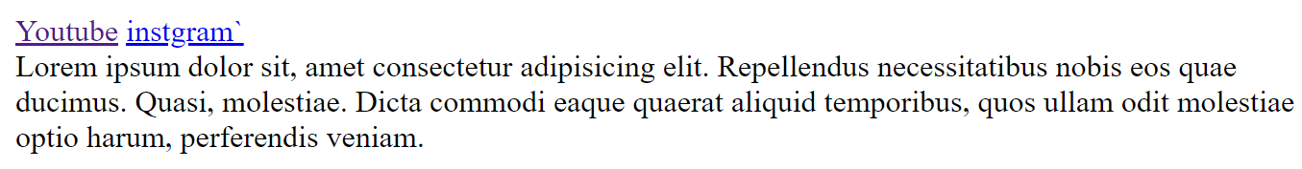



1. **What are the different tags to separate sections of text?**

<br> tag is used to separate link of break the current line.

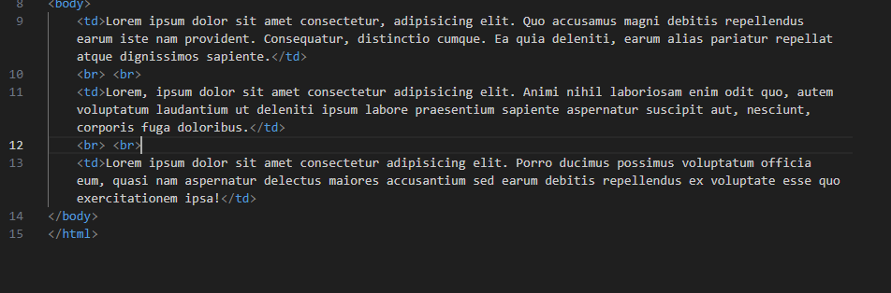

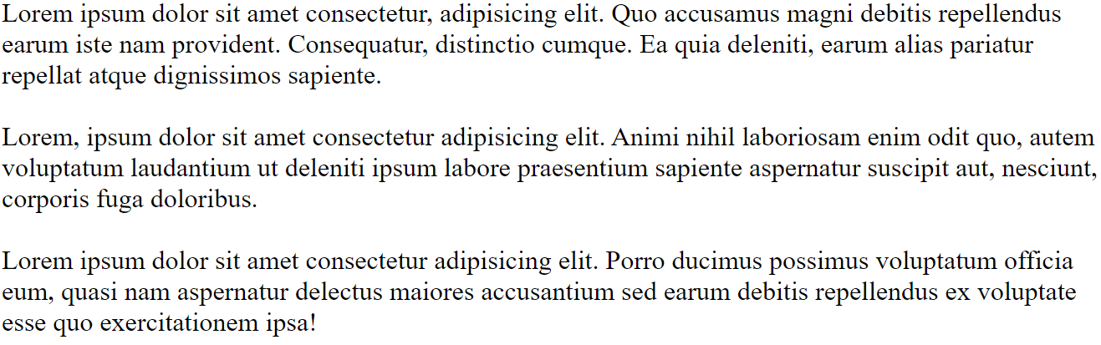

1. **What is SVG?**

SVG means scalable vector graphics.

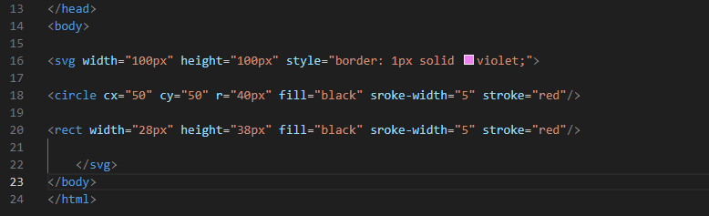

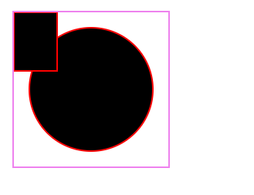

1. **What is difference between HTML and XHTML?**

html: hyper text markup language

Xhtml: extensible hyper text markup language

Html is more lenient in its syntex , while xhtml has a more

strict syntex and follow xml rules

Html is a sensitive while xhtml are not sensitive

1. **What are logical and physical tags in HTML?**

physical and logical tag are used in html for better visibility and understanding.

**Logical tag:**

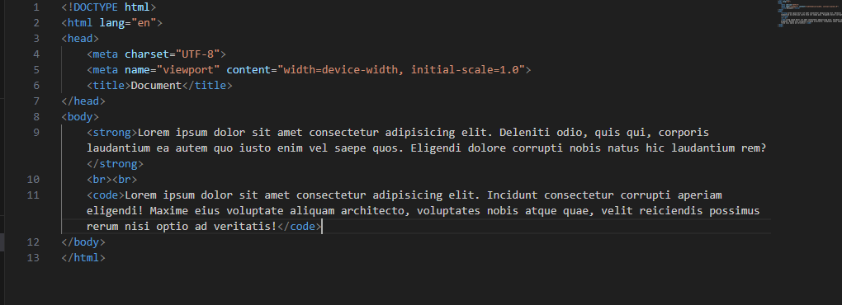

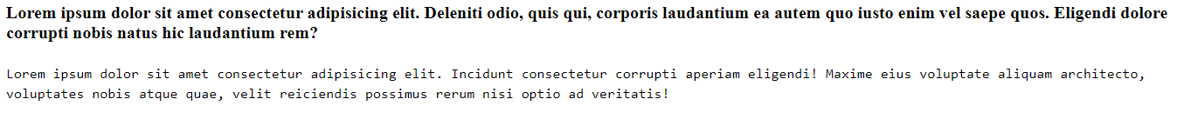

**Physical tag:**

