**HTML 5 – Assignment**

* **What are the new tags added in HTML 5?**
  + <header>
  + <nav>
  + <section>
  + <audio>
  + <video>
  + <footer>
  + <main>
  + <table> etc.
* **How to embed audio and video in a webpage ?**
  + To embed audio use <audio> tag and give it a source path and just like that use <video> tag to embed video.
  + Ex.





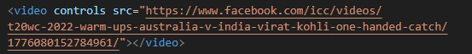



* **Semantic element in HTML 5?**
  + <header>
  + <nav>
  + <section>
  + <aside>
  + <article>
  + <footer>
* **Canvas and SVG tags.**

|  |  |
| --- | --- |
| * + SVG has better scalability. So it can be printed with high quality at any resolution. | * + Canvas has poor scalability. So it is not suitable for printing on higher resolution. |
| * + SVG gives better performance with smaller number of objects or larger surface. | * + Canvas gives better performance with smaller surface or larger number of objects. |
| * + SVG can be modified through script and CSS. | * + Canvas can be modified through script only. |
| * + SVG is vector based and composed of shapes. | * + Canvas is raster based and composed of pixel. |