Plastic Filament Extruder Quick Operation Manual

Product Parameters
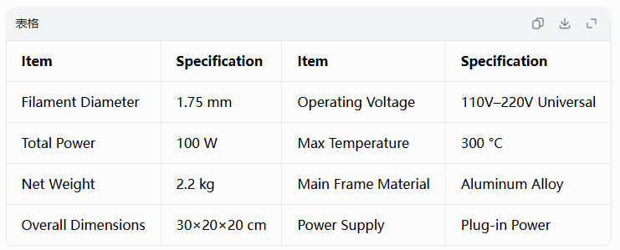

Raw Material & Plastic Strip Preparation
1.Peel off the outer label of Sprite, Coke or other plastic beverage bottles, completely remove residual adhesive from the bottle surface, rinse the bottle interior thoroughly, then air-dry fully.  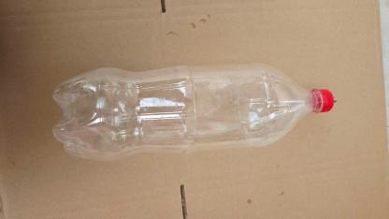 | 2.Blow a small amount of air into the bottle, then use a heat gun to flatten the bottle body for easier slicing later.  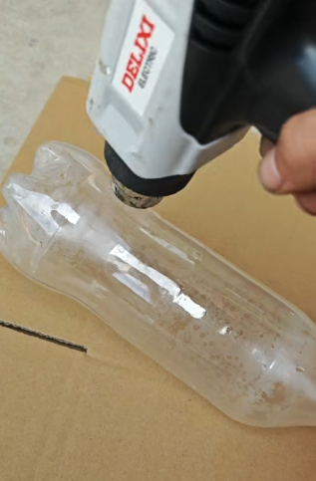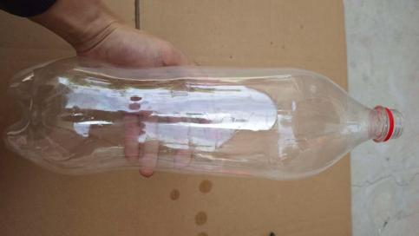
3.Cut off the bottle bottom, then slice the plastic sheet into strips with the slicer included with the machine.  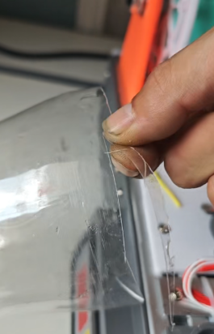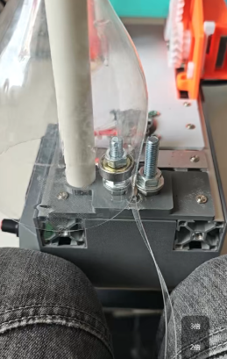 | 4. Thread the Plastic Strip Through the Nozzle  Cut the end of the sliced plastic strip into a diagonal tip, then feed it through the nozzle. Do NOT heat the machine during this step.  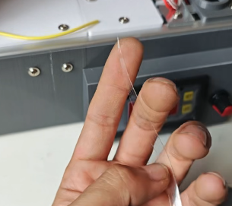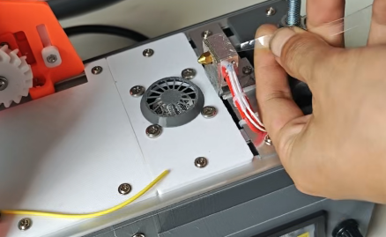

4. Power On & Heat Up the Machine
Set the stop temperature to 180–190 °C. Adjust the temperature according to different PET bottle materials as needed. Normally, only the third setting item "Stop Temperature" needs adjustment.
H56TR Quick 3-Step Setting Guide  1.Set Operation Mode: Hold the SET button for approx. 3 seconds to display P1. Press SET again to edit P1 value. H = Heating Mode, C = Cooling Mode.  2.Set Hysteresis Value: Hysteresis refers to the temperature drop threshold that triggers reheating after reaching target temperature; default value is 2. To modify: Hold SET for 3s to show P1, press U/D to switch to P2, then press SET to adjust P2 value. | 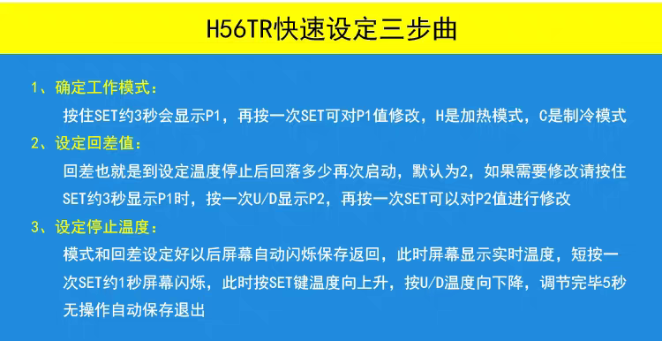
- 3.Set Stop Temperature: After finishing mode and hysteresis setup, the screen flashes to save and return to real-time temperature display. Short-press SET for 1 second to activate temperature adjustment: press SET to raise temperature, press U/D to lower temperature. Settings auto-save after 5 seconds of inactivity.
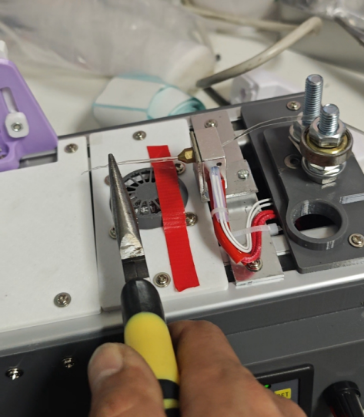
- Pre-Draw Filament Manually

Once the temperature rises to roughly 150 °C,

manually pull a short length of extruded filament out first.

6. Secure Filament to Traction Buckle for Automatic Drawing
Clip the pre-drawn filament to the machine’s traction lock buckle to activate motor-driven automatic filament stretching.
7. Adjust Motor Traction Speed  Start with a slow stretching speed, then gradually increase speed. Monitor traction speed closely: excessive speed causes incomplete plastic melting and leads to motor overload jamming.  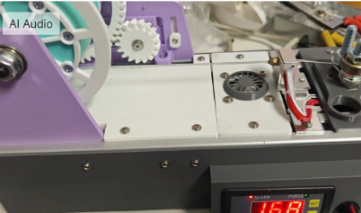 | 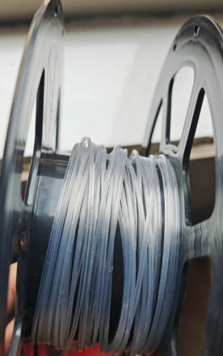  Display of finished products
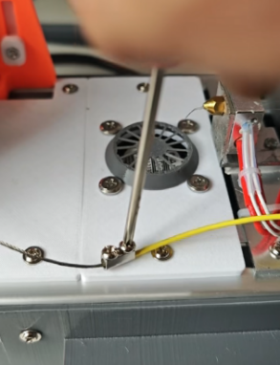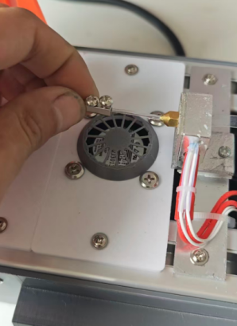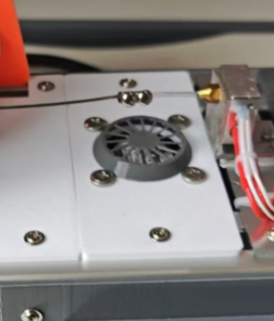

8. Accessory Installation (Spool Holder Kit)
Some models come with a plastic spool holder accessory. Remove the original slicer and install the spool assembly to hold coiled plastic strips.

1.Unscrew and remove the built-in slicer plate  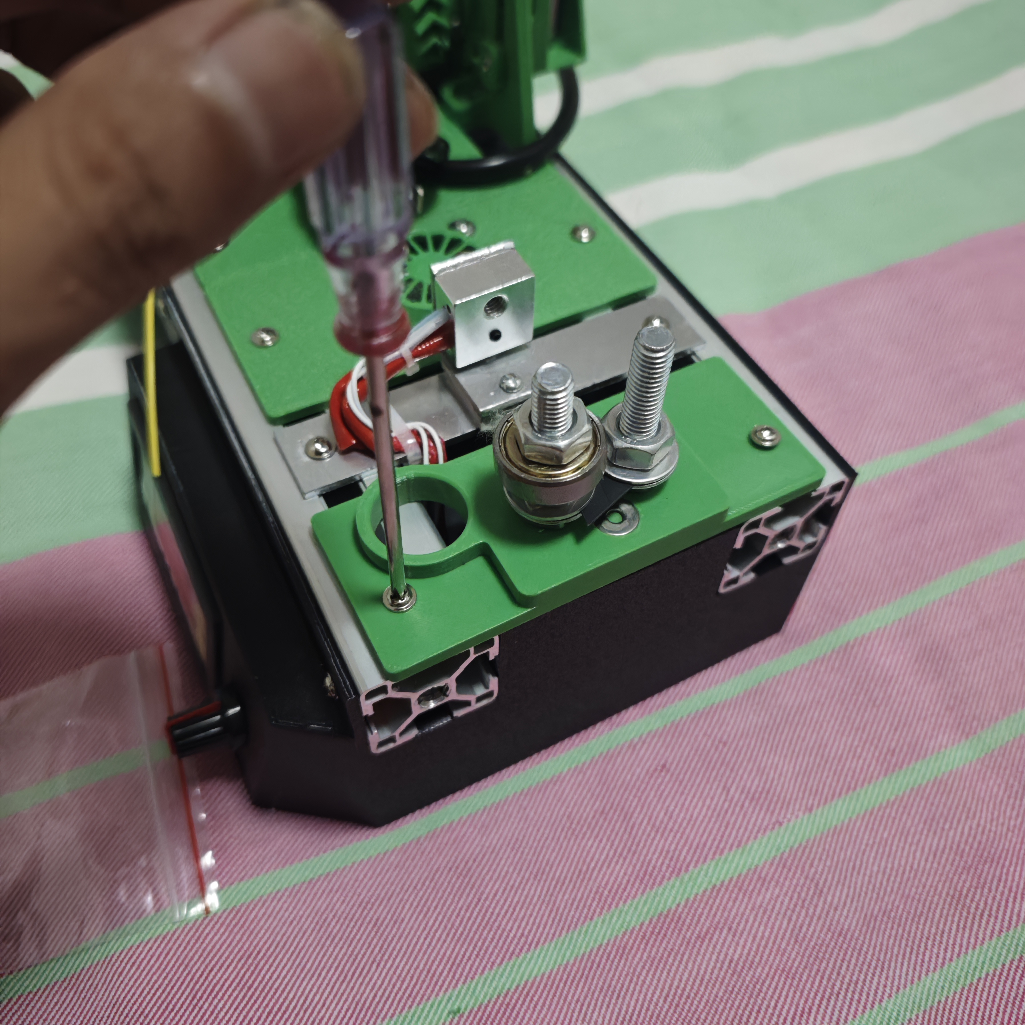 | - Mount the blank cover plate  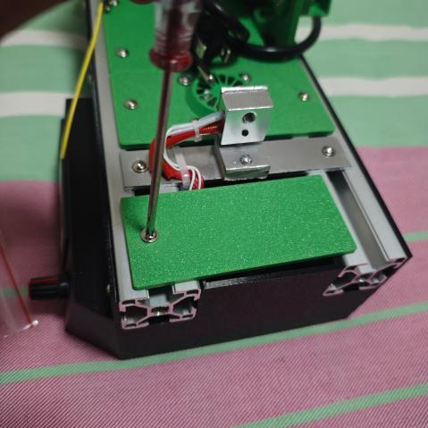
3.Install the spool support bracket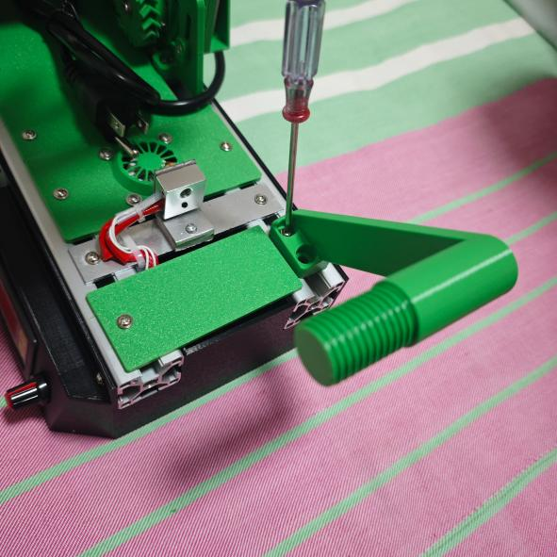 | 4.Attach the plastic spool and locking nut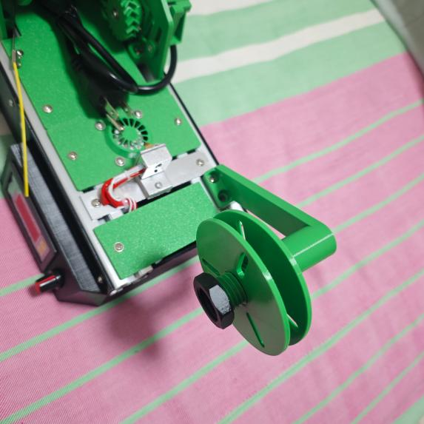

Usage Note
Wind sliced plastic strips between the two flanges of the spool before extrusion. The spool holder requires frequent disassembly of the slicer and is not mandatory for basic operation; skip installation if unnecessary.

