//====================Mongo DB Crud Operations=====================
//MongoDBConnection.java

package CRUD;

import com.mongodb.client.MongoClient;
import com.mongodb.client.MongoClients;
import com.mongodb.client.MongoDatabase;

public class MongoDBConnection {
public static void main(String[] args){
String connectionString = "mongodb://localhost:27017";

try (MongoClient mongoClient = MongoClients.create(connectionString)) {
MongoDatabase database = mongoClient.getDatabase("testdb");
System.out.println("Connected successfully to MongoDB!");
}
}
}

OUTPUT:
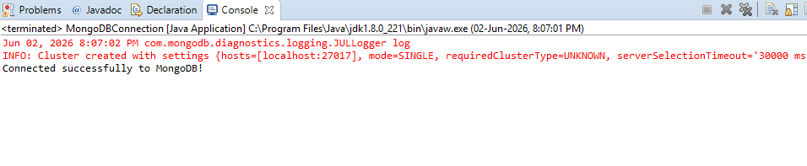

//MongoCRUD.java

package CRUD;

import com.mongodb.client.*;
import com.mongodb.client.model.Filters;
import com.mongodb.client.model.Updates;
import org.bson.Document;

public class MongoCRUD {

public static void main(String[] args) {
// Connect to MongoDB
MongoClient mongoClient = MongoClients.create("mongodb://localhost:27017");

// Access database
MongoDatabase database = mongoClient.getDatabase("CollegeDB");

// Access collection
MongoCollection<Document> collection =
database.getCollection("Students");

// ==========================
// CREATE (Insert)
// ==========================
Document student = new Document("id", 101)
.append("name", "John")
.append("department", "CSE")
.append("cgpa", 8.7);

collection.insertOne(student);
System.out.println("Document Inserted Successfully");

// ==========================
// READ (Find)
// ==========================
System.out.println("\nStudent Records:");

FindIterable<Document> students = collection.find();

for (Document doc : students) {
System.out.println(doc.toJson());
}

// ==========================
// UPDATE
// ==========================
collection.updateOne(
Filters.eq("id", 101),
Updates.set("cgpa", 9.2)
);

System.out.println("\nDocument Updated Successfully");

// ==========================
// READ Updated Record
// ==========================
Document updatedStudent =
collection.find(Filters.eq("id", 101)).first();

System.out.println("\nUpdated Record:");
System.out.println(updatedStudent.toJson());

// ==========================
// DELETE
// ==========================
collection.deleteOne(Filters.eq("id", 101));

System.out.println("\nDocument Deleted Successfully");

// Close connection
mongoClient.close();
}
}

OUTPUT:
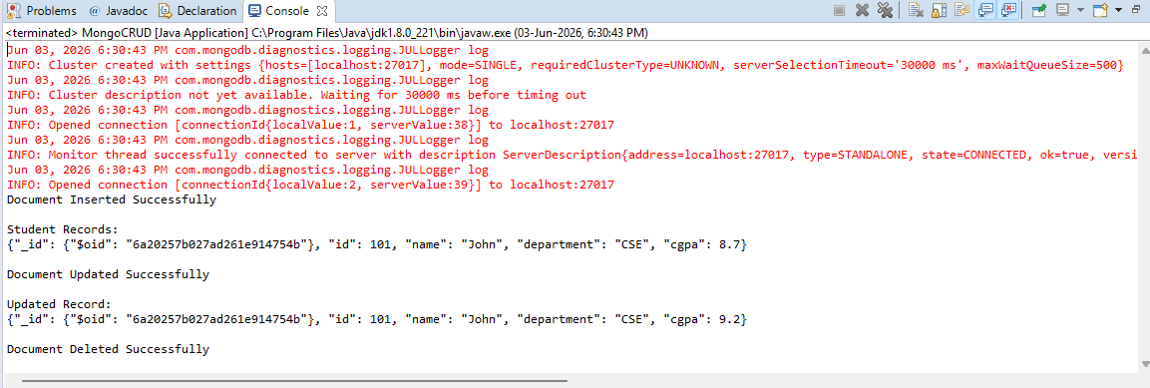

//MongoCRUDMultiple.java

package CRUD;

import com.mongodb.client.*;
import com.mongodb.client.model.Filters;
import com.mongodb.client.model.Updates;
import org.bson.Document;

import java.util.Arrays;
import java.util.List;

public class MongoCRUDMultiple {

public static void main(String[] args) {

// Connect to MongoDB
MongoClient mongoClient =
MongoClients.create("mongodb://localhost:27017");

// Access Database
MongoDatabase database =
mongoClient.getDatabase("CollegeDB");

// Access Collection
MongoCollection<Document> collection =
database.getCollection("Students");

// ==========================
// INSERT MANY
// ==========================

List<Document> students = Arrays.asList(

new Document("id", 101)
.append("name", "John")
.append("department", "CSE")
.append("cgpa", 8.7),

new Document("id", 102)
.append("name", "Alice")
.append("department", "IT")
.append("cgpa", 8.5),

new Document("id", 103)
.append("name", "Bob")
.append("department", "CSE")
.append("cgpa", 8.1)

);

collection.insertMany(students);

System.out.println("Documents Inserted Successfully");

// ==========================
// READ ALL RECORDS
// ==========================

System.out.println("\nStudent Records:");

FindIterable<Document> records =
collection.find();

for (Document doc : records) {
System.out.println(doc.toJson());
}

// ==========================
// UPDATE MANY
// Increase CGPA of all CSE students
// ==========================

collection.updateMany(
Filters.eq("department", "CSE"),
Updates.set("cgpa", 9.0)
);

System.out.println("\nDocuments Updated Successfully");

// ==========================
// READ UPDATED RECORDS
// ==========================

System.out.println("\nUpdated Records:");

FindIterable<Document> updatedRecords =
collection.find(Filters.eq("department", "CSE"));

for (Document doc : updatedRecords) {
System.out.println(doc.toJson());
}

// ==========================
// DELETE MANY
// Delete all CSE students
// ==========================

collection.deleteMany(
Filters.eq("department", "CSE")
);

System.out.println("\nDocuments Deleted Successfully");

// ==========================
// DISPLAY REMAINING RECORDS
// ==========================

System.out.println("\nRemaining Records:");

FindIterable<Document> remaining =
collection.find();

for (Document doc : remaining) {
System.out.println(doc.toJson());
}

// Close Connection
mongoClient.close();
}
}

OUTPUT:
