//==================MongoDB unset and rename operators===================
//MongoDBConnection.java
package CRUD;

import com.mongodb.client.MongoClient;
import com.mongodb.client.MongoClients;
import com.mongodb.client.MongoDatabase;

public class MongoDBConnection {
public static void main(String[] args){
String connectionString = "mongodb://localhost:27017";

try (MongoClient mongoClient = MongoClients.create(connectionString)) {
MongoDatabase database = mongoClient.getDatabase("testdb");
System.out.println("Connected successfully to MongoDB!");
}
}
}

OUTPUT:
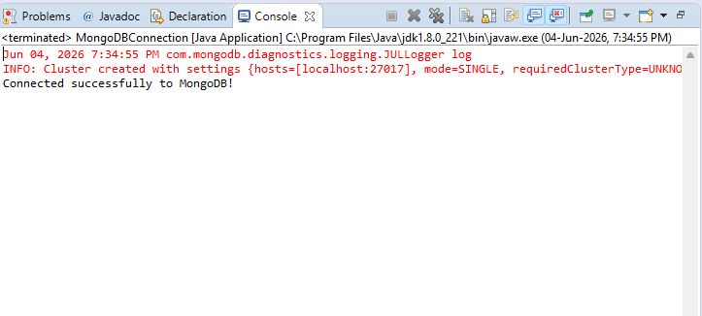

//MongoDB_unset_rename_operator.java

package CRUD;

import com.mongodb.client.*;
import com.mongodb.client.model.Filters;
import org.bson.Document;

public class MongoDB_unset_rename_operator {

public static void main(String[] args) {

// Connect to MongoDB
MongoClient mongoClient =
MongoClients.create("mongodb://localhost:27017");

// Access Database
MongoDatabase database =
mongoClient.getDatabase("CollegeDB");

// Access Collection
MongoCollection<Document> collection =
database.getCollection("Students");

// ==========================
// INSERT ONE
// ==========================
Document student = new Document("id", 102)
.append("name", "Alice")
.append("department", "CSE")
.append("cgpa", 8.5);

collection.insertOne(student);

System.out.println("Document Inserted Successfully");

// Display Original Document
System.out.println("\nOriginal Document:");
System.out.println(
collection.find(Filters.eq("id", 102)).first().toJson()
);

// ==========================
// UNSET OPERATOR
// Remove cgpa field
// ==========================
collection.updateOne(
Filters.eq("id", 102),
new Document("$unset",
new Document("cgpa", ""))
);

System.out.println("\nAfter $unset:");

System.out.println(
collection.find(Filters.eq("id", 102)).first().toJson()
);

// ==========================
// RENAME OPERATOR
// department -> branch
// ==========================
collection.updateOne(
Filters.eq("id", 102),
new Document("$rename",
new Document("department", "branch"))
);

System.out.println("\nAfter $rename:");

System.out.println(
collection.find(Filters.eq("id", 102)).first().toJson()
);

mongoClient.close();
}
}

OUTPUT:
