//=======================MongoDb Aggregate Functions=======================
//MongoDBConnection.java

package CRUD;

import com.mongodb.client.MongoClient;
import com.mongodb.client.MongoClients;
import com.mongodb.client.MongoDatabase;

public class MongoDBConnection {
public static void main(String[] args){
String connectionString = "mongodb://localhost:27017";

try (MongoClient mongoClient = MongoClients.create(connectionString)) {
MongoDatabase database = mongoClient.getDatabase("testdb");
System.out.println("Connected successfully to MongoDB!");
}
}
}

OUTPUT:
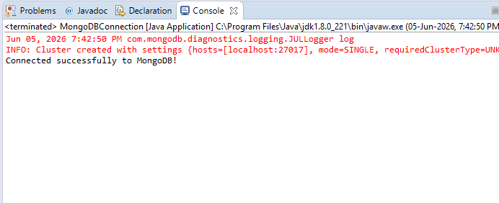

//MongoDb_AggregateFunction.java

package CRUD;

import com.mongodb.client.AggregateIterable;
import com.mongodb.client.MongoClient;
import com.mongodb.client.MongoClients;
import com.mongodb.client.MongoCollection;
import com.mongodb.client.MongoDatabase;
import org.bson.Document;

import java.util.Arrays;

public class MongoDb_AggregateFunction {

public static void main(String[] args) {

// Connect to MongoDB
MongoClient mongoClient =
MongoClients.create("mongodb://localhost:27017");

// Access Database
MongoDatabase database =
mongoClient.getDatabase("CollegeDB");

// Access Collection
MongoCollection<Document> collection =
database.getCollection("Students");

// Aggregation: Department-wise Average CGPA
AggregateIterable<Document> result =
collection.aggregate(Arrays.asList(
new Document("$group",
new Document("_id", "$department")
.append("averageCGPA",
new Document("$avg", "$cgpa")))
));

System.out.println("Department-wise Average CGPA:");

for (Document doc : result) {
System.out.println(doc.toJson());
}

// Close Connection
mongoClient.close();
}
}

OUTPUT:
