//=======================MYSQL_CRUD=========================

//CRUD_Test.java

package CRUD;

import java.sql.Connection;
import java.sql.PreparedStatement;
import java.sql.ResultSet;

public class CRUD_Test {

public static void main(String[] args) {
CRUD_Test objTest = new CRUD_Test();

// Insert data
objTest.create_data("1", "jinu", "jinu@gmail.com");
objTest.create_data("2", "jawad", "jawad@gmail.com");

// Read data
objTest.read_data("2");

// Update data
objTest.update_data("2", "22", "jawad2", "jawad2@gmail.com");

// Delete data
objTest.delete_data("1");

// Truncate data
objTest.truncate_data();

// Alter data
objTest.alter_table();
}

public void create_data(String sl_no, String name, String email) {
DB_Connection obj_DB_Connection = new DB_Connection();
Connection connection = obj_DB_Connection.get_connection();
PreparedStatement ps = null;

try {
String query = "insert into user(sl_no, name, email) values (?, ?, ?)";
ps = connection.prepareStatement(query);
ps.setString(1, sl_no);
ps.setString(2, name);
ps.setString(3, email);
System.out.println("Insert Query: " + ps);
int rows = ps.executeUpdate();
System.out.println("Inserted " + rows + " row(s) successfully.");

} catch (Exception e) {
System.out.println("Create Error: " + e.getMessage());
} finally {
try { if (ps != null) ps.close(); } catch (Exception e) { }
try { if (connection != null) connection.close(); } catch (Exception e) { }
}
}

public void read_data(String sl_no) {
DB_Connection obj_DB_Connection = new DB_Connection();
Connection connection = obj_DB_Connection.get_connection();
PreparedStatement ps = null;
ResultSet rs = null;

try {
String query = "select * from user where sl_no = ?";
ps = connection.prepareStatement(query);
ps.setString(1, sl_no);
System.out.println("Read Query: " + ps);
rs = ps.executeQuery();

boolean found = false;
while (rs.next()) {
found = true;
System.out.println("Sl no - " + rs.getString("sl_no"));
System.out.println("Name - " + rs.getString("name"));
System.out.println("Email - " + rs.getString("email"));
System.out.println("---------------");
}
if (!found) {
System.out.println("No record found for sl_no: " + sl_no);
}

} catch (Exception e) {
System.out.println("Read Error: " + e.getMessage());
} finally {
try { if (rs != null) rs.close(); } catch (Exception e) { }
try { if (ps != null) ps.close(); } catch (Exception e) { }
try { if (connection != null) connection.close(); } catch (Exception e) { }
}
}

public void update_data(String sl_no, String new_sl_no, String name, String email) {
DB_Connection obj_DB_Connection = new DB_Connection();
Connection connection = obj_DB_Connection.get_connection();
PreparedStatement ps = null;

try {
String query = "update user set sl_no = ?, name = ?, email = ? where sl_no = ?";
ps = connection.prepareStatement(query);
ps.setString(1, new_sl_no);
ps.setString(2, name);
ps.setString(3, email);
ps.setString(4, sl_no);
System.out.println("Update Query: " + ps);
int rows = ps.executeUpdate();
System.out.println("Updated " + rows + " row(s) successfully.");

} catch (Exception e) {
System.out.println("Update Error: " + e.getMessage());
} finally {
try { if (ps != null) ps.close(); } catch (Exception e) { }
try { if (connection != null) connection.close(); } catch (Exception e) { }
}
}

public void delete_data(String sl_no) {
DB_Connection obj_DB_Connection = new DB_Connection();
Connection connection = obj_DB_Connection.get_connection();
PreparedStatement ps = null;

try {
String query = "delete from user where sl_no = ?";
ps = connection.prepareStatement(query);
ps.setString(1, sl_no);
System.out.println("Delete Query: " + ps);
int rows = ps.executeUpdate();
System.out.println("Deleted " + rows + " row(s) successfully.");

} catch (Exception e) {
System.out.println("Delete Error: " + e.getMessage());
} finally {
try { if (ps != null) ps.close(); } catch (Exception e) { }
try { if (connection != null) connection.close(); } catch (Exception e) { }
}
}

//=============UPDATED WITH TRUNCATE AND ALTER COMMANDS==============

public void truncate_data() {
DB_Connection obj_DB_Connection = new DB_Connection();
Connection connection = obj_DB_Connection.get_connection();
PreparedStatement ps = null;

try {
String query = "truncate table user";
ps = connection.prepareStatement(query);

System.out.println(ps);

ps.executeUpdate();
System.out.println("All records deleted successfully.");

} catch (Exception e) {
System.out.println(e);
}
}

public void alter_table() {
DB_Connection obj_DB_Connection = new DB_Connection();
Connection connection = obj_DB_Connection.get_connection();
PreparedStatement ps = null;

try {
String query = "alter table user ADD address VARCHAR(20)";
ps = connection.prepareStatement(query);

System.out.println(ps);

ps.executeUpdate();
System.out.println("Column added successfully.");

} catch (Exception e) {
System.out.println(e);
}
}
}

//DB_Connection.java

package CRUD;

import java.sql.Connection;
import java.sql.DriverManager;

public class DB_Connection {

private static final String DRIVER = "com.mysql.cj.jdbc.Driver";
private static final String URL = "jdbc:mysql://localhost:3308/crud";
private static final String USERNAME = "root";
private static final String PASSWORD = "1234";

public Connection get_connection() {
Connection connection = null;
try {
Class.forName(DRIVER);
connection = DriverManager.getConnection(URL, USERNAME, PASSWORD);
System.out.println("Database connected successfully!");

} catch (ClassNotFoundException e) {
System.out.println("Driver not found: " + e.getMessage());
System.out.println("MySQL Connector JAR add karo Build Path mein.");

} catch (Exception e) {
System.out.println("Connection failed: " + e.getMessage());
}
return connection;
}

// Connection test karne ke liye main method
public static void main(String[] args) {
DB_Connection obj = new DB_Connection();
Connection con = obj.get_connection();

if (con != null) {
System.out.println("Connection Object: " + con);
try { con.close(); } catch (Exception e) { }
} else {
System.out.println("Connection null hai - settings check karo.");
}
}
}

//OUTPUT:

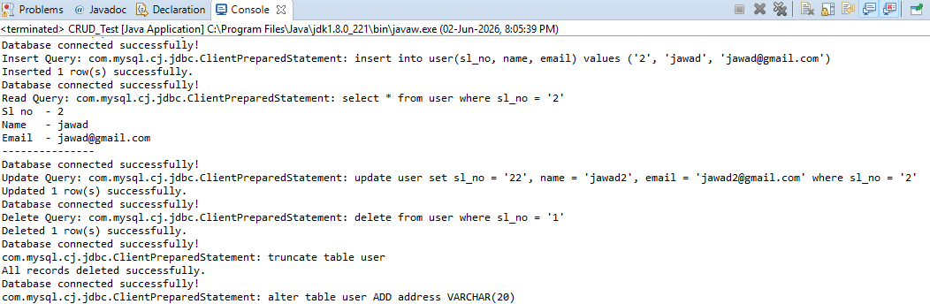

//==================MongoDB CRUD===================

//MongoDBConnection.java

package CRUD;

import com.mongodb.client.MongoClient;
import com.mongodb.client.MongoClients;
import com.mongodb.client.MongoDatabase;

public class MongoDBConnection {
public static void main(String[] args){
String connectionString = "mongodb://localhost:27017";

try (MongoClient mongoClient = MongoClients.create(connectionString)) {
MongoDatabase database = mongoClient.getDatabase("testdb");
System.out.println("Connected successfully to MongoDB!");
}
}
}

// OUTPUT:

