**Programming Languages**

16

**GitHub Tutorial Assignment**

**CS611**

**By Sanyukta K. Madan**

**U01365071**

**GitHub Username**: Sanyukta09

**Part 3**

**Questions:**

* **What is GitHub? When was it created? Why? By who? What similar platforms exist? Why would you use such a platform?**

*Answer*: GitHub is an online repository hosting service. GitHub was created by Linus Torvalds in the year 2007.

The main idea behind the creation of GitHub is that it is an open source project, which enables storage of program codes and its revisions.

**Similar platforms used**: ALLURA, CHILIPROJECT, BITBUCKET, KILN, CODEPLANE

GitHub is a platform that people can use to do software projects in collaboration. Sometimes clients that have no background in coding, but that wish to view the coding of projects can access and download the coding from repository. GitHub has an efficient storage system and ensures file integrity.

**Part 4**

**Git Tutorial Program Command Execution: (Screenshots)**

**1.1 git init command execution**

(Screenshot)

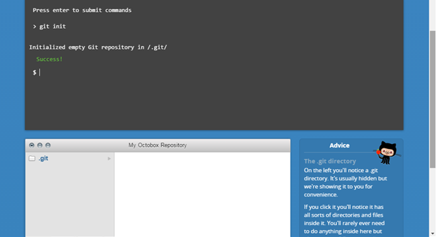

**1.2 Checking the status (screenshot):**

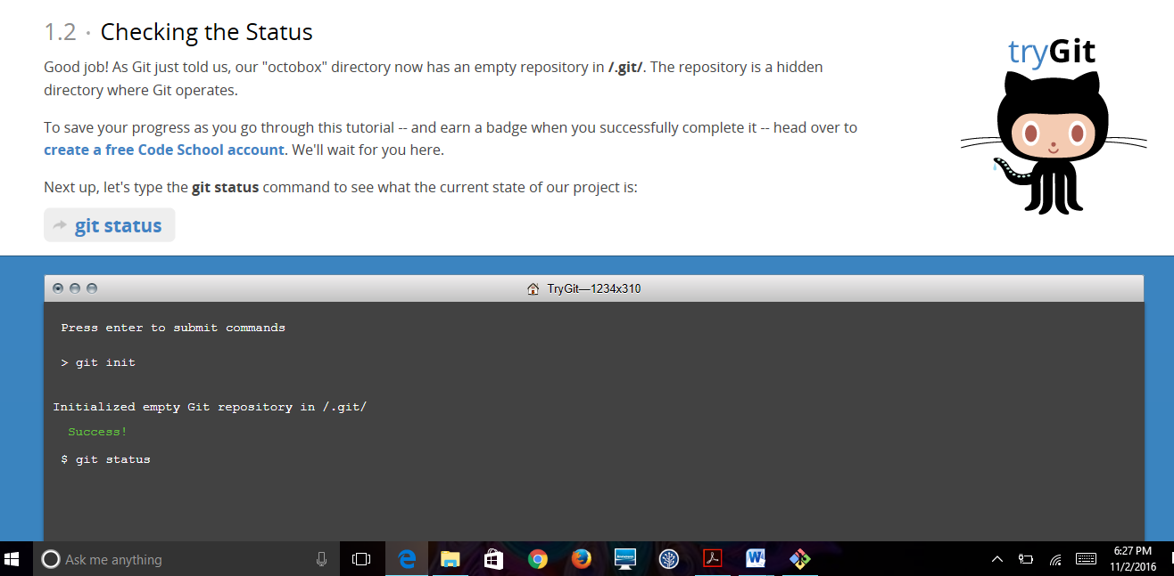

**Command Execution (screenshot):**

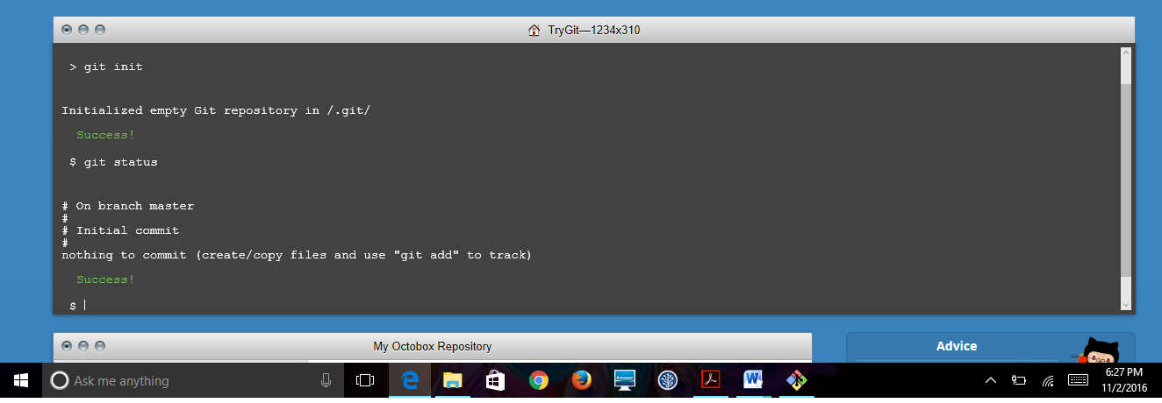

**1.3 Adding & committing (screenshot):**

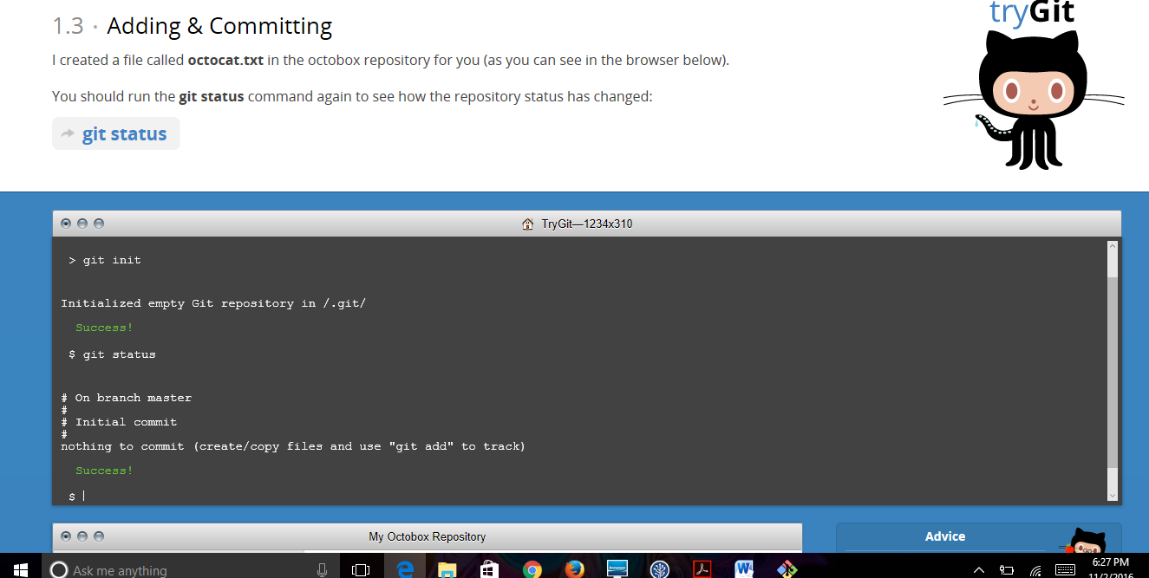

**Command Execution (screenshot)**

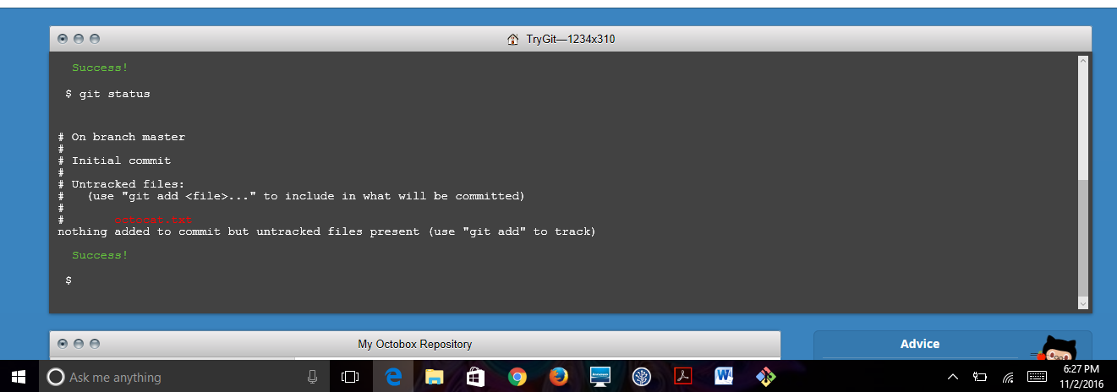

**1.4 Adding Changes (screenshot):**

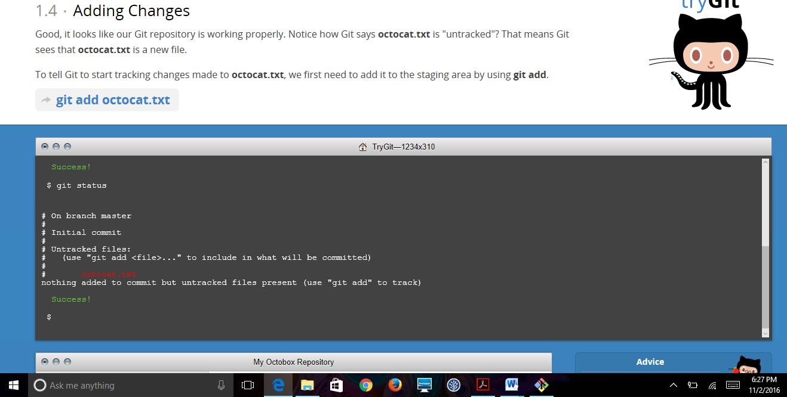

**Command Execution (screenshot)**

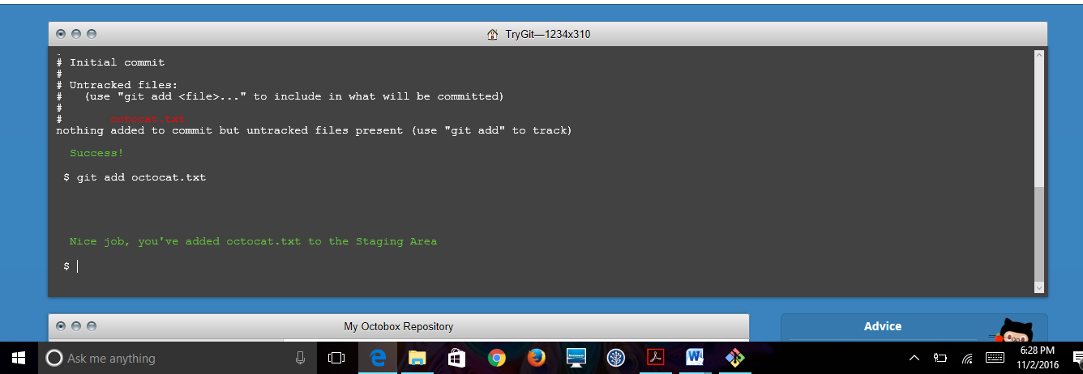

**1.5 Checking for Changes (screenshot):**

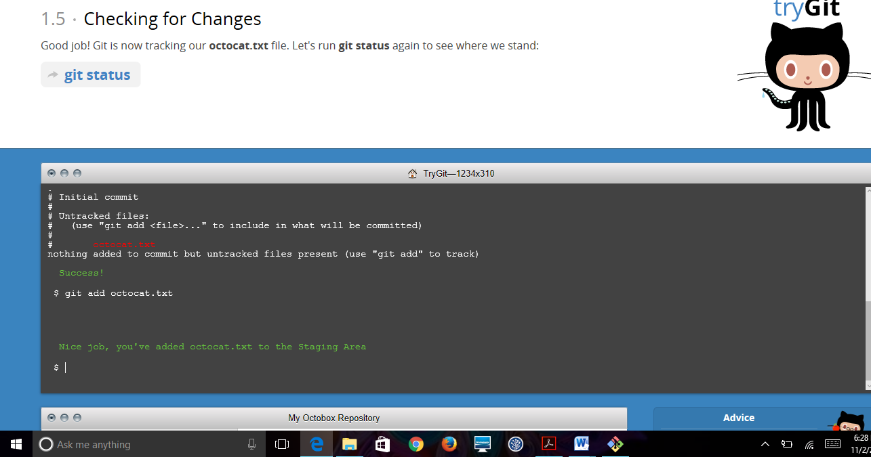

**Command Execution (screenshot)**

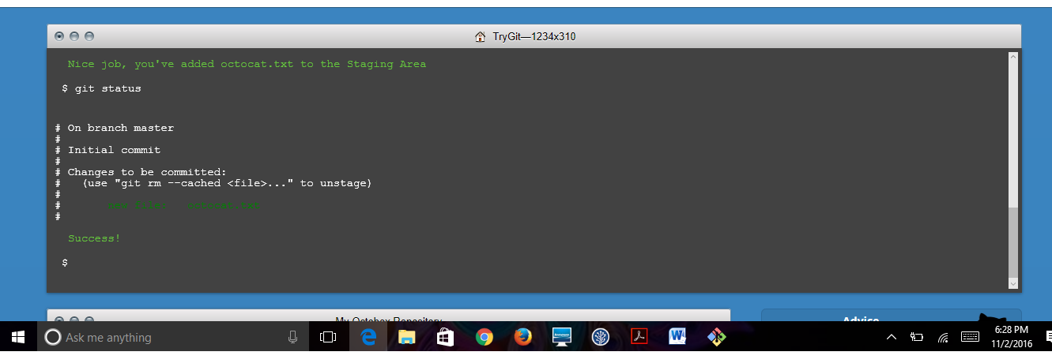

**1.6 Committing (screenshot):**

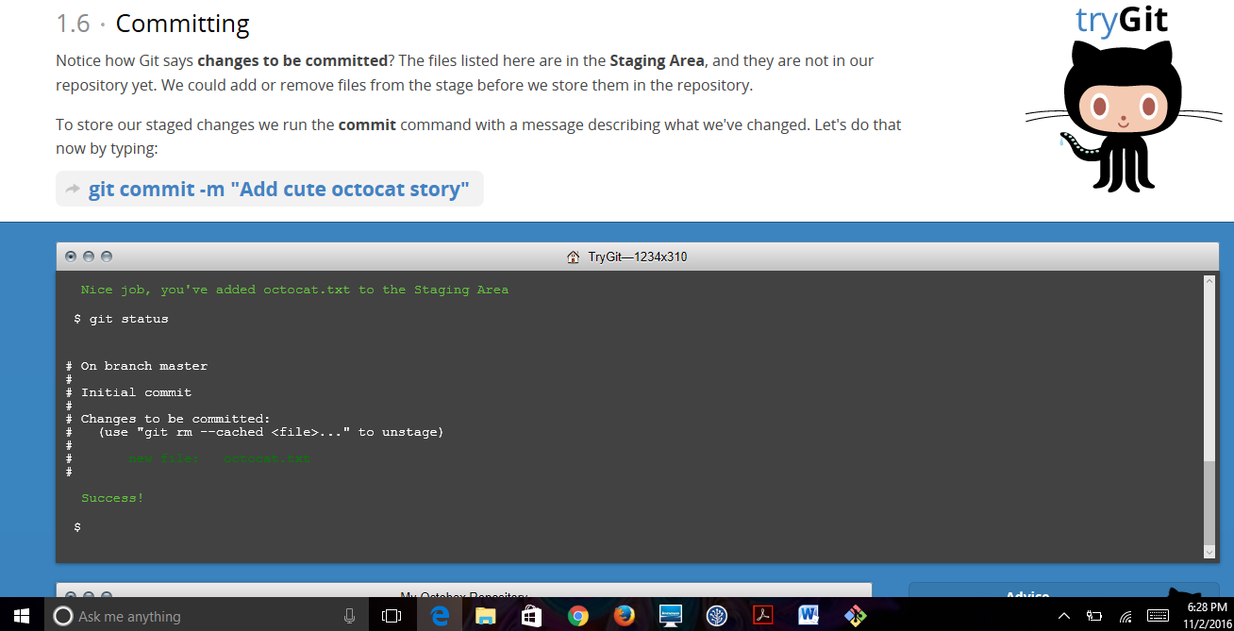

**Command Execution (screenshot)**

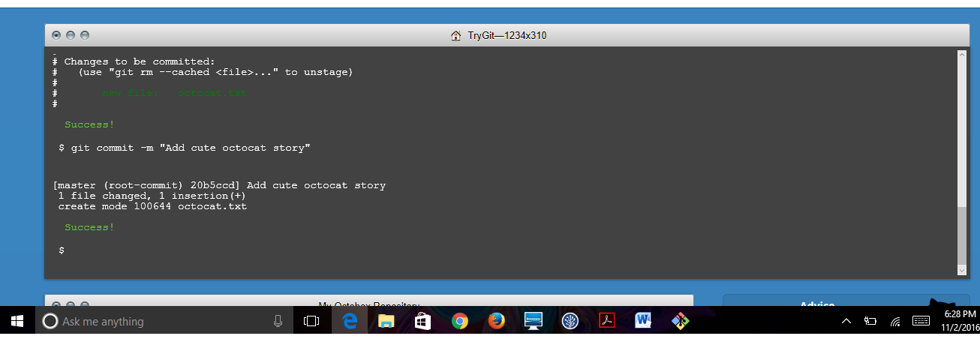

**1.7 Adding All Changes (screenshot):**

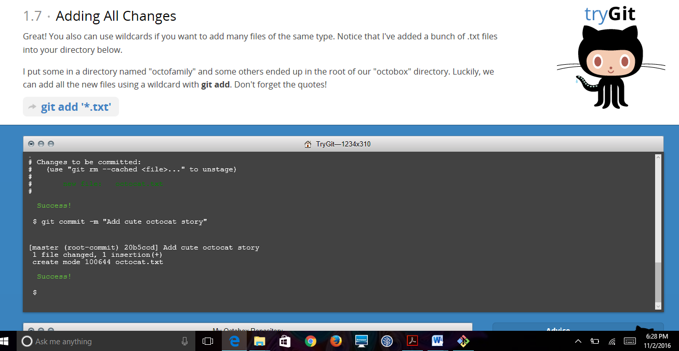

**Command Execution (screenshot):**

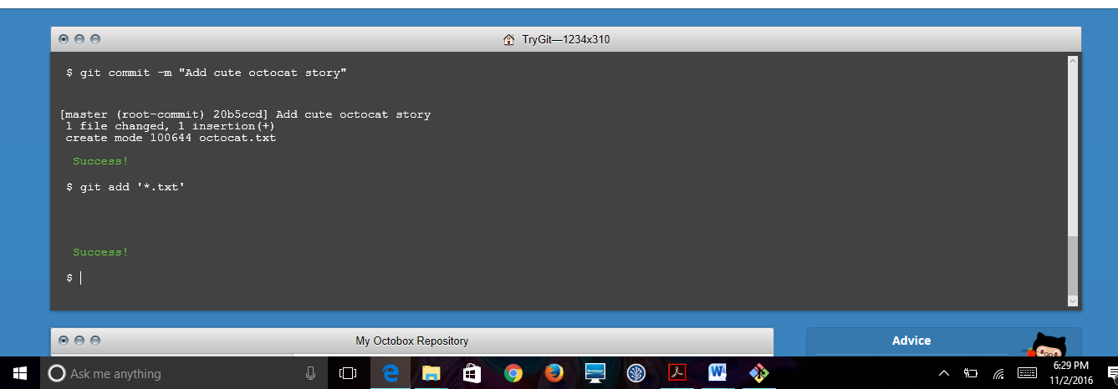

**1.8 Committing All Changes (screenshot):**

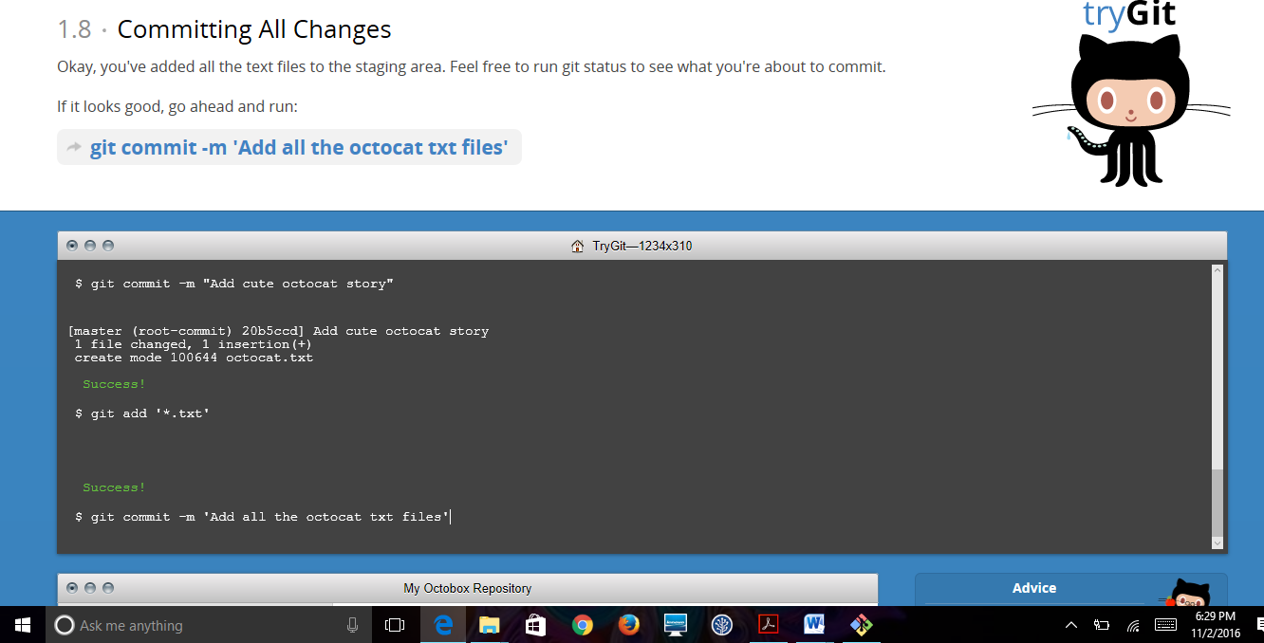

**Command Execution (screenshot):**

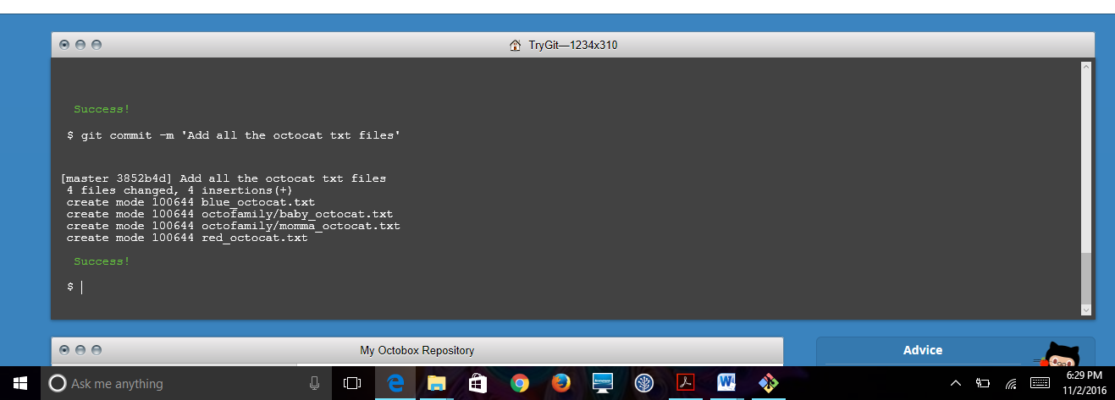

**1.9 History (screenshot):**

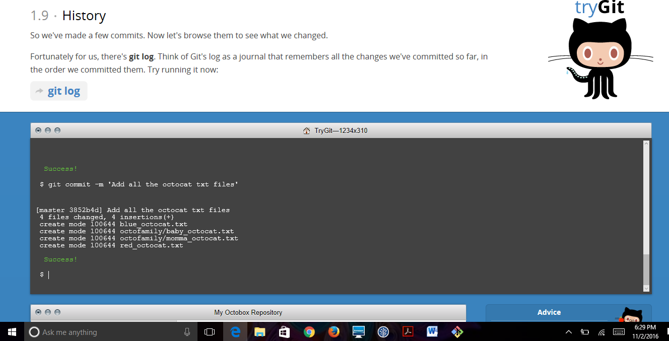

**Command Execution (screenshot):**

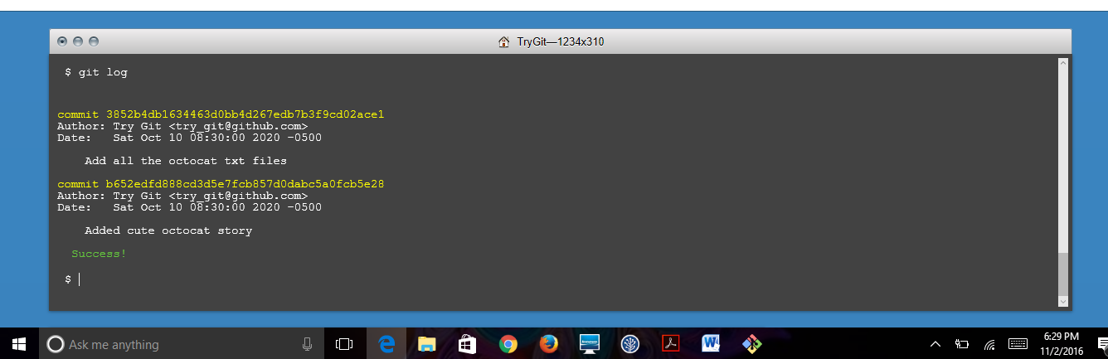

**1.10 Remote Repositories (screenshot):**

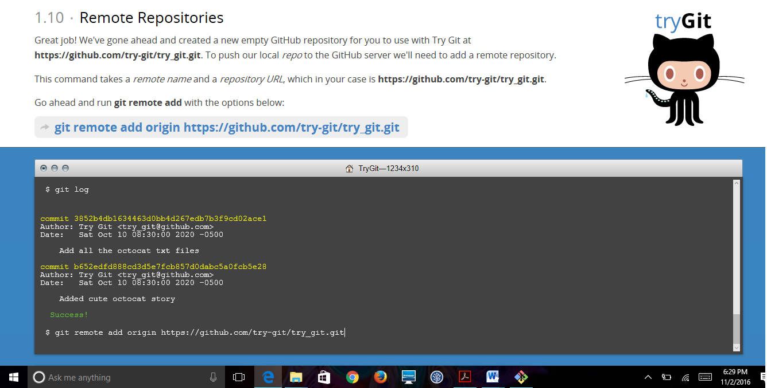

**Command Execution (screenshot):**

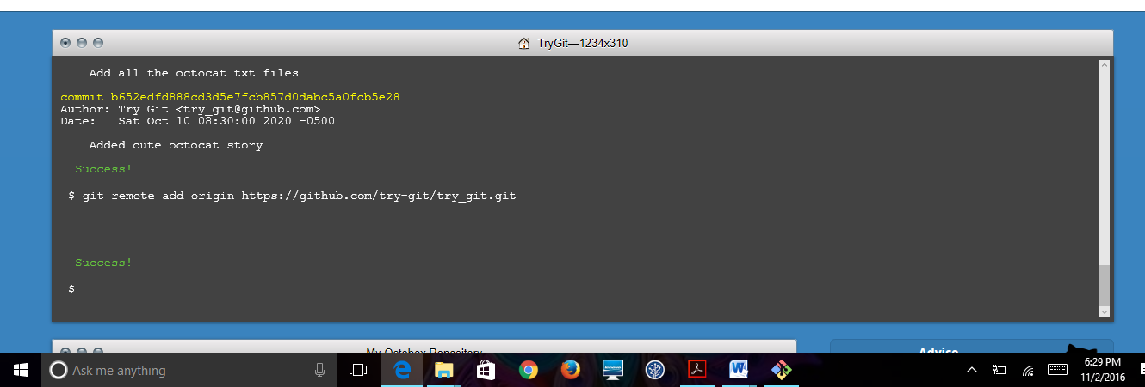

**1.11 Pushing remotely (screenshot):**

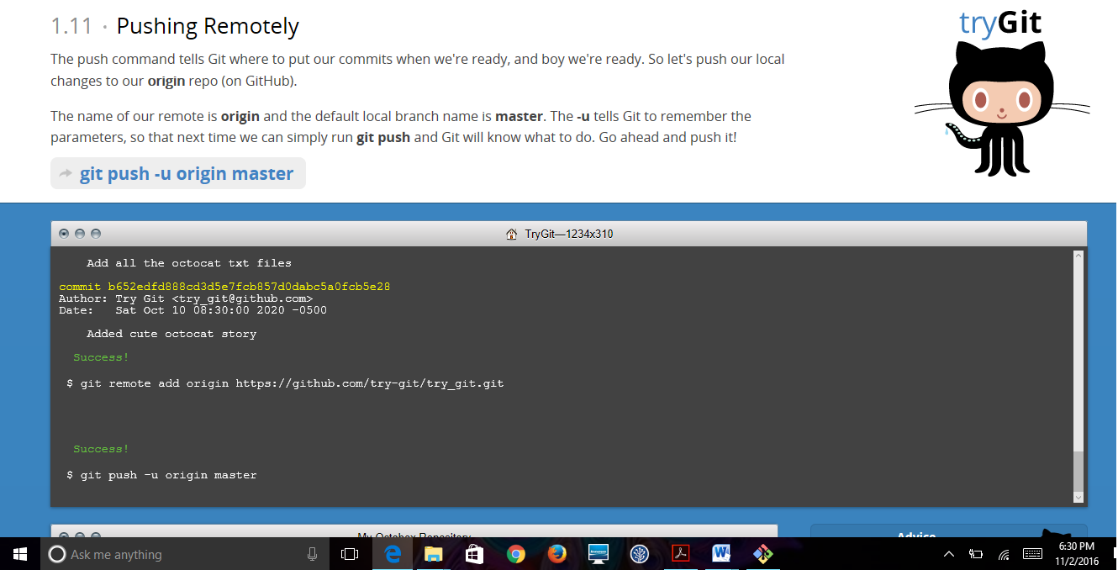

**Command Execution (screenshot):**

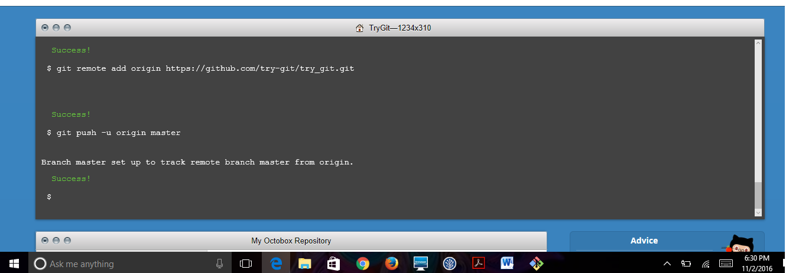

**1.12 Pulling remotely (screenshot):**

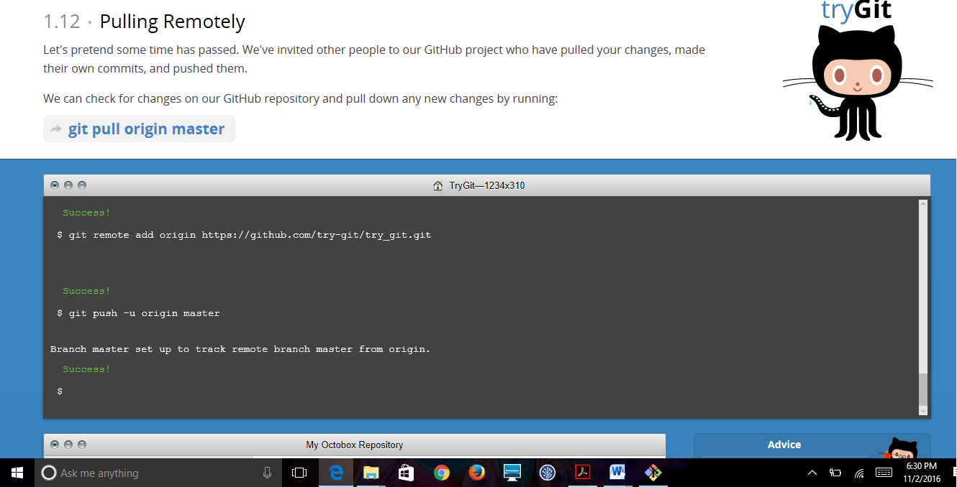

**Command Execution (screenshot)**

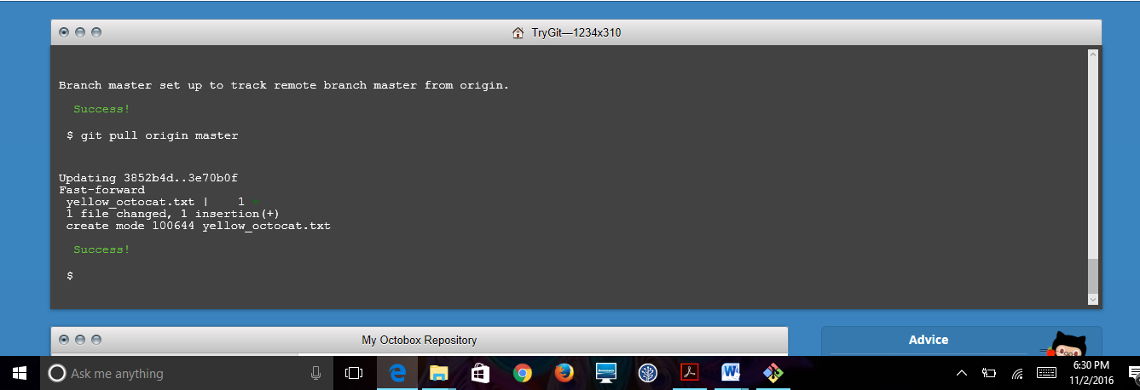

**1.13 Differences (screenshot):**

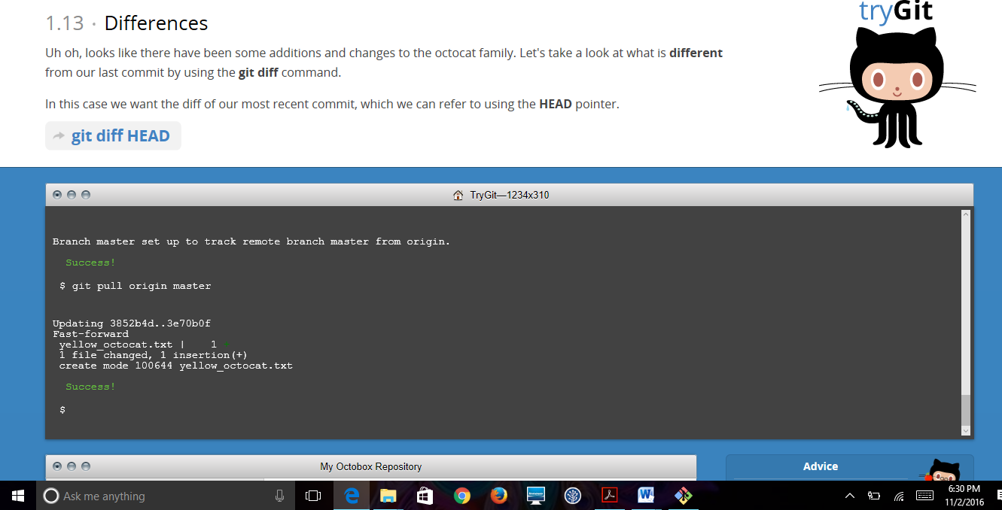

**Command Execution (screenshot):**

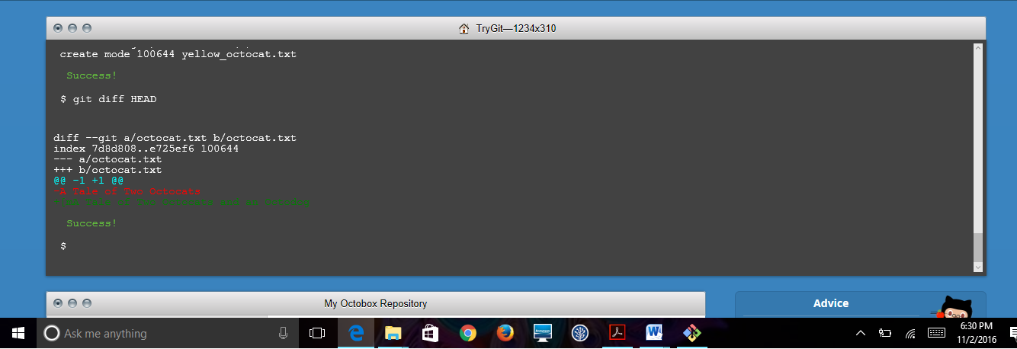

**1.14 Staged Differences (screenshot):**

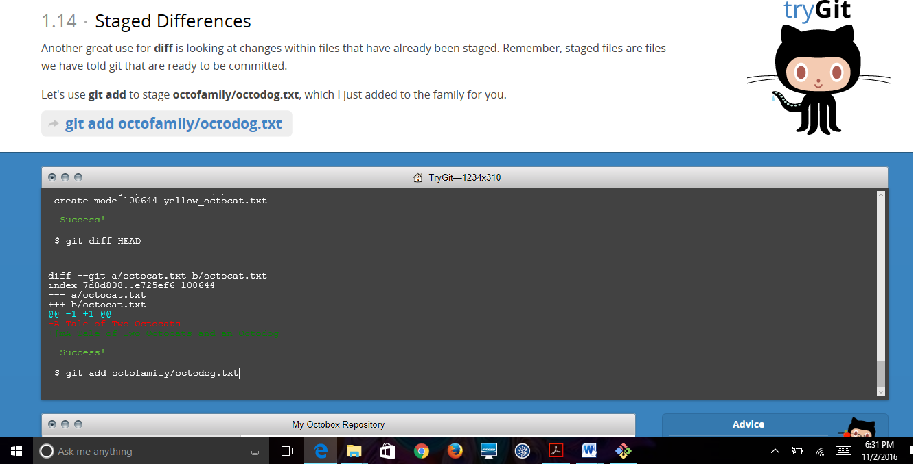

**Command Execution (screenshot)**

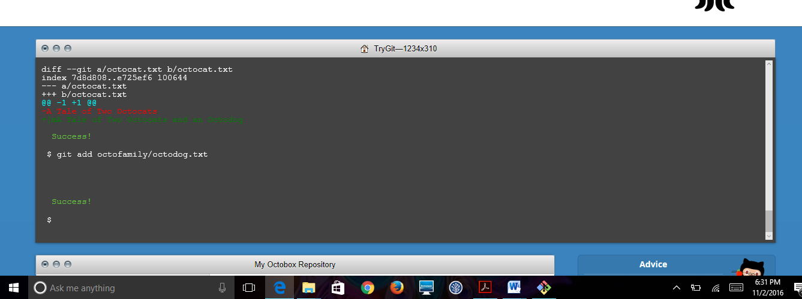

**1.15 Staged Difference cont’d (screenshot):**

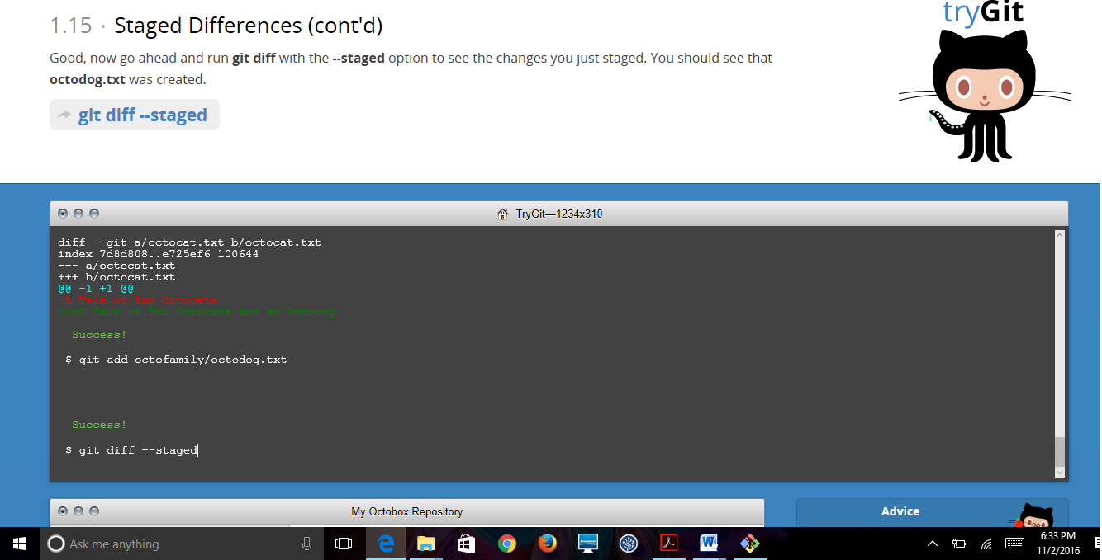

**Command Execution (screenshot)**

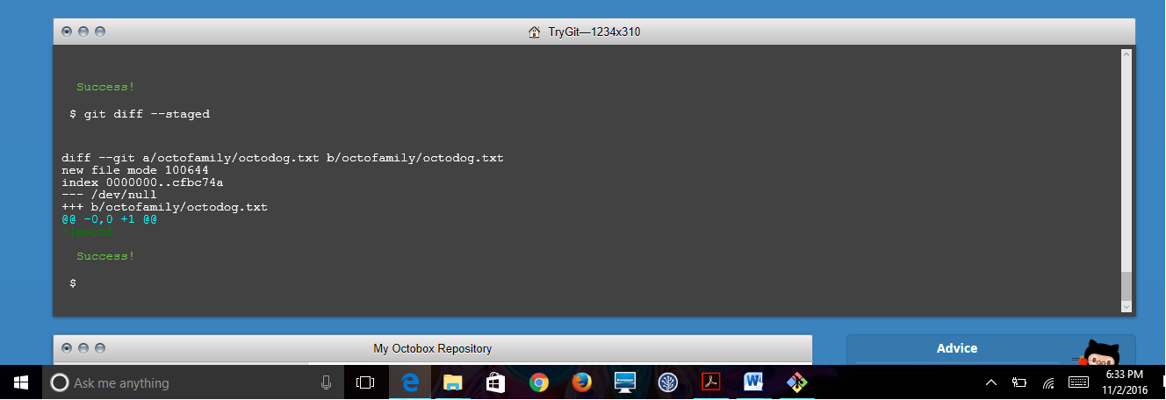

**1.16 Resetting the Stage (screenshot):**

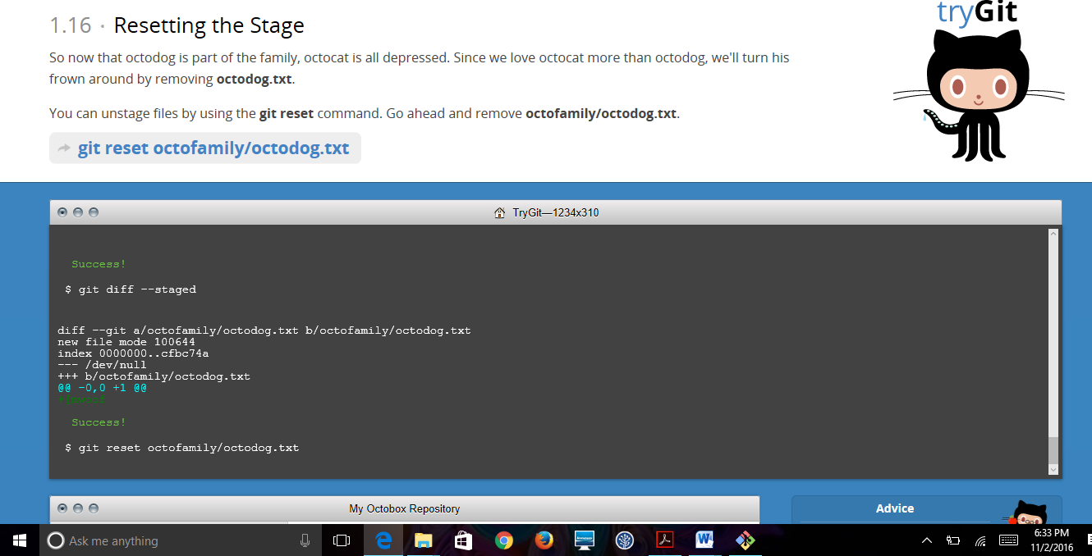

**Command Execution (screenshot)**

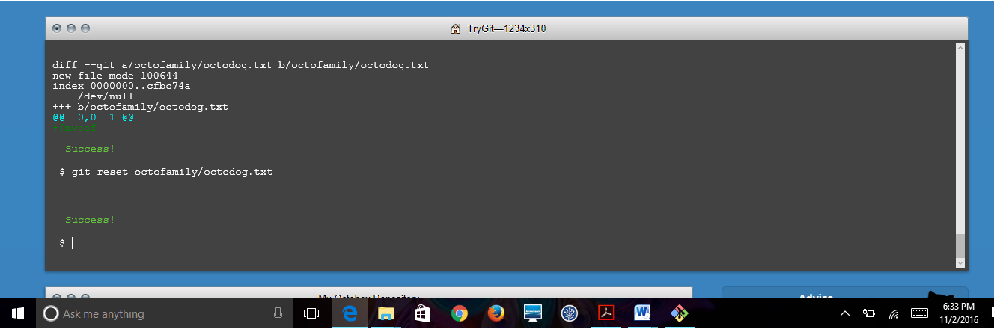

**1.17 Undo (screenshot):**

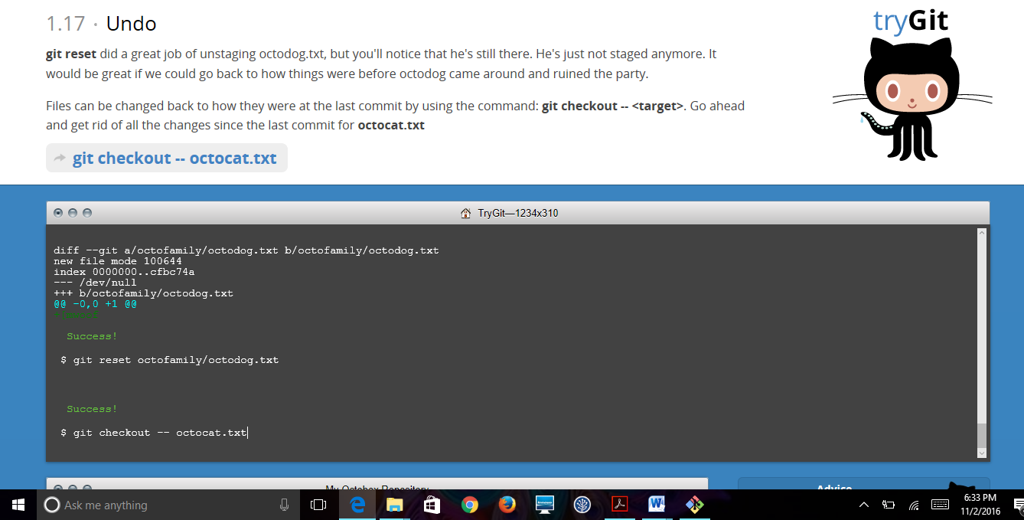

**Command Execution (screenshot)**

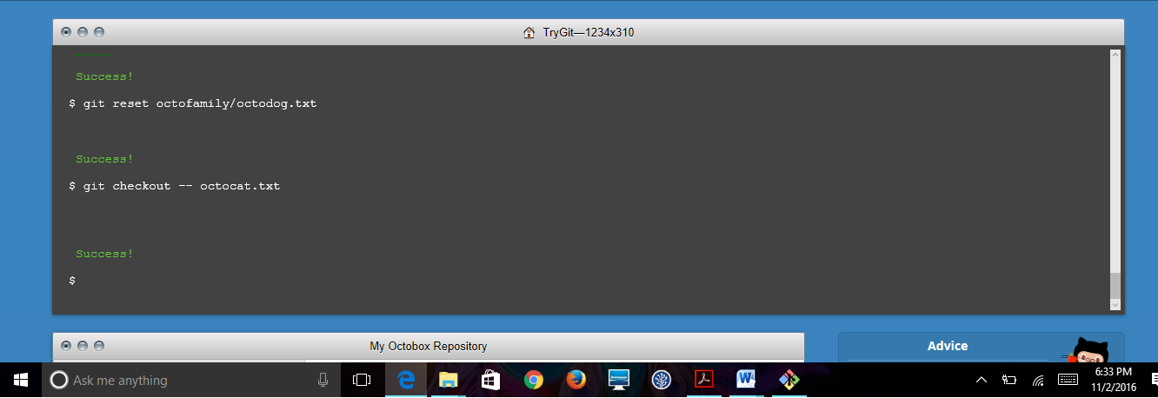

**1.18 Branching Out (screenshot):**

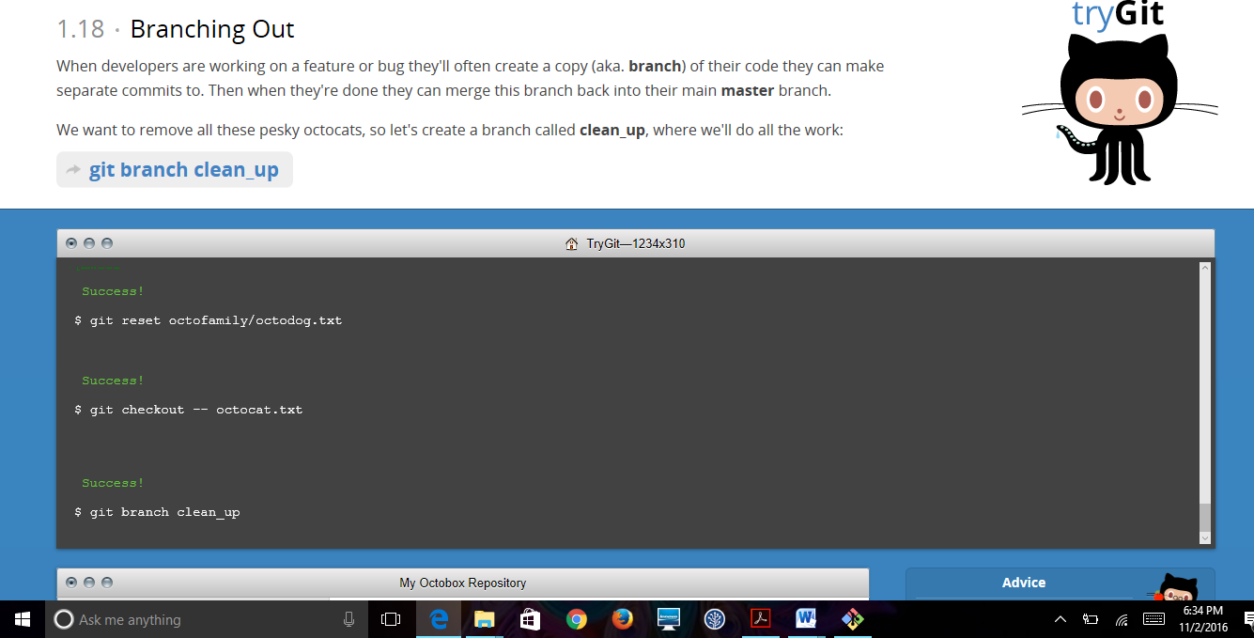

**Command Execution (screenshot)**

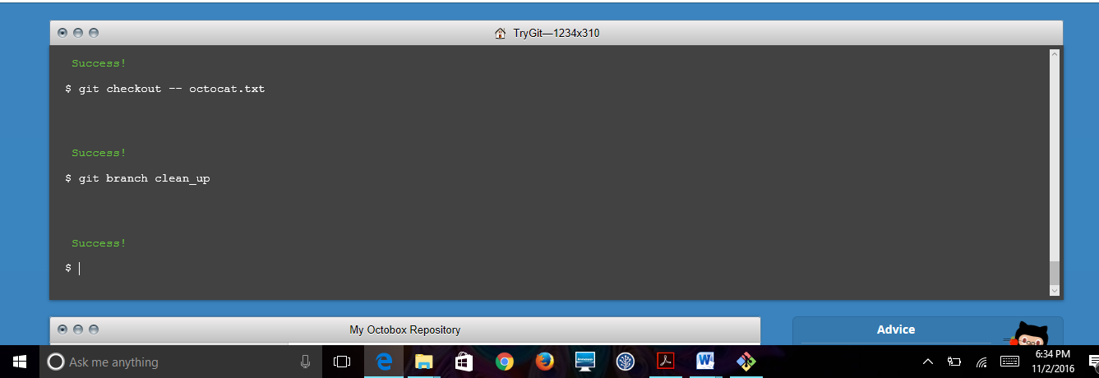

**1.19 Switching Branches (screenshot):**

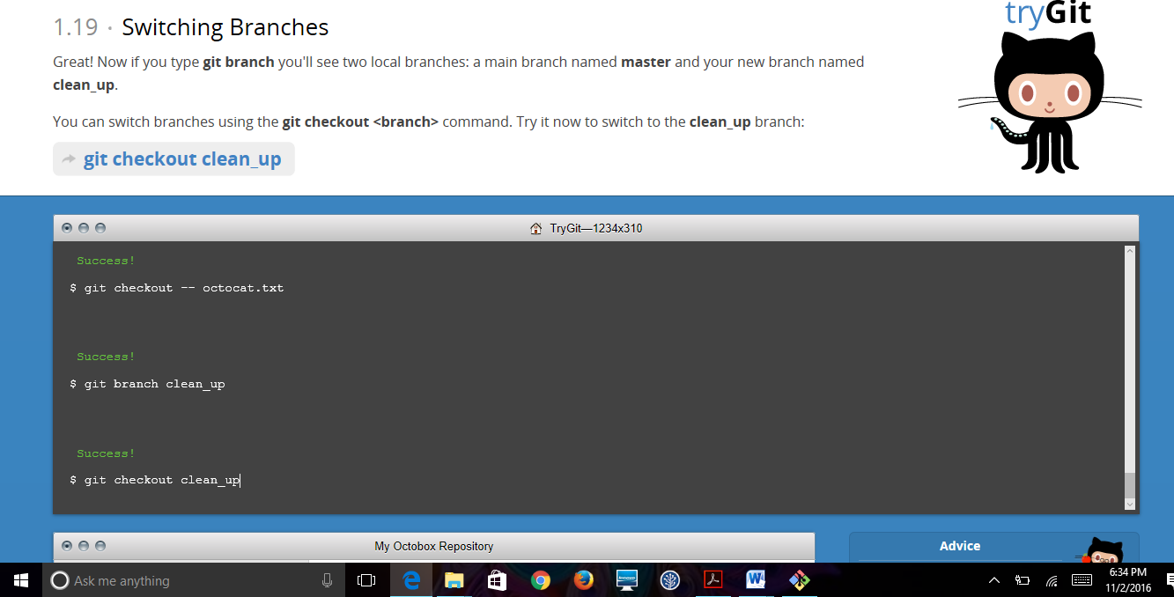

**Command Execution (screenshot):**

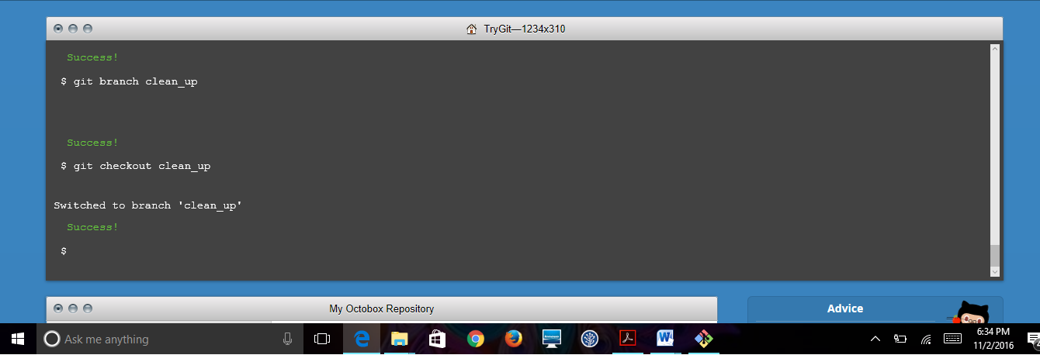

**1.20 Removing All the Things (screenshot):**

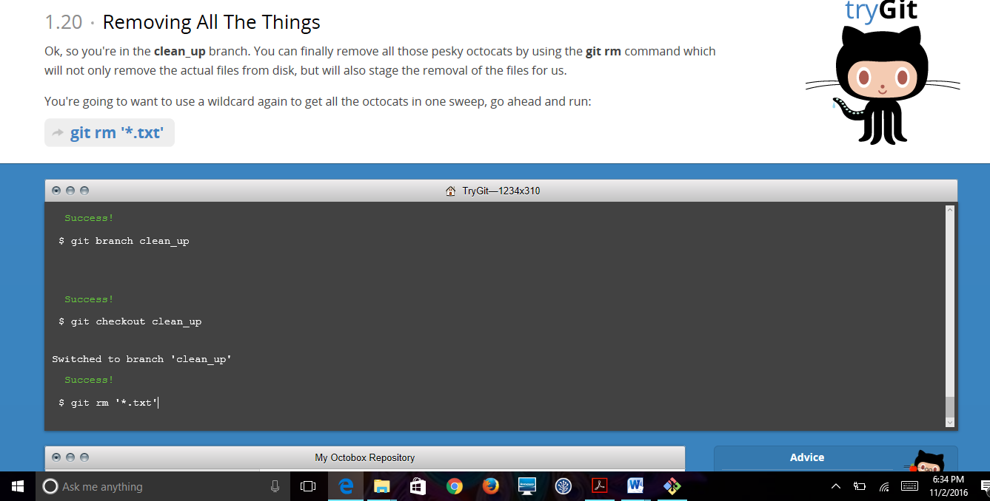

**Command Execution (screenshot):**

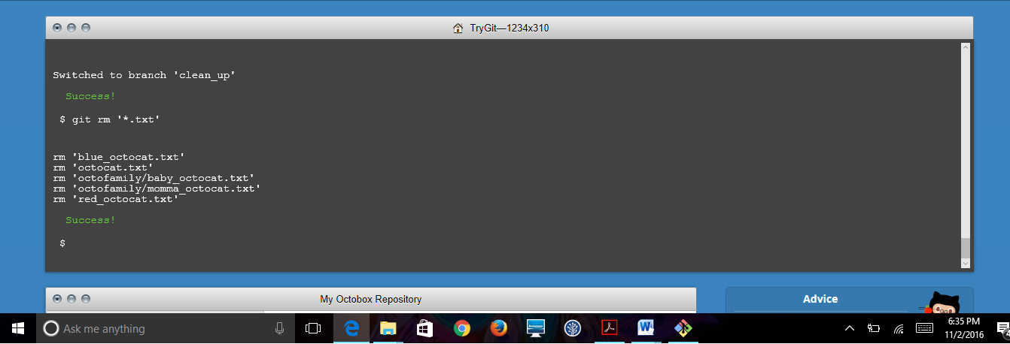

**1.21 Committing Branch Changes (screenshot):**

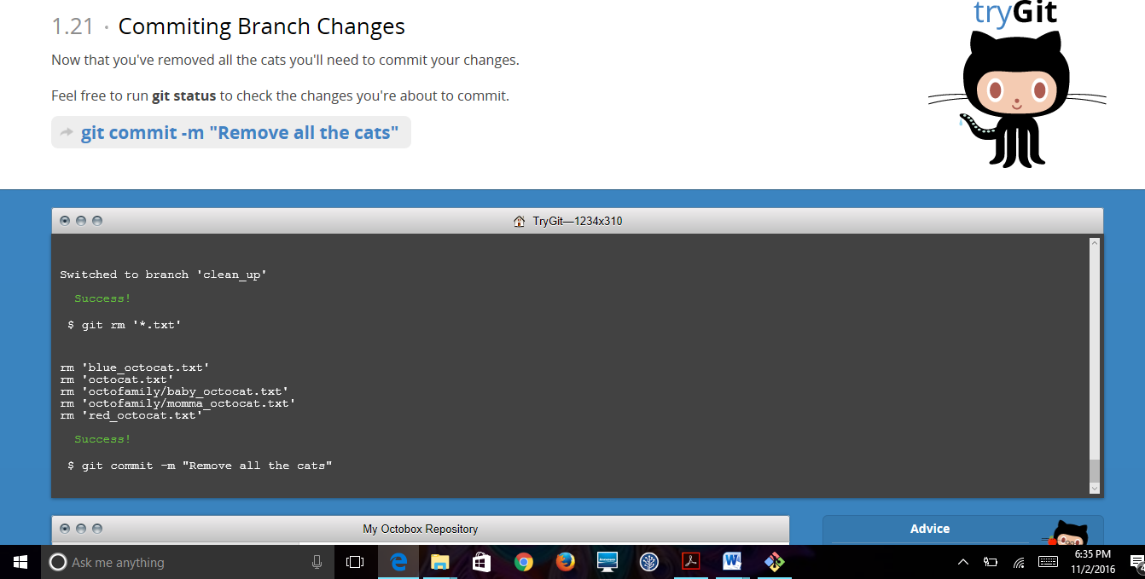

**Command Execution (screenshot):**

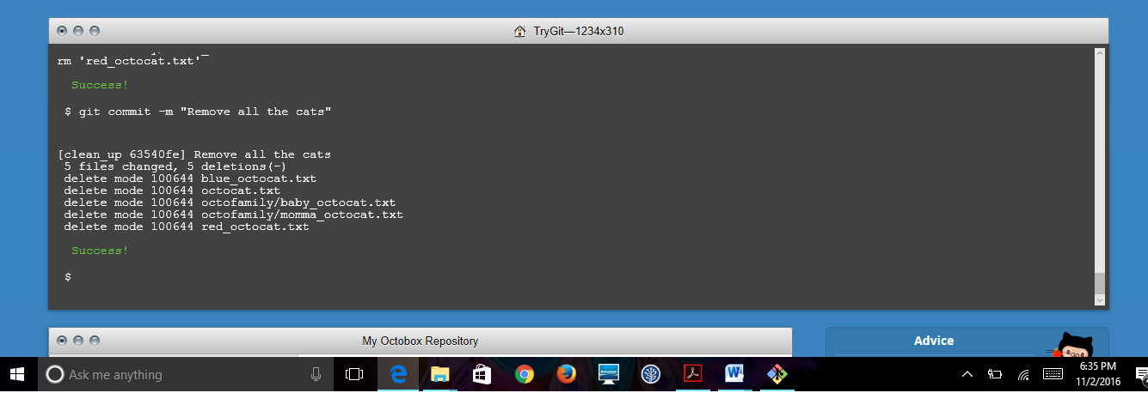

**1.22 Switching back to master (screenshot):**

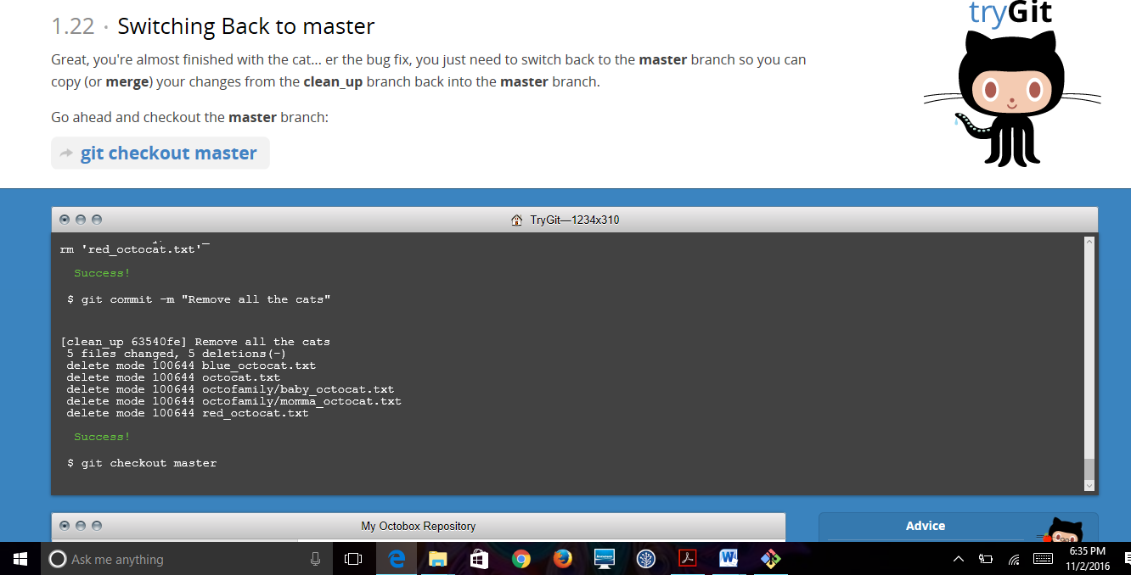

**Command Execution (screenshot):**

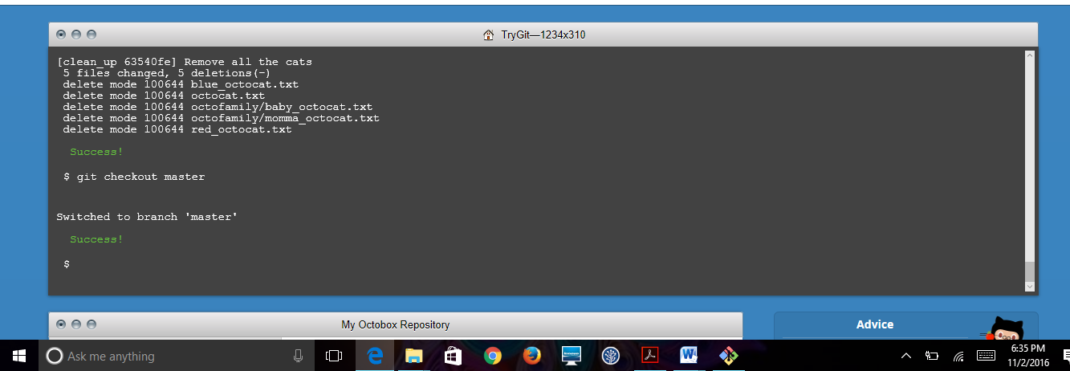

**1.23 Preparing to Merge (screenshot):**

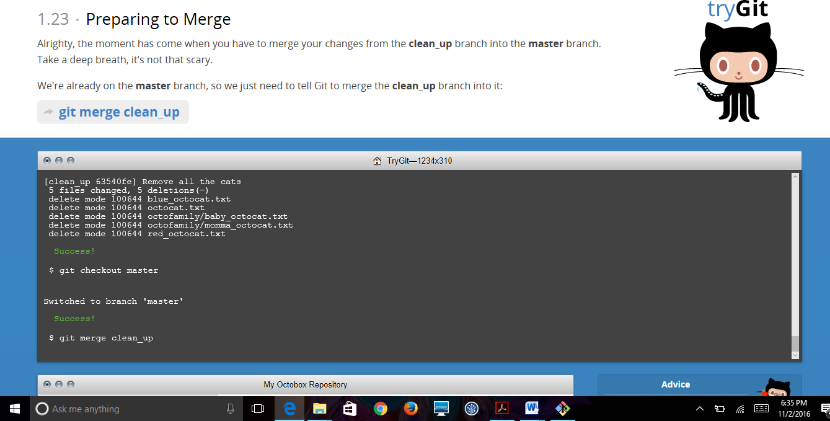

**Command Execution (screenshot)**

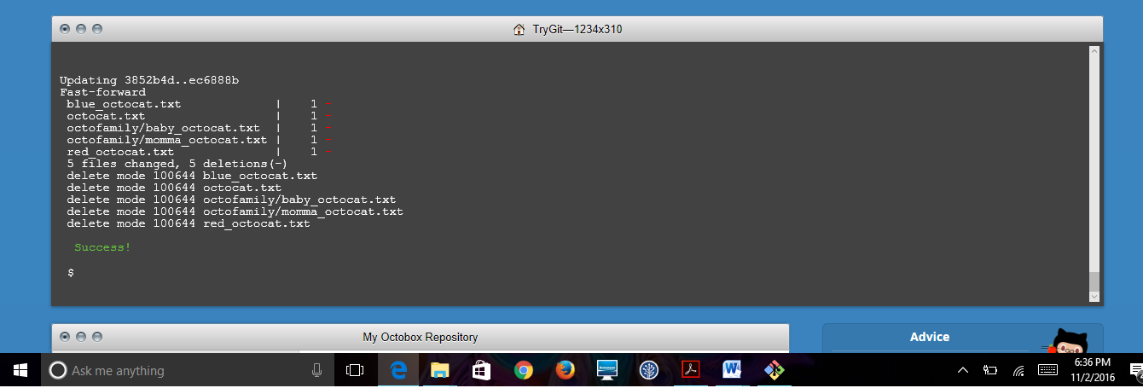

**1.24 Keeping Things Clean (screenshot):**

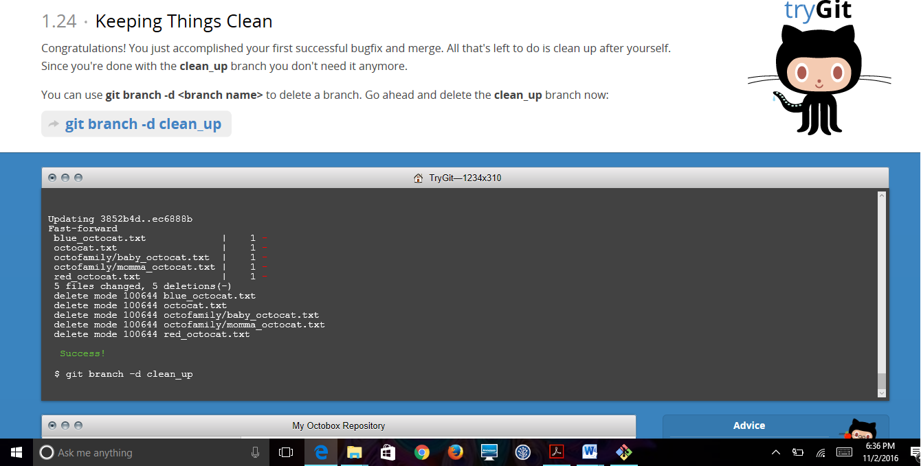

**Command Execution (screenshot)**

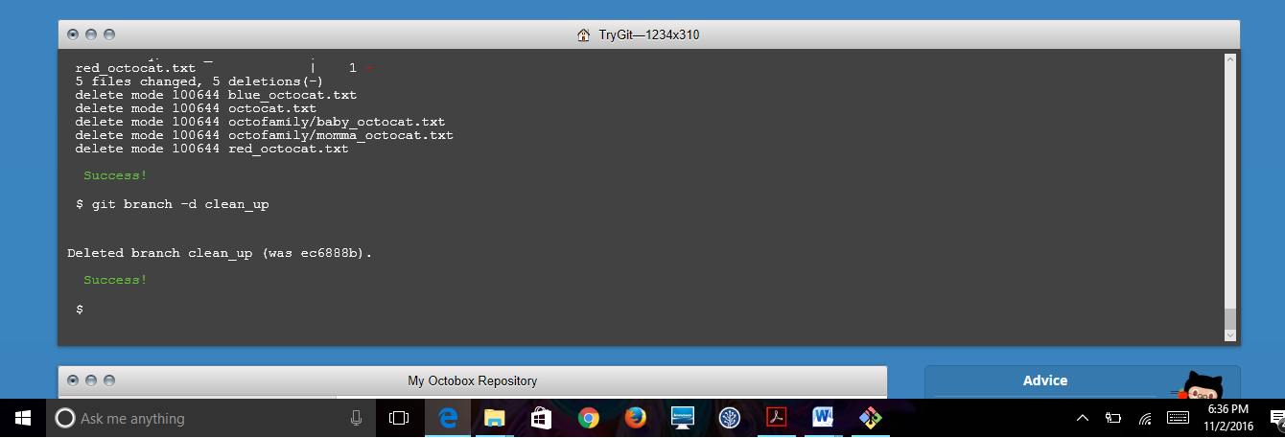

**1.25 The Final Push (screenshot):**

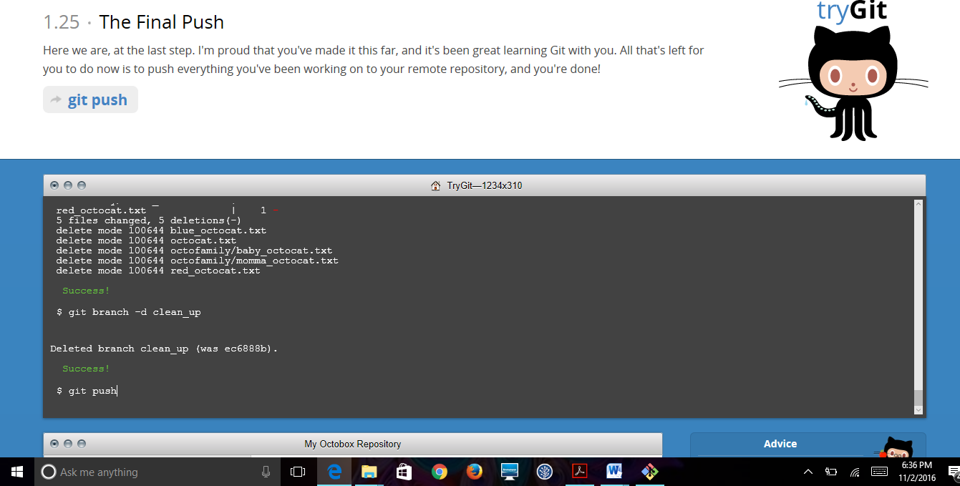

**Command Execution (screenshot)**

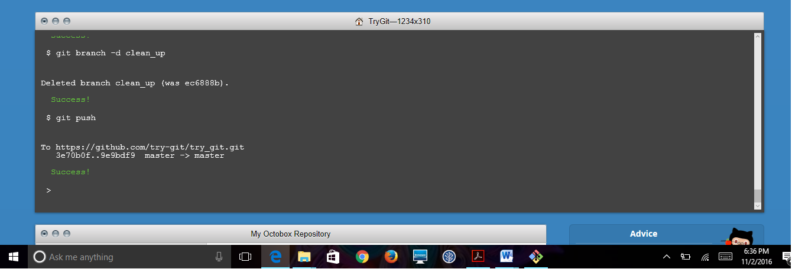

**1.25 The Final Push – Wrap it all Up (screenshot):**

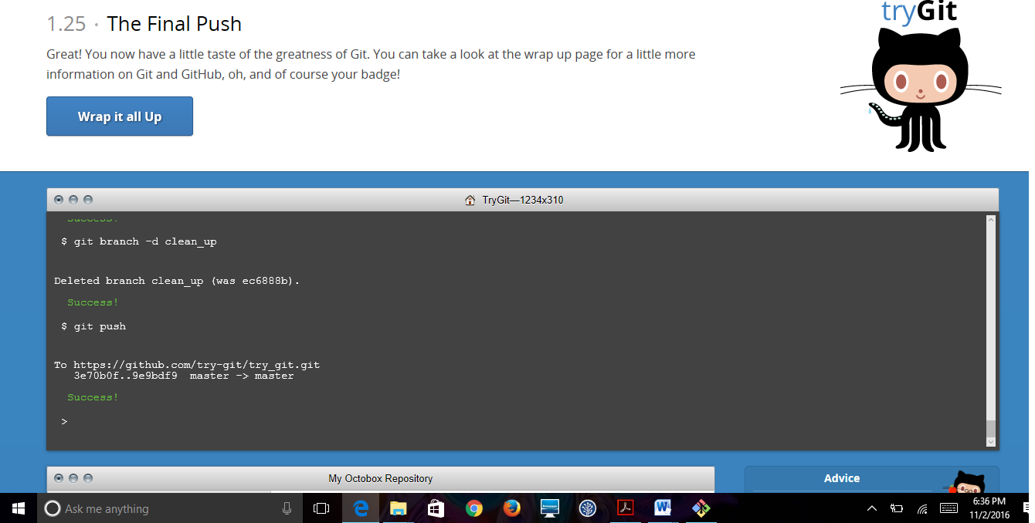

**Part 5**

* **Define the following terms in the context of Git (2 lines maximum):**
* **Repository**

Answer: In the Git platform, repository is a storage place for data. Files and revised codes can be stored in the repository.

* **Commit**

Answer: This command records the changes made to the program files and updates it in the Git repository.

* **Push**

Answer: This command transfers the recently committed changes to the server.

* **Branch**

Answer: Several code construction and revisions take place while working on project. Branches are formed to manage the workflow of codes.

* **Fork**

Answer: This command is used to create a duplicate code file of someone else’s project.

* **Merge**

Answer: This command is used to join all the commits into a single branch.

* **Clone**

Answer: This command is used to create a copy of an online repository on to your local computer.

* **Pull**

Answer: This command is used to pull all the changes made in the online repository onto our local repository.

* Pull request

Answer: This command is used to alert others about the changes you have made to the Git repository.

**Part 7**

**Commands and Strategies used to retrieve the README.md file**

* Accessed the ‘pace university courses page’ and clicked on the README.md file present in the Git repository.
* Selected the ‘Edit’ option at the top right-hand corner of the repository.
* A new page uploads onto the screen with the ‘README.md’ file in editing format.
* Updated last name, first name, time and date in the file.
* Requested file update to the repository.
* Created a new ‘Pull Request’ and added a comment to the ‘Pull Request’.
* Submitted the ‘Pull Request’.

The ‘Pull Request’ is accepted and merged with the main repository.